[Manual:Routing/BGP - MikroTik Wiki](https://wiki.mikrotik.com/wiki/Manual:Routing/BGP)

<https://wiki.mikrotik.com/wiki/Manual:Simple_Static_Routing>

1. <https://download.mikrotik.com/routeros/6.47.10/mikrotik-6.47.10.iso>

IDE

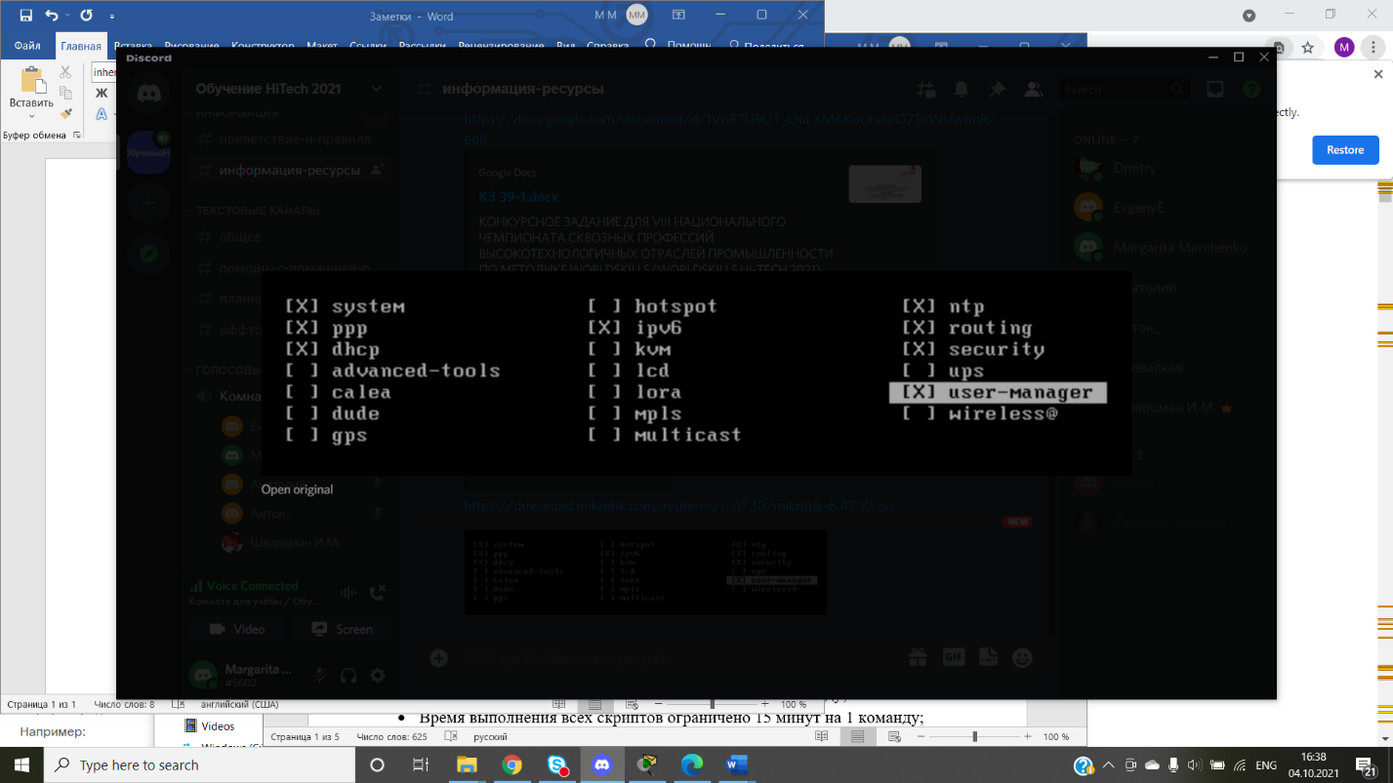

1. 89852691019
2. [4:47 PM]

ilya32167@gmail.com

**NEW**