Post-Interview Debrief Assistant — project report
Course: Data Sanity — Intro to AI Agents (Belgrade, 2026) Checkpoint deadline: 2026-05-14, 23:59
Team: AM Best Offer — Anton Voskobovich, Margarita Markova · Mentor — Alex Svetkin

Brief description of the project and its current status

Summary
We are building a tool that takes an interview transcript and produces a structured debrief from it: a list of questions and answers as they were spoken, an evaluation of each answer against predefined rubrics, and an aggregated report.

Problem and value
Both of us are actively job-hunting and want to analyze our past interviews. We want to understand how well each answer matched the interviewer's expectations and what needs to change for the next round — grounded in evaluation standards from data analysis and data science.

A regular chat with an LLM is not enough: results are typically not reproducible, since they depend on prompt wording, are not tied to a fixed structure, lack explicit quality checks, and it is unclear which sources the model relies on when scoring. The web contains a vast body of mock interviews, interview prep advice, and evaluation criteria; reviewing all of it manually is unrealistic. We narrow the agent's knowledge base down to sources we trust.

High level architecture
The system consists of three modules:

- Assessment and Recommendations — the main module: scoring, recommendations for the candidate on preparation and growth, and a structured report on how the candidate's profile matches the job requirements.
- Candidate Context — a purely informational module representing one candidate's journey through the job market. It contains everything tied to the candidate or arising from their interaction with the market: profile, target companies, their vacancies and JDs, applications and their stages, completed interview rounds with transcripts and feedback.
- Knowledge Base — general knowledge about the hiring market, not tied to any specific candidate: curated external materials (guides, YouTube mock interviews, courses), and the rubrics and typical requirements extracted from them. We rely on it as a set of trusted market references; it is not bound to a single person and changes less frequently than personal interviews.

The system is built as a pipeline (Workflow) — the same chain of steps runs on every new interview:

- Prepare the interview transcript.
- Splitter: extracts question–answer pairs (Q&A) from the transcript and returns a JSON file with the relevant fields populated.
- Evaluator: scores answers against predefined criteria and assembles a structured report (per-Q&A breakdown + overall summary).

Internally, the system has its own methodology for evaluating the work of individual steps (Splitter and Evaluator). This methodology is used to improve the system but is not exposed to the end user.

Data description: sources, volume, storage format, preprocessing steps

Data

Candidate context
Here we use transcripts of Anton's real interviews: six transcripts — 3 fit, 2 technical, 1 system design.

Knowledge base
Source | Transcripts | Description
Karpov Courses | 21 | Major Russian online university (Karpov.Courses): public mock interviews and post-interview breakdowns for DA/DS/ML/system design.
Yandex Praktikum | 2 | Major Russian educational platform; public resume reviews and analytics interview breakdowns.
Vadim Novoselov | 12 | YouTube creator: interview breakdowns and recordings for DS and adjacent roles (including "real" interviews at Russian companies).
Interview Query (Jay Feng) | 14 | Mock interviews targeting Western companies (Amazon, Meta/Facebook, DoorDash, LinkedIn, Walmart, Dropbox, etc.).
DataInterview | 7 | Mock interviews targeting Amazon, Meta, DoorDash, and others.
interviewing.io | 9 | ML / system design mocks, including with Meta / Google engineers.
Data Engineers PRO | 8 | Mock interviews and educational content on data engineering (including Spark).
mock Avito | 1 | Public Avito mock (product analytics, middle level).
Total | 74

How mock interview data gets into the repository
We built a YouTube downloader script (scripts/transcript_downloader/, invoked via the download-transcript skill). For a single video or a playlist it produces:

- the transcript as plain text (from subtitles);
- timecodes.txt — the same subtitles with YouTube-style timecodes ([mm:ss] / [hh:mm:ss]);
- video.md — video metadata, including the description and chapters extracted from timecodes (when YouTube exposes them);
- a separate .md file with feedback from the interviewer.

There is no diarization (speaker separation into "interviewer / candidate") in this pipeline: YouTube does not provide speaker labels — only a single subtitle stream. This is a hard constraint; Q&A boundaries are reconstructed by the Splitter's prompts and the subsequent validation step.

Pipeline architecture

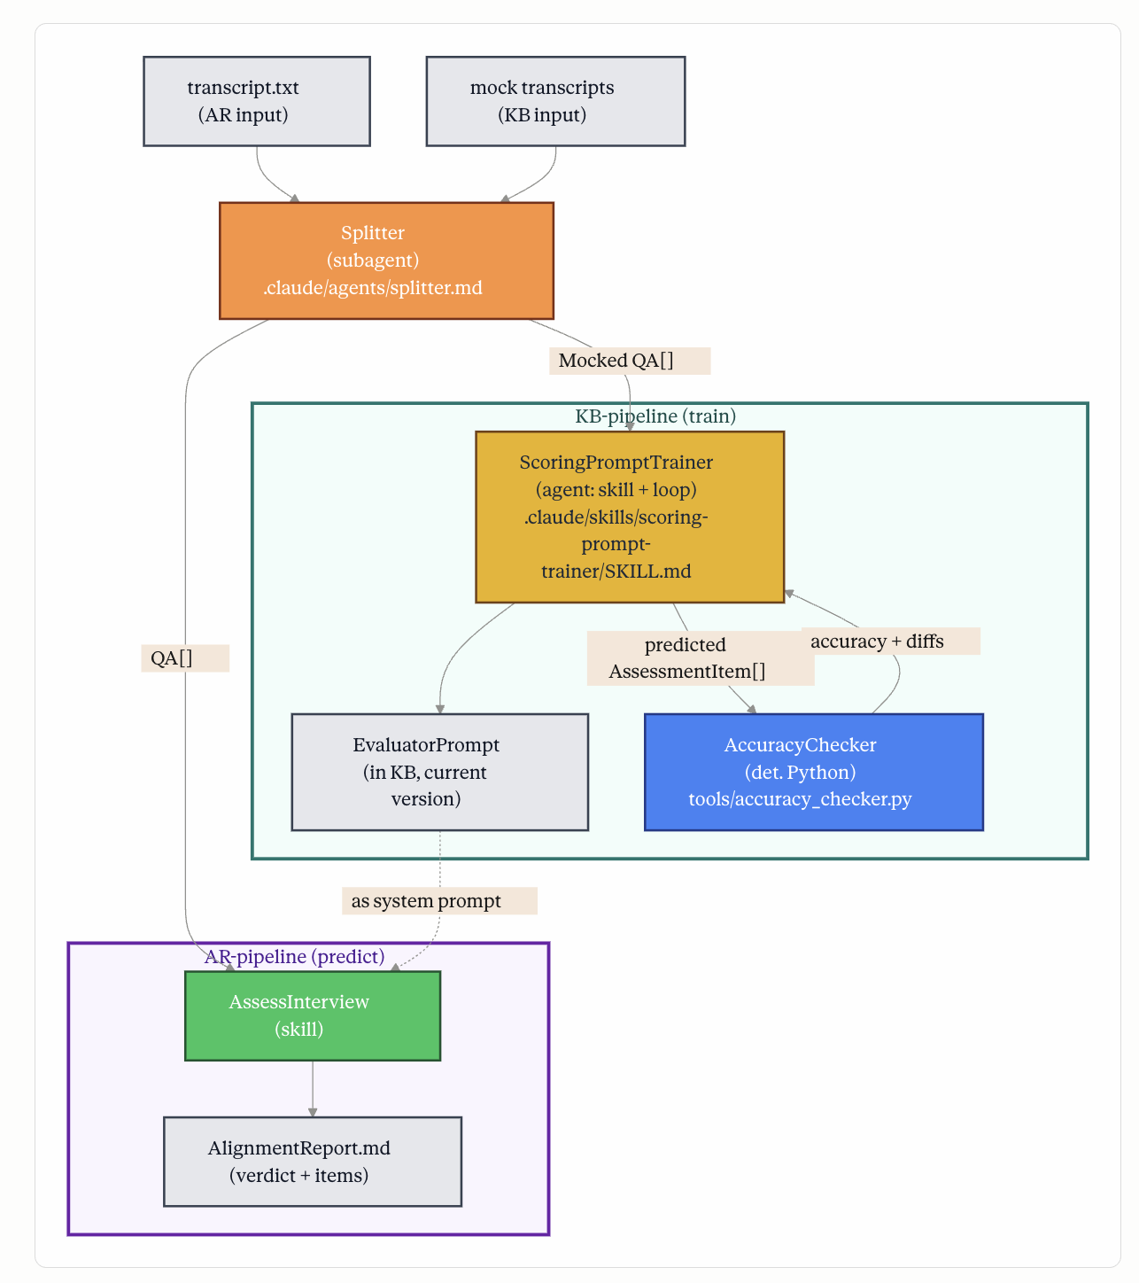

Input and output of the main Assessment and Recommendations module
Input — materials from a single interview round:

- required: the interview transcript;
- when available: CV, vacancy posting, job description, interviewer feedback.

Output — a structured result: per-question scoring and an overall summary.

How it is invoked
The scenarios are packaged as skills in Claude Code:

download-transcript — fetches materials from YouTube (for the Knowledge Base) run-splitter — extracts Q&A build-evaluator-prompt — selects an effective evaluator prompt assess-interview — produces interview reports

The user runs the scenario in a single environment, without manually copying prompts between chats. For run-splitter, a shared GitHub repository and a Claude Code subscription are sufficient; Q&A extraction uses the claude-sonnet-4-6 model (as a subagent), so a separate API key is not required for this step.

Splitter outputs are saved to labeling/data/ (JSON, Excel; and, when video.md is present, a validation report).

Step-by-step procedure

1. Splitter (Q&A extraction)
Purpose: from the interview text, produce a structured list of "interviewer question — candidate answer" pairs plus auxiliary fields (question type, topic, stage, etc.) as a single JSON object conforming to a fixed schema.

Every run is checked to ensure the output is valid JSON that matches the schema. If the folder contains video.md (metadata and description pulled from YouTube), an additional cross-check is run: the extracted Q&A pairs are compared against the reference signals from the video description and timecodes. The resulting report covers how many reference questions were expected, how many were captured, how well question topics matched; discrepancies caused by follow-ups and segment boundaries are explained separately.

Modes

- mock_assisted_split — for mock interviews. Selected automatically if the interview folder contains video.md (YouTube metadata and chapters).
- raw_split — for analyzing real interview transcripts. The default when no video.md is present. Only transcript.txt is passed to the model as the primary input.

Prompts and schema

The model's role and the immutable extraction rules are set by the system prompt; the output structure is defined by a JSON Schema.

splitter_prepare_prompt.py produces two files per run:

…splitter.v1.mock.user_prompt.txt — the user part (schema + transcript + post-processing hints); …splitter.v1.mock.splitter_llm_input.txt — the full input for a single LLM call (system + user + schema in one file — convenient for Cursor / Claude Code).

The version number vN is selected automatically by scanning all existing files for the given source_id and mode (mock or raw); if none exist, v1 is used, otherwise the next number after the maximum already in use.

Full splitter cycle

Prepare (Python): generate *.user_prompt.txt and *.splitter_llm_input.txt, and print the target paths for the JSON / xlsx / validation report. Extraction (LLM): from splitter_llm_input.txt (or separate system + user inputs) — a single response: valid JSON without markdown wrapping; saved to …splitter.vN.<mock|raw>.json. Excel (Python): splitter_json_to_excel.py converts the JSON into an .xlsx for convenient viewing. Validation (Python, only when the mode is mock and video.md is present): splitter_validate_video.py produces …vN.<mock|raw>.validation.md; video.md itself is still never passed to the LLM.

From a review standpoint, the Splitter's primary output is the …json file: a list of items conforming to splitter_output_schema.json (Q&A pairs in the contract fields plus auxiliary fields). The .xlsx and .validation.md files are the mandatory "tail" of a full run, kept for ease of inspection and offline cross-checking against YouTube.

2. Assessment and Recommendations module
Assembles per-Q&A scores for the user using the trained prompt, and produces an aggregated report (verdict / scoring in terms of the current MVP).

3. Knowledge Base
In this module we search for a prompt whose evaluations on mock-interview questions match the evaluations from the mock interviews themselves as closely as possible.

Evaluation approach: what metrics will be used and on what data

Splitter: Q&A extraction quality control
Run via splitter_validate_video.py inside the Splitter skill. No LLM is called — only the previously generated JSON and (when available) video.md are read. Two levels of checks:

1. JSON validation
For every interview that has a splitter output. The file is checked to be valid JSON and to strictly conform to splitter_output_schema.json.

2. Q&A extraction quality check
Only for mock interviews from YouTube. For mock interviews downloaded from YouTube, the folder contains video.md: a list of chapters with timecodes and titles — effectively the video's table of contents. We can use it to verify whether the JSON captured all the key question blocks visible in the video description.

Important: this list is not passed to the LLM during Q&A extraction (so as not to "leak" the description's structure to the model). Once the splitter has finished, the extracted question–answer pairs and the question topic field are aligned with the chapters from video.md by timestamp, with a configurable tolerance (the --tolerance flag, 90 seconds by default).

Metrics in the Q&A validation report *.validation.md
- Coverage — the share of chapters with questions from video.md for which at least one question was found in the JSON: (matched chapters) / (total chapters with questions) × 100%.

Only chapters with actual questions are counted; introductory sections without a substantive question are excluded (e.g., interview format overview, greetings, participant introductions, closing feedback, etc.). Example: if the video description lists 20 questions and the splitter found 18, coverage is 90%.

- JSON gaps — the report separately lists the uncovered timecodes: chapters from video.md for which no matching question was found in the JSON, with explanations.

- Extra questions in JSON — Q&A pairs the splitter produced for which no match exists in the video description. These are often follow-up questions: in the video description they are bundled with the main question, while in the Q&A they are counted as separate questions. The report provides explanations and examples where possible.

- Topic consistency — if the video description groups questions by topic, a separate --section-config JSON is used to validate the question_topic field. The file defines section boundaries (by timecodes) and which question_topic values are allowed in each section. For each pair "description chapter ↔ JSON question" where this check is meaningful, we record whether the question's topic falls within the allowed list for its section.

Formula: the share of successful checks among all rows where the topic was actually checked: (times the topic was recognized correctly) / (times the topic was checked) × 100%. Example: 14 out of 15 topics recognized in the description → 93%. If --section-config is not supplied, the metric in the summary is "N/A": topic checking simply wasn't enabled, this is not a run failure.

In progress: adding iterations. If Coverage or Topic consistency != 100%, or there are gaps, the LLM analyzes the video description and the transcript, improves the prompt, and re-runs validation. The cycle repeats until both quality metrics reach 100%.

Evaluator
This will score the metrics the answers? for factual accuracy, focus, and clarity of the answer. Each metric will be scored on a 0–100 scale.

A golden set is being built (manual labeling of reference scores on a subset of Q&A). The train / test split is at the level of entire mock sessions (so that correlated answers from a single dialogue do not leak between splits). The target proportions, agreed with the spec, are roughly 70% of sessions for train and 30% for test (e.g., out of 74 usable mock sessions — about 52 / 22, with stratification by source collection so that test retains a mix of sources).

As noted above, optimization is done so that the prompt scores as closely as possible to the scores from the mock interviews themselves. For evaluation we will use MAPE because:

- it is relative — and therefore interpretable;
- all questions are weighted equally (weighting samples is not required).

Preliminary results if available, or a description of what has been tested so far
So far we have run the end-to-end Splitter loop on a subset of our curated mock-interview corpus: prompt assembly (prepare_prompt.py), JSON extraction by the model against the fixed schema, export to Excel, and the validation step (JSON-schema check plus cross-checking against video.md and YouTube subtitle timecodes where available). Qualitatively, the pipeline reliably produces parseable JSON and readable validation reports; the summary table of quantitative metrics (how many reference questions were captured, match rates per interview) is still being filled in as of the checkpoint submission.

The Evaluator block and the golden set (manual labeling, train/test split) are in progress; we are not committing to final accuracy numbers yet — those will come once the reference set is built and frozen.

