Margot Wagner

A53279875

CSE 250a HW7

Due: 11/24/20

**7.1 Viterbi Algorithm**

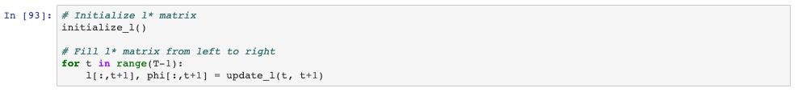



**“hindsight is always twenty twenty”**

