Margot Wagner

A53279875

CSE 250A Principles of AI

HW 1

Due: 2pm 10/13/20

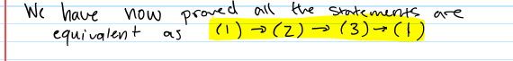

(c)

