**Semiclassical contribution**.

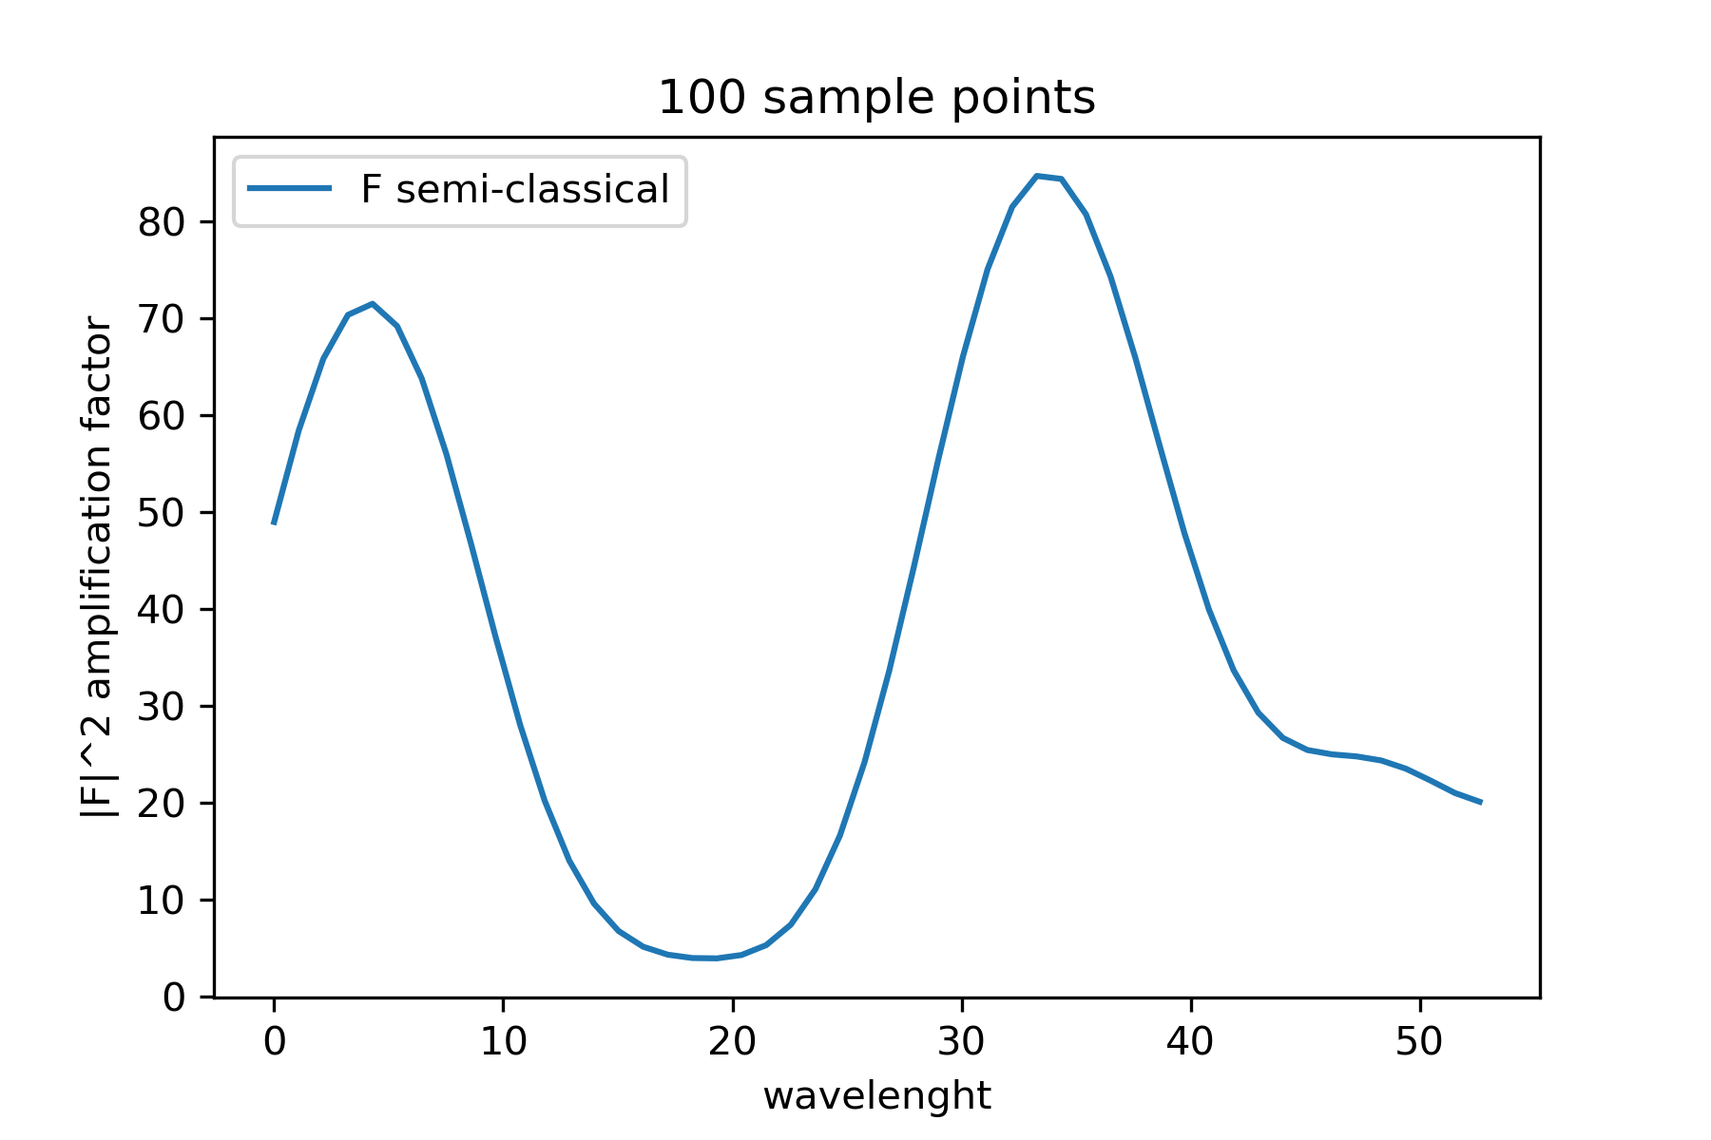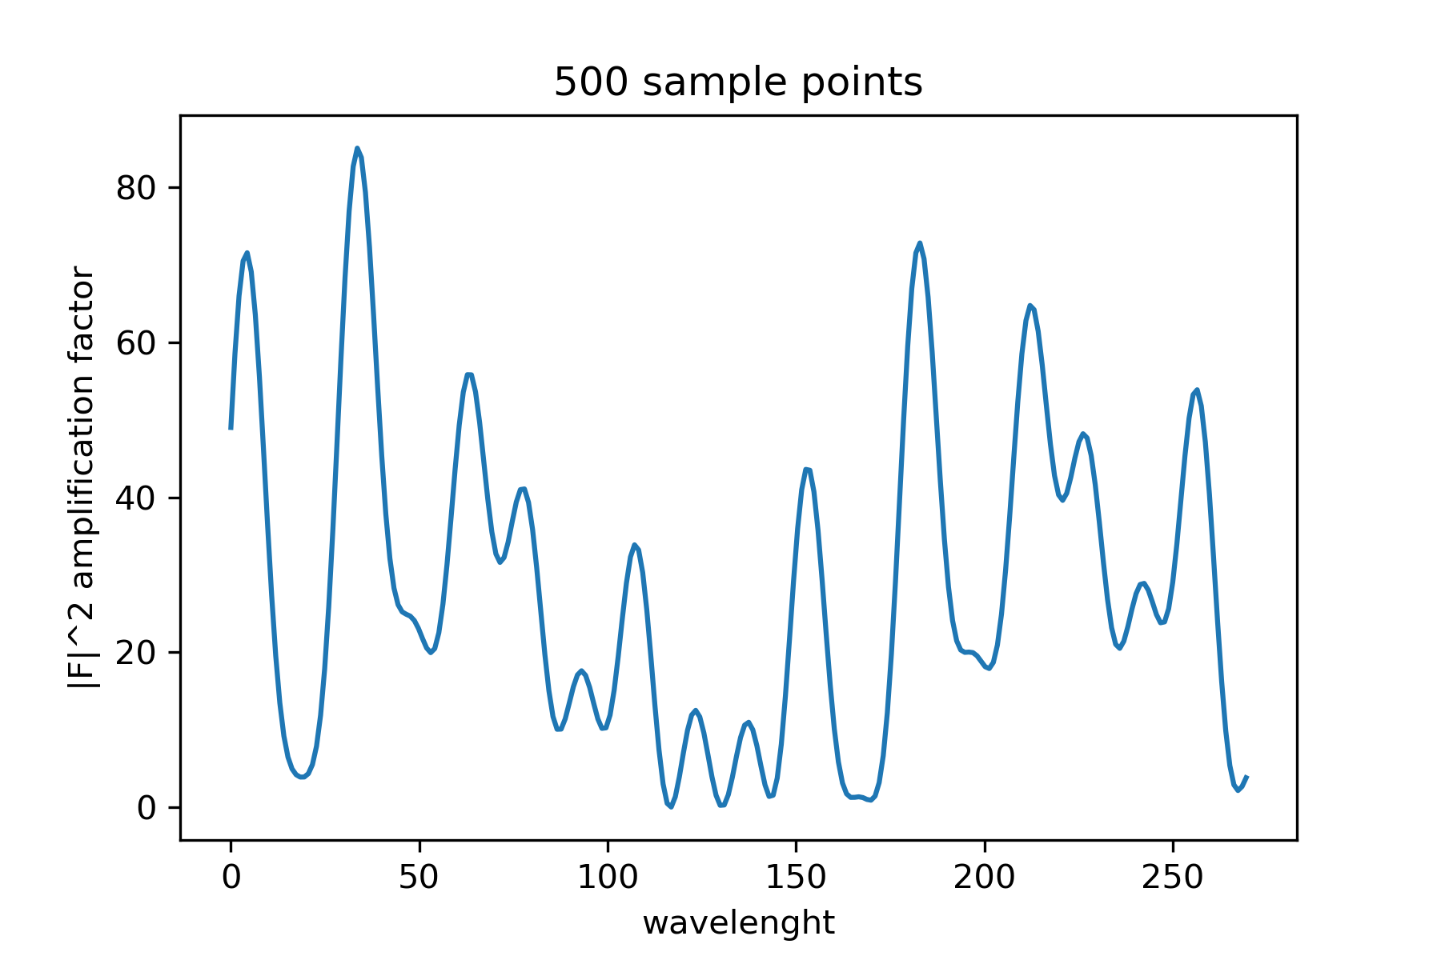I change the amount of sampling points. In total we have 923 bins. If I change the amount of sampling points I therefore will have more wavelennghts, i.e. the x axis reaches higher values.

I think this part is correct even though I am not sure about the constants, the values are higher than the ones in the original paper (which should have the same values since we are using the same constants.)

**Contribution from the diffraction**

Tilde F_d is the remaining part of the histogram when I remove the contribution of the critical points.

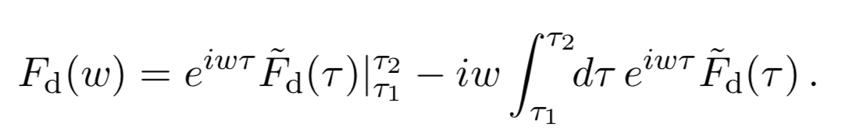F_d has two different terms:

For the first term the only things that could be changed are the tau 1 and tau 2, aka the starting and ending point of the time.

The second term is the Fourier transform.