Exposé — Master's Thesis
Working Title: Integrating Cognitive Predictive Metrics into the AIM Platform for Automated GUI Evaluation
Author: Hannah
Programme: User Experience Design
Supervisors: Gerhard Graf and Prof. Dr. Christian Sturm
Date: June 2026

1. Introduction and Problem Statement
Automated evaluation of graphical user interfaces (GUIs) is a central challenge in HCI research: designers need scalable, reproducible quality indicators without having to conduct a costly user study for every design decision. This is particularly critical in safety-relevant contexts such as automotive HMI, where a poorly designed dashboard can increase cognitive load and compromise driver safety. The Aalto Interface Metrics (AIM) platform provides an established approach that computes perception-based metrics such as visual clutter, salience, and symmetry from static screenshots (Oulasvirta et al., 2018). These metrics are reproducible and objective — but they capture only the physical properties of the image, not the interplay between interface structure, usage context, and the user's cognitive capacity. Das et al. (2024) show empirically that cognitive dual-task load (e.g., simultaneously driving and reading a dashboard) fundamentally alters gaze behaviour: users exhibit pronounced tunnel vision, miss peripheral UI elements, and form shorter, less efficient scanpaths. AIM cannot predict this behaviourally relevant phenomenon because it contains neither task context nor a cognitive model. Jiang et al. (2023) further demonstrate that UI-specific attention patterns across interface types are systematically underestimated by task-agnostic saliency models.
The present master's thesis therefore asks: Does the integration of cognitive predictive metrics into the AIM platform improve the computational evaluation of GUIs?

2. Related Work and Theoretical Framework

2.1 AIM and Computational GUI Evaluation
AIM (Oulasvirta et al., 2018) is an open-source platform that computes a range of perception-based metrics from GUI screenshots. Related tools such as UiLab (Burny & Vanderdonckt, 2021) and Criticmate (Ko et al., 2026) extend the evaluation framework with consistency checks and multi-stage critique processes. UIClip (Wu et al., 2024) demonstrates that data-driven CLIP models can learn GUI quality judgements — but provide no mechanistic explanatory framework and no behavioural prediction. A systematic review of computational models specifically for automotive HMI design (Lorenz et al., 2024) finds that none of the 34 surveyed approaches operates on generic screenshots, and only one accounts for individual user characteristics — precisely the two gaps the present pipeline addresses.

2.2 Computational Rationality as Theoretical Foundation
The Computational Rationality (CR) framework by Oulasvirta, Jokinen, and Howes (2022) replaces rule-based engineering models (such as GOMS or ACT-R, which describe interaction as fixed rule sequences) with sequential decision theory: interaction is modelled as an optimal control policy that balances cognitive, perceptual, and motor constraints. Formalised as a Partially Observable Markov Decision Process (POMDP) and solved via Reinforcement Learning, CR explains the transition from novice-driven, bottom-up search to expert-guided, top-down memory retrieval (Jokinen et al., 2020). Current CR applications include gaze-based selection (Chen et al., 2021), touchscreen typing (Shi et al., 2024), task-conditioned scanpaths (Shi et al., 2025), attention switching in dual-task scenarios (Lingler et al., 2024), adaptive UI via multi-agent RL (Langerak et al., 2024), driver adaptation to assistance systems (Jokinen & Kujala, 2021), and dual-task attention allocation on head-mounted displays (Bai et al., 2024) — the latter two directly establishing the automotive dual-task context as a CR-tractable problem.

2.3 Saliency, Scanpaths, and Cognitive Load
Scanpath prediction has evolved from task-agnostic saliency models (DeepGaze II, Kümmerer et al., 2017) towards task-conditioned approaches: SeekUI (Guo et al., 2026) and Chartist (Shi et al., 2025) show that task-specific conditioning significantly improves prediction quality. EyeFormer (Jiang et al., 2024) demonstrates the feasibility of personalised scanpaths through few-shot conditioning. That cognitive load measurably reshapes scanpaths is empirically established by Krejtz et al. (2018), who show that fixation-based pupillometry and microsaccade magnitude reliably discriminate task difficulty (η²≈0.16–0.17) — validating eye-tracking as a cognitive load measure for both the HCEye dataset and the planned user study. Das et al. (2024) provide the most direct empirical precedent for the pipeline's target domain: in automotive dual-task conditions, cognitive load produces tunnel vision, shorter fixations, and missed peripheral elements — the exact behavioural pattern Stage 2 is trained to predict. Cognitive load itself is most commonly operationalised via the NASA Task Load Index (Hart & Staveland, 1988), a multi-dimensional subjective workload measure that serves as the validation target for Head 3 of Stage 2. For the simultaneous prediction of multiple outputs (speed, accuracy, effort from one model), Miazga et al. (2026) provide methodological foundations.

2.4 Research Gap
No existing work combines: (a) task-independent complexity extraction as an interpretable input layer, (b) task-conditioned behavioural prediction with (c) an explicit coherence constraint between saliency, scanpaths, and cognitive load — integrated into an established GUI evaluation platform (AIM).

3. Research Design and Methodology

3.1 Architecture: Two-Stage Pipeline
The pipeline converts a GUI screenshot into three simultaneous behavioural predictions. Figure 1 shows the overall data flow. A screenshot first passes through a task-agnostic feature extraction layer (Stage 1), which produces a compact visual feature vector. This vector is then passed to a task-conditioned multi-output regression model (Stage 2), which uses the task context and an optional user profile to simultaneously predict saliency, fixation distribution, and cognitive load. The decoupled architecture ensures that Stage 1 outputs are reusable across task contexts, while Stage 2 is the only component that requires training data.
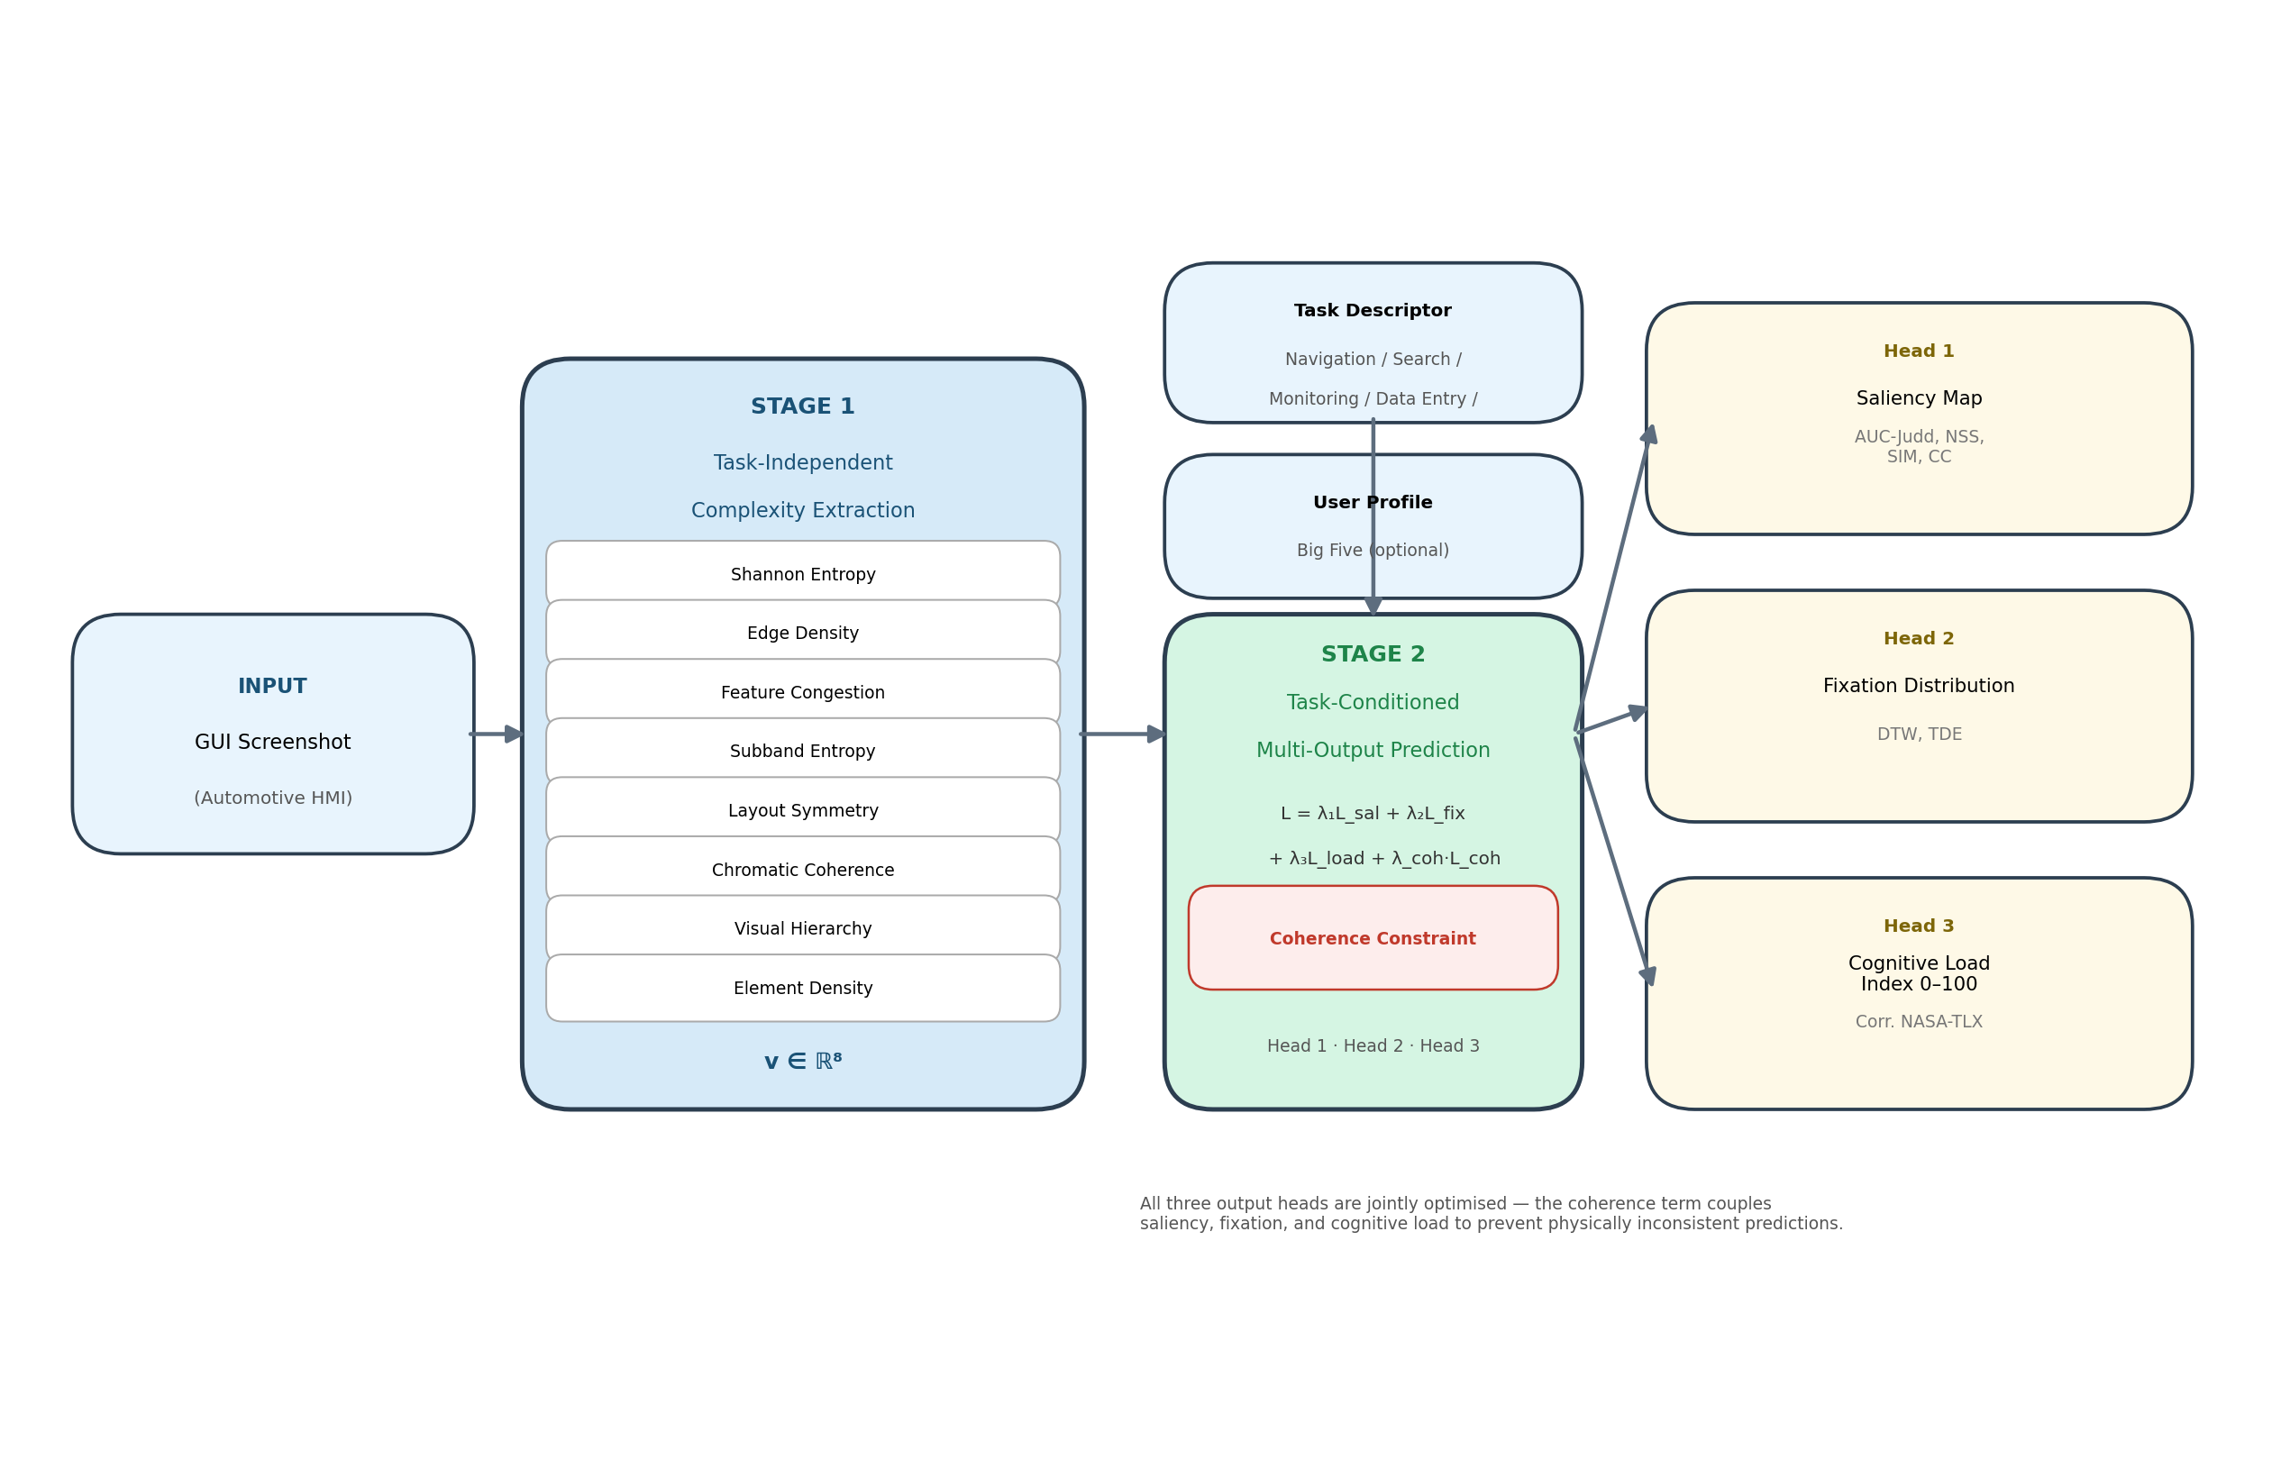
Figure 1: Two-Stage Pipeline Architecture

Stage 1 — Task-Independent Complexity Extraction
Stage 1 computes eight perceptual features from a raw screenshot. All features are derived from established image-analysis models from the GUI evaluation and visual perception literature; the majority are already implemented within the open-source AIM framework (Oulasvirta et al., 2018). Input is a GUI screenshot; output is a feature vector v ∈ ℝ⁸.
Feature | Description | Source
Shannon Entropy | Information density (greyscale histogram) | Shannon (1948)
Edge Density | Proportion of edge pixels via Canny | AIM / image processing
Feature Congestion | Multi-channel clutter: colour, contrast, orient. | Rosenholtz et al. (2007)
Subband Entropy | Redundancy via steerable pyramid decomposition | Rosenholtz et al. (2007)
Layout Symmetry | Vertical/horizontal balance of elements | Miniukovich & De Angeli (2015)
Chromatic Coherence | Colour palette variance | Hasler & Süsstrunk (2003)
Visual Hierarchy | Size gradient, contrast, grouping structure | Tuch et al. (2009)
Element Density | Number of interactive controls per area | AIM / UI segmentation

Stage 1 is task-agnostic and directly integrable into the existing AIM infrastructure.

Stage 2 — Task-Conditioned Multi-Output Prediction
Stage 2 is a multi-output regression model that takes the Stage 1 feature vector together with a Task Descriptor and an optional User Profile and simultaneously predicts three behavioural outputs. The joint training objective couples all three prediction heads through a coherence penalty, which is the central methodological contribution (see below).
Input: v (Stage 1) + Task Descriptor (categorical: Navigation, Search, Monitoring, Data Entry, Decision) + User Profile (Big Five, optional).
Output: Three simultaneous heads with mutual coherence constraints.
L = λ₁·L_sal + λ₂·L_fix + λ₃·L_load + λ_coh·L_coherence
where λ₁, λ₂, λ₃ ≥ 0 are loss weights balancing the contribution of each output head, and λ_coh ≥ 0 controls the strength of the cross-head coherence penalty.
Head | Output | Validation Metric
Head 1 | Saliency Map | AUC-Judd, NSS, SIM, CC
Head 2 | Fixation Distribution / Scanpath Entropy | DTW, TDE
Head 3 | Cognitive Load Index (0–100) | Correlation with NASA-TLX

The coherence term L_coherence penalises physically inconsistent output combinations (e.g., high saliency dispersion combined with low fixation count). The coupling of all three heads is the methodological novelty of this work.
User Profile: LLM-based simulation at Big Five trait level is methodologically defensible (Serapio-García et al., 2023; Argyle et al., 2023). State-based simulation (acute stress, fatigue) is explicitly declared as non-validated (Kapania et al., 2025).

3.2 Empirical Validation
Data Source 1 — HCEye Dataset (Das et al., 2024; publicly available):
- N=27, eye-tracking + dual-task cognitive load manipulation, 150 web UI screenshots
- Use: exploratory calibration of Stage 1 feature norms; benchmark for saliency prediction (Head 1)
- Limitation: web UIs, not automotive HMI — transferability to the target domain is an open question

Data Source 2 — Planned Empirical Validation:
Open question — supervisor input requested: The form of empirical validation has not yet been decided. The following options are under consideration; the final choice depends on feasibility, lab access, and timing, which I would like to discuss.

Option A — User Study (N≈15–30, within-subjects, eye-tracking + NASA-TLX, automotive HMI simulator): provides quantitative validation of predictive accuracy and enables the variance decomposition between Stage 1 and Stage 2.

Option B — Expert Interviews (N≈5–12 automotive UX/HMI practitioners, structured walkthrough protocol): assesses plausibility and practical utility of the pipeline outputs from a design perspective.

Option C — Sequential Mixed Methods (reduced user study + focused expert panel): combines quantitative prediction validation with qualitative practitioner assessment, at the cost of greater organisational effort.

No decision has been made. I would welcome your guidance on which approach is most appropriate given the timeline and available resources.
Baseline Comparisons:
Baseline | Description
B1 | Stage 1 alone + linear regression
B2 | Stage 2 without coherence term (λ_coh = 0)
B3 | Single-output model (Head 3: load only)

Core Analysis:
- Variance decomposition: how much does Stage 1 explain alone? What does Stage 2 add?
- Coherence gain: B2 vs. full Stage 2
- Null results will be reported explicitly

4. Expected Contributions

Academic Contributions
Theoretical: Empirical test of the Computational Rationality hypothesis that cognitive load can be predicted as the outcome of an optimal control policy over visual interface properties.
Empirical (contingent on validation Option A or C): Variance decomposition of task-independent visual complexity (Stage 1) vs. task-conditioned behavioural prediction (Stage 2) in a controlled automotive HMI setting — establishing which layer of the pipeline carries explanatory weight. If Option B (expert interviews) is chosen instead, this contribution is replaced by a qualitative plausibility assessment of the pipeline outputs from a practitioner perspective.
Methodological: First integration of a coherence-constrained multi-output model into a GUI evaluation platform, coupling saliency, scanpath, and cognitive load prediction in a single architecture.

Practical Deliverables
Two-Stage Pipeline: The pipeline itself is the primary deliverable — functioning as a pre-deployment screening tool for automotive HMI designers. It provides a scalable first estimate of cognitive load risk at the layout stage, without requiring eye-tracking infrastructure or a user study.
Open-Source AIM Extension: The implementation is released as an AIM-compatible module, enabling adoption as a web service or design tool integration.

5. Timeline
Implementation will make use of AI-assisted development (large language model coding tools) throughout, in line with current practice in computational HCI research.
Phase | Content | Period
Exposé | Finalise and submit exposé; supervisor meeting | June 2026
Literature | Finalize reading, close remaining gaps | June 2026
Registration | Official thesis registration | July 2026
Implementation (finalization) | Complete remaining 10%, integration testing, AIM compatibility | July 2026
Study (Preparation) | Ethics approval (parallel), recruitment, stimuli, pilot test | July–Aug 2026
Study (Data Collection) | Main study N≈15–30 (form TBD, see Section 3.2) | Aug–Sep 2026
Analysis & Training | Eye-tracking processing, model training on real data, baseline comparisons (B1–B3) | Sep–Oct 2026
Writing | Thesis chapters 1–7 (begins in parallel with analysis) | Oct–Nov 2026
Submission | — | End of Dec 2026

6. Scope and Limitations
- Domain restriction: automotive HMI screenshots only; generalisation to other UI types requires separate validation
- Cognitive Load Index ≠ NASA-TLX; the output is a computed interaction complexity indicator
- LLM user simulation: trait-level only (Big Five); state-based simulation (fatigue, acute stress) is not validated and should not be interpreted as such — the User Profile feature is exploratory; core validation rests on the structural and task-based inputs to Stage 2 (Kapania et al., 2025)
- Pilot dataset: single-GUI design without complexity variation; suitable for calibration only

7. References
- Oulasvirta, A. et al. (2018). Aalto Interface Metrics (AIM). UIST 2018 Adjunct.
- Oulasvirta, A. et al. (2022). Computational Rationality as a Theory of Interaction. ACM TOCHI.
- Das, D. et al. (2024). HCEye: Dynamics of Visual Highlighting and Cognitive Load. ETRA 2024.
- Jiang, M. et al. (2023). UEyes: Understanding Visual Saliency across UI Types. CHI 2023.
- Jokinen, J. et al. (2020). Adaptive Feature Guidance: Visual Search with Graphical Layouts. CHI 2020.
- Jokinen, J.P.P. & Kujala, T. (2021). Modelling Drivers' Adaptation to Assistance Systems. AutomotiveUI 2021.
- Lorenz, M. et al. (2024). Computational Models for In-Vehicle UI Design. AutomotiveUI 2024.
- Krejtz, K. et al. (2018). Eye Tracking Cognitive Load Using Pupil Diameter and Microsaccades. PLOS ONE.
- Guo, Z. et al. (2026). SeekUI. CHI 2026.
- Shi, D. et al. (2024). CRTypist: Simulating Touchscreen Typing via Computational Rationality. CHI 2024.
- Shi, D. et al. (2025). Chartist: Task-driven Eye Movement Control for Charts. CHI 2025.
- Bai, Y. et al. (2024). Heads-Up Multitasker: Simulating Attention Switching on Optical HMDs. CHI 2024.
- Langerak, T. et al. (2024). MARLUI: Multi-Agent Reinforcement Learning for Adaptive UIs. ACM TOCHI.
- Wu, J. et al. (2024). UIClip. UIST 2024.
- Ko, J. et al. (2026). Criticmate. CHI 2026.
- Kapania, S. et al. (2025). Simulacrum of Stories. CHI 2025.
- Miazga, M.P. et al. (2026). Log2Motion. CHI 2026.
- Hart, S.G. & Staveland, L.E. (1988). Development of NASA-TLX. Human Mental Workload.
- Hasler, D. & Süsstrunk, S.E. (2003). Measuring Colourfulness in Natural Images. SPIE HVEI VIII.
- Miniukovich, A. & De Angeli, A. (2015). Computation of Interface Aesthetics. CHI 2015.
- Rosenholtz, R. et al. (2007). Measuring Visual Clutter. Journal of Vision.
- Tuch, A.N. et al. (2009). Visual Complexity of Websites. CHI 2009.
- Serapio-García, G. et al. (2023). Personality Traits in LLMs. arXiv.
- Argyle, L.P. et al. (2023). Out of One, Many. Political Analysis.

