

**Project Manager:**

Marianna Hollanda Campos Pedroso

**Date:**

01-24-2022

SleepEasy Hotel

Registry System

**APPROVAL PAGE**

Joey Kitson, Client

SleepEasy Hotel Registry System

SHRS

This document is to receive the approval of the client, *Joey Kitson*, and the project manager, *Marianna Hollanda Campos Pedroso*, for the proposed project. By signing this document, both parties acknowledge they have read the document in its entirety and agree to the plans in this document. If the proposed plan is accepted, date and sign below to move forward with the proposed object outlined in this document.

|  |  |  |  |
| --- | --- | --- | --- |
| Approver Title | Approver Name | Signature | Date |
| Client | Joey Kitson |  |  |
| Project Manager | Marianna H C Pedroso |  |  |

|  |  |  |  |  |
| --- | --- | --- | --- | --- |
| Version | Document Name | Date | Author | Comments |
| 1.0 | CIS2261_ProjectStatement_Azam_Badal_Karina_Marianna | 01-06-2022 | Marianna Pedroso | First Draft. |
| 1.1 | CIS2261_ProjectStatement_Azam_Badal_Karina_Marianna | 01-07-2022 | Marianna Pedroso | Half of the project is done. |
| 1.2 | CIS2261_ProjectStatement_Azam_Badal_Karina_Marianna | 01-24-2022 | Marianna Pedroso | Final document. |

**DOCUMENT TRACKING**

Table of Contents

**DOCUMENT TRACKING3**

**PROJECT SUMMARY5**

Project Summary5

Definitions5

Resources5

**PROJECT OBJECTIVE6**

**PROJECT DELIVERABES7**

Non-Deliverables7

**ASSUMPTIONS & CONSTRAINTS8**

Assumptions8

Constraints8

**PROJECT PLAN9**

Gantt Chart9

Resource Sheet9

**TEAM ORGANIZATION10**

Organizational Chart10

Responsibilities10

**BUDGET12**

**CHANGE MANAGEMENT13**

**PROGRESS/STATUS REPORTING14**

Schedule14

**DECISION MAKING15**

**STANDARDS & CONVENTIONS16**

**APPENDIX18**

Appendix A: Team Contract/Charter18

Appendix B: Change Request/Notification23

Appendix C: Progress Status Report24

**PROJECT SUMMARY**

Project Summary:

|  |  |
| --- | --- |
| Client | Joey Kitson |
| Project Name | SleepEasy Hotel Registry System |
| Project Acronym | SHRS |
| Project Manager | Marianna Hollanda Campos Pedroso |
| Project Start Date | 01-06-2022 |
| Project Completion Date | 03-14-2022 |
| Total Budget Allocation | $10,000 |

Definitions:

|  |  |
| --- | --- |
| Staff | A user who has restricted system access (view only). |
| Manager | A user who has create, read, and edit access. |
| Administrator | A user who has full system access. |
| Database | A storage system for the program data. |
| Company | SleepEasy Hotel Registry System |
| Shareholders | An owner of shares in a company. |
| CRUD | Database access nomenclature: Create Read Update Delete |

Resources:

|  |  |
| --- | --- |
|  | Microsoft Office Software (Word, Excel, Project, Visio) |
|  | Draw.io |
|  | System Analysis and Database Documentation (ERD, Class Diagrams, Use Case, etc.). |
|  | Business forms and processes documentation from the client. |
|  | Human Resources (Project Manager, System Analysts, DB Admin, Developer, Client, etc.). |

**PROJECT OBJECTIVE**

The overall objective of this project is to analyze, design, and develop a system to manage SleepEasy Hotel Registry System. This new system, SHRS, will allow the staff to manage the hotel registry system more efficiently instead of the original registration system that was created when the hotel was established. SHRS will securely store data and offer a more robust registry system. It will also include a multitiered authentication system allowing members to use basic access, and the administrator full system access.

The system will include a full room listing report showing availability, a guest checkout bill report, a guest listing registered in what room alphabetical, the services available by type of service listed alphabetical, and a staff report showing each staff and what they recorded in services.

This project will be completed between January 06, 2022, and March 14, 2022, to allow staff training and active business usage for the next fiscal year. The budget for the project is $10,000.

**PROJECT DELIVERABLES**

|  |  |  |
| --- | --- | --- |
| Phase | Deliverable | Description |
| **1** | **Elaboration and preparation** |  |
|  | Business Meeting | Meeting with all six staff members to determine basic requirements for the system. |
|  | Review of Output Requirements | Review of the procedures like checkout bill, guest listing, services available, and etc. |
| **2** | **Analysis and design** |  |
|  | Logical Modelling | A plan that will outline the logical design for the new system, including a diagram of the database to be used in a new system. |
|  | Physical Modelling | Develop a design prototype of the user interface design and output (reports and exports). |
| **3** | **Development** | **Due Date:** |
|  | Database scripts | SQL scripts for the database to be used for the system. |
|  | Source Code and Executable | Application and source code for the application needed to run the system. |
|  | Test Plan | Documentation to ensure all system components meet the requirements. |
| **4** | **Documentation** |  |
|  | Installation Guide | Instruction manual for setup of the system in the office. |
|  | User Manual | Manual for staff members to use the system. |

Non-Deliverables:

* Hardware – Company will provide its hardware. All the hardware will be as per the requirements of the system or higher.

**ASSUMPTIONS & CONSTRAINTS**

Assumptions:

* Hardware and network infrastructure must meet the minimum requirements for the system to run without any problems. Higher system requirements are recommended but not required.
* All the equipment for testing will be available as required.
* Users will be available to test and provide feedback for each stage of the development process. Users for testing will be on both side sides., from the member side and administrator side.
* Funding for the project is sufficient to cover the development of the entire project.
* The scope of the project or dates (due dates, delivery dates, development timeline) will not be changed without written consent (see Appendix B.)
* Previous data of guests and services available to enter the new system.

Constraints:

* Timeline: Project must be completed, deployed and staff needs to be trained before the deliverable due date.
* Budget: The client and project manager must authorize any changes to scope related to timeline and budget.
* Technology stack: Must accommodate web access at any hours for staff and management for retrieving the data of the patients also must be accommodated web access for patients for registration.

**PROJECT PLAN**

GANTT Chart:

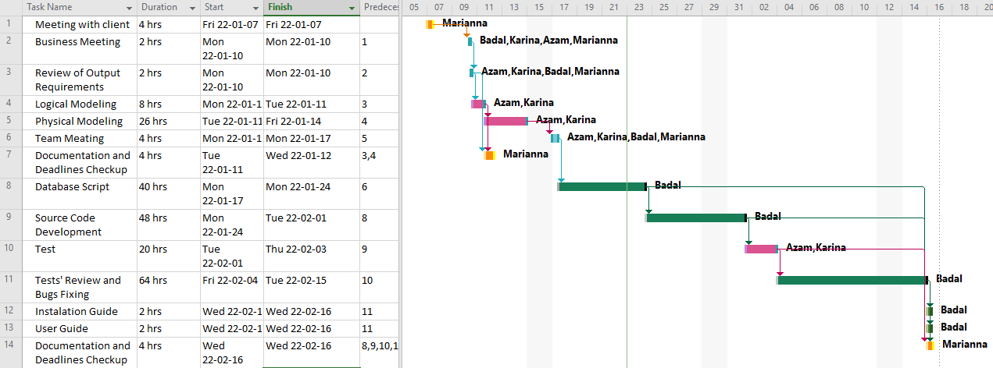

Resource Sheet:



**TEAM ORGANIZATION**

Organizational Chart:

Responsibilities:

Project Manager:

* Leads and plans the project.
* Meets with clients and stakeholders.
* Participate and supervise the execution of each stage of the project.
* Time management and budget management.
* Evaluate client feedback and change requests.
* Documentation and ongoing maintenance.

System Analyst:

* Analyse current systems and processes.
* Determine the problem.
* Define new system requirements.
* Design a system that will be a cost-effective solution.
* Document the new system component details and requirements.

System developer:

* Design key system components
* Implement design documentation
* Test implemented functionality

Client:

* Communicate with the project manager to provide project details, goals, and authorization.
* Authorize change requests.
* Provide funding for the project.

**BUDGET**

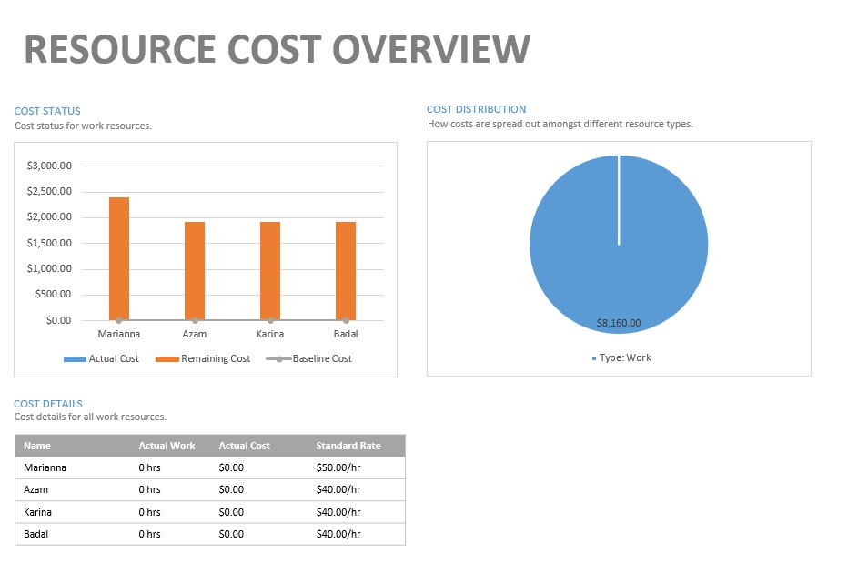

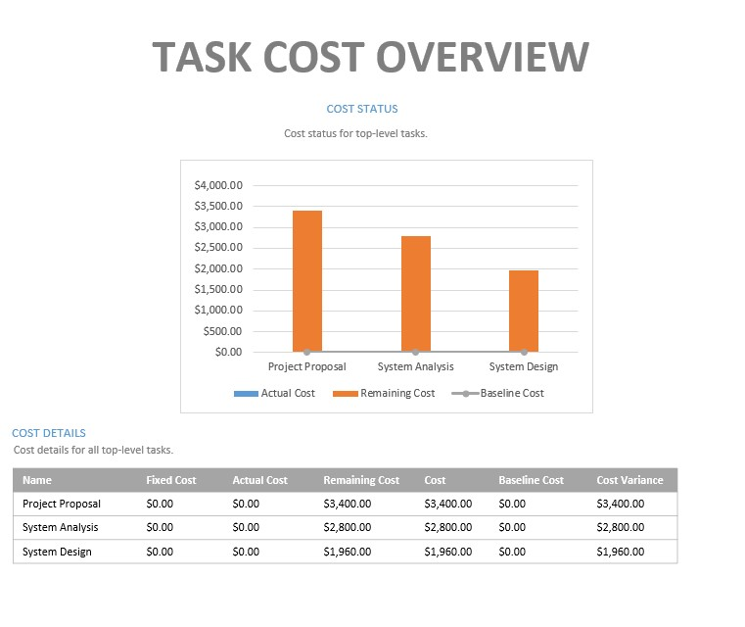

**CHANGE MANAGEMENT**

Project development will take an iterative approach to allow quick pivoting as feedback is received throughout the process. The current schedule has allotted extra time to allow some flexibility to the project based on the expectation of change in this approach.

The Project Manager (PM) will assess the requested feedback to determine the scope and effect it will have on the project. For small changes, the PM will update the requirements and the project will continue as normal.

If the feedback changes the scope of the project, or multiple small changes affect the deliverable timetable, the PM will meet with the stakeholders to determine the effects on the timeline and budget. If the change is determined to be important, a Change Request (Appendix B) must be completed and authorized by both parties. If approved, the PM updates the timeline and budget accordingly, and the project continues.

The following is a summary of the feedback process:

Note: See Appendix B: Change Request/Notification for a template of this form.

**PROGRESS/STATUS REPORTING**

Progress and status reports will be completed as per the schedule below. Reports will be created by the Project Manager, Marianna Hollanda Campos Pedroso, and sent to the various stakeholders and the client, Joey Kitson.

The progress reports will consist of:

* Updated budget
* Outstanding issues from the last report
* Change Request Forms
* Any approved or denied changes

Schedule:

* Report One: January 28, 2022
* Report Two: February 11, 2022
* Report Three: February 25, 2022
* Report Four: March 11, 2022

Note: See Appendix C: Progress Status Report for a template of this form.

**DECISION MAKING**

The decision-making process throughout this project will consist of 6 steps.

1. Identify the problem. This can be done by asking an array of questions:

* What is the problem, define the aspects of the issue?
* Who is affected by this problem?
* What will be achieved if this problem is solved?

1. Identify the criteria for the decision. This is done by gathering as much information about the problem as possible.
2. Brainstorm solutions and evaluate costs.
3. Select a solution that best resolves the need to fix the problem.
4. Implement the solution. The solution was added to the project plan.
5. Evaluate the effectiveness of the implemented solution.

To keep the project progressing, all decisions will be made within two business days.

For decisions that change the scope or timeline of the project, please complete Appendix B.

**STANDARDS & CONVENTIONS**

Storage Units:

This application will be developed on local computers (desktops laptops) using XAMPP for the local development environment. Testing will be completed on a test server on the company infrastructure that is similar to their production servers. The project will then be deployed on the company productions servers.

Git will be utilized for version control of the source code, utilizing BitBucket as a repository, and for issue tracking.

Executable & Source code file naming:

Executables and source code files will be named using the camelCase conventions.

Source code internal module header documentation content:

Header documentation will include the following information:

Author:

Date:

Purpose:

Note:

Database & Table naming:

Database name will use PastalCase or initials of the project. (e.g. SHRS)

Table names will be in singular form and PastalCase. (e.g. Staff)

Column/Attribute names will be singular and include the table name underscore attribute name, both in PascalCase. (e.g. Staff_LastName)

Variable/function/class naming:

Class – PascalCase

Variable/Function/Method – camelCase

Constant – All Capitals

Document naming:

Naming will follow a simple pattern of including project, deliverable, and author name.

Project_Deliverable_AuthorName(e.g.CIS2261_ProjectStatement_Azam_Badal_Karina_Marianna)

Note:

In addition to the previous standards and conventions, the project will adhere to the C# conventions as much as possible.

**APPENDIX**

Appendix A: Team Contract/Charter

|  |  |  |
| --- | --- | --- |
| Name | Email | Phone Number |
| Azam Sheik | azam.sheikh721@gmail.com | 782-377-2550 |
| Badalkumar Patel | badalkumar9198@gmail.com | 902-314-0113 |
| Karina Akramov | kakramov@hollandcollege.com | 647-262-8211 |
| Marianna H C Pedroso | mhollandacampos@hollandcollege.com | 902-916-2480 |

Communication

* Microsoft Teams
* Group text messaging
* Video conferencing calls
* Audio conferencing calls
* Screen sharing
* File sharing

Goals

* To gain valuable experience that can be applied to future work
* Meet deliverable deadlines
* Stay within the project budget
* Establish milestones
* Learn from mistakes
* Successfully create and deliver analysis and design of the requested system that is:
* Functional
* Usable
* Efficient
* Simple
* What marks does the team as a whole want to achieve?
* The team would like to achieve a grade of 90% or higher.

Roles & Responsibilities

1. Marianna H C Pedroso – Project Manager
2. Azam Sheik – System Analyst
3. Karina Akramov – System Analyst
4. Badalkumar Patel – Developer

Team Meetings

* Group text messaging will occur daily to discuss and set plans for the next 24 hours.
* Audio or video conference call meetings will occur twice each week to ensure team members are on the same page and to check that progress is being made to meet deliverable deadlines. Meetings will be held using Microsoft Teams collaboration tools.
* Meeting agendas will be developed by first identifying any goals for upcoming deliverables. Team members will also provide input prior to the meeting to ensure all needs are fulfilled. Time spent on each topic will be estimated in advance and a plan will be developed accordingly.
* The project manager will start and facilitate meetings, but each topic covered during a meeting will be led by a designated team member who is focusing on the subject.
* Microsoft Teams will be used to schedule meetings, and the built-in Microsoft Forms tool can be used to track decisions and activities through surveys, quizzes, and polls.
* Missing or being late for a meeting can lead to productivity loss, declined team morale, client dissatisfaction, and project management problems. To help avoid these issues meetings will be planned well in advance and all team members will be notified. Reminders and notifications will be set in Microsoft Teams.
* Some valid reasons for missing or being late to a meeting include poor planning or organization of a meeting. Scheduling conflicts are also a possibility. Since most communication and meetings will occur remotely through Microsoft Teams, technology failure is a risk.
* Repeated absences/lateness will be addressed by the project manager privately. An action plan will be developed to help the situation. This may include introducing time-management lessons or utilizing a more flexible schedule.

Decision-Making

Decisions on the development of this project will be made in consensus with the group conscience and will proceed as the group deems to be acceptable. However, decisions will be made in the following steps:

1. The problem or issue will first be identified.
2. Further information and details will then be gathered regarding this problem or issue, if necessary.
3. Solutions will be evaluated amongst team members and discussed.
4. Once the solutions have been discussed, the team will decide together which solution to implement to correct the problem or issue.
5. If there is not 100% agreement on a solution, the team will then discuss further until a decision can be made in which all members agree it is acceptable.

Note: Decisions will be made in 24 hours or less.

Decisions requiring assistance from the instructor will be those that may require further clarification or details to make a sound and efficient decision for the project.

Team Project Contribution & Member Accountability

1. How will the team proceed if someone’s work is deemed unacceptable?
   1. The issue will be addressed early and privately. This will help promote a more informal chat instead of a more serious discussion. It will also help prevent future occurrences of a similar issue.
   2. Thoughtful questions will be asked to determine if there is a solvable problem that is causing the declined quality of work.
   3. Relevant examples of more acceptable work will be provided.
2. If someone does not submit their work on time, what will be the course of action to ensure the project is completed and/or the overall team mark is not compromised?
   1. Questions will be asked to determine what happened, how the team member intends to recover, and how the team member intends to prevent it from happening again.
   2. Other team members will help complete the late task as quickly as possible to keep the project moving along and avoid compromising the team mark.
3. How will you reward individual members for outstanding contributions?
   1. Individual praise and showcase their work.
   2. Overachieving members may receive time off or a more flexible schedule without compromising future deadlines.
4. Under what circumstances will you remove a team member from your group?
   1. An excessive number of absences or missed deadlines.
   2. A team member leaves the CIS program. Access to project files and group collaboration tools will be revoked.
5. Grading assignment:
   1. The team would prefer to be graded as a group and receive the same marks.

Conflict

Steps towards handling conflicts within the team are as follows:

1. Acknowledge the conflict.
2. Discuss the conflict and any possible resolutions that may be made.
3. If necessary, request feedback from another team member to assist in the resolution.

Revisiting & Revising the Team Charter

The Team Charter will be re-evaluated using the decision-making protocols described in this Appendix. A review will occur at the mid-point of the project schedule, coinciding with Status Report Three on February 25, 2022.

All project members and the client will receive signed copies of the original and revised Team Charter.

Appendix B: Change Request/Notification

**SHRS | Change Request/Notification**

DATE: REQUEST #:

TO:

FROM:

SUBJECT:

|  |  |  |  |
| --- | --- | --- | --- |
| Key Dates |  | | |
| Anticipated Decision: |  | Expected Implementation: |  |

|  |
| --- |
| Brief Description |
|  |

|  |  |
| --- | --- |
| Impact (Time) | Days: |
|  |  |
|  |  |
| Impact (Budget) | Amount: |
|  | |

|  |
| --- |
| Recommendation/Resolution |
|  |

|  |  |  |
| --- | --- | --- |
| Approved ☐ | Disapproved ☐ | Reason: |

|  |  |  |  |
| --- | --- | --- | --- |
| Approver Title | Approver Name | Signature | Date |
| Client | Joey Kitson |  |  |
| Project Manager | Marianna H C Pedroso |  |  |

Appendix C: Progress Status Report

**SHRS| Progress Status Report**

DATE: REPORT #:

TO:

FROM:

SUBJECT:

|  |
| --- |
| Overview of Progress |
|  |

|  |  |  |  |
| --- | --- | --- | --- |
| Outstanding Issues/ Recommended Action | | Count: | 0 |
| 1 |  |  |  |
| 2 |  |  |  |
| 3 |  |  |  |

|  |  |  |  |
| --- | --- | --- | --- |
| Change Requests Log | | Count: | 0 |
| 1 |  |  |  |
| 2 |  |  |  |
| 3 |  |  |  |

|  |
| --- |
| Plans for Next Period |
|  |

|  |
| --- |
| Overview of Budget (attached MS Project file) |
|  |