ATM Project: A Manual

https://github.com/mari-husain/csharp-atm

To Launch Our Project

To test our ATM system, simply download the ATM-Web project, build the project, and run on your local machine. Note: The page may take awhile to load initially because the server (hosted on Heroku) takes a long time to wake up. Additionally, due to the unfortunate limitations imposed by the free-tier Heroku service, the database is periodically wiped. This should not affect testing in the short term (i.e. any accounts you make should be there immediately after you create them), but if you create an account, then stop interacting with the website for a significant period of time and come back later and try to log in, you may find your account has been erased. There is unfortunately nothing we can do to prevent this.

To create a persistent database, you can use the code in atm_backend to create your own locally hosted database API. You'll have to do the following:  
1. In the command prompt, navigate to Other/atm_backend.

2. type 'python3' to activate the python3 interpreter.

3. In the interpreter, enter 'from atm_serv import init_db'

4. in the interpreter, enter 'init_db()'

5. In the interpreter, enter 'quit()'

6. In the command prompt, enter 'python3 atm_serv.py'

7. You should see the Flask app boot up in the command prompt window. Please note which port it's running at (likely 5000). Leave it running in this window.

8. In Visual Studio, navigate to Default.aspx.cs.

9. Change line 37 from    
    client.BaseAddress = new Uri("<https://atm-backend.herokuapp.com/>");

      to

      client.BaseAddress = new Uri("[http://localhost](http://localhost/):<port>/");

       where <port> is the port number where your flask app is running (i.e. the url would be [http://localhost:5000](http://localhost:5000/) if the app is running on port 5000).

10. Build and run the webapp as usual. You now have a persistent database.

The Requirements

**1. Login and Accounts**

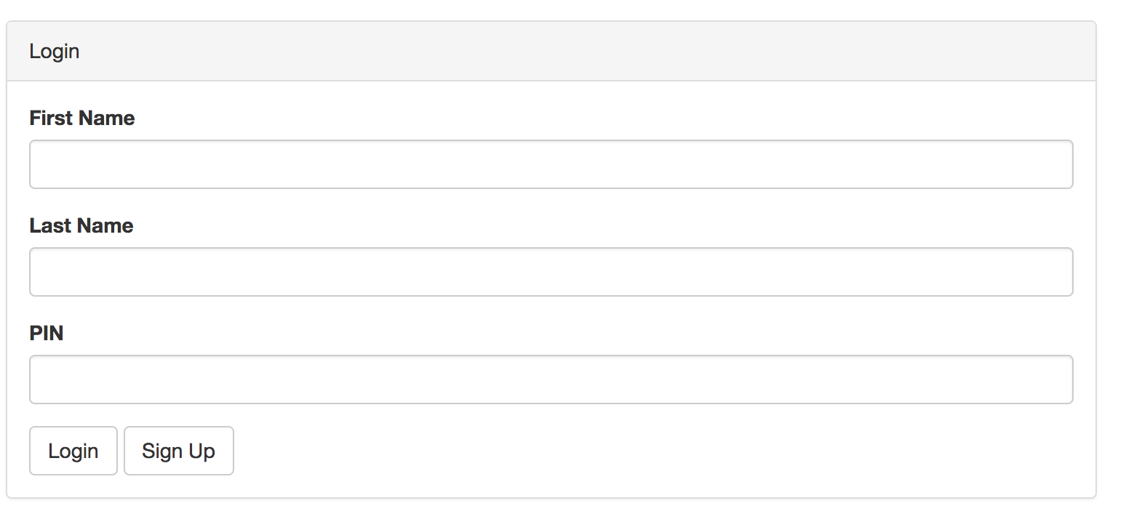

*Pictured: the login page*

**1.1 How to Sign Up**

To sign up, click the "Sign Up" Button from the homepage. You will be shown the following form:

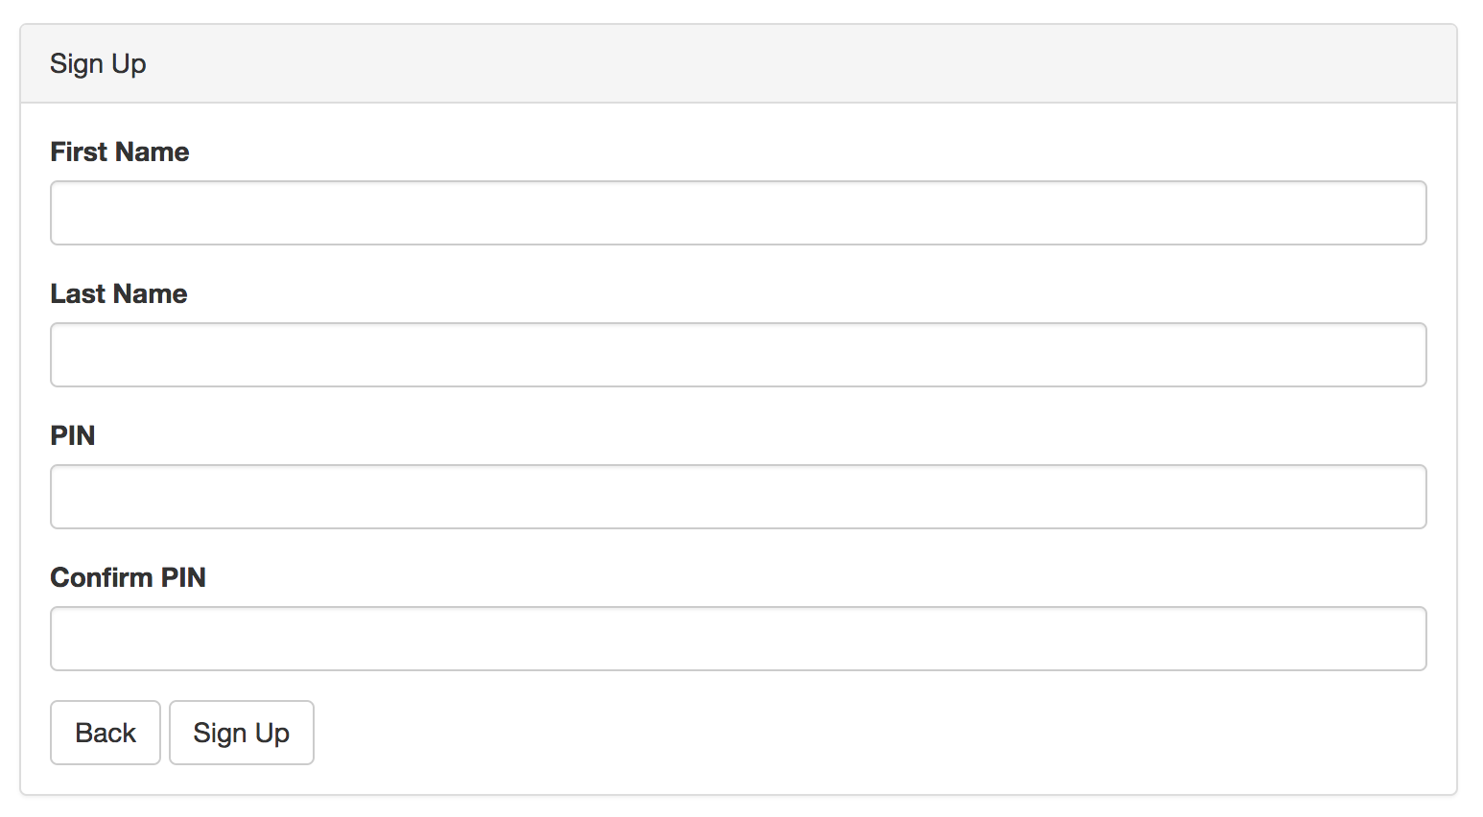

Enter your first name in the first name box, your last name in the last name box, and your PIN in the PIN boxes. The firstname/lastname combination must not already be in use (each user may only have one account). The PINs must match and must be composed only of numbers. The PIN can be as long as you want.

**1.1.1 Validation**

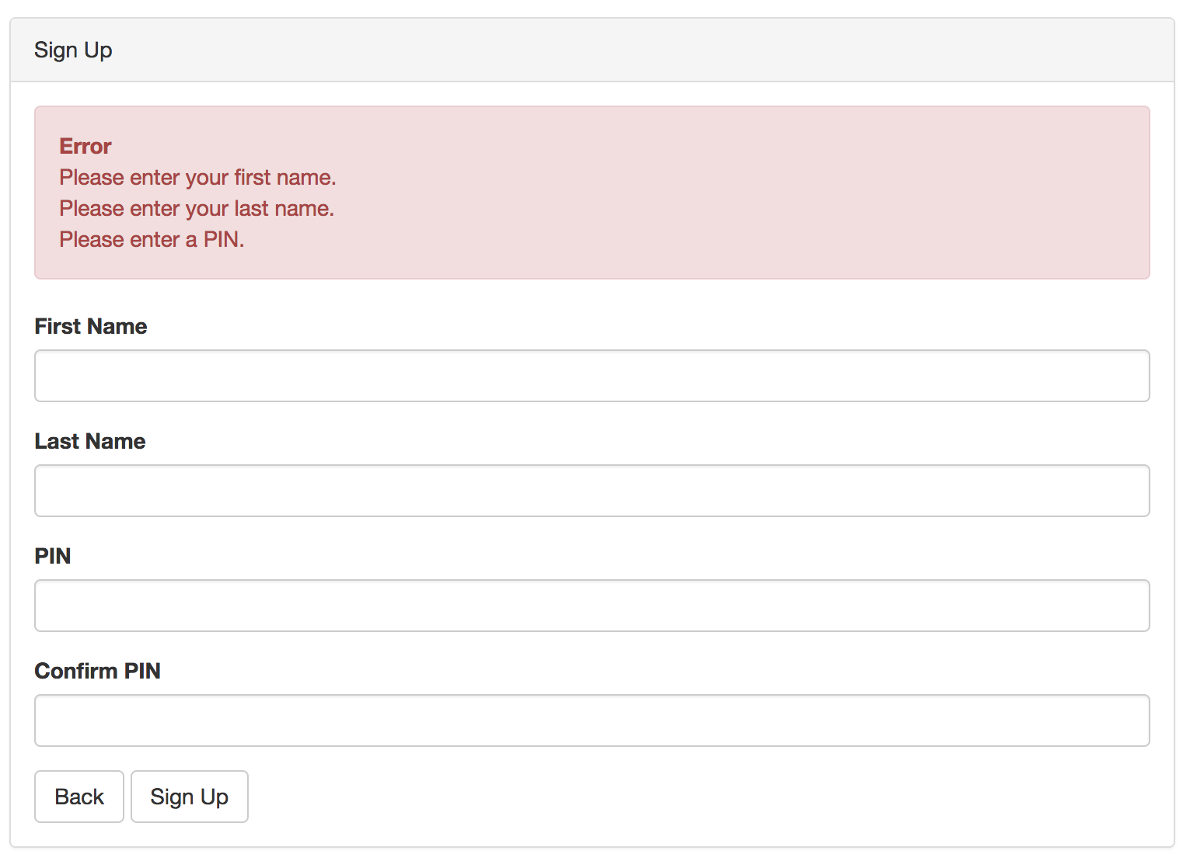

*Fields cannot be left blank.*

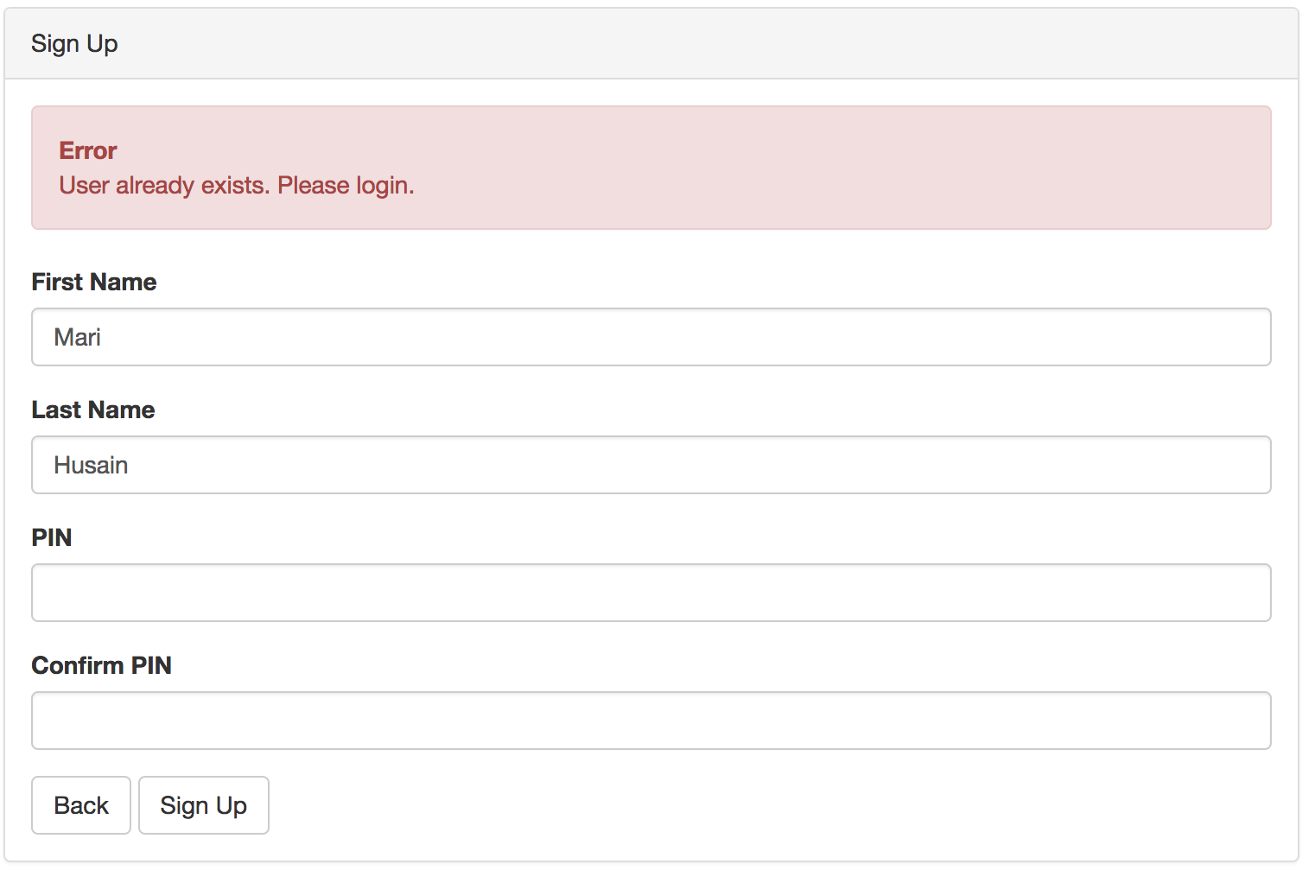

*Name cannot already be in use.*

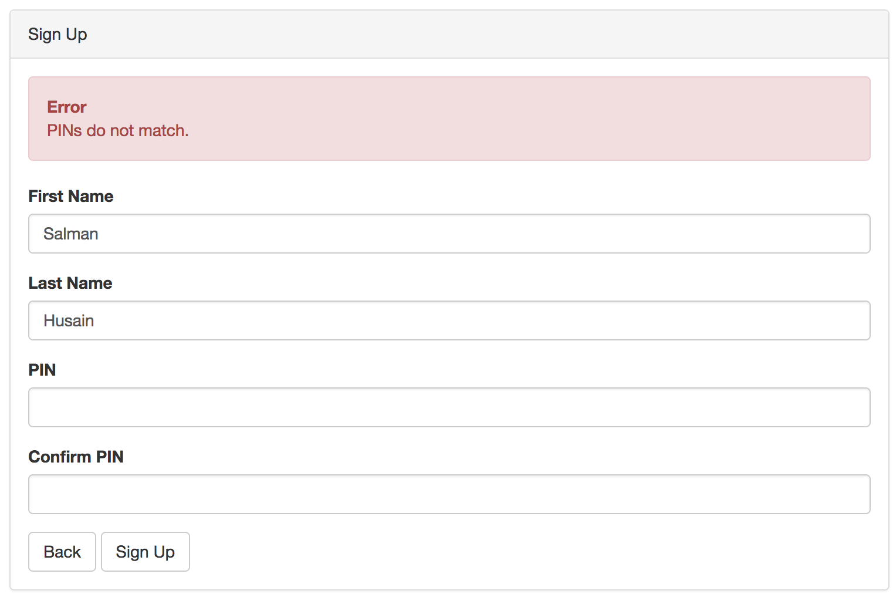

*PINs must match.*

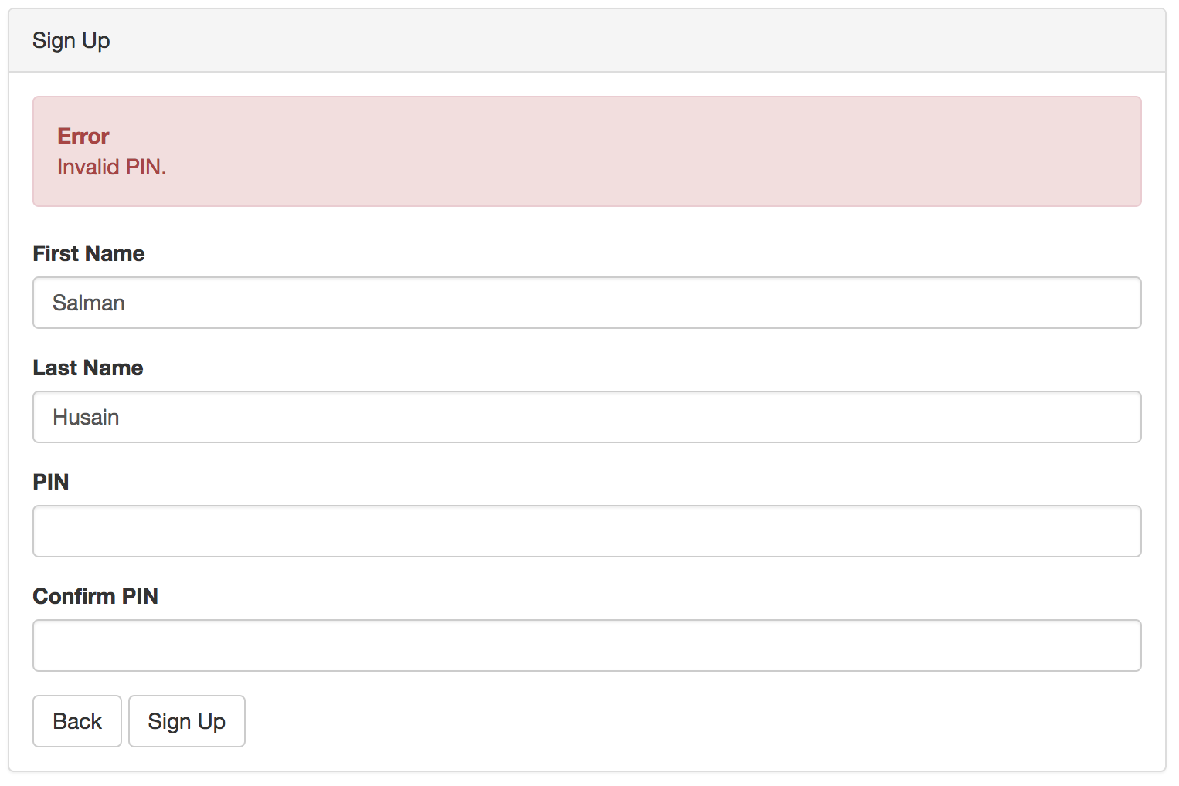

*PINs must be composed of numbers.*

**1.2 How to Log In**

From the login page, simply type in your name and your PIN.

**1.2.1 Validation**

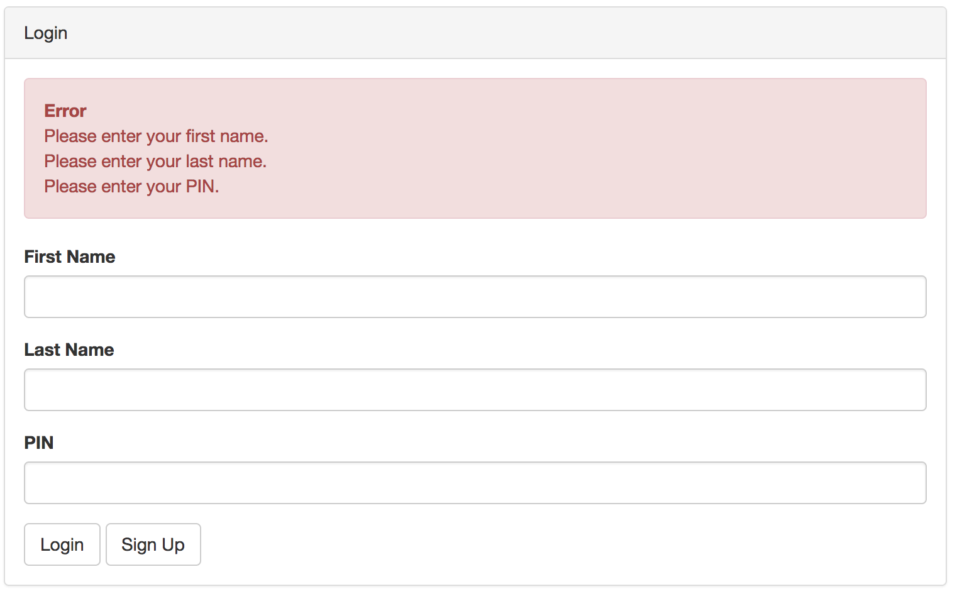

*Fields cannot be left blank.*

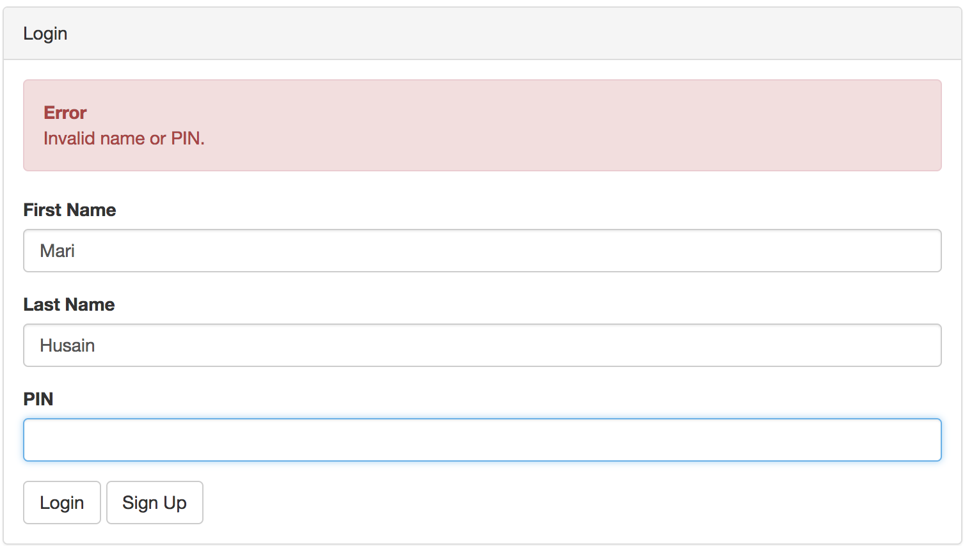

*Login information must be correct.*

**1.3 Logging Out**



Once you are signed in, you can logout anytime by clicking the "logout" button in the header. The Logout button will only be displayed if you're logged in.

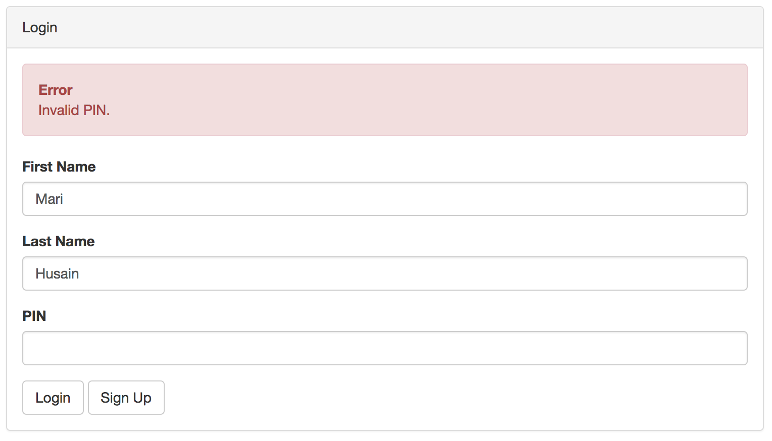

*PIN must be composed of numbers only.*

**2. The ATM**

The ATM keeps track of what bills are inside of it on the server. These values are displayed in the header, as follows:



The ATM begins the day loaded with 500 $20 bills. Every day (i.e. at 12:00am each morning) the ATM is emptied of its current bills and refilled with 500 $20 bills.

The ATM interface, after you've logged in, looks like this:

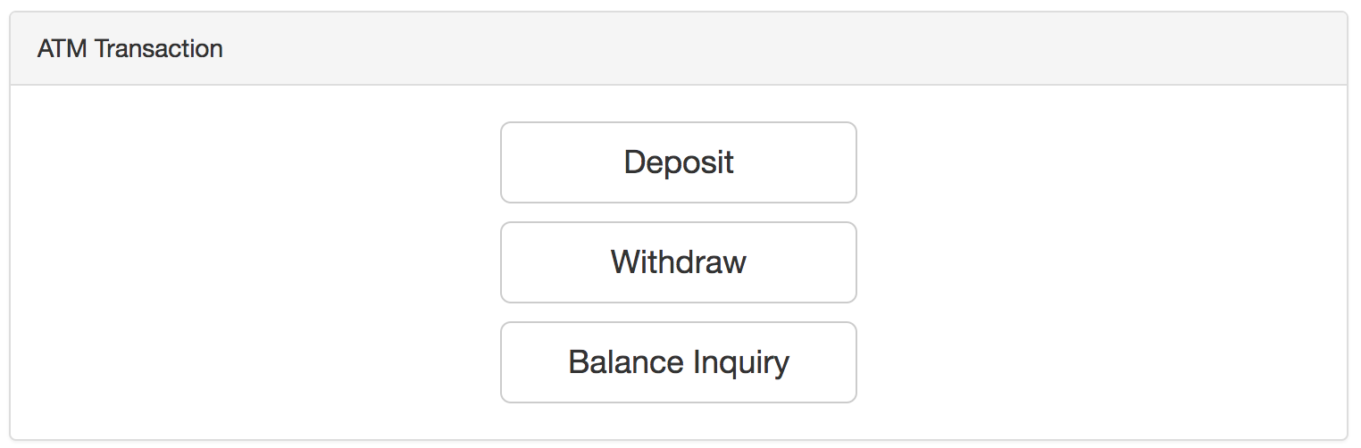

**3. Viewing the Account Balance**

To view your account balance, click the "Balance Inquiry" button while logged in.

You will see your account balance as follows:

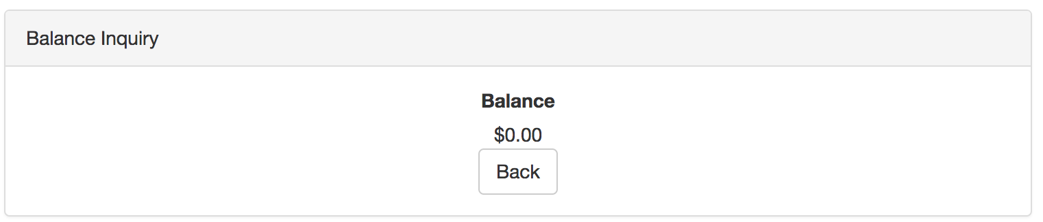

To return to the home screen to complete other transactions, click the "back" button.

**4. Withdrawing Cash**

To withdraw cash, click the "Withdraw" button while logged in. You will see the following screen:

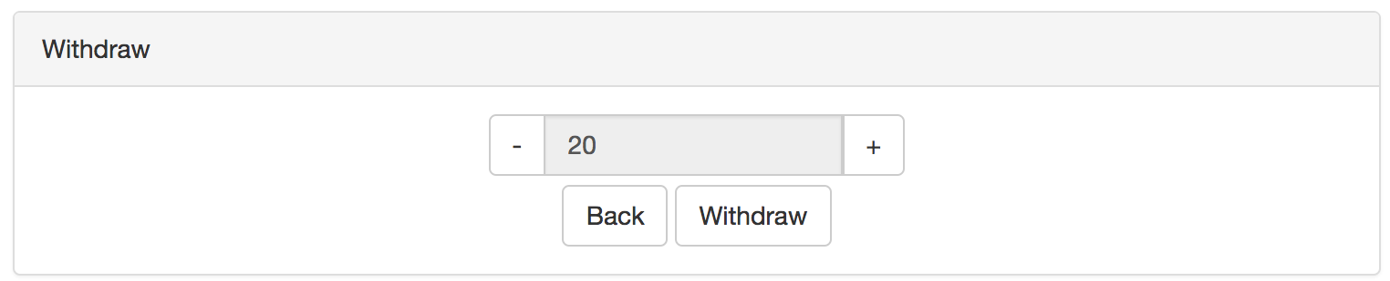

Like a real ATM, you can withdraw cash in increments of $20. Click the "-" or "+" buttons to decrease or increase the amount to withdraw, respectively.

You cannot withdraw less than $20, and you cannot withdraw more $20 bills than are available in the ATM (as in, hitting the "-" button will do nothing when the amount to withdraw is set to $20, and hitting the "+" button will do nothing when the amount to withdraw is set to the maximum number of bills the ATM can dispense).

You cannot withdraw more money than is in your account.

**4.1 Validation**

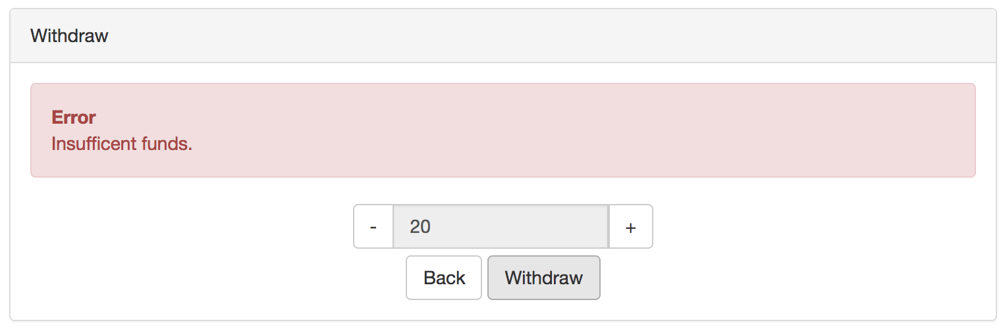

*You cannot withdraw more money than is in your account.*

**4.2 A Successful Withdrawal**

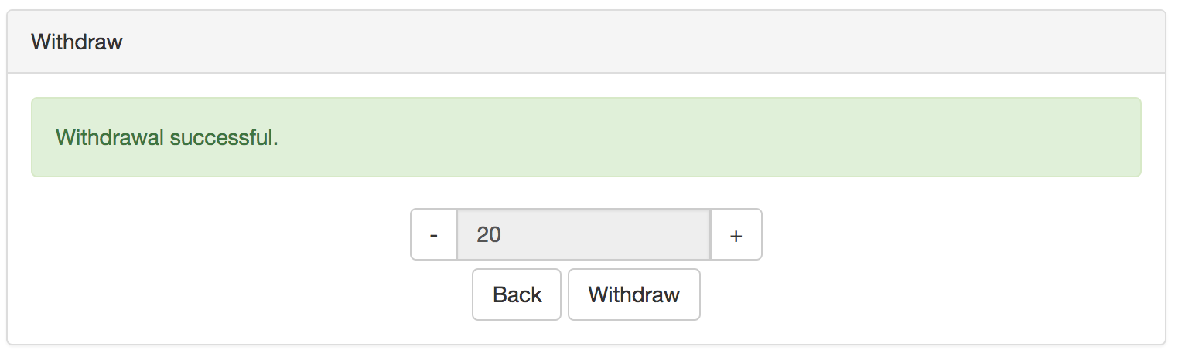

A successful withdrawal will display the above message.

You will also notice that the number of $20 bills in the ATM has been updated to reflect that the ATM has dispensed some $20 bills.



If you perform a balance inquiry, you will also notice that your balance has been udpated.

To return to the home view, simply hit the "back" button.

**5. Depositing Funds**

To deposit funds, click the "Deposit" button from the home view. You will then see the following screen:

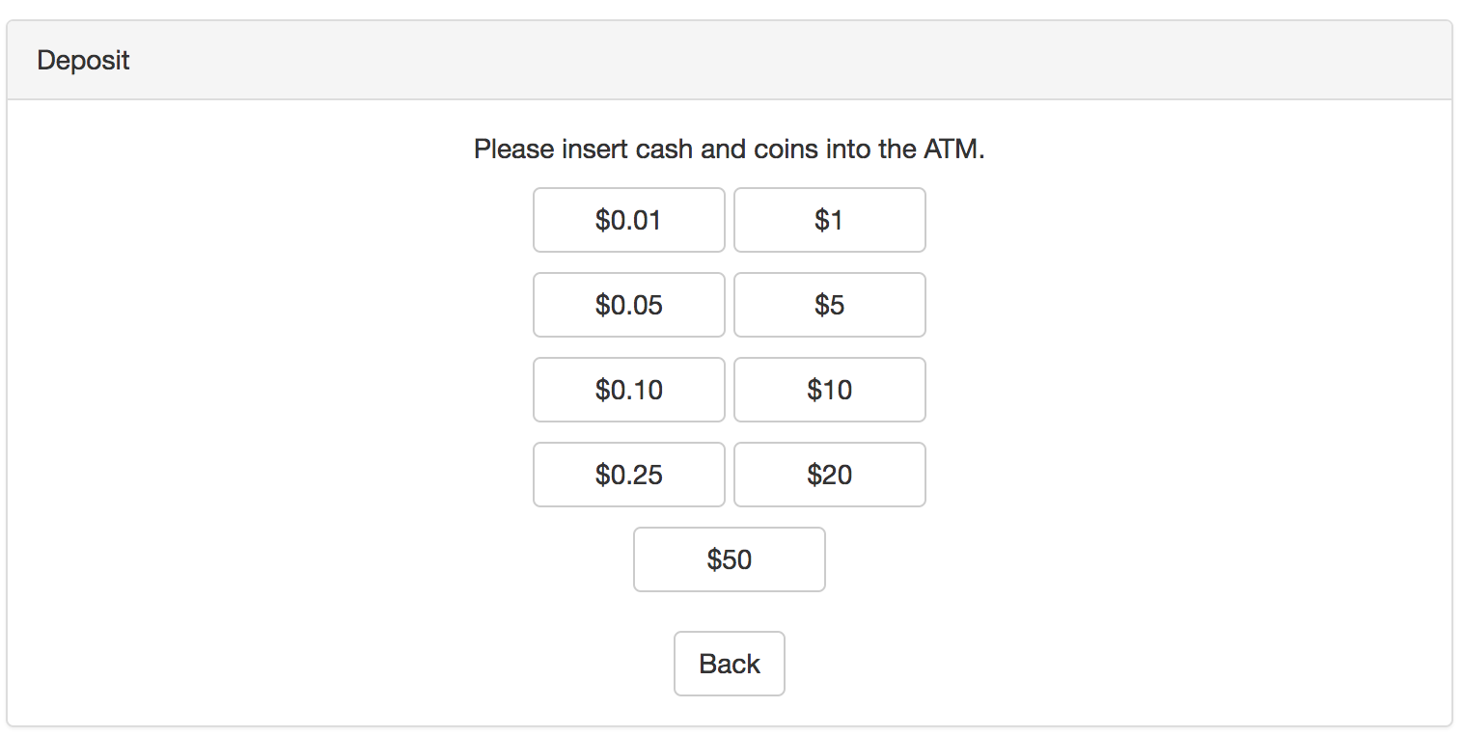

Like a real ATM, you can only add cash in real increments (bills or coins). Click the denomination of the bill or coin you wish to insert.

Upon inserting a bill or coin, you will see the following message:

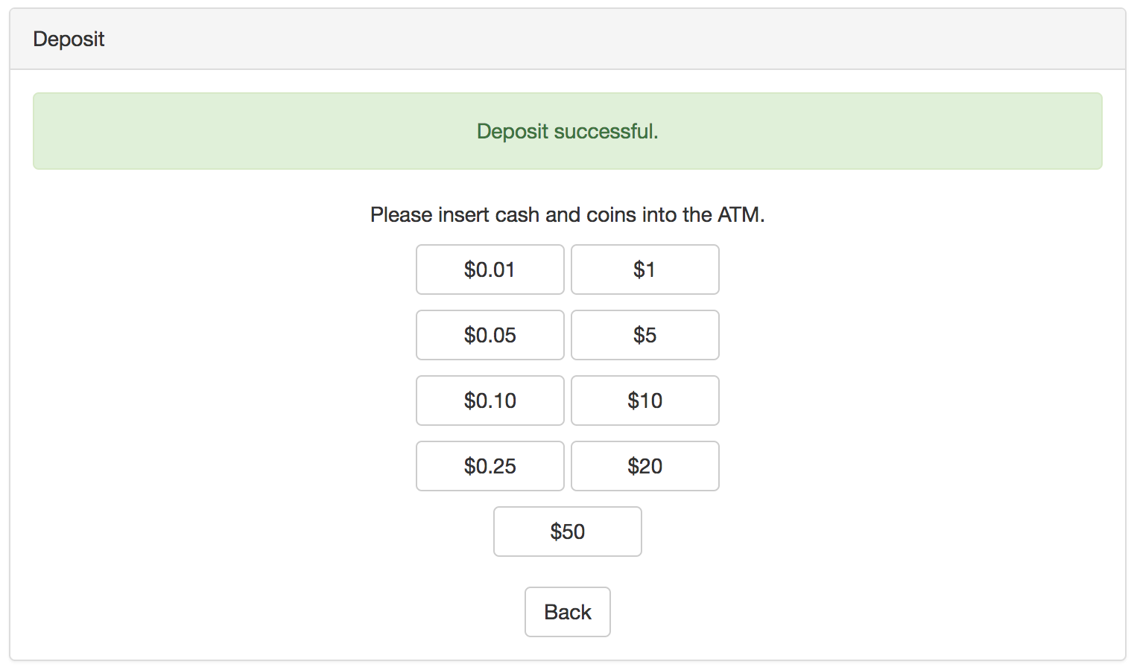

You will also see upon refreshing the page that the number of coins and bills in the ATM has been updated to reflect what you just inserted.



You will also notice, if you perform a balance inquiry, that your balance has been updated to reflect what you inserted into your account.

To return to the homepage to complete another transaction, hit the "back" button.