Bahria University,
Karachi Campus
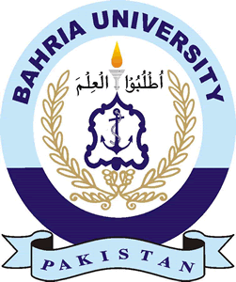

COURSE: SEL-448 SOFTWARE APPLICATIONS FOR MOBILE DEVICES

TERM: SPRING 2026, CLASS: BSE- 6 (A/B/C)

Group Members | Enrollment No.
Maria Khan ( Lead ) | 02-131232-114
Muhammad Umer Qureshi | 02-131232-108
Muhammad Umer | 02-131232-090

Engr. Adnan-ur-Rehman/Engr. Saniya Sarim

Signed Remarks: Score:

HEADINGS:
- Table of Content
- System architecture and design
- Implementation details (code explanation)
- Output screenshots
- Challenges and solutions

