**CSS Basics**

**DEADLINE:** 30/09/2020

## **FOLDER STRUCTURE**

FL14_HW2/* **\*\* - required**

├─ task/** **\*\* - restricted (no need to submit)**

├─ examples/**

   └─ homework/*

        └─ css/*

            └─ bootstrap.min.css*

└─ general.css*

└─ style.css*

        └─ img/*

     └─ index.html*

## **TASK**

1) Open **index.html**. Apply your custom CSS styles to modify the page print view (skeleton). The result should look close (not pixel perfect) to the example provided in **folder: examples -> final.png**.

2) Add a hover effect for the section 1, 2, 3.

a) Text color - #76cdd8. (see **Figure 2.B**)

b) Add triangle which should be located in the top right or left corner depend on the text. (see **Figure 2.B**)



**Figure 2.A – Sections without hover effect**



**Figure 2.B – Section with hover effect**

3) Add a hover effect for the button (background-color: rgb(118, 205, 216)) ( see **Figure 3**)



**Figure 3 – Button.**

4) Add scale effect on hover to image in section 3 (see **Figure 4**)



**Figure 4.A –** Image without effect



**Figure 4.B –** Image with effect

5) a) Add a hover effect for the button (background-color: rgb(118, 205, 216)) ( see **Figure 5**)

b) Add scale effect on hover to image in section 4

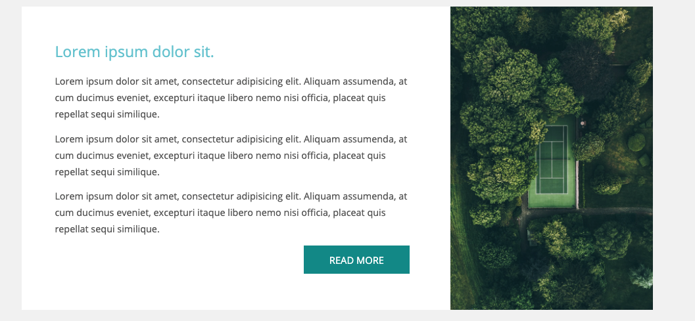

**Figure 5 – Section 5**

6) Add scale effect on hover to image in section 6 ( see **Figure 6**)

a) Add a hover effect for plan (see **Figure 6.B**) (For block: box-shadow: 0 0 0 0.2rem #24d4d4, for Button: background: #24d4d4;)

c) Show **special discount** only on hover in **Advanced** plan (see **Figure 6.C**)

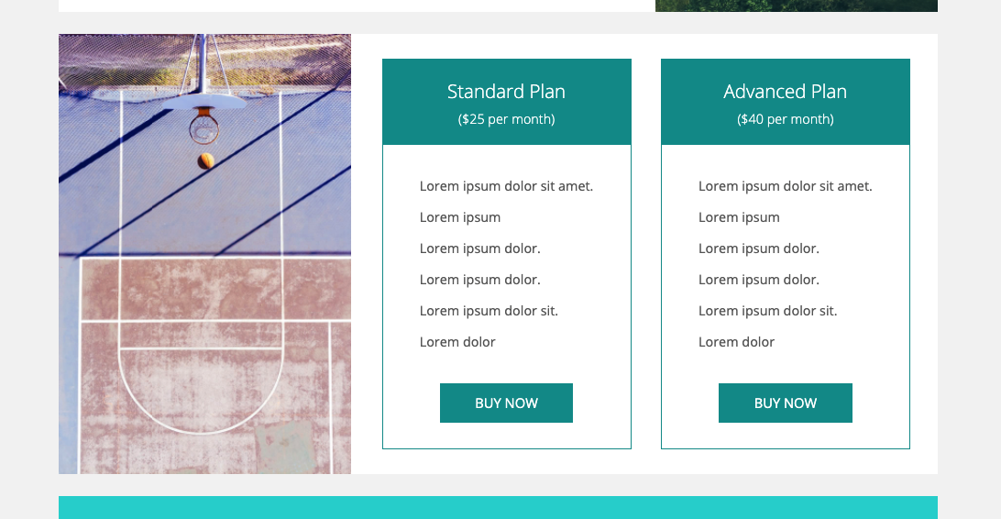

**Figure 6.A – Section 6**

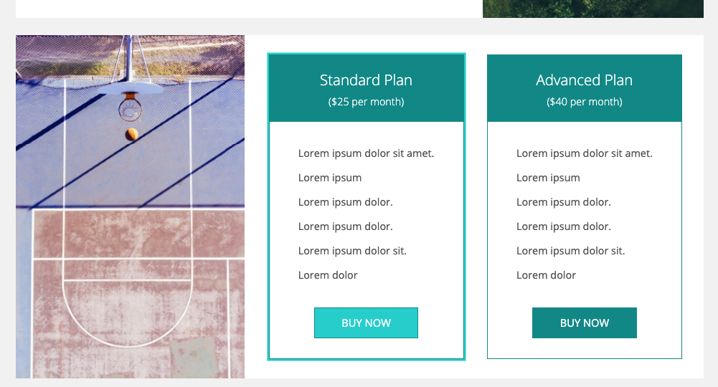

**Figure 6.B – Section 6**

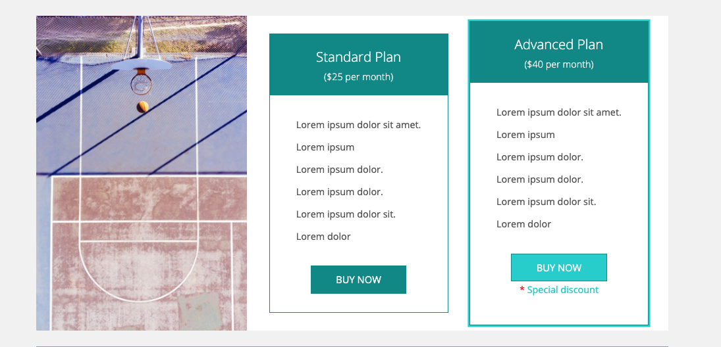 **Figure 6.C – Section 6 with special discount**

6) Style form section as shown in **Figure 7**( see **Figure 7**)

a) Add style on **focus** event for all elements ( border-color: #24d4d4; box-shadow: 0 0 0 0.2rem #24d4d4; )

( see **Figure 7.B**)

b) Add a hover effect for the submit button (background-color: rgb(118, 205, 216))

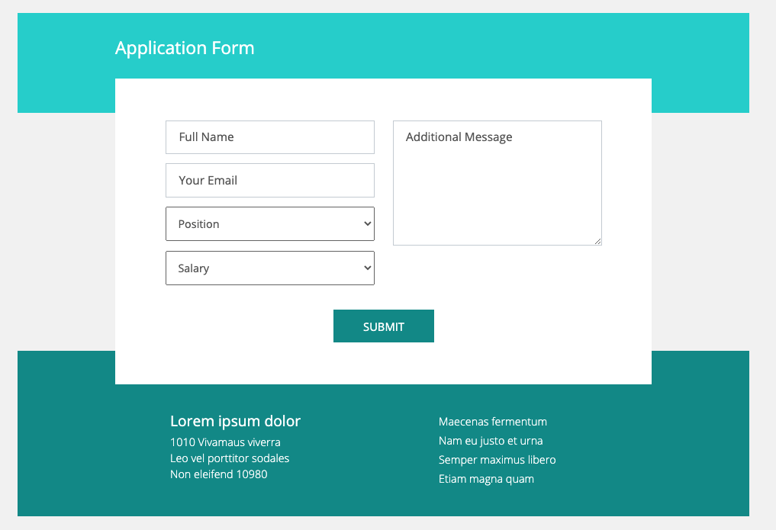

**Figure 7 - Application Form section**

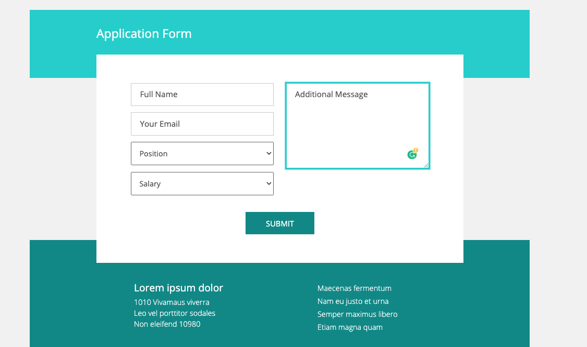

**Figure 7.B - Application Form section with focus event**

## **RESTRICTIONS**

* Adding/editing styles in the **general.css** and **bootstrap.min.css** file is forbidden;
* Usage of **JavaScript** is forbidden;
* Adding anything to **index.html** is forbidden;
* Adding **task/** and **example/** folders is forbidden. Do not push it to repository (only homework/ folder should be pushed);
* No requirements for browser support (should work properly in Google Chrome last version).

## **BEFORE SUBMIT**

* Read requirements and compare to your homework result;
* Format the code (remove unnecessary lines of code);
* Make sure your GitLab folder structure meets the required one (without **task** and **examples** folders);
* Validate your CSS (https://jigsaw.w3.org/css-validator/.

## **SUBMIT**

* The **FL14_HW2** folder should be uploaded to GitLab repository **“FL-14”** into **master** branch

## **USEFUL LINKS**

* <https://www.smashingmagazine.com/2007/07/css-specificity-things-you-should-know/>
* <https://dev.to/doppelmutzi/understand-how-css-styles-are-applied-to-html-elements-by-learning-the-fundamentals-precedence-specificity-cascade-de4>
* <http://specificity.keegan.st/>
* <https://vegibit.com/css-selectors-tutorial/>
* https://www.sitepoint.com/css-printer-friendly-pages/