**Web debugging and profiling tools**

**DEADLINE:** 14.10.2020

**FOLDER STRUCTURE**

|  |  |
| --- | --- |
| FL14_HW8/*  └─ homework/*     └─ src/*  └─ js/*  └─ questions.js*  └─ app.js*  └─ .eslintrc.js*  └─ index.html*  └─ style.css* | * ­­­- required |

**TASK**

## Quiz game application

Your task is to write a simple quiz game.

Requirements:

* On page load, there is one button – ‘Start new game’
* When user clicks this button, game starts.

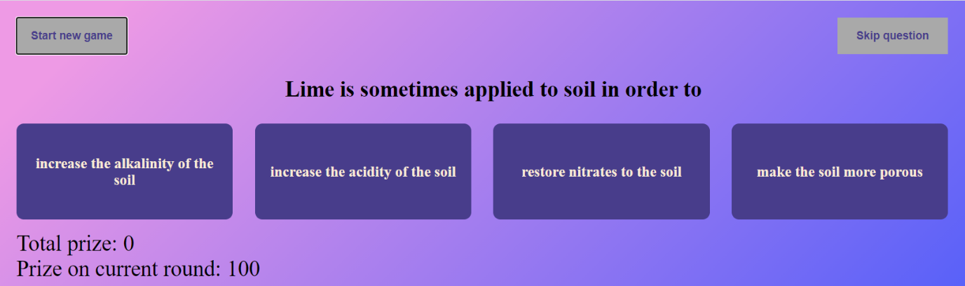

* Each round, a random question is selected from an array of questions.
* It has to be impossible to repeat the same question in one game.
* At first round, prize equals 100.
* At every round, user see questions and can choose option one of 4.
* When the user answers correctly, current prize is added to the total prize, new question appears on the screen and current prize is doubled.
* There is also ‘Skip question’ button. When the user clicks on it, the current question is replaced by a new one. This button can only be used once per game, after which it should disappear or be disabled.
* When user has answered incorrectly, the game ends and notification is displayed: ‘Game over. Your prize is: {total prize}’.

* as soon as the total prize reaches 1000000 (one million), the game ends and win notification is displayed.

* Screenshots are provided for demonstration purposes only. It is allowed to implement any UI/UX design that covers the required functionality.

**BEFORE SUBMIT**

* Remove all unnecessary files that you might have included by mistake
* Verify that all functionality is implemented according to requirements
* Make sure you code is well-formatted, and validated via validator (w3org Markup Validation Service)
* Add comments if the code is difficult to understand
* Fix warnings/errors in the browser console
* Verify that the name of the folders and files meet the requirements
* Make sure there are no errors/warnings in the browser console
* Run the linter and fix all warnings and errors.

## RESTRICTIONS

* External libraries usage is forbidden

**HOW TO**

Use linter :

* In order to use npm package manager you should install nodejs (https://nodejs.org/ )
* Install eslint to check your code (npm install -g eslint)

- open a terminal (or cmd)

- run eslint (i.e. eslint ./js/task1.js)

Code should be without ‘errors’

**SUBMIT**

* The folder should be uploaded to GitLab repository 'FL-14' into master branch