Simulations of Stock-Recruit Data with Forestry
Maria Kuruvilla
June 2025
Table of Contents

Goal
Determine the accuracy of the estimates of Stock-Recruitment model parameters by using simulated data from Beverton-Holt and Ricker models.

Generating Recruit Time Series
We generated data using the Beverton Holt equation and the Ricker equation for 50 years and with an initial population size of 100.

Beverton-Holt Equation
$N_{t+1}=N_{t} \frac{e^{α+βForestry+ϵ}}{1+\frac{e^{α}N_{t}}{R_{k}}}$
$R_{K}=\frac{K}{e^{α}−1}$

Ricker Equation
$N_{t+1}=N_{t} e^{α−\frac{N_{t}}{S_{max}}+βForestry+ϵ}$
$S_{max}=\frac{K}{α}$
$ϵ∼N\left(0,σ\right)$
We used $K=1000$, $Forestry=\sqrt{CPD}$ of Carnation Creek and varied $α$, $σ$, and $β$.
We discarded data in which the population crashed ($<1$). This occurred when $α$ was high in the Ricker model. We fit the model with normal prior for $α∼N\left(5,10\right)$ and $0<α<10$ constraint.
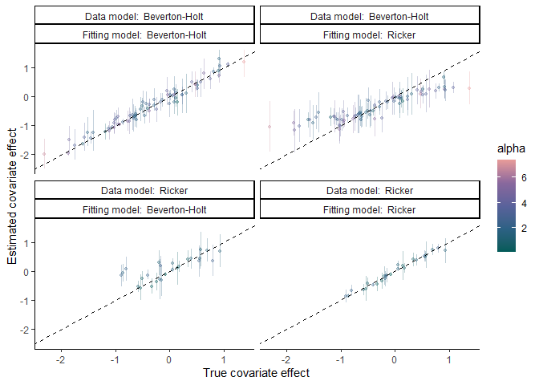
When the Ricker model is fit to Beverton-Holt data (and perhaps vice versa), the effect of a covariate is underestimated.
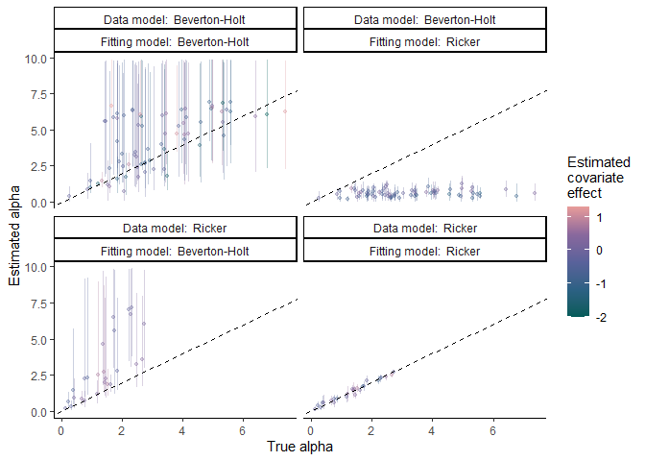
The Ricker model is able to estimate $α$ from data generated from the Ricker model. The Ricker model underestimates $α$ values from Beverton-Holt data. The Beverton-Holt model is unable to estimate $α$ precisely.

Generating $ln\left(\frac{R}{S}\right)$ data
To overcome the chaotic dynamics of the Ricker model at high values of $α$, we generated $ln\left(\frac{R}{S}\right)$ data by using empirical spawner data from Carnation Creek.

Beverton-Holt Equation
$ln\left(\frac{R}{S}\right)=e^{α}−ln\left(1+\frac{e^{α}S}{R_{k}}\right)+βForestry+ϵ$
$R_{K}=\frac{K}{e^{α}−1}$

Ricker Equation
$ln\left(\frac{R}{S}\right)=α−\frac{S}{S_{max}}+βForestry+ϵ$
$S_{max}=\frac{K}{α}$
$ϵ∼N\left(0,σ\right)$
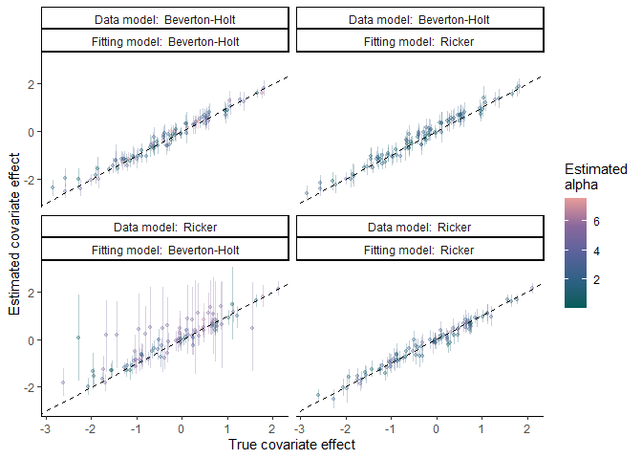
The estimate of covariate effect is usually accurate. It can have high levels of uncertainty when fitting Beverton-Holt data to Ricker data which coincides with high estimated $α$ values.
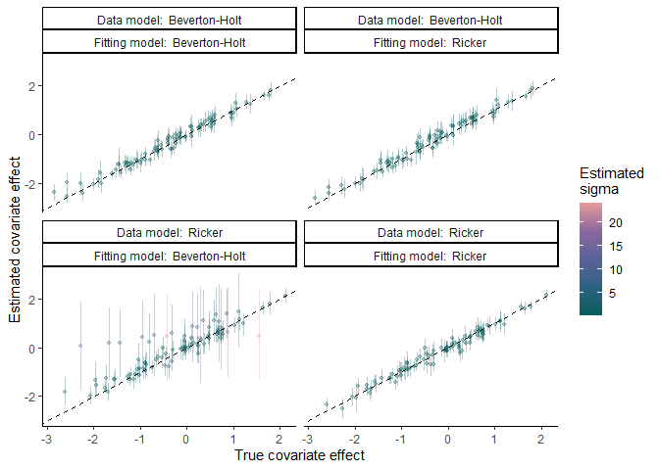
The estimate of covariate effect is usually accurate. It can have high levels of uncertainty when fitting Beverton-Holt data to Ricker data which coincides with high estimated $σ$ values.
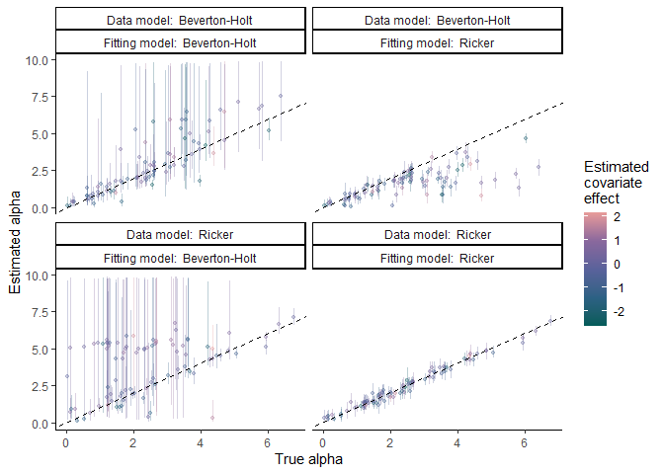
The Ricker model is able to estimate $α$ from data generated from the Ricker model. The Ricker model underestimates $α$ values from Beverton-Holt data. The Beverton-Holt model is unable to estimate $α$ precisely.

