Проверка программы на утечки памяти до сознательного внесения ошибок

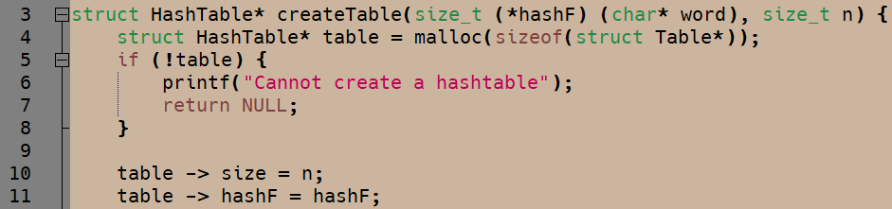

Ошибка в выделении памяти под struct Table*, а не struct HashTable, все Error #1-8 возникли из-за этого

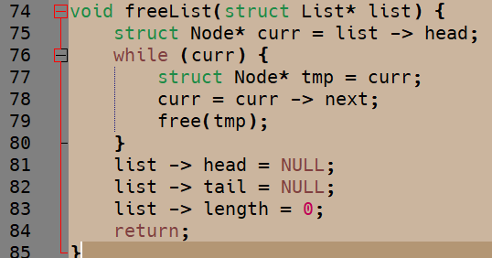

Ошибка в выставлении параметрам списка нулевых значений, а не освобождения памяти, выделенной под список, Error #9 возник из-за этого

Error #10 как-то связана с использованием файла, ее исправить не удалось

Скриншот проверки после устранения ошибок

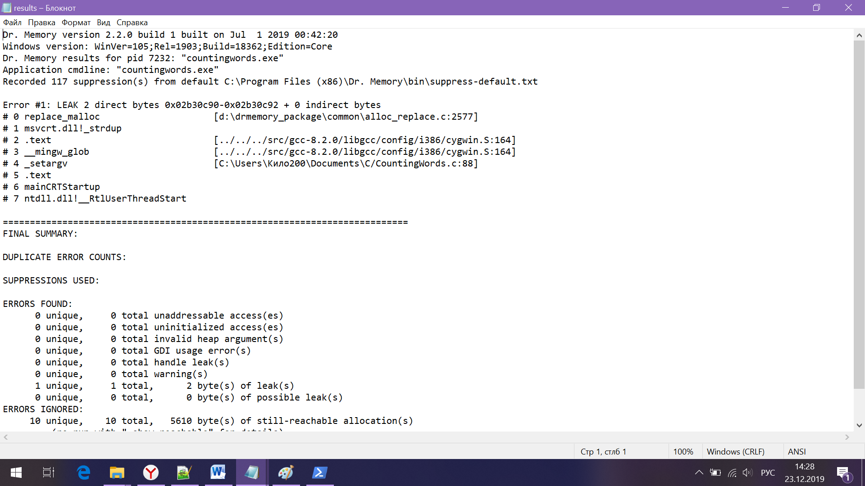

Ниже результаты первой проверки со списком и описанием ошибок (в один скриншот не влезло☺)

Dr. Memory version 2.2.0 build 1 built on Jul 1 2019 00:42:20

Windows version: WinVer=105;Rel=1903;Build=18362;Edition=Core

Dr. Memory results for pid 14288: "countingwords.exe"

Application cmdline: "countingwords.exe"

Recorded 117 suppression(s) from default C:\Program Files (x86)\Dr. Memory\bin\suppress-default.txt

Error #1: UNADDRESSABLE ACCESS beyond heap bounds: writing 0x02db0dd4-0x02db0dd8 4 byte(s)

# 0 createTable [C:\Users\Кило200\Documents\C/HashTable.c:10]

# 1 main [C:\Users\Кило200\Documents\C/CountingWords.c:62]

Note: @0:00:01.542 in thread 7736

Note: refers to 0 byte(s) beyond last valid byte in prior malloc

Note: prev lower malloc: 0x02db0dd0-0x02db0dd4

Note: instruction: mov %edx -> 0x04(%eax)

Error #2: UNADDRESSABLE ACCESS beyond heap bounds: writing 0x02db0dd8-0x02db0ddc 4 byte(s)

# 0 createTable [C:\Users\Кило200\Documents\C/HashTable.c:11]

# 1 main [C:\Users\Кило200\Documents\C/CountingWords.c:62]

Note: @0:00:01.545 in thread 7736

Note: refers to 4 byte(s) beyond last valid byte in prior malloc

Note: prev lower malloc: 0x02db0dd0-0x02db0dd4

Note: instruction: mov %edx -> 0x08(%eax)

Error #3: UNADDRESSABLE ACCESS beyond heap bounds: reading 0x02db0dd8-0x02db0ddc 4 byte(s)

# 0 addWord [C:\Users\Кило200\Documents\C/HashTable.c:28]

# 1 main [C:\Users\Кило200\Documents\C/CountingWords.c:76]

Note: @0:00:01.735 in thread 7736

Note: next higher malloc: 0x02db0df8-0x02db0e04

Note: refers to 4 byte(s) beyond last valid byte in prior malloc

Note: prev lower malloc: 0x02db0dd0-0x02db0dd4

Note: instruction: mov 0x08(%eax) -> %eax

Error #4: UNADDRESSABLE ACCESS beyond heap bounds: reading 0x02db0dd8-0x02db0ddc 4 byte(s)

# 0 getData [C:\Users\Кило200\Documents\C/HashTable.c:46]

# 1 main [C:\Users\Кило200\Documents\C/CountingWords.c:77]

Note: @0:00:01.738 in thread 7736

Note: next higher malloc: 0x02db0df8-0x02db0e04

Note: refers to 4 byte(s) beyond last valid byte in prior malloc

Note: prev lower malloc: 0x02db0dd0-0x02db0dd4

Note: instruction: mov 0x08(%eax) -> %eax

Error #5: UNADDRESSABLE ACCESS beyond heap bounds: reading 0x02db0dd8-0x02db0ddc 4 byte(s)

# 0 setData [C:\Users\Кило200\Documents\C/HashTable.c:56]

# 1 main [C:\Users\Кило200\Documents\C/CountingWords.c:77]

Note: @0:00:01.740 in thread 7736

Note: next higher malloc: 0x02db0df8-0x02db0e04

Note: refers to 4 byte(s) beyond last valid byte in prior malloc

Note: prev lower malloc: 0x02db0dd0-0x02db0dd4

Note: instruction: mov 0x08(%eax) -> %eax

Error #6: UNADDRESSABLE ACCESS beyond heap bounds: reading 0x02db0dd4-0x02db0dd8 4 byte(s)

# 0 statistics [C:\Users\Кило200\Documents\C/HashTable.c:76]

# 1 main [C:\Users\Кило200\Documents\C/CountingWords.c:81]

Note: @0:00:05.457 in thread 7736

Note: next higher malloc: 0x02db0df8-0x02db0e04

Note: refers to 0 byte(s) beyond last valid byte in prior malloc

Note: prev lower malloc: 0x02db0dd0-0x02db0dd4

Note: instruction: mov 0x04(%eax) -> %eax

Error #7: UNADDRESSABLE ACCESS beyond heap bounds: reading 0x02db0dd4-0x02db0dd8 4 byte(s)

# 0 statistics [C:\Users\Кило200\Documents\C/HashTable.c:77]

# 1 main [C:\Users\Кило200\Documents\C/CountingWords.c:81]

Note: @0:00:05.457 in thread 7736

Note: next higher malloc: 0x02db0df8-0x02db0e04

Note: refers to 0 byte(s) beyond last valid byte in prior malloc

Note: prev lower malloc: 0x02db0dd0-0x02db0dd4

Note: instruction: mov 0x04(%eax) -> %edx

Error #8: UNADDRESSABLE ACCESS beyond heap bounds: reading 0x02db0dd4-0x02db0dd8 4 byte(s)

# 0 freeTable [C:\Users\Кило200\Documents\C/HashTable.c:67]

# 1 main [C:\Users\Кило200\Documents\C/CountingWords.c:82]

Note: @0:00:05.880 in thread 7736

Note: next higher malloc: 0x02db0df8-0x02db0e04

Note: refers to 0 byte(s) beyond last valid byte in prior malloc

Note: prev lower malloc: 0x02db0dd0-0x02db0dd4

Note: instruction: mov 0x04(%eax) -> %edx

Error #9: LEAK 12 direct bytes 0x02db0120-0x02db012c + 0 indirect bytes

# 0 replace_malloc [d:\drmemory_package\common\alloc_replace.c:2577]

# 1 createList [C:\Users\Кило200\Documents\C/ListForHash.c:7]

# 2 createTable [C:\Users\Кило200\Documents\C/HashTable.c:18]

# 3 main [C:\Users\Кило200\Documents\C/CountingWords.c:62]

Error #10: LEAK 2 direct bytes 0x02db0d70-0x02db0d72 + 0 indirect bytes

# 0 replace_malloc [d:\drmemory_package\common\alloc_replace.c:2577]

# 1 msvcrt.dll!mbsdup +0x24 (0x759d6d35 <msvcrt.dll+0x86d35>)

# 2 .text [../../../src/gcc-8.2.0/libgcc/config/i386/cygwin.S:164]

# 3 __mingw_glob [../../../src/gcc-8.2.0/libgcc/config/i386/cygwin.S:164]

# 4 _setargv [C:\Users\Кило200\Documents\C/CountingWords.c:88]

# 5 .text

# 6 mainCRTStartup

# 7 ntdll.dll!__RtlUserThreadStart

Reached maximum leak report limit (-report_leak_max). No further leaks will be reported.

===========================================================================

FINAL SUMMARY:

DUPLICATE ERROR COUNTS:

Error # 1: 3

Error # 2: 3

Error # 3: 48246

Error # 4: 48246

Error # 5: 48246

Error # 6: 3

Error # 7: 150003

Error # 8: 150003

Error # 9: 9992

SUPPRESSIONS USED:

ERRORS FOUND:

8 unique, 444753 total unaddressable access(es)

0 unique, 0 total uninitialized access(es)

0 unique, 0 total invalid heap argument(s)

0 unique, 0 total GDI usage error(s)

0 unique, 0 total handle leak(s)

0 unique, 0 total warning(s)

2 unique, 9993 total, 119906 byte(s) of leak(s)

0 unique, 0 total, 0 byte(s) of possible leak(s)

ERRORS IGNORED:

7 unique, 7 total, 1498 byte(s) of still-reachable allocation(s)

(re-run with "-show_reachable" for details)

140764 leak(s) beyond -report_leak_max

Details: C:\Users\РљРёР»Рѕ200\AppData\Roaming\Dr. Memory\DrMemory-countingwords.exe.14288.000\results.txt