MAIKCRAFT: THE DEVELOPMENT OF A WEB-BASED ORDERING AND POS SYSTEM WITH AI-BASED DESIGN CUSTOMIZATION FOR MAIKENS GOWN AND BARONG

A Capstone Project Proposal
Presented to the Faculty of the
Information and Communications Technology Program
STI College Sta. Maria

In Partial Fulfillment
of the Requirements for the Degree
Bachelor of Science in Information Technology

Gabrielle T. Buluran
Aldwin Miel G. Espiritu
Princess Mary Nicole S. Gopez
Christian Janmher G. Lovendino

October 25, 2026

ENDORSEMENT FORM FOR ORAL DEFENSE

TITLE OF RESEARCH: MAIKCRAFT: THE DEVELOPMENT OF A WEB-BASED ORDERING AND POS SYSTEM WITH AI-BASED DESIGN CUSTOMIZATION FOR MAIKENS GOWN AND BARONG

NAME OF PROPONENTS: Gabrielle T. Buluran
Aldwin Miel G. Espiritu
Princess Mary Nicole S. Gopez
Christian Janmher G. Lovendino

In Partial Fulfillment of the Requirements
for the degree Bachelor of Science in Information Technology
has been examined and is recommended for Proposal Defense.

ENDORSED BY:

Mr. Ralf Alvin Bausas
Capstone Project Adviser

APPROVED FOR ORAL DEFENSE:

Asst. Prof. Alfie B. Benito, MIT
Capstone Project Coordinator

NOTED BY:

Ms. Lara Camille V. Vergara
Program Head

October 25, 2026

ABSTRACT

Title of research: MAIKCRAFT: THE DEVELOPMENT OF A WEB-BASED ORDERING AND POS SYSTEM WITH AI-BASED DESIGN CUSTOMIZATION FOR MAIKENS GOWN AND BARONG

Researchers: Gabrielle T. Buluran
Aldwin Miel G. Espiritu
Princess Mary Nicole S. Gopez
Christian Janmher G. Lovendino

Degree: Bachelor of Science in Information Technology

Date of Completion: October 2026

Keywords: Point of Sale, Customization, Artificial Intelligence, Inventory Management, Messaging, Digital

This capstone project describes the development of MAIKCRAFT, an online ordering and POS system equipped with an AI-based design customization tool created for Maikens Gown & Barong boutique in Disenyo Pandi, Bulacan. The system enhances online and in-store business operations by digitalizing the traditional paper-based operations of the boutique, including sales recording and stock management, while providing customers a way to design and visualize their preferred and requested garments. It also includes important features like messaging tool, order status tracking, and Virtual Try-On.
The system is developed with technologies including React.js, Tailwind CSS, Node.js, Express.js, and MongoDB which makes the system responsive, scalable, and secure. Evaluation and testing showed that the system successfully improved customer engagement, order processing accuracy, and synchronization of online customer transactions with in-store stocks. MAIKCRAFT established a reliable digital solution that integrated POS, digital stock monitoring, and AI innovation, helping Maikens Gown & Barong grow and modernize its operations.
APPROVAL SHEET

This capstone project proposal titled MAIKCRAFT: The Development of a Web-Based Ordering and POS System with AI-Based Design Customization for Maikens Gown and Barong, prepared and submitted by Gabrielle T. Buluran, Aldwin Miel G. Espiritu, Princess Mary Nicole S. Gopez, and Christian Janmher G. Lovendino, in partial fulfillment of the requirements for the degree of Bachelor of Science in Information Technology has been examined and is recommended for acceptance and approval.
Mr. Ralf Alvin Bausas
Capstone Project Adviser

Accepted and approved by the Capstone Project Review Panel in partial fulfillment of the requirements for the degree of Bachelor of Science in Information Technology

Mr. Mark Angelo S.P Sanjorjo Ms. Myka Nicole I. Coles
Panel Member Panel Member

Asst. Prof. Alfie B. Benito. MIT
Lead Panelist

Noted:

Asst. Prof. Alfie B. Benito MIT Ms. Lara Camille V. Vergara
Capstone Project Coordinator Program Head

October 25, 2026
ACKNOWLEDGEMENTS

We would like to take this opportunity to express our deep appreciation to all those who contributed to the successful completion of our capstone project. This research would not have been possible without their unfailing support, guidance and encouragement.
As a researcher, we would like to express our deepest gratitude to our Capstone Project Coordinator, Asst. Prof. Alfie B. Benito, MIT, and our IT Program Head, Ms. Lara Camille V. Vergara, for their dedication and guidance throughout our study. To his constant support and motivation that kept us focused and organized from start to finish. He was instrumental in helping us manage our time frame and ensure that our project met the required Academic standards.
We are sincerely thankful to our Capstone Project Adviser, Mr. Ralf Alvin Bausas for his valuable insights, technical expertise and constant encouragement during the development of our system. His mentorship and thoughtful advice helped us improve our project and overcome complex development situation with courage. We thank him for his time, patience and sincere effort to help us produce quality research.
We would also like to thank our Capstone Project Review Panel for their time, expertise and valuable suggestions during the evaluation phases. The feedback and recommendations we receive helped us in increasing the quality and effectiveness of our project. Their positive comments led us to refine our study to the best possible outcome.
We would like to extend our special gratitude to the owners of Maikens Gown & Barong Mr. Rolan Sayo, Mrs. Pattrick Marites Sayo and Ms. Maila Katrina Sayo for giving us the permission and opportunity to work with their boutique, and giving us essential operational insights and evaluating our system.
To our parents and guardians, we wish to convey our boundless gratitude for their unconditional love, support, and encouragement. The sacrifices they made, both financially and emotionally, provided us with the strength and perseverance needed to reach this milestone. Their faith in us has served as our source of motivation and inspiration throughout this entire journey.
We would also like to thank our friends and inspirations for their unwavering encouragement and understanding. Their moral support and motivational words helped us remain positive, even in difficult moments. They reminded us of the importance of hard work, teamwork, and perseverance.
Finally, we extend our appreciation to everyone else who contributed to this research in any way. Whether through technical assistance, shared knowledge, or encouragement, your help has been invaluable to this project's success. Your contributions have made a meaningful difference to our study, and for that, we are deeply thankful.
TABLE OF CONTENTS
Page
Title Page i
Endorsement Form ii
Abstract iii
Approval sheet iv
Acknowledgements vi
Table of Contents vii
List of Figures ix
List of Tables xi
Introduction
Project Context 1
Purpose and Description 8
Objectives 9
Scope and Limitations 11
Revie of Related Literature/Studies/Systems
Review of Related Literature 14
Benchmarking 19
Review Related Studies and/or Systems 21
Synthesis 23
Technical Background
Conceptual Model of the Study 24
Technologies to be used 26
Calendar of Activities 27
Hardware and Software Resources 28
Methodology
Respondents of the Study 33
Sampling Technique and Sample Size 33
Statistical Treatment of Data 35
Requirement Analysis 37
Requirement Documentation 39
Design of Software, Systems and/or Processes 41
Development 44
Result and Discussion
Testing 46
Description of Prototype 55
Implementation Plan 65
Implementation Results 66
Conclusion 67
Recommendation 68
References 69
Appendices
Appendix A. Resource Person 74
Appendix B. Evaluation Tools/Test Documents 76
Appendix C. Diagrams 96
Appendix D. Personal Technical Vitae 75

LIST OF FIGURES

Figure Page
1 Input-Process-Output (IPO) Framework 24
2 Agile Methodology 30
3 User/Customer Level 41
4 Cashier Level 41
5 Admin Level 42
6 Customer Product Catalog 55
7 Product Detailed Page 55
8 Cart Page 56
9 Checkout Module 56
10 Order Detailed and Status 57
11 AI Customization Tool 57
12 Messaging Tool 58
13 Virtual Try-On 58
14 Admin Dashboard 59
15 User Account Management 59
16 Order Customization Design Management 60
17 Order Status Updates 60
18 Add Product 61
19 Admin Messaging Tool 61
20 Report Page 62
21 Cashier Product Catalog 62
22 Cashier POS 63
23 Receipt Generation 63
24 Orders 64
25 Test Case: User/Customer Level 90
26 Test Case: Admin Level 92
27 Test Case: Cashier Level 94

28 Flowchart: Customer/User Level 96
29 Flowchart: Admin Level 97
30 Flowchart: Cashier Level 98
31 Context Diagram 99
32 Data Flow Diagram (DFD) 100
33 Entity Relationship Diagram (ERD) 101

LIST OF TABLES

Figure Page
1 Benchmarking Table 19
2 Gantt Chart of Activities 27
3 Hardware Resources 28
4 Software Resources 29
5 Four Point Likert Scale Interpretation 25
6 Test Case Scenario Summary 46
7 IT Specialist Evaluation Summary 47
8 Customer Acceptance Testing Summary 49
9 Cashier Acceptance Testing Summary 50
10 Admin Acceptance Testing Summary 52
11 Resource Person 73
11 Test Case: User/Customer Level 69
12 Test Case: Cashier Level 28
13 Test Case: Admin Level 28

INTRODUCTION
Project Context
A boutique is a small retail shop that provides wide variety of unique selection and high-quality fashion products, which also offers personalized service and caters to customer preferences, creating a welcoming shopping experience (Sandy, 2023). Additionally, boutiques are made to provide quality style and uniqueness, they set themselves apart from bigger chain stores by providing specialized products and a cozier shopping environments (Mahmound, 2024). According to Brooks (2026), citing the National Bridal Survey, about 61% of bride’s shop for gowns and dresses online indicating a notable shift in consumer behavior toward digital platforms. In a study conducted by Chang et al. (2024), result shows that systems like Point-of-Sale and e-commerce platform are the most well-known retail technologies that fashion retailers are currently using. Furthermore, Chang et al. (2024) highlights that improvement, as well as personalization in fit, fabric, and color are the important considerations for independent SME fashion retailers in adopting technologies, which they noted that consumers both seek appropriateness and conveniences.
Meanwhile, several studies have been conducted when it comes to customization in retail apparel stores. In a study by Wang et. al (2023), emphasized the limitations in traditional garment customization approach, such limitations include wasteful consumptions of materials and time-consuming process of repeatedly creating physical prototypes of designs, as well as in modifications and assessments of such prototypes. The study combines technologies which includes machine learning, 3D simulation, and virtual fitting as their proposed approach in addressing these limitations. They also noted that such approach improves communication between customers and retailers. Another study conducted by Choi et al. (2023) which explores a much simple approach by using Artificial Intelligence, which they introduced as “one of the key drivers in shaping the transformation of contemporary society alongside Big data, virtual reality, and technological advancement”. Their approach enables design attributes such as sleeve, silhouette, neckline, color, pattern, and print to be manipulated during the process of designing, which demonstrate the potential of AI generate fashion designs that are based on the specific preferences and design requirements of consumers.
Maikens Gown & Barong, is a family-owned boutique that is established in September 2019 in Stall A18 Disenyo Pandi Wedding Depot located Grace Park Street, Bagong Barrio, Pandi, 3014 Bulacan, that offers different gowns, dresses and barongs for different occasions like weddings, school events, and parties. It is owned and managed by Mr. Rolan Sayo and Mrs. Pattrick Marites Sayo as well as their daughter Mrs. Maila Katrina Sayo, with assistance of one staff. The business has been operating for seven years, starting on the September of two thousand nineteen. They serve up to six to ten customers on a normal day, and eleven to twenty on peak days. Customers may either purchase available ready-to-wear garments or request a made-to-order design, with staff and owner assisting them about the fabrics, colors, and styles. The boutique shop also obtains their products by making their own, as well as from suppliers.
The current process of the boutique primarily follows in-store, and online approach. Customers visits the shop for design consultations, fitting, and order placement, while some inquiries are handled though phone calls, social media messaging like Facebook, and online platforms like Lazada and Shopee, which are handled by owners of the store with assistance of a staff. The process begins when the customer looks for a gown and barong suitable for the events they are aiming. Once a design is chosen, the customers and the store owner, as well as the staff assistant discusses the design details, measurements, and any reference photos and sketches if the customers wanted alterations or requested a full blown made-to-order design. The process is similar for customers who inquire through online platforms such as Facebook by browsing available gowns posted in their page, while the discussions is conducted using messaging tools like Messenger. After the discussions, the staff leads the customer for fitting to ensure the size and determine necessary modifications. The details about the orders, including design adjustments, measurements, and payments, are recorded by store owners and staff in a record book. After that the boutique prepares the gown or barong in compliance with the finalized specifications while keeping the customer informed of any updates and changes. The boutique currently uses a paper-based inventory system. Orders are manually recorded by the owner in a record book. To monitor inventory, they conduct a weekly review where all recorded orders are counted and compared against the available stock in the store. The boutique notifies the customer for the status of the product, final fitting and confirmations through either phone calls, social media messaging and text messages, once the gowns or barong is finished, payments are collected through available payment methods such as cash or digital payment platforms such as GCash, if the order has not been fully paid yet, and then the order is officially finalized and handed over to the customer. The customers can either visit the store to pick up the item, or request it for delivery.
While the boutique manages to continuously serve its customer by their current process, the responses gathered from the beneficiary though interview presents several areas where operations may still be improved. According to the boutique, they have experience delayed in transaction processing due to manual computations of payments and paper-based record keeping, which also makes it difficult for them to organize and track each orders and sales especially when order volume increases. Similarly, Lewis et al. (2021) found that many corner store owners in Baltimore City does not use electronic Point-of-Sales systems and often results to difficulty in tracking sales due to lack of formal records of stocking and sales. While the use of third-party-e-commerce platforms and various communication channels is useful, these tools are not designed to support boutique's services like customer requested customized gown and barong designs. The boutique owner also mentions miscommunications of the design details also happens such as preferred colors, sizes, and garments, which results to frequent design changes and time-consuming discussions, especially in fully requested customized designs, which sometimes causes difficulties in visualizing the desired output. Customer messages and inquiries are also sometimes overlooked due to conversations being handled in different messaging platforms like messenger and phone number messages, as well as having not enough staff to handle different platforms and messages, making it hard to track previous conversations, which leads to delayed responses. In a study by Darics and Lockwood (2022), communication challenges in customer services occur due to communications being disrupted, particularly when the sequence and flow of conversation becomes confusing, wherein relevant responses do not immediately follow the preceding turn in sequential order. The study also found out that occurrence of this issues, specially under stress or heightened emotional stress may lead to communication problems like conceptual misunderstanding and customer dissatisfaction. There are also instances, according to the boutique, that sometimes they weren't able to update customers about the status of their orders due to difficulty of tracking multiple orders, especially in peak business season, which leads to repetitive follow-ups. According to the boutique, there are times when the gown is not yet finished but some customers arrives too early for pick-ups. Furthermore, Kawa and Światowiec-Szczepańska (2021) citing Zhang et al. (2020), emphasized the significance of monitoring of order-status by noting that sellers should give customers access with information about the progress of order fulfillment. Providing such information to customers allows them to remain informed about the progress of their order without relying solely on direct inquiries to the seller, as well as it also creates value to the customer (Kawa and Światowiec-Szczepańska, 2021). The boutiques process of recording orders and transaction details in a record book and tallying it weekly to their available in-store stocks, has become time consuming when there is a large volumes of orders. This also makes it difficult to maintain real-time visibility of available sizes and designs. Accurate Inventory is also a necessity for having the right product and quantity at the right time and place. Inaccurate record of inventory can negatively affect replenishment decisions and availability, which can lead to issues like product stock outs and loss of revenue (Shabani et al., 2021). The owner also mentions the risks of losing or damaging the record books. According to a study conducted by Wang et al. (2022) in the medicine field of keeping inventory records, tracking inventory of medical stores are still carried out by using based stock books in developing countries including Uganda, which leads to difficulty in real-time transaction recording and the requirement of extreme effort and time-consuming compilation of information that leads to issues like stock out or overstock, in which our beneficiary have also experience. The proponents also conducted a brief survey among respondents with previous experience in purchasing, ordering, and inquiring from a boutique to provide an additional perspective from the customer side. It is indicated in the findings that the respondents encountered concerns that relates to the aspects mentioned by the beneficiary and expressed the usefulness of more convenient ways to communicate design preferences, monitoring of order status and message inquiries. These findings were used as supplementary information to provide additional context to the problems that are identified though the beneficiary interviews.
Given the issues presented by the boutique and the existing studies, the proponents this study proposes the development of a web-based ordering and point of sale system, which addresses issues presented by the interviews conducted with the beneficiary, as well as the existing studies gathered. The proposed system will support product showcasing, as well as both in-store and online transaction management and recording of sales. Additionally, an AI-powered customization tool will be implemented to help the customers visualized their preferred gown and barong designs based on the combinations of their selections of pre-defined designs. Order Status Tracking will also be implemented to keep the customers aware of the status of their orders. Furthermore, to address the problems in paper-based inventory recording and monitoring, the system will offer digital inventory stock monitoring feature for accurate timely tracking of available garments. Lastly, the system will integrate a messaging tool to facilitate communications between the boutique and its customers.
The proposed system will enhance the boutique's overall operations by providing a more centralized and structured way to process transactions, track inventory, communicate with customers, and manage orders. The system will reduce the boutique's dependence on paper-based processes, improve the availability and accuracy of its data, and offer a more practical way to monitor and personalize orders to clients. The system will make the operation more efficient and enhance Maiken's Gown and Barong's overall operations with these enhancements.

General Problem
Maikens Gown & Barong currently lacks an integrated web-based system, making it challenging to efficiently manage orders, inventory, and customer communication. This sometimes leads to delays, errors, and uncertainties in gown selection and customization.
Specific Problems
- How can the system provide a way to efficiently manage transactions and track sales
The boutique currently relies paper-based method for processing and recording orders and payments, which can cause delays and difficulties in tracking sales and managing transactions.
- How can the system provide a way for customers to design their own requested gown designs
The shops current process of ordering fully customized designs is through messages in social media and walk-ins’ discussions, with either reference photos or sketches, which are recorded though logbooks, which can be time consuming and would often result to miscommunications and difficulties in visualizing the desired output.
- How can the system provide a way for the boutique staffs to update their customers on the status of their orders
Without status tracking of orders for customized orders, the customers are not aware of the status of their orders, which results to repetitive follow ups and sudden changes request without knowing the current production stage of their orders.
- How can the system improve the stock monitoring of available gowns
The approach of monitoring available gowns, designs, and sizes is by relying on paper-based record books that makes it difficult and time-consuming for the boutique to accurately maintain real-time inventory records, especially when handling multiple customer orders.
- How can the system provide a tool for customers and the boutique to interact
Currently the shop primarily uses walk-ins, phone calls, social media and ordering platform messaging to coordinate with customers for their inquiries and customized requests which can occasionally make managing discussions, revisions, and follow-ups more difficult.

Purpose and Description
The purpose of the study, The Development of a Web-Based Ordering System with AI Customization tool for Maikens Gown & Barong is to make business operations better and improve how orders and inventory are managed. This study aims to create a place online where customers can easily look at products, place orders, talk to the boutique, check the status of their orders, and customize their own requested gown and barong designs supported by AI. The system also wants to help the employees and owners of the boutique to manage transactions and keep track of orders, monitor inventory, and make transactions faster, which can make the whole business run more smoothly.
The system will have three parts, the Admin/Owner Module, the Staff/Owner Module, and the Customer Module. The Admin/Owner Module will take care of sales records, product listings, and looking at designs that are available in the system. This part will also let the owner keep an eye on what's happening in the system and manage important business information. The Staff/Owner Module will focus on doing tasks like managing orders on the internet, answering customer questions, and checking stock levels of gowns and materials to make sure inventory is managed properly. The Customer Module will be the way for customers to use the system. With this part, customers can look at products that are available, place orders with their selected methods of payments like Gcash, talk to the boutique, and customize and preview what the gowns will look like using the AI image generation. The system aims to fix issues with visualizations, status updates, talking to customers, and monitoring inventory. By making business processes easier and giving customers tools to visualize things and make their business run efficiently, Maikens Gown & Barong is becoming more modern.

Objectives
General Objective
To develop a web-based ordering system for Maikens Gown & Barong that streamlines order processing and inventory management, improves communication between the boutique and customers, and provides an AI-Based customization feature for gown customization and visualization.
Specific Objectives
- To be able to develop a system that efficiently manage transactions and tracks sales
The proponents will develop a web-based system that will not only allow customers to browse different gowns and barong products, but also enables the boutique to track sales and manage transactions of both online and in-store orders via POS.
- To be able to develop an AI-Based design customization tool
The user will be able to design their own gowns or barong, either redesigning an available gown, or design their own from scratch that will be supported by an AI preview generations based on combination of selected pre-defined design elements that the system provides or on the photo and sketches that can be submitted by the users as a reference.
- To be able to implement order status tracking
The proponents will implement an order status tracking for each orders, whether it is a purchase of a ready to buy and wear products, or a full customized design gowns, customers will be able to monitor the status of their orders. With status tracking and customization tool, customers will also be able to change and edit their own customized design orders, as long as it does not yet reach the production stage.

- To be able to develop inventory stock monitoring
The proponents will develop a stock monitoring to address challenges faced in paper-based inventory handling. The system aims to provide inventory that digitally records and updates gown availability, such as the available gown and barong designs and sizes. This enables the boutique staff to easily track which gowns are available, reserved, in customization, as well as it gives timely updates of low stocks.
- To be able to integrate messaging tool
The proponents will integrate a messaging module that enables efficient and organized interaction between the boutique and customers, allowing inquiries, updates, and requests to be managed smoothly within the system.

Scope and Limitations
Scope of the Study
The study focuses on the development of a Web-Based Ordering System with AI Customization Tool for Maikens Gown & Barong, located at Disenyo Pandi, Bulacan. The system aims to improve business operations, improve transaction and inventory management through digital solutions. The system will support three (3) user levels: Admin/Owner, Staff/Owner, and Customer.
Scope of the System
Admin Modules
- User Account Management: Manage system users such as staff and customer accounts.
- Product Catalog Management: Add, update, archive, and showcase available gowns.
- Order and Customization Design Management: Review, approve, or manage customer submitted custom gown designs and orders
  - Order Status Update: Update order progress such as order-received, In-Production, Preparing, Finished Productions, Ready for Pick-Up, and Ready for Delivery.
  - Admin Messaging Tool: Respond to customer inquiries and coordinate request changes.
- Reports: Generate sales reports, order summaries, and inventory reports.
Cashier Modules
- Order Processing: The Boutique can create and process walk in orders such order and customer details, this will reduce the stocks of a specific product in their inventory.
- Receipt Generation: Generate transaction receipts for completed orders with an option to print.
- Record Keeping: Automatically store completed transactions such as order details and for tracking and reporting purposes
- Inventory Monitoring: Monitor real-time stock levels of gowns and barong, view stock movement such as the available gown and barongs and their quantities with high and low stocks displayed. Order history of both online and walk-ins are also shown and searchable.
Customer Modules
- Product Catalog: Customers can browse or search gowns and barong by category, with filters such as event type, design, color, and size for easier and more organized searching.
- Order Status Tracking: Customers can view the status or their orders.
- Customization Tool with AI support: Customers can design their own gowns, either modify an existing gown or full customized a design, with selections of pre-defined designs like color, styles, sleeve types, with AI image generation.
- Customer Messaging Tool: Customers can message the boutique anytime as it answers basic questions including but not limited to, store hours, and prices. The boutique owner can still personally reply on customer inquiries. The tool can do text, audio, and video call.
- Virtual Try-On: Customers can upload full body photo and preview selected gown designs.
- Cart: Customers can add or delete multiple products in their cart before checking out.
- Checkout Module: Customers can view the summary of their selected orders, total costs, discounts, and payment methods, such as Gcash. Customers may confirm their payments and shipping details or pick-up schedules before placing orders.

Limitations
- The customization tool will not function as a 3D professional fashion design software and will only provide predefined design elements and templates.
- The system may initially support GCash as a payment method, and may not include all online payment gateways.

REVIEW OF RELATED LITERATURE/STUDIES/SYSTEMS

Review of Related Literature

Point of Sale
POS systems are instrumental in sales recording, inventory tracking, customer purchase monitoring, and processing diverse payment methods, offering businesses efficiency, accuracy, and valuable insights into sales and inventory data for effective operational management (Asrani et al., 2024). According to Chang et. Al (2024), based on their study "Opportunities and challenges of smart technology for small independent fashion retailers", conducting an interview with 11 participants working from fashion companies, result shows that retailers generally identifies e-commerce and point-of-sales systems as a critical technology in their operations, which they identified as Shopify, BigCommerce, Square, and others.
In the study by Lewis et al. (2022), the researchers found that that many corner store owners in Baltimore City does not use electronic Point-of-Sales systems and often results to difficulty in tracking sales due to lack of formal records of stocking and sales. In response to this, the researcher developed a simplified mobile POS mobile application which they called Point-of-Sale Table or POST, designed to assist store owners specifically in recording and tracking sales. They also conduct a feasibility study involving four corner store owners evaluating the application by using it in eleven days. The finding shows that POST has high operability, wherein stores owners reported that it was easy to use and that they are willing to use it again as it would provide them time and cost efficient way of tracking sales.
Similarly, Maharani and James (2026) developed a Point of Sale application which includes rea-time inventory and dashboard integration for an MSME. The study focusses on the need to replace manual sales and inventory recording by integrating digital system that has the capability to manage transactions, inventory, and operational reports. The researchers used Agile as their methodology in making the system which includes analysis of requirements, sprint-based development, implementation, and evaluation. The evaluations result to having successful execution on all 42 scenarios that are tested and the system obtained 90.5% usability score. This results shows the functional feasibility of integrating POS, inventory management, and dashboard functions into an MSME's operations.

AI-Based Customization Tool
The integration of artificial intelligence in garment customization has significantly transformed how customers design and visualize clothing. A study by Lu (2026) presented an intelligent personalized garment customization system using deep learning, which was developed using multi-stage experimental with continuous refinement through feedback loops, in which it achieved an accuracy of 87.4% in style matching and an average overall user satisfaction score of 4.55 out of 5.0 among 250 users, demonstrating the potential of AI in personalized fashion design while advancing resource-efficient customization and better alignment with consumer needs.
Furthermore, Choi et al. (2023) has developed an AI-Based automated fashion design system that address the limitations in existing fashion AI designing tools, like limited integration of actual garment development process. The researchers used a three-stage development process which involves requirement analysis, system design, and system development and implementation, which involved an iterative process of evaluating and refining the system. They developed their system using StyleGAN2, which was trained on 52,000 garment images. This allowed the system the ability to provide attributes like silhouette, sleeve length, neckline, color, and patterns to be generated and modified. A pilot tests was done involving eight fashion designers using a five-point Likert scale, which shows an increase in participants' rating of AI-generated designs from 2.44 before use to 3.81 after use.
A study by Ryjov, et al. (2024) explored the use of large language models (LLMs) and generative intelligence (GI) in the fashion industry, particularly in design, personalization, and customer interaction. The study found that while generative AI tools can speed up design creation and allow customers to take part in the design process, these tools still face challenges in accurately understanding spatial details such as sleeve length, fit, and placement of design elements based on user instructions. To address this, the researchers proposed a hybrid intelligence approach, which combines AI-generated design suggestions with human designer input to produce results that better match the user's intended design. These findings support the development of MaikCraft's AI-based customization tool, which uses predefined design elements alongside AI-generated previews, helping reduce the kind of miscommunication and inaccurate design outputs identified in the study.
Order status tracking
A study by Dhanya and Nanthini (2026) examined customer perception of order tracking features in e-commerce applications with special reference to Tirupur City. The study found that most customers prefer applications that provide accurate and timely tracking updates, and that improving tracking transparency helps enhance the overall customer experience. The results also suggest that real-time tracking, accurate delivery updates, and consistent notifications reduce uncertainty during the delivery process and strengthen customer trust and satisfaction. Similarly, Kawa and Światowiec-Szczepańska (2021) examined the logistic factors that affect customer satisfaction in e-commerce. 592 valid responses are collected by the researchers from online sellers in Poland through telephone and web interviews and analyze the data using exploratory facto analysis and hierarchical linear modeling. Through this, logistics factors are found such as delivery monitoring and flexibility, and return convenience contributes to customer satisfaction. This also highlighted the importance of providing customers with shipment tracking and order-status information to keep customer informed throughout the order process. These findings support the need for Maikens Gown & Barong to implement an order status tracking feature, as it allows customers to stay updated on their order's progress and reduces repetitive follow-ups caused by the boutique's current lack of a real-time tracking system.

Digital Inventory Stock Monitoring and Management
Based on the study by Shabani et al. (2021), examining the effects of inaccurate inventory on the performance of retail stores using real-life data from an international fashion retailer, which covers more than 5.25 million inventory items across 81 stores, shows that inaccurate inventory records could negatively affect replenishment decisions and availability, resulting in issues like product stock outs and lost revenue. According to Corsini et al. (2024), the use of digital twins, which combine machine learning and optimization techniques, makes it possible to monitor production and distribution conditions and modify replenishment parameters. It is shown how digital solutions are capable of utilizing up-to-date information related to operations to aid replenishment decisions, which is especially relevant for companies handling multiple products requiring timely information on their availability.
Inventory and replenishment operations may become vulnerable due to sudden changes leading to disruptions and problems with product availability. Corsini et al. (2024) have proved that digital twins outperform the traditional approach where replenishment parameters are constant; in particular, the former solution performs better in terms of recovery after disruption and operations continuity. Therefore, the potential of data-based digital technologies for inventory management should be recognized, as they provide up-to-date information to enable organizations to make appropriate replenishment decisions. It means that incorporation of Digital Inventory Stock Monitoring into the web-based ordering system can be beneficial.
A study conducted by Wang et al. (2022), tracking inventory of medical stores are still carried out by using paper-based stock books in developing countries including Uganda, which results to difficulty in real-time transaction recording and the requirement of extreme effort and time-consuming compilation of information that leads to issues like stock out or overstock. To address this issue, the researcher developed a digital system that supports inventory monitoring and decision making. The researchers used an iterative co-design process in collaboration with end users, where user needs and feedback were used to refine the system design workflow. They also conduct a six-month pilot testing which shows that the system is effective in monitoring inventory, updating stock and generating real-time reports, all of which have improved the availability and decision making of stores and medical supplies.

Messaging tool
On a systematic literature review of 84 publications, conducted by Strauss et al. (2024), absence of non-verbal cues and time asynchrony is identified by the researchers as the characteristics that discern digital communications and face-to-face interactions. These characteristics shows that digital platforms involve various interaction patterns, particularly in terms of timing and availability of communication cues. This highlights the distinct nature of digital communications as the means of interactions between individuals and organizations. Furthermore, by examining eighteen naturally occurring web chat interactions, Daricks and Lockwood (2022) shows that communication breakdowns can result from conceptual misunderstandings and interrupted message sequences, most importantly when participants are under stress.
Grewal et al. (2022) explains that digital communication involves the exchange of information between consumers and retailers electronically, and which can occur in different modalities, like text, audio, images, and video. These modalities enable retailers and consumers to exchange various forms of information in digital channels. Thus, consumer-retailer interactions can be supported not only by having text-based exchanges but may also with multiple formats. This nature of digital communications known as multimodal is important in giving business a different way to accommodate and communicate customers. Dubey et al. (2022) developed a real-time shopping chat system that improves customer interaction, as well as discovery of product in e-commerce platform. product search, cart management, order tracking, and inquiries through a conversational interface were included in the features that the system provides. Modular and iterative methodology that combines SDLC principles and Agile Development, with user testing and feedback used to refine the system are used to developed the system. This demonstrates the potential of real-time chat and conversational features in providing a more interactive and efficient online shopping experience.

Benchmarking

Features | Wear Web System | Chromis POS | C-POS | Zoho Inventory | Loyverse | MaikCraft
POS | ✔ | ✔ | ✔ |  | ✔ | ✔
Customization tool |  |  |  |  |  | ✔
Order Status Tracking | ✔ |  |  |  |  | ✔
Inventory Stock Management and Monitoring |  | ✔ | ✔ | ✔ | ✔ | ✔
Messaging Tool |  |  |  |  | ✔ | ✔
Table 1.0 Benchmarking Table

The benchmarking results indicate that the systems offer commonly available features such as Point of Sale (POS) capabilities and inventory stocks management and monitoring. The Wear Web System, Chromis POS, C-POS, Loyverse, and MaikCraft offers POS functionalities. Inventory management and monitoring are also provided by systems including Chromis POS, C-POS, Loyverse, as well has Zoho Inventory. These features are considered important in most of the existing systems, as they enhance the convenience of the customer and the smoothness of the transaction process.
The results indicate that the majority of the systems do not offer certain features, such as the way for customers to customized and visualized their own requested gown and barong, which none of the system have. Moreover, the majority of the systems does not offer the order status tracking, which are only available in the Wear Web System and messaging feature, which are only available in Loyverse. These features are considered important in the majority of the existing systems.
The results indicate that the propose system MaikCraft offers the majority of the key features in one single system, such as the POS, and the customization tool, the ability to track the status of the orders, the automated inventory stock monitoring feature, and the messaging feature. The integration of these features enables the MaikCraft to be efficient and reliable to Maikens Gown & Barong.

Review of Related Systems and/or Studies

Wear Web System
The Wear Web System, according to Soni and Upadhyay (2025), is a modern e-commerce platform designed to improve online shopping. It offers a user-friendly interface for purchasing and browsing products in various categories including shoes and accessories. This system was developed as a B.Tech capstone project at Parul University in 2025. This supports online ordering and order status tracking, which aligns with two of the proponents’ objectives for Maikens Gown & Barong system. However, it does not have an AI-Based customization tool that enables the users to select a combinations of designs. It is also mentioned by the authors that Wear Web System doesn't have automated inventory management and does not implement real time stock updates, as well as a messaging tool for customers and store owners to interact. Therefore, the proponents aim to address this gaps for Maikens Gown & Barong by integrating customization tool, automated inventory and updates, and a communication tool to enhance the operational efficiency of the boutique.

Chromis POS
Chromis POS is a free, open-source, and commercial-grade Point of Sale software designed for retail stores, cafes, restaurants, and small businesses. I was launched and developed by John Lewis as a fork of uniCenta oPOS software. It features a robust, customizable interface, supporting multi-terminal setups, inventory management, kitchen display screens, and various hardware, including USB printers. However, because Chromis POS is mostly concerned with point of sale and inventory operations, it lacks features like product customization tool, messaging tool and order status tracking. By creating a system with an order status tracking, messaging tool, as well as a user-friendly customization tool for customers to create their own gowns and barongs, the proponents aim to address these gaps MaikCraft system for Maikens Gown & Barong.

C-POS
C-POS is a point of sale system that is used by businesses to manage transactions, and records inventory. It provides features such as handling payments, sales processing, generation of receipt, and monitoring of stocks which enable businesses organize their transactions daily. However, C-POS lacks built-in customization tools, order status tracking, and messaging features for customer and business transactions. The system is mainly focused on sales and cashiering operations, and does not provide a tool for customers to design or customize their own products.
Zoho Inventory
Zoho Inventory is a cloud-based inventory management software developed by Zoho Corporation, a global technology company based in India. It is made to assist companies to effectively manage orders and monitor stock levels and automating inventory process across various sales channels. It guarantees accurate inventory levels and more effective order fulfillment with automated reorder alerts multi-warehouse management and real-time stock updates. The systems integration with shipping services and support for managing sales orders give businesses a unified view of inventory and operations. Zoho Inventory is accessible online through mobile devices and web browsers making it appropriate for companies of all sizes. The Maikens Gown and Barong systems automated inventory management module would benefit from these Zoho Inventory insights.
Loyverse
Loyverse POS is a free point-of-sale system for small businesses like retail stores, cafes shops, and salons that uses mobile devices, either iOS or Android to manage sales, inventory, and customer loyalty. It functions as a full digital cash register allowing users to process transactions, monitor inventory, and oversee employee performance. Based on their website, the have features like inventory management such as tracking stock of the products and counts. The system also has 24/7 live chat for customer support. The system for Maikens Gown & Barong aims to adapt these features while also having features like order status tracking for online customers and product customization features.

Synthesis
The benchmarking review highlighted some key areas in the Wear Web System, Chromis POS, C-POS, Zoho Inventory, Loyverse POS, and the proposed system MaikCraft. The review considered five key features, the point of sale, order status tracking, automated inventory stock monitoring, integrated messaging tools, and product customization features. Based on the benchmarking results, the features with the most similarities among the reviewed systems are the POS and inventory management. Almost all system has POS functionalities except Zoho Inventory, while almost all system has Inventory monitoring and management except Wear Web System. This would indicate that most modernize business systems is prioritizing to enhance transactions that contain features that can handle an efficient stock monitoring and organized sales management to improve business operations and customer satisfaction.
The integrated messaging tool is provided only in Loyverse, and MaikCraft, which highlights the gap of communication between businesses and customers, while order status tracking is only available in Wear Web System. The reviewed systems have gaps in terms of combining all essential key features into one system. Wear Web System lacks in automated inventory updates and messaging tool, and Chromis POS and C-POS does not provide order status tracking and as messaging tool. Zoho Inventory also lack all features except inventory management and monitoring as it is only focus on optimizing inventory. Overall, none of the reviewed systems had fully provide an AI-Based customization tool, specifically for gowns and barongs. As the results in combining the key features, MaikCraft has the most complete set of key features, that may improve their process, including online ordering, order status tracking, automated inventory management, integrated messaging tools, AI support customization making it more suitable for the needs of customer and Maikens Gown & Barong.

TECHNICAL BACKGROUND
Conceptual Model of the Study
Input |  | Process |  | Output
Knowledge Gathering  - Data Gathering via Interview  - Research on RRL/RRS  Software Requirements  - Visual Studio Code  - Web Browser  - HTML, CSS, JavaScript, React JS  - Node.js, Express.js, MongoDB  - GitHub  Hardware Requirements  - RAM: 16GB  - CPU: Intel Core i5 / AMD Ryzen 5  - Internet Connection  - Monitor, Keyboard, Mouse |  | - Planning  - Design  - Development  - Testing  - Deployment  - Review |  | - MAIKCRAFT: The Development of A Web-Based Ordering and POS system with AI-Based Design Customization Feature for Maikens Gown and Barong
 |  | Evaluation

Figure 1.0 Input-Process-Output (IPO) Framework
In this study, the IPO model conceptualizes the general structure of the research. The proponents developed the IPO model to illustrate the overall framework of the study. The model consists of three components: Input, Process, and Output. The Input includes data gathering and interviews conducted with the owners of Maikens Gown & Barong to identify operational challenges and system needs. The Process involves the methodological steps taken to develop the system. Finally, the Output represents the result of the entire process, which is the fully developed web-based ordering and POS system with AI-Based customization tool for Maikens Gown & Barong.

Technologies to be Used
The proponents will identify the technology that will be utilized in the development of a Web-Based Ordering and POS system with AI-Based Customization feature for Maiken’s Gown & Barong located at Stall A18, Disensyo Pandi Wedding Depot, Grace Park Street, Bagong Barrio, Pandi 3014. The development of web-based ordering and POS system aims to improve the existing business process by creating a more efficient and organized system of ordering and transaction processing. This system also intends to improve communication between the business and its customers, including its main feature, customization tool, which allows customers to select combination of pre-defined design elements as well as upload image and sketches for reference.
When developing the Web-Based Ordering System with customization tool, the developer will be utilizing a web development environment through Visual Studio, along with a web browser that will be used for testing and utilizing the system developed. In creating the system, the proponents will be utilizing HTML, which is used for creating web page structure, CSS for designing the system, and JavaScript for creating system functionality. These technologies will be working hand-in-hand in creating a system that is not only user-friendly but also allows customers to design and visualized their own customized gown and barong using AI-Based customization tool.

Calendar of Activities

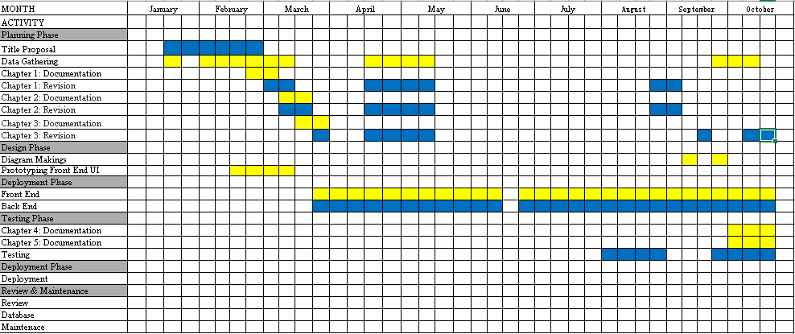

Table 2.0 Gantt Chart of Activities

Resources
Hardware

The proponents used the following hardware specifications to complete the project.
Hardware Components | Description
Random Access Memory (RAM) | 16GB 3200MHz or Higher
Central Processing Unit (CPU) | Intel Core i5 / AMD Ryzen 5 or higher
Connection | Stable Internet Connection
Peripherals | Monitor, Keyboard, and Mouse
Table 3.0 Hardware Resources

Software
Here are the key software requirements used in developing the proposed system.
Software Categories | Specific Software
Integrated Development Environment | Visual Studio Code
Front-end Web Development Tool | HTML, Tailwind CSS, React.js
Back-end Web Development Tool | Node.js, Express.js
Database Management Tool | MongoDB
Source Code Hosting | GitHub
Communication Tool | Messenger
Word Processing Software | Microsoft Word
Presentation Graphics Software | Microsoft PowerPoint
Internet Browser | Google Chrome
Prototyping Tool | Figma
Table 4.0 Software Resources

METHODOLOGY
The proponents employed a developmental research design for this study, which involved the systematic design, development, and evaluation of MAIKCRAFT, a web-based ordering and Point-of-Sale (POS) system with AI-based design customization for Maikens Gown and Barong. This approach is supported by Oh and Song (2021), who applied developmental research in developing and evaluating a software application through expert reviews and usability testing. To guide the system's development, the proponents shall use the AGILE Development Methodology for developing web-based system for Maikens Gown and Barong in Disenyo Pandi Wedding Depot located Grace Park Street, Bagong Barrio, Pandi, 3014 Bulacan. The selection of Agile Development Methodology is supported by related studies found by the proponents that demonstrates the use of iterative development, continuous refinement, and user feedback in developing software systems.
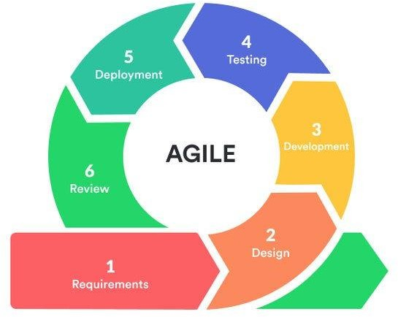

Figure 2.0 Agile Methodology
Planning
On January 29, the group was formed for the capstone project, members were then assigned to brainstorm three or more title proposals which will be evaluated by capstone adviser. On the first week of February, one title was approved and the group was assigned to further brainstorm title ideas which took place on February 2 to February 20. During February 21 to February 22, the proponents are focused on finalizing the titles for the upcoming title proposal scheduled on February 26, in which two titles where proposed. After proposing the titles, the panelists accepted the title for the boutique but assigns the proponents to find better beneficiary.
In the last week of February, the proponents searched for and interviewed potential beneficiaries who have operational needs and are willing to adopt the proposed system, which led to the boutique Maikens Gown & Barong becoming the project beneficiary. The proponents gathered necessary data from the owners who manage the boutique’s operations. After gathering data about the boutique’s history and their processes, the proponents analyzed the information to better understand and identify areas where the proposed system could help improve efficiency and organization, in which MaikCraft officially became the focus of the capstone project.
Design
In this phase, the proponents began designing and wire framing initial concepts to visualize the system's interface and functionality, in which the proponents uses Figma. This will serve as a visual guide that helps the proponents organized how users would interact with different components of the MaikCraft system.
Development
In this phase, when the system's design has been finalized through wire framing, the proponents proceed with the development phase, where the actual system will be constructed. Each sprint in this phase concentrates on developing particular MaikCraft system features. The developers worked together to ensure a seamless integration of front-end and back-end components utilizing tools like GitHub and Visual Studio Code for coding. Additionally, MongoDB is used by the developers to link the system to a database and manage the storage and retrieval of user data. The system is then prepared to proceed to the next stage.
Testing
In this phase, the developers make sure that MaikCraft works as intended. Reliability and usability tests will be conducted on each module including the admin dashboard, AI-Based Customization feature, and user registration. The system database and back-end will also be looked at to ensure that data is stored and retrieved correctly. The owners, staff, and a few chosen customers will be asked to test the system and provide feedback. This helps the proponents identify issues, improve usability and ensure that the system is efficient and user-friendly.
Deployment
In this phase, after the system is finished and the functionality is tested, the proponents proceeds to the deployment phase. The boutique will now be able to use MaikCraft and their customers will be able to purchase products using the system. The proponents ensure that the system functions smoothly and serves its purpose. After deployment, the proponents will monitor the system’s functions and take care of possible problems.
Review
After the deployment of the system, the proponents further monitor the system and will gather more feedback from the boutique. This is to check if there are any issues with the system that needs to be addressed and improved. The system will continuously be updated if there are any issues. This will help the proponents to determine if there are any new features that can be added to the system to improve system’s functionality for future updates.

Respondents of the Study
The respondents of the study include customers, the cashier, and the admin/owner of Maikens Gown and Barong, who participated in the User Acceptance Testing (UTA) of MAIKCRAFT. The study was primarily designed and specifically intended to evaluate whether the developed MAIKCRAFT system improves and supports the daily operations, ordering process, customer interactions, and inventory management of its primary beneficiary, Maikens Gown and Barong. However, to gather further additional feedback, the proponents decided to extend the evaluation to other boutique owners, and cashiers, based on their availability and willingness to participate on the MAIKCRAFT's User Acceptance Testing. Separate questionnaires were prepared for each user level to assess the system's features and functions that are relevant to their roles. Customer-facing features, such as product browsing, AI-based design customization, order placement, order tracking, and integrated messaging. The cashier questionnaire assessed functions related to transaction processing, order management, and inventory monitoring, while the admin/owner questionnaire focused on administrative and business management functions. This approach allowed each respondent group to evaluate the system based on the features relevant to their intended use.
In addition to the UAT respondents, IT experts participated in the software quality evaluation of MAIKCRAFT using the ISO/IEC 25010:2023 Software Quality Model. They were selected based on their relevant technical knowledge and qualifications to assess the system's software quality characteristics. Their evaluations were conducted separately from the UAT to distinguish the assessment of software quality by technical experts from the acceptance evaluation conducted by the intended system users.
Sampling Technique and Sample Size
The proponents employed convenience sampling, a non-probability sampling technique, to recruit participants for the User Acceptance Testing (UAT) of MAIKCRAFT. According to Ahmed (2024), convenience sampling involves selecting participants who are readily accessible to the researchers. This technique was appropriate for recruiting available and willing participants within the study's data-gathering period. A total of Sixty-four (64) respondents participated in the evaluations, consisting of Fifty (50) customers, One (1) cashier from our beneficiary, and Six (6) more from other boutiques and One (1) admin/owner from our beneficiary and Six (6) more from other boutiquesof Maikens Gown & Barong. The participation of personnel from other boutiques provided additional feedback from individuals with experience in similar business operations, while Maikens Gown and Barong remained the main focus and beneficiary of the study. A study conducted by Kupka-Klepsch et al. (2023), in which participants are recruited through convenience sampling for usability walkthroughs in conducting their evaluation of a digital software solution for documentation and training in home care, demonstrates the consistency of the use of convenience sampling. system users.
The sample size of Sixty-four (64) respondents for User Acceptance Testing (UAT) was considered based on the Central Limit Theorem (CLT), which explains the sampling distribution of sample means. According to The Pennsylvania State University (n.d.), a sample size greater than thirty (30) is commonly treated as a large sample for learning and applying the CLT under suitable statistical conditions. The proponents study exceeded the commonly benchmark by having Sixty-four respondents. The Sixty-four (64) size respondents were used to gather feedback on the system's features and acceptance, and their responses were summarized using frequency counts and weighted means.
Data Gathering Procedure
The proponents started conducting data gathering though interviews and documentations of beneficiary’s current operations, from cashier related tasks to administrative, as well as the necessary needs and issues that can be improved. The developing system is sometimes sent or shown to the beneficiary to gather their feedbacks and suggestions through goole meet and messenger.
The data gathered from the testing phase was conducted by the proponents by inviting an IT Industry Expert to evaluate the developed system based on the criteria of ISO/IEC 25010:2023 Software Quality Model. User Acceptance Testing (UAT) was also done by sending an electronic online survey to the respondents including the beneficiary’s customer, cashier, and admin.
Statistical Treatment of Data
According to Siang (2022), Statistic is used as a method to organize information and is utilized to have a more comprehensive understanding of the entire scenario of research. The response from the survey questionnaires in User Acceptance Testing will be interpreted using the 4 Point-Likert Scale.
Interpretation:
Mean Range | Interpretation
3.26 – 4.00 | Excellent  (Strongly Agree)
2.51 – 3.25 | Good  (Agree)
1.76 – 2.50 | Fair  (Disagree)
1.00 – 1.75 | Poor  (Strongly Disagree)
Table 5.0 Four Point Likert Scale Interpretation
Likert Scale
A Likert scale is a rating scale commonly used in questionnaires to measure respondents’ levels of agreement or disagreement with a set of statements. According to Siang (2022), the Likert scale can be used to evaluate aspects of a system, such as functionality, usability, reliability, maintainability, and security. In this study, a four-point Likert scale was used to assess the software quality and user acceptance of MAIKCRAFT, with each numerical value corresponding to a specific response option. The collected ratings were then analyzed using descriptive statistics to summarize the respondents’ evaluations of the system.
User Acceptance Testing:
$$WM=\frac{4f_{4}+3f_{3}+2f_{2}+1f_{1}}{N}$$
Where:
WM = Weighted Mean
$f_{4}$ = Frequency of responses rated 4
$f_{3}$ = Frequency of responses rated Agree (3)
$f_{2}$ = Frequency of responses rated Disagree (2)
$f_{1}$ = Frequency of responses rated Strongly Disagree (1)
N = Total Number of respondents

Requirements Analysis

Who - The proponents of the system are the Admin/Owner, Staff and Customers of Maikens Gown & Barong. The Admin/Owner takes care of managing products checking reports and controlling user accounts within the system. The Staff is in charge of processing orders updating inventory records and making sure all transactions are properly recorded. Customers are the users who will look at available products place orders and use the customization feature. Each user plays a role in making sure the system works well and meets business needs.

What - The system is a web-based ordering system with an AI Customization Tool feature for Maikens Gown & Barong. It is designed to improve order processing, inventory management and customer communication, and designin. The system lets customers see gowns and barongs in a digital catalog. It also lets users place orders online track their order status. Overall the system aims to provide a convenient, accurate and interactive ordering experience for Maikens Gown & Barong.

Where - The system will be used at Stall A18 Disenyo Pandi Wedding Depot located at Grace Park Street, Bagong Barrio, Pandi, Bulacan. This is where the Admin and Staff will manage the system operations. The platform can be accessed through internet-connected devices like desktop computers, laptops and mobile phones. Users can access the system using a web browser, making it easy to use. This setup lets both local and remote users interact with the system without any limitations for Maikens Gown & Barong.

When - The system will be used during boutique operations to support business activities. It will be used when customers ask about products, place orders, schedule fittings and check stock. Staff and Admin will regularly access the system to update data and manage transactions for Maikens Gown & Barong. Customers can use the proposed system at any time since it is online 24/7. This ensures service and improves accessibility for users at any time of the day for Maikens Gown & Barong.

How - The system will be used by customers through a web-based interface where they can look at products and select what they want. They will be able to design the gown or barong according to their preferences using AI Customization tools that generates designs. After selecting products customers can place orders. Check their order status through the system for Maikens Gown & Barong. The Admin and Staff will manage product listings orders and inventory through their assigned modules. This process ensures coordination between users and improves overall system efficiency, for Maikens Gown & Barong.

Requirements Documentation
The MAIKCRAFT system was conceptualized to resolve the problems encountered by Maikens Gown & Barong in catering to the demands of clients, managing the inventory, communicating with customers, and receiving and processing customized gown and barong orders. The system is an online platform that offers a central point for customers to access the boutique’s services, interact with it, make payments, and monitor the status of their orders. It also contains Point-of-Sale (POS) software for managing the boutique’s transactions and inventory. The requirements of the system were prioritized considering their significance, impact, and overall quality.
MAIKCRAFT will be used through a web application that requires an internet connection to access its features and manage the boutique’s operations. The system will be employed using desktops, laptops, and mobile devices with internet to ensure easier access as it will be designed using HTML, CSS, and JavaScript, React.js, Node.js, Express.js, and MongoDB. It will run on a computer with at least 16GB RAM and a core i5 or Ryzen 5 processor. Additionally, it will require peripheral devices for input and output of information.
The first key system requirement is the Point-of-Sale (POS) module. The module will be utilized not only for managing sales through cash but also for processing the transactions captured in the online platform. Information related to the sales, including details about the item sold, will be stored and later used to generate statistics and reports. With the POS component, the boutique can eliminate manual recording of sales transactions and the problems associated with it. As a result, the company will be in a position to minimize the chances of committing errors.
The second key system requirement is an AI-Based Customization Tool that will enable customers to personalize the gown or barong they intend to purchase using the boutique’s online platform. The tool will have design options that will allow clients to choose their preferred color, sleeve, and neckline styles as well as pattern and material among other features. They will also provide an option for clients to view the preview of their customization using the AI tool before they can place their order for the customized item. This will reduce miscommunication between the customers and the boutique, therefore, improving client satisfaction.
The system’s third key requirement is an Order Status Tracking feature that will help the boutique stay connected with its clients by keeping them informed about the progress of their order. The feature will be used to provide real-time data regarding the status of their order from when they place the request to the moment it is delivered to them. Other statuses include Order Received, Order Production, Ready for Pickup, and Ready for Delivery. This will reduce the need for clients to provide the reason for their inquiry or complaint since the status of their order will be visible. It will also play a significant role in enhancing the communication of the boutique with its customers.
The fourth key system requirement pertains to inventory monitoring and management. The system will have a component that will track and update the inventory of the boutique’s available sizes and stock of barongs and gowns. Data about the inventory will be updated automatically whenever a sale is made to reflect the current level. This will help the employees in ensuring they are meeting minimum stock levels for each size and style of the apparel, therefore, improving the boutique’s operations. The system will replace the physical record book currently used by the boutique to monitor its inventory.
Finally, the fifth key system requirement is a messaging tool that will be utilized to provide a communication channel between the boutique and its customers. The messaging tool component will be used alongside the email feature to enable clients to send feedback, inquiries, or complaints and receive the boutique’s response. Additionally, it will allow the staff to respond to the customers’ concerns, which will result in improved client relations. It is a better option compared to having the boutique’s social media accounts respond to the customers’ concerns.

Design of Software, System, Product, and/or Processes
The design stage of the project was focused on translating the identified requirements into a design that will be used as a guide in developing the MAIKCRAFT system. These designs involve interfaces and functions that are meant for the Customer, Cashier, and Admin/Owner levels, which were established to support the various activities within the proposed system.
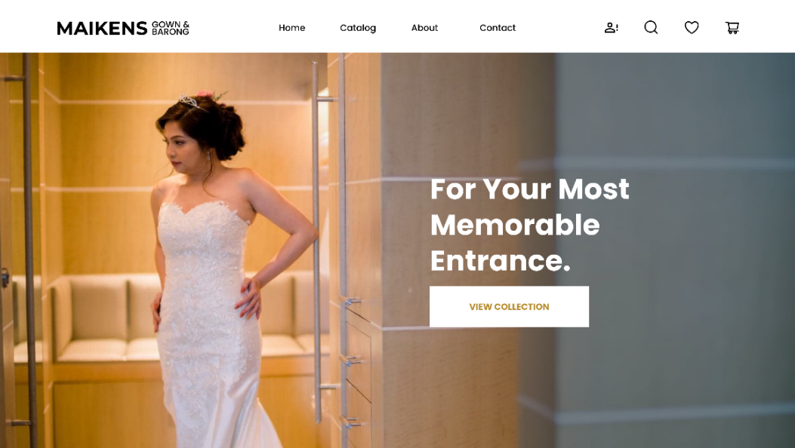

Figure 3.0 User/Customer Level
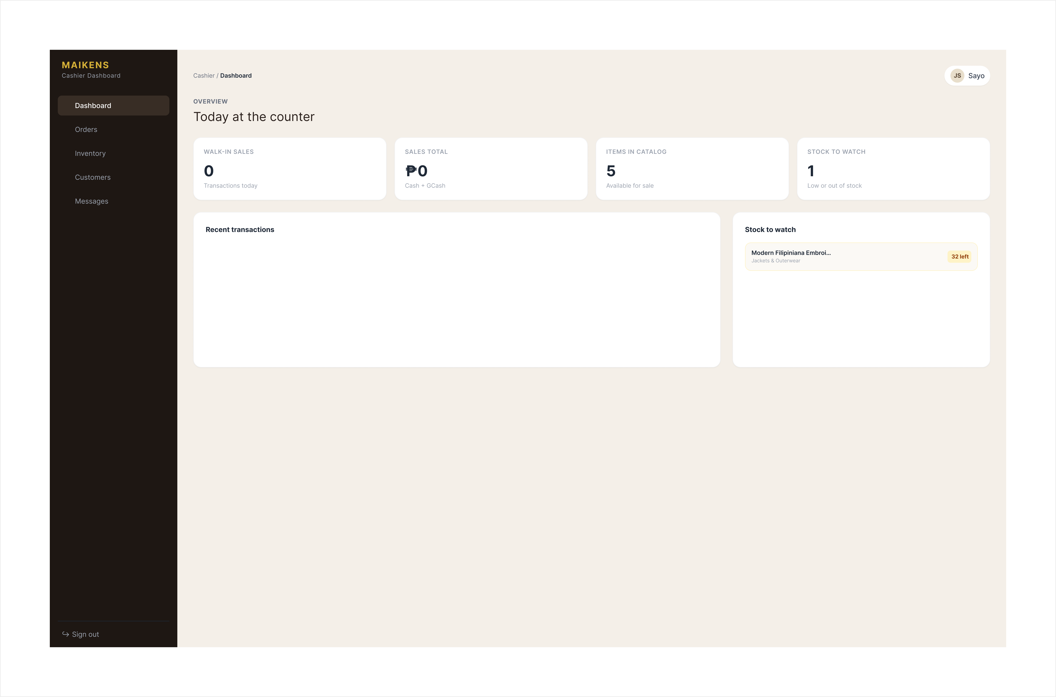
Figure 4.0 Cashier Level
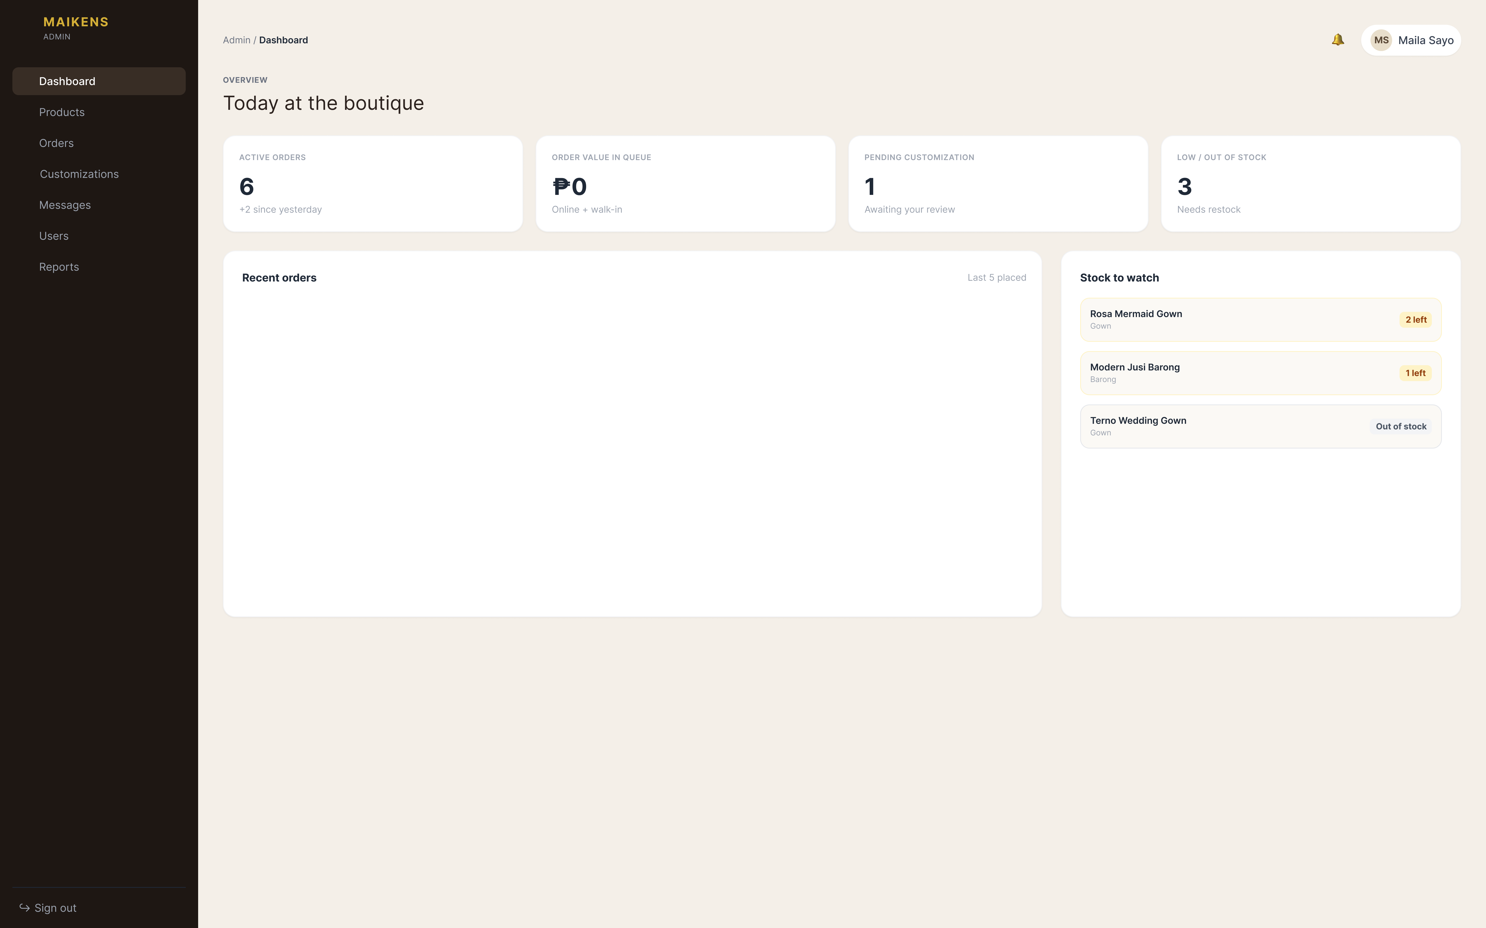
Figure 5.0 Admin Level

Customer Level: The customer level design displays interface that is indented for customers when accessing the MAIKCRAFT system. This design provides access to product catalog, ordering functions, AI-Based Customization tool, order tracking, and messaging tool. This interface was organized to allow customer to browse products, customize designs based on their preferences, place order, and monitor transactions. The design also prioritized the ease of navigation that provides customer with clear and organized way of interacting with the system.
Cashier Level: The Cashier level design displays interface that is indented for cashier member that is responsible for assisting with transaction and managing in-store customer orders. This design provides access to functions that are related to order management, transaction processing, order status updates, inventory monitoring, and customer communication. This interface was organized for operational tasks and provide cahier with access to the information that are needed to process and monitor transactions. The ease of use was also considered in designing the interface.
Admin/Owner Level: The Admin/Owner level design displays interface that is indented for administrator or owner Maikens Gown and Barong. This design provides access to functions that manages product listings, account management, online transactions and orders, and inventory. This interface was organized to provide overview of the system's operational activities and support monitoring and management of business transaction.
These interface was initially designed using Figma to established visual structure, navigation, and arrangements of the system before the development. These designs follow layout that are consistent that support usability across different user levels. These designs served as the visual reference for the subsequent development of the MAIKCRAFT system.
React.js and Tailwind CSS were used to developed an actual user interface that is organized to support navigation and usability across the different user levels. The frontend design follows the established layouts and visual structure that provides users the access to system's features and functions. Node.js and Express.js were also used for backend, which handles server-side processes, while MongoDB is used for storing and retrieving system data. RESTful APIs were also utilized to facilitate communication between the frontend and backend, enabling data exchanged between various system components. These technologies work together to support the implementation of MAIKCRAFT's web-based ordering and POS functions, AI-based design customization, order tracking, inventory monitoring, and integrated messaging.

Development
The development of the MAIKCRAFT: Web-Based Ordering and POS System with AI-Based Design Customization for Maikens Gown and Barong was conducted adhering to software engineering standards and the Agile methodology to ensure quality, efficiency, and flexibility throughout the entire project. The team divided the project into multiple sprints, each of which was focused on a specific module such as messaging integration, AI based customization, POS, product management and user authentication. That way, the developers could keep on testing and improving each feature, before they put them all together in the main system.
The development was set using Visual Studio Code as the main code editor of our programmer and GitHub for version control and teamwork, the development phase was first set up. React.js and Tailwind CSS were used for the front-end to create a responsive design, a clean user interface, and reusable components.Node.js and Express.js were employed for the back-end to manage the communication between the database and the user interface, as well as to implement server-side logic.
The MongoDB database was chosen to stores user accounts, product details, transaction history, custom design details, and chat logs. In order to effectively manage data with following the security guidelines of the database to ensure data integrity and protect sensitive data, Create, Read, Update, Delete (CRUD) operations were implemented. The primary digital transaction channel, GCash integration, was implemented in this phase, along with secure authentication protocols to ensure data security and compliance.
To further boost customer engagement and visualization of designs, developers eencapsulated an AI-based customization module and vvirtual try-on with AI image generation. Users can merge design elements and submit an sketches to visualize custom gowns and barongs before placing an order. A real-time messaging tool was also added to enable direct communication between the client and the shop manager for details on custom fitting, order inquiries and design changes. The POS system was designed to pprogrammatically to records sales from walk in and online orders with inventory records to provide real-time accuracy on stocks level updates.
Testing was performed regularly after each developing part to verify that all modules met qualifications, specifications, and functioned as intended. Unit tests, integration testings, and tests by actual users were conducted with boutique owners, employees, and selected customers to detect and fix bug in the system and ensure its stability and reliability. After of completing of testing, the project proceeded to deployment, launching the application into a cloud environment for optimal availability and scalable performance.
During the team development, the developers continuous maintained the technical documentation, adhered to clean code practices, and utilize modern web design standards including responsive web layouts, data privacy, and component-based architecture. The collaboration between team members and adherence to Agile methodology enabled effective development and delivery of the product according to the specified requirements for Maikens Gown & Barong.

RESULTS AND DISCUSSION

Testing
The testing phase of the Maikcraft: The Development of A Web-Based Ordering and Pos System with AI-Based Design Customization for Maikens Gown And Barong was conducted to ensure that the system works properly, achieves its goals, and adheres to the software standards. Two main testing approaches were used: the Test Case Scenario and the IT Specialist Evaluation. These tests were designed to identify errors, verify system reliability, and evaluate performance and usability from both technical and user perspectives.
The project developers carried out the Test Case Scenario, with the goal of verifying that each module of the system behaved as expected. Each component at the User, Admin, and Staff levels was tested separately using predefined test cases. Each test case contained a specific function, expected output, actual output, and a corresponding result indicating whether the function passed or failed.
The testing included user authentication, product management, cart and checkout, order tracking, and the AI-powered virtual try-on feature. The goal was to ensure that all modules interacted seamlessly and provided a smooth user experience without any system errors or failures. Bugs discovered during this phase were fixed before the final evaluation.
Module Level | Total Test Case | Passed | Failed | Pass Rate (%)
User Level | 57 | 56 | 1 | 98.25
Admin Level | 33 | 33 | 0 | 100
Cashier Level | 21 | 20 | 1 | 95.24
Average | 111 | 109 | 2 | 98.19
Table 6.0 Test Case Scenarios Summary
The results demonstrated that the majority of core modules worked as expected, securing a 98.19% overall pass rate. Failed tests were limited and rectified immediately after testing, ensuring that the system was stable, reliable, and ready for IT evaluation.
To ensure the software’s quality from technical and design perspectives, three IT specialists were invited to assess the platform using the IT Specialist System Evaluation Form. The evaluation criteria were based on Functional Suitability, Performance Efficiency, Compatibility, Interaction Capability, Reliability, Security, Maintainability, Flexibility, and Documentation and technical Knowledge.
The evaluators were asked to assess the system according to technical standards, performance efficiency, and user experience quality. They also provided written feedback highlighting both strengths and areas for improvement.

Criteria | IT 1 | IT 2 | IT 3 | Average | Interpretation
Functional Suitability | 4.00 | 4.00 | 3.33 | 3.77 | Excellent
Performance Efficiency | 3.33 | 3.66 | 3.66 | 3.55 | Excellent
Compatibility | 3.50 | 4.00 | 3.00 | 3.50 | Excellent
Interaction Capability | 4.00 | 3.8 | 4.00 | 3.93 | Excellent
Reliability | 2.33 | 3.66 | 3.33 | 3.11 | Good
Security | 4.00 | 3.85 | 3.86 | 3.90 | Excellent
Maintainability | 3.00 | 4.00 | 4.00 | 3.66 | Excellent
Flexibility | 4.00 | 4.00 | 3.66 | 3.88 | Excellent
Documentation and Technical Knowledge | 2.50 | 4.00 | 4.00 | 3.50 | Excellent
Overall Mean | 3.41 | 3.88 | 3.65 | 3.64 | Excellent
Table 7.0 IT Specialist Evaluation Summary
The IT Specialists rated the system with an overall mean of 3.64 (out of 4.0), interpreted as Very Good, indicating that the system meets IT standards and performs well across all evaluated categories. The experts highlighted the system's strengths in design, functionality, intuitiveness, clarity, and completeness, while suggesting enhancements mainly focused on the implementation of standard HTTP status codes (such as 403 Forbidden Access), proper source code documentation and version control utilization, and the future expansion of the platform into a dedicated cross-platform mobile application for Android and iOS.
Following the technical evaluation conducted by IT experts using the ISO 25010 software quality model, to assess the system's acceptability from the perspectives of its intended users, User Acceptance Testing (UAT) was conducted by the proponents. Separate acceptance testing surveys were distributed to boutique customers, cashiers, and admin/owners. A total of 64 respondents participated in the evaluation, consisting of 50 customers, 7 cashiers, and 7 administrators/owners.
The responses were evaluated by using a four-point Likert scale. The weighted mean for each statement was computed by multiplying the frequency of responses for each rating by its corresponding numerical value, adding the products, and dividing the sum by the total number of respondents for the respective user group.
Statement | 4 | 3 | 2 | 1 | Weighted  Mean | Interpretation
1. The system makes it easy to browse available gowns and barongs. | 35 | 15 | 0 | 0 | 3.70 | Excellent
2. The product information helps me understand the available items. | 33 | 17 | 0 | 0 | 3.66 | Excellent
3. The AI-based customization tool helps me visualize my preferred gown or barong design more effectively and quickly. | 27 | 21 | 2 | 0 | 3.50 | Excellent
4. The system makes it easy to place an order. | 38 | 12 | 0 | 0 | 3.76 | Excellent
5. The system provides clear information about my order status, reducing the need for follow-ups. | 36 | 14 | 0 | 0 | 3.72 | Excellent
6. The integrated messaging feature makes it easier to communicate with the boutique. | 34 | 16 | 0 | 0 | 3.68 | Excellent
7. The system is easy to understand and navigate. | 32 | 17 | 1 | 0 | 3.62 | Excellent
8. Overall, the system meets my needs as a customer. | 35 | 15 | 0 | 0 | 3.70 | Excellent
Overall Weighted  Mean |  |  |  |  | 3.67 | Excellent
Table 8.0 Customer Acceptance Testing Summary
Table 7.0 presents the results of the Customer Acceptance Testing Survey, which obtain an overall weighted mean of 3.67, which can be interpreted as Excellent (Strongly Agree). The statement "The system makes it easy to place an order" became the highest rated statement with the weighted mean of 3.76, while the statement for AI-Based customization tool received a weighted mean of 3.50, which was still interpreted as Excellent (Strongly Agree) despite being the lowest among the statements. All the results for each statements are interpreted as Excellent or Strongly Agree. These findings significantly support the intended objectives and features, particularly the ordering process, AI Customization Tool, order tracking, and integrated messaging feature. Additionally, respondent feedback suggested minor improvements such as adding more products to the catalog and refining the user interface and layout designs.
Statement | 4 | 3 | 2 | 1 | Weighted  Mean | Interpretation
1. The system makes it easy to process walk-in customer orders and record customer details. | 5 | 2 | 0 | 0 | 3.71 | Excellent
2. The system accurately calculates transaction totals. | 4 | 2 | 1 | 0 | 3.14 | Excellent
3. The system automatically updates product stock after a walk-in order is processed. | 4 | 3 | 0 | 0 | 3.57 | Excellent
4. The system makes it easy to generate receipts for completed transactions. | 5 | 2 | 0 | 0 | 3.71 | Excellent
5. The system automatically records completed transactions for tracking and reporting purposes. | 6 | 1 | 0 | 0 | 3.86 | Excellent
6. The system makes it easy to search and view the order history of online and walk-in transactions. | 6 | 1 | 0 | 0 | 3.86 | Excellent
7. The system makes it easy to accurately monitor stock quantities and identify products with high or low stock levels. | 5 | 2 | 0 | 0 | 3.71 | Excellent
8. Overall, the system helps me perform my cashier tasks efficiently. | 6 | 1 | 0 | 0 | 3.86 | Excellent
Overall Weighted  Mean |  |  |  |  | 3.68 | Excellent
Table 9.0 Cashier Acceptance Testing Summary
Table 8.0 presents the results of the Cashier Acceptance Testing Survey, which obtain an overall weighted mean of 3.68, which can be interpreted as Excellent (Strongly Agree). The highest rated statements that concern recording completed transactions, searching and viewing order history, and overall task efficiency received the highest weighted mean of 3.86. Meanwhile, statements concerning processing walk-in customer orders, generating receipts, and accurately monitoring stock quantities received a weighted mean of 3.71, while updating product stock automatically received a weighted mean of 3.57, and calculating transaction totals received a weighted mean of 3.14. All the results for each statement are interpreted as Excellent or Strongly Agree. These findings significantly support the intended objectives and features for cashiers, particularly in transaction processing, recordkeeping, and inventory monitoring.
Statement | 4 | 3 | 2 | 1 | Weighted  Mean | Interpretation
1. The system makes it easy to manage user accounts. | 5 | 2 | 0 | 0 | 3.71 | Excellent
2. The system makes it easy to add, update, and manage gown and barong product information. | 6 | 1 | 0 | 0 | 3.86 | Excellent
3. The system makes it easy to view and manage customer orders. | 6 | 1 | 0 | 0 | 3.86 | Excellent
4. The system makes it easy to review and manage customer customization requests. | 6 | 1 | 0 | 0 | 3.86 | Excellent
5. The system makes it easy to update and monitor order statuses. | 5 | 2 | 0 | 0 | 3.71 | Excellent
6. The system makes it easy to communicate with customers regarding their orders and inquiries. | 6 | 1 | 0 | 0 | 3.86 | Excellent
7. The system makes it easy to access sales and transaction reports. | 5 | 2 | 0 | 0 | 3.71 | Excellent
8. Overall, the system helps me manage the boutique's operations efficiently. | 4 | 3 | 0 | 0 | 3.57 | Excellent
Overall Weighted  Mean |  |  |  |  | 3.77 | Excellent
Table 10.0 Admin/Owner Acceptance Testing Summary
Table 8.0 presents the results of the Admin/Owner Acceptance Testing Survey, which obtained an overall weighted mean of 3.77, interpreted as Excellent. The statements that concerns about product management, customer order management, customization requests, and customer communication received the highest weighted means of 3.86. In comparison, other statements about updating and monitoring order status, account management, and accessing sales and transaction reports received the weighted means of 3.71, while the lowest rated statement "Overall, the system meets my needs as a customer." received the weighted mean of 3.57. All the results for each statements are interpreted as Excellent or Strongly Agree. The results significantly support the intended objectives and features for administrative operations, particularly the product management, order handling, and customer communication.

Description of Prototype
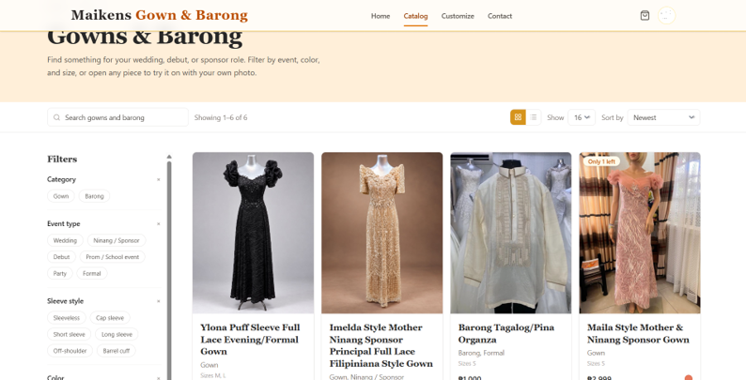

Figure 6.0 Customer Product Catalog
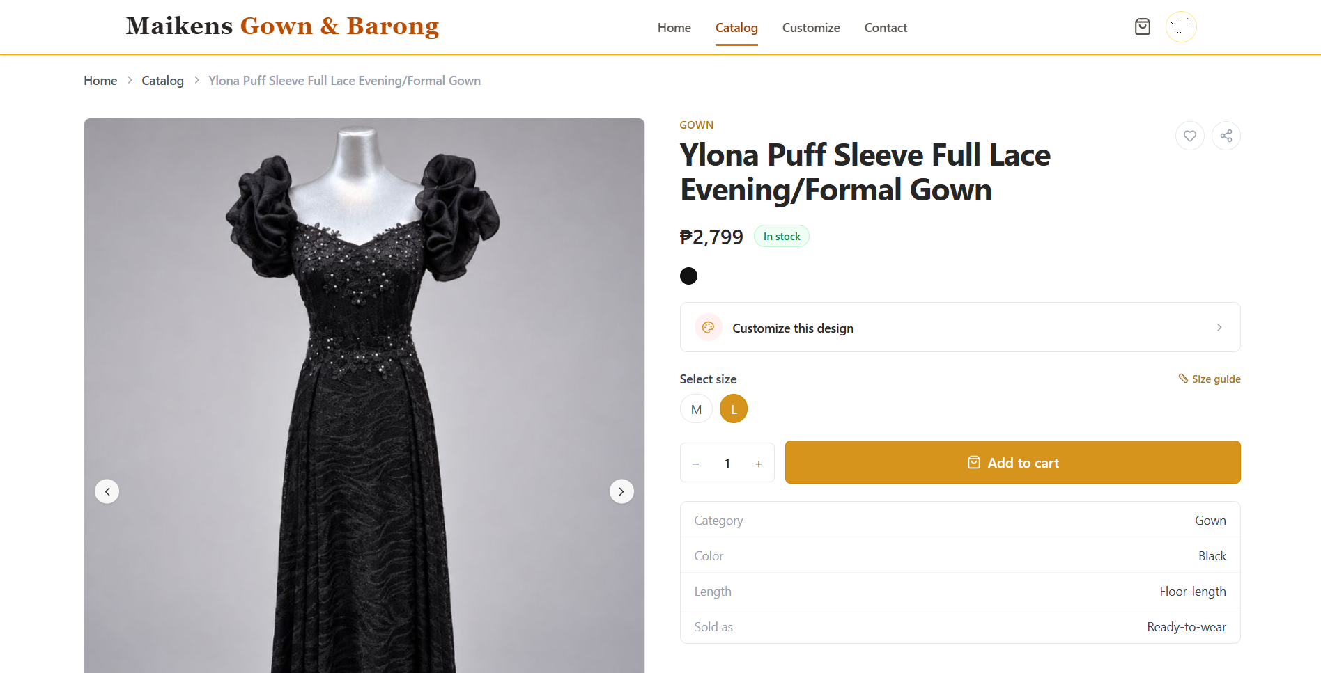
The product catalog displays variety of available ready to wear gowns and barongs that are organized by categories. Users are allowed to apply filters to easily find what they are looking for. Image, product name, and price are displayed for each product card for quick and clear browsing.
Figure 7.0 Product Detailed Page
The product Detailed page displays information about a selected product such as available size, fabric descriptions, and pricing. These images can be viewed by customers before proceeding to customization or adding it to their cart.
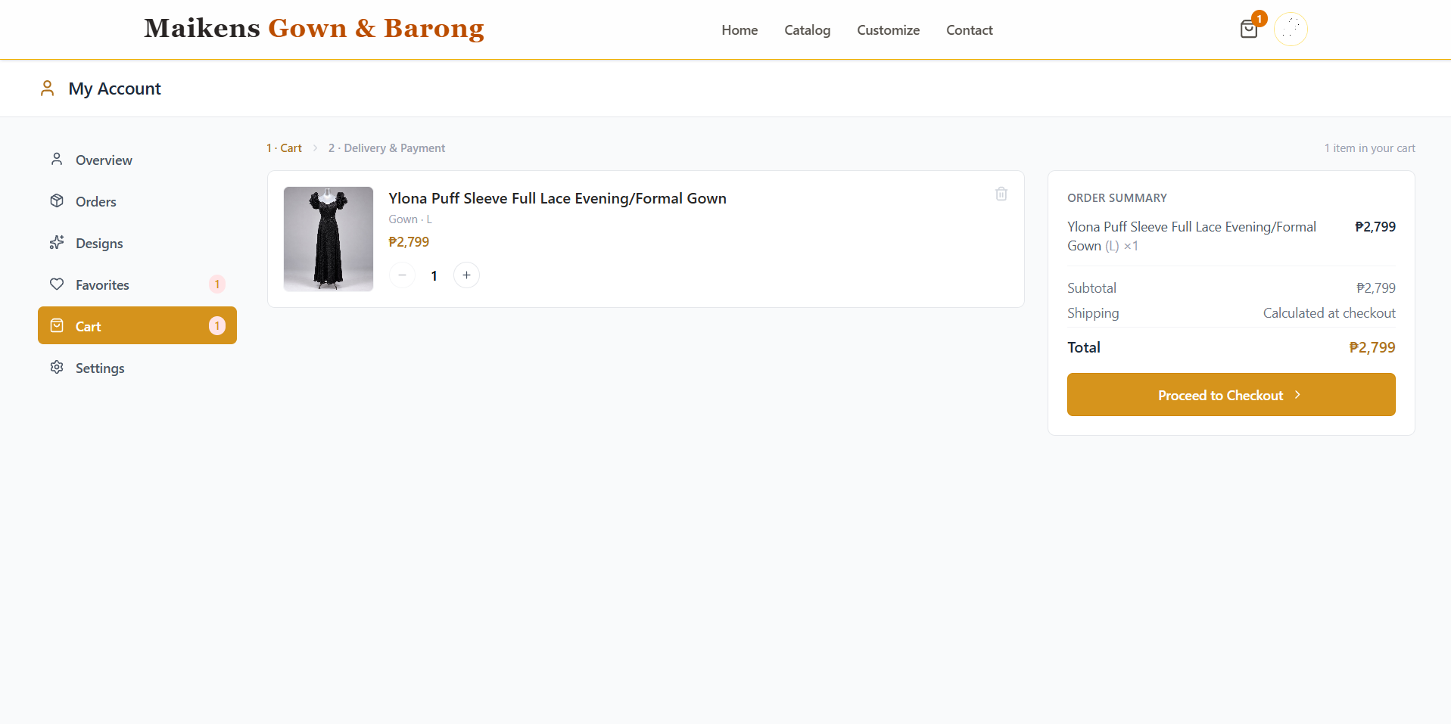
Figure 8.0 Cart Page
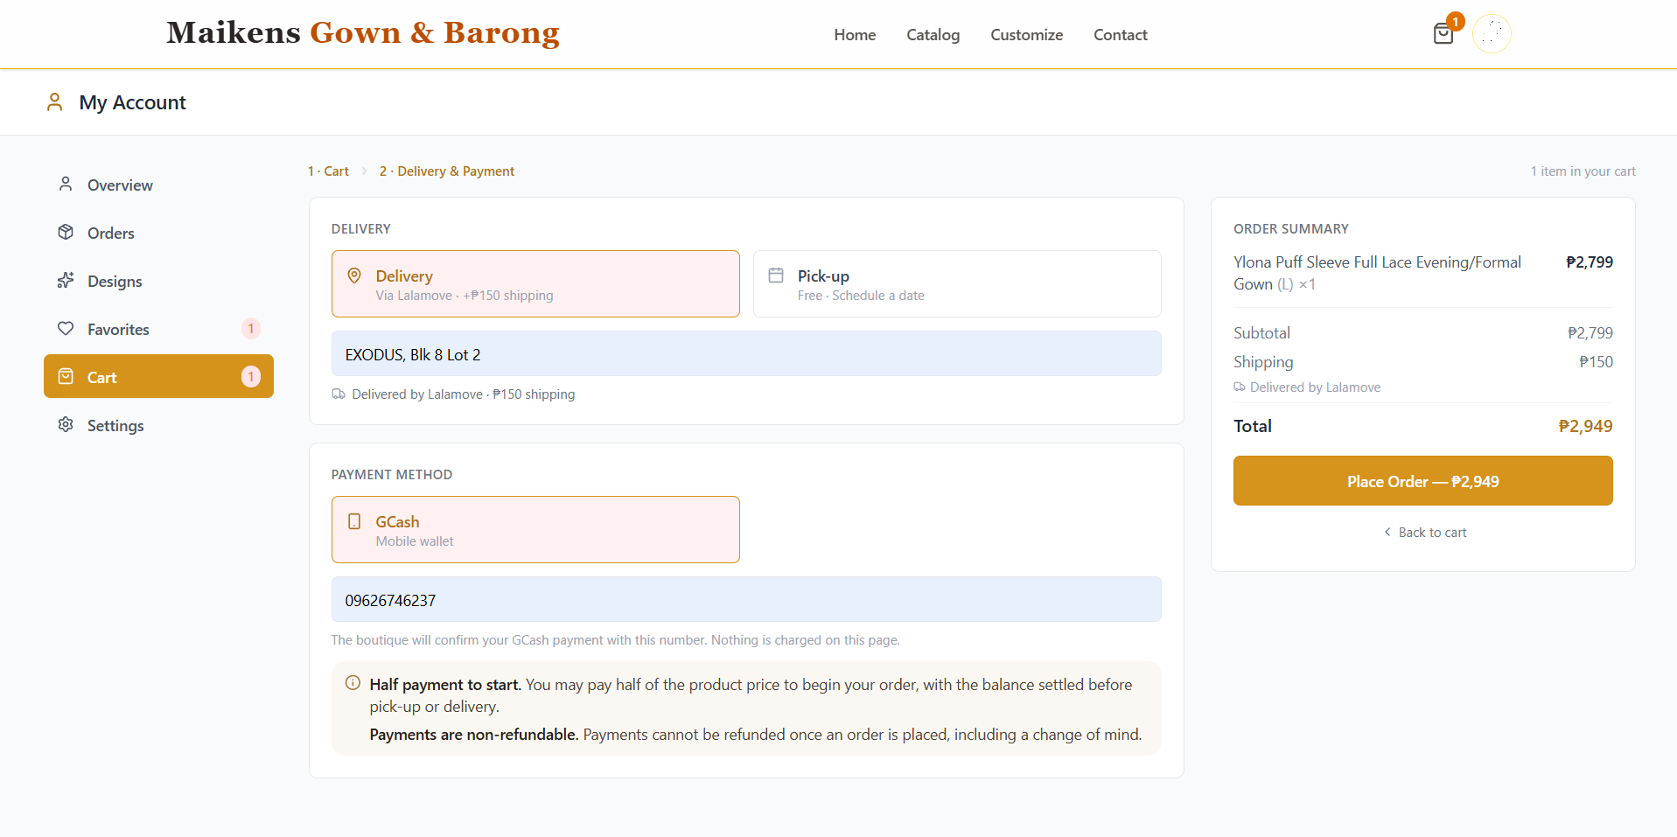
The cart page enables customers to review, adjust quantities, or remove products before proceeding to checkout by providing clear and organized summary of selected and added items.
Figure 9.0 Checkout Module
The checkout module allows users to finalize orders, input their shipping details or pick up schedule, and select their preferred payment method, such as GCash.

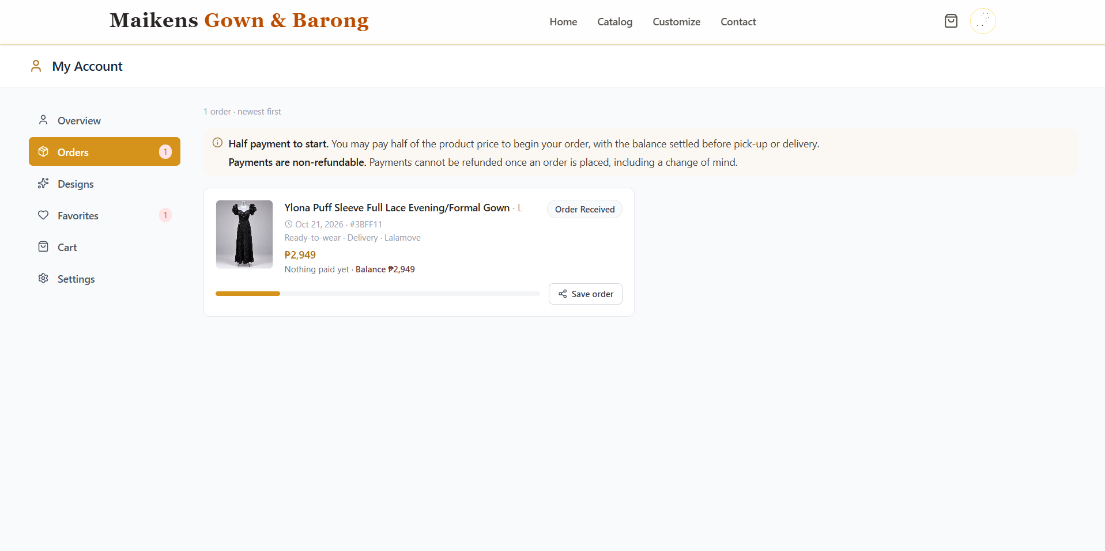
Figure 10.0 Order Detail and Status
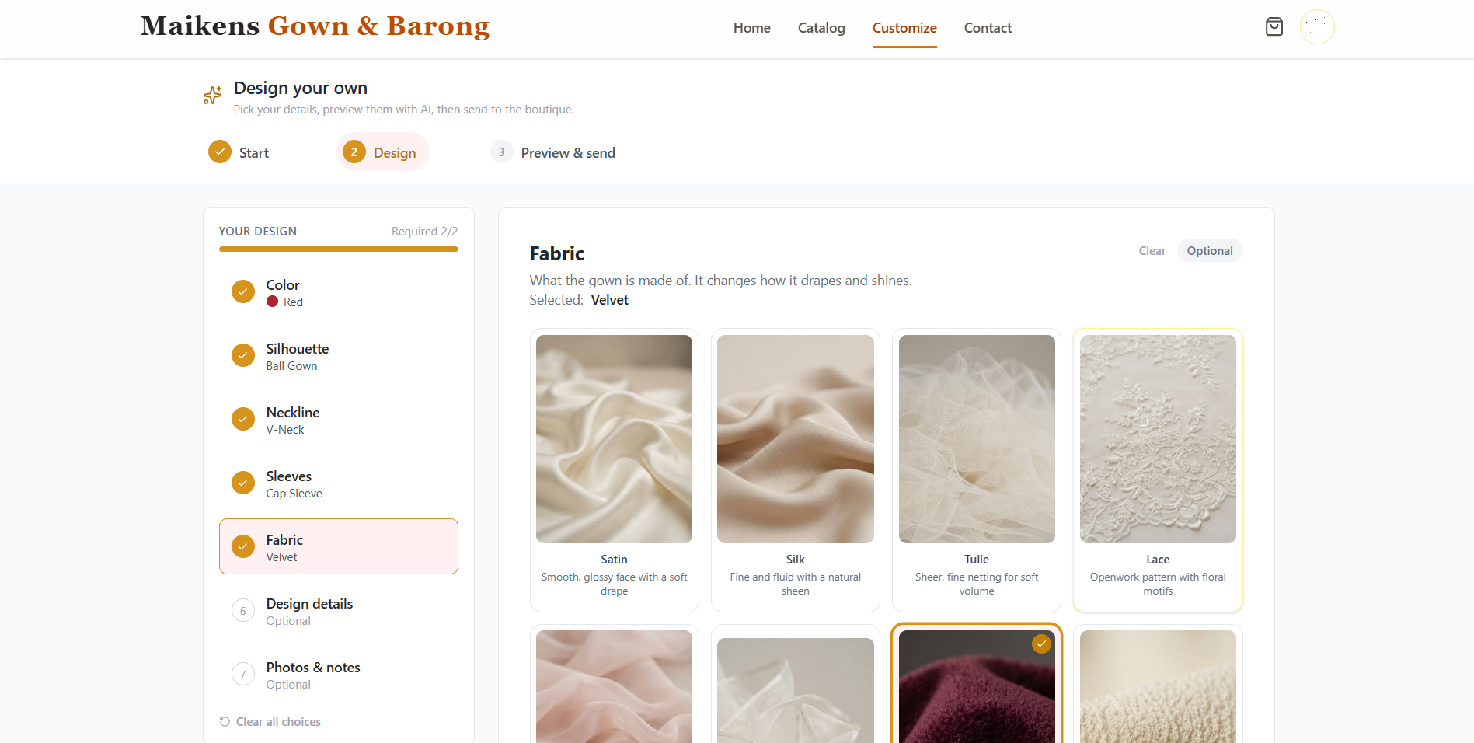
The order details and status page allow customers to monitor the progress of their purchases, which includes In-Production stage and Ready for Pick-Up or Delivery.
Figure 11.0 AI Customization Tool
The AI Customization Tool enables customers to customize product based on their preferred designs by selecting on the pre-defined styles including color, sleeve types, and silhouette, either from scratch or modifying an existing design.

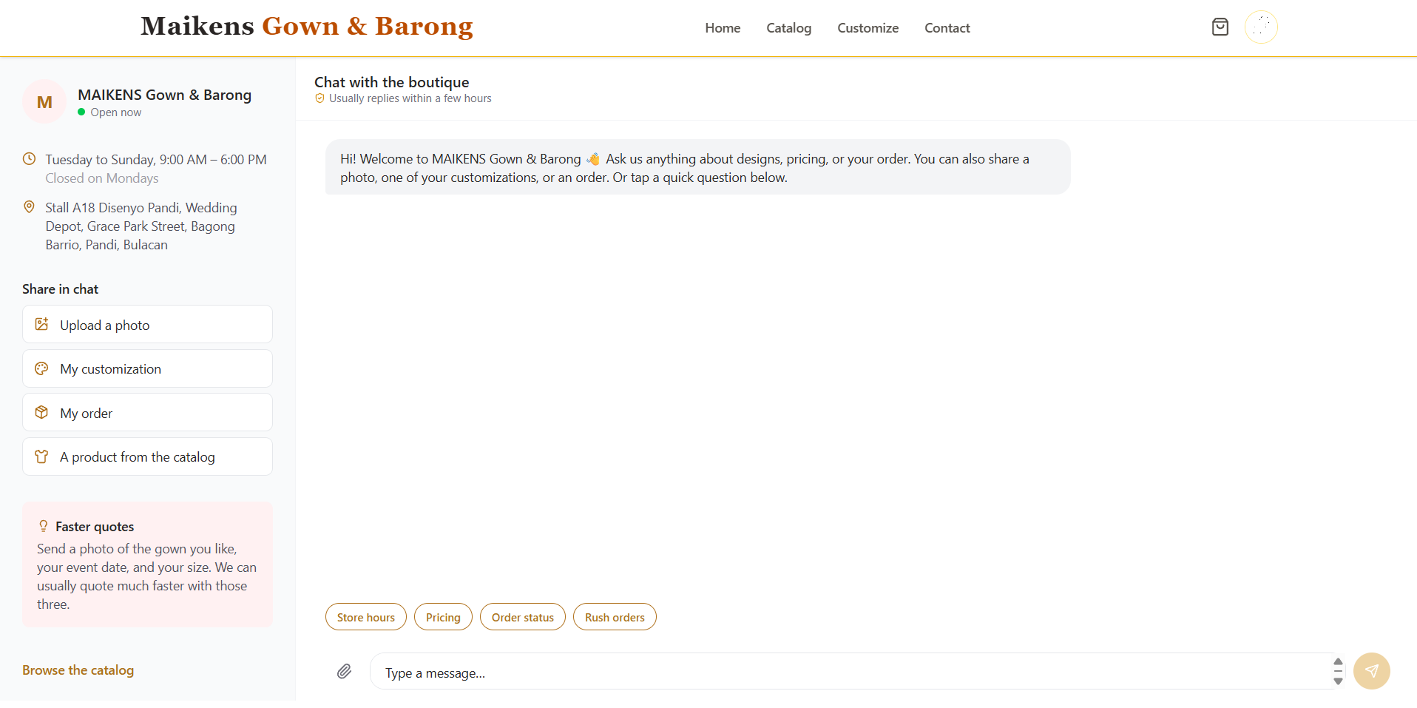
Figure 12.0 Messaging Tool
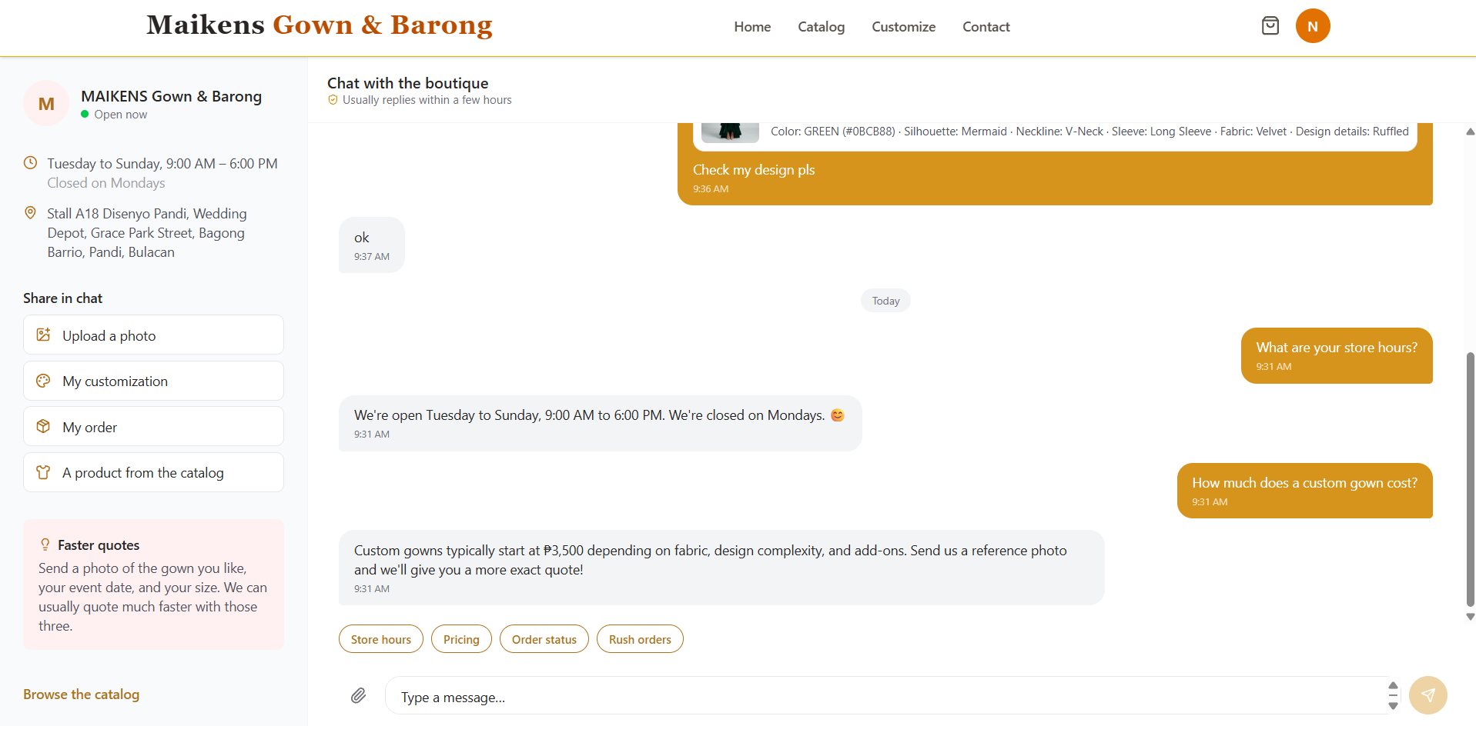
The Messaging Tool provides direct communication channel between the customer and boutique. Basic inquiries like store hours are also automatically answered.
Figure 13.0 Virtual Try-On
The Virtual Try-On feature allows customers to upload a full-body photo to preview how selected gown or designs look on them.

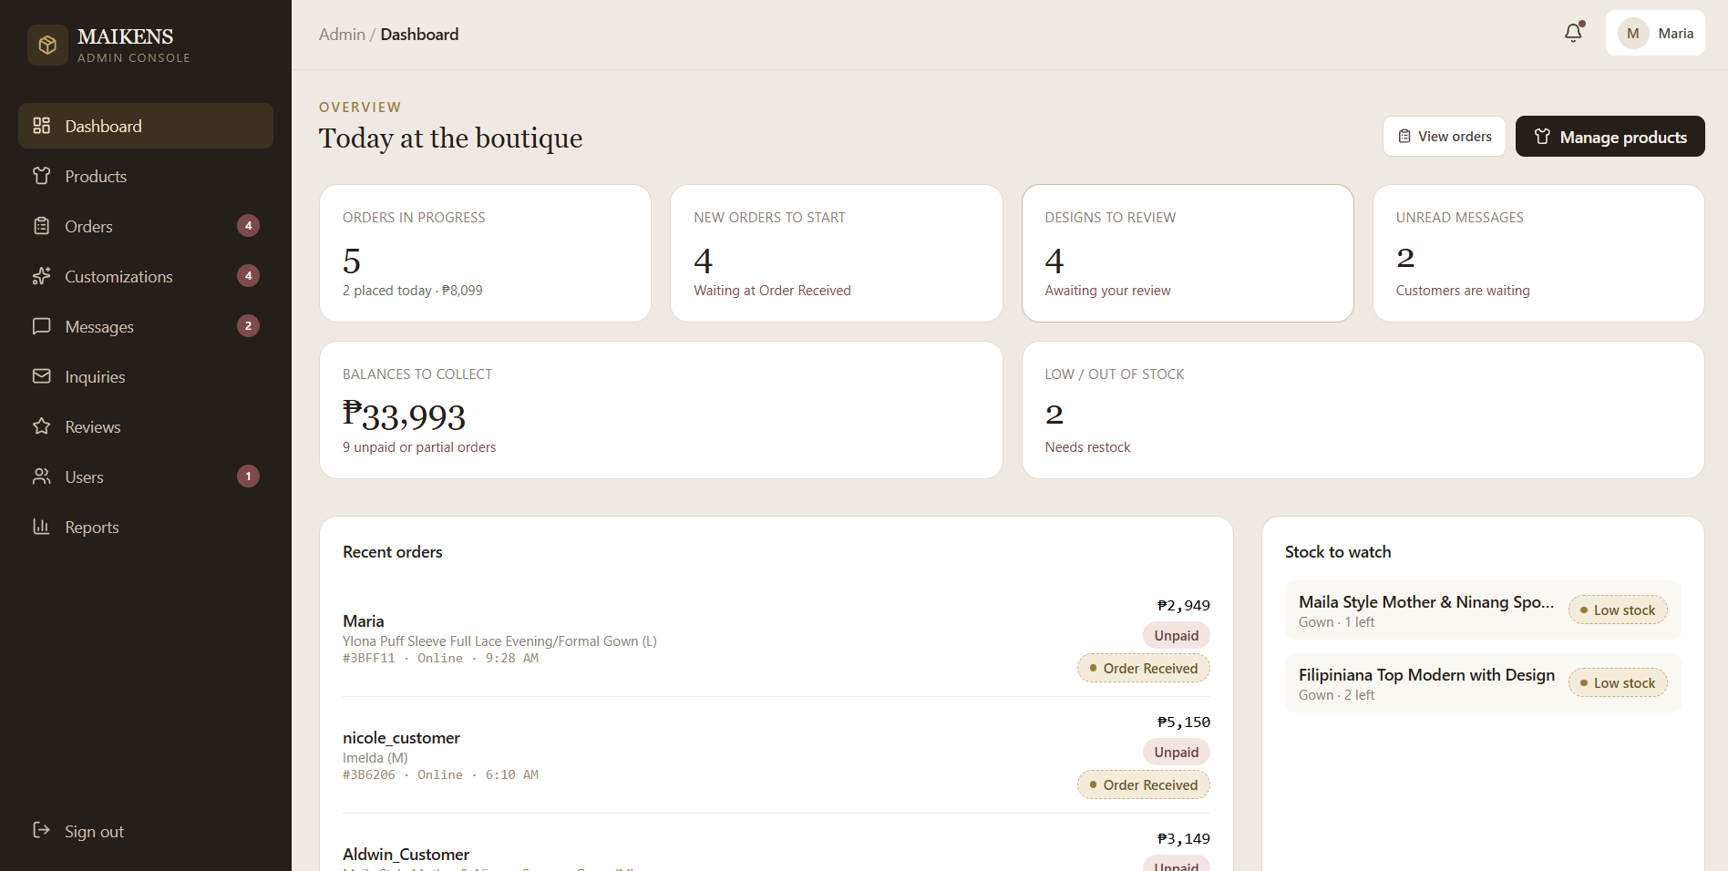
Figure 14.0 Admin Dashboard
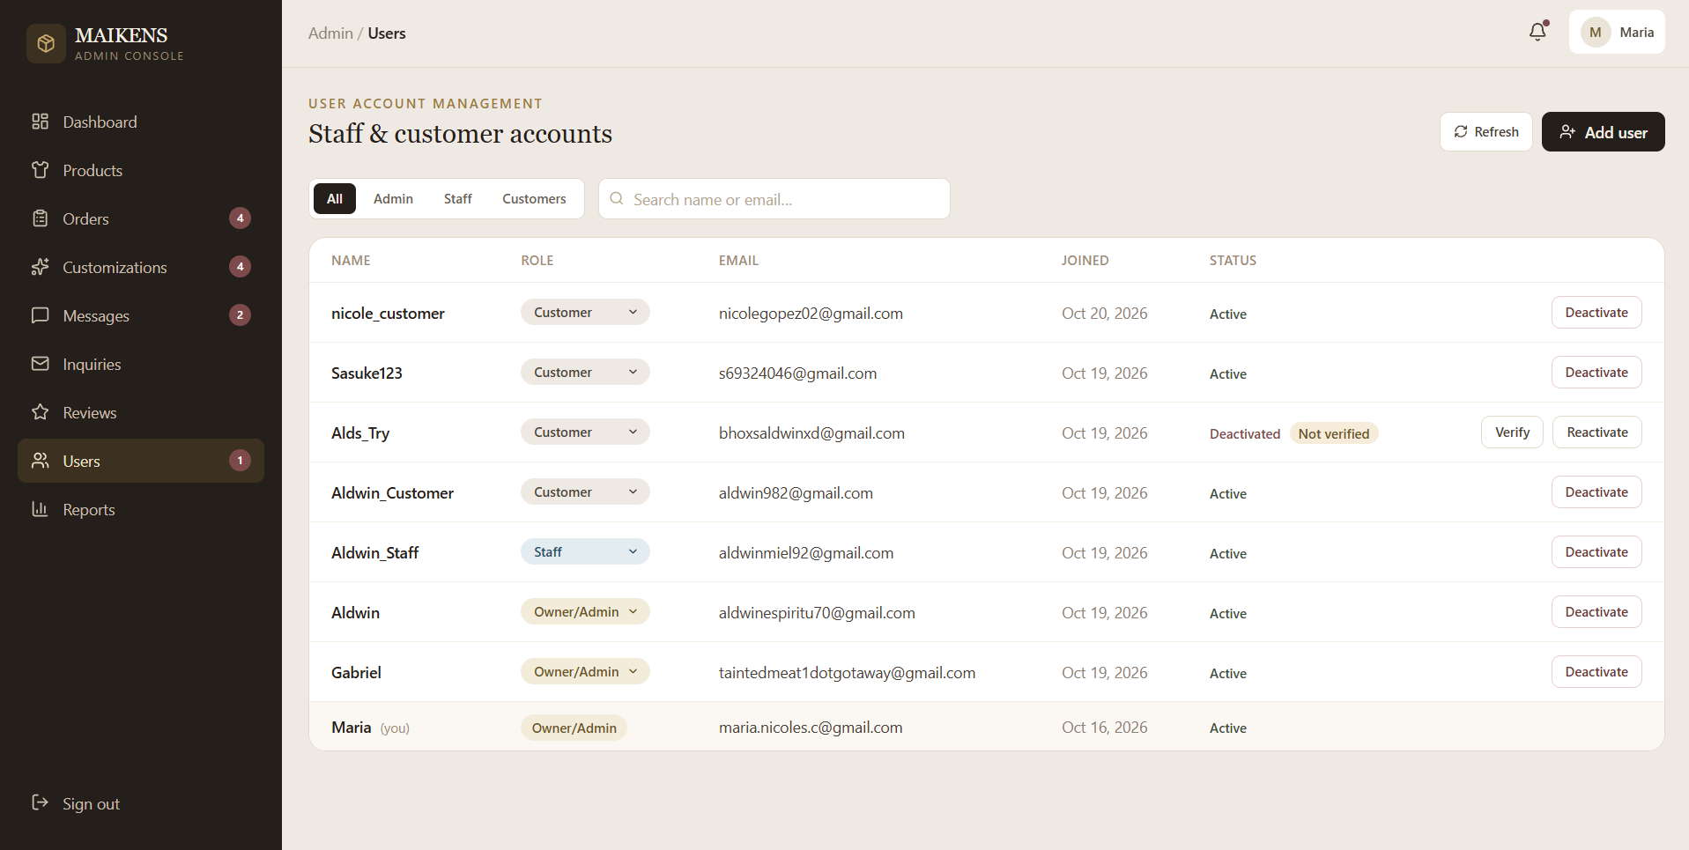
The Admin Dashboard provides overview of the daily operations of the boutique. The total sales, active orders, and inventory status are also displayed in this page. It is easy to use and comprehensive.
Figure 15.0 User Account Management
The User Account Management page enables the admin to oversee, create, and manage accounts for staff members and system users. It enables proper role-based access control and security across the platform.

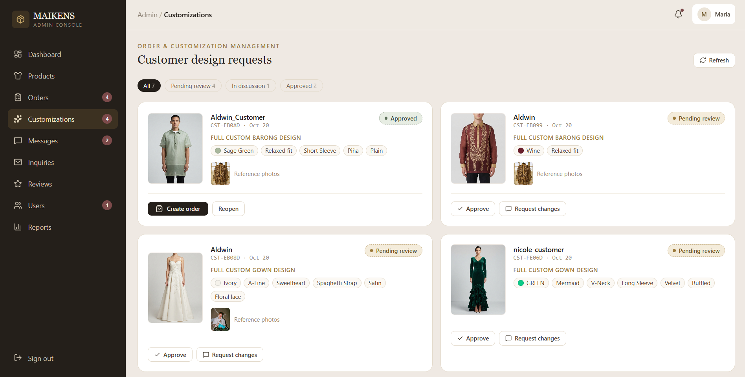

Figure 16.0 Order Customization Design Management
The order customization management allows the admin to review and evaluate the submitted customized request of the customers, and either approve or decline them. It ensures that personal specifications from customers are verified before the production begins.
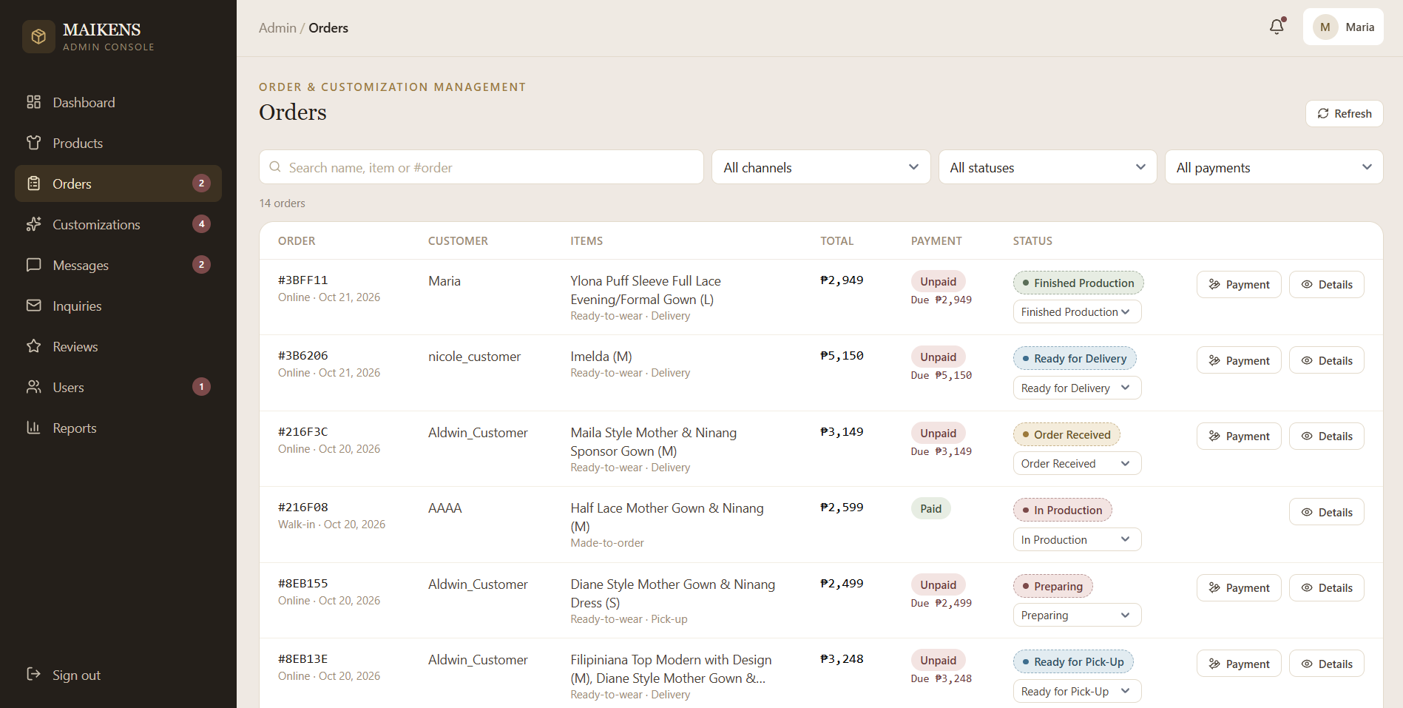

Figure 17.0 Order Status Update
The order status update page allows the admin to update the customers about the status of their orders, such as moving them from production stage to ready for pickup.

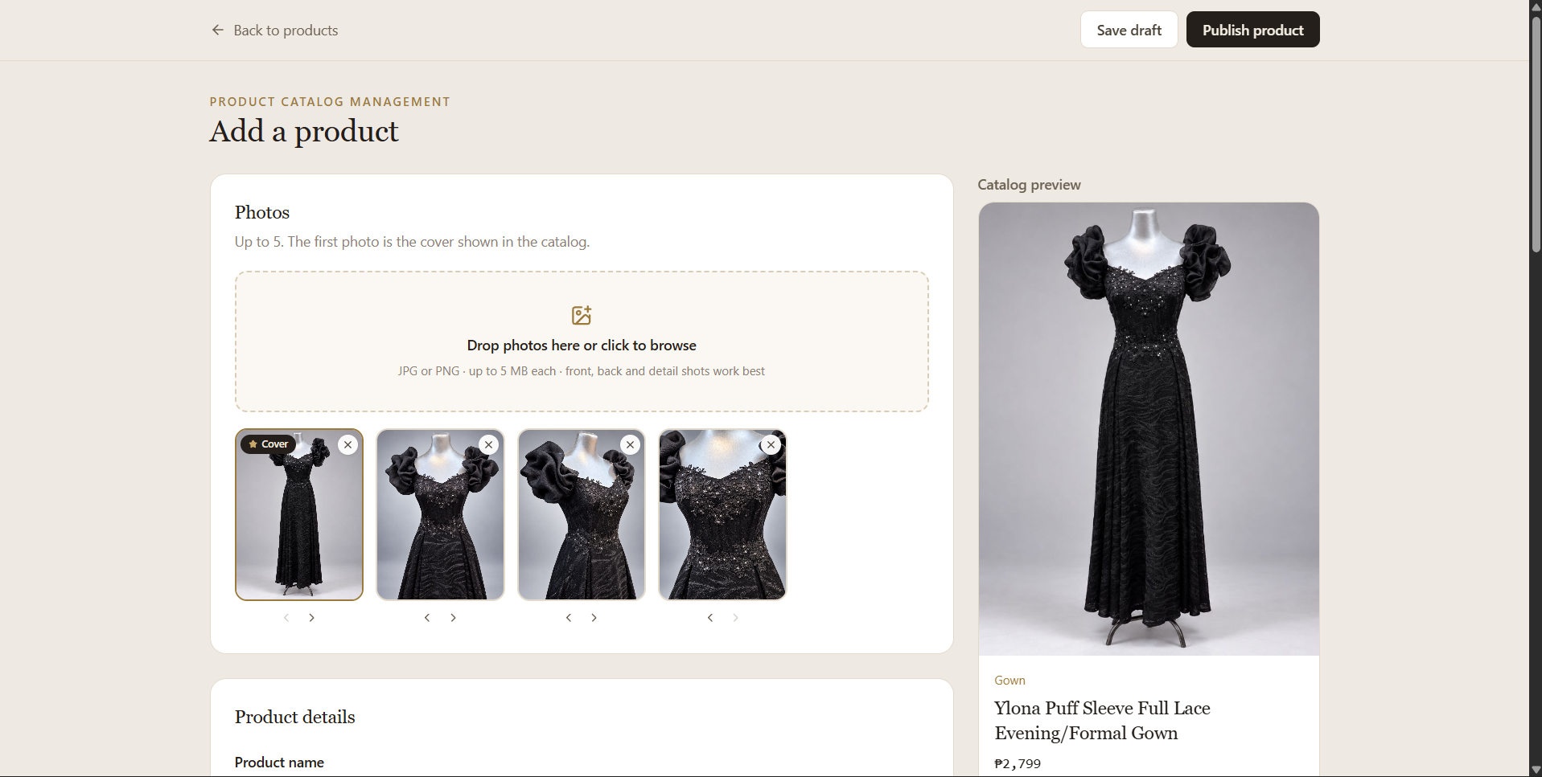
Figure 18.0 Add Product
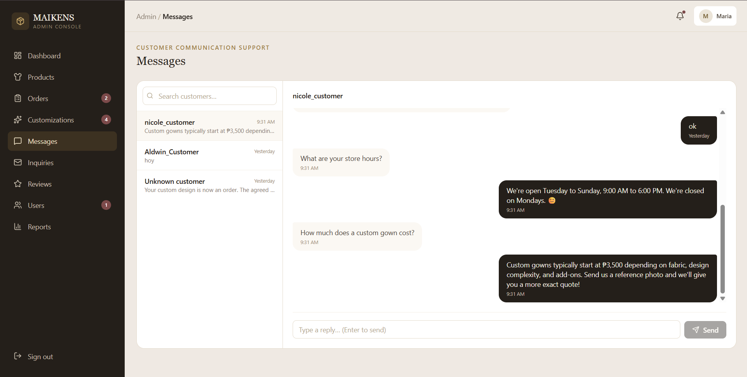
The add product module enables the admin to input new items into the product catalog, including the product names, detailed descriptions, prices, and uploaded images. It maintains updated store inventory and catalog.
Figure 19.0 Admin Messaging Tool
he admin messaging tool allows the boutique owner to view and reply to customer inquiries and chat logs in one organized inbox. Customized request can also be discussed in this tool.

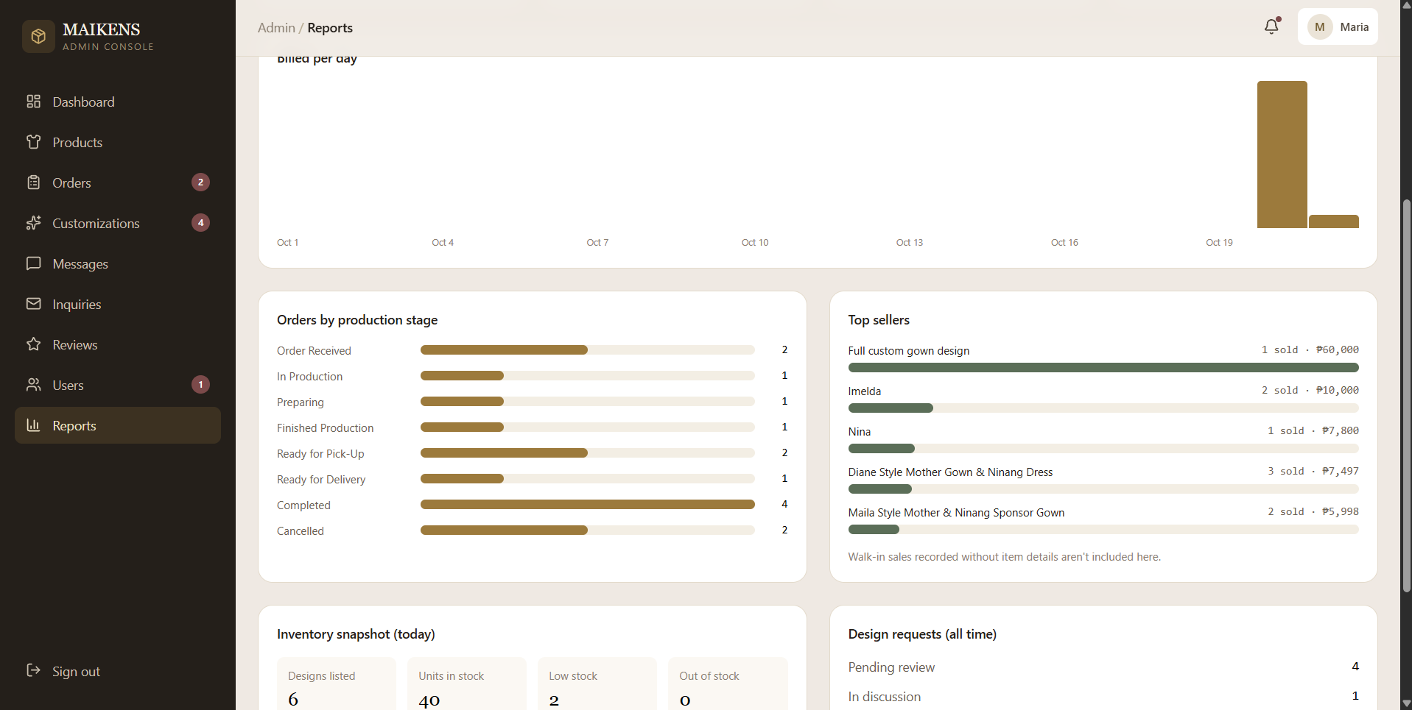
Figure 20.0 Reports Page
The reports page generates easy to understand sales summaries, transaction histories, and inventory movement reports. It provides support to the boutique in making informed business decisions.
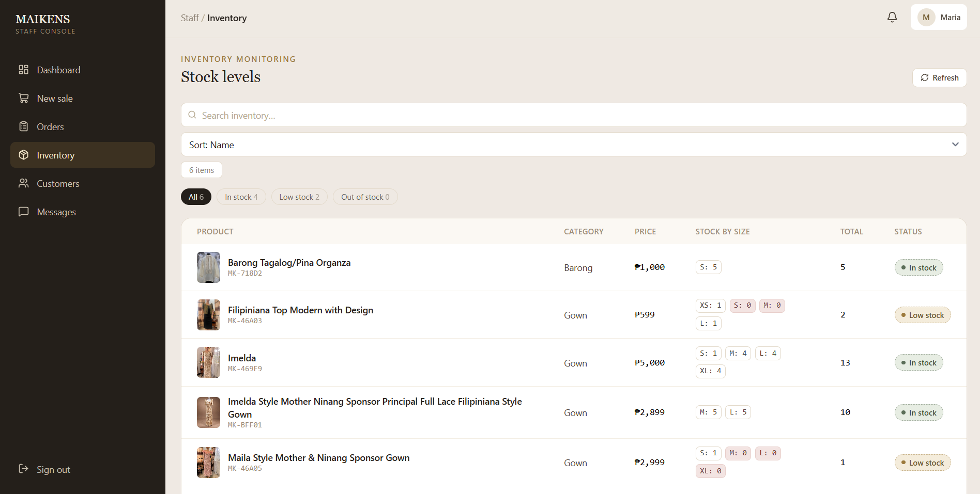
Figure 21.0 Cashier Product Catalog
The Cashier Product Catalog displays the searchable inventory of available gowns and barongs for walk-in transactions. Cashiers can quickly check item availability, descriptions, and prices directly at the counter.

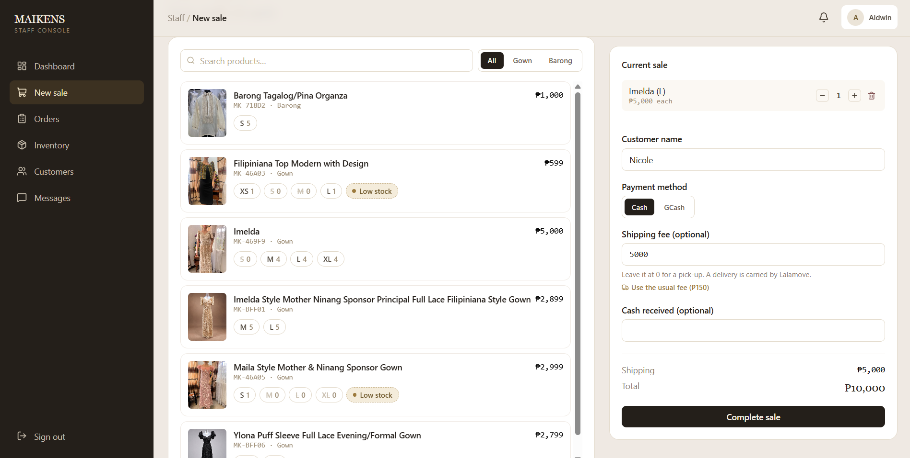
Figure 22.0 Cashier POS
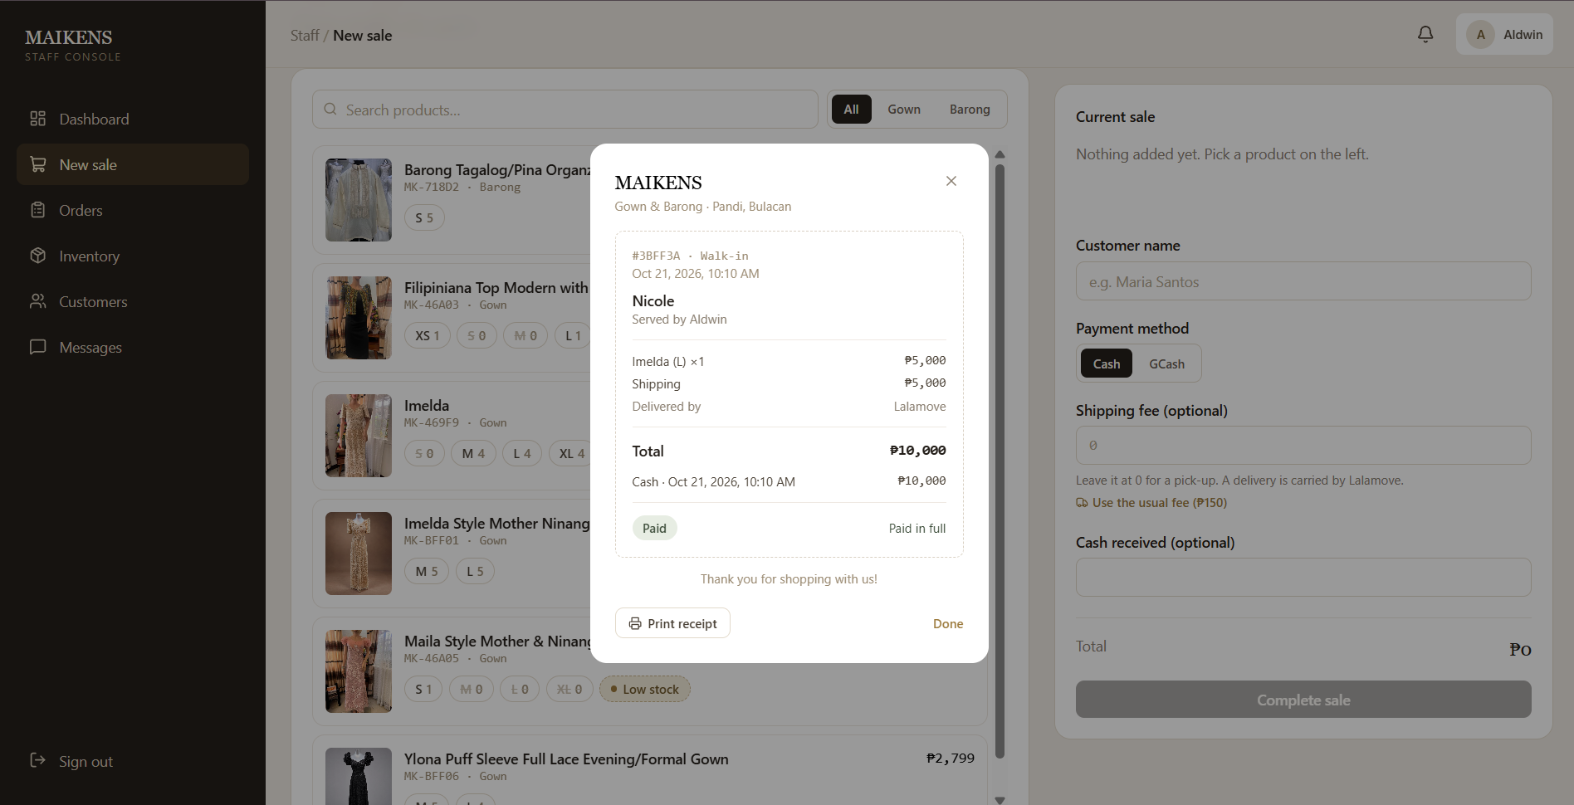
The Cahier POS module enables staff to process walk-in orders and handle face-to-face transactions efficiently at the counter. Total prices, with the applied adjustments and accurately computed, and data are instantly syncs in the inventory.
Figure 23.0 Receipt Generation
Receipt Generation creates digital summary of completed in-store transactions. It records purchased items, payment details, and change calculations for official customer records.
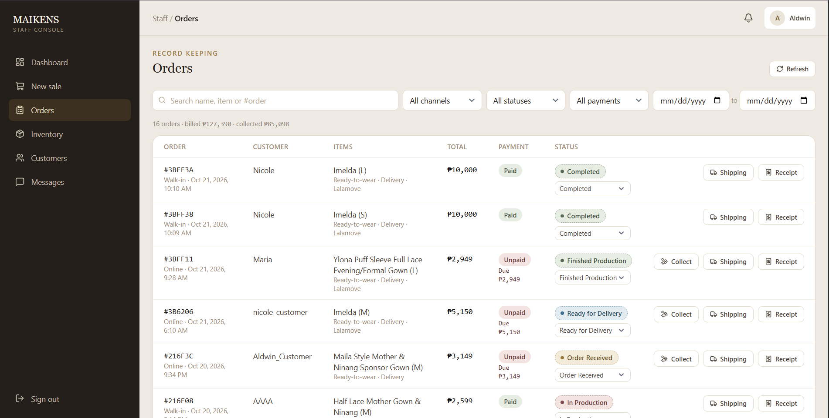
.
Figure 24.0 Orders
The Orders tab logs completed sales and walk-in orders processed by the cashier. Staffs can easily search, review, and track past counter transactions for auditing.

Implementation Plan
The "MAIKCRAFT: The Developement of a Web-Based Ordering and POS System with AI-Based Design Customization for Maikens Gown and Barong" implementation focuses on following a series of planned phases that ensures the appropriate preparation, testing, deployment, and the transition of the system into the business opearations. The process began by interviewing the owners and managers of Maikens Gown and Barong boutique above their current business process such as their ordering and transaction processing, inventory monitoring, and customer communication procedures, as well as their existing operational needs.
During the design phase, Figma were used by the developers to create interface and established the system's layout, navigations, and visual structures. The system was also developed using the MERN stack, which consist MongoDB, Express.js, React.js, and Node.js, with RESTful APIs that facilitates communication between frontend and backend. The development phase involves implementing and integrating the system's components based on the identified requirements and approved designs. To system will undergo testing to ensure its functionality, integration, and usability, once a major function was developed. Testing phase includes checking the system's features and collecting feedback from intended evaluators and users to identify issues that requires improvements.
Following the testing and the necessary revisions, the system is planned for deployment and use by Maikens Gown and Barong. Preparing the required hardware and software, configuring the system for its intended environment, and providing guidance to the owner and staff on its functions are the necessary steps that are involved in this phase. After the deployment, the system will be monitored and the necessary maintenance will be conducted to identify technical issues, and address user feedback, which helps support and maintain the operation of the system.

Implementation Results
MAIKCRAFT: Web-Based Ordering and POS System with AI-Based Design Customization for Maikens Gown and Barong was successfully deployed to enhanced the boutique's daily operations. This platform had an integrated point of sale(POS) activities and web-based ordering into a one system, enabling the boutique to process both walk in and online transactions competently. This streamlined process reduce tracking errors caused by paper based inventory recording while accelerating order processing times. The AI-generation customization tool and virtual try on feature provided the customer with an interactive web design experience, allowing them to visualize their preference gown and barong modifications before checking out the orders. This feature is capable to reduced miscommunications regarding product specifications and increased buyer confidence. Also, we integrated messaging tool that handle that improved client engagement with significant time savings in response rates to boost customer satisfaction.
Further, our integration of digital payment is G-Cash that have different bank options to enhances transaction processing for customers, enabling smoother and faster purchasing experiences and secure payment options. The Real-time order status tracking gives complete visibility into production stages which reduces repetitive follow-ups and builds trust for customers with the boutique. For boutique side, the automated stock monitoring and sales report tools offer actionable operational metrics to make data-driven business decisions. Finally, by implementing MAIKCRAFT we optimized operational efficiency, minimized manual dependencies and established modern digital tools for Maikens Gown & Barong. Our system modernizes their business model through integration of physical retail operations with intelligent web features that prepares their boutique for long-term growth in the custom fashion industry.

CONCLUSION
The development and implementation of MAIKCRAFT: Web-Based Ordering and POS System with AI-Based Design Customization for Maikens Gown and Barong represents a considerable step in the direction of modernizing the operations of conventional clothing boutiques in today’s retail environments. The system reduced the difficulties of paper-based operations in record keeping, improves inventory accuracy and tracking, and streamlined order processing, by digitalizing transaction processing and weekly inventory. At the same time, it improves client engagement with the aid of integrating innovative functions which includes an AI-Powered design customization tool, messaging tool, order and order status tracking.
From the conducted validations of high acceptance ratings from the boutique cashiers and owners, previous operational problems like manual sales computation delays, error-prone paper record-keeping, and weekly stock discrepancies we're eliminated by a successful deployment of the Point of Sale and digital inventory. This success was strongly validated by cashiers and owners of the boutique which confirmed that they system helped in ensuring efficient stock monitoring and visibility. Furthermore, the integration of AI-Based customization tool successfully resolved issues regarding customer visualization and design miscommunications. This enables customers to modify gown or barong designs efficiently and significantly reduced lengthy consultation times and design errors. Features like order status tracking and centralized messaging tool also eliminates uncertainty, and repetitive follow-ups and inquiries.
In conclusion, the MAIKCRAFT system served as a reliable and complete digital solution for Maikens Gown & Barong. Supported via user evaluations and compliance with IT software quality standards, and evaluated by IT industry experts, the system successfully shows that such local family-owned apparel stores can incorporate modernized web technologies and artificial intelligence to resolve operational inefficiencies, raise client satisfaction, and ensure long-term competitiveness within the present day fashion industry.
RECOMMENDATION

REFERENCE
Ahmed, S. K. (2024). How to choose a sampling technique and determine sample size for research: A simplified guide for researchers. Oral Oncology Reports, 12, Article 100662. https://doi.org/10.1016/j.oor.2024.100662
Asrani, H., Vishwakarma, S., Asrani, D., & Asrani, K. (2024). Point of sale systems. International Journal of Innovative Research in Computer Science & Technology, 12(Special Issue-1), 358–363. https://doi.org/10.55524/CSISTW.2024.12.1.63
Brooks, H. (2026, February 6). Worldwide Bridal Gowns Market Research Report 2026, Forecast to 2032 – PW Consulting. https://pmarketresearch.com/worldwide-bridal-gowns-market-research-2024-by-type-application-participants-and-countries-forecast-to-2030/
Chang, H. J., Bruess, F., & Chong, J. W. (2024). Opportunities and challenges of smart technology for small independent fashion retailers: a reflexive thematic analysis using the technology-organization-environment framework. Fashion and Textiles, 11(1). https://link.springer.com/article/10.1186/s40691-024-00391-x
Choi, W., Jang, S., Kim, H. Y., Lee, Y., Lee, S., Lee, H., & Park, S. (2023). Developing an AI-based automated fashion design system: reflecting the work process of fashion designers. Fashion and Textiles, 10(1). https://link.springer.com/article/10.1186/s40691-023-00360-w
Chromis. (n.d.). https://chromis.co.uk/chromispos/
Corsini, R. R., Costa, A., Fichera, S., & Framiñan, J. M. (2024). Digital twin model with machine learning and optimization for resilient production–distribution systems under disruptions. Computers & Industrial Engineering, 191, 110145. https://doi.org/10.1016/j.cie.2024.110145
C-POS - Next Generation POS system. (n.d.). https://cpos.store/?utm_#features
Darics, E., & Lockwood, J. (2022). ‘I’m actually shocked of how rude you are!’ Communication challenges in webchat-based customer service. Discourse & Communication, 17(1), 3–22. https://doi.org/10.1177/17504813221123843
Dhanya, K., & Nanthini, E. (2026). A study on customer perception of order tracking features in e-commerce application with special reference to Tirupur City. International Journal of Creative Research Thoughts, 14(3), e710–e714. https://ijcrt.org/papers/IJCRT2603558.pdf
Dubey, U., Raghorte, S., Joshi, S., & Dode, T. (2021/2022). Online shopping system. Acropolis Institute of Technology and Research, Indore, India. https://l1nq.com/NuOAfMv
Features. (n.d.). Loyverse. https://loyverse.com/features
Free inventory management software | Zoho Inventory. (n.d.). https://surl.li/dviuwa
Grewal, D., Herhausen, D., Ludwig, S., & Villarroel Ordenes, F. (2022). The future of digital communication research: Considering dynamics and multimodality. Journal of Retailing, 98(2), 224–240. https://doi.org/10.1016/j.jretai.2021.01.007
Kawa, A., & Światowiec-Szczepańska, J. (2021). Customer value creation in online retail logistics. International Journal of Retail & Distribution Management, 49(11), 1512–1527.
https://www.sciencedirect.com/org/science/article/pii/S0885862421000894
Kupka-Klepsch, E., Hauser, C., Werner, F., & Haslinger-Baumann, E. (2023). “Qualitative evaluation of a digital software solution for documentation and training in 24-hour home care.” Home Health Care Services Quarterly, 43(1), 39–53. https://doi.org/10.1080/01621424.2023.2290284
Lewis, E. C., Harper, K. M., Poirier, L. K., & Gittelsohn, J. (2021). Feasibility of using Mobile Point-of-Sale Technology in Baltimore City Corner Stores for Tracking Sales: A Brief Report. Journal of Public Health Research, 11(1). https://doi.org/10.4081/jphr.2021.2607
Lu, Y. (2026). Research and implementation of intelligent clothing personalized customization system based on deep learning. Scientific Reports, 16(1), 12080. https://doi.org/10.1038/s41598-026-40436-3
Maharani, S. A., & James, B. A. (2026). Agile development of point of sale applications with real time inventory and dashboard integration. Bit-Tech, 9(1), 999–1010. https://doi.org/10.32877/bt.v9i1.4029
Mahmoud, R. (2024, August 9). Boutique. Retail Dogma. https://www.retaildogma.com/boutique/
Oh, E. Y., & Song, D. (2021). Developmental research on an interactive application for language speaking practice using speech recognition technology. Educational Technology Research and Development, 69(2), 861–884. https://doi.org/10.1007/s11423-020-09910-1
Ryjov, A., Kazaryan, V., Golub, A., & Egorova, A. (2024). Towards enhanced creativity in fashion: Integrating generative models with hybrid intelligence. Frontiers in Artificial Intelligence, 7, Article 1460217. https://doi.org/10.3389/frai.2024.1460217
Sandy, E. (2023, March 28). What is a boutique store? The 308 Boutique. https://www.the308boutique.com/blogs/fashion-boutique-blog/what-is-a-boutique-store?srsltid=AfmBOop4kZRAk62RIPyVidC21iyplsCkAET3DOI9yQa6WQIE3PT69C6
Shabani, A., Maroti, G., de Leeuw, S., & Dullaert, W. (2021). Inventory record inaccuracy and store-level performance. International Journal of Production Economics, 235, 108111. https://doi.org/10.1016/j.ijpe.2021.108111
Soni, S., & Upadhyay, S. (2025). The Wear Web System: A Modern E-Commerce Platform Using MERN Stack. Parul University. https://tinyurl.com/WearWebSystem
Strauss, C., Harr, M. D., & Pieper, T. M. (2024). Analyzing digital communication: a comprehensive literature review. Management Review Quarterly, 75(4), 3119–3157. https://link.springer.com/article/10.1007/s11301-024-00455-8
The Pennsylvania State University. (n.d.). 4: Estimating with confidence. STAT 800: Applied Research Methods. https://online.stat.psu.edu/stat800/Lesson04
Wang, D., Kerh, R., Jun, S., Lee, S., Mayega, R. W., Ssentongo, J., Oumer, A., Haque, M., Brunese, P., & Yih, Y. (2022). Demand sensing and digital tracking for maternal child health (MCH) in Uganda: a pilot study for ‘E+TRA health.’ BMC Medical Informatics and Decision Making, 22(1), 239. https://link.springer.com/article/10.1186/s12911-022-01982-8
Wang, Z., Tao, X., Zeng, X., Xing, Y., Xu, Z., & Bruniaux, P. (2023). Design of customized garments towards sustainable fashion using 3D digital simulation and Machine Learning-Supported Human–Product interactions. International Journal of Computational Intelligence Systems, 16(1). https://doi.org/10.1007/s44196-023-00189-7

APPENDIX A. RESOURCE PERSONS
RESOURCE PERSONS

NAME | POSITION | COMPANY/ORGANIZATION
Ms. Lara Camille V. Vergara | IT Program Head | STI College Sta. Maria
Asst. Prof. Alfie B. Benito, MIT | Capstone Project Coordinator | STI College Sta. Maria
Mr. Ralf Alvin Bausas | Capstone Adviser | STI College Sta. Maria
Mrs. Patrickk G. Sayo | Business Owner | Maikens Gown & Barong
Table 11.0 Resource Person

APPENDIX B. EVALUATION TOOLS / TEST DOCUMENTS
EVALUATION TOOLS / TEST DOCUMENTS
Evaluator 1: Reymart Betana
Job Title / Work Position: Mid Software Engineer
Date: October 16, 2026

Part I. ISO/IEC 25010 Software Quality Evaluation
(Rate from 1 – Poor, 2 – Fair, 3 – Good, 4 – Excellent)
- Functional Suitability
Criteria | 1 | 2 | 3 | 4
Completeness – The system provides the necessary functions to cover the specified user requirements. | ☐ | ☐ | ☐ | ☑
Correctness - The system produces accurate results when performing its functions. | ☐ | ☐ | ☐ | ☑
Appropriateness - The system's functions help users accomplish their intended tasks effectively. | ☐ | ☐ | ☐ | ☑

- Performance Efficiency

Criteria | 1 | 2 | 3 | 4
Time Behavior – The system responds to user actions and processes transactions within the required time. | ☐ | ☐ | ☑ | ☐
Resource utilization - The system uses computing resources efficiently while performing its functions. | ☐ | ☐ | ☐ | ☑
Capacity – The system can support the expected number of concurrent users, orders, and stored records. | ☐ | ☐ | ☑ | ☐

- Compatibility

Criteria | 1 | 2 | 3 | 4
Integration – The system works properly with its connected components and external services, where applicable. | ☐ | ☐ | ☑ | ☐
Co-existence – The system operates properly alongside other applications or services in its intended environment. | ☐ | ☐ | ☐ | ☑

- Interaction Capability

Criteria | 1 | 2 | 3 | 4
Design – Clean, professional, consistent look | ☐ | ☐ | ☐ | ☑
Usability – Intuitive navigation, ease of use | ☐ | ☐ | ☐ | ☑
Accessibility – Consideration for different users (e.g., readability, device access) | ☐ | ☐ | ☐ | ☑
Responsiveness – Layout adapts across devices/screens | ☐ | ☐ | ☐ | ☑
Error Feedback – Clear, helpful error messages and validation | ☐ | ☐ | ☐ | ☑

- Reliability

Criteria | 1 | 2 | 3 | 4
Availability – The system is accessible and operational when needed under its intended operating conditions. | ☐ | ☐ | ☑ | ☐
Faultlessness - The system performs its intended functions without faults during normal operation. | ☐ | ☑ | ☐ | ☐
Recoverability - The system can recover data and restore its operating state after an interruption or failure. | ☐ | ☑ | ☐ | ☐

- Security

Criteria | 1 | 2 | 3 | 4
Integrity (Input Validation) – Proper handling of user inputs to prevent SQL Injection and Command Injection | ☐ | ☐ | ☐ | ☑
Authentication – Secure login (hashed passwords, sessions, MFA if applicable) | ☐ | ☐ | ☐ | ☑
Authorization – Proper role-based access control (users can only access allowed data) | ☐ | ☐ | ☐ | ☑
Data Protection – Sensitive data encrypted in transit (HTTPS/SSL) and at rest | ☐ | ☐ | ☐ | ☑
Session Management – Secure cookies, session timeout, logout handling | ☐ | ☐ | ☐ | ☑
XSS & CSRF Protection – Proper escaping, tokens, and headers implemented | ☐ | ☐ | ☐ | ☑
Error Handling – No sensitive system information exposed in error messages | ☐ | ☐ | ☐ | ☑

- Maintainability

Criteria | 1 | 2 | 3 | 4
Database Design – Proper normalization, relationships, efficiency | ☑ | ☐ | ☐ | ☐
System Architecture – Clear layering, modularity, scalability | ☐ | ☐ | ☐ | ☑
Code Quality – Readability, maintainability, and standards followed | ☐ | ☐ | ☐ | ☑

- Flexibility

Criteria | 1 | 2 | 3 | 4
Adaptability – The system can adapt to changes in its intended operating environment. | ☐ | ☐ | ☐ | ☑
Scalability – The system can accommodate increases in users, orders, and stored data without requiring major changes to its core design. | ☐ | ☐ | ☐ | ☑
Modifiability – The system can be modified to accommodate future requirements with minimal impact on existing functions. | ☐ | ☐ | ☐ | ☑

Part II: Documentation & Technical Knowledge

Criteria | 1 | 2 | 3 | 4
System Documentation – Completeness, clarity, technical accuracy | ☐ | ☑ | ☐ | ☐
Source Code Documentation – Comments, guidelines, version control | ☐ | ☑ | ☐ | ☐
Deployment Guide – Installation, configuration, troubleshooting steps | ☐ | ☑ | ☐ | ☐
Student Knowledge – Ability to explain technical decisions | ☐ | ☐ | ☐ | ☑

Part III. Evaluator’s Feedback
Strengths of the System:
Intuitive, easy to use, Good UX design, word as expected

Areas for Improvement:

Usage of standard Http code, e.g 403 Forbidden Access
Source code not in version control tool and proper code documentation

Part IV. Overall Assessment
ISO/IEC 25010 Software Quality Composite Score (Part I Mean): Supplemental Criteria Score (Part II Mean):
Recommendation:
  - ☐ Passed – System meets IT standards
  - ☑ Passed with Minor Revisions
  - ☐ Passed with Major Revisions
  - ☐ Not Recommended


Evaluator’s Signature: ________________________________

Evaluator 2: Paul John Cadag
Job Title / Work Position: Senior Test Analyst
Date: October 16, 2026

Part I. ISO/IEC 25010 Software Quality Evaluation
(Rate from 1 – Poor, 2 – Fair, 3 – Good, 4 – Excellent)
- Functional Suitability
Criteria | 1 | 2 | 3 | 4
Completeness – The system provides the necessary functions to cover the specified user requirements. | ☐ | ☐ | ☐ | ☑
Correctness - The system produces accurate results when performing its functions. | ☐ | ☐ | ☐ | ☑
Appropriateness - The system's functions help users accomplish their intended tasks effectively. | ☐ | ☐ | ☐ | ☑

- Performance Efficiency

Criteria | 1 | 2 | 3 | 4
Time Behavior – The system responds to user actions and processes transactions within the required time. | ☐ | ☐ | ☐ | ☑
Resource utilization - The system uses computing resources efficiently while performing its functions. | ☐ | ☐ | ☐ | ☑
Capacity – The system can support the expected number of concurrent users, orders, and stored records. | ☐ | ☐ | ☑ | ☐

- Compatibility

Criteria | 1 | 2 | 3 | 4
Integration – The system works properly with its connected components and external services, where applicable. | ☐ | ☐ | ☐ | ☑
Co-existence – The system operates properly alongside other applications or services in its intended environment. | ☐ | ☐ | ☐ | ☑

- Interaction Capability

Criteria | 1 | 2 | 3 | 4
Design – Clean, professional, consistent look | ☐ | ☐ | ☐ | ☑
Usability – Intuitive navigation, ease of use | ☐ | ☐ | ☐ | ☑
Accessibility – Consideration for different users (e.g., readability, device access) | ☐ | ☐ | ☑ | ☐
Responsiveness – Layout adapts across devices/screens | ☐ | ☐ | ☐ | ☑
Error Feedback – Clear, helpful error messages and validation | ☐ | ☐ | ☐ | ☑

- Reliability

Criteria | 1 | 2 | 3 | 4
Availability – The system is accessible and operational when needed under its intended operating conditions. | ☐ | ☐ | ☐ | ☑
Faultlessness - The system performs its intended functions without faults during normal operation. | ☐ | ☐ | ☐ | ☑
Recoverability - The system can recover data and restore its operating state after an interruption or failure. | ☐ | ☐ | ☑ | ☐

- Security

Criteria | 1 | 2 | 3 | 4
Integrity (Input Validation) – Proper handling of user inputs to prevent SQL Injection and Command Injection | ☐ | ☐ | ☐ | ☑
Authentication – Secure login (hashed passwords, sessions, MFA if applicable) | ☐ | ☐ | ☐ | ☑
Authorization – Proper role-based access control (users can only access allowed data) | ☐ | ☐ | ☐ | ☑
Data Protection – Sensitive data encrypted in transit (HTTPS/SSL) and at rest | ☐ | ☐ | ☐ | ☑
Session Management – Secure cookies, session timeout, logout handling | ☐ | ☐ | ☑ | ☐
XSS & CSRF Protection – Proper escaping, tokens, and headers implemented | ☐ | ☐ | ☐ | ☑
Error Handling – No sensitive system information exposed in error messages | ☐ | ☐ | ☐ | ☑

- Maintainability

Criteria | 1 | 2 | 3 | 4
Database Design – Proper normalization, relationships, efficiency | ☐ | ☐ | ☐ | ☑
System Architecture – Clear layering, modularity, scalability | ☐ | ☐ | ☐ | ☑
Code Quality – Readability, maintainability, and standards followed | ☐ | ☐ | ☐ | ☑

- Flexibility

Criteria | 1 | 2 | 3 | 4
Adaptability – The system can adapt to changes in its intended operating environment. | ☐ | ☐ | ☐ | ☑
Scalability – The system can accommodate increases in users, orders, and stored data without requiring major changes to its core design. | ☐ | ☐ | ☐ | ☑
Modifiability – The system can be modified to accommodate future requirements with minimal impact on existing functions. | ☐ | ☐ | ☐ | ☑

Part II: Documentation & Technical Knowledge

Criteria | 1 | 2 | 3 | 4
System Documentation – Completeness, clarity, technical accuracy | ☐ | ☐ | ☐ | ☑
Source Code Documentation – Comments, guidelines, version control | ☐ | ☐ | ☐ | ☑
Deployment Guide – Installation, configuration, troubleshooting steps | ☐ | ☐ | ☐ | ☑
Student Knowledge – Ability to explain technical decisions | ☐ | ☐ | ☐ | ☑

Part III. Evaluator’s Feedback
Strengths of the System:
GOOD DESIGN AND FUNCTIONALITY

Areas for Improvement:

MUST HAVE FILTERING. ADD PICTURES IN CUSTOMIZATION TOOL

Part IV. Overall Assessment
ISO/IEC 25010 Software Quality Composite Score (Part I Mean): Supplemental Criteria Score (Part II Mean):
Recommendation:
  - ☐ Passed – System meets IT standards
  - ☑ Passed with Minor Revisions
  - ☐ Passed with Major Revisions
  - ☐ Not Recommended
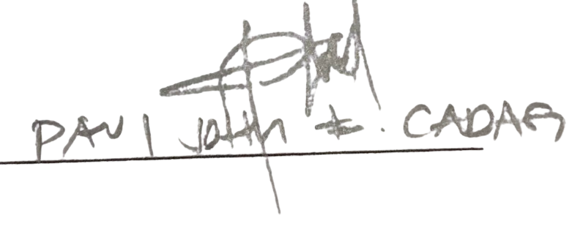

Evaluator’s Signature: ________________________________

Evaluator 3: Ludivina S. Gopez
Job Title / Work Position: Service Delivery Manager
Date: October 18, 2026

Part I. ISO/IEC 25010 Software Quality Evaluation
(Rate from 1 – Poor, 2 – Fair, 3 – Good, 4 – Excellent)
- Functional Suitability
Criteria | 1 | 2 | 3 | 4
Completeness – The system provides the necessary functions to cover the specified user requirements. | ☐ | ☐ | ☑ | ☐
Correctness - The system produces accurate results when performing its functions. | ☐ | ☐ | ☐ | ☑
Appropriateness - The system's functions help users accomplish their intended tasks effectively. | ☐ | ☐ | ☑ | ☐

- Performance Efficiency

Criteria | 1 | 2 | 3 | 4
Time Behavior – The system responds to user actions and processes transactions within the required time. | ☐ | ☐ | ☐ | ☑
Resource utilization - The system uses computing resources efficiently while performing its functions. | ☐ | ☐ | ☐ | ☑
Capacity – The system can support the expected number of concurrent users, orders, and stored records. | ☐ | ☐ | ☑ | ☐

- Compatibility

Criteria | 1 | 2 | 3 | 4
Integration – The system works properly with its connected components and external services, where applicable. | ☐ | ☐ | ☑ | ☐
Co-existence – The system operates properly alongside other applications or services in its intended environment. | ☐ | ☐ | ☑ | ☐

- Interaction Capability

Criteria | 1 | 2 | 3 | 4
Design – Clean, professional, consistent look | ☐ | ☐ | ☐ | ☑
Usability – Intuitive navigation, ease of use | ☐ | ☐ | ☐ | ☑
Accessibility – Consideration for different users (e.g., readability, device access) | ☐ | ☐ | ☐ | ☑
Responsiveness – Layout adapts across devices/screens | ☐ | ☐ | ☐ | ☑
Error Feedback – Clear, helpful error messages and validation | ☐ | ☐ | ☐ | ☑

- Reliability

Criteria | 1 | 2 | 3 | 4
Availability – The system is accessible and operational when needed under its intended operating conditions. | ☐ | ☐ | ☐ | ☑
Faultlessness - The system performs its intended functions without faults during normal operation. | ☐ | ☐ | ☑ | ☐
Recoverability - The system can recover data and restore its operating state after an interruption or failure. | ☐ | ☐ | ☑ | ☐

- Security

Criteria | 1 | 2 | 3 | 4
Integrity (Input Validation) – Proper handling of user inputs to prevent SQL Injection and Command Injection | ☐ | ☐ | ☑ | ☐
Authentication – Secure login (hashed passwords, sessions, MFA if applicable) | ☐ | ☐ | ☐ | ☑
Authorization – Proper role-based access control (users can only access allowed data) | ☐ | ☐ | ☐ | ☑
Data Protection – Sensitive data encrypted in transit (HTTPS/SSL) and at rest | ☐ | ☐ | ☐ | ☑
Session Management – Secure cookies, session timeout, logout handling | ☐ | ☐ | ☐ | ☑
XSS & CSRF Protection – Proper escaping, tokens, and headers implemented | ☐ | ☐ | ☐ | ☑
Error Handling – No sensitive system information exposed in error messages | ☐ | ☐ | ☐ | ☑

- Maintainability

Criteria | 1 | 2 | 3 | 4
Database Design – Proper normalization, relationships, efficiency | ☐ | ☐ | ☐ | ☑
System Architecture – Clear layering, modularity, scalability | ☐ | ☐ | ☐ | ☑
Code Quality – Readability, maintainability, and standards followed | ☐ | ☐ | ☐ | ☑

- Flexibility

Criteria | 1 | 2 | 3 | 4
Adaptability – The system can adapt to changes in its intended operating environment. | ☐ | ☐ | ☐ | ☑
Scalability – The system can accommodate increases in users, orders, and stored data without requiring major changes to its core design. | ☐ | ☐ | ☐ | ☑
Modifiability – The system can be modified to accommodate future requirements with minimal impact on existing functions. | ☐ | ☐ | ☑ | ☐

Part II: Documentation & Technical Knowledge

Criteria | 1 | 2 | 3 | 4
System Documentation – Completeness, clarity, technical accuracy | ☐ | ☐ | ☐ | ☑
Source Code Documentation – Comments, guidelines, version control | ☐ | ☐ | ☐ | ☑
Deployment Guide – Installation, configuration, troubleshooting steps | ☐ | ☐ | ☐ | ☑
Student Knowledge – Ability to explain technical decisions | ☐ | ☐ | ☐ | ☑

Part III. Evaluator’s Feedback
Strengths of the System:
USER FRIENDLY, CLARITY, ALMOST COMPLETE WHAT THE USER REQUIRE

Areas for Improvement:

Include color picker, Customer order should be able to be redirected to messenger, add customer reviews, cancelled orders should be visible, add invoice.

Part IV. Overall Assessment
ISO/IEC 25010 Software Quality Composite Score (Part I Mean): Supplemental Criteria Score (Part II Mean):
Recommendation:
  - ☐ Passed – System meets IT standards
  - ☑ Passed with Minor Revisions
  - ☐ Passed with Major Revisions
  - ☐ Not Recommended



Evaluator’s Signature: ________________________________

USER ACCEPTANCE TESTING
MAIKCRAFT Admin/Owner Survey Questionnaire
After using the Admin/Owner features of the MAIKCRAFT system, please rate each statement based on your experience.
Rating Scale:
4 - Strongly Agree
3 - Agree
2 - Disagree
1 - Strongly Disagree
Question: | 1 | 2 | 3 | 4
The system makes it easy to manage user accounts. | ☐ | ☐ | ☐ | ☑
The system makes it easy to add, update, and manage gown and barong product information. | ☐ | ☐ | ☐ | ☑
The system makes it easy to view and manage customer orders. | ☐ | ☐ | ☐ | ☑
The system makes it easy to review and manage customer customization requests. | ☐ | ☐ | ☐ | ☑
The system makes it easy to update and monitor order statuses. | ☐ | ☐ | ☐ | ☑
The system makes it easy to communicate with customers regarding their orders and inquiries. | ☐ | ☐ | ☐ | ☑
The system makes it easy to access sales and transaction reports. | ☐ | ☐ | ☐ | ☑
Overall, the system helps me manage the boutique's operations efficiently. | ☐ | ☐ | ☐ | ☑
Overall Weighted Mean: 4.00
Do you have any recommendations or suggestions for improving the MAIKCRAFT system?
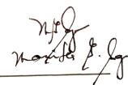

Admin/Owner Signature: Marites Sayo

USER ACCEPTANCE TESTING
MAIKCRAFT Cashier Survey Questionnaire
After using the cashier features of the MAIKCRAFT system, please rate each statement based on your experience.
Rating Scale:
4 - Strongly Agree
3 - Agree
2 - Disagree
1 - Strongly Disagree
Question: | 1 | 2 | 3 | 4
The system makes it easy to process walk-in customer orders and record customer details. | ☐ | ☐ | ☐ | ☑
The system accurately calculates transaction totals. | ☐ | ☐ | ☐ | ☑
The system automatically updates product stock after a walk-in order is processed. | ☐ | ☐ | ☐ | ☑
The system makes it easy to generate receipts for completed transactions. | ☐ | ☐ | ☐ | ☑
The system automatically records completed transactions for tracking and reporting purposes. | ☐ | ☐ | ☐ | ☑
The system makes it easy to search and view the order history of online and walk-in transactions. | ☐ | ☐ | ☐ | ☑
The system makes it easy to accurately monitor stock quantities and identify products with high or low stock levels | ☐ | ☐ | ☐ | ☑
Overall, the system helps me perform my cashier tasks efficiently. | ☐ | ☐ | ☐ | ☑
Overall Weighted Mean: 4.00
Do you have any recommendations or suggestions for improving the MAIKCRAFT system?

Cashier Signature: Marites Sayo
Customer Test Case
Test Case ID | Description | Test Procedure | Test Data | Expected Result | Actual Result | Status | Remarks | Executed By | Executed Date
TC_CUST_ACCESS_001 | Enter the valid link for MaikCraft | Type the link at the browser's address bar. | <MaikCraft URL, e.g. http://localhost:5173/> | The system should load the homepage with the carousel, features, and featured collection. | The homepage has been appear correctly with the carousel, features and featured collection. | Passed |  | Aldwin Miel G. Espiritu | 10-19-26
TC_CUST_ACCESS_002 | Enter the invalid link for MaikCraft | Type an invalid link at the browser's address bar. | <Invalid URL> | The system should show the Not Found page. | Page does not exist. | Passed |  | Aldwin Miel G. Espiritu | 10-19-26
TC_CUST_AUTH_001 | Register with valid input | Fill out username, email, password (8+ characters with a number), and matching confirm password, then click Create Account. | <Valid username, email, and password> | The system should create the account and redirect the user to the Verify Email page. | Verify Email Appear. | Passed |  | Aldwin Miel G. Espiritu | 10-19-26
TC_CUST_AUTH_002 | Register with empty fields | Leave the form empty and click Create Account. | <User data input> | The system should show a notification to please fill out the required field. | Fill out is required. | Passed |  | Aldwin Miel G. Espiritu | 10-19-26
TC_CUST_AUTH_003 | Register with a weak password | Enter a password shorter than 8 characters or without a number, then click Create Account. | <Weak password> | The system should show the password checklist and the message to choose a password that meets all requirements. | Password doest meet the requirements. | Passed |  | Aldwin Miel G. Espiritu | 10-19-26
TC_CUST_AUTH_004 | Register with mismatched passwords | Enter different values in Password and Confirm Password, then click Create Account. | <Mismatched passwords> | The system should show 'Passwords do not match.' and not create the account. | Passwords do not match. | Passed |  | Aldwin Miel G. Espiritu | 10-19-26
TC_CUST_AUTH_005 | Register with an already used email | Register using an email that already has an account. | <Existing email> | The system should show an error message and not create a duplicate account. | User already exist. | Passed |  | Aldwin Miel G. Espiritu | 10-19-26
TC_CUST_AUTH_006 | Verify email with a valid code | Enter the verification code sent to the registered email on the Verify Email page. | <Valid verification code> | The system should verify the account and allow the user to log in. | The email verification wasn't sent to my email. | Failed |  | Aldwin Miel G. Espiritu | 10-19-26
TC_CUST_AUTH_007 | Verify email with an invalid code | Enter a wrong verification code on the Verify Email page. | <Invalid verification code> | The system should show an error message and keep the account unverified. | That code isn't correct. | Passed |  | Aldwin Miel G. Espiritu | 10-19-26
TC_CUST_AUTH_008 | Login with valid credentials | Fill out a valid email and password, then click Log In. | <Valid email and password> | The system should redirect the customer to the homepage. | Directly to the homepage. | Passed |  | Aldwin Miel G. Espiritu | 10-19-26
TC_CUST_AUTH_009 | Login with invalid credentials | Fill out an invalid email and password, then click Log In. | <Invalid email or password> | The system should show a notification that the credentials are invalid. | Invalid credentials. | Passed |  | Aldwin Miel G. Espiritu | 10-19-26
TC_CUST_AUTH_010 | Login with an unverified account | Log in using an account whose email is not yet verified. | <Unverified account> | The system should redirect the user to the Verify Email page. | Accounts need verification. | Passed |  | Aldwin Miel G. Espiritu | 10-19-26
TC_CUST_AUTH_011 | Login with a deactivated account | Log in using an account deactivated by the admin. | <Deactivated account> | The system should deny access and show that the account has been deactivated. | This account has been deactivated. | Passed |  | Aldwin Miel G. Espiritu | 10-19-26
TC_CUST_AUTH_012 | Continue with Google | Click the Google sign-in button and choose a Google account. | <Access token> | The system should show the Google accounts and redirect the user to the homepage after choosing one. | Redirect to user hompage. | Passed |  | Aldwin Miel G. Espiritu | 10-19-26
TC_CUST_AUTH_013 | Log out | Open the user menu and click Sign out. | <User action> | The system should clear the session and redirect the user to the homepage as logged out. | Accounts Log out. | Passed |  | Aldwin Miel G. Espiritu | 10-19-26
TC_CUST_CAT_001 | View the product catalog | Click Catalog on the navigation bar. | <User action> | The system should list the published gowns and barongs, hiding Draft and Archived products. | Published Product has been display. | Passed |  | Aldwin Miel G. Espiritu | 10-20-26
TC_CUST_CAT_002 | Search a product by name | Type a product name in the search box. | <Product name> | The system should show only the products that match the search term. | The item search correctly. | Passed |  | Aldwin Miel G. Espiritu | 10-20-26
TC_CUST_CAT_003 | Search with no match | Type a name that does not exist in the search box. | <Unmatched keyword> | The system should show a 'No matches' message with an option to clear the search. | No matches found. | Passed |  | Aldwin Miel G. Espiritu | 10-20-26
TC_CUST_CAT_004 | Filtering functionality | Select options in the filter sidebar (e.g., category, event type, color, size). | <Checkbox selection> | The system should show only the products that match the selected filters. | Filter product displayed. | Passed |  | Aldwin Miel G. Espiritu | 10-20-26
TC_CUST_CAT_005 | Clear filters | Select filters, then click Clear on the active filters. | <User action> | The system should remove all filters and show the full catalog. | Filter remove. | Passed |  | Aldwin Miel G. Espiritu | 10-20-26
TC_CUST_CAT_006 | Sorting functionality | Select Price low to high, Price high to low, and Newest in the sort dropdown. | <Drop down menu> | The system should reorder the products according to the selected sort option. | The product displayed as selected sort option. | Passed |  | Aldwin Miel G. Espiritu | 10-20-26
TC_CUST_CAT_007 | Items per page and pagination | Change the number of items shown, then click next and previous page. | <Drop down menu> | The system should update the number of items per page and navigate between pages correctly. | Items displayed according to the selected quantity. | Passed |  | Aldwin Miel G. Espiritu | 10-20-26
TC_CUST_CAT_008 | View product details | Click View or the photo of a product. | <User action> | The system should open the product page with photos, price, sizes, and details. | Details displayed. | Passed |  | Aldwin Miel G. Espiritu | 10-20-26
TC_CUST_CAT_009 | Out-of-stock product indicator | Open the catalog and look for a product with no stock. | <Out of stock product> | The system should show an 'Out of stock' label on the product. | Out of stock label displayed. | Passed |  | Aldwin Miel G. Espiritu | 10-20-26
TC_CUST_CART_001 | Invalid add to cart functionality | Click Add to Cart without selecting a size. | <User select> | The system should show a notification to please select a product size. | Please select a size before adding to cart. | Passed |  | Aldwin Miel G. Espiritu | 10-20-26
TC_CUST_CART_002 | Valid add to cart functionality | Select a size and click Add to Cart. | <User select> | The system should add the product to the cart and show a success notification. | Added 1x item. | Passed |  | Aldwin Miel G. Espiritu | 10-20-26
TC_CUST_CART_003 | Add to cart while logged out | Click Add to Cart without being logged in. | <User action> | The system should prompt the user to log in before adding to the cart. | User need to log in. | Passed |  | Aldwin Miel G. Espiritu | 10-20-26
TC_CUST_CART_004 | Edit product quantity | Open My Cart and change the product quantity. | <User input> | The system should update the quantity and the total cost. | The quantity and the total cost are update. | Passed |  | Aldwin Miel G. Espiritu | 10-20-26
TC_CUST_CART_005 | Delete product functionality | Click the delete icon on a cart item. | <User action> | The system should remove the product from the cart. | Product delete. | Passed |  | Aldwin Miel G. Espiritu | 10-20-26
TC_CUST_FAV_001 | Add a product to favorites | Click the favorite (heart) button on a product. | <User action> | The system should save the product and show it in Favorites. | The Favorites added and displayed | Passed |  | Aldwin Miel G. Espiritu | 10-20-26
TC_CUST_FAV_002 | Remove a product from favorites | Click the favorite button again, or remove it from the Favorites page. | <User action> | The system should remove the product from Favorites. | The favorites added and displayed are remove. | Passed |  | Aldwin Miel G. Espiritu | 10-20-26
TC_CUST_CUSTOM_001 | Customize without the required options | Open Customize and click Generate without choosing the required options (Gown: color and silhouette; Barong: color and fit). | <Incomplete selection> | The system should show a message listing the missing required options and not generate a preview. | Required option must fill. | Passed |  | Aldwin Miel G. Espiritu | 10-20-26
TC_CUST_CUSTOM_002 | Generate an AI preview for a gown | Choose Gown, select color, silhouette, and other design elements, then click Generate. | <Design selections> | The system should generate an AI preview image of a gown based on the selected options. | Selected options displayed. | Passed |  | Aldwin Miel G. Espiritu | 10-20-26
TC_CUST_CUSTOM_003 | Generate an AI preview for a barong | Choose Barong, select color, fit, fabric, and design, then click Generate. | <Design selections> | The system should generate an AI preview image of a barong based on the selected options. | Selected options displayed | Passed |  | Aldwin Miel G. Espiritu | 10-20-26
TC_CUST_CUSTOM_004 | Redesign an existing gown | Pick an existing gown as the base, change some options, then click Generate. | <Base product and selections> | The system should generate a preview that keeps the base gown's construction and changes only the selected options. | The selected options has change. | Passed |  | Aldwin Miel G. Espiritu | 10-20-26
TC_CUST_CUSTOM_005 | Generate with reference image and notes | Upload a shape and/or style reference photo, add extra notes, then click Generate. | <Image file and notes> | The system should generate a preview that follows the reference images and notes. | Successful generateted with style reference. | Passed |  | Aldwin Miel G. Espiritu | 10-20-26
TC_CUST_CUSTOM_006 | Upload an invalid reference file | Upload a non-image file or an image larger than 5MB as a reference. | <Invalid file> | The system should reject the file and show an error message. | Image Only. | Passed |  | Aldwin Miel G. Espiritu | 10-20-26
TC_CUST_CUSTOM_007 | Submit a custom design to the boutique | Click the submit/send design button after a preview is generated. | <User action> | The system should save the design with the status 'Pending review'. | Design Send to Boutiqe and waiting for approval. | Passed |  | Aldwin Miel G. Espiritu | 10-20-26
TC_CUST_CUSTOM_008 | Edit a design that is not yet approved | Open a design with status 'Pending review' or 'In discussion' and click Edit. | <User action> | The system should open the design for editing and save the changes. | The design can edit. | Passed |  | Aldwin Miel G. Espiritu | 10-20-26
TC_CUST_CUSTOM_009 | Edit an approved design | Check a design with status 'Approved'. | <User action> | The system should not allow editing (no Edit option shown). | The approve design can edit. | Passed |  | Aldwin Miel G. Espiritu | 10-20-26
TC_CUST_TRYON_001 | Virtual try-on functionality | Upload a full-body photo, choose a gown or barong, and click Generate. | <Person photo and garment> | The system should generate an AI image of the person wearing the selected garment. | The references is follow bt virtual try-on | Passed |  | Aldwin Miel G. Espiritu | 10-20-26
TC_CUST_TRYON_002 | Virtual try-on with an invalid photo | Upload a file that is not JPG, PNG, or WebP, or is larger than 5MB. | <Invalid file> | The system should reject the photo and show an error message. | Image only. | Passed |  | Aldwin Miel G. Espiritu | 10-20-26
TC_CUST_CHECK_001 | Checkout with missing details | Click Place Order without filling in the required delivery or pick-up details. | <User data input> | The system should show a notification to fill out the required details. | Pick up date must filled. | Passed |  | Aldwin Miel G. Espiritu | 10-20-26
TC_CUST_CHECK_002 | Checkout with pick-up | Fill in the details, choose pick-up and a schedule, then place the order. | <Pick-up details> | The system should create the order and redirect the user to the order details. | Directly go to order details. | Passed |  | Aldwin Miel G. Espiritu | 10-20-26
TC_CUST_CHECK_003 | Checkout with delivery and GCash | Fill in the delivery details, choose GCash, and confirm the payment. | <Delivery and GCash details> | The system should create the order with the GCash payment and show the order summary. | Order placed with Gcash. | Passed |  | Aldwin Miel G. Espiritu | 10-20-26
TC_CUST_CHECK_004 | Stock deducted after order | Place an order, then check the product's stock in the catalog or admin. | <Ordered product and size> | The system should reduce the stock of the ordered size by the ordered quantity. | Quantity reduce. | Passed |  | Aldwin Miel G. Espiritu | 10-20-26
TC_CUST_TRACK_001 | Order status tracking | Open Profile > Order History. | <User action> | The system should list the orders with their current status and progress bar. | Order can track. | Passed |  | Aldwin Miel G. Espiritu | 10-20-26
TC_CUST_TRACK_002 | Order status reflects staff updates | Let admin/staff update an order's status, then refresh Order History. | <Updated status> | The system should show the new status (e.g., In Production, Ready for Pick-Up). | Status Update. | Passed |  | Aldwin Miel G. Espiritu | 10-20-26
TC_CUST_MSG_001 | Send a message to the boutique | Open Message, type a message, and send. | <User data input> | The system should show the message in the conversation. | Message Conversation appear. | Passed |  | Aldwin Miel G. Espiritu | 10-20-26
TC_CUST_MSG_002 | Ask a basic business question | Ask about store hours or prices. | <User data input> | The system should reply accordingly with the business information. | Question answer correctly. | Passed |  | Aldwin Miel G. Espiritu | 10-20-26
TC_CUST_MSG_003 | Receive a reply from the boutique | Let admin/staff reply to the customer's message. | <User action> | The system should show the boutique's reply in the conversation. | Reply Receive. | Passed |  | Aldwin Miel G. Espiritu | 10-20-26
TC_CUST_PROF_001 | View profile while logged out | Open the Profile page without logging in. | <User action> | The system should show 'Please log in first' with Log In and Create account options. | User cant do this action with no accounts. | Passed |  | Aldwin Miel G. Espiritu | 10-20-26
TC_CUST_PROF_002 | Edit profile with valid details | Click Edit, enter a valid mobile number and address, then Save Changes. | <Valid mobile number and address> | The system should save the changes and show 'Profile updated.. | Profile Updated. | Passed |  | Aldwin Miel G. Espiritu | 10-20-26
TC_CUST_PROF_003 | Edit profile with invalid mobile number | Enter an invalid mobile number, then Save Changes. | <Invalid mobile number> | The system should show a notification to enter a valid mobile number. | Enter a valid mobile number. | Passed |  | Aldwin Miel G. Espiritu | 10-20-26
TC_CUST_PROF_004 | Upload a valid profile picture | Click the camera icon, choose a JPG/PNG/WebP image under 2MB, then Save. | <Image file> | The system should update the profile picture. | Profile change. | Passed |  | Aldwin Miel G. Espiritu | 10-20-26
TC_CUST_PROF_005 | Upload an invalid profile picture | Choose a non-image file or an image larger than 2MB. | <Invalid file> | The system should show an error message and not change the picture. | Error Appear only JPG, PNG WebP Accept. | Passed |  | Aldwin Miel G. Espiritu | 10-20-26
TC_CUST_PROF_006 | Customer opens the admin page | Log in as a customer and type the /admin link. | <Customer account> | The system should show 'Admin access needed' and not display the console. | 403 acces denied. | Passed |  | Aldwin Miel G. Espiritu | 10-20-26
Figure 25.0 Customer Test Case

Admin/Owner Test Case
Test Case ID | Description | Test Procedure | Test Data | Expected Result | Actual lt | Status | Remarks | Executed By | Executed Date
TC_ADMIN_ACCESS_001 | Enter the valid link for the admin console | Type the /admin link at the browser's address bar. | <Admin URL> | The system should land on the admin login or console. | Land in admin log in. | Passed |  | Aldwin Miel G. Espiritu | 10-20-26
TC_ADMIN_ACCESS_002 | Enter the invalid link | Type an invalid link at the browser's address bar. | <Invalid URL> | The system should show the Not Found page. | Page doesn’t exist. | Passed |  | Aldwin Miel G. Espiritu | 10-20-26
TC_ADMIN_AUTH_001 | Login with valid admin credentials | Provide the valid admin credentials in the login form. | <Valid admin email and password> | The system should redirect the admin to the dashboard. | Sign in Directly to dashboard. | Passed |  | Aldwin Miel G. Espiritu | 10-20-26
TC_ADMIN_AUTH_002 | Login with invalid credentials | Provide invalid credentials in the login form. | <Invalid email or password> | The system should show a notification that the credentials are invalid. | Invalid Credentilas | Passed |  | Aldwin Miel G. Espiritu | 10-20-26
TC_ADMIN_AUTH_003 | Open the admin page without logging in | Type the /admin link without a session. | <User action> | The system should show 'Admin access needed' with a Go to login button. | Need to log in Admin. | Passed |  | Aldwin Miel G. Espiritu | 10-20-26
TC_ADMIN_AUTH_004 | Staff opens the admin page | Log in with a staff account and type the /admin link. | <Staff account> | The system should deny access to the admin console. | 403 Acess denied. | Passed |  | Aldwin Miel G. Espiritu | 10-20-26
TC_ADMIN_AUTH_005 | Sign out | Click Sign out on the sidebar. | <User action> | The system should clear the session and redirect to the login page. | Session Clear. | Passed |  | Aldwin Miel G. Espiritu | 10-20-26
TC_ADMIN_DASH_001 | View the dashboard overview | Open the Dashboard tab. | <User action> | The system should show the sales and order overview and the badges for new orders, pending designs, and unread messages. | Displayed the Overview and other important details including pending design. | Passed |  | Aldwin Miel G. Espiritu | 10-20-26
TC_ADMIN_DASH_002 | Navigate from a dashboard alert | Click the bell icon or a dashboard shortcut. | <User action> | The system should open the tab that needs attention (messages, customizations, or orders). | Tab appears that need updates. | Passed |  | Aldwin Miel G. Espiritu | 10-20-26
TC_ADMIN_DASH_003 | Tab stays after refresh | Open the Orders tab and refresh the browser. | <User action> | The system should remain on the Orders tab. | Remain in order tab. | Passed |  | Aldwin Miel G. Espiritu | 10-20-26
TC_ADMIN_PROD_001 | Create product functionality | Click Add product, upload images, enter name, category, event type, price, color, sizes with stock, then save. | <Admin Action> | The system should add the product to the product list. | Can add product. | Passed |  | Aldwin Miel G. Espiritu | 10-20-26
TC_ADMIN_PROD_002 | Create product with missing required fields | Fill in only some fields and click save. | <Admin Action> | The system should show a notification for the missing required fields and not save the product. | Missing field must fill. | Passed |  | Aldwin Miel G. Espiritu | 10-20-26
TC_ADMIN_PROD_003 | Edit product details | Open a product, change the price or stock, then save. | <Admin Action> | The system should update the product and show the new values. | Admin can update the products. | Passed |  | Aldwin Miel G. Espiritu | 10-20-26
TC_ADMIN_PROD_004 | Save product as draft | Save a new product with the status Draft. | <Admin Action> | The system should save it, and it should not appear in the customer catalog. | Draft save. | Passed |  | Aldwin Miel G. Espiritu | 10-20-26
TC_ADMIN_PROD_005 | Archive a product | Archive a published product. | <Admin Action> | The system should archive the product and hide it from the customer catalog. | Product hide because of archieve. | Passed |  | Aldwin Miel G. Espiritu | 10-20-26
TC_ADMIN_PROD_006 | Low stock and out-of-stock status | Set a product's total stock to 2 or less, then to 0. | <Stock values> | The system should automatically set the status to Low stock, then Out of stock. | Displayed Low stock | Passed |  | Aldwin Miel G. Espiritu | 10-20-26
TC_ADMIN_PROD_007 | Upload an invalid product image | Upload a non-image file or a file larger than 5MB. | <Invalid file> | The system should reject the file and show an error message. | Automitically reject invalid file type. | Passed |  | Aldwin Miel G. Espiritu | 10-20-26
TC_ADMIN_ORD_001 | View orders | Open the Orders tab. | <User action> | The system should list online and walk-in orders with their details. | Online and walk-in appear. | Passed |  | Aldwin Miel G. Espiritu | 10-20-26
TC_ADMIN_ORD_002 | Update order status | Select an order and change its status (Order Received, In Production, Preparing, Finished Production, Ready for Pick-Up / Ready for Delivery, Completed). | <Admin Action> | The system should save the new status and show it to the customer. | Status can update according to progress. | Passed |  | Aldwin Miel G. Espiritu | 10-20-26
TC_ADMIN_ORD_003 | Search or filter orders | Search or filter the order list. | <Search keyword or status> | The system should show only the matching orders. | Search Matches. | Passed |  | Aldwin Miel G. Espiritu | 10-20-26
TC_ADMIN_CUST_001 | Review a submitted custom design | Open the Customizations tab and view a 'Pending review' design. | <Admin Action> | The system should show the design preview, selections, and reference images. | Design preview appear. | Passed |  | Aldwin Miel G. Espiritu | 10-20-26
TC_ADMIN_CUST_002 | Approve a custom design | Approve a submitted design. | <Admin Action> | The system should change the design status to 'Approved'. | Admin can change the status | Passed |  | Aldwin Miel G. Espiritu | 10-20-26
TC_ADMIN_CUST_003 | Set a design to In discussion | Mark a design as 'In discussion' and coordinate changes with the customer. | <Admin Action> | The system should change the design status to 'In discussion'. | Status Change both admin and customer. | Passed |  | Aldwin Miel G. Espiritu | 10-20-26
TC_ADMIN_MSG_001 | Reply to a customer message | Open the Messages tab, select a conversation, and send a reply. | <Admin Action> | The system should send the reply and show it in the conversation. | Can Reply to the customer. | Passed |  | Aldwin Miel G. Espiritu | 10-20-26
TC_ADMIN_MSG_002 | Unread message badge | Have a customer send a message, then check the sidebar. | <User action> | The system should show an unread count badge on Messages. | Badge unread count appear. | Passed |  | Aldwin Miel G. Espiritu | 10-20-26
TC_ADMIN_USER_001 | View user accounts | Open the Users tab. | <User action> | The system should list staff and customer accounts. | Can view both staff and customer account. | Passed |  | Aldwin Miel G. Espiritu | 10-20-26
TC_ADMIN_USER_002 | Create a staff account | Add a new user with the staff role. | <Admin Action> | The system should create the staff account. | Admin can add new user. | Passed |  | Aldwin Miel G. Espiritu | 10-20-26
TC_ADMIN_USER_003 | Deactivate a user account | Deactivate a user account. | <Admin Action> | The system should deactivate the account, and that user can no longer log in. | Admin can deactivate account. | Passed |  | Aldwin Miel G. Espiritu | 10-20-26
TC_ADMIN_USER_004 | Reactivate a user account | Reactivate a deactivated account. | <Admin Action> | The system should allow the user to log in again. | Admin can Reactivate account. | Passed |  | Aldwin Miel G. Espiritu | 10-20-26
TC_ADMIN_REP_001 | Generate a sales report | Open the Reports tab and generate a sales report for a date range. | <Date range> | The system should show the sales report for the selected range. | Sales report display. | Passed |  | Aldwin Miel G. Espiritu | 10-20-26
TC_ADMIN_REP_002 | Generate an order summary report | Generate the order summary report. | <Date range> | The system should show the summary of orders. | Have a summary of orders. | Passed |  | Aldwin Miel G. Espiritu | 10-20-26
TC_ADMIN_REP_003 | Generate an inventory report | Generate the inventory report. | <Admin Action> | The system should show the stock levels, including low and out-of-stock items. | Have Automated Inventory. | Passed |  | Aldwin Miel G. Espiritu | 10-20-26
TC_ADMIN_REP_004 | Print a report | Click print on a generated report. | <Admin Action> | The system should open the print view without the sidebar and top bar. | Report can print and download. | Passed |  | Aldwin Miel G. Espiritu | 10-20-26
Figure 26.0 Admin/Owner Test Case

Staff/Cashier Test Case
Test Case ID | Description | Test Procedure | Test Data | Expected Result | Actual Result | Status | Remarks | Executed By | Executed Date
TC_STAFF_ACCESS_001 | Enter the valid link for the staff console | Type the /staff link at the browser's address bar. | <Staff URL> | The system should land on the staff login or console. | Land on Staff log in console. | Passed |  | Aldwin Miel G. Espiritu | 10-20-26
TC_STAFF_ACCESS_002 | Enter the invalid link | Type an invalid link at the browser's address bar. | <Invalid URL> | The system should show the Not Found page. | Page does not exist. | Passed |  | Aldwin Miel G. Espiritu | 10-20-26
TC_STAFF_AUTH_001 | Login with valid staff credentials | Provide the valid staff credentials in the login form. | <Valid staff email and password> | The system should redirect the staff to the staff dashboard. | Staff log in and redirect to dashboard. | Passed |  | Aldwin Miel G. Espiritu | 10-20-26
TC_STAFF_AUTH_002 | Login with invalid credentials | Provide invalid credentials in the login form. | <Invalid email or password> | The system should show a notification that the credentials are invalid. | Invalid Credentilas. | Passed |  | Aldwin Miel G. Espiritu | 10-20-26
TC_STAFF_AUTH_003 | Customer opens the staff page | Log in as a customer and type the /staff link. | <Customer account> | The system should show 'Staff access needed' and not display the console. | You don't have access to this page. It belongs to the shop's admin and staff area and your account can't open it. | Passed |  | Aldwin Miel G. Espiritu | 10-20-26
TC_STAFF_AUTH_004 | Sign out | Click Sign out on the sidebar. | <User action> | The system should clear the session and redirect to the login page. | Session Clear and redirect to log in page. | Passed |  | Aldwin Miel G. Espiritu | 10-20-26
TC_STAFF_DASH_001 | View the dashboard | Open the Dashboard tab. | <User action> | The system should show the daily summary and shortcuts. | Summary and shortcut appear. | Passed |  | Aldwin Miel G. Espiritu | 10-20-26
TC_STAFF_SALE_001 | Create a walk-in sale | Open New sale, select a product and size, set the quantity, and process the sale. | <Staff selection> | The system should record the walk-in order with the customer and order details. | Walk in record appear. | Passed |  | Aldwin Miel G. Espiritu | 10-20-26
TC_STAFF_SALE_002 | Stock deducted after a sale | Process a walk-in sale, then open Inventory. | <Sold product and size> | The system should reduce the stock of that size by the quantity sold. | Stocks deducted. | Passed |  | Aldwin Miel G. Espiritu | 10-20-26
TC_STAFF_SALE_003 | Quantity exceeds available stock | Enter a quantity higher than the available stock and process the sale. | <Quantity above stock> | The system should reject the sale and show a stock error message. | Only Admin adjust the quantity of available stock. | Failed |  | Aldwin Miel G. Espiritu | 10-20-26
TC_STAFF_SALE_004 | Process a sale without a product | Click process on an empty sale. | <User action> | The system should not process the sale and show a notification to select a product. | Cant process sale. | Passed |  | Aldwin Miel G. Espiritu | 10-20-26
TC_STAFF_RCPT_001 | Generate a receipt | Complete a walk-in sale. | <Staff selection> | The system should generate a receipt with the transaction details. | Generate a receipt. | Passed |  | Aldwin Miel G. Espiritu | 10-20-26
TC_STAFF_RCPT_002 | Print or download a receipt | Select a receipt from the order history and click print or download. | <Staff selection> | The system should print or download the selected receipt. | Receipt can download and print. | Passed |  | Aldwin Miel G. Espiritu | 10-20-26
TC_STAFF_ORD_001 | View order history | Open the Orders tab. | <User action> | The system should list both online and walk-in orders. | Both order are listed. | Passed |  | Aldwin Miel G. Espiritu | 10-20-26
TC_STAFF_ORD_002 | Search order history | Search by order number, customer, or status. | <Search keyword> | The system should show only the matching orders. | Search Match. | Passed |  | Aldwin Miel G. Espiritu | 10-20-26
TC_STAFF_ORD_003 | Update order status | Select an order and update its status. | <Staff selection> | The system should save the new status and show it to the customer. | Staff can update order status. | Passed |  | Aldwin Miel G. Espiritu | 10-20-26
TC_STAFF_INV_001 | Monitor inventory | Open the Inventory tab. | <User action> | The system should show the stock per product and size, with low and out-of-stock items flagged. | Stock details displayed. | Passed |  | Aldwin Miel G. Espiritu | 10-20-26
TC_STAFF_INV_002 | Inventory after an online order | Let a customer place an online order, then refresh Inventory. | <Ordered product and size> | The system should show the reduced stock. | Stock has been reduce. | Passed |  | Aldwin Miel G. Espiritu | 10-20-26
TC_STAFF_CUST_001 | View customers | Open the Customers tab. | <User action> | The system should list customers in read-only mode. | The Customer Displayed. | Passed |  | Aldwin Miel G. Espiritu | 10-20-26
TC_STAFF_MSG_001 | View customer conversations | Open the Messages tab. | <User action> | The system should list the customer conversations in read-only mode. | Customer message appear in read only mode. | Passed |  | Aldwin Miel G. Espiritu | 10-20-26
TC_STAFF_MSG_002 | Unread message badge | Have a customer send a message and wait for the refresh. | <User action> | The system should show the unread count on Messages. | Badge appear. | Passed |  | Aldwin Miel G. Espiritu | 10-20-26
Figure 27.0 Cashier Test Case

APPENDIX C. DIAGRAMS
FLOWCHARTS
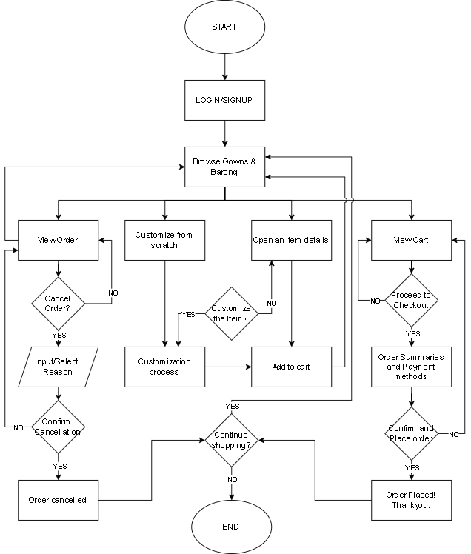
Customer / User Level
Figure 28.0 Flowchart: Customer / User Level
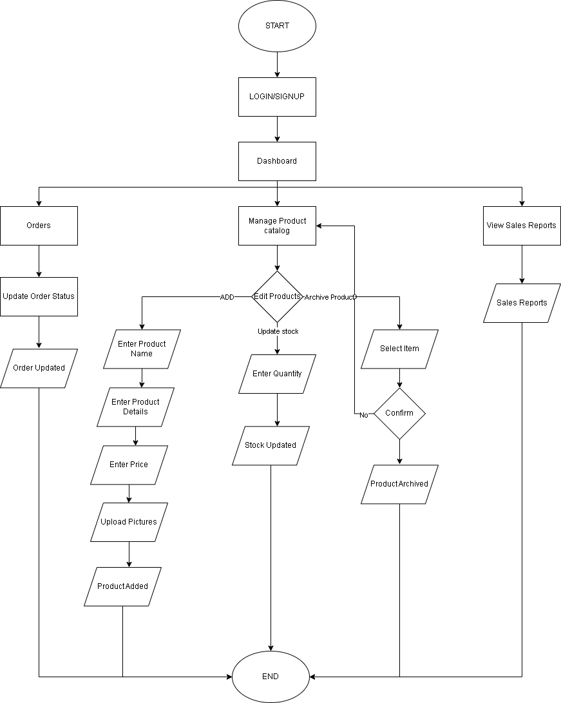
Admin Level
Figure 29.0 Flowchart: Admin / User Level
Cashier
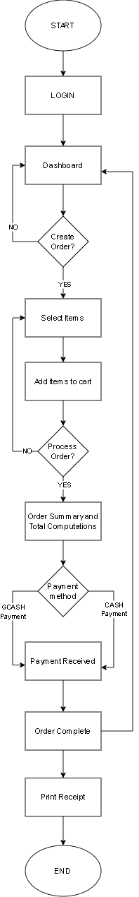
Figure 30.0 Flowchart: Cashier Level
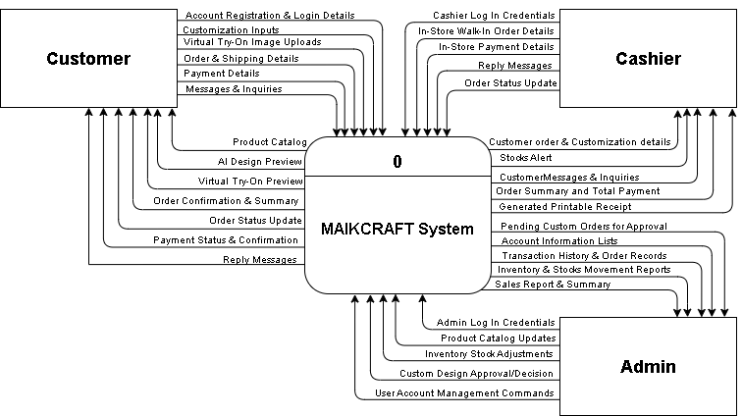
Context Diagram
Figure 31.0 Context Diagram

Data Flow Diagram
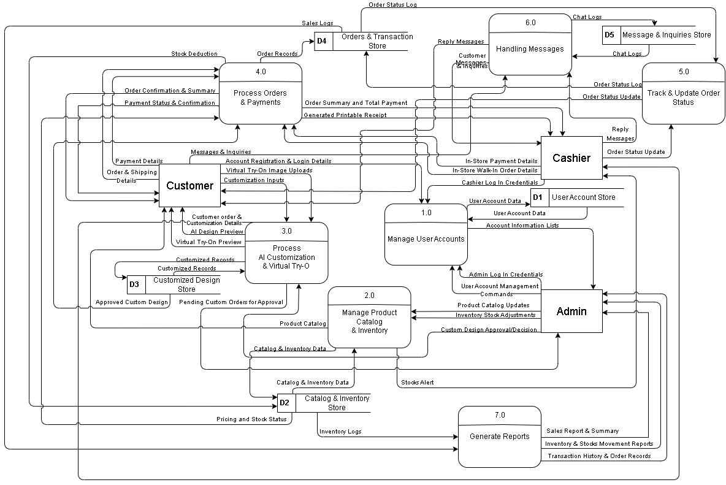
Figure 32.0 Data Flow Diagram

Entity Relationship Diagram
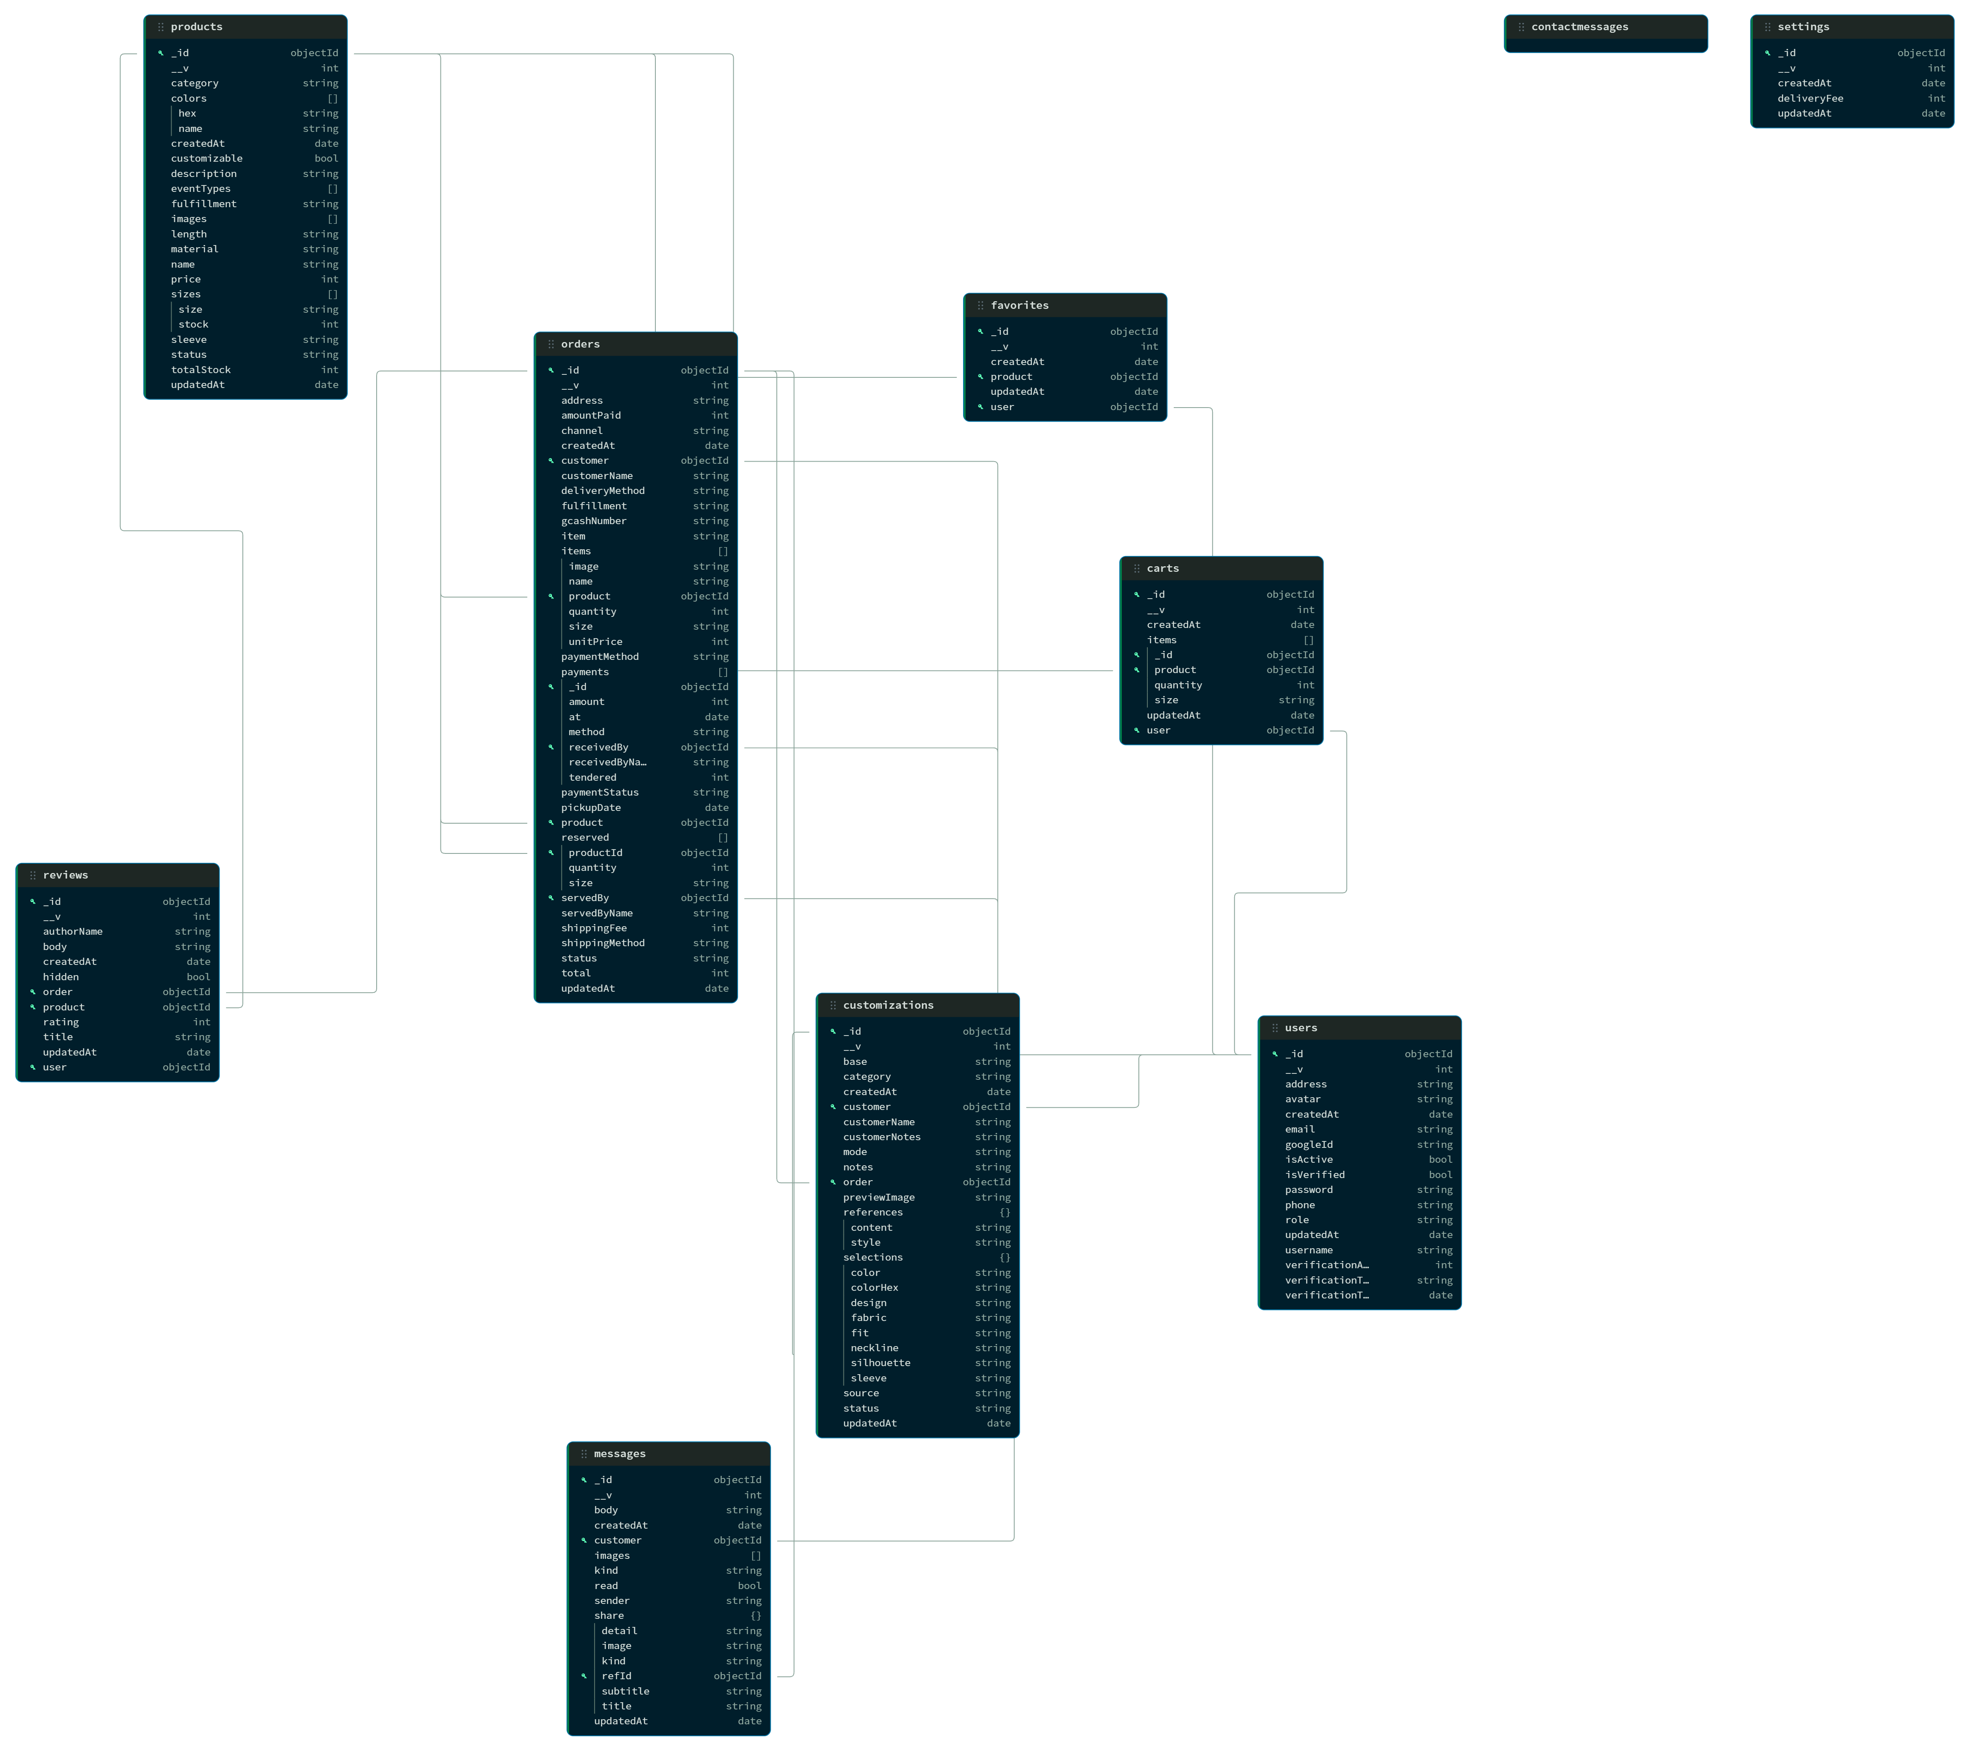

APPENDIX D. PERSONAL TECHNICAL VITAE


GABRIELLE T. BULURAN
1704 P Dela Merced St. Norzagaray, Bulacan
gabriellebuluran@gmail.com 0975 019 6013

 | EDUCATIONAL BACKGROUND
Level | Inclusive Dates | Name of school/ Institution
Tertiary | August 2023-2027 | STI College Sta. Maria
High School | June 2017-2023 | Norzagaray National High School
Elementary | June 2010-2016 | Norzagay Elementary School

SKILLS
Skills Level of Competency Date Acquired
Android Studio | Basic | January 2026
C# | Basic | August 2025
SQL | Basic | January 2025
SAP S4/Hana | Intermediate | January 2025
HTML/CSS | Basic | September 2024
Java | Basic | September 2023

TRAININGS, SEMINARS, OR WORKSHOPS ATTENDED
Inclusive Dates Title of Training, Seminar, or Workshop
2025 SAP Enterprise S/4 HANA – STI College
June 2026 Cybersecurity Fundamentals – EC- Council
2026 Research Methodology in ICT fromConcepts to Implementaion | STI College



ALDWIN MIEL G. ESPIRITU
Block 92 Lot 17 Sonoma Residence, Sta Cruz, Sta Maria Bulacan
aldwinespiritu70@gmail.com
09319393082

 | EDUCATIONAL BACKGROUND
Level | Inclusive Dates | Name of school/ Institution
Tertiary | August 2023-2026 | STI College Sta. Maria
High School | June 2016-2023 | Christian Academy of Pandi
Elementary | June 2009-2015 | Manuel G Santos Memorial School

SKILLS
Skills Level of Competency Date Acquired
Android Studio | Basic | January 2025
HTML/CSS | Basic | January 2026
C# | Basic | August 2024
SQL | Basic | August 2025
SAP S4/Hana | Intermediate | September 2023
Java  Ec-Council | Basic  Intermediate | September 2023  June 2026

TRAININGS, SEMINARS, OR WORKSHOPS ATTENDED
Inclusive Dates Title of Training, Seminar, or Workshop
2025 SAP Enterprise S/4 HANA – STI College
June 2026 Cybersecurity Fundamentals – EC- Council
2026 Research Methodology in ICT fromConcepts to Implementaion | STI College



PRINCESS MARY NICOLE S. GOPEZ
San Vicente Home Sta. Maria, Bulacan
marynicolegopez@gmail.com 0962 674 6237

EDUCATIONAL BACKGROUND
Level | Inclusive Dates | Name of school/ Institution
Tertiary | August 2023-2026 | STI College Sta. Maria
High School | June 2017-2023 | JPI Technologies Sta. Maria
Elementary | June 2010-2016 | Holy Child Montessori School of Bulacan
SKILLS
Skills | Level of Competency | Date Acquired
JavaScript | Intermediate | February 2024
HTML/CSS | Intermediate | March 2022
Java | Intermediate | August 2024
MongoDB | Intermediate | August 2026
Express.js | Intermediate | September 2025
React | Intermediate | January 2026
Node.js | Intermediate | January 2026
TRAININGS, SEMINARS, OR WORKSHOPS ATTENDED
Inclusive Dates | Title of Training, Seminar, or Workshop
2026 | EC-Council: Cybersecurity Fundamentals Certification
2025 | Software Training (SAP Enterprise S/4HANA)
2024 | The Odin Project: Full Stack JavaScript Certification
2020 | FreeCodeCamp: Responsive Web Design Certification



CHRISTIAN JANMHER G. LOVENDINO
Phirst Park Homes Pandi Bulacan
janmherchristian05@gmail.com
09928132907

EDUCATIONAL BACKGROUND
Level | Inclusive Dates | Name of school/ Institution
Tertiary | August 2023-2026 | STI College Sta. Maria
High School | June 2017-2023 | Tinajeros National High School
Elementary | June 2010-2016 | Manibaug Libutad Elementary School
SKILLS
Skills | Level of Competency | Date Acquired
HTML/CSS | Basic | October 2023
Java | Basic | January 2024
SQL | Basic | August 2025
SAP S4/Hana | Intermediate | September 2023
Java  Ec-Council | Basic  Intermediate | September 2023  June 2026
C# | Basic | August 2024
TRAININGS, SEMINARS, OR WORKSHOPS ATTENDED
Inclusive Dates | Title of Training, Seminar, or Workshop
2026 | EC-Council: Cybersecurity Fundamentals Certification
2025 | Software Training (SAP Enterprise S/4HANA)

