P3

- Name & purpose:
→ it computes n^{k} efficiently by reducing the number of multiplications using exponentiation by squaring

- Inputs:
→ n: integer (the base)
→ k: integer (the exponent)
- Outputs:
→ p: integer (the result of n^{k})
- Preconditions:
→ k ≥ 0
→ both n and k are integers
- Postconditions:
→ returns the exact value $p=n^{k}$
- High-level idea:
→ if k is odd multiply the result by n and subtract 1 from k
→ if k is even square n and halve k
→ repeat until k becomes 0
→ it reduces the number of multiplications by halving k when possible
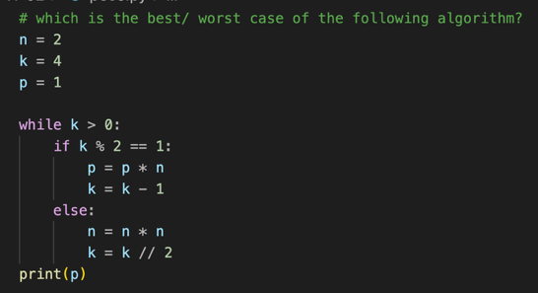
- Pseudocode:

- Complexity:
→ time: O(log k)
→ space: O(1)
→ best case: k is a power of 2 (fewest multiplications)
→ worst case: k is odd (extra multiplications)
- Correctness sketch:
→ it works because each step keeps the result equal to $n^{k}$, and when k = 0, p is the final value.
- Edge cases:
→ k = 0 returns 1
→ n = 0, k = 0 undefined, assumed 1
→ n = 0, k > 0 returns 0
→ very large numbers may overflow

