P4

- Name & purpose:
→ counts how many times the nested loops execute by combining linear and logarithmic iteration patterns.

- Inputs:
→ n: integer (controls the range of both the outer and inner loops)
- Outputs:
→ nr: integer (total number of iterations performed)
- Preconditions:
→ n is a positive integer
- Postconditions:
→ returns the total count of all inner-loop executions
- High-level idea:
→ the outer loop runs from n/2 up to n
→ for each outer step, the inner loop repeatedly divides j by 2 until it drops below 1
→ the total count increases each time the inner loop runs.
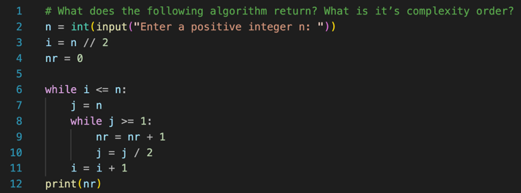
- Pseudocode:

- Complexity:
→ time: Θ(n log n) → outer loop Θ(n), inner loop Θ(log n)
→ space: Θ(1)
- Correctness sketch:
→ each outer loop runs for all i between n/2 and n
→ each inner loop halves j until 1, so total count correctly tracks all iterations
- Edge cases:
→ n = 1 outer loop runs once; inner loop runs once
→ n = 0 or negative invalid input (loop not executed)
→ very large numbers may overflow nr

