Report 2021/2022

Table of contents

## 1 Acknowledgements

Friends, Romans, countrymen, lend me your ears; I come to bury Caesar, not to praise him. The evil that men do lives after them; The good is oft interred with their bones; So let it be with Caesar. The noble Brutus Hath told you Caesar was ambitious: If it were so, it was a grievous fault, And grievously hath Caesar answer’d it. Here, under leave of Brutus and the rest– For Brutus is an honourable man; So are they all, all honourable men– Come I to speak in Caesar’s funeral. He was my friend, faithful and just to me: But Brutus says he was ambitious; And Brutus is an honourable man. He hath brought many captives home to Rome Whose ransoms did the general coffers fill: Did this in Caesar seem ambitious?

## 2 Executive Summary

Friends, Romans, countrymen, lend me your ears; I come to bury Caesar, not to praise him. The evil that men do lives after them; The good is oft interred with their bones; So let it be with Caesar. The noble Brutus Hath told you Caesar was ambitious: If it were so, it was a grievous fault, And grievously hath Caesar answer’d it. Here, under leave of Brutus and the rest– For Brutus is an honourable man; So are they all, all honourable men– Come I to speak in Caesar’s funeral. He was my friend, faithful and just to me: But Brutus says he was ambitious; And Brutus is an honourable man. He hath brought many captives home to Rome Whose ransoms did the general coffers fill: Did this in Caesar seem ambitious?

## 3 Background

Friends, Romans, countrymen, lend me your ears; I come to bury Caesar, not to praise him. The evil that men do lives after them; The good is oft interred with their bones; So let it be with Caesar. The noble Brutus Hath told you Caesar was ambitious: If it were so, it was a grievous fault, And grievously hath Caesar answer’d it. Here, under leave of Brutus and the rest– For Brutus is an honourable man; So are they all, all honourable men– Come I to speak in Caesar’s funeral. He was my friend, faithful and just to me: But Brutus says he was ambitious; And Brutus is an honourable man. He hath brought many captives home to Rome Whose ransoms did the general coffers fill: Did this in Caesar seem ambitious?## Aim

## 4 Methodology

Quant: Compare results from all schools – 2021 and 2022

Demographics of schools participating in the self-assessment tool (SAT): 2021 & 2022

Pie charts side-by-side: 2021 and 2022. Sector, Type, SES, ADII, Metro/non-metro; 2022 only: Engagement A (Low, High) and Engagement B (Low, Medium, High)

|  |  |
| --- | --- |
|  | Plot 1 |

|  |  |
| --- | --- |
|  | Plot 2 |

|  |
| --- |
| Participants by sector |

Figure 3. Participants by SES

Participants by SES

Participants by SES

Figure 4. Participants by ADII

Participants by ADII

Participants by ADII

Figure 5. Participants by location: metro / non-metro

Participants by location: metro / non-metro

Participants by location: metro / non-metro

Figure 6. Participants by DET region N/A Figure 7. Participants by eSmart status N/A

Figure 8. Part A: average (median) number of eSmart action items completed by sector (out of 23)

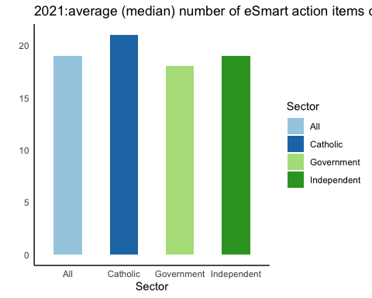

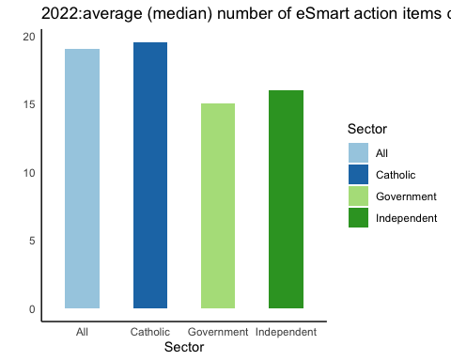

Figure 9. Part A: number of eSmart action items achieved (out of 23) by sector

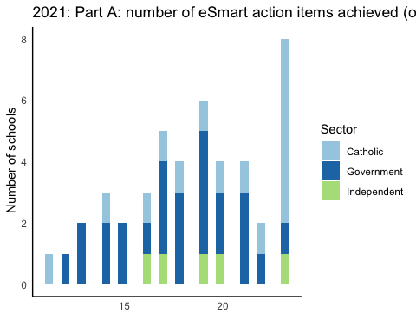

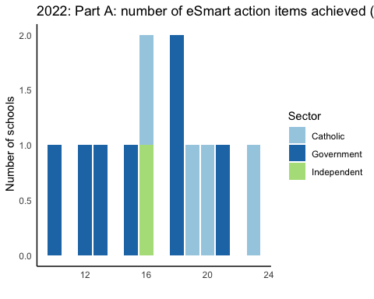

Figure 10. Part A: average (mean) completion of eSmart action items - all schools by Domain

# A tibble: 2 × 10  
 `DOMAIN: DATA` DOMAI…¹ DOMAI…² DOMAI…³ DOMAI…⁴ PRE-S…⁵ PRE-S…⁶ POST-…⁷ POST-…⁸  
 <dbl> <dbl> <dbl> <dbl> <dbl> <dbl> <dbl> <dbl> <dbl>  
1 51 45 40 54 63 5 5 6 6  
2 33 45 43 51 60 7 7 7 7  
# … with 1 more variable: `TOTAL: Domains` <dbl>, and abbreviated variable  
# names ¹​`DOMAIN: GATEWAY BEHAVIOURS`, ²​`DOMAIN: REPORTING`,  
# ³​`DOMAIN: RESPONSE`, ⁴​`DOMAIN: SCHOOL CLIMATE`, ⁵​`PRE-SURVEY1`,  
# ⁶​`PRE-SURVEY2`, ⁷​`POST-SURVEY1`, ⁸​`POST-SURVEY2`  
# ℹ Use `colnames()` to see all variable names

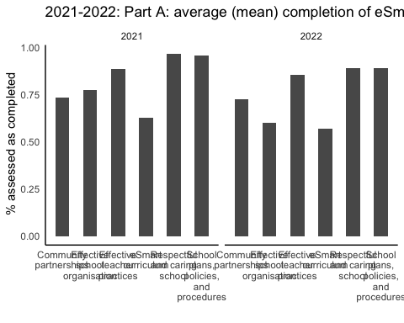

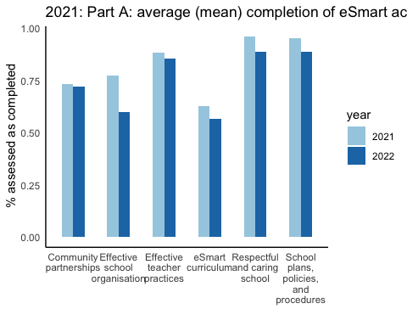

Figure 11. Part A: average (mean) completion of eSmart action items by Domain by sector

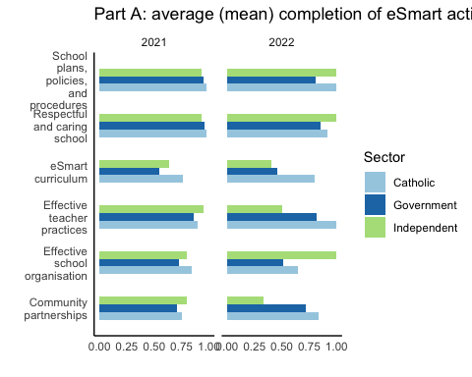

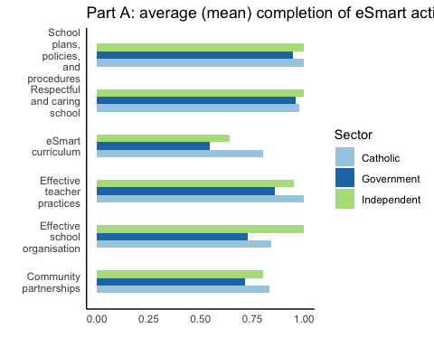

Figure 12. Part A: Average (mean) completion by Domain by SES.

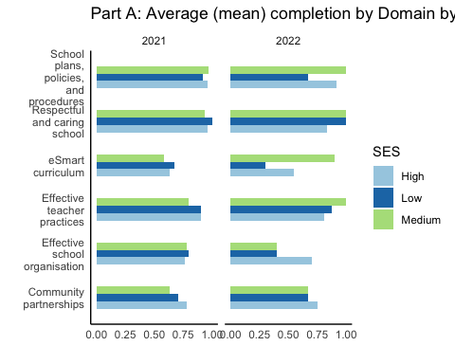

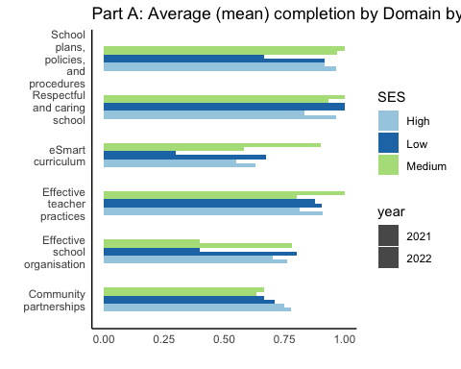

Figure 13. Part B: results by Focus Area - all schools

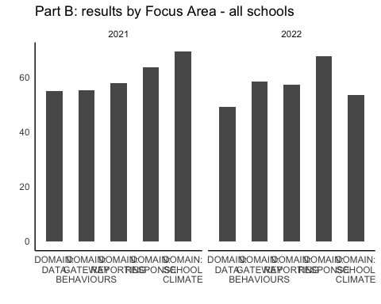

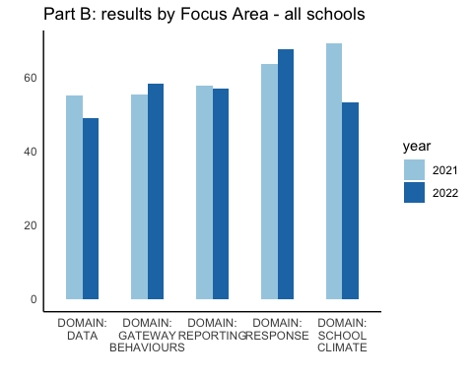

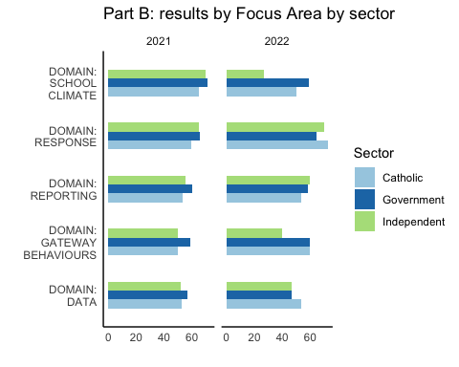

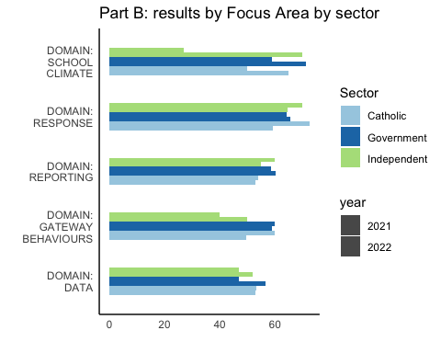

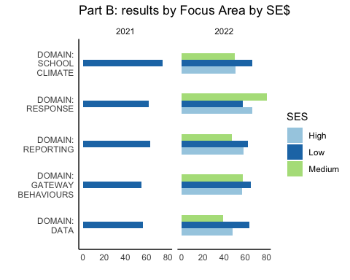

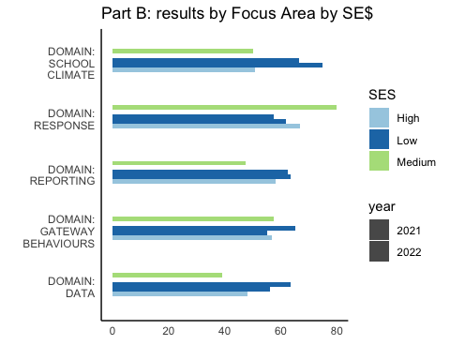

Figure 16. Part B: results by Focus Area by school type

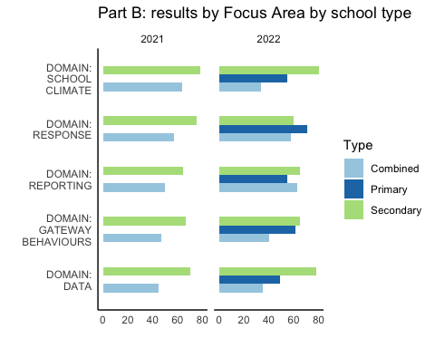

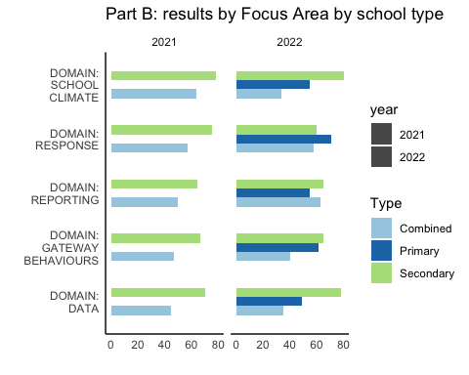

Figure 17. Part B: progress in eSmart journey - all schools - no data

Engagement - 2022 data only

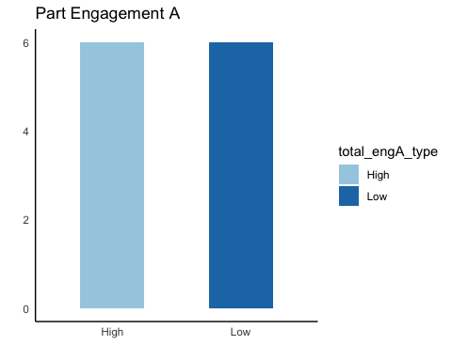

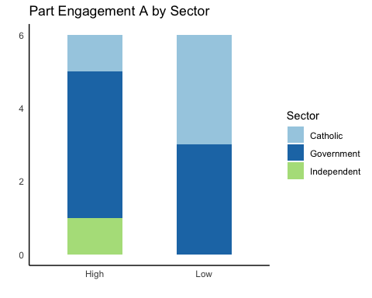

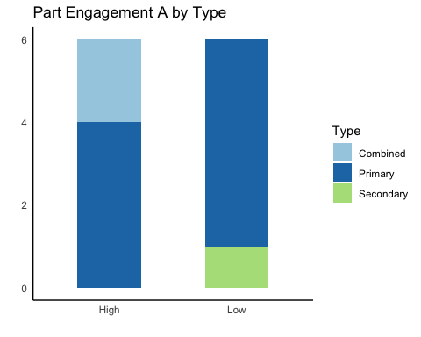

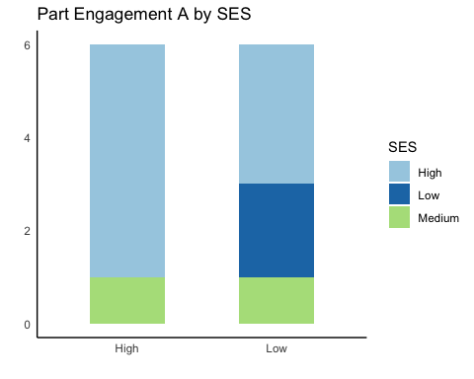

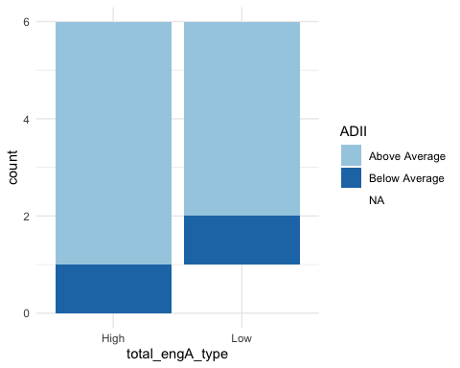

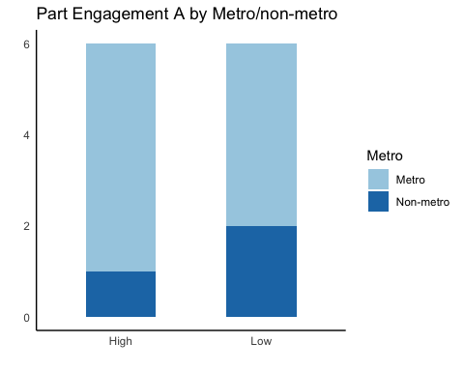

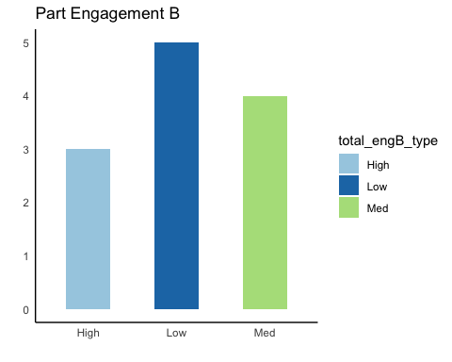

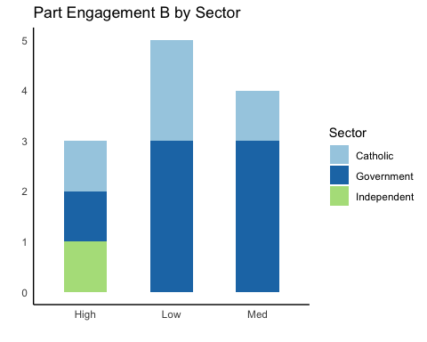

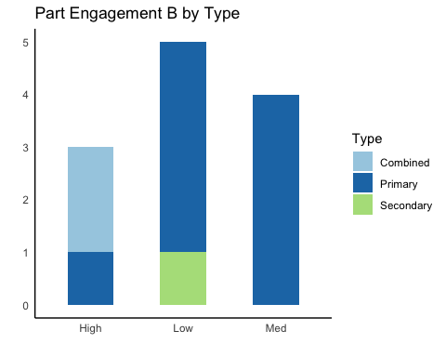

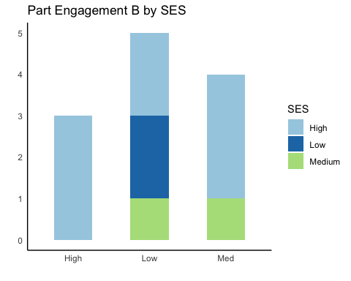

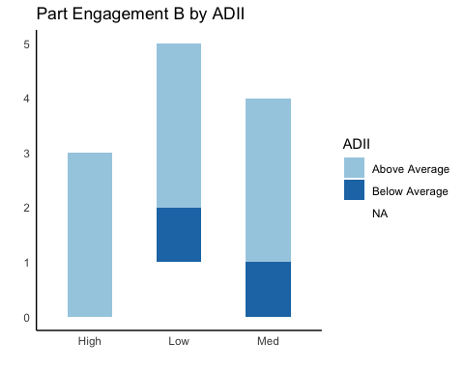

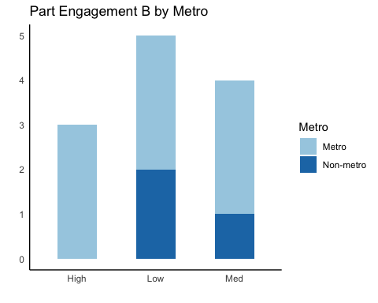

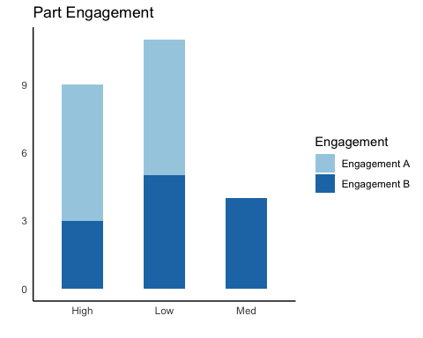

Figure 18.How well-placed schools believe they are to prevent a situation: pre- vs. post-Part B: self-assessment

Pre-post 1

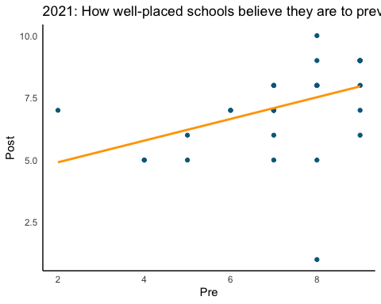

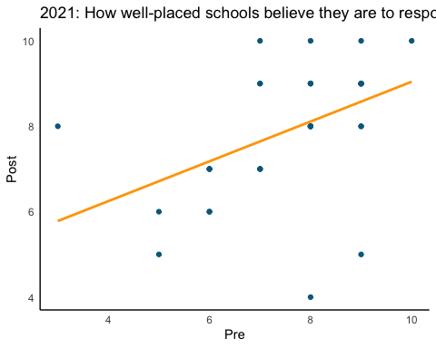

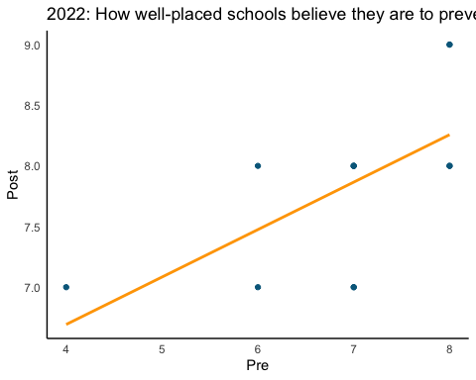

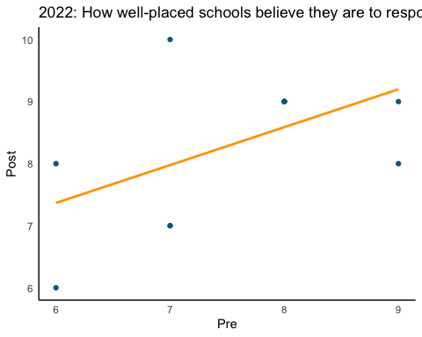

Figure 19. How well-placed schools believe they are to respond to a situation: pre- vs. post-Part B: self-assessment/

Figure 20. Comparison of Part A and Part B scores - all schools

Figure 21. two bar charts that include the 2021 vs. 2022 results for the six schools that completed the instrument both years – by Domain and total for Part A, and by Focus Area and total for Part B. ## Results

[Repeat charts from 2021 report, but with comparison to 2022 data. So, for example, bar charts would show both 2021 data (striped) next to 2022 data (solid). If charts get too crowded/too hard to read, can present side-by-side or vertically. Test for any statistically significant differences and indicate in chart.]

### 4.1 Part A Results

### 4.2 Part B Results

## 5 Summary – quantitative results

  ## Discussion [Integration of quant and qual results] ## Conclusion ## References ## Appendices