HelloJess
Application documentation
Task and habit tracker (TaskFlow subject, bonuses B1 to B4)
Node.js / Express / MongoDB API + React web app + React Native (Expo) mobile app
Contents: overview, getting started, backend, data model, API reference, statistics and calendar logic, web app, mobile app, profile, security, tests.

Table of contents
1. Overview 3
2. Getting started 5
3. Backend 7
4. API reference 10
5. Statistics (bonuses B3 and B4) 12
6. Calendar 14
7. Web application 15
8. Mobile application 19
9. Profile and editing your account 21
10. Tests and verification 23

How to read this document
- Just want to run it? Sections 1 and 2.
- Backend: sections 3 and 4 explain each folder, the data model, validation, security and every endpoint.
- How the numbers are computed: sections 5 (statistics) and 6 (calendar).
- Web and mobile apps: sections 7 and 8, with screenshots of every screen.
- Profile editing, tests and limits: sections 9 and 10.

1. Overview
HelloJess is a task and habit tracker. A user registers, manages their own tasks (title, status, description, due date, priority), filters them, tracks recurring habits day by day, and follows their activity on a calendar, a GitHub-style heatmap and weekly or monthly completion statistics. It implements the TaskFlow university subject with all four bonuses.
The project is made of three pieces that share one backend:
- backend/ : a Node.js + Express REST API storing data in MongoDB with Mongoose, with JSON Web Token authentication.
- web/ : a React + TypeScript single-page application built with Vite.
- mobile/ : a React Native application built with Expo (runs on a phone with Expo Go, on an emulator, or in a browser).

1.1 Architecture
Web app  React + Vite  Mobile app (Expo) | HTTP + JSON  → | Express API  routes, middleware  controllers, services  zod validation, JWT | Mongoose  → | MongoDB  users, tasks,  habits, habitevents

Both clients are thin: they only display data and send requests. All rules (validation, ownership, statistics, calendar) live in the API, so the web and mobile apps always behave the same.

1.2 Technology
Area | Technology | Why
API | Node.js 22+, Express 5 | Simple, widely used; the course language is JavaScript
Database | MongoDB + Mongoose 9 | Document storage; Compass lets you browse the data
Validation | zod 4 | One schema per request; precise per-field messages
Authentication | bcryptjs (12 rounds) + jsonwebtoken (HS256) | Passwords are never stored in clear; stateless login
Tests | Node built-in test runner (node --test) | No extra dependency, no database needed
Web | React 19, React Router 7, axios, Vite, TypeScript | Fast dev server, typed code
Mobile | React Native 0.86, Expo SDK 57, React Navigation 7, AsyncStorage | One code base for iOS and Android

1.3 What is implemented
Mandatory part (MVP): registration and login, the list of your own tasks, add, detail, edit and delete, validation with clear error messages, persistent storage in MongoDB, and authorization enforced by the API (you can never read or change someone else's task).
Bonus | Feature
B1 | priority field (low, medium, high); filters by status, priority and due date (overdue, today, next 7 days, no date); counter per status
B2 | Second entity Habit with dated completion events (one per habit per day)
B3 | GitHub-style heatmap of daily activity (completed tasks + habit completions), including empty days, time zones handled
B4 | Statistics: weekly or monthly completion rate and evolution against the previous period
Extra | Calendar with a colour per status, overdue tasks carried onto today; profile page where name and email can be edited

2. Getting started

2.1 Requirements
- Node.js 22 or newer.
- A running MongoDB server (locally: MongoDB Community Server on 127.0.0.1:27017). MongoDB Compass is optional and shows the data.
- For the phone: the Expo Go app and a phone on the same Wi-Fi as the computer.

2.2 Backend
cd backend
npm install
npm run dev # restarts automatically on changes
npm test # 60 unit tests
The server listens on 0.0.0.0:8000 so that a phone on the same network can reach it. The database hellojess and its collections are created automatically on first use.
Variable | Default | Purpose
PORT | 8000 | Port the API listens on
MONGODB_URI | mongodb://127.0.0.1:27017/hellojess | MongoDB connection string
CORS_ORIGIN | * | Allowed browser origin(s), comma-separated
SECRET_KEY | development placeholder | Secret used to sign login tokens. Change it outside local development
ACCESS_TOKEN_EXPIRE_MINUTES | 10080 (7 days) | How long a login token stays valid
Settings are read in backend/src/config/env.js. Copy backend/.env.example to backend/.env to override them.

2.3 Web app
cd web
npm install
npm run dev # http://localhost:5173
web/.env holds VITE_API_URL (default http://localhost:8000). The app adds the /api prefix itself.

2.4 Mobile app
cd mobile
npm install
npx expo start
Scan the QR code with Expo Go. mobile/.env holds EXPO_PUBLIC_API_URL, which must be the computer's LAN address (for example http://192.168.1.250:8000), because a phone cannot reach localhost. Find the address with ipconfig (IPv4 Address). If the IP changes or the network changes, update this file and restart Expo. On the Android emulator, http://10.0.2.2:8000 also works.
If the login screen spins forever on the phone, the address in mobile/.env is almost always stale. The app times out after 10 seconds and shows which URL it tried to reach.

3. Backend
The backend is organised in layers. A request travels through them in order, and each layer has one job.
request -> app.js (CORS, JSON, mount /api routes)
-> routes/ which URL goes to which controller, with which middleware
-> middleware validate(schema) and requireAuth
-> controllers/ read the request, call a service, build the response
-> services/ business rules and database queries
-> models/ Mongoose schemas (the shape of each collection)

3.1 Folder map (backend/src)
Path | Role
config/env.js | Reads environment variables (port, MongoDB URL, CORS origin, secret, token lifetime) into one config object
config/db.js | Connects to MongoDB with Mongoose (connectDB)
models/ | User, Task, Habit, HabitEvent schemas
schemas.js | All zod validation schemas (one per request)
middleware.js | validate() (input checking) and requireAuth (login check)
security.js | Password hashing and token creation/decoding
controllers/ | One file per resource: auth, tasks, habits, stats, calendar
routes/ | One router per resource, declaring URL + middleware + controller
services/app.js | Builds the Express app and mounts every router under /api
services/server.js | Connects to MongoDB, then starts listening on the port
services/*Service.js | Business logic: tasks, habits, statistics, calendar
services/statsCalculations.js, calendarEvents.js | Pure calculation functions (no database), easy to unit-test
utils/dates.js | Calendar-date helpers and time-zone conversion

3.2 Starting the server
services/server.js first connects to MongoDB, and only then calls app.listen, so the API never accepts requests it cannot serve. services/app.js creates the Express application, enables CORS (config.corsOrigin), enables JSON body parsing, and mounts the routers:
app.get("/health", ...) // is the server up?
app.use("/api/auth", authRouter)
app.use("/api/tasks", taskRouter)
app.use("/api/habits", habitRouter)
app.use("/api/stats", statsRouter)
app.use("/api/calendar", calendarRouter)
After the routers come two catch-alls: an unknown URL returns 404 { detail: "Not Found" }, and an error handler turns malformed JSON into 400, Mongoose validation errors into 422, and anything else into a logged 500.

3.3 Models
Every model removes internal fields when converted to JSON: _id becomes id, owner and the password hash are never sent.
Model (collection) | Fields
User (users) | email (unique), name, hashed_password, created_at
Task (tasks) | owner, title (1-120), status (todo, doing, done), description (0-1000), dueDate (YYYY-MM-DD or null), priority (low, medium, high), completedAt, timestamps
Habit (habits) | owner, name (1-100), description (0-500), timestamps
HabitEvent (habitevents) | owner, habit, date (YYYY-MM-DD), createdAt. A unique index on (habit, date) allows only one completion per habit per day
dueDate and habit date are plain calendar days stored as text, not timestamps. A due date of 2026-10-05 therefore never shifts to another day depending on the time zone.

3.4 Validation
schemas.js defines one zod schema for each request (register, login, profile update, task create/update/list filters, habit create/update/range, habit event, calendar, heatmap, completion). The validate(schema, source) middleware runs a schema against the body or the query string and replaces it with the cleaned values. When something is wrong the API answers 422:
{ "detail": "Validation failed",
"errors": [ { "field": "title", "message": "title must not be empty" } ] }
Examples of rules: the title is trimmed and limited to 120 characters; the status must be exactly todo, doing or done; a due date must be a real date (2026-02-30 is refused); an email must be a valid address; unknown fields such as owner or completedAt are ignored so a client cannot forge them.

3.5 Authentication and security
- Passwords are hashed with bcrypt (12 rounds) in security.js. Only the hash is stored.
- Login returns a signed JWT (HS256) whose subject is the user's id. The token is valid for 7 days by default.
- requireAuth reads Authorization: Bearer <token>, decodes it, loads the user, and puts it on the request. A missing, expired, tampered or foreign-signed token gets 401. Tokens issued before the id-based format (whose subject was an email) are still accepted.
- Ownership: every service query includes the logged-in user's id. A task, habit or event belonging to someone else behaves exactly like one that does not exist (404), so its existence is not even revealed.

3.6 Services
Service | What it does
taskService | List tasks with filters (status, priority, due range, no due date), count by status, create, read, update, delete. When the status changes to done it stamps completedAt; when it leaves done it clears it
habitService | CRUD for habits and for their dated events. Optionally returns, with each habit, the days it was done in a range. Deleting a habit deletes its events. Adding an event twice for the same day returns the existing one
statsService + statsCalculations | Loads tasks and habit events, then builds the heatmap and the completion rates with pure functions
calendarService + calendarEvents | Loads tasks and habit events for a period and turns them into calendar events (see section 6)

3.7 Date utilities
utils/dates.js works with civil dates (YYYY-MM-DD): validity check (leap years included), addDays, daysBetween, eachDay, start and end of week (Monday to Sunday) and month, and toCivilDate(instant, timeZone), which converts a moment in time to the calendar day in a given time zone using Intl. Converting each instant to a day, instead of adding 24 hours, keeps daylight-saving days of 23 or 25 hours correct.

4. API reference
All routes except register, login and /health need the header Authorization: Bearer <token>.
Method and path | What it does
POST /api/auth/register | Create an account { email, name, password }; logs in immediately. 400 if the email is already registered
POST /api/auth/login | { email, password } returns { access_token, user }
GET /api/auth/me | The logged-in user
PATCH /api/auth/me | Edit profile { name?, email? }; returns the updated user and a fresh token. 400 if the email is used, 422 if invalid
GET /api/tasks | Your tasks. Filters: status, priority, dueFrom, dueTo, noDueDate=true
GET /api/tasks/count | { total, todo, doing, done }
POST /api/tasks | Create a task (title and status required)
GET /api/tasks/:id | Task detail
PATCH /api/tasks/:id | Edit a task; only the fields sent change
DELETE /api/tasks/:id | Delete a task
GET /api/habits | Your habits (?from=&to= adds the days each was done)
POST /api/habits | Create a habit
GET / PATCH / DELETE /api/habits/:id | Read, edit, delete a habit (deleting removes its events)
GET /api/habits/:id/events | Completions of a habit (optional range)
POST /api/habits/:id/events | Mark a day done: { "date": "2026-10-05" }
DELETE /api/habits/:id/events/:date | Unmark a day
GET /api/calendar?from=&to=&tz= | Calendar events for a period (at most 62 days)
GET /api/stats/heatmap?from=&to=&tz= | Heatmap data (default last 52 weeks, at most 366 days)
GET /api/stats/completion?period=&count=&tz= | Completion rate per week or month
GET /health | { status: "ok" }

4.1 Status codes
Code | Meaning
200 / 201 / 204 | Success (read or update / created / deleted)
400 | Email already registered, or malformed JSON
401 | Not logged in, bad credentials, or invalid / expired token
404 | Resource not found (or it belongs to someone else)
422 | Validation failed, with one message per field
500 | Unexpected server error (logged, details not exposed)

5. Statistics (bonuses B3 and B4)
Everything is computed on calendar days in the user's time zone. The apps send their zone (tz, for example Europe/Paris) automatically; the default is UTC. A task completed at 23:30 UTC on 1 March counts for 2 March in Paris but for 1 March in New York. Weeks run Monday to Sunday and months are calendar months.

5.1 Heatmap
The API returns one entry for every day of the period, including days without activity:
- tasks: tasks completed that day.
- habits: habit completions that day.
- total: the sum of both.
- level from 0 to 4: 0 when the total is 0, otherwise ceil(total / max * 4), where max is the busiest day of the period.
The clients draw the grid (one column per week), month labels, a legend and a tooltip per day.

5.2 Completion rate
For each week or month:
- completed = tasks whose completion day falls in the period.
- workload = tasks "in play": created on or before the last day of the period and not completed before its first day.
- rate = completed / workload, between 0 and 1, or null (not 0) when the workload is 0, because a rate cannot be measured on zero tasks.
- change = rate minus the previous period's rate (null if either is null).
Known limitation: reopening a completed task clears its completion date, so it no longer counts as completed in the past.
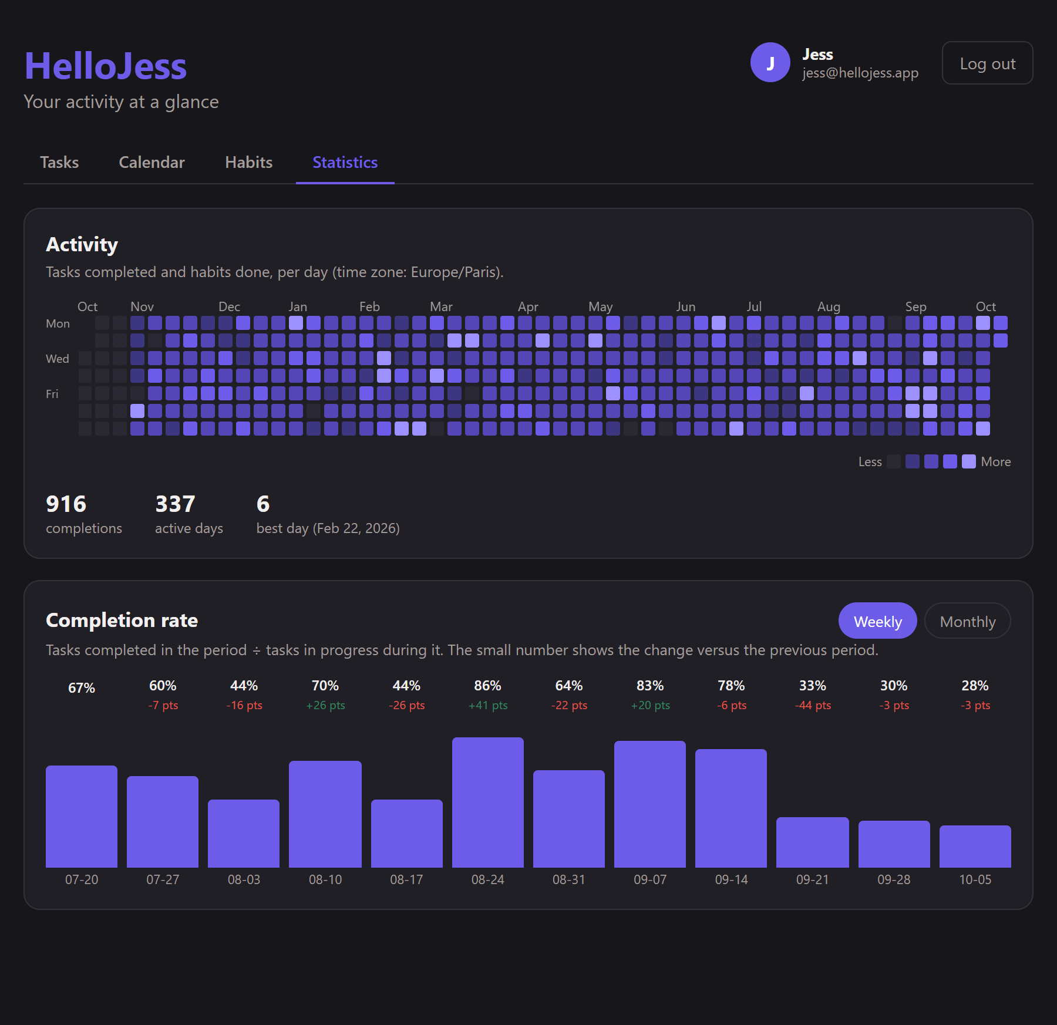
Statistics page: summary, heatmap and completion chart (web)

6. Calendar
GET /api/calendar returns a list of events for a period. Each event has a date, a type and a title:
Type | Shown when | Colour
task-due | An open task on its due date, or on the day it was created when it has no due date | To do purple, Doing orange
task-overdue | An open task whose due date has passed | Status colour with a red outline
task-undated | An open task without a due date | Status colour
task-done | A completed task, on the day it was completed | Green
habit | A habit completion on its day | Blue
Overdue tasks that are due before the visible period (for example last month) are carried onto today, so they are never hidden. The pure function buildCalendarEvents produces all of this and is covered by unit tests.
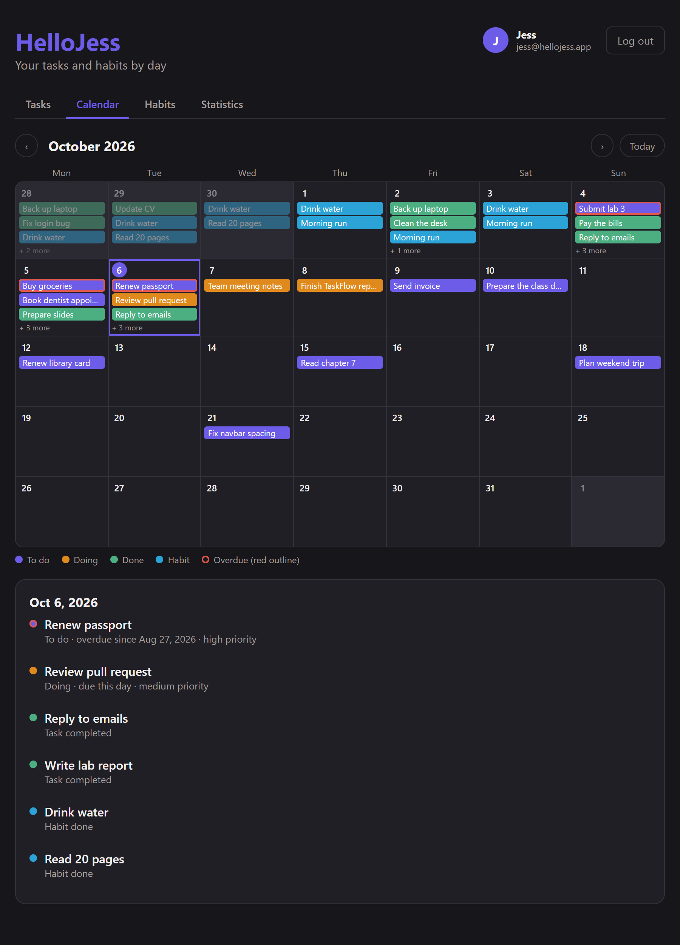
Calendar: month grid with coloured events and the selected day's list (web)

7. Web application
A React 19 + TypeScript single-page app built with Vite. Pages are routed with React Router; every page except login and register is wrapped in RequireAuth, which redirects to /login when nobody is logged in.

7.1 Structure (web/src)
File | Role
main.tsx, App.tsx | Entry point; router with the routes /login, /register, /, /tasks/:id, /calendar, /habits, /stats, /profile
api.ts | axios client with base URL VITE_API_URL + /api, a 10-second timeout, automatic Authorization header from the stored token, errorMessages() that extracts readable messages from API errors, and the TypeScript types of the API data
context/AuthContext.tsx | Holds the logged-in user; login, register, updateProfile, logout; stores the token in localStorage (hellojess_token) and re-checks it on startup
components/AppHeader.tsx | Title, navigation tabs, the user chip (avatar, name, email) linking to the profile, and Log out
components/TaskItem.tsx | One task row: checkbox, status selector, priority, due date, overdue marker
components/CalendarView.tsx | The month grid and day list
components/Heatmap.tsx, CompletionChart.tsx | Drawing of the statistics
components/ErrorList.tsx | Shows a list of error messages
utils/dates.ts | Local date formatting and today's date
pages/*.tsx | One component per screen (below)

7.2 Pages

Login and Register
Forms that call the API and show the real server message (for example "Email already registered"). A successful register logs the user in at once.

Tasks (home)
An add-task form (with live validation messages from the API), filters by status, priority and due date, a counter per status, and the task list. Each row has a checkbox (done / not done) and a status selector, and overdue tasks are highlighted. Clicking a title opens the detail page.
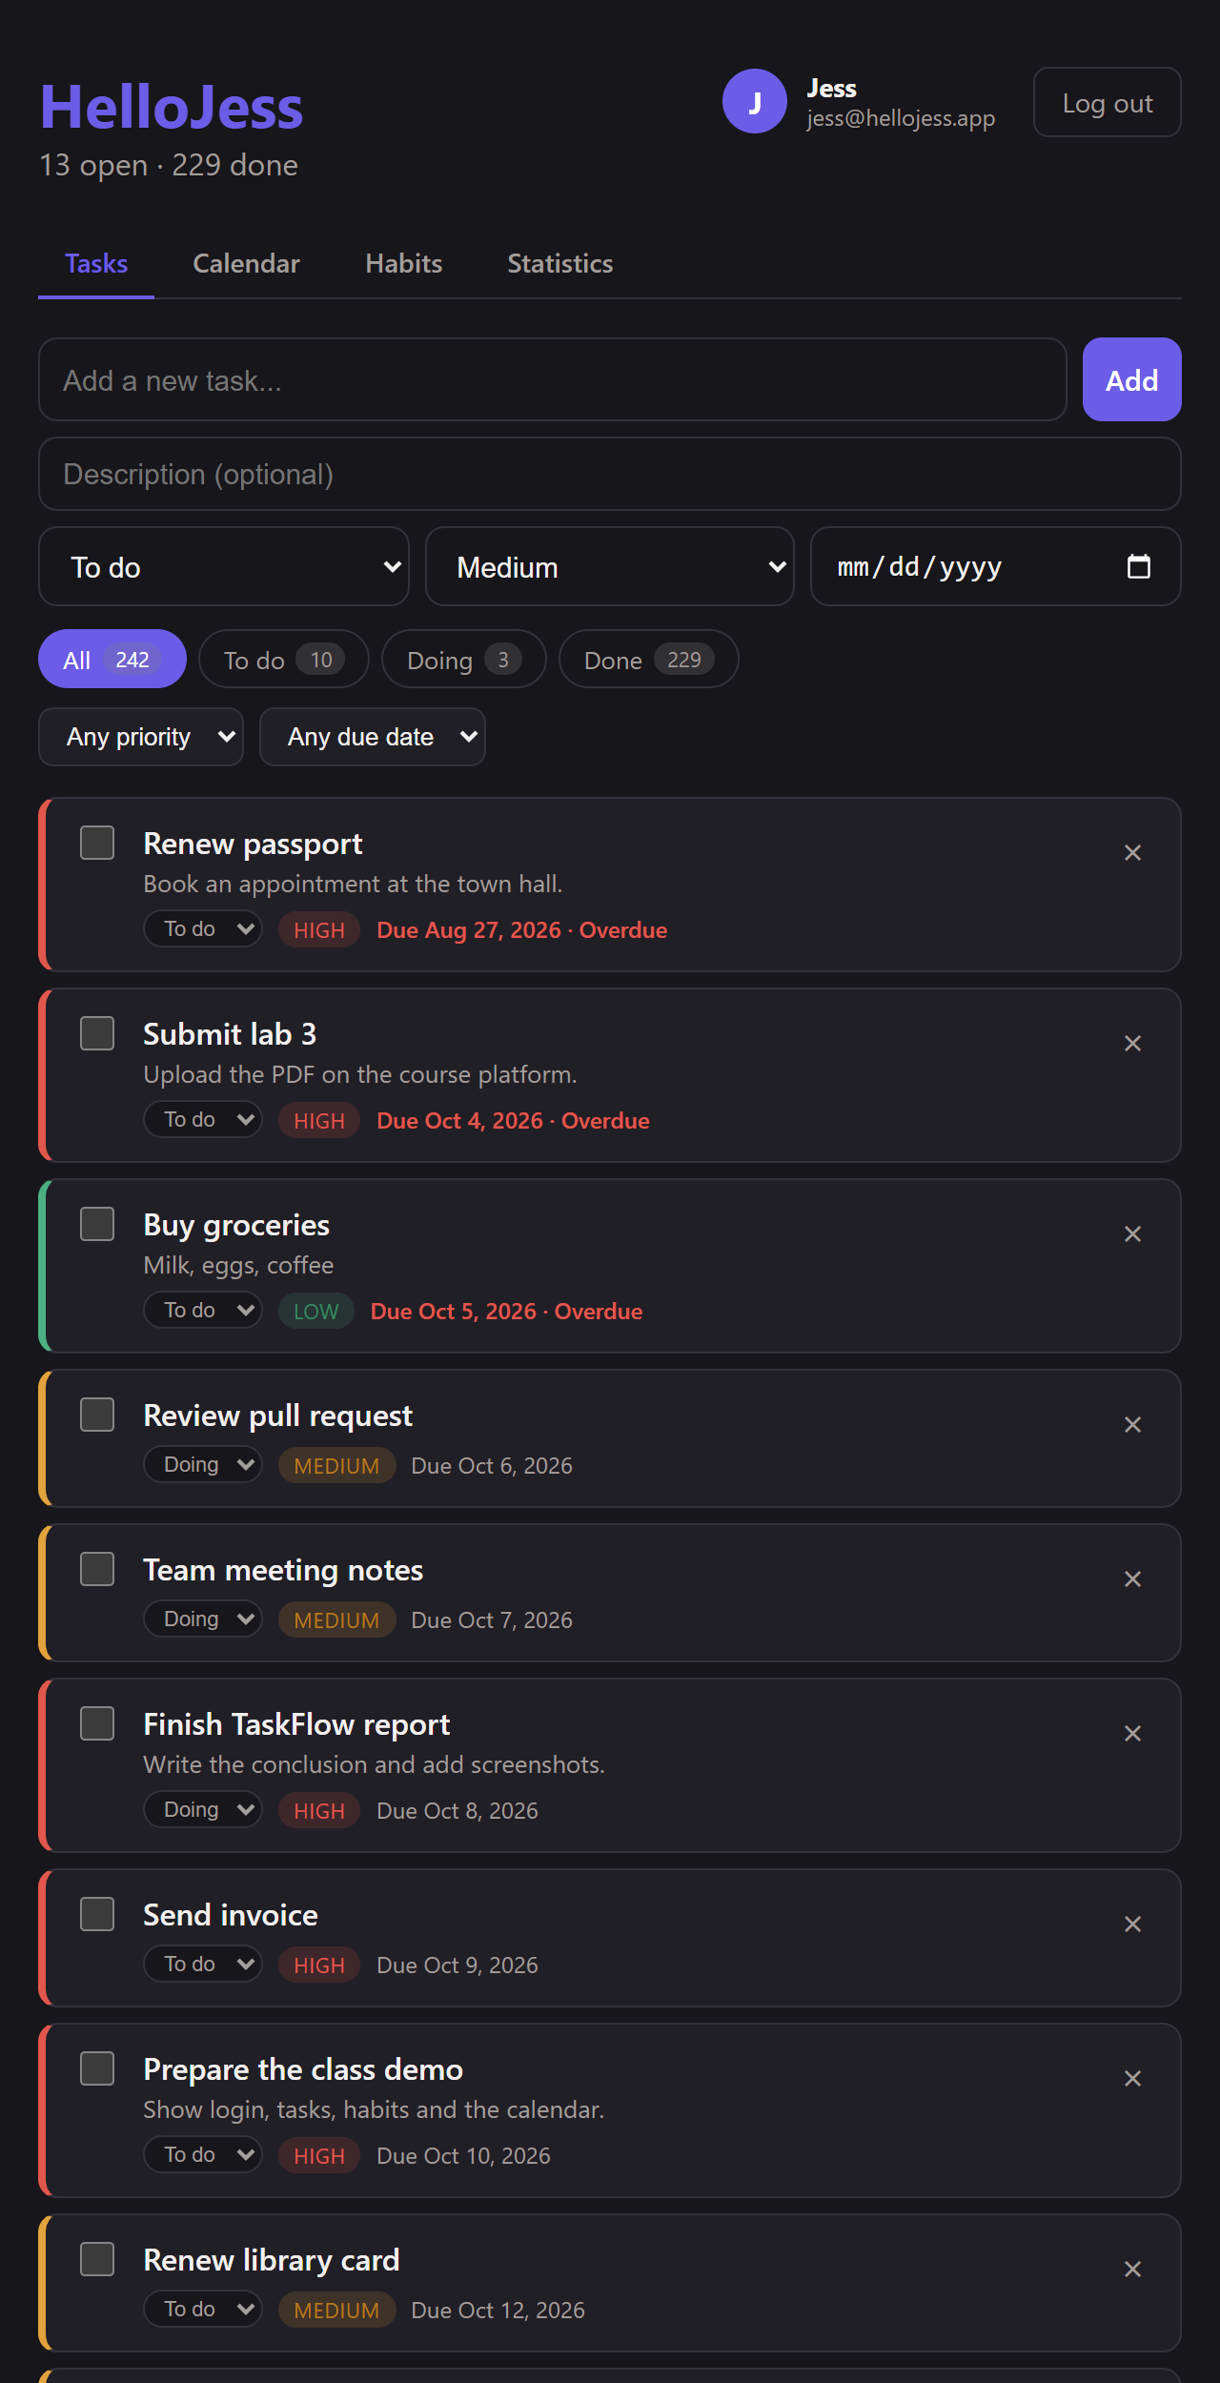
Tasks page with filters, counter and overdue tasks

Task detail
Shows all fields of one task and lets you edit or delete it. Validation errors are shown next to the form.
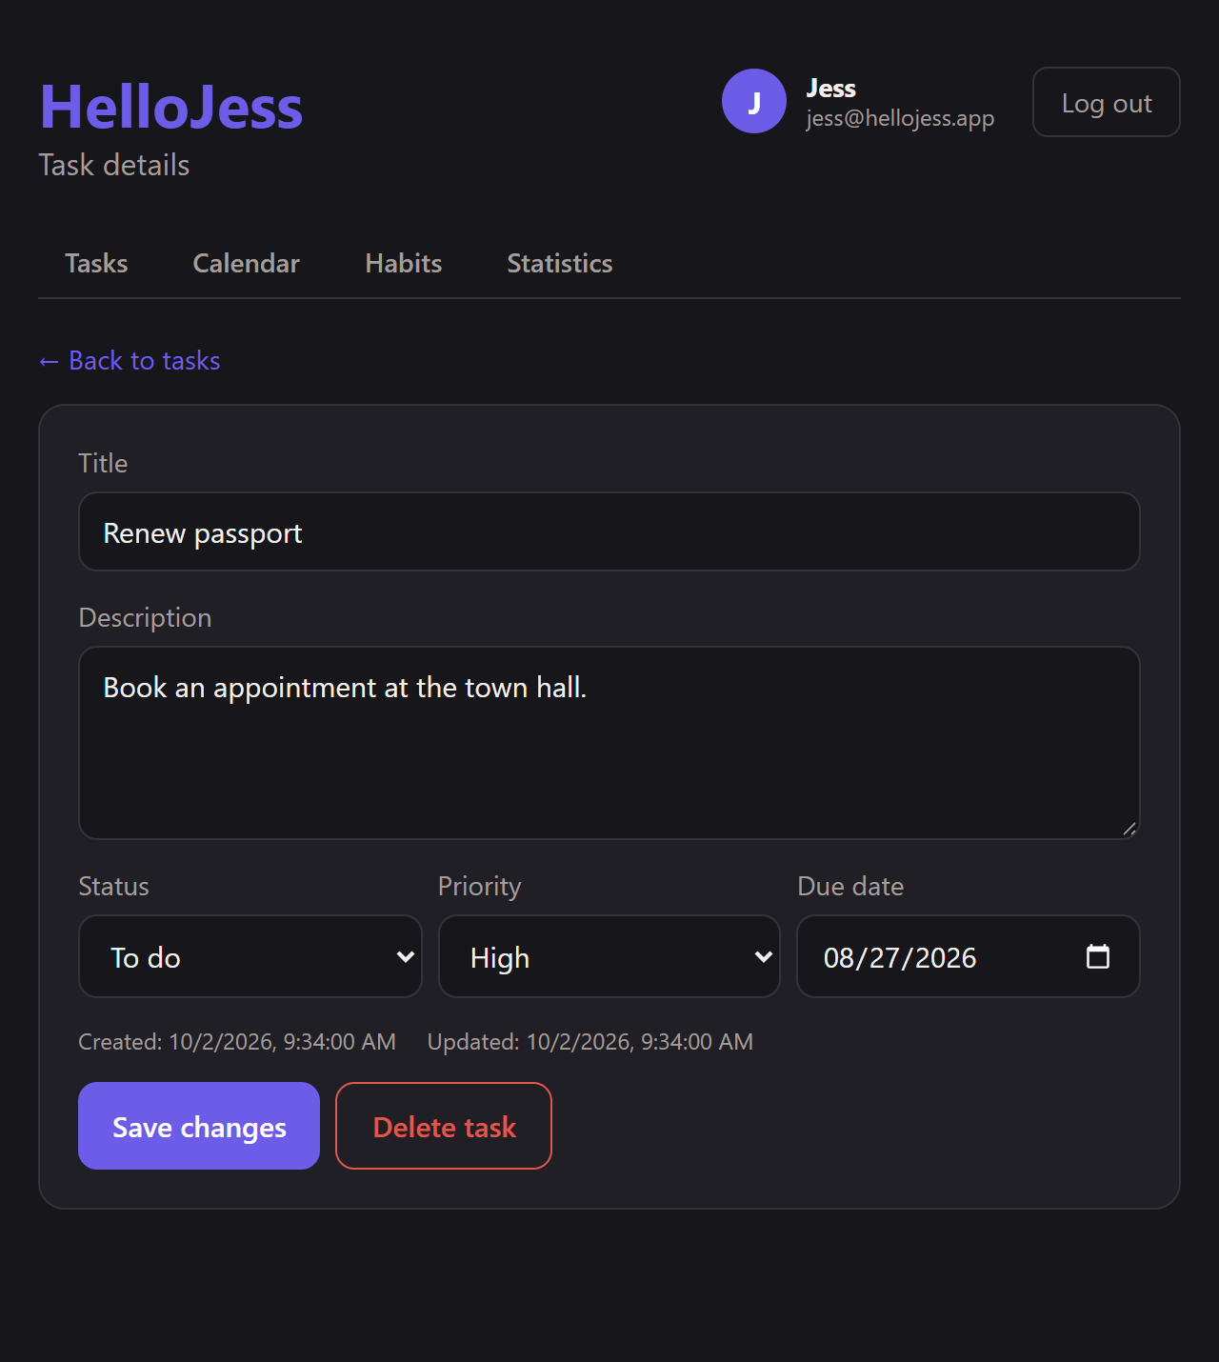
Task detail and edit
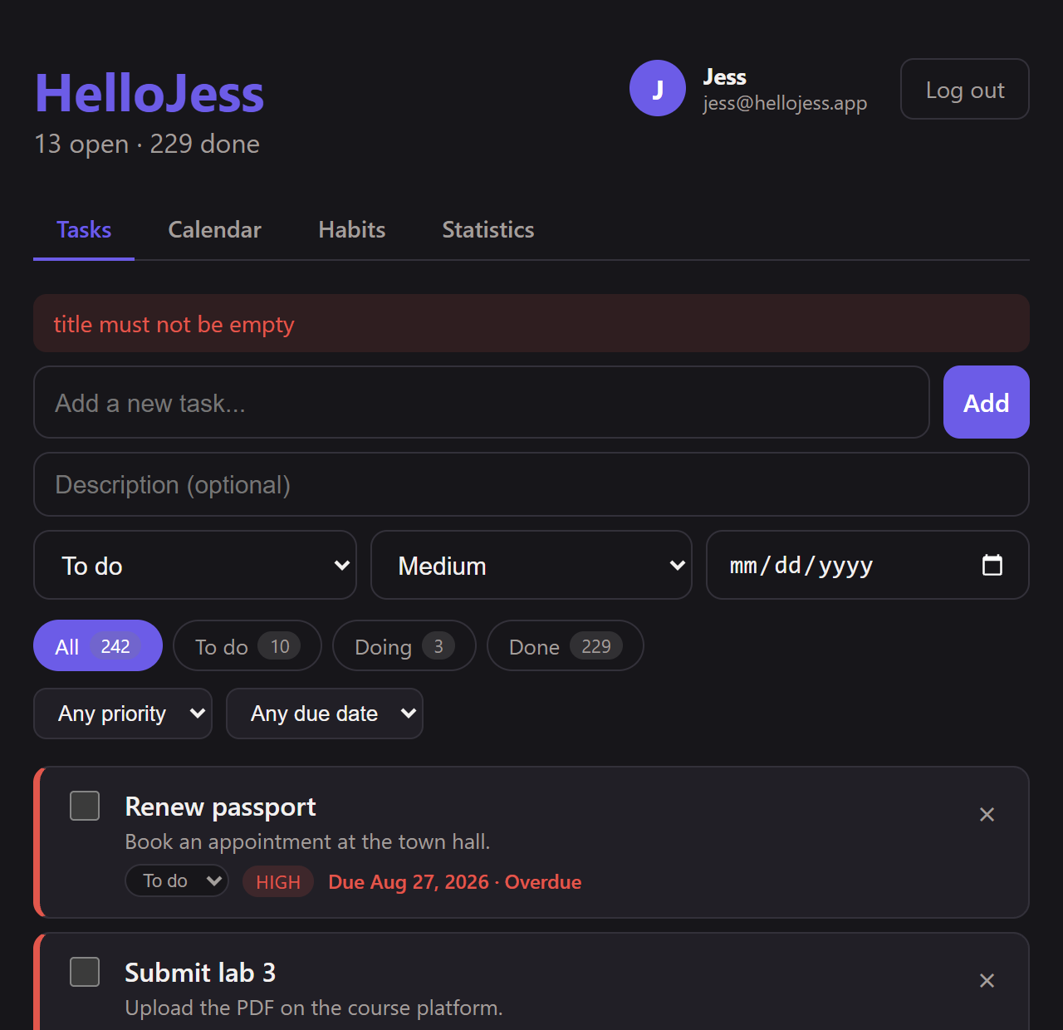
Validation messages on an empty title

Calendar, Habits, Statistics
The calendar is described in section 6. Habits lists habits with a strip of the last 7 days that you can tick or untick, plus a form to add a habit. Statistics shows the summary numbers, the heatmap and the completion chart (section 5).
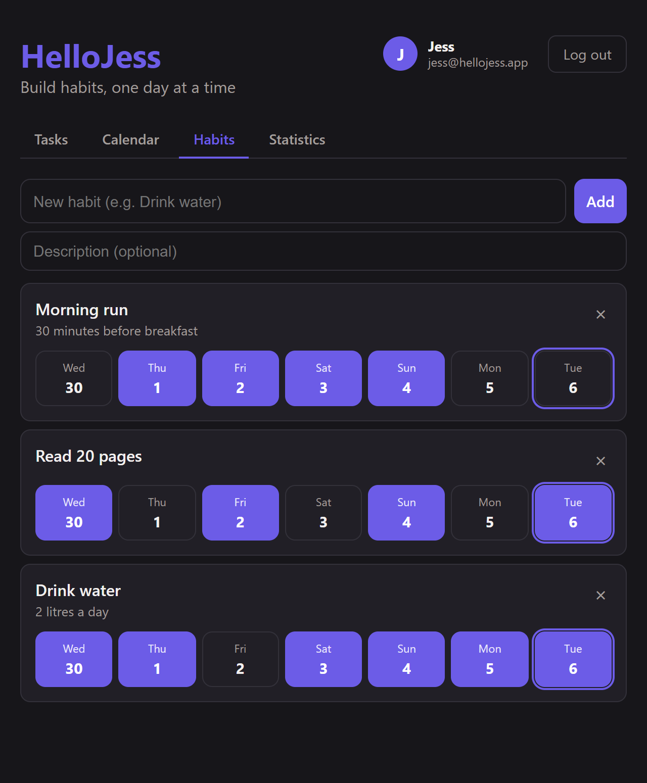
Habits: tick a day to record a completion

Profile
Opened by clicking the user chip in the header. It shows the account details (name, email, member since, user ID) and an activity summary (tasks by status, habits). Edit profile opens a form to change the name and email; see section 9.
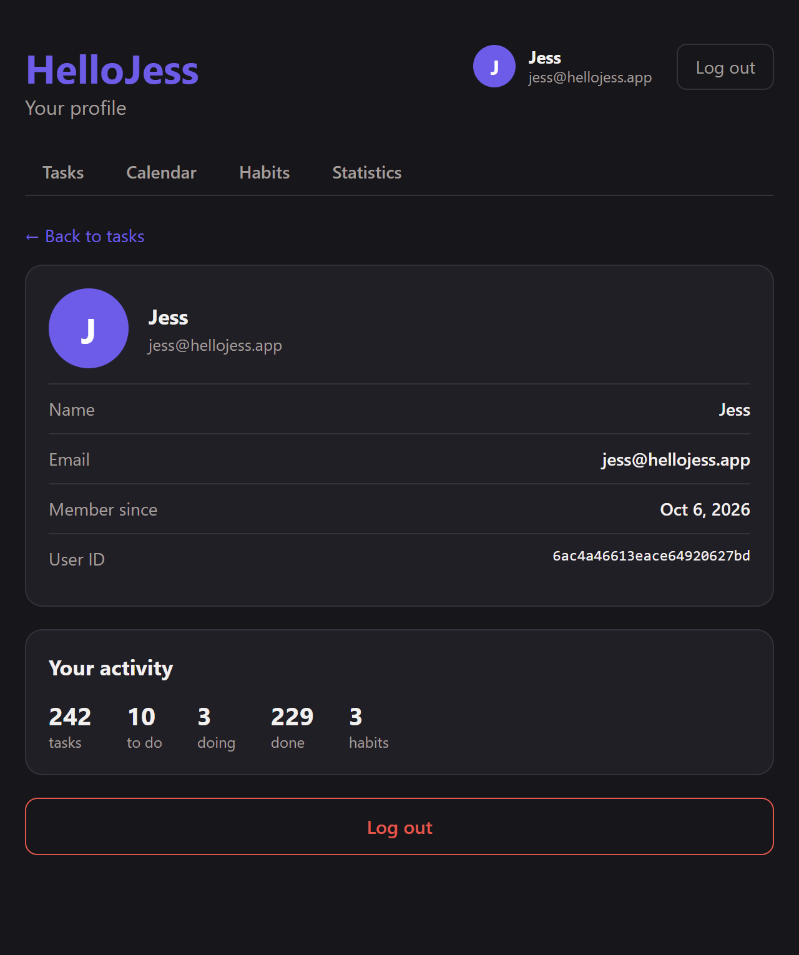
Profile page

8. Mobile application
A React Native app built with Expo SDK 57. It has the same features as the web app and talks to the same API. Navigation uses a native stack (React Navigation): when logged out only Login and Register exist; when logged in, Tasks, TaskDetail, Calendar, Habits, Stats and Profile.

8.1 Structure (mobile)
File | Role
App.tsx | Wraps everything in AuthProvider and the navigator; shows a spinner while the saved session is being checked
src/api.ts | axios client (EXPO_PUBLIC_API_URL + /api, 10-second timeout, token header from AsyncStorage) and the shared types; error messages name the URL that could not be reached
src/context/AuthContext.tsx | Same role as on the web, with the token stored in AsyncStorage
src/screens/*Screen.tsx | Tasks, TaskDetail, Calendar, Habits, Stats, Profile, Login, Register
src/screens/styles.ts | All styles in one place (dark theme, purple accent)
src/components/ | TopNav (title, user chip, tabs), Chip, ErrorList, Heatmap, CompletionChart
src/utils/ | calendar.ts (month grid), dates.ts (date names written by hand, no Intl dependence), confirm.ts (confirmation before destructive actions such as deleting a habit, working on phone and web)

8.2 Screens
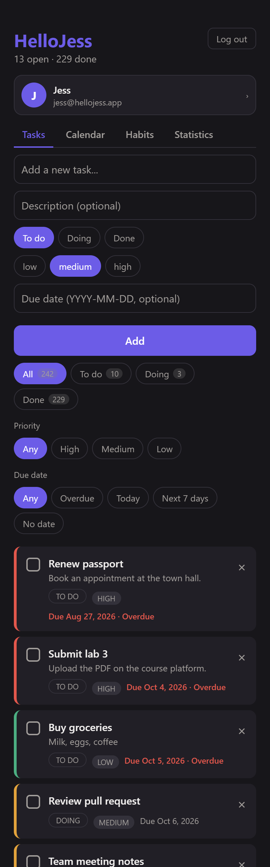  Tasks | 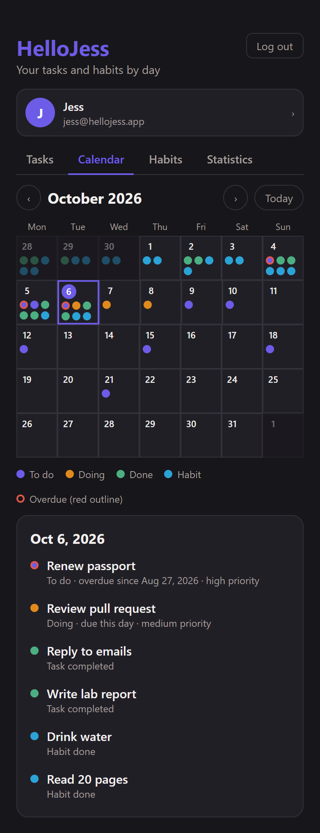  Calendar | 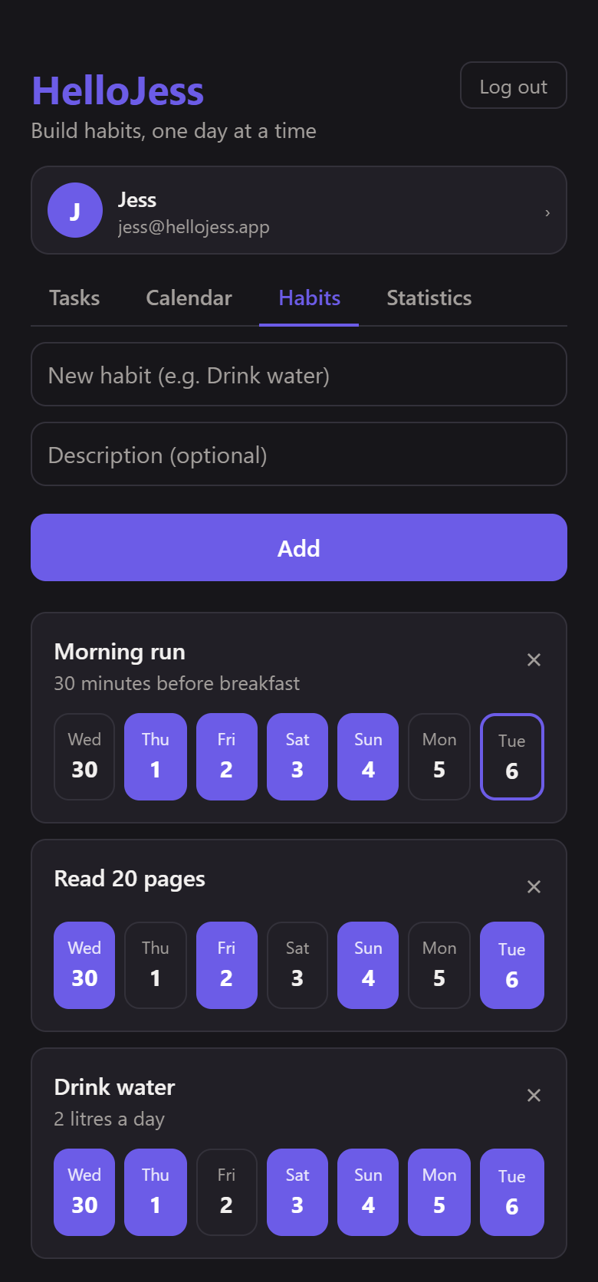  Habits | 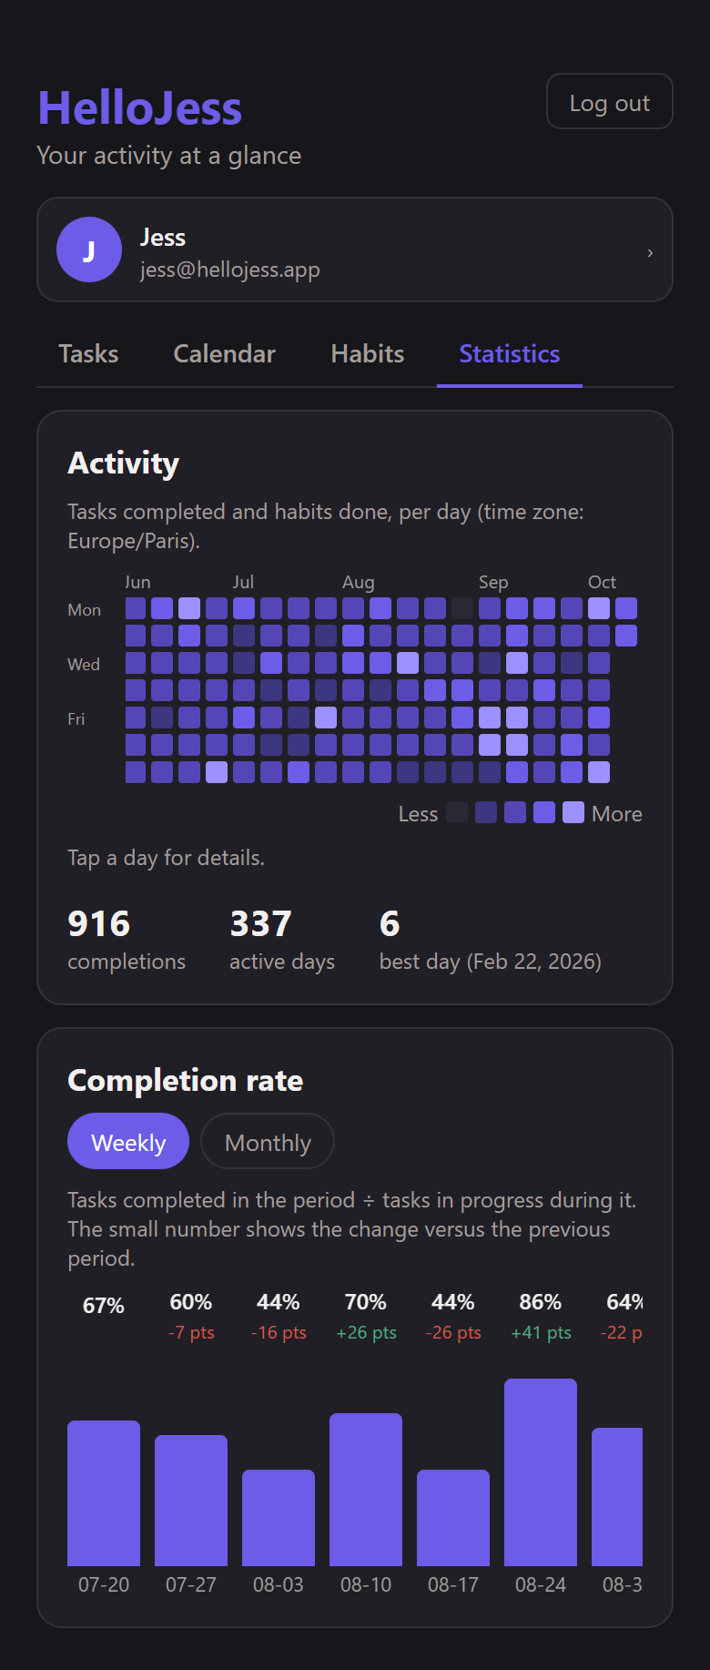  Statistics | 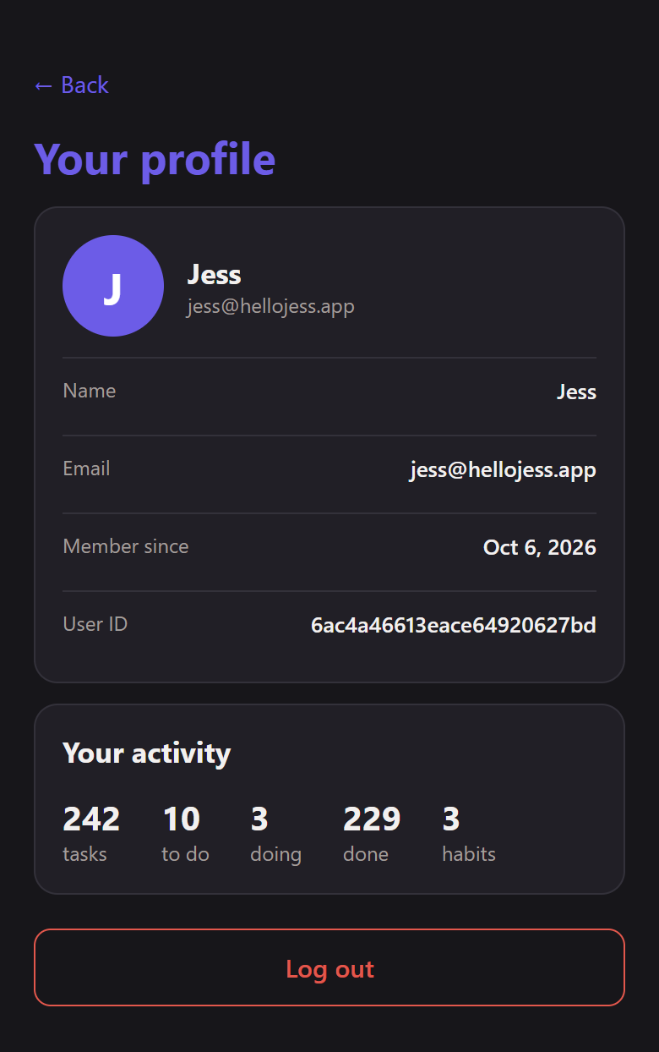  Profile

- Tasks: add field, filters, counter, rows with status chips; tap a task for its detail.
- Calendar: month grid with coloured dots, tap a day to list its events.
- Habits: tap a day cell to record or remove a completion.
- Statistics: summary, scrollable heatmap and completion bars.
- Profile: tap the user shown under the title; account details, activity summary, edit form and Log out.

8.3 Running on a phone
Expo Go loads the JavaScript bundle from the computer over Wi-Fi. The phone also needs to reach the API, which is why EXPO_PUBLIC_API_URL must be the computer's LAN IP. The backend listens on all interfaces and the Windows firewall must allow Node on private networks.

9. Profile and editing your account
The logged-in user's name and email are visible at the top of every screen. Clicking or tapping them opens the profile, where the name and email can be changed.

9.1 Flow
1. "Edit profile" -> form opens, pre-filled with name and email
2. "Save changes" -> PATCH /api/auth/me { name, email }
3. zod validation -> 422 with per-field messages if invalid
4. Save the user -> 400 "Email already registered" if taken
5. API answers -> { access_token, user }
6. Client stores -> new token; header and screens update at once

9.2 Design choices
- The token holds the user id, not the email. Changing the email therefore never invalidates a session or orphans data. Old tokens that contain an email are still accepted.
- Only `name` and `email` can be edited. The schema ignores any other field, so the password hash, id or creation date cannot be changed through this route.
- Tasks and habits are linked to the user's id, so they are all kept after a rename or an email change; the new email works immediately for the next login.
- Errors keep the form open so the user can correct the value (blank name, invalid email, email already used).
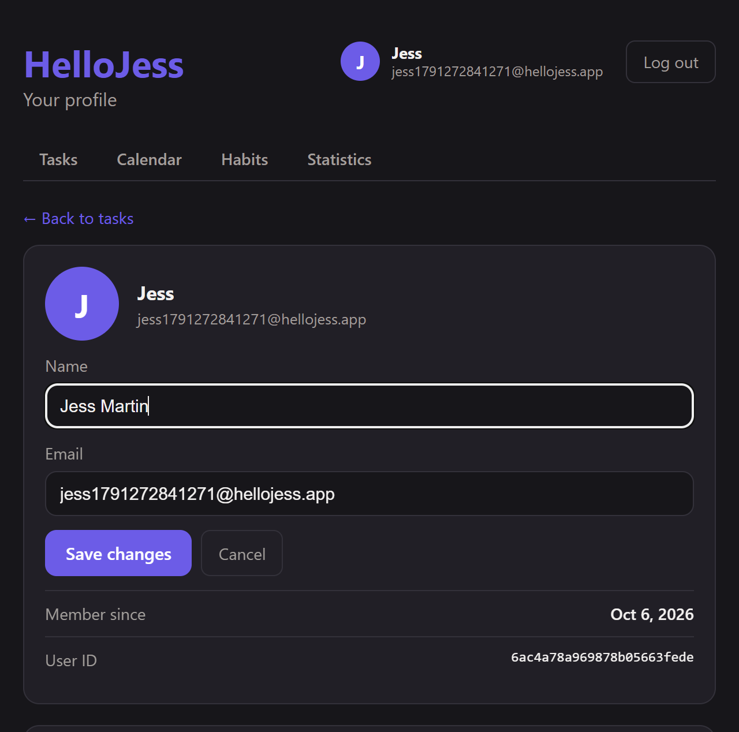
Editing the profile (web)
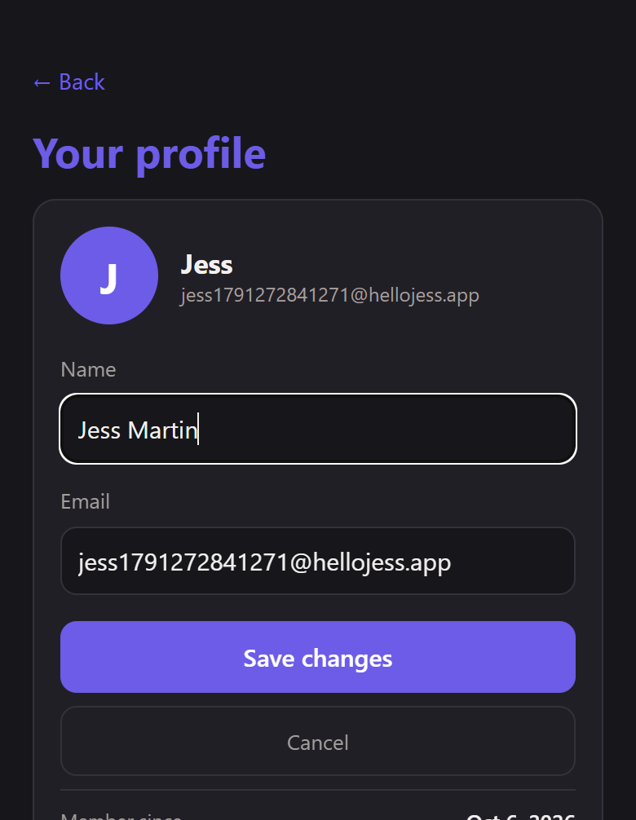
Editing the profile (mobile)

10. Tests and verification
npm test in backend/ runs 60 unit tests with Node's built-in runner. They need no database because the logic under test is in pure functions.
Test file | Covers
dates.test.js | Leap years, invalid dates, weeks and months, time-zone conversion, daylight-saving days
schemas.test.js | Validation rules of every field: tasks, habits, events, profile, queries
security.test.js | Password hashing, id and legacy tokens, tampered, expired, wrong-secret and alg: none tokens
stats.test.js | Heatmap levels and totals, completion rates, previous-period change, empty periods
calendar.test.js | Calendar event types, overdue carry-over, undated tasks, habit events
Beyond unit tests, the API and both clients were exercised end to end against throwaway databases: scripted scenarios for tasks, calendar and profile (including duplicate and invalid emails and old tokens), plus browser runs of the web app and of the mobile app (through Expo web) for the edit flows and their error cases. Type checks (tsc) and the production build pass for web and mobile.

Known limitations
- Reopening a completed task clears its completion date, so past statistics lose it.
- There is no password change or account deletion yet.
- Tokens are valid for 7 days and cannot be revoked before they expire.
- SECRET_KEY has a development default; set a strong value in any shared deployment.

