1. Дерево зависимостей (передвижение вершин)

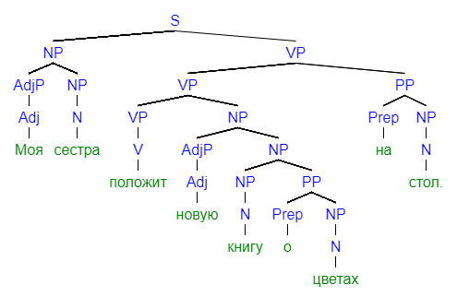

Алгоритм: поднимаем в узел вершину составляющей начиная снизу (кроме функциональных единиц типа предлогов, которые в этой парадигме считаются зависимыми).

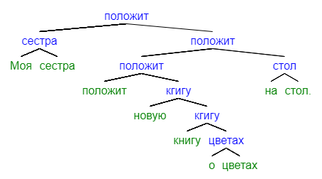

1. Алгоритм на ограничениях

Полное прилагательное

1. word(pos(x)) = ADJ => (lebel(X) = nmod, word(mod(x)) = NP, pos(x) < mod(x))

An adjective (ADJ) modifies a NP on the right with the label NMOD.

местоимение

1. word(pos(x)) = PRON => (lebel(X) = nmod, word(mod(x)) = NP, pos(x) < mod(x))

A pronoun (PRON) modifies a NP on the right with the label NMOD.

существительное

1. (word(pos(x)) = NP, word(mod(x)) = VP, pos(x) < mod(x)) => lebel(X) = SBJ

If NP modifies a VP on the right, its label is SBJ.

1. (word(pos(x)) = NP, word(mod(x)) = VP, mod(x) < pos(x)) => lebel(X) = OBJ

If NP modifies a VP on the left, its label is OBJ.

предлог

1. word(pos(x)) = Pron => (lebel(X) = NMOD, word(mod(x)) = NP, pos(x) < mod(x))

A pronoun (Pron) modifies NP on the right with the label NMOD.

1. Алгоритм Nivre

-root- Моя сестра положит новую книгу о цветах на стол .  
 1 2 3 4 5 6 7 8 9 10

|  |  |  |  |  |
| --- | --- | --- | --- | --- |
|  | operation | stack | queue | arc |
|  |  | (root) | (1,2,3,4,5,6,7,8,9,10) |  |
| 1 | SH | (root, 1) | (2,3,4,5,6,7,8,9,10) |  |
| 2 | LA | (root) | (2,3,4,5,6,7,8,9,10) | (1 <- 2) |
| 3 | SH | (root, 2) | (3,4,5,6,7,8,9,10) |  |
| 4 | LA | (root) | (3,4,5,6,7,8,9,10) | (2 <- 3) |
| 5 | RA | (root, 3) | (4,5,6,7,8,9,10) | (root -> 3) |
| 6 | SH | (root, 3, 4) | (5,6,7,8,9,10) |  |
| 7 | LA | (root, 3) | (5,6,7,8,9,10) | (4 <- 5) |
| 8 | RA | (root, 3, 5) | (6,7,8,9,10) | (3 -> 5) |
| 9 | SH | (root, 3, 5, 6) | (7,8,9,10) |  |
| 10 | LA | (root, 3, 5) | (7,8,9,10) | (6 <- 7) |
| 11 | RA | (root, 3, 5, 7) | (8,9,10) | (5 -> 7) |
| 12 | RE | (root, 3, 5) | (8,9,10) |  |
| 13 | RE | (root, 3) | (8,9,10) |  |
| 14 | SH | (root, 3, 8) | (9,10) |  |
| 15 | LA | (root, 3) | (9,10) | (8 <- 9) |
| 16 | RA | (root, 3, 9) | (10) | (3 -> 9) |
| 17 | RE | (root, 3) | (10) |  |
| 18 | RA | (root, 3, 10) | () | (3 -> 10) |