|  |  |
| --- | --- |
| **Ex. No: 01** | **LINEAR REGRESSION** |
| **27/12/2023** |

**Aim:**

1. To simulate 1000 different lines of fit for a randomly generated 2-D NumPy array, find the line with the least error among them, and then predict the target variable for the remaining 500 values using this line of best fit.
2. To build a simple linear regression model from scratch using data from data1.csv without using sklearn libraries.

**Algorithm:**

1.

1. Generate Data:
2. Create a random 2-D NumPy array with 1500 values.
3. Simulation of Lines of Fit:

Randomly select 1000 values from the array to simulate lines of fit.

1. For each selection, compute the parameters of the line of fit (e.g., slope and intercept).
2. Calculate the errors for each line of fit using the selected 1000 values.
3. Find Line of Best Fit:

Identify the line with the least error among all simulated lines.

1. Prediction:

Using the line of best fit, predict the target variable for the remaining 500 values.

1. Output:

Display the line of best fit along with the predicted values

2.

1. Data Loading:
2. Load the data from data1.csv.
3. Data Preprocessing:

If necessary, handle missing values and ensure the data is in a suitable format for regression.

1. Split Data:

Split the data into features (X) and target variable (y).

1. Equation Method:

Calculate the coefficients using the equations for simple linear regression.

1. Prediction:

Use the obtained coefficients to make predictions on the test data.

1. Evaluation:

Calculate RMSE and MAE using the predictions and actual target values.

1. Comparison:

Compare the intercept and coefficient values obtained from the equation method and gradient descent method.

1. Print the RMSE, MAE, and coefficient values for comparison.

**Program :**

1.

import numpy as np

import matplotlib.pyplot as plt

from sklearn.linear_model import LinearRegression

from sklearn.metrics import mean_squared_error

random_array = np.random.rand(1500,1)

# Split the 2D array into independent variable(X) and dependent variable (y)

X = random_array[:1000]

y = 3 * X.squeeze() + 2 + 0.1 * np.random.randn(1000)  # Simulate a line with some noise,is a 1d array

#variables to store the best fit line and its error

best_fit_line = None

min_error = float('inf')

#different lines of fit using 1000 values

for i in range(1000):

    # Randomly select 1000 indices for fitting the line

    indices = np.random.choice(1000, size=1000, replace=True)

    # Fit a line for selected indices

    X_train = X[indices]

    y_train = y[indices]

    model = LinearRegression()

    model.fit(X_train, y_train)#to train the model

    # Predict on the entire dataset,predicts y based on x

    y_pred = model.predict(X)

    # Calculate mean squared error

    error = mean_squared_error(y, y_pred)

    # Update the best fit line if the current error is smaller

    if error < min_error:

        min_error = error

        best_fit_line = model

# Using the best fit line, predict the target variable for the other 500 values

X_test = random_array[1000:]

y_pred_test = best_fit_line.predict(X_test)

# Print the coefficients of the best fit line

print("Intercept:", best_fit_line.intercept_)

print("Mean Squared Error of Best Fit Line:", min_error)

# Plot the data points and the best fit line

plt.scatter(X, y, label='Data Points',c='yellow')#plot data points

plt.plot(X_test,y_pred_test, color='magenta', label='Best Fit Line')#plot best line of fit

plt.xlabel('X')

plt.ylabel('y')

plt.title('Scatter Plot with Best Fit Line')

plt.legend()

plt.show()

**2.**

import pandas as pd

import numpy as np

import matplotlib.pyplot as plt

data = pd.read_csv("data1.csv")

X = data.iloc[:,:-1].values

y = data.iloc[:,-1].values

def mean_absolute_error(y_true, y_pred):

    return np.mean(np.abs(y_true - y_pred))

def root_mean_squared_error(y_true, y_pred):

    return np.sqrt(np.mean((y_true - y_pred) ** 2))

def simple_linear_regression(X, y):

    n = len(X)

    mean_X = np.mean(X)  #x'

    mean_y = np.mean(y)   #y'

    numerator = np.sum((X - mean_X) * (y - mean_y))

    denominator = np.sum((X - mean_X) ** 2)

     #c=y'-mx'

    m = numerator / denominator

    b = mean_y - m * mean_X

    return m, b #m-slope,b-intercept

#simple linear regression

slope, intercept = simple_linear_regression(X, y)

# Print the coefficients (slope and intercept)

print("Coefficient (slope):", slope)

print("Intercept:", intercept)

# Predict the values using the model

y_pred = slope * X + intercept

rmse = root_mean_squared_error(y, y_pred)

mae = mean_absolute_error(y, y_pred)

print("Root Mean Squared Error (RMSE):", rmse)

print("Mean Absolute Error (MAE):", mae)

**Output:**

**1.**

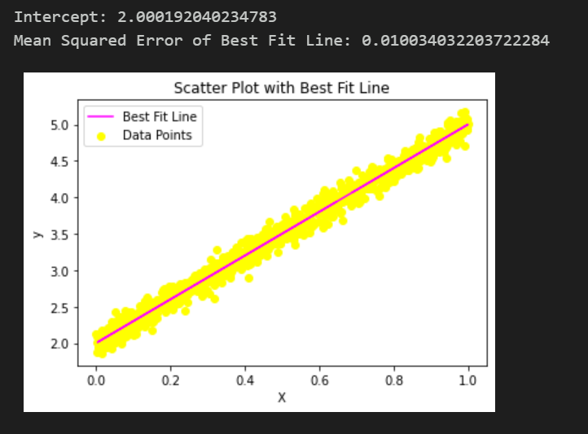

**2.**

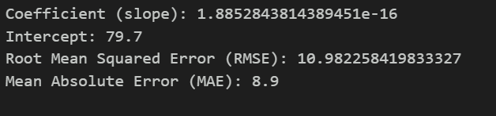

**Result:** The above program to execute linear regression from scratch and using in built library has been successfully executed.

|  |  |
| --- | --- |
| **Ex. No: 02** | **MULTIPLE LINEAR REGRESSION** |
| **03/01/2024** |

**Aim:** To build a multiple linear regression model using the provided dataset to predict house prices.

**Algorithm:**

1. Preprocess the data, including handling missing values, encoding categorical variables, and scaling numerical features.
2. Check for outliers and handle them appropriately.
3. Check for multicollinearity among the independent variables.
4. Train the multiple linear regression model.
5. Apply the same preprocessing steps to the test dataset (test.csv) for consistency.
6. Use the trained model to predict house prices on the test dataset.
7. Evaluate the model's performance using Root Mean Squared Error (RMSE).

**Program :**

# Import necessary libraries

import pandas as pd

from sklearn.model_selection import train_test_split

from sklearn.linear_model import LinearRegression

from sklearn.metrics import mean_squared_error

# Load the dataset

df = pd.read_csv('house_pred.csv')

df.head()

X =  df.iloc[:,:-1].values

y = df.iloc[:,-1].values

df['intercept']=1

vif = pd.DataFrame()

vif['variable']= df.columns

from statsmodels.stats.outliers_influence import \

variance_inflation_factor

vif['vif'] = [variance_inflation_factor(df.values,i)

 for i in range(df.shape[1])]

vif

df = df.drop(['BsmtFinSF2','GrLivArea'], axis=1)

df= df.values

df = pd.DataFrame(df)

vif = pd.DataFrame()

vif['variable']= df.columns

from statsmodels.stats.outliers_influence import \

variance_inflation_factor

vif['vif'] = [variance_inflation_factor(df.values,i)

 for i in range(df.shape[1])]

vif

X_train, X_test, y_train, y_test = train_test_split(X, y, test_size=0.2)

# Build the linear regression model

model = LinearRegression()

# Fit the model to the training data

model.fit(X_train, y_train)

# Make predictions on the test set

y_pred = model.predict(X_test)

# Evaluate the model using Root Mean Squared Error (RMSE)

rmse = np.sqrt(mean_squared_error(y_test, y_pred))

print(f'Root Mean Squared Error (RMSE): {rmse}')

from sklearn.metrics import r2_score, mean_squared_error

r2_score(y_test,y_pred)

# Now, load the test dataset for making predictions

test_data = pd.read_csv('test.csv')

# Use the trained model to predict house prices on the test set

test_predictions = model.predict(test_data)

submission_df = pd.DataFrame({'Id': test_data['Id'], 'PredictedPrice': test_predictions})

submission_df.to_csv('predictions4.csv', index=False)

**Output:**



**Result:** The above program to build a multiple linear regression model using the provided dataset to predict house prices has been successfully executed.

|  |  |
| --- | --- |
| **Ex. No: 03** | **LOGISTIC REGRESSION** |
| **17/01/2024** |

**Aim:** To build a logistic regression model using the provided dataset, perform necessary preprocessing, and evaluate its performance using a 70-30 train-test split.

**Algorithm:**

1. Load the dataset into a DataFrame.
2. Perform exploratory data analysis (EDA) to understand the data's structure, distributions, and relationships.
3. Preprocess the data
4. Split the dataset into features (X) and the target variable (y).
5. Split the data into training and testing sets using a 70-30 ratio.
6. Build a logistic regression model using the training data.
7. Train the logistic regression model on the training data.
8. Make predictions on the test data using the trained model.
9. Evaluate the performance of the model using various metrics:
10. Print the performance metrics to assess the model's effectiveness in classifying instances.

**Program :**

import pandas as pd

from sklearn.model_selection import train_test_split

from sklearn.linear_model import LogisticRegression

from sklearn.metrics import accuracy_score,precision_score, recall_score, f1_score

df = pd.read_csv('telecom_customer_churn.csv')

df.head()

#one hot encoding

import pandas as pd

col= ['Gender','Married','Phone Service','Multiple Lines','Internet Service','Online Security','Online Backup','Premium Tech Support','Streaming TV','Unlimited Data',]

data = pd.get_dummies(df, columns=col, drop_first=True)

data.head()

#segregate independent and dependent variable

x = data.iloc[:,:-1].values

y = data.iloc[:,-1].values

#build the model

x_train, x_test, y_train, y_test = train_test_split(x, y, test_size=0.3)

reg= LogisticRegression()

reg.fit(x_train, y_train)

y_pred =reg.predict(x_test)

# performance metrics

accuracy = accuracy_score(y_test, y_pred)

print("Accuracy" ,accuracy)

precision = precision_score(y_test, y_pred)

recall = recall_score(y_test, y_pred)

print("Precision:",precision)

print("Recall",recall)

f1 = f1_score(y_test, y_pred)

print("F1 Score:",f1)

**Output:**

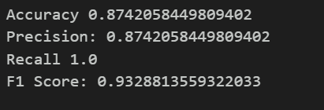

**Result:** The above program to build a logistic regression model using the provided dataset, perform necessary preprocessing, and evaluate its performance using a 70-30 train-test split has been successfully executed.

|  |  |
| --- | --- |
| **Ex. No: 04** | **DECISION TREE** |
| **24/01/2024** |

**Aim:**

1. To compute the Gini index for the 'age' and 'salary' columns in the classification.csv file.
2. To implement a decision tree algorithm from scratch without using the sklearn library.

**Algorithm:**

**1.**

1. Data Loading.
2. Data Preprocessing.
3. If necessary, handle missing values and ensure that 'age' and 'salary' columns are numerical.
4. Compute Gini Index:

For each column (age and salary):

Sort the unique values in ascending order.

For each unique value, split the dataset into two groups based on whether the value is less than or equal to the current value.

Calculate the Gini index for each split.

Weighted sum the Gini indices for all splits to compute the Gini index for the column.

1. Comparison:

Compare the computed Gini indices for the 'age' and 'salary' columns.

**2.**

1. Determine the best feature to split on based on a chosen criterion (e.g., Gini impurity, entropy).
2. Calculate impurity of each feature and select the one that reduces impurity the most.
3. Define conditions to stop further splitting.
4. Criteria may include maximum depth limit, minimum samples in a node, or no further reduction in impurity.
5. Recursively build the tree:
6. Repeat splitting and stopping criteria for each child node created from the split.
7. Use the built tree to make predictions:
8. Traverse down the tree based on feature values of the input sample until a leaf node is reached.
9. Assign the majority class in the leaf node as the predicted class.

**Program :**

1.

import numpy as np

import pandas as pd

df = pd.read_csv("classification.csv")

df.head()

def GI(df,col,target,diff):

    tot = df.shape[0]

    lower = df[df[col] <= diff].shape[0]

    greater = df[df[col] > diff].shape[0]

    yes_and_greater = df[(df[target] == 1) & (df[col] > diff)].shape[0]

    no_and_greater = df[(df[target] == 0) & (df[col] > diff)].shape[0]

    yes_and_lower = df[(df[target] == 1) & (df[col] <= diff)].shape[0]

    no_and_lower = df[(df[target] == 0) & (df[col] <= diff)].shape[0]

    gini_greater = 1 - (yes_and_greater/greater)**2 - (no_and_greater/greater)**2

    gini_lower = 1 - (yes_and_lower/lower)**2 - (no_and_lower/lower)**2

    ans = gini_greater*(greater/tot) + gini_lower*(lower/tot)

    return ans

l = list(df["Age"].unique())

l.sort()

for i in range(len(l)-1):

    diff = (l[i]+l[i+1]) / 2

    print(diff," : ",GI(df,"Age","Purchased",diff))

l = list(df["EstimatedSalary"].unique())

l.sort()

for i in range(len(l)-1):

    diff = (l[i]+l[i+1]) / 2

    print(diff," : ",GI(df,"EstimatedSalary","Purchased",diff))

2.

import numpy as np

import pandas as pd

import matplotlib.pyplot as plt

train = {"Color" : ["Green","Yellow","Red","Red","Yellow"], "Diameter" : [3,3,1,1,3], "Label" : ["Apple","Apple","Grape","Grape","Lemon"]}

train = pd.DataFrame(train)

def unique_value(df,col):

    return list(df[col].unique())

def class_counts(df):

    ans = {}

    for i in df.iloc[:,-1]:

        if i not in ans:

            ans[i] = 0

        ans[i] += 1

    return ans

def is_numeric(val):

    if(type(val) == int or  type(val) == float):

        return True

    else:

        return False

def is_numeric(val):

    if(type(val) == int or  type(val) == float):

        return True

    else:

        return False

class Question:

    def __init__(self,col,value):

        self.column = col

        self.value = value

    def match(self,example):

        val = example[self.column]

        if is_numeric(val):

            return val >= self.value

        else:

            return val == self.value

    def __repr__(self):

        condition = "=="

        if is_numeric(self.value):

            condition = ">="

        return "Is %s %s %s?" % (self.column,condition,str(self.value))

q = Question("Color","Green")

q.match(train)

def partition(df,question):

    true = pd.DataFrame()

    false = pd.DataFrame()

    true = df[question.match(df) == True]

    false = df[question.match(df) == False]

    return true,false

true_rows,false_rows = partition(train,Question("Color","Red"))

def gini(l):

    counts = class_counts(l)

    impurity = 1

    for i in counts:

        prob = counts[i]/float(len(l))

        impurity -= prob**2

    return impurity

l = pd.DataFrame({"Res" : ["Apple","Apple"]})

print(gini(l))

l = pd.DataFrame({"Res" : ["Orange","Apple"]})

print(gini(l))

l = pd.DataFrame({"Res" : ["Apple","Apple","Grape","Fruit"]})

print(gini(l))

def info_gain(left,right,current_uncertainty):

    left_len = left.shape[0]

    right_len = right.shape[0]

    p = float(left_len) / (left_len + right_len)

    return current_uncertainty - p*gini(left) - (1-p)*gini(right)

current_uncertainty = gini(train)

current_uncertainty

# how much info do we gain by partioning on "Green"

true_rows, false_rows = partition(train, Question("Color", 'Green'))

info_gain(true_rows, false_rows, current_uncertainty)

# how much info do we gain by partioning on "Red"

true_rows, false_rows = partition(train, Question("Color",'Red'))

info_gain(true_rows, false_rows, current_uncertainty)

def find_best_split(df):

    best_gain = 0

    best_question = None

    current_uncertainty = gini(df)

    col = df.columns[:-1]

    for i in col:

        l = unique_value(df,i)

        for j in l:

            question = Question(i,j)

            true_rows,false_rows = partition(df,question)

            if(len(true_rows) == 0 or len(false_rows) == 0):

                continue

            gain = info_gain(true_rows,false_rows,current_uncertainty)

            if(gain >= best_gain):

                best_gain, best_question = gain, question

    return best_gain, best_question

best_gain, best_question = find_best_split(train)

class Leaf:

    def __init__(self,df):

        self.predictions = class_counts(df)

class Decision_Node:

    def __init__(self,question,true_branch,false_branch):

        self.question = question

        self.true_branch = true_branch

        self.false_branch = false_branch

def built_tree(df):

    gain,question = find_best_split(df)

    if(gain == 0):

        return Leaf(df)

    true_rows, false_rows = partition(df,question)

    true_branch = built_tree(true_rows)

    false_branch = built_tree(false_rows)

    return Decision_Node(question,true_branch,false_branch)

def print_tree(node,spacing=""):

    if isinstance(node,Leaf):

        print(spacing + "Predcit",node.predictions)

        return

    print(spacing + str(node.question))

    print(spacing + "--> True:")

    print_tree(node.true_branch,spacing + " ")

    print(spacing + "--> False:")

    print_tree(node.false_branch,spacing + " ")

my_tree = built_tree(train)

print_tree(my_tree)

def Classify(df,node):

    if isinstance(node,Leaf):

        return node.predictions

    if node.question.match(df):

        return Classify(df,node.true_branch)

    else:

        return Classify(df,node.false_branch)

test = pd.DataFrame({"Color" : ["Green","Yellow","Red","Red","Yellow"],

                     "Diameter" : [3,4,2,1,3]})

test

for i in range(test.shape[0]):

    print(Classify(test.iloc[i],my_tree)

**Output:**

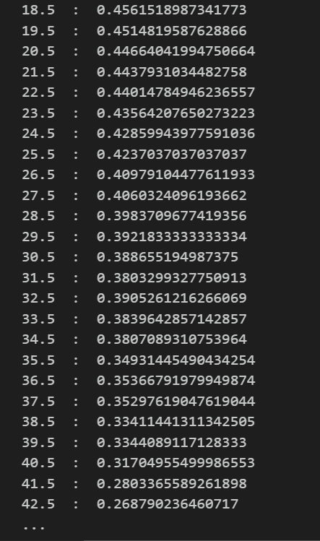

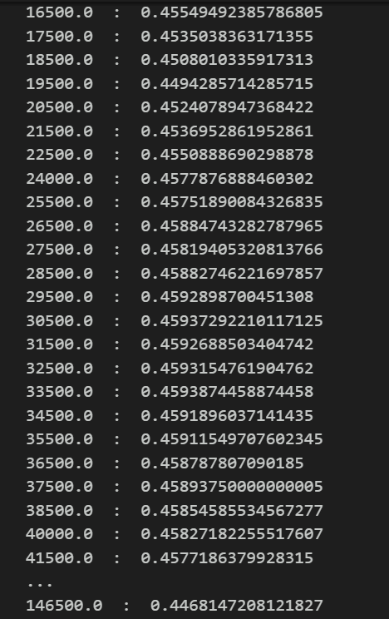

**2.**

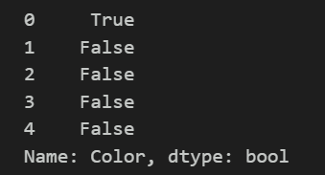

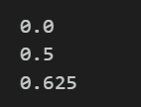



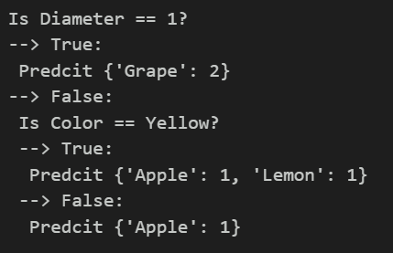

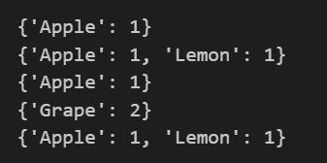

**Result:** The above program to compute gini index and to build decision tree from scratch has been successfully executed.

|  |  |
| --- | --- |
| **Ex. No: 05** | **CLASSIFICATION ALGORITHMS** |
| **31/01/2024** |

**Aim:** To compare the performance of different classification algorithms (KNN, Logistic Regression, Naive Bayes, Decision Trees, SVM) on the teleco-customer-churn dataset.

**Algorithm:**

1. Load the teleco-customer-churn dataset into a Data Frame.
2. Perform exploratory data analysis (EDA) to understand the data's structure, distributions, and relationships.
3. Preprocess the data: a. Handle missing values, if any, using imputation techniques like mean, median, or mode. b. Encode categorical variables using one-hot encoding or label encoding. c. Scale numerical features using standardization or normalization.
4. Split the dataset into features (X) and the target variable (y).
5. Split the data into training and testing sets.
6. Apply each classification algorithm: a. Train a KNN (K-Nearest Neighbours) classifier. b. Train a Logistic Regression classifier. c. Train a Naive Bayes classifier. d. Train a Decision Trees classifier. e. Train a Support Vector Machine (SVM) classifier.
7. Evaluate the performance of each classifier using accuracy.
8. Print the accuracies of all the classifiers.
9. Determine which algorithm achieved the best accuracy.
10. Provide a justification for why that algorithm performed the best

**Program :**

import pandas as pd

from sklearn.model_selection import train_test_split

from sklearn.tree import DecisionTreeClassifier, export_graphviz

from sklearn.metrics import accuracy_score,precision_score

import pydotplus

from sklearn.linear_model import LogisticRegression

from sklearn.naive_bayes import GaussianNB

from IPython.display import Image

from sklearn.neighbors import KNeighborsClassifier

from sklearn.tree import DecisionTreeClassifier, export_graphviz

df = pd.read_csv('telco-customer-churn.csv')

df.head()

#one got encoding

col= ['gender','Partner','Dependents','PhoneService','MultipleLines','InternetService','DeviceProtection','OnlineSecurity','OnlineBackup','TechSupport','StreamingTV','StreamingMovies','PaperlessBilling','Churn']

data = pd.get_dummies(df, columns=col, drop_first=True)

data.head()

# Assume 'X' contains features and 'y' contains the target variable (churn)

X = data.iloc[:,:-1].values

y = data.iloc[:,-1].values

# Split the dataset into training and testing sets

X_train, X_test, y_train, y_test = train_test_split(X, y, test_size=0.3)

# Create and train the Decision Tree model

decision_tree_model = DecisionTreeClassifier()

decision_tree_model.fit(X_train, y_train)

# Make predictions on the test set

y_pred = decision_tree_model.predict(X_test)

# Assume 'X' contains features and 'y' contains the target variable (churn)

X = data.iloc[:,:-1].values

y = data.iloc[:,-1].values

# Split the dataset into training and testing sets

X_train, X_test, y_train, y_test = train_test_split(X, y, test_size=0.3)

# Create and train the Decision Tree model

decision_tree_model = DecisionTreeClassifier()

decision_tree_model.fit(X_train, y_train)

# Make predictions on the test set

y_pred = decision_tree_model.predict(X_test)

# performance metrics

accuracy = accuracy_score(y_test, y_pred)

print("Accuracy" ,accuracy)

precision = precision_score(y_test, y_pred)

print("Precision:",precision)

knn_model = KNeighborsClassifier(n_neighbors=2)

knn_model.fit(X_train_scaled, y_train)

y_pred = knn_model.predict(X_test_scaled)

# performance metrics

accuracy = accuracy_score(y_test, y_pred)

print("Accuracy" ,accuracy)

precision = precision_score(y_test, y_pred)

print("Precision:",precision)

reg= LogisticRegression()

reg.fit(x_train, y_train)

y_pred =reg.predict(x_test)

# performance metrics

accuracy = accuracy_score(y_test, y_pred)

print("Accuracy" ,accuracy)

precision = precision_score(y_test, y_pred)

print("Precision:",precision)

scaler = StandardScaler()

X_train_scaled = scaler.fit_transform(X_train)

X_test_scaled = scaler.transform(X_test)

svm_model = SVC(kernel='linear', random_state=42)

svm_model.fit(X_train_scaled, y_train)

y_pred = svm_model.predict(X_test_scaled)

#performance

accuracy = accuracy_score(y_test, y_pred)

print("Accuracy" ,accuracy)

precision = precision_score(y_test, y_pred)

print("Precision:",precision)

scaler = StandardScaler()

X_train_scaled = scaler.fit_transform(X_train)

X_test_scaled = scaler.transform(X_test)

naive_bayes_model = GaussianNB()

naive_bayes_model.fit(X_train_scaled, y_train)

y_pred = naive_bayes_model.predict(X_test_scaled)

# performance metrics

accuracy = accuracy_score(y_test, y_pred)

print("Accuracy" ,accuracy)

precision = precision_score(y_test, y_pred)

print("Precision:",precision)

**Output:**

**Decision Tree:**

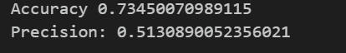

**KNN:**

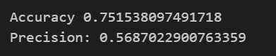

**Logistic Regression:**

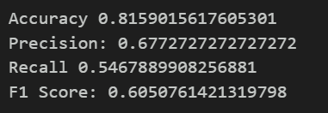

**SVM:**

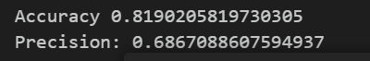

**Naïve bayes:**

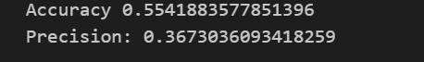

**Result:** The above program to compare the performance of different classification algorithms (KNN, Logistic Regression, Naive Bayes, Decision Trees, SVM) has been successfully executed.

|  |  |
| --- | --- |
| **Ex. No: 06** | **GRIDSEARCHCV AND RANDOMIZEDSEARCHCV** |
| **21/02/2024** |

**Aim:** To Optimize classification algorithms (SVM, Decision Tree, Random Forest, and boosting) on a dataset by tuning parameters using GridSearchCV and RandomizedSearchCV to maximize accuracy.

**Algorithm:**

1. Load the dataset provided.
2. Perform any necessary preprocessing steps such as handling missing values, encoding categorical variables, and scaling numerical features.
3. Split the dataset into features (X) and the target variable (y).
4. For each classification algorithm (SVM, Decision Tree, Random Forest, and one boosting algorithm) identify the different tuneable parameters that can be adjusted to improve performance.
5. Apply GridSearchCV and RandomizedSearchCV to find the best combination of parameters for each algorithm
6. Fit each classification algorithm with the best parameters obtained from GridSearchCV or RandomizedSearchCV.
7. Evaluate the performance of each model using appropriate evaluation metrics such as accuracy, precision, recall, F1-score, etc., on a holdout test set.
8. Compare the performance of each algorithm and identify the best-performing one.

**Program :**

**DECISION TREE:**

import pandas as pd

from sklearn.model_selection import train_test_split

from sklearn.tree import DecisionTreeClassifier

from sklearn.model_selection import GridSearchCV, RandomizedSearchCV

from sklearn.metrics import classification_report, confusion_matrix

df = pd.read_csv('telco-customer-churn.csv')

df.head()

#one hot encoding

col= ['gender','Partner','Dependents','PhoneService','MultipleLines','InternetService','DeviceProtection','OnlineSecurity','OnlineBackup','TechSupport','StreamingTV','StreamingMovies','PaperlessBilling','Churn']

data = pd.get_dummies(df, columns=col, drop_first=True)

data.head()

##segregate independent and dependent variable

X = data.iloc[:,:-1].values

y = data.iloc[:,-1].values

#build the model

X_train, X_test, y_train, y_test = train_test_split(X, y, test_size=0.3)

# Decision Tree

dt_model = DecisionTreeClassifier()

#tunable parameters for Decision Tree

print("Decision Tree Parameters:", dt_model.get_params())

dt_model.fit(X_train, y_train)

# print prediction results

predictions = dt_model.predict(X_test)

print(classification_report(y_test, predictions))

# parameter grid for Decision Tree

dt_param_grid = {'criterion': ['gini', 'entropy'], 'max_depth': [None, 10, 20, 30], 'min_samples_split': [2, 5, 10], 'min_samples_leaf': [1, 2, 4]}

#GridSearchCV for Decision Tree

dt_grid_search = GridSearchCV(dt_model, dt_param_grid, cv=5)

dt_grid_search.fit(X_train, y_train)

print("Best Parameters for Decision Tree (GridSearchCV):", dt_grid_search.best_params_)

grid_predictions =dt_grid_search.predict(X_test)

# print classification report

print(classification_report(y_test, grid_predictions))

#RandomizedSearchCV for Decision Tree

dt_random_search = RandomizedSearchCV(dt_model, dt_param_grid, n_iter=5, cv=5)

dt_random_search.fit(X_train, y_train)

print("Best Parameters for Decision Tree (RandomizedSearchCV):", dt_random_search.best_params_)

grid_predictions =dt_random_search.predict(X_test)

# print classification report

print(classification_report(y_test, grid_predictions))

**SVM:**

##segregate independent and dependent variable

X = data.iloc[:,:-1].values

y = data.iloc[:,-1].values

#build the mode

X_train, X_test, y_train, y_test = train_test_split(X, y, test_size=0.3)

model = SVC()

model.fit(X_train, y_train)

# print prediction results

predictions = model.predict(X_test)

print(classification_report(y_test, predictions))

#to get all tunable parameters:

print(model.get_params())

from sklearn.model_selection import GridSearchCV

# defining parameter range

param_grid = {'C': [0.1, 1, 10, 100, 1000],

              'gamma': [1, 0.1, 0.01, 0.001, 0.0001],

              'kernel': ['rbf']}

#perform grid search

grid = GridSearchCV(SVC(), param_grid, refit = True, verbose = 3)

# fitting the model for grid search

grid.fit(X_train, y_train)

#best parameter after tuning

print(grid.best_params_)

grid_predictions = grid.predict(X_test)

# print classification report

print(classification_report(y_test, grid_predictions))

**ADABOOST:**

##segregate independent and dependent variable

X = data.iloc[:,:-1].values

y = data.iloc[:,-1].values

#build the model

X_train, X_test, y_train, y_test = train_test_split(X, y, test_size=0.3,random_state=20)

adaboost_model = AdaBoostClassifier()

#tunable parameters for AdaBoost

print("AdaBoost Parameters:", adaboost_model.get_params())

adaboost_model.fit(X_train, y_train)

# print prediction results

predictions = adaboost_model.predict(X_test)

print(classification_report(y_test, predictions))

#parameter grid for AdaBoost

adaboost_param_grid = {'n_estimators': [50, 100, 200], 'learning_rate': [0.01, 0.1, 0.2], 'algorithm': ['SAMME', 'SAMME.R']}

#GridSearchCV for AdaBoost

adaboost_grid_search = GridSearchCV(adaboost_model, adaboost_param_grid, cv=5)

adaboost_grid_search.fit(X_train, y_train)

print("Best Parameters for AdaBoost (GridSearchCV):", adaboost_grid_search.best_params_)

grid_predictions =adaboost_grid_search.predict(X_test)

# print classification report

print(classification_report(y_test, grid_predictions))

#RandomizedSearchCV for AdaBoost

adaboost_random_search = RandomizedSearchCV(adaboost_model, adaboost_param_grid, n_iter=5, cv=5)

adaboost_random_search.fit(X_train, y_train)

print("Best Parameters for AdaBoost (RandomizedSearchCV):", adaboost_random_search.best_params_)

grid_predictions =adaboost_random_search.predict(X_test)

# print classification report

print(classification_report(y_test, grid_predictions))

**Output:**

**DECISION TREE:**



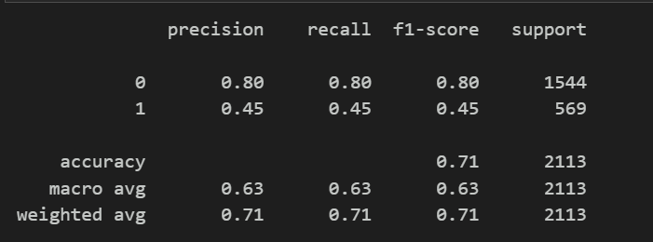

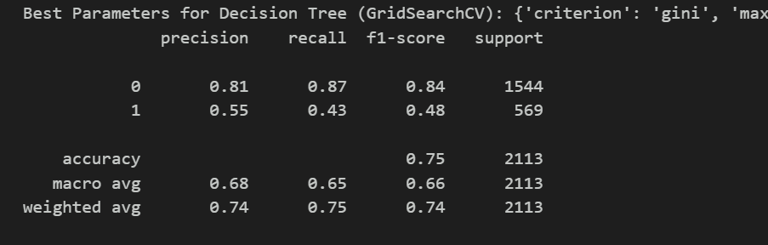

**SVM:**

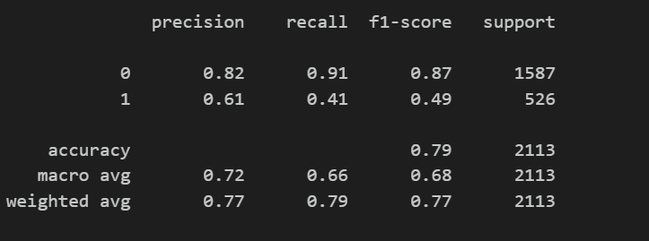



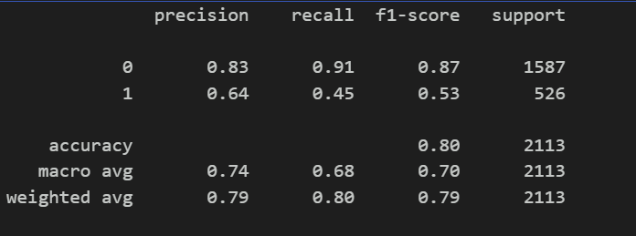

**ADABOOST:**

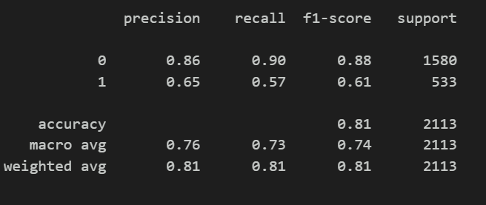

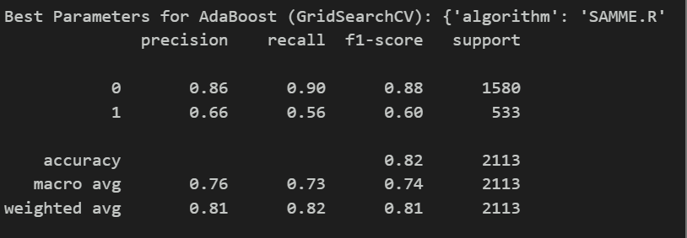

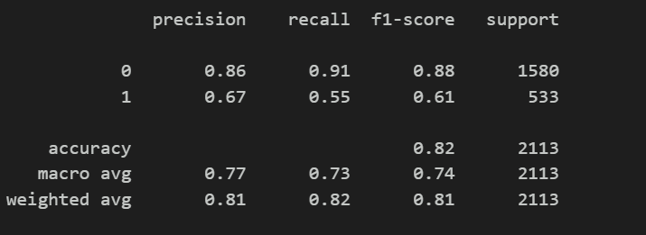

**Result:** The above program to optimize classification algorithms (SVM, Decision Tree, Random Forest, and boosting) on a dataset by tuning parameters using GridSearchCV and RandomizedSearchCV to maximize accuracy. has been successfully executed.

|  |  |
| --- | --- |
| **Ex. No: 07** | **K-MEANS** |
| **28/02/2024** |

**Aim:** to implement the K-Means clustering algorithm from scratch and compare its results with the implementation provided by scikit-learn.

**Algorithm:**

1. Load the given dataset.
2. Preprocess the data if necessary (e.g., handling missing values, scaling features).
3. Implement K-Means clustering algorithm from scratch:
   1. Initialize K cluster centroids randomly.
   2. Assign each data point to the nearest cluster centroid based on Euclidean distance.
   3. Update the cluster centroids by calculating the mean of all data points assigned to each cluster.
   4. Repeat steps b and c until convergence (either the cluster centroids stop changing significantly or a maximum number of iterations is reached).
4. Use the scikit-learn implementation of K-Means clustering
5. Compare the results of the two implementations

**Program :**

import pandas as pd

import numpy as np

from sklearn.cluster import KMeans

from sklearn.metrics import silhouette_score

# Function to implement K-Means from scratch

def kmeans_from_scratch(X, n_clusters, max_iters=400):

    # Initialize centroids randomly

    centroids = X[np.random.choice(X.shape[0], n_clusters, replace=False)]

    for i in range(max_iters):

        # Assign each data point to the closest centroid

        labels = np.argmin(np.linalg.norm(X[:, np.newaxis] - centroids, axis=2), axis=1)

        # Update centroids

        new_centroids = np.array([X[labels == i].mean(axis=0) for i in range(n_clusters)])

        # Check for convergence

        if np.all(centroids == new_centroids):

            break

        centroids = new_centroids

    return labels, centroids

df1 =pd.read_csv('data (1).csv')

df = df1.sort_values(by='Age', ascending=True)

col= ['Gender']

data = pd.get_dummies(df, columns=col, drop_first=True)

data.head()

n_clusters = 5

from sklearn.preprocessing import StandardScaler

scaler = StandardScaler()

data_scaled = scaler.fit_transform(data)

#K-Means from scratch

labels_scratch, centroids_scratch = kmeans_from_scratch(data.values, n_clusters)

#K-Means using sklearn

kmeans_sklearn = KMeans(n_clusters=n_clusters,init='k-means++',  max_iter=400,random_state=90)

labels_sklearn = kmeans_sklearn.fit_predict(data_scaled)

# Print the silhouette scores

from sklearn.metrics import silhouette_score

silhouette_scratch = silhouette_score(data, labels_scratch)

silhouette_sklearn = silhouette_score(data_scaled, labels_sklearn)

print(f"Silhouette Score (Scratch): {silhouette_scratch}")

print(f"Silhouette Score (Sklearn): {silhouette_sklearn}")

**Output:**

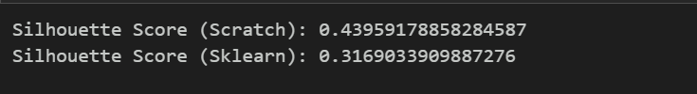

**Result**: The above program to implement the K-Means clustering algorithm from scratch and compare its results with the implementation provided by scikit-learn has been successfully executed.

|  |  |
| --- | --- |
| **Ex. No: 08** | **PRINCIPAL COMPONENT ANALYSIS**  **(PCA)** |
| **13/03/2024** |

**Aim:** To apply Principal Component Analysis (PCA) from scratch to the MNIST dataset.

**Algorithm:**

1. Download the MNIST dataset.
2. Preprocess the MNIST dataset.
3. Compute the covariance matrix.
4. Perform eigen decomposition.
5. Select the top k eigenvectors.
6. Project the data onto the new feature space.
7. Apply PCA to reduce the dimensionality of the MNIST dataset
8. Analyse the results.

**Program:**

# MNIST dataset downloaded from Kaggle : https://www.kaggle.com/c/digit-recognizer/data

# importing necessary libraries

import numpy as np

import pandas as pd

import matplotlib.pyplot as plt

import seaborn as sns

# load data from csv into pandas dataframe

mnist_df = pd.read_csv('train.csv')

# display first few rows

mnist_df.head()

# store the labels into a variable y

y = mnist_df['label']

# store the pixel data in X

X = mnist_df.drop("label", axis = 1)

# shape of data

print(X.shape)

print(y.shape)

(42000, 784)

(42000,)

# display some random number from datset

for i in [2, 99, 10001, 20422]:

    index = i

    plt.figure(figsize = (3,3))

    grid_data = X.iloc[index].values.reshape(28,28)  # reshape from 1d to 2d pixel array

    plt.imshow(grid_data, interpolation = "none", cmap = 'gray')

    plt.show()

    # print the corresponding class label

    print("- "*50)

    print("class label:", y[index])

# Data-preprocessing: Standardizing the data with standard scaler

from sklearn.preprocessing import StandardScaler

X_s= StandardScaler()

X_std=X_s.fit_transform(X)

print(X_std.shape)

# find the co-variance matrix:  (A^T * A)/n

# matrix multiplication using numpy

covar_matrix = np.matmul(X_std.T , X_std)/X_std.shape[1]

print ( "The shape of covariance matrix = ", covar_matrix.shape)

# find top two eigen-values and corresponding eigen-vectors for projection on a 2-D space

from scipy.linalg import eigh

# the parameter 'eigvals' is defined (low value to high value)

# eigh function will return the eigen values in asending order

# this code generates only the top 2 (782 and 783) eigenvalues

values, vectors = eigh(covar_matrix, eigvals = (782,783))

print("Shape of eigen vectors: ",vectors.shape)

# projecting the original data sample on the plane formed by two principal eigen vectors by vector-vector multiplication

new_coordinates = np.matmul(vectors.T, X_std.T)

print ("resultant new data points' shape ", vectors.T.shape, "X", X_std.T.shape," = ", new_coordinates.shape)

# appending class label to the new coordinated in 2D projected space

new_coordinates = np.vstack((new_coordinates, y)).T

# creating a new data frame for plotting the labeled points

new_df = pd.DataFrame(data = new_coordinates, columns = ("2nd_principal", "1st_principal", "label"))

print(new_df.head())

# ploting the 2D data points with seaborn

sns.lmplot(x = '1st_principal', y = '2nd_principal', data = new_df,

           hue = 'label', legend = True, legend_out = True, height = 10,

           fit_reg = False, scatter_kws = {'alpha': 0.5})

plt.show()

**Output:**

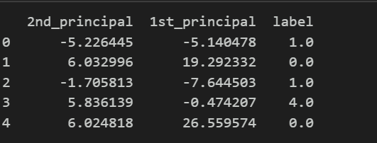

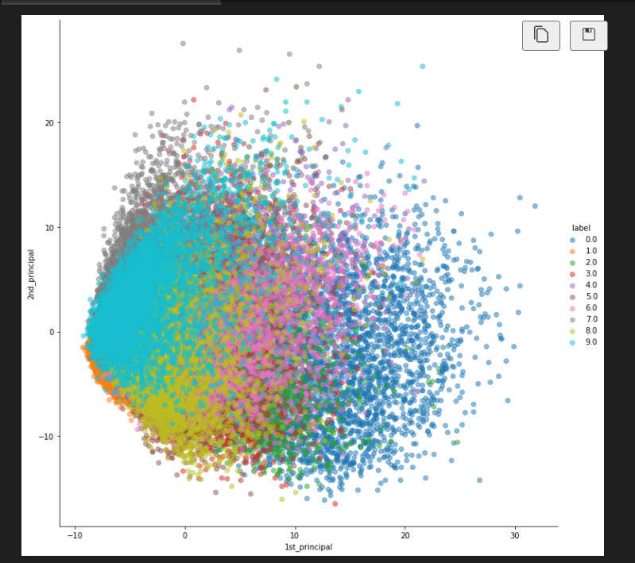

**Result:** The above program to apply Principal Component Analysis (PCA) from scratch to the MNIST dataset. has been successfully executed.

|  |  |
| --- | --- |
| **Ex. No: 09** | **NEURAL NETWORK** |
| **19/03/2024** |

**Aim:** To compare the performance of a neural network for regression built from scratch with one built using the Keras library, using the MNIST dataset.

**Algorithm:**

1. Initialize parameters: Randomly initialize weights and biases.
2. Forward propagation: Compute predictions using the current weights and biases.
3. Compute cost: Calculate the mean squared error (MSE) between predictions and actual values.
4. Backpropagation: Compute gradients of the cost function with respect to weights and biases.
5. Update parameters: Update weights and biases using gradient descent.
6. Repeat steps 2-5 for a number of iterations (epochs).

**Program :**

FROM SCRATCH:

#import libraries

import numpy as np

from mnist import MNIST

from urllib.request import urlretrieve

import gzip

import os

#to download and extract MNIST dataset

def load_mnist():

    url_base = 'http://yann.lecun.com/exdb/mnist/'

    file_names = ['train-images-idx3-ubyte.gz', 'train-labels-idx1-ubyte.gz',

                  't10k-images-idx3-ubyte.gz', 't10k-labels-idx1-ubyte.gz']

    save_path = './mnist_data/'

    if not os.path.exists(save_path):

        os.makedirs(save_path)

    for file_name in file_names:

        url = (url_base + file_name).format(**locals())

        file_path = save_path + file_name

        if not os.path.exists(file_path):

            print('Downloading ' + file_name + ' ... ')

            urlretrieve(url, file_path)

        else:

            print('Already exists: ' + file_name)

        with gzip.open(file_path, 'rb') as f_in:

            file_content = f_in.read()

            with open(file_path.replace('.gz', ''), 'wb') as f_out:

                f_out.write(file_content)

        print('Extracting ' + file_name + ' ...')

# Load MNIST dataset

def load_data():

    mnist = MNIST('./mnist_data/')

    images, _ = mnist.load_training()

    images = np.array(images) / 255.0

    images = images.reshape((-1, 784))

    return images

# Load MNIST dataset

load_mnist()

images = load_data()

# Generate random weights and bias

np.random.seed(42)

input_size = 784

hidden_size = 128

output_size = 784

weights1 = np.random.randn(input_size, hidden_size)

bias1 = np.random.randn(hidden_size)

weights2 = np.random.randn(hidden_size, output_size)

bias2 = np.random.randn(output_size)

#activation function used-sigmoid

def sigmoid(x):

    return 1 / (1 + np.exp(-x))

#derivative of activation function

def sigmoid_derivative(x):

    return x * (1 - x)

# Training parameters

learning_rate = 0.001

epochs = 200   #200 iterations

# Training loop

for epoch in range(epochs):

    # Forward propagation

    hidden_layer_input = np.dot(images, weights1) + bias1

    hidden_layer_output = sigmoid(hidden_layer_input)

    output_layer_input = np.dot(hidden_layer_output, weights2) + bias2

    output_layer_output = sigmoid(output_layer_input)

    # Calculate loss

    loss = np.mean(np.square(output_layer_output - images))

    # Backpropagation

    output_error = output_layer_output - images

    output_delta = output_error * sigmoid_derivative(output_layer_output)

    hidden_error = np.dot(output_delta, weights2.T)

    hidden_delta = hidden_error * sigmoid_derivative(hidden_layer_output)

    # Update weights and bias

    weights2 -= learning_rate * np.dot(hidden_layer_output.T, output_delta)

    bias2 -= learning_rate * np.sum(output_delta, axis=0)

    weights1 -= learning_rate * np.dot(images.T, hidden_delta)

    bias1 -= learning_rate * np.sum(hidden_delta, axis=0)

    if epoch % 10 == 0:

        print(f'Epoch {epoch}, Loss: {loss}')

print(f'Final Loss: {loss}')

USING KERAS:

# Load MNIST dataset

# Function to download and extract MNIST dataset

def load_mnist():

    url_base = 'http://yann.lecun.com/exdb/mnist/'

    file_names = ['train-images-idx3-ubyte.gz', 'train-labels-idx1-ubyte.gz',

                  't10k-images-idx3-ubyte.gz', 't10k-labels-idx1-ubyte.gz']

    save_path = './mnist_data/'

    if not os.path.exists(save_path):

        os.makedirs(save_path)

    for file_name in file_names:

        url = (url_base + file_name).format(**locals())

        file_path = save_path + file_name

        if not os.path.exists(file_path):

            print('Downloading ' + file_name + ' ... ')

            urlretrieve(url, file_path)

        else:

            print('Already exists: ' + file_name)

        with gzip.open(file_path, 'rb') as f_in:

            file_content = f_in.read()

            with open(file_path.replace('.gz', ''), 'wb') as f_out:

                f_out.write(file_content)

        print('Extracting ' + file_name + ' ...')

# Load MNIST dataset

def load_data():

    mnist = MNIST('./mnist_data/')

    images, _ = mnist.load_training()

    images = np.array(images) / 255.0

    images = images.reshape((-1, 784))

    return images

# Load MNIST dataset

load_mnist()

images = load_data()

# Convert images to numpy arrays

images = np.array(images)

# Normalize pixel values

images = images / 255.0

# Flatten images

images = images.reshape((-1, 784))

#neural network parameters

model = Sequential([

    Dense(128, input_shape=(784,), activation='sigmoid'),

    Dense(784, activation='sigmoid')

])

# Compile model

sgd = SGD(learning_rate=0.001)

model.compile(optimizer=sgd, loss='mean_squared_error',metrics=['accuracy'])

# Training parameters

epochs = 200

batch_size = 32

# Train model

model.fit(images, images, epochs=epochs, batch_size=batch_size, verbose=1)

# Calculate loss

loss = model.evaluate(images, images, verbose=0)

print(f'Keras Model Final Loss: {loss}')

**Output:**

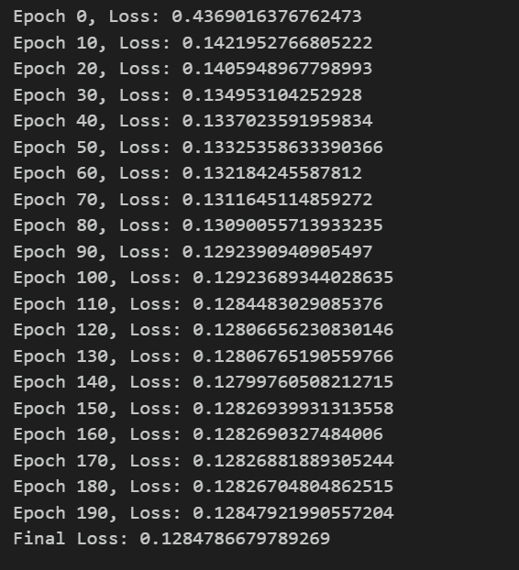

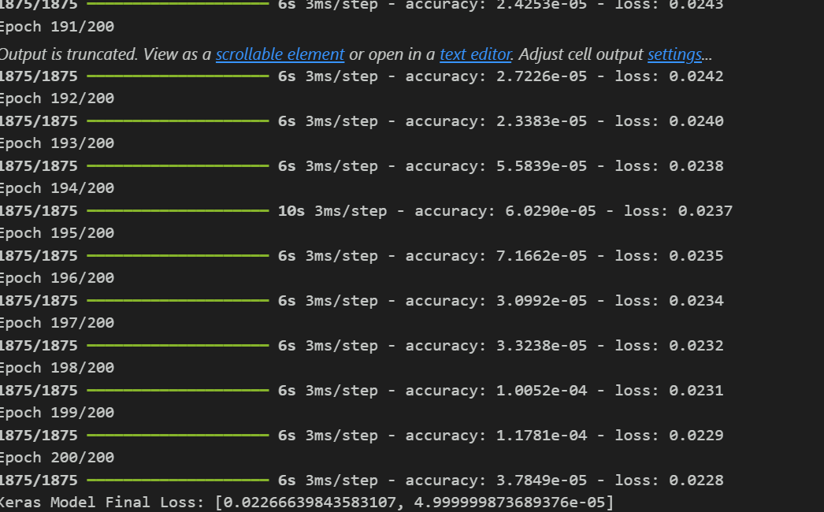

**Result:** The above program to execute neural network from scratch and using keras library has been successfully executed.

|  |  |
| --- | --- |
| **Ex. No: 10** | **ASSOCIATION RULE LEARNING** |
| **28/03/2024** |

**Aim:** To Implement Apriori from scratch on the given dataset.

**Algorithm:**

1. Initialize a list of frequent item sets (F) with frequent individual items.
2. Set the minimum support threshold (min_sup) for frequent item sets.
3. Generate candidate item sets by combining frequent item sets of size k to create item sets of size k+1.
4. Prune candidate item sets that contain subsets which are not frequent. This step is based on the Apriori property which states that if an itemset is infrequent, all its supersets will also be infrequent.
5. Count the support for each candidate itemset by scanning the transaction dataset.
6. Discard candidate item sets whose support is below the minimum support threshold.
7. Repeat steps 3-5 until no new frequent item sets can be generated.
8. Generate association rules from the set of frequent item sets.
9. Calculate confidence for each rule and discard rules with confidence below a specified threshold.
10. Output the frequent item sets found in the dataset along with their support values.

**Program :**

import pandas as pd

from itertools import combinations

dataset = pd.read_csv('Market_Basket_Optimisation.csv', header=None)

dataset = dataset.fillna(0)

transactions = []

for i in range(0, 7501):

    transactions.append([str(dataset.values[i, j]) for j in range(0, 20)])

def create_candidates(transactions, length):

    """Create initial candidate itemsets of length 1"""

    candidates = []

    for transaction in transactions:

        for item in transaction:

            if [item] not in candidates:

                candidates.append([item])

    candidates.sort()

    return list(map(frozenset, candidates))

def scan_database(transactions, candidates, min_support):

    """Scan the database and count the support of each candidate itemset"""

    itemset_counts = {}

    for transaction in transactions:

        for candidate in candidates:

            if candidate.issubset(transaction):

                itemset_counts[candidate] = itemset_counts.get(candidate, 0) + 1

    num_transactions = float(len(transactions))

    frequent_itemsets = []

    support_data = {}

    for itemset in itemset_counts:

        support = itemset_counts[itemset] / num_transactions

        if support >= min_support:

            frequent_itemsets.append(itemset)

        support_data[itemset] = support

    return frequent_itemsets, support_data

def generate_candidates(frequent_itemsets, length):

    """Generate candidate itemsets of length k from frequent itemsets of length k-1"""

    candidates = []

    num_frequent_itemsets = len(frequent_itemsets)

    for i in range(num_frequent_itemsets):

        for j in range(i + 1, num_frequent_itemsets):

            itemset1 = list(frequent_itemsets[i])[:length - 2]

            itemset2 = list(frequent_itemsets[j])[:length - 2]

            itemset1.sort()

            itemset2.sort()

            if itemset1 == itemset2:

                candidates.append(frequent_itemsets[i] | frequent_itemsets[j])

    return candidates

def apriori(transactions, min_support=0.5):

    """Apriori algorithm"""

    candidates = create_candidates(transactions, 1)

    frequent_itemsets1, support_data = scan_database(transactions, candidates, min_support)

    frequent_itemsets = [frequent_itemsets1]

    k = 2

    while len(frequent_itemsets[k - 2]) > 0:

        candidates = generate_candidates(frequent_itemsets[k - 2], k)

        frequent_itemsets_k, support_data_k = scan_database(transactions, candidates, min_support)

        support_data.update(support_data_k)

        frequent_itemsets.append(frequent_itemsets_k)

        k += 1

    return frequent_itemsets, support_data

if __name__ == "__main__":

    frequent_itemsets, support_data = apriori(transactions, min_support=0.03)

    """Print results"""

    for i, itemset_list in enumerate(frequent_itemsets):

        print("Frequent itemsets of length {}: {}".format(i+1, len(itemset_list)))

        for itemset in itemset_list:

            print(itemset, "Support:", round(support_data[itemset], 4))

**Output:**

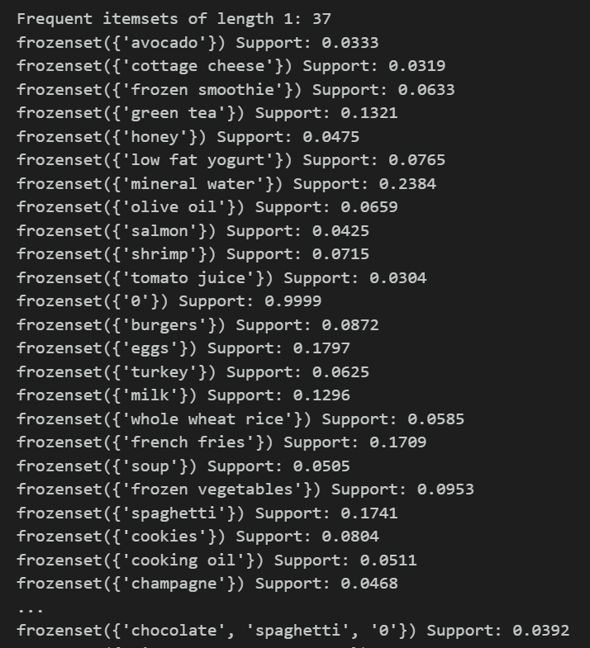

**Result:** The above program to implement apriori algorithm from scratch has been successfully executed.