AquaMind AI
Software Design Document (SDD)
PHASE 2 — Distributed OpenDC / CloudSim + AWS-Scale Deployment
Version 2.0 | Document Status: Draft for Engineering Review | July 2026
This document is the Phase 2 extract of the full AquaMind AI SDD, covering the distributed, cloud-scale evolution of the platform. Phase 2 is a superset of Phase 1 (same data contracts, same API shapes, same database schema extended rather than replaced) — see the companion Phase 1 document for the standalone laptop design it builds on.

1. Executive Summary
AquaMind AI is a digital-twin platform for AI data-centre operations that continuously ingests compute telemetry, simulates rack- and facility-level thermal/water behaviour, retrieves relevant operational memory, and produces AI-generated recommendations for cooling and capacity decisions. The system combines a FastAPI orchestration layer, a CockroachDB operational and vector memory store, Amazon Bedrock for reasoning and embeddings, and a React dashboard for visualisation.
Phase 2 extends the Phase 1 standalone laptop digital twin into a distributed, cloud-scale system:
- Phase 1's laptop telemetry source is extended (not replaced) with OpenDC/CloudSim-simulated data-centre workloads and, eventually, real IoT rack sensors.
- The single FastAPI monolith is decomposed into independently scalable microservices deployed on AWS (ECS/EKS, Lambda, Batch).
- The AI Decision Agent evolves from a single-agent Bedrock call into a governed multi-agent system (Orchestrator, Water & Cooling Agent, Capacity Planning Agent, Memory/RAG Agent, Guardrail/Critic Agent).
- CockroachDB scales from a single serverless node to a multi-region cluster with tiered memory retention and Change Data Capture (CDC) into an S3 data lake.
Because Phase 2 is architected as a superset of Phase 1 (same data contracts, same API shapes, same database schema extended rather than replaced), the migration path is additive: nothing built in Phase 1 needs to be rewritten to reach Phase 2.

1.1 Goals
- Design every component so that scaling from Phase 1 to Phase 2 is a matter of configuration, deployment topology, and additional data sources — not a rewrite.
- Provide an auditable, explainable AI reasoning trail (memory + recommendation provenance) suitable for operational trust, at fleet scale.

1.2 Non-Goals (out of scope for this document)
- Procurement or physical build-out of real data-centre hardware.
- Detailed CFD (computational fluid dynamics) modelling — covered only at a conceptual level under Future Scope.
- Billing/procurement integration with specific utility providers.
- The standalone laptop-only workflow itself — see the companion Phase 1 document.

2. Requirements Specification

2.1 Functional Requirements — Phase 2 (Distributed / Cloud-Scale)
ID | Requirement | Priority
FR-2.1 | The system shall ingest telemetry from N concurrent laptop/edge agents and OpenDC/CloudSim-simulated data-centre workloads through a common ingestion contract. | Must
FR-2.2 | The Digital Twin Service shall run OpenDC/CloudSim simulations as asynchronous jobs and return results via the shared telemetry/simulation schema. | Must
FR-2.3 | The AI Decision Agent shall be decomposed into a multi-agent system with an Orchestrator, specialised reasoning agents, and a Guardrail/Critic agent that validates outputs before persistence. | Must
FR-2.4 | CockroachDB shall be deployed as a multi-region cluster with configurable table survival goals (REGIONAL/GLOBAL). | Must
FR-2.5 | The system shall implement tiered memory retention (hot/warm/cold) with CDC export of cold data to S3. | Should
FR-2.6 | The system shall support fleet-wide dashboards with per-site and aggregate views, and role-based access control. | Must
FR-2.7 | The system shall expose a rate-limited, API-key-authenticated public/partner API for external integrations. | Should
FR-2.8 | The system shall support horizontal auto-scaling of stateless services based on ingestion and simulation load. | Must
FR-2.9 | The system shall support future integration of real IoT rack sensors without changing the telemetry schema. | Should
FR-2.10 | The system shall support reinforcement-learning-driven cooling policy suggestions as a pluggable agent (Future Scope hook). | Could

2.2 Non-Functional Requirements — Phase 2 Targets
Category | Phase 2 Target
Availability | 99.9% for ingestion/dashboard; multi-AZ
Latency (ingest → recommendation) | < 3s p95 at fleet scale
Scalability | Horizontally scalable to hundreds of sites, thousands of racks (simulated)
Data Retention | Tiered hot/warm/cold with automated TTL and S3 archival
Security | TLS everywhere, IAM least-privilege, Secrets Manager, Cognito auth
Observability | Centralised logs/metrics/traces via CloudWatch + X-Ray
Cost | Pay-as-you-go, cost-monitored via AWS Budgets
Portability | Containerised, cloud-agnostic core (AWS-first)

3. Detailed System Architecture

3.1 Phase 2 Architecture — Distributed / Cloud-Scale Digital Twin
Phase 2 extends Phase 1 rather than replacing it. The single FastAPI monolith is split into independently deployable microservices. Telemetry sources expand from one laptop to a fleet of laptops/edge agents plus OpenDC/CloudSim-simulated racks and (in the future) real IoT sensors. The AI Decision Agent becomes a governed multi-agent system. CockroachDB becomes a multi-region cluster with tiered memory and CDC into an S3 data lake.
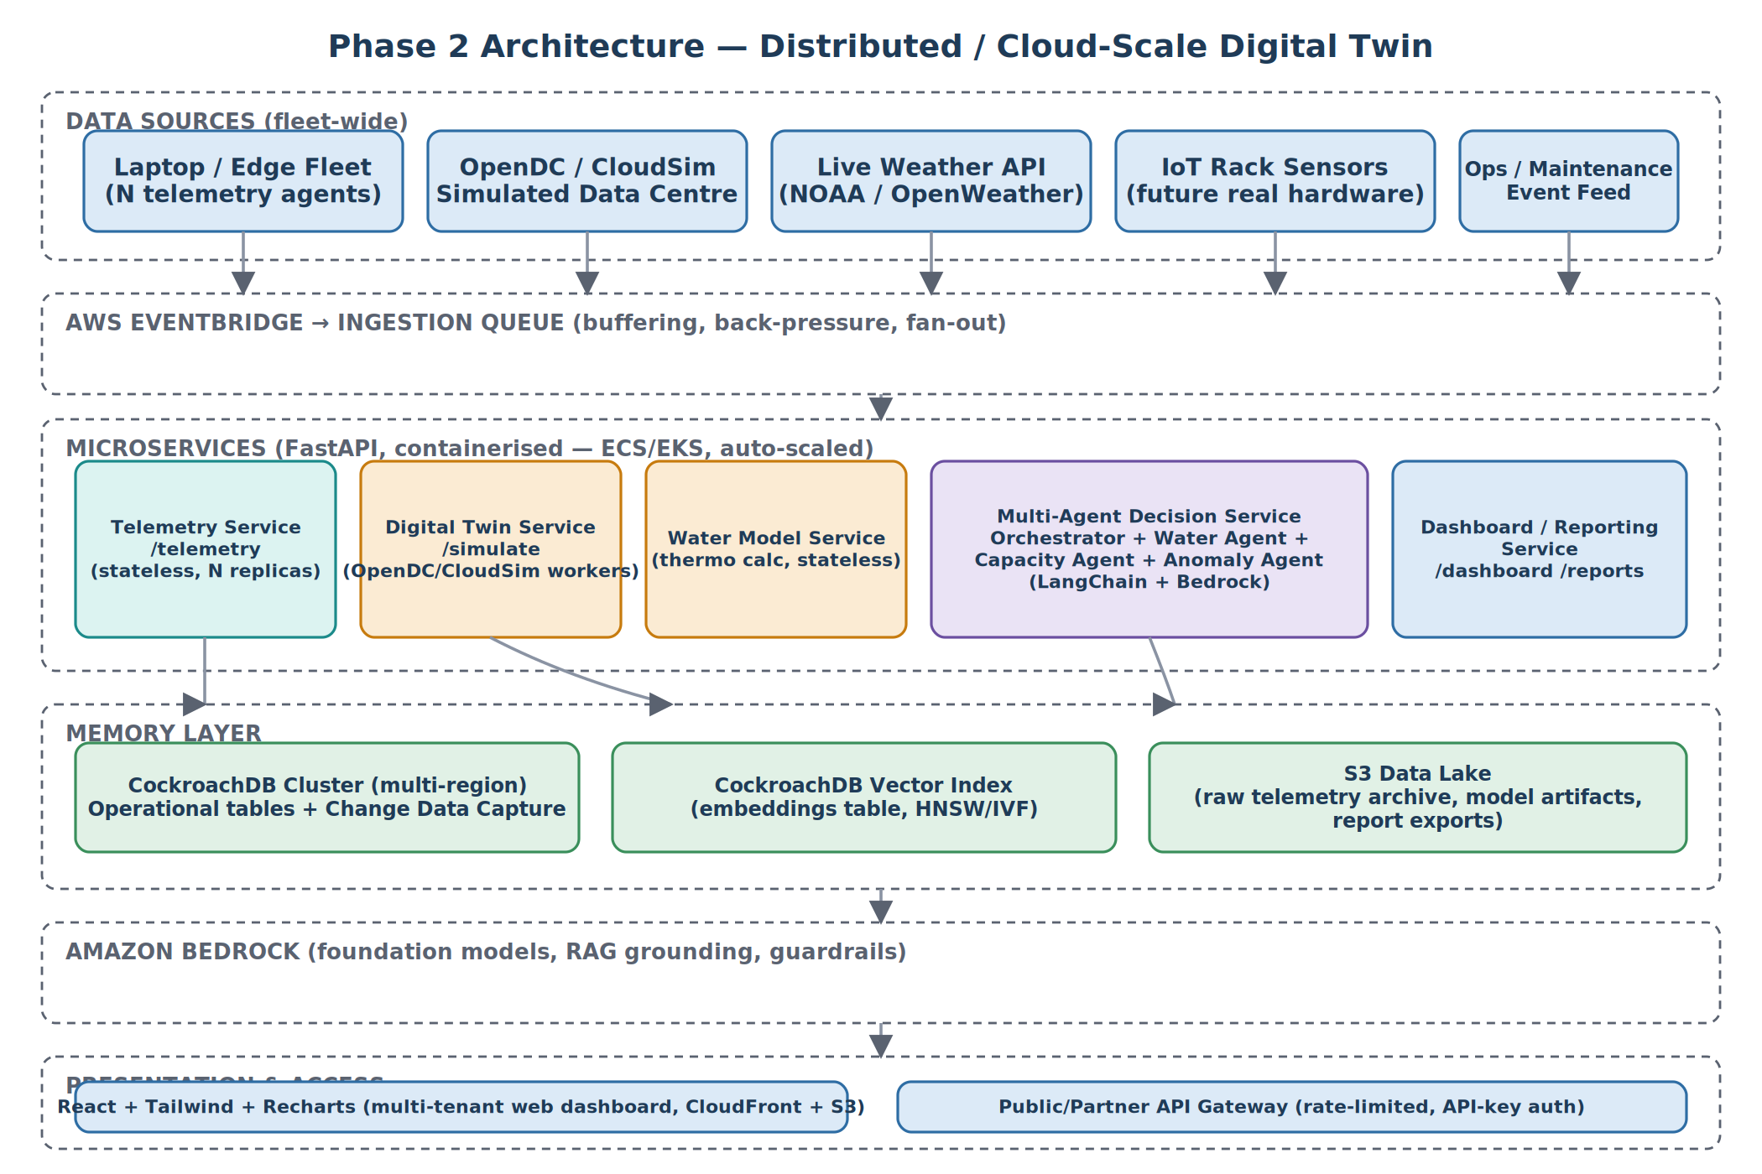
Figure 2 — Phase 2 Architecture: distributed, multi-source, cloud-scale digital twin.

3.2 Migration Path from Phase 1 to Phase 2
Phase 1 Component | Phase 2 Evolution | Migration Approach
Single FastAPI process | Independently deployed microservices (ECS/EKS) | Split existing routers into separate services; no interface changes
Synthetic rack profile | OpenDC/CloudSim simulation jobs | Add adapter behind existing DigitalTwinEngine interface
Single-node CockroachDB (free tier) | Multi-region CockroachDB cluster | Schema unchanged; add REGIONAL/GLOBAL table locality
Single Bedrock call / rules fallback | Multi-agent Orchestrator + specialised agents | Wrap existing call as the 'Water & Cooling Agent'; add peers
Local file buffering | EventBridge + SQS ingestion queue | Collector's HTTP client unchanged; endpoint moves behind queue
Local dashboard | Multi-tenant dashboard on CloudFront/S3 | Same React app; add auth (Cognito) and site selector

4. AWS Architecture (Phase 2 Deployment)
Phase 2 deploys AquaMind AI into a single AWS account/VPC, using managed services to minimise operational overhead.
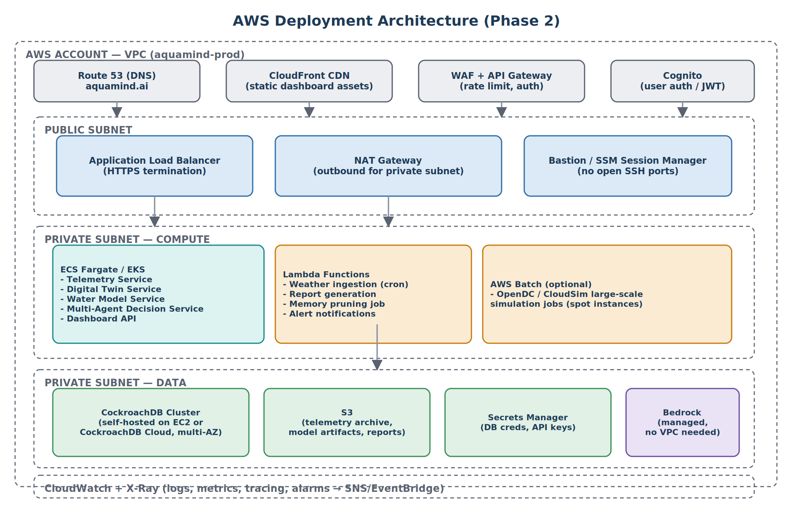
Figure 3 — AWS deployment topology for Phase 2.

4.1 Key AWS Services and Their Role
Service | Role
Route 53 + CloudFront | DNS and global CDN for the React dashboard
WAF + API Gateway | Perimeter protection, rate limiting, request routing for the public API
Cognito | User authentication and JWT issuance for the dashboard and API
Application Load Balancer | Routes traffic to ECS/EKS services in the private subnet
ECS Fargate / EKS | Runs the FastAPI microservices (Telemetry, Digital Twin, Water Model, Agent, Dashboard API)
Lambda | Scheduled jobs: weather ingestion, report generation, memory pruning, alert notifications
AWS Batch | Large-scale OpenDC/CloudSim simulation jobs on spot instances
CockroachDB (self-hosted or Cloud) | Operational + vector memory store, multi-AZ
S3 | Telemetry archive, model artifacts, generated reports, CDC cold-tier export
Secrets Manager | Database credentials, third-party API keys
Amazon Bedrock | Managed foundation models for reasoning and embeddings
CloudWatch + X-Ray | Logging, metrics, distributed tracing, alarms
EventBridge + SQS | Event bus and ingestion buffering/back-pressure across services

5. CockroachDB Memory Architecture
CockroachDB serves two roles simultaneously: an ACID-compliant operational database for structured telemetry/event data, and a vector store for semantic memory retrieval used by the AI Decision Agent (Retrieval-Augmented Generation).
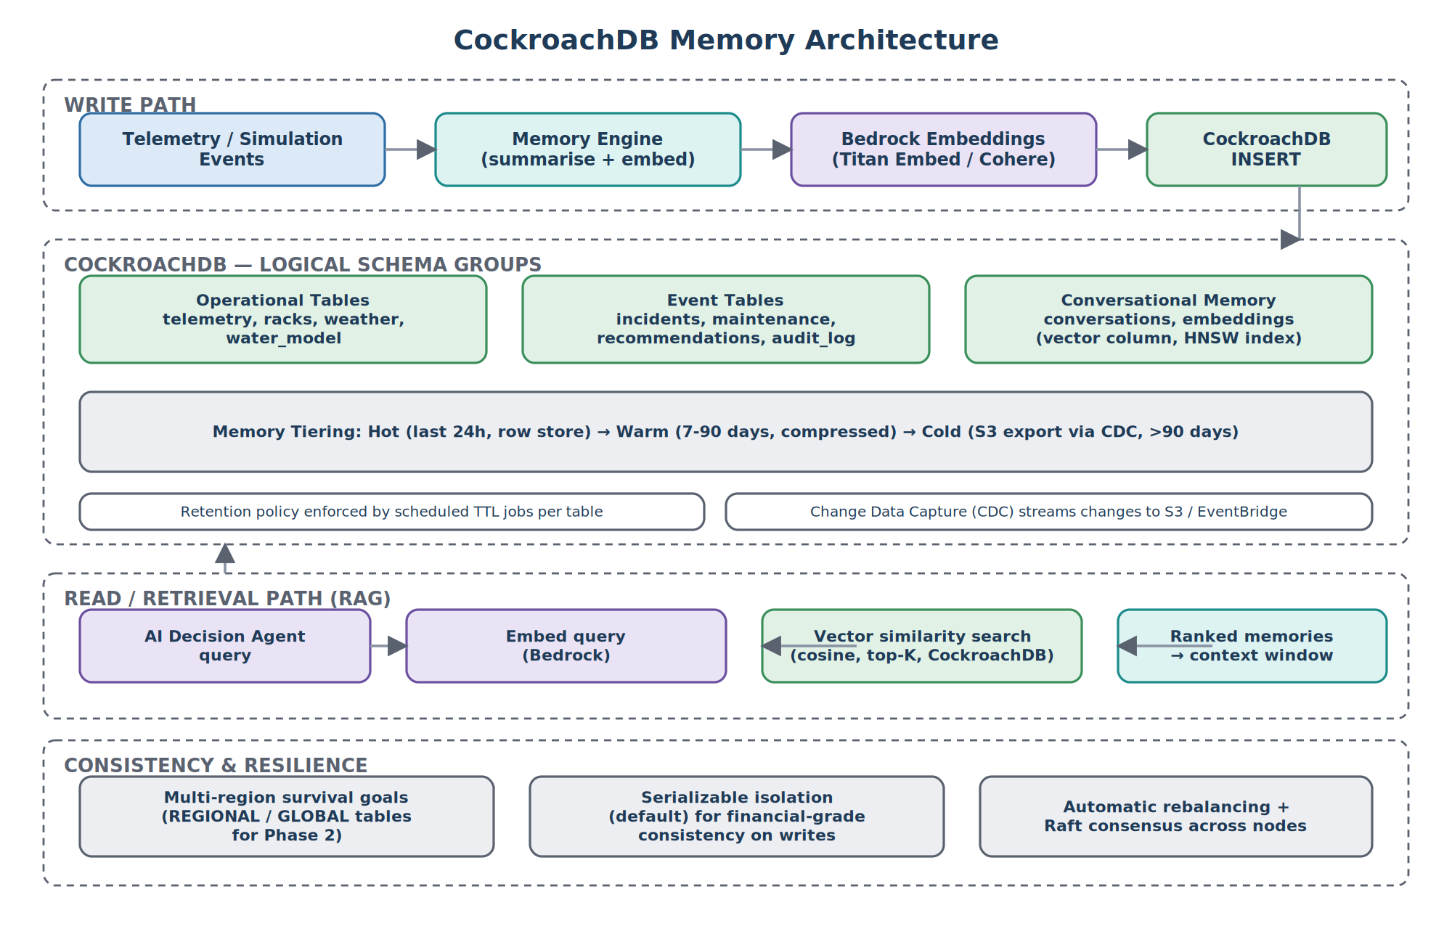
Figure 4 — CockroachDB write path, schema groups, tiering, read/retrieval path, and resilience model.

5.1 Memory Tiering
Hot data (last 24 hours) lives in the standard row store for fast reads. Warm data (7–90 days) is compressed and range-partitioned. Cold data (>90 days) is exported via Change Data Capture to S3 and removed from the live cluster, with a pointer retained for audit purposes.

5.2 Consistency and Resilience
REGIONAL/GLOBAL table locality for multi-region survival goals; Raft consensus and automatic rebalancing across nodes; SERIALIZABLE isolation retained for recommendation and audit tables.

6. Multi-Agent Architecture
Phase 2 replaces Phase 1's single AI Decision Agent with a governed multi-agent system, orchestrated with LangChain, so that different reasoning concerns are separated, testable, and independently improvable.
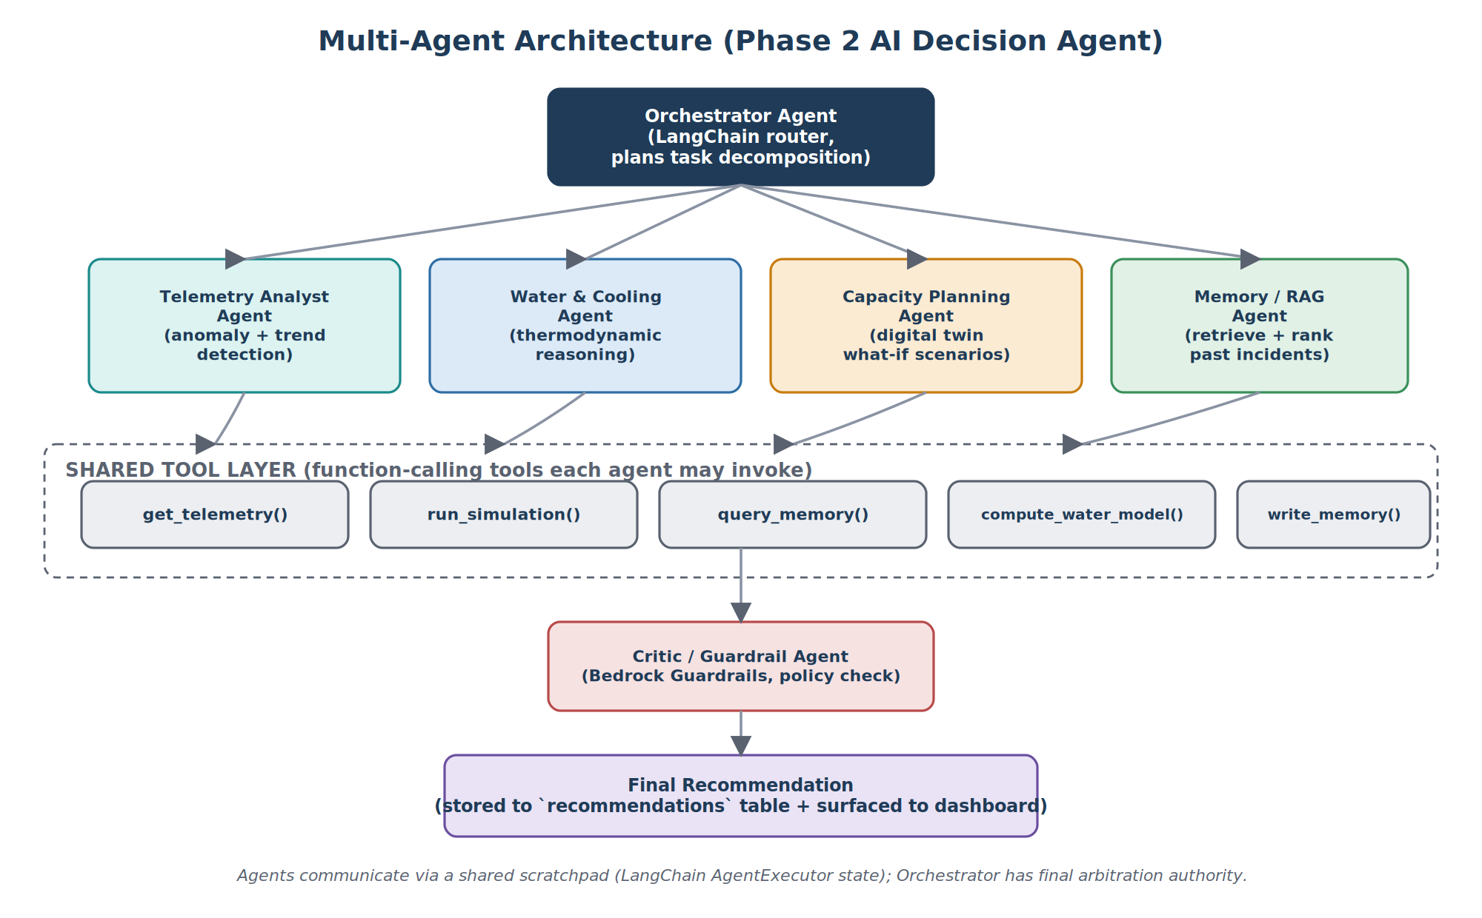
Figure 5 — Phase 2 multi-agent decomposition of the AI Decision Agent.

6.1 Agent Roles
Agent | Responsibility
Orchestrator | Decomposes the incoming task, routes to specialised agents, aggregates their outputs
Telemetry Analyst Agent | Detects anomalies and trends in raw/normalised telemetry
Water & Cooling Agent | Reasons over the Water Model's thermodynamic output (this is the Phase 1 single-agent logic, promoted to a peer agent)
Capacity Planning Agent | Runs digital-twin what-if scenarios for capacity decisions
Memory / RAG Agent | Retrieves and ranks relevant historical incidents and recommendations
Critic / Guardrail Agent | Applies Bedrock Guardrails and policy checks before a recommendation is persisted or surfaced

6.2 Shared Tool Layer
All agents call into a shared, versioned tool layer (function-calling tools) rather than accessing data stores directly: get_telemetry(), run_simulation(), query_memory(), compute_water_model(), write_memory(). This keeps agent logic declarative and testable, and reuses the exact same tool implementations that back Phase 1's single-agent implementation.

7. Sequence Diagram
The sequence diagram below shows the end-to-end flow from a telemetry reading to a stored, displayed AI recommendation. In Phase 2, the 'AI Decision Agent' lifeline represents the full Orchestrator/multi-agent flow described in Section 6.
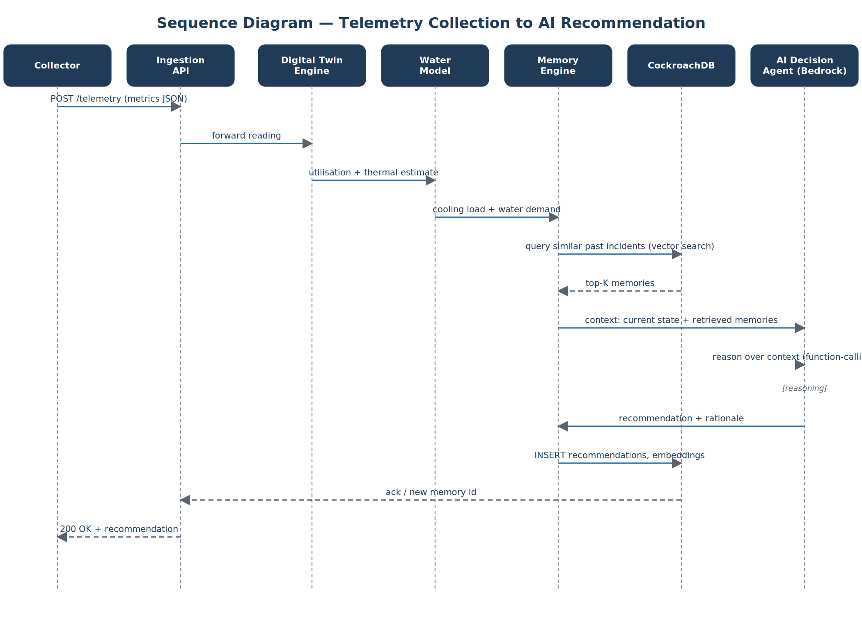
Figure 6 — Sequence: Telemetry Collection → Digital Twin → Water Model → Memory Retrieval → AI Recommendation → Persistence → Dashboard.

7.1 Key Interaction Notes
- Step 4 (vector similarity search) is the main latency contributor as memory volume grows; tiering ensures only hot/warm data is searched by default.
- The reasoning loop (function-calling) may issue multiple internal tool calls before returning; this is shown as a single self-referential step for clarity.
- Persistence of the new memory (INSERT into recommendations, embeddings) happens before the response is returned, guaranteeing the recommendation is retrievable by the next request.

8. Class Diagram
The class diagram below shows the core domain model. Phase 2 instantiates the full set of Agent subclasses shown, coordinated by the Orchestrator.
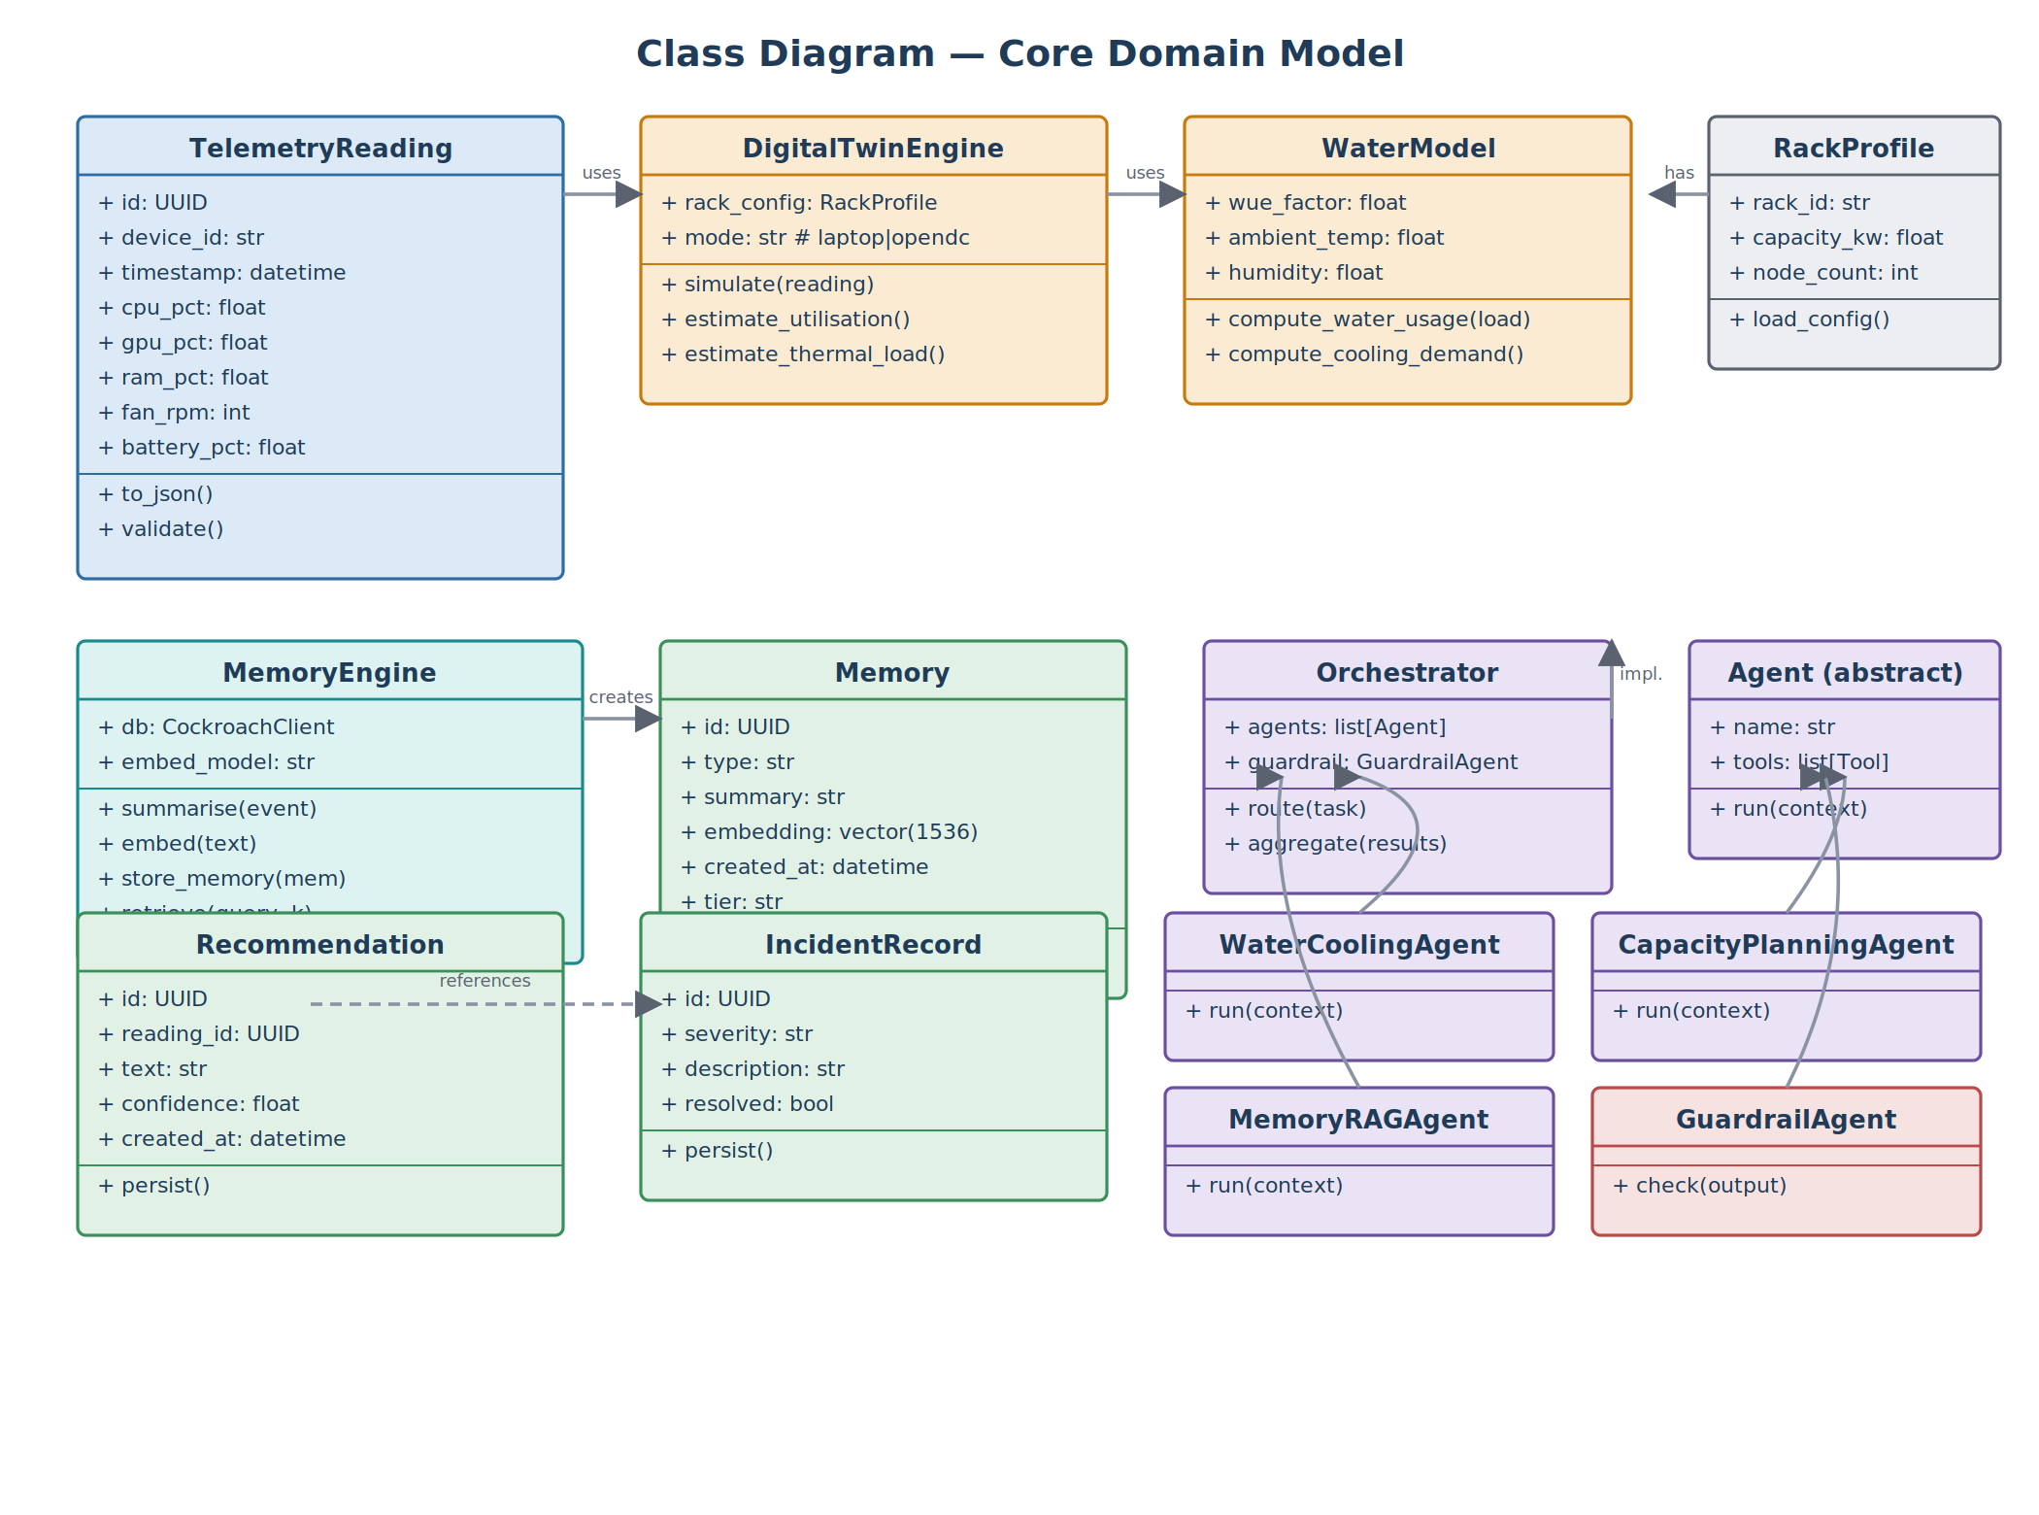
Figure 7 — Core domain class diagram.

9. Component Diagram
The component diagram groups the system into Presentation, Application, and Data/Integration tiers. In Phase 2, each Application-tier component becomes an independently deployable component with its own scaling policy.
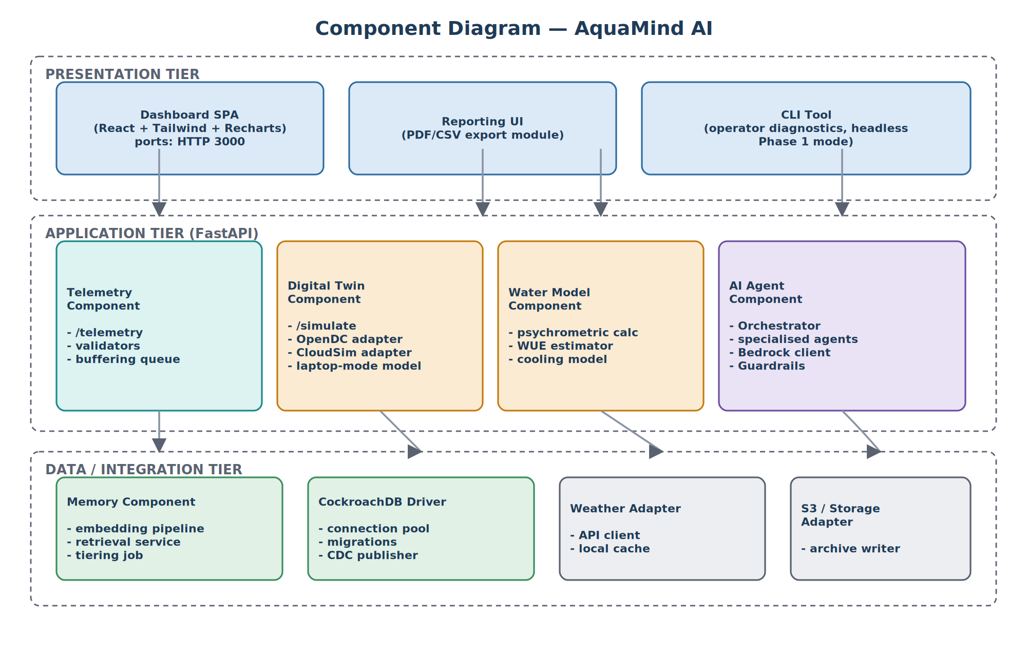
Figure 8 — Component diagram with presentation, application, and data/integration tiers.

10. ER Diagram (Database Schema)
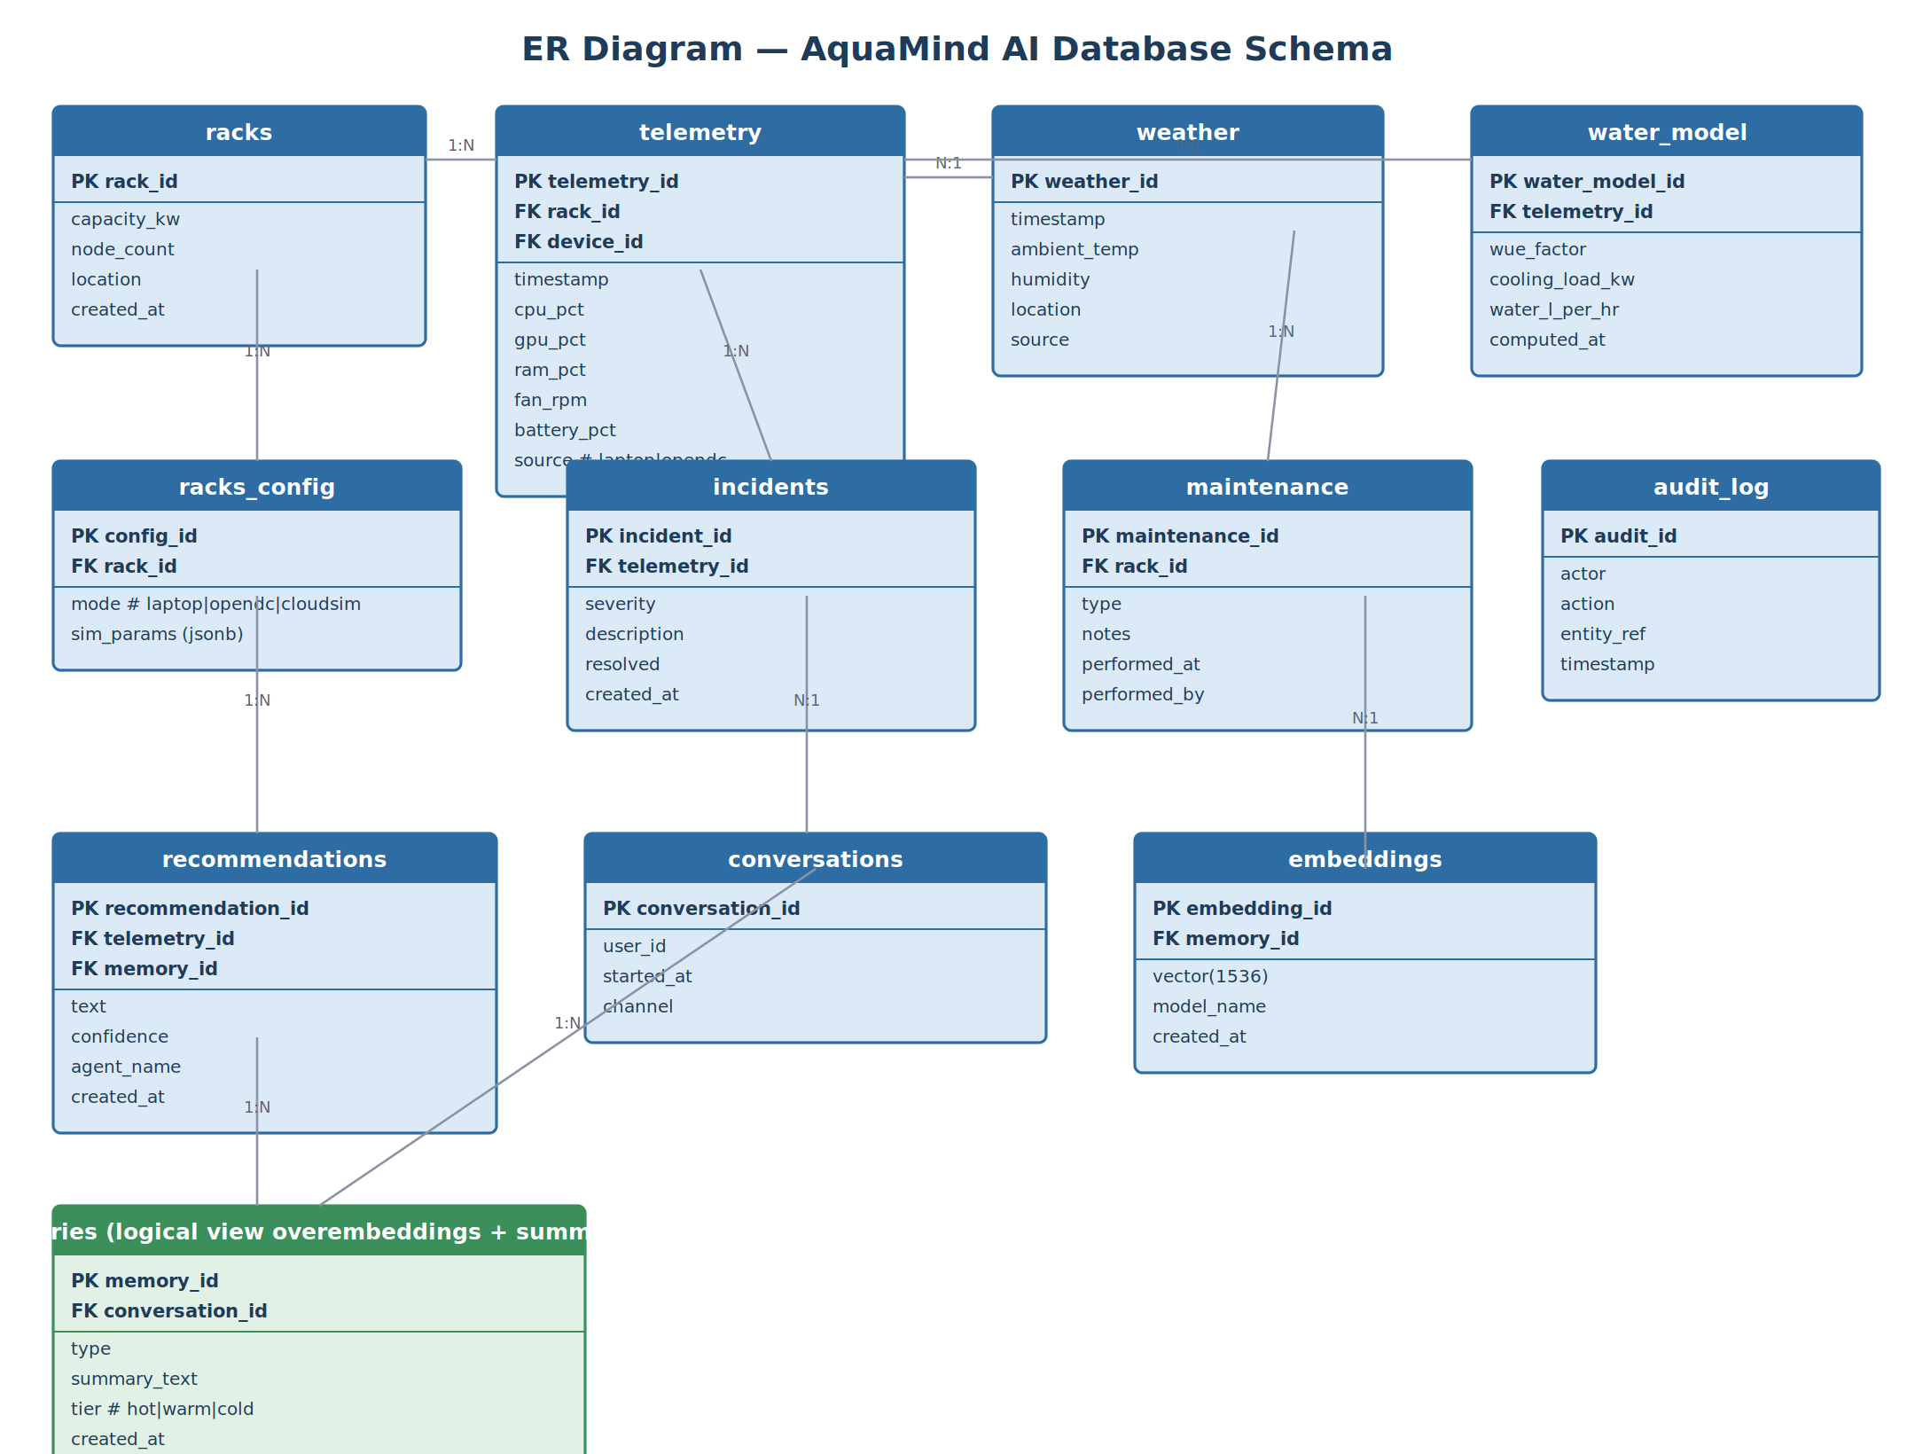
Figure 9 — Entity-relationship diagram for the AquaMind AI database.

10.1 Table Definitions
The schema below is used unchanged from Phase 1 into Phase 2 — Phase 2 adds table locality settings and CDC configuration, but no columns are removed or renamed, preserving backward compatibility for the dashboard and API.
Table | Key Columns | Phase 2 Notes
racks | rack_id (PK), capacity_kw, node_count, location, created_at | Real/simulated racks.
telemetry | telemetry_id (PK), rack_id (FK), device_id (FK), timestamp, cpu_pct, gpu_pct, ram_pct, fan_rpm, battery_pct, source | source distinguishes 'laptop' vs 'opendc' vs future 'iot'.
weather | weather_id (PK), timestamp, ambient_temp, humidity, location, source | Uses a live API.
water_model | water_model_id (PK), telemetry_id (FK), wue_factor, cooling_load_kw, water_l_per_hr, computed_at | Output of the Water Thermodynamic Model (Section 13).
racks_config | config_id (PK), rack_id (FK), mode, sim_params (jsonb) | mode = laptop / opendc / cloudsim.
incidents | incident_id (PK), telemetry_id (FK), severity, description, resolved, created_at | Anomalies flagged by the Telemetry Analyst Agent.
maintenance | maintenance_id (PK), rack_id (FK), type, notes, performed_at, performed_by | Ops-integrated.
audit_log | audit_id (PK), actor, action, entity_ref, timestamp | Append-only; required for security design (Section 16).
recommendations | recommendation_id (PK), telemetry_id (FK), memory_id (FK), text, confidence, agent_name, created_at | agent_name = specific agent name.
conversations | conversation_id (PK), user_id, started_at, channel | Groups related memory entries.
embeddings | embedding_id (PK), memory_id (FK), vector(1536), model_name, created_at | Vector column indexed with CockroachDB's vector index (HNSW).
memories | memory_id (PK), conversation_id (FK), type, summary_text, tier, created_at | tier used from Phase 2 onward.

11. API Specification (FastAPI / OpenAPI)
All endpoints are versioned under /api/v1. Phase 2 adds fleet-scale and simulation-management endpoints on top of the Phase 1 core set. Request/response bodies use the shared telemetry schema so no breaking changes are needed between phases.

11.1 Additional Endpoints (Phase 2 — fleet & simulation scale)
Method & Path | Description | Request Body | Response
POST /api/v1/telemetry/batch | Bulk ingest from N edge agents | list[TelemetryReading] | 202 Accepted, {accepted, rejected}
POST /api/v1/simulate/opendc | Submit an OpenDC/CloudSim job (async, AWS Batch) | SimulationJobSpec JSON | 202 Accepted, {job_id}
GET /api/v1/simulate/opendc/{job_id} | Poll simulation job status/result | — | SimulationJobResult JSON
GET /api/v1/sites | List all registered sites/racks (fleet view) | — | list[Rack]
GET /api/v1/recommendations | List/filter historical recommendations | ?site_id&from&to | list[Recommendation]
POST /api/v1/agents/feedback | Human feedback on a recommendation (for guardrail tuning) | {recommendation_id, rating, notes} | 204 No Content
GET /api/v1/health | Service health/readiness probe | — | {status, dependencies}

11.2 Shared TelemetryReading Schema (OpenAPI-style)
TelemetryReading { telemetry_id: string (uuid, server-generated); device_id: string; rack_id: string; timestamp: string (ISO-8601); cpu_pct: number (0-100); gpu_pct: number (0-100, nullable); ram_pct: number (0-100); fan_rpm: integer (nullable); battery_pct: number (0-100, nullable); source: enum [laptop, opendc, cloudsim, iot] }

11.3 Error Model
All endpoints return RFC 7807 problem+json on error: {type, title, status, detail, instance}. Validation errors (422) include a field-level errors array.

11.4 Authentication — Phase 2
All endpoints require a Cognito-issued JWT (dashboard/API users) or an API key (partner integrations), enforced at API Gateway.

12. Memory Lifecycle Design
Memory in AquaMind AI is not just conversation history — it is the operational record that lets the AI Decision Agent learn from past incidents.

12.1 Summarise & Embed — Phase 2
The Memory Engine converts the structured event into a short natural-language summary (LLM-assisted in Phase 2 for richer summaries), then generates a 1536-dimension embedding via Bedrock Titan Embeddings.

12.2 Age and Retire
- Age: a scheduled Lambda job re-tiers memories from hot → warm → cold based on age and access frequency.
- Retire: cold memories are exported to S3 via CDC and removed from the live cluster after the configured retention window (default 1 year), with an audit_log entry recording the export.

12.3 Provenance and Explainability
Every recommendation stores the IDs of the memories that were retrieved to produce it, so any recommendation can be explained after the fact by re-fetching its cited memories.

13. Digital Twin Design
The Digital Twin Engine is the abstraction that lets the same downstream pipeline (Water Model → Memory → AI Agent) operate identically whether the underlying data source is a single laptop or a simulated 10,000-node data centre.

13.1 Interface (shared with Phase 1)
class DigitalTwinEngine: def simulate(self, reading: TelemetryReading) -> TwinState: ... def estimate_utilisation(self) -> float: ... def estimate_thermal_load(self) -> float: # kW

13.2 Phase 2 — OpenDC / CloudSim Mode
The same interface is backed by an adapter that submits a job to OpenDC or CloudSim (Section 14) describing the workload trace, rack topology, and cooling configuration, and maps the simulator's utilisation/power output back into the same TwinState object consumed downstream.

13.3 TwinState Output Contract (shared)
TwinState { rack_id: string; utilisation_pct: number; thermal_load_kw: number; power_draw_kw: number; mode: enum [laptop, opendc, cloudsim] }

14. Water Thermodynamic Model
The Water Model converts a Digital Twin's thermal load into an estimate of cooling energy demand and water consumption, using standard data-centre efficiency metrics. The same equations apply as in Phase 1; only the input scale changes.

14.1 Key Metrics and Equations
Q_cooling (kW) = thermal_load_kw × (1 + PUE_thermal_overhead)
PUE = Total_Facility_Energy / IT_Equipment_Energy
WUE (L/kWh) = Water_Consumed_L / IT_Equipment_Energy_kWh
Water_L_per_hr = WUE × IT_Equipment_Energy_kWh × f(ambient_temp, humidity)

14.2 Assumptions — Phase 2
- PUE, cooling technology (air/liquid/immersion), and ambient conditions can vary per simulated rack, and the lookup table can be substituted with a proper psychrometric calculation library.
- Model output remains a decision-support estimate, not a certified engineering measurement; this caveat is surfaced in the dashboard UI.

14.3 Validation Approach
Model outputs are sanity-checked against published industry WUE benchmarks (typically 0.5–2.0 L/kWh for air-cooled facilities) as an automated test assertion, flagging any configuration that produces physically implausible results.

15. OpenDC / CloudSim Integration Design (Phase 2 Only)
OpenDC and CloudSim are data-centre simulation frameworks used to generate realistic, larger-scale workload and rack-topology data once the Phase 1 laptop-scale proof of concept is validated.

15.1 Integration Pattern
- A SimulationJobSpec (workload trace, rack topology, cooling config, duration) is submitted via POST /api/v1/simulate/opendc.
- The Digital Twin Service places the job on an AWS Batch queue backed by spot instances running the OpenDC (or CloudSim) engine in a container.
- The simulator produces a time-series of utilisation and power-draw values per simulated rack.
- An adapter maps this time-series into the shared TelemetryReading / TwinState schema (Section 13.3), tagging source='opendc'.
- Results flow through the identical Water Model → Memory → AI Agent pipeline used for real laptop telemetry.

15.2 Why This Design De-Risks Phase 2
Because OpenDC/CloudSim output is mapped into the exact same schema used by Phase 1's laptop telemetry, every downstream component (Water Model, Memory Engine, AI Decision Agent, Dashboard) requires zero changes to consume simulated data centre-scale workloads — only the Digital Twin Engine's adapter layer is new.

15.3 Job Management
- Jobs are asynchronous; clients poll GET /api/v1/simulate/opendc/{job_id} or subscribe to a completion event via EventBridge.
- Long-running jobs are checkpointed so partial results are available for dashboard preview before completion.

16. Laptop Telemetry Collection — Carrying Forward Into Phase 2
The Telemetry Collector built in Phase 1 (Python daemon polling OS-level metrics) is reused unchanged. In Phase 2, the identical collector binary is distributed to N edge devices; the only change is the ingestion endpoint (single-device /telemetry vs fleet-aware /telemetry/batch) and the addition of a device_id/site_id in the payload, both of which are already present in the shared schema.

17. Vector Memory & RAG Flow
Retrieval-Augmented Generation (RAG) is what allows the AI Decision Agent to reason with institutional memory rather than a stateless single-shot prompt. The flow is the same as Phase 1; Phase 2 standardises the embedding model across the fleet and partitions the vector index by tier.

17.1 Embedding Model — Phase 2
Titan Embeddings V2 standardised across the fleet for consistency of the shared vector index.

17.2 Index Maintenance
The vector index is rebuilt/optimised on a scheduled basis as the embeddings table grows; Phase 2 additionally partitions the index by tier (hot/warm) so retrieval latency stays flat as historical volume grows.

18. Amazon Bedrock Prompt Architecture
Prompts are structured, versioned, and stored as templates (not hard-coded strings) so that prompt changes are auditable and testable independently of application code.

18.1 Phase 2 Prompt Usage
The Orchestrator issues one prompt invocation per specialised agent, then a final aggregation/critic prompt that merges their outputs and applies Bedrock Guardrails before persistence.

18.2 Guardrails
Amazon Bedrock Guardrails are configured to block denied topics (e.g. unrelated general chit-chat, unsafe operational instructions outside the cooling/water domain) and to enforce that numeric claims in the response are traceable to CONTEXT or MEMORIES fields, reducing hallucinated figures in operational recommendations.

19. Security Design — Phase 2 (Cloud-Scale)
- All external traffic terminates TLS at the Application Load Balancer / CloudFront; internal service-to-service traffic uses VPC-private networking.
- Cognito issues short-lived JWTs for dashboard/API users; partner integrations use rotated API keys validated at API Gateway.
- IAM roles are scoped per service (Telemetry Service cannot invoke Bedrock; Agent Service cannot write directly to S3, etc.) following least-privilege.
- Secrets Manager stores all database credentials and third-party API keys, with automatic rotation enabled.
- WAF rules mitigate common web exploits and basic rate-based abuse at the edge.
- All administrative access uses SSM Session Manager; no bastion hosts with open inbound SSH.
- audit_log captures every write to recommendations, incidents, and maintenance for after-the-fact review.

19.1 Data Privacy
This scope boundary established in Phase 1 (device performance metrics only — no personal files, keystrokes, or content) is maintained into Phase 2 for all edge/IoT telemetry sources.

20. Scalability Design — Phase 2 Scaling Strategy
Layer | Scaling Approach
Ingestion | Stateless Telemetry Service behind ALB, horizontally auto-scaled on request rate; EventBridge/SQS absorbs bursts
Digital Twin (OpenDC/CloudSim) | AWS Batch with spot-instance fleets; jobs are independent and embarrassingly parallel across racks
Database (CockroachDB) | Add nodes to the cluster; range-based automatic rebalancing; multi-region table locality for latency-sensitive reads
AI Agents | Each agent service scales independently based on its own request volume; Bedrock itself is a managed, auto-scaling dependency
Dashboard | Static assets on CloudFront/S3 scale globally by default; API layer scales with the Dashboard API service

20.1 Bottleneck Watch-List
- Vector search latency as the embeddings table grows — mitigated via tiering (Section 12.2) and index partitioning (Section 17.2).
- Cross-region write latency if GLOBAL table locality is overused — mitigated by defaulting to REGIONAL locality except for tables genuinely requiring global consistency.

21. Deployment Architecture (AWS)
Deployment architecture is described in detail in Section 4 (AWS Architecture) and Figure 3. This section adds environment and promotion details.

21.1 Environments
Environment | Purpose | Infrastructure
dev | Integration testing of Phase 2 microservices | Small ECS Fargate cluster, single-node CockroachDB Cloud, mocked Bedrock optional
staging | Pre-production validation, load testing | Scaled-down mirror of production topology
production | Live Phase 2 deployment | Full topology per Figure 3, multi-AZ/multi-region CockroachDB

21.2 CI/CD
- Each microservice has its own container image built and pushed on merge to main; deployment promoted dev → staging → production via approval gates.
- Infrastructure is defined as code (Terraform/CDK) to keep environments reproducible.
- Phase 1's single-process app is packaged as a Docker image usable both for local `docker run` and as the base image for the Phase 2 Telemetry/Digital Twin/Water Model services, minimising drift between phases.

22. Folder Structure (Phase 2 Portion)
aquamind-ai/
├── phase2_distributed/ # Deployed to AWS
│ ├── services/
│ │ ├── telemetry_service/
│ │ ├── digital_twin_service/
│ │ │ └── opendc_adapter/
│ │ ├── water_model_service/
│ │ ├── agent_service/
│ │ │ ├── orchestrator.py
│ │ │ ├── agents/
│ │ │ │ ├── telemetry_analyst.py
│ │ │ │ ├── water_cooling.py
│ │ │ │ ├── capacity_planning.py
│ │ │ │ ├── memory_rag.py
│ │ │ │ └── guardrail_critic.py
│ │ │ └── tools/ # shared function-calling tools
│ │ └── dashboard_api_service/
│ ├── infra/ # Terraform/CDK
│ │ ├── networking/
│ │ ├── ecs/
│ │ ├── cockroachdb/
│ │ └── lambda/
│ └── dashboard_web/ # Production React build, CloudFront
├── shared/ # Used by both phases
│ ├── schemas/ # Pydantic models: TelemetryReading, TwinState, etc.
│ ├── db/ # CockroachDB migrations (schema in Section 10)
│ └── prompts/ # Versioned Bedrock prompt templates
├── tests/
│ └── phase2/
└── docs/
└── AquaMind_AI_SDD_Phase2.docx # This document

23. Implementation Timeline — Phase 2 (Target: 12 weeks, starts after Phase 1 sign-off)
Weeks | Milestone
1–2 | AWS foundation: VPC, networking, IAM, Secrets Manager, CI/CD pipelines
3–4 | Split monolith into microservices (Telemetry, Digital Twin, Water Model, Dashboard API); deploy to ECS/EKS in dev
5–6 | OpenDC/CloudSim integration via AWS Batch; simulation job API; adapter into shared schema
7–8 | Multi-agent Orchestrator, specialised agents, Guardrail/Critic agent; Bedrock Guardrails configuration
9 | CockroachDB multi-region cluster; memory tiering jobs; CDC export to S3
10 | Multi-tenant dashboard (Cognito auth, per-site views); public/partner API via API Gateway
11 | Load testing, security review, observability (CloudWatch/X-Ray) wiring
12 | Staging validation, production cutover, Phase 2 sign-off

24. Risk Analysis — Phase 2
Risk | Likelihood | Impact | Mitigation
OpenDC/CloudSim output doesn't map cleanly onto the laptop-derived schema | Medium | High | Shared TwinState/TelemetryReading contract defined up front (Section 13.3); adapter pattern isolates simulator-specific logic
Multi-agent system introduces latency or inconsistent recommendations vs Phase 1's single agent | Medium | Medium | Guardrail/Critic agent enforces consistency checks; latency budget tracked against NFR targets (Section 2.2)
CockroachDB multi-region migration introduces downtime or data loss | Low | High | Staged migration in dev/staging first; schema unchanged (Section 10.1) minimises migration risk
Vector search latency degrades as memory volume grows | Medium | Medium | Tiering (Section 12.2) and index partitioning (Section 17.2) planned from Phase 2 design, not retrofitted

25. Future Scope
- Real IoT rack sensor integration, replacing/augmenting OpenDC/CloudSim simulated data with live hardware telemetry from an actual data centre.
- Reinforcement-learning-driven cooling policy agent, plugged into the existing multi-agent Orchestrator (Section 6) as an additional peer agent.
- Full CFD (computational fluid dynamics) modelling for airflow-level water/cooling precision, replacing the simplified psychrometric lookup table (Section 14.2).
- Multi-region, multi-tenant deployment supporting external customers with isolated data boundaries per tenant.
- Automated closed-loop control: AI recommendations automatically applied to cooling systems (with human-in-the-loop approval gates) rather than advisory-only.
- Carbon and energy-cost optimisation layered alongside the existing water-focused objective.

Appendix A — Glossary
Term | Definition
Digital Twin | A software model that mirrors the behaviour of a physical (or simulated) system in near real time
PUE | Power Usage Effectiveness — ratio of total facility energy to IT equipment energy
WUE | Water Usage Effectiveness — litres of water consumed per kWh of IT energy
RAG | Retrieval-Augmented Generation — grounding an LLM's response in retrieved documents/memories
CDC | Change Data Capture — streaming database changes to downstream consumers (e.g. S3 archival)
HNSW | Hierarchical Navigable Small World — a vector index structure for approximate nearest-neighbour search
Orchestrator | The coordinating agent that routes tasks to specialised agents and aggregates their outputs
Guardrail | A policy-enforcement layer (Bedrock Guardrails) that filters or blocks disallowed model outputs

