Refer to the given schema.

  Write a single query to update the TARGET_POLICY_SUM column values in T_AGENT table, based on following criteria:

-         IF the AGENT_CITY is 'PUNE' and the AGENT_ID starts with M then update the TARGET_POLICY_SUM to 400000

-         OR IF THE AGENT CITY is 'CHENNAI' and the AGENT_ID with M then update the TARGET_POLICY_SUM to 250000

Design Rules:

1.       You must write ONE update query to update the table.

(Note: Evaluate only the respective DML query to get the desired results. Data is case sensitive)

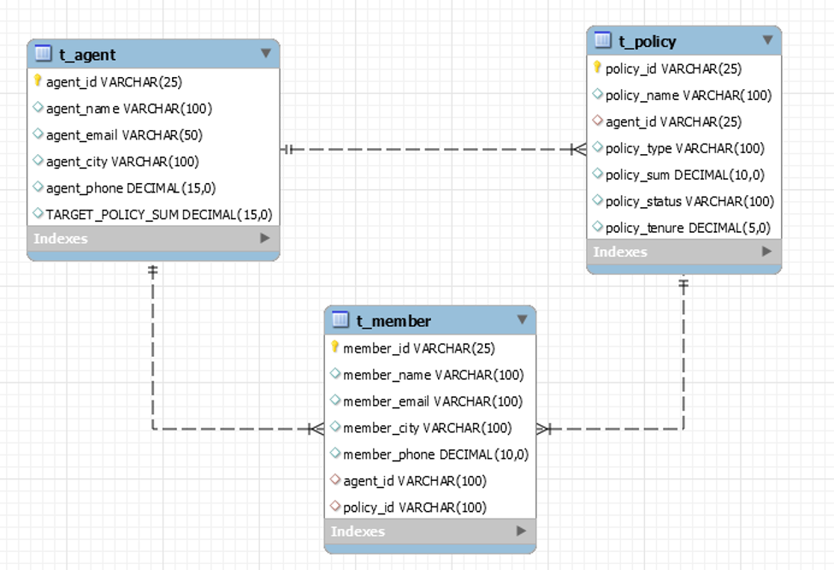

use new1;

update t_agent set TARGET_POLICY_SUM =400000

where (agent_city ='PUNE' and agent_id like 'M%');

select * from t_agent;

update t_agent set TARGET_POLICY_SUM =250000

where (agent_city ='CHENNAI' AND agent_id like'M%');

SELECT * FROM t_agent;

