Write a query to create foreign key for Available_doctor in the T_HOSPITAL table. The available_doctor must refer the column in table T_DOCTOR

**Note:** the ER diagram shows the futuristic relationship between T_HOSPITAL, T_DOCTOR and T_PATIENT tables. The constraint you would create as part of requirement, will ensure that the described relationship will be created.

(Note: Evaluate only the respective DDLquery to get the desired result)

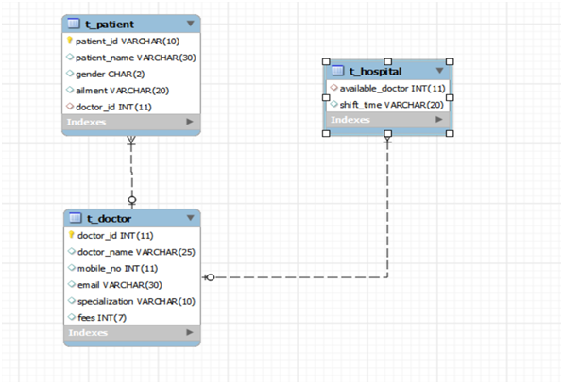



create database new2;

use new2;

create table t_patient

(

patient_id varchar(10) primary key,

patient_name varchar(30),

gender char(2),

aliment varchar(20),

doctor_id int(11)

);

create table t_doctor

(

doctor_id int(11) primary key,

doctor_name varchar(25),

mobile_no int(11),

email varchar(30),

specialization varchar(10),

fees int(7)

);

create table t_hospital

(

available_doctor int(11),

shift_time varchar(20)

);

alter table t_hospital

add foreign key (available_doctor) references t_doctor(doctor_id);