Refer to the given schema. Assume the tables has been already created.

Write a single query to update the Fees values in T_DOCTOR table, based on following criteria:

 -         IF the specialization is 'ENT' and the doctor_name starts with J then update the fees to 350

-         OR IF THE specialization is 'DERMA' and the doctor_name starts with J then update the fees to 600

**Design Rules:**

1.       You must write ONE update query to update the table

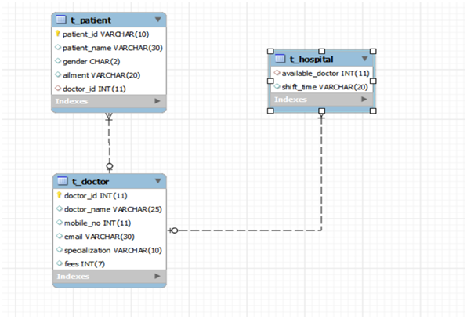

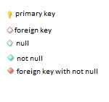

use new2;

SELECT fees,

case

when(specialization='ent' AND doctor_name regexp doctor_name = '^[j]') then fees=350

when (specialization='derma' AND doctor_name regexp doctor_name='^[j]') then fees=600

end

from t_doctor;