Write a query to create foreign keys for HALL_ID and CUSTOMER_ID in the T_HALL_BOOKING table. The HALL_ID must refer the column in table T_HALL_DETAILS and CUSTOMER_ID must refer the column in table T_CUSTOMER_DETAILS.

**Note:** the ER diagram shows the futuristic relationship between T_HALL_DETAILS, T_HALL_BOOKING and T_CUSTOMER_DETAILS tables. The constraint you would create as part of requirement, will ensure that the described relationship will be created.

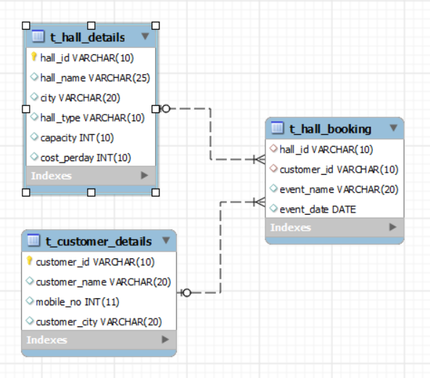

create database hall;

use hall;

create Table t_hall_details(

hall_id Varchar(10) primary key,

hall_name Varchar(25),

city varchar(20),

hall_type varchar(10),

capacity int(10),

cost_perday int(10)

);

create Table t_customer_details(

customer_id Varchar(10) primary key,

customer_name Varchar(20),

mobile_no int(11),

customer_city varchar(20)

);

create Table t_hall_booking(

hall_id Varchar(10),

customer_id Varchar(10),

event_name varchar(20),

event_date DATE

);

ALTER table t_hall_booking

ADD FOREIGN KEY(hall_id) REFERENCES t_hall_details(hall_id),

ADD FOREIGN KEY(customer_id) REFERENCES t_customer_details(customer_id);