Write a query to create the Plan table with the specified columns and constraints. Refer to the below schema diagram

. 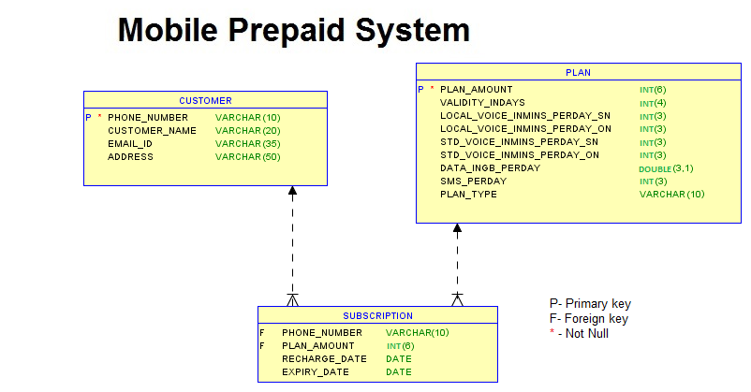

create database ddl6;

use ddl6;

create table customer(

PHONE_NUMBER varchar(10) primary key not null,

CUSTOMER_NAME varchar(20),

EMAIL_ID varchar(35),

ADDRESS varchar(50)

);

create table plan(

PLAN_AMOUNT int(6) primary key not null,

VALIDITY_INDAYS int(4),

LOCAL_VOICE_INMINS_PERDAY_SN int(3),

LOCAL_VOICE_INMINS_PERDAY_ON int(3),

STD_VOICE_INMINS_PERDAY_SN int(3),

STD_VOICE_INMINS_PERDAY_ON int(3),

DATA_INGB_PERDAY double(3,1),

SMS_PERDAY int(3),

PLAN_TYPE varchar(10)

);

create table subscription(

PHONE_NUMBER varchar(10),

PLAN_AMOUNT int(6),

RECHARGE_DATE date,

EXPIRY_DATE date

);

select * from plan;

alter table subscription

add foreign key(PHONE_NUMBER)references customer(PHONE_NUMBER),

add foreign key(PLAN_AMOUNT)references PLAN(PLAN_AMOUNT);