Write a query to display the customer id, customer name and number of pets purchased as NO_OF_PETS of those customers who have purchased more than one pet. Sort the records based on customer id.

(Hint: Use **CUSTOMER_DETAILS and PURCHASE_DETAILS**tables to retrieve records.)

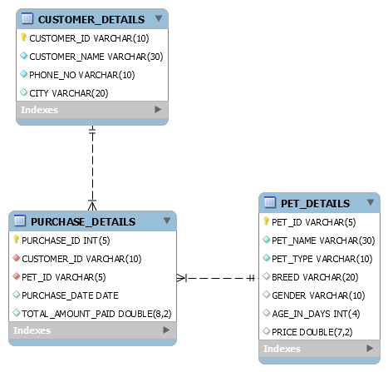

CREATE DATABASE Shop;

USE Shop;

CREATE TABLE Customer_Details(

Customer_id VARCHAR(10) PRIMARY KEY,

Customer_Name VARCHAR(30),

Phone_No VARCHAR(10),

City VARCHAR(20)

);

CREATE TABLE Purchase_Details(

Purchase_id INT(5) PRIMARY KEY,

Customer_id VARCHAR(10),

FOREIGN KEY (Customer_id) REFERENCES Customer_Details(Customer_id),

Pet_id VARCHAR(5),

Purchase_Date DATE,

Total_Amount_Paid DOUBLE(8,2)

);

INSERT INTO Customer_Details VALUES('3','Kevin','9000000000','Kochi');

INSERT INTO Purchase_Details VALUES('6','1','6','2022-10-23',10000.00);

SELECT * FROM Customer_Details;

SELECT * FROM Purchase_Details;

SELECT q1.Customer_id,Customer_Details.Customer_Name,q1.No_of_Pets

FROM (SELECT * FROM (SELECT Customer_id, COUNT(Customer_id) AS 'No_of_Pets' FROM Purchase_Details GROUP BY Customer_id) q2 WHERE No_of_Pets > 1) q1

JOIN Customer_Details

WHERE q1.Customer_id = Customer_Details.Customer_id ORDER BY q1.Customer_id ASC;