Write a query to display  staff id, staff name,salary,dept id of all staff who get a salary greater than average salary of any department. Retrieve this details only for staff working for department 10.Sort the results in ascending order of staff id.

Note : Average salary should not be considered for any employee who has not been allocated any department.

Design Rules:

  1.Do Not Change the name of the column. Please use as per the design rules

  2.Order of the output columns : staff_id, staff_name,salary, dept_id

  3.Query output should have details only for dept id 10.

  4.Exclude staff who has not been assigned department while calculating average salary

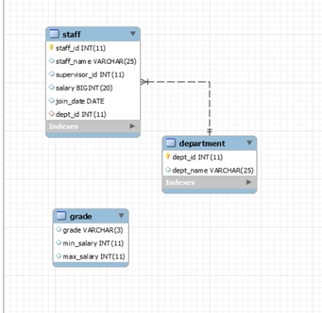

CREATE DATABASE dql3;

USE dql3;

CREATE TABLE Department(

Dept_id INT(11) PRIMARY KEY,

Dept_name VARCHAR(25)

);

CREATE TABLE Staff(

Staff_id int(11) PRIMARY KEY,

Staff_name VARCHAR(25),

Supervisor_id INT(11),

Salary BIGINT(20),

Join_date DATE,

Dept_id INT(11),

FOREIGN KEY (Dept_id) REFERENCES Department(Dept_id)

);

INSERT INTO Department VALUES(9,'ME');

INSERT INTO Staff VALUES(5,'Siji',1,10000,'2022-09-09',9);

SELECT MIN(Avg_Salary) FROM (SELECT Dept_id,AVG(Salary) AS 'Avg_Salary' from Staff GROUP BY Dept_id) q1 WHERE Dept_id IS NOT NULL AND Dept_id != 10;

SELECT Staff_id,Staff_name,salary,dept_id

FROM STAFF

WHERE salary > (SELECT MIN(Avg_Salary)FROM (SELECT Dept_id,AVG(Salary) AS 'Avg_Salary' from Staff GROUP BY Dept_id) q1 WHERE Dept_id IS NOT NULL AND Dept_id != 10) AND dept_id=10

ORDER BY Staff_id ASC;