Pizza store wants to know which pizza is fastselling and the count of that pizza  sold so far.Help them to achieve the task.

Write a query to find the highest selling pizza_name and the number of pizza's sold so far under that pizza _name category. Provide an alias for number  of pizza's sold as No.Sold.

Design Rules:

        1.Do Not Change the name of the column. Please use as per the design rules

        2.Order of the output columns: pizza_name,No.sold

Please refer to the schema:

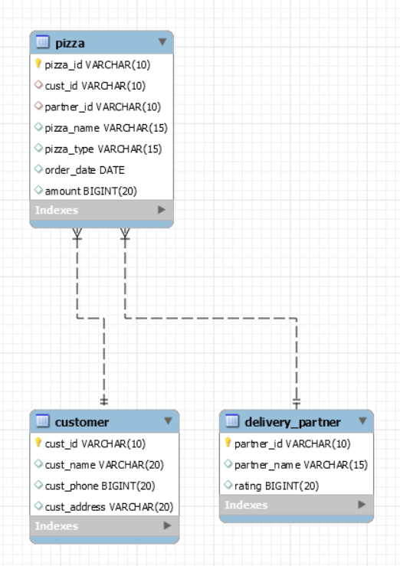

create database pizza;

use pizza;

CREATE TABLE Pizza(

Pizza_id VARCHAR(10) PRIMARY KEY,

Cust_id VARCHAR(10),

Partner_id VARCHAR(10),

Pizza_name VARCHAR(50),

Pizza_type VARCHAR(50),

Order_Date DATE,

Amount BIGINT(20)

);

INSERT INTO Pizza VALUES('5','5','23','BBQ Chicken','Cheese','2022-10-23',250);

SELECT Pizza_name,COUNT(Pizza_name) AS 'No.Sold' FROM Pizza GROUP BY Pizza_name;