Database Directory Layout

Installation Directory Layout:

* PostgreSQL is typically installed to /usr/local/pgsql or /var/lib/pgsql on linux.
* C:\Program Files\PostgreSQL\<version number> on windows.

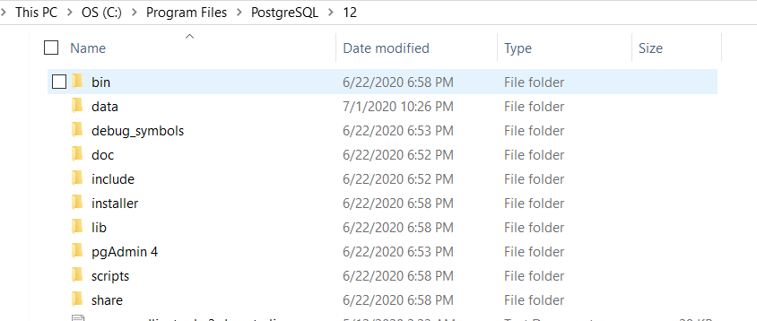

* bin-> programs(createdb, initdb,createuser,etc)
* data -> Data Directory
* Doc --> Documentation
* Include --> Header Files
* Installer -> Installer files
* Scripts --> scripts like runpsql, serverctl vbscript files
* Share -> Sample configuration files
* pgadmin - pgadmin files.

Database Directory Layout:

|  |  |
| --- | --- |
| Directory Name | Description |
| Base | Subdirectory containing per-database subdirectories |
| Current_logfiles | File recording the log file(s) currently  written to by the logging collector |
| Global | Subdirectory containing cluster-wide tables, such as pg_database,pg_tablespace,pg_index etc |
| pg_commit_ts | Subdirectory containing transaction commit timestamp data= 9.5 and later, track_commit_timestamp |
| pg_dynshmem | Subdirectory containing files used by the dynamic shared memory subsystem |
| pg_logical | Subdirectory containing status data for  logical decoding |
| pg_multixact | Subdirectory containing multitransaction status data (used for shared row locks) |
| pg_notify | Subdirectory containing LISTEN/NOTIFY status data |
| pg_replslot | Subdirectory containing replication slot data |
| pg_serial | Subdirectory containing information about  committed serializable transactions |
| Log | All error logs kept in this directory. |
| pg_snapshots | Subdirectory containing exported snapshots |
| pg_stat | Subdirectory containing permanent files for the statistics subsystem |
| pg_stat_tmp | Subdirectory containing temporary files for the statistics subsystem |
| pg_subtrans | Subdirectory containing subtransaction status data |
| pg_tblspc | Subdirectory containing symbolic links to tablespaces |
| pg_twophase | Subdirectory containing state files for prepared transactions |
| pg_wal | Subdirectory containing WAL (Write Ahead Log) files |
| pg_xact | Subdirectory containing transaction commit status data, transaction metadata logs |
| Pg_ident.conf | User name maps are defined in the ident map file.user name map can be applied to map the operating system user name to a database user. |
| postgresql.auto.conf | A file used for storing configuration parameters  that are set by ALTER SYSTEM |
| postmaster.opts | A file recording the command-line options the server was last started. |
| postmaster.pid | A lock file recording the current postmaster process ID (PID), cluster data directory path, postmaster start timestamp, port number, Unix-domain socket directory path (empty on Windows), first valid listen_address (IP address or *, or empty if not listening on TCP), and shared memory segment ID (this file is not present after server shutdown) |
| PG_VERSION | A file containing the major version number of PostgreSQL |

Base_Directory:

* Contains databases, that represented as directories named after their object identifier (OID).
* Template 1 always has oid 1.
* Syntax to find oid of database:

Select oid,datname from pg_database;