**List of Top Ten Business Schools in Bangladesh**

**1. Institute of Business Administration, University of Dhaka**

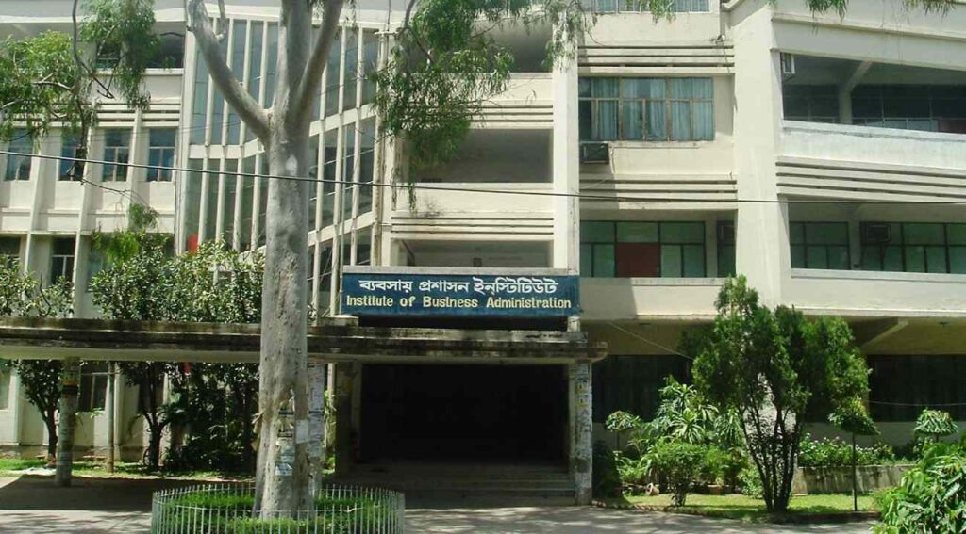

[The Institute of Business Administration (IBA)](https://www.iba-du.edu/)at the University of Dhaka was the first institution in Bangladesh to offer business education and currently is the nation’s leading business school. It was started in 1966 with the help of Indiana University in Bloomington, USA, through a Ford Foundation Financial Assistance Program. Professor M. Shafiullah is the IBA’s founding director. IBA is distinguished among Bangladeshi educational institutions by its dedication to the highest educational standards. Graduates of this institute are highly demanded in the industry, as they have made significant domestic and international contributions in a variety of fields. Here a unique curriculum, based on North American business schools, is followed that fits the needs of the local market. On top of that, students here are taught using both experimentation and hands-on learning.

IBA The goal was to train future business leaders with professional skills. Although its journey began with the launch of its flagship MBA program, later on, MPhil and PhD programs were introduced in the 1970s. In response to the rising demand for undergraduate business education, the BBA program was established in 1993. The Executive MBA program was introduced in 2007 to meet the increasing demand for quality education among mid-career executives. IBA’s faculty and students have collaborated to achieve an enviable level of excellence in Bangladesh over the course of more than five decades of illustrious history.

**2. Faculty of Business Studies, University of Dhaka**



The present-day [Faculty of Business Studies under the University of Dhaka](https://du.ac.bd/faculty/FACBUSNS) has a long history. In 1921, the Department of Commerce was established within the Faculty of Arts at the University of Dhaka. In 1970, only two departments, the Department of Management Studies and the Department of Accounting Information System comprised this department’s independent faculty. Afterwards, In 1995, they changed the name of the Faculty of Commerce to the Faculty of Business Studies. In the 1994-1995 session, the B.Com. (Hons.) and M.Com. degrees changed their names to BBA and MBA, respectively. And the 3-year B.Com. (Hons.) the program was replaced by the 4-year BBA Program in the same school year.

Currently, they offer BBA, MBA, Evening MBA, and Doctor of Business Administration programs for the students and intake only once every year for their programs. According to the Dean of this faculty, Prof. Dr Muhammad Abdul Moyeen, at present, there are 153 teachers, 10 Officers, and 58 employees, working for the department. And the number of students studying in the 8 departments under the Faculty of Business Studies of the University of Dhaka is around 6,092.

**3. Institute Of Business Administration, Jahangirnagar University**



[The Institute of Business Administration, Jahangirnagar University (IBA-JU)](https://iba-ju.edu.bd/life-at-iba-ju/) is one of the prominent institutions in Bangladesh to provide the Bachelor of Business Administration (BBA) degree. It began its journey as a department in 1991 and acquired the honour of becoming an institution in 2009. As a result of the successful operation of the undergraduate and graduate business programs, a number of competent and competent graduates have been contributing to society.

IBA-JU provides an exemplary academic atmosphere in a breathtakingly gorgeous location. It is inside the charming campus of Jahangirnagar University and is situated only 30 kilometres away from Dhaka. The institute’s greatest strength resides in its qualified and devoted instructors and personnel. Numerous academicians have extensive and vibrant research and teaching experiences at internationally renowned universities. In addition, the institute gives students from varied social, cultural, and economic backgrounds the opportunity to realize their full potential. It enables students to be prepared for business difficulties at the national level and to create careers on an international scale. This institute offers BBA, MBA, and Weekend MBA and intakes students for M.Phil and PhD too. Dr K. M. Zahidul Islam is the current director of IBA-JU.

**4. School of Business and Economics, North-South University**



After the IBA-DU, [North-South University- School of Business and Economics](http://www.northsouth.edu/academic/sbe/) is considered to be the best business school in the country. They aim to provide students with a theoretical, practical, and managerial understanding of the operation of businesses. North-South University’s School of Business and Economics (SBE) is accredited (ACBSP) and it’s Bangladesh’s first American-accredited business school.

The NSU Business School is located on four floors of the North Academic Building on NSU’s beautiful urban campus in Bashundhara, Dhaka. The School of Business and Economics (SBE) consists of four departments which are the Department of Accounting & Finance, Department of Economics, Department of Management, and Department of Marketing & International Business. Additionally, the School is notable for its size. The majority of students at NSU are enrolled in business and economics programs. The graduates are enjoying tremendous success in their workplaces and businesses in Bangladesh and around the world. The SBE is well equipped with the qualifications and expertise of 100+ full-time faculty members in the four departments. Plus, they offer some of the most important degrees in business administration and majors in the most demanding fields.

**5. BRAC Business School, BRAC University**



BRAC University (BracU) was established in 2001 with the missions of fostering knowledge creation, upholding human values, and promoting sustainable development. The [Brac Business School or BBS](https://www.bracu.ac.bd/academics/institutes-and-schools/brac-business-school" \t "_blank) is one of the largest institutes in the university according to the number of students. The degrees offered by the department are the Bachelor of Business Administration (BBA) for undergrads and the Master of Business Administration (MBA) and Executive Master of Business Administration (EMBA) for grads. The BBA program lets you major or specializes in many different areas of business, such as accounting, finance, e-business, entrepreneurship, human resource management, information system, management, marketing, operations and supply chain management, and e-business.

BBS has recently partnered with reputable international institutes including Texas A&M University-Commerce (TAMUC) and Lincoln University. It has become one of the best business schools in the country since it always focuses on providing high-quality education and training to future business leaders. This quality is made possible by its distinguished faculty pool. As of now, 54% of the faculty members have doctorate degrees, and 82% of the faculty members got their highest degree from a school outside the United States. Professor Sang H Lee, PhD is the current Dean of Brac Business School.

**6. Faculty of Business Studies, Bangladesh University of Professionals**

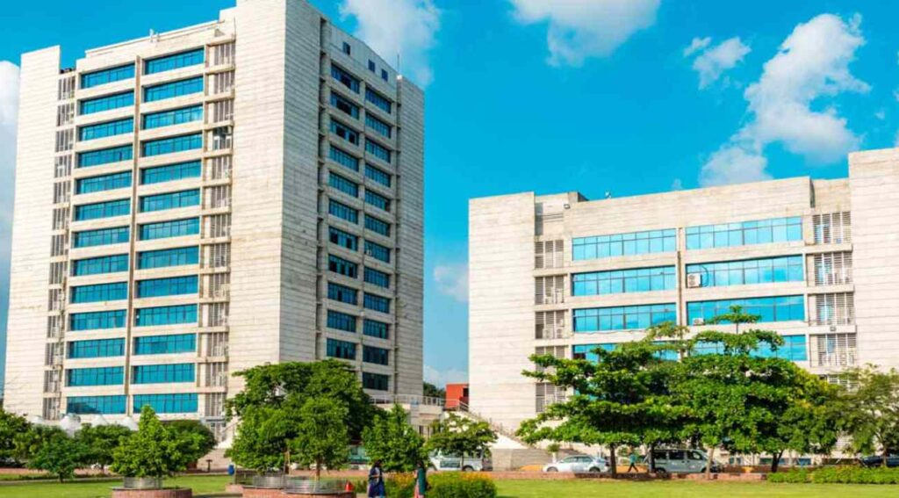

Established in 2010, the [Department of Business Administration- General](https://www.bup.edu.bd/departments/department-of-business-administration-general) is one of the oldest departments of the Bangladesh University of Professionals. It aspires to be the prominent source of innovative ideas and expertise in all fields of business, thereby encouraging fresh perspectives for the modern economy.

The “Bangladesh University of Professionals” (BUP) began its journey on June 5, 2008, and became the 31st public university in Bangladesh. It is run by the military with the motto- “Excellence through Knowledge.” In 2009, the Faculty of Business Studies (FBS) began with a new MBA and Executive MBA curriculum at BUP. In 2010, the FBS started the first group of students in its BBA (General) program for first-year university students. At the start of 2016, FBS opened four new departments: the Department of Business Administration in Accounting & Information Systems, the Department of Business Administration in Marketing, the Department of Business Administration in Finance & Banking, and the Department of Business Administration in Management Studies. Now, this faculty is made up of five departments. The admissions process for BBA, and MBA programs starts in October, and the MBA (Professional) starts three times a year in January, May, and September.

**7. Faculty of Business & Economics, East-West University**



Since the beginning of the journey, EWU offers both undergraduate and graduate programs in Business Administration through the [Faculty of Business And Economics](http://home.ewubd.edu/department-of-business-administration/). The main goal of the department is to help students understand current business practices in a way that is both theoretical and practical.

East-West University’s biggest department is the Department of Business Administration. It has about 3500 students and 80 teachers, and it offers seven majors in BBA and eight majors in MBA/EMBA programs. The Department of Business Administration’s faculty members are qualified and devoted. This department has more full-time faculty members than any other private university in the country. There are approximately 70 professors in this department including 50 full-time faculty members and twenty adjunct faculty members. There are fourteen full professors with Ph.D. from prestigious domestic and international universities with extensive experience teaching at the university level. They have also begun employing business experts from the corporate world to instruct students on real-world cases. The Department of Business Administration is devoted to producing business leaders through scholastic excellence.

**8. Faculty of Business Studies, United International University**

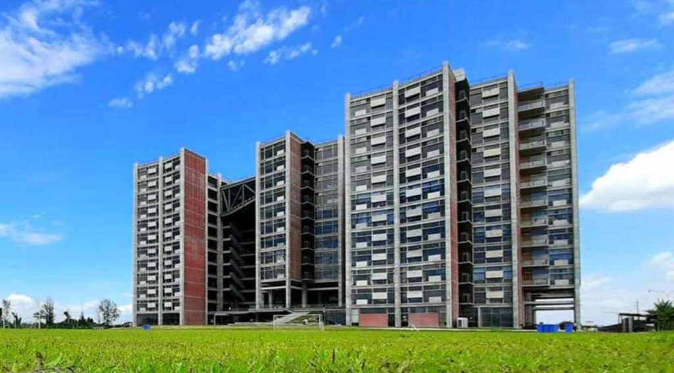

Since 2003, [The United International University School of Business and Economics](https://sobe.uiu.ac.bd/) has developed business-world-changing ideas and leaders. Their rigorous, well-conceived approach to business education transforms the students into self-assured, imaginative, and devoted business leaders who are equipped to address global issues. The School of Business & Economics has a number of remarkable strengths, one of which is its highly qualified faculty members with exceptional academic credentials from prestigious local and international universities. The SoBE now has 68 full-time faculty members. It currently offers various demanding degrees in the business world including, BBA, BBA in AIS, MBA, EMBA, Master in International Human Resource Management (MIHRM), and graduation and postgrad in Economics. Moreover, this school operates in a trimester system and intakes three batches every year.

**9. Faculty of Business Administration, American International University of Bangladesh**

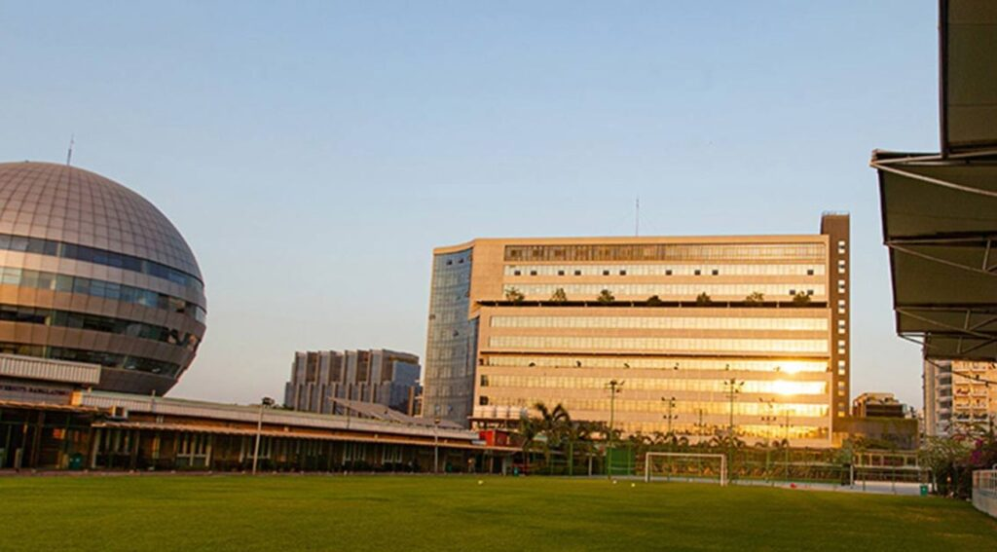

American International University – Bangladesh (AIUB) was formed in 1994 as a government-approved private university. [The Faculty of Business Administration at AIUB](https://www.aiub.edu/faculties/fba) seeks sustainable excellence in business administration programs, whose graduates are equipped with competent learning domains and a strong sense of ethical values, ready to meet the emerging demands and requirements of the local and international markets.

The FBA is one of the wealthy faculties of this university. In response to the requirements and expectations of the times, the institution is continually reorganizing its curriculum and courses, enhancing teacher competencies, enhancing facilities, and adopting new teaching methodologies. This faculty currently operates nine departments and offers the BBA, MBA, and EMBA degrees. It provides three admissions per year.

**10. School of Business, Independent University Bangladesh**

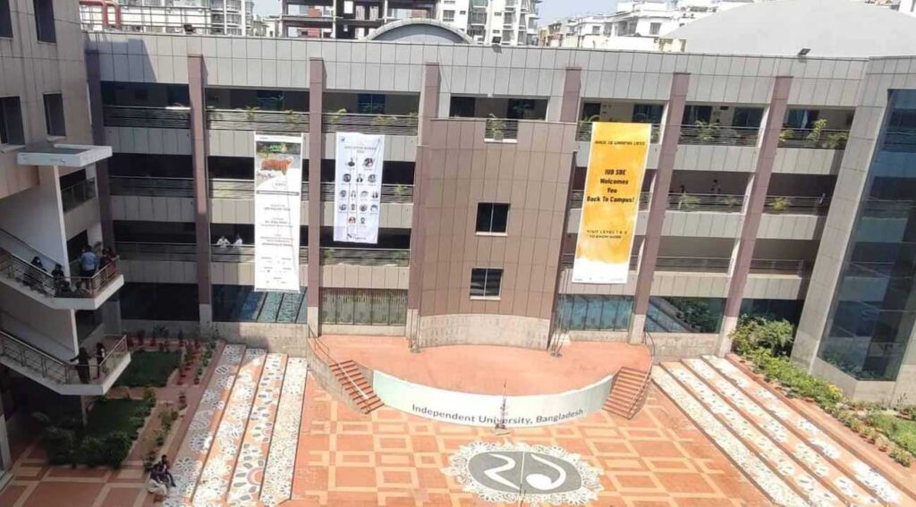

Independent University Bangladesh is one of the top-ranked universities in the country established in 1993. Among the 6 academic schools of this university, the [School of Business and Entrepreneurship (SBE)](http://www.sbe.iub.edu.bd/)is one of the most prominent. It offers both undergraduate and graduate degrees and provides students with numerous opportunities for study, employment, and intellectual development. More than 4,500 pupils are enrolled in this school, and the quality of education is also maintained as the student-to-teacher ratio in most classes is 30:1. The institution now offers nine undergraduate majors and four graduate majors to the students to choose their desired destination. The institution’s courses are transferable to any other university in the world.

It offers 3 intakes each year and runs in a trimester format. Other than BBA, MBA, and EMBA, this school also offers Honors and Masters in Economics. The eight departments of this institution are Accounting, Economics, Finance, General Management, Human Resource, Management, International Business, Management Information Systems, and Marketing. Prof. Dr. Meherun Ahmed is the current Dean of this business school.