WEEK 06
- Correct Parallel Summation using #pragma omp critical
#include <stdio.h>
#include <omp.h>
#define N 1000000

int main() {
static int arr[N], i;

// Serially
double start = omp_get_wtime();

for (i = 0; i < N; i++) {
arr[i] = i * 2;
}

double end = omp_get_wtime();

printf("Serial Array Initialization Time: %f seconds\n", end - start);

// Parallel
start = omp_get_wtime();

#pragma omp parallel for
for (i = 0; i < N; i++) {
arr[i] = i * 2;
}

end = omp_get_wtime();

printf("Parallel Array Initialization Time: %f seconds\n", end - start);

printf("Verified arr[0] = %d, arr[100000] = %d, arr[999999] = %d\n", arr[0], arr[100000], arr[999999]);

return 0;
}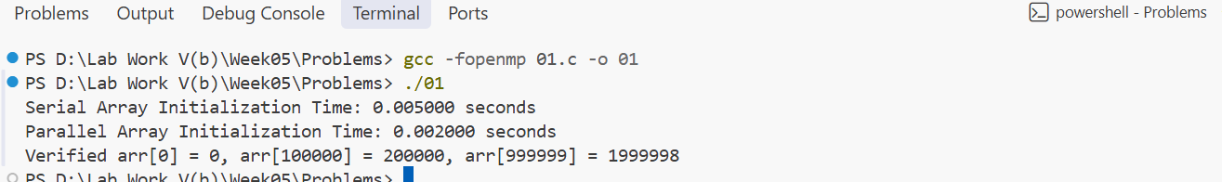
- Correct Parallel Summation using #pragma omp atomic
#include <stdio.h>
#include <omp.h>
#define N 500000

int main() {
static double A[N], B[N], C[N];
int i;

for (i = 0; i < N; i++) {
A[i] = i;
B[i] = i * 0.5;
}

// Serial
double start = omp_get_wtime();

for (i = 0; i < N; i++) {
C[i] = A[i] + B[i];
}

double end = omp_get_wtime();

printf("Serial Element-wise Addition Time: %f seconds\n", end - start);

// Parallel
start = omp_get_wtime();

#pragma omp parallel for
for (i = 0; i < N; i++) {
C[i] = A[i] + B[i];
}

end = omp_get_wtime();

printf("Parallel Element-wise Addition Time: %f seconds\n", end - start);

return 0;
}
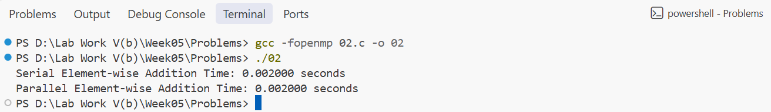
- Finding Max Value with omp_lock_t
#include <stdio.h>
#include <stdlib.h>
#include <omp.h>
#include <time.h>

#define N 1000000

int main() {
static int arr[N];
int min_value, i;

srand(time(NULL));

for (i = 0; i < N; i++) {
arr[i] = rand() % 1000000 + 1;
}

min_value = arr[0];

#pragma omp parallel for
for (i = 0; i < N; i++) {
if (arr[i] < min_value) {
min_value = arr[i];
}
}

printf("Array Min Value (Parallel, potentially incorrect): %d\n", min_value);

return 0;
}
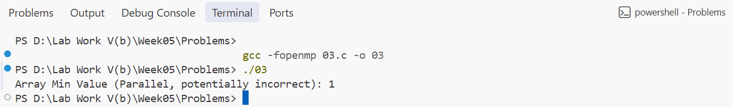
- Data Exchange using omp_barrier
#include <stdio.h>
#include <omp.h>

#define N 1000000

int main() {
static double A[N], B[N];

double serial_dot = 0.0, parallel_dot = 0.0, start, end;
int i;

for (i = 0; i < N; i++) {
A[i] = i;
B[i] = i * 0.5;
}

// Serial
start = omp_get_wtime();

for (i = 0; i < N; i++) {
serial_dot += A[i] * B[i];
}

end = omp_get_wtime();

printf("Serial Dot Product: %lf\n", serial_dot);
printf("Serial Time: %f seconds\n", end - start);

// Parallel
start = omp_get_wtime();

#pragma omp parallel for
for (i = 0; i < N; i++) {
parallel_dot += A[i] * B[i];
}

end = omp_get_wtime();

printf("Parallel Dot Product (Race Condition): %lf\n", serial_dot);
printf("Parallel Time: %f seconds\n", end - start);

return 0;
}
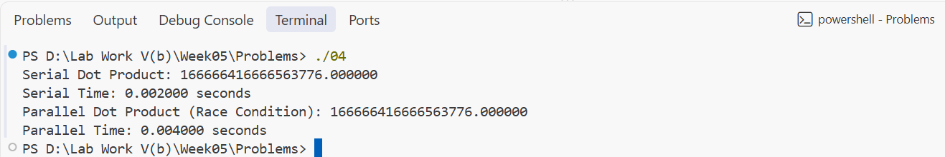
- Shared Counter with firstprivate Loop Variable
#include <stdio.h>
#include <stdlib.h>
#include <omp.h>
#include <time.h>

#define N 2000000

int main() {

static int arr[N];
int even_count = 0, parallel_even_count = 0, i;

srand(time(NULL));

for (i = 0; i < N; i++) {
arr[i] = rand();
}

// Serial count
double start = omp_get_wtime();

for (i = 0; i < N; i++) {
if (arr[i] % 2 == 0) {
even_count++;
}
}

double end = omp_get_wtime();

printf("Serial Even Count: %d\n", even_count);
printf("Serial Time: %f seconds\n", end - start);

// Parallel count Race Condition
parallel_even_count = 0;

start = omp_get_wtime();

#pragma omp parallel for
for (i = 0; i < N; i++) {

if (arr[i] % 2 == 0) {
parallel_even_count++;
}
}

end = omp_get_wtime();

printf("Parallel Even Count (Race Condition): %d\n", parallel_even_count);
printf("Parallel Time: %f seconds\n", end - start);

return 0;
}
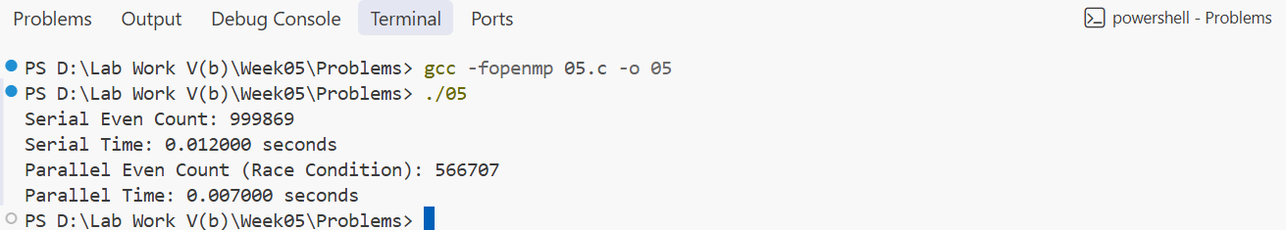
- Counting Occurrences of a Character in a String Array
#include <stdio.h>
#include <omp.h>

#define N 20

int main() {

int arr[N] = {0};
int i;

omp_set_num_threads(4);

#pragma omp parallel
{
int thread_id = omp_get_thread_num();
int num_threads = omp_get_num_threads();

int elements = N / num_threads;

int start = thread_id * elements;
int end = start + elements;

for (int j = start; j < end; j++) {
arr[j] = thread_id;
}
}

printf("Final Array: ");

for (i = 0; i < N; i++) {
printf("%d", arr[i]);
}

printf("\n");

return 0;
}
