Game Design Document

Fill up the Following document

1. Write the title of your project.

Elf Santa!

1. What is the goal of the game?

Win the most points by giving gifts to the houses.

1. Write a brief story of your game?

Santa is sick, so he cannot give away the gifts this year. So, he asks one of

one of his elves to do the job for him. Since this elf is clumsy, he

needs to be careful with the clouds and Christmas trees.

1. Which are the playing characters of this game?

* Playing characters are the ones which respond to the user based on the input from the user
* Cars, monkeys, dinos, wizards etc, are the playing characters in the game.

|  |  |  |
| --- | --- | --- |
| Number | Character Name | What can this character do? |
| 1 | elf | Move the sled |
| 2 |  |  |
| 3 |  |  |
| 4 |  |  |
| 5 |  |  |
| 6 |  |  |
| 7 |  |  |
| 8 |  |  |

1. Which are the Non Playing Characters of this game?

* Non Playing characters are the ones which don't have an action or a behaviour when the user interacts with the game.
* Hurdles, stones, bananas, coins, etc are non playing characters in the game.

|  |  |  |
| --- | --- | --- |
| Number | Character Name | What can this character do? |
| 1 | stars | Give the elf 500 points. |
| 2 | House roofs | Once the gift touches the roof, the player should get 100-300 pts. |
| 3 | Christmas tree | If the player touches it, game is over. |
| 4 | clouds | Blurs the screen for 5 seconds. |
| 5 | gift | Once you press Space, gift should spawn from the sled. |
| 6 |  |  |
| 7 |  |  |
| 8 |  |  |

Draw your imagination of this game. What does this game look like?

* Draw the game either on your computer or on paper,
* Add images of scenes of the game to show each of the playing and non-playing characters at least once.

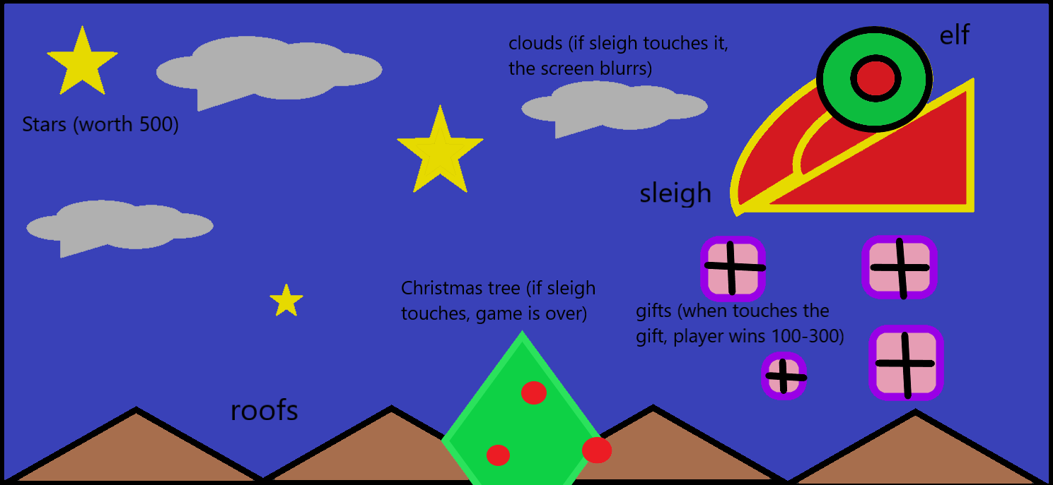

How do you plan to make your game engaging?

The farther the player goes, the harder the game becomes (more christmas trees and clouds)