Solera .NET Coding Assessment

João Costa

M.ª Ángeles Pardo

Repository

https://github.com/mariaangeles6768/finalAssesmentNet.6

Acceptance criteria

1. SQL management screenshot showing how did you created your database.

- In order to create the database, an instance of MySQL was created as a Docker container using the following command:

$ docker run --env MYSQL_ROOT_PASSWORD=slat --env MYSQL_USER=jjjjjj --env MYSQL_PASSWORD=123 --env MYSQL_DATABASE=snaDatabase --name mysql --publish 3306:3306 mysql:8-oracle

2. SQL management screenshot with the select of each table you created with your MVC application, without data.

3. Screenshots of.NET application execution (views) with a simple web page where you display the information from your tables (localhost site)

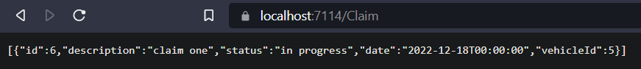

4. SQL management screenshot with the select of the tables you created, showing the data inserted with the application

