Monthly Business Review (MBR)

Reporting Month: 11/01/2025 to 11/30/2025

Report Generated: December 31, 2025 at 12:20 AM

Table of Contents
Right-click and select 'Update Field' to generate Table of Contents

Executive Summary
NEWSLETTER PERFORMANCE
Key Improvements:
• Net New Subscribers: +111.03% MoM
• Growth Rate (%): +108.05% MoM
• Visits: +99.27% MoM
Areas of Concern:
• Auto Unsubs: +229.99% MoM
• Unsubscribes: +75.15% MoM
• List Unsub Rate: +68.52% MoM
SALES PERFORMANCE
Key Improvements:
• Booked Calls (Setters): +61.80% MoM
• Average Lead Time: +50.20% MoM
• Visits: +44.03% MoM
Areas of Concern:
• Show Rate: -20.61% MoM
• Offer Rate: -20.33% MoM
• CVR %: -16.75% MoM

Section 1: Newsletter Metrics

Landing Page Funnel
Newsletter Visits
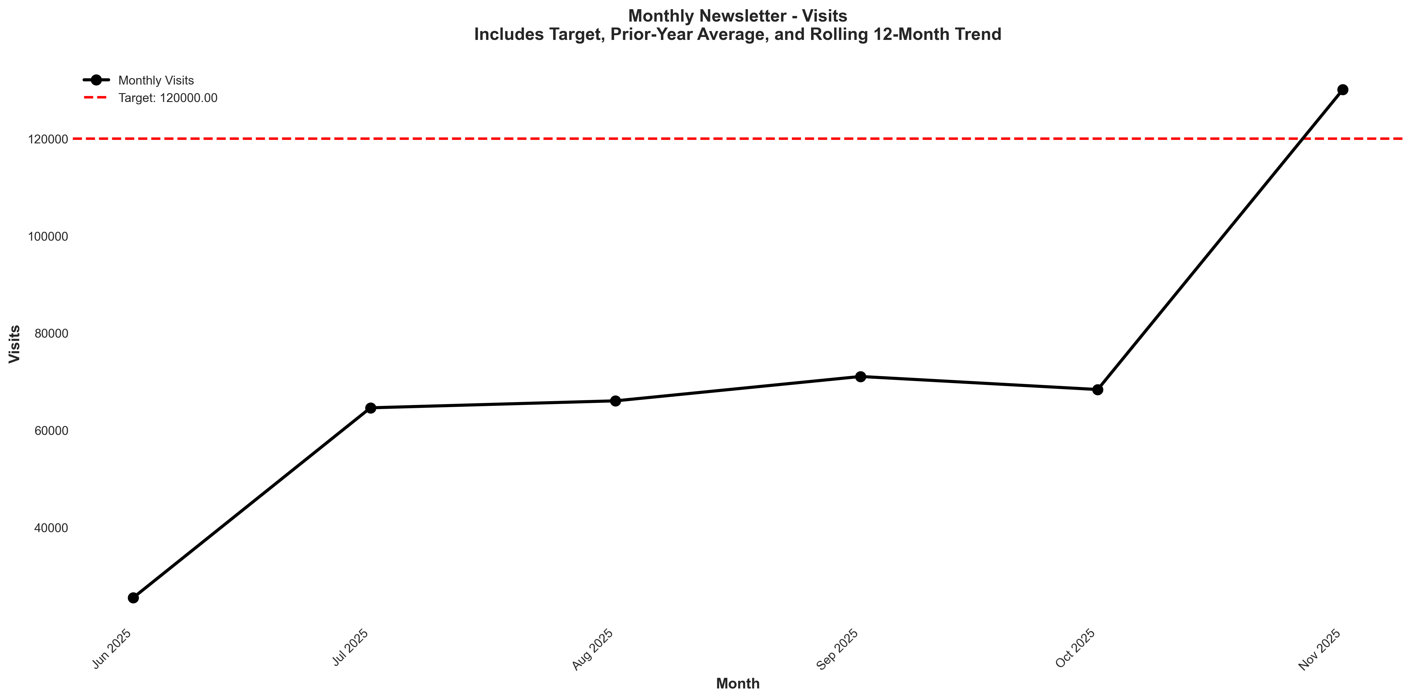
Chart: visualizations/newsletter_monthly/monthly_visits.png
Source: outputs/newsletter/monthly_newsletter.csv
Insights:
• Current month: 130,054 vs 68,327 last month (+61,727, +90.3% MoM) (favorable)
• Performance is 83.4% above the 6-month average (avg = 70,908) → High CV vs 6Mo Avg
• Goal met: Yes (target = 120,000; actual = 130,054; +8.4% above goal)
• Trend: ↑ Rising (6mo)
Newsletter Visit Duration
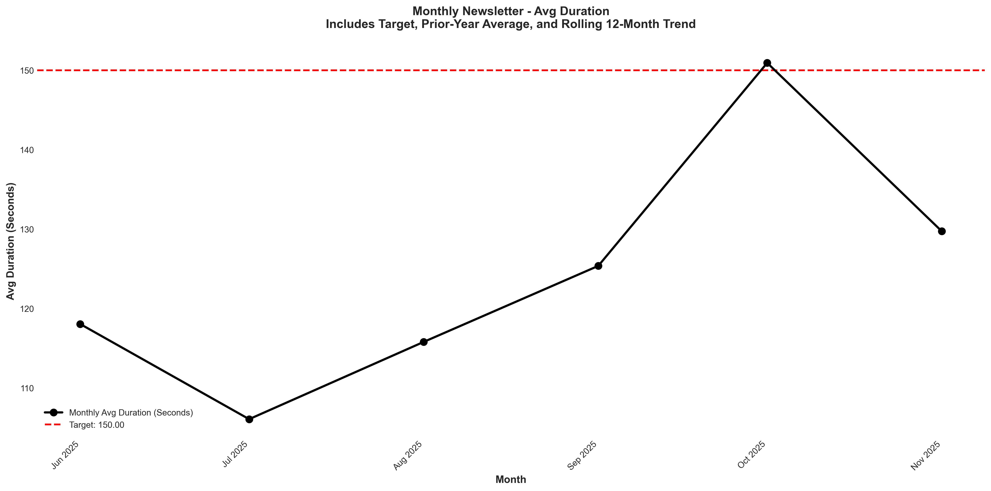
Chart: visualizations/newsletter_monthly/monthly_avg_duration.png
Source: outputs/newsletter/monthly_newsletter.csv
Insights:
• Current month: 130 vs 151 last month (21.20, -14.0% MoM) (unfavorable)
• Performance is 4.3% above the 6-month average (avg = 124) → Normal (Near Avg)
• Goal missed by 13.5% (target = 150; actual = 130)
• Trend: ↑ Rising (6mo)
Newsletter Bounce Rate
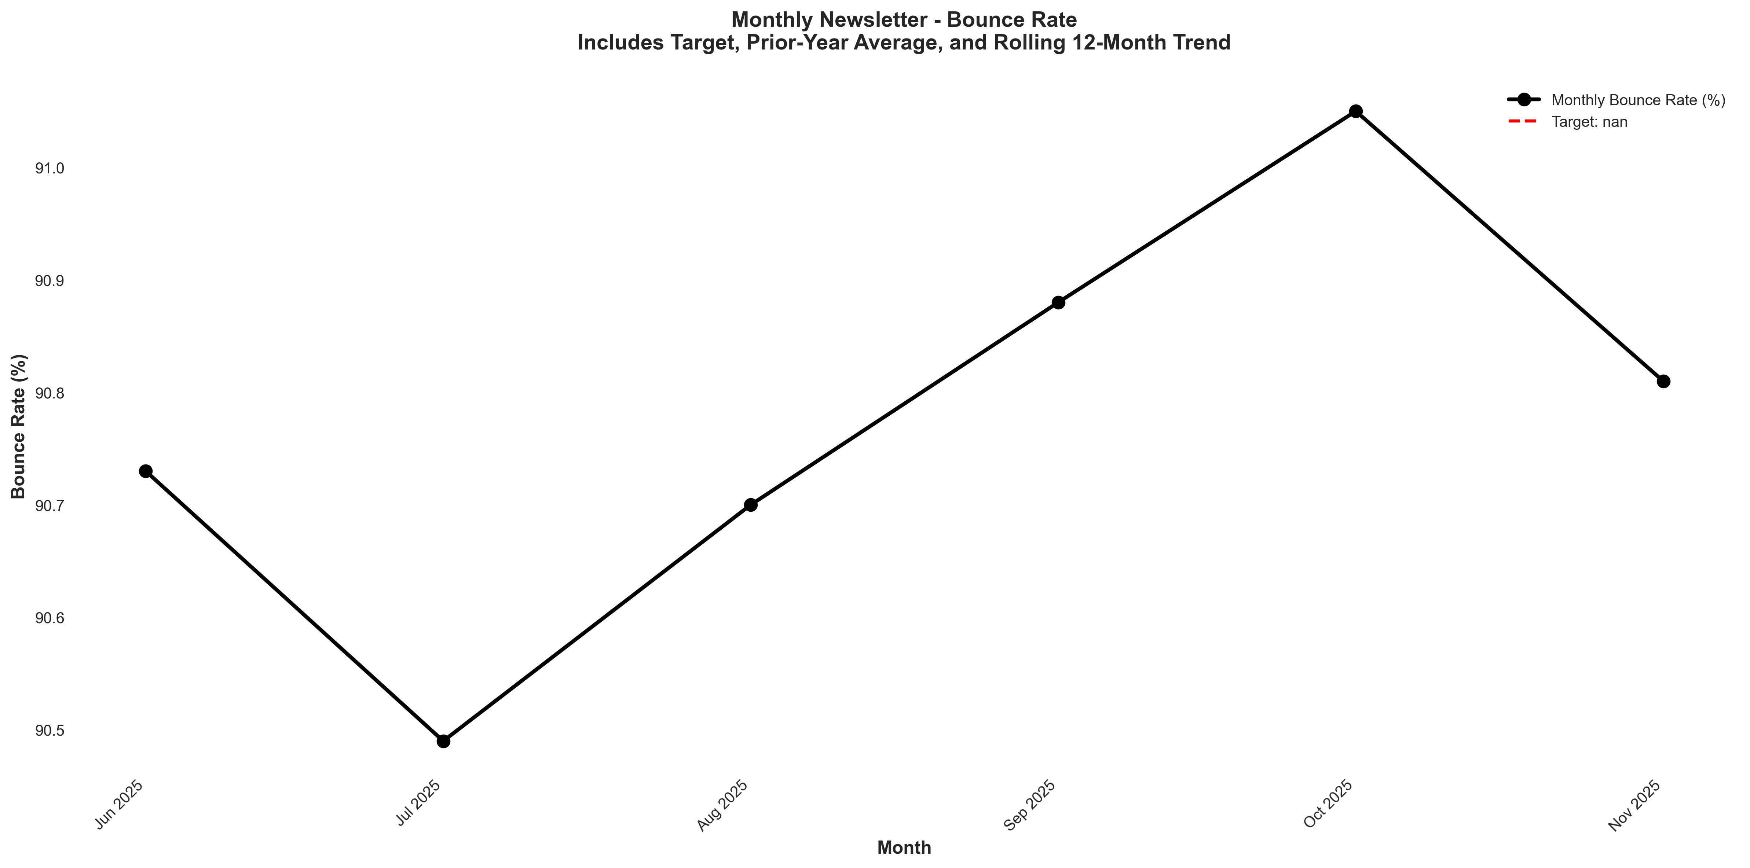
Chart: visualizations/newsletter_monthly/monthly_bounce_rate.png
Source: outputs/newsletter/monthly_newsletter.csv
Insights:
• Current month: 90.81% vs 91.05% last month (0.24%, -0.3% MoM) (favorable)
• Performance is 0.0% above the 6-month average (avg = 90.78%) → Normal (Near Avg)
• Trend: → Stable (6mo)
Newsletter CVR %
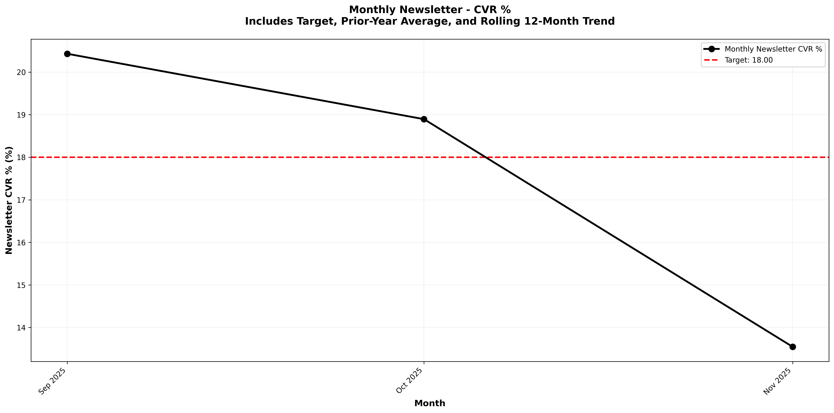
Chart: visualizations/general_newsletter_monthly/monthly_newsletter_cvr.png
Source: outputs/general_newsletter/monthly_table.csv
Insights:
• Current month: 13.55% vs 18.89% last month (5.35%, -28.3% MoM) (unfavorable)
• Performance is 23.1% below the 6-month average (avg = 17.62%) → Low CV vs 6Mo Avg
• Goal missed by 24.7% (target = 18.00%; actual = 13.55%)
• Trend: Not enough data for 6-month trend (3 points)

Engagement Metrics
Blended Open Rate
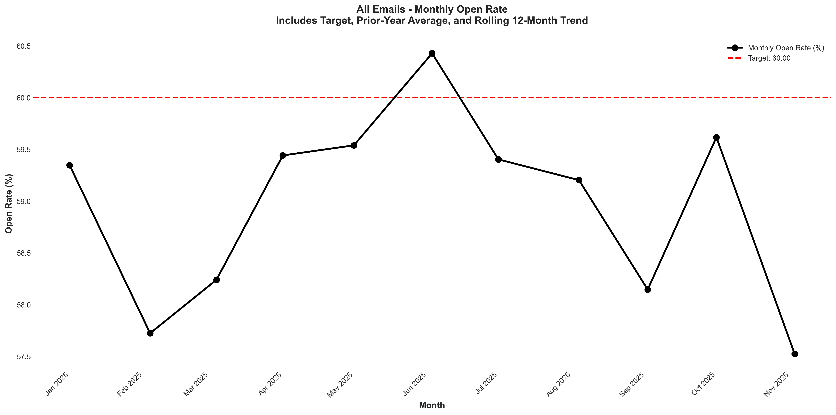
Chart: visualizations/newsletter_series_monthly/blended_open_rate.png
Source: outputs/newsletter_series/08_blended_monthly.csv
Insights:
• Current month: 57.52% vs 59.62% last month (2.10%, -3.5% MoM) (unfavorable)
• Performance is 2.6% below the 6-month average (avg = 59.05%) → Normal (Near Avg)
• Goal missed by 4.1% (target = 60.00%; actual = 57.52%)
• Trend: → Stable (6mo)
Blended Verified Click-Through Rate
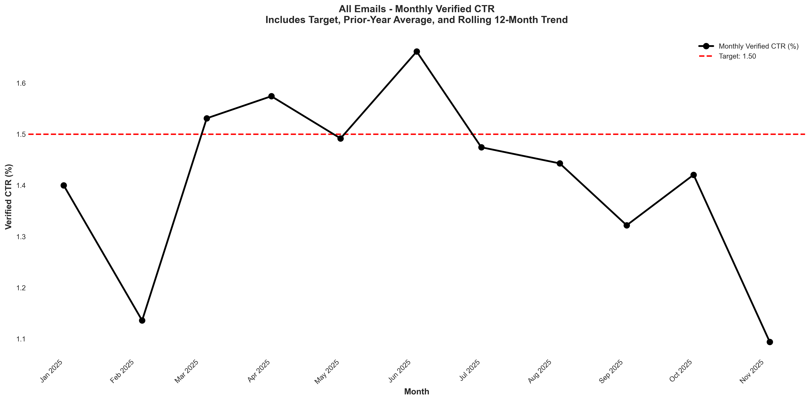
Chart: visualizations/newsletter_series_monthly/blended_verified_ctr.png
Source: outputs/newsletter_series/08_blended_monthly.csv
Insights:
• Current month: 1.09% vs 1.42% last month (0.33%, -23.2% MoM) (unfavorable)
• Performance is 22.1% below the 6-month average (avg = 1.40%) → Low CV vs 6Mo Avg
• Goal missed by 27.3% (target = 1.50%; actual = 1.09%)
• Trend: ↓ Falling (6mo)
Blended Unsub Rate
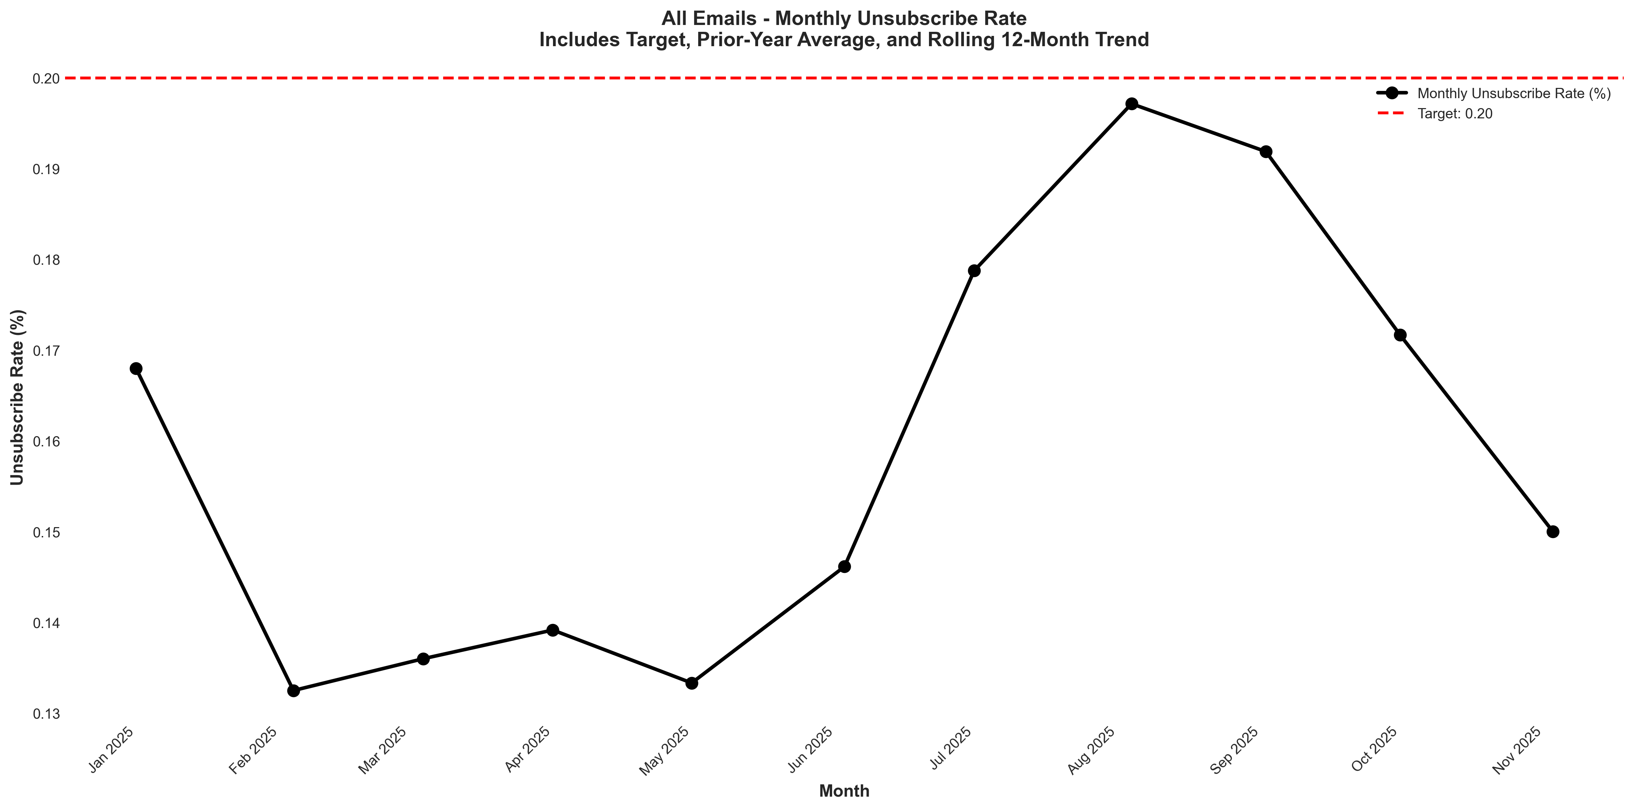
Chart: visualizations/newsletter_series_monthly/blended_unsubscribe.png
Source: outputs/newsletter_series/08_blended_monthly.csv
Insights:
• Current month: 0.15% vs 0.17% last month (0.02%, -11.8% MoM) (favorable)
• Performance is 13.5% below the 6-month average (avg = 0.17%) → Low CV vs 6Mo Avg
• Goal met: Yes (target = 0.20%; actual = 0.15%; 25.0% below goal)
• Trend: → Stable (6mo)

Growth & Churn
Growth Rate
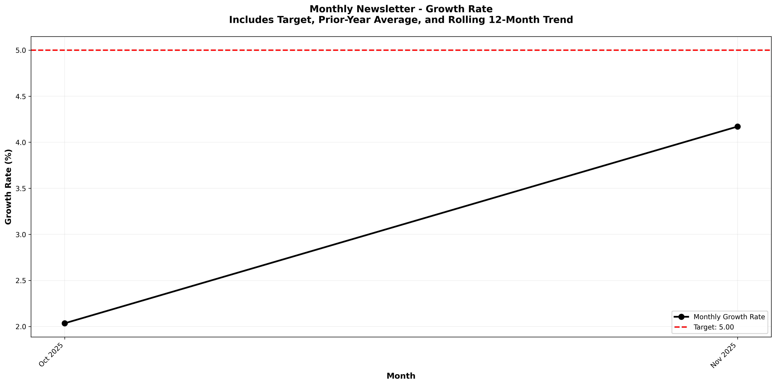
Chart: visualizations/general_newsletter_monthly/monthly_growth_rate.png
Source: outputs/general_newsletter/monthly_table.csv
Insights:
• Current month: 4.17% vs 2.03% last month (+2.14%, +105.0% MoM) (favorable)
• Performance is 34.4% above the 6-month average (avg = 3.10%) → High CV vs 6Mo Avg
• Goal missed by 16.6% (target = 5.00%; actual = 4.17%)
• Trend: Not enough data for 6-month trend (2 points)
New Subscribers
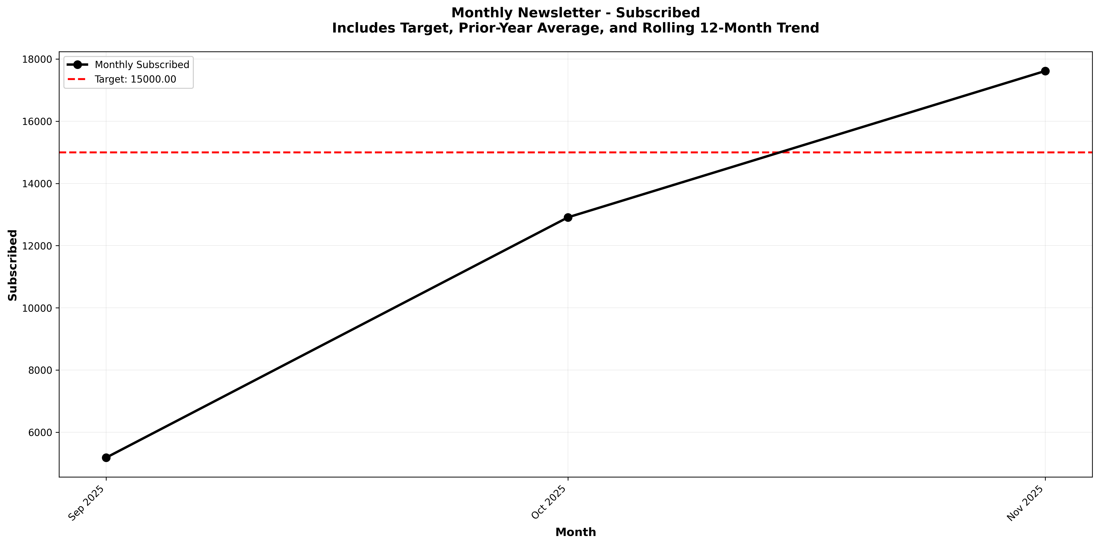
Chart: visualizations/general_newsletter_monthly/monthly_subscribed.png
Source: outputs/general_newsletter/monthly_table.csv
Insights:
• Current month: 17,616 vs 12,910 last month (+4,706, +36.5% MoM) (favorable)
• Performance is 48.0% above the 6-month average (avg = 11,903) → High CV vs 6Mo Avg
• Goal met: Yes (target = 15,000; actual = 17,616; +17.4% above goal)
• Trend: Not enough data for 6-month trend (3 points)
Unsubscribes
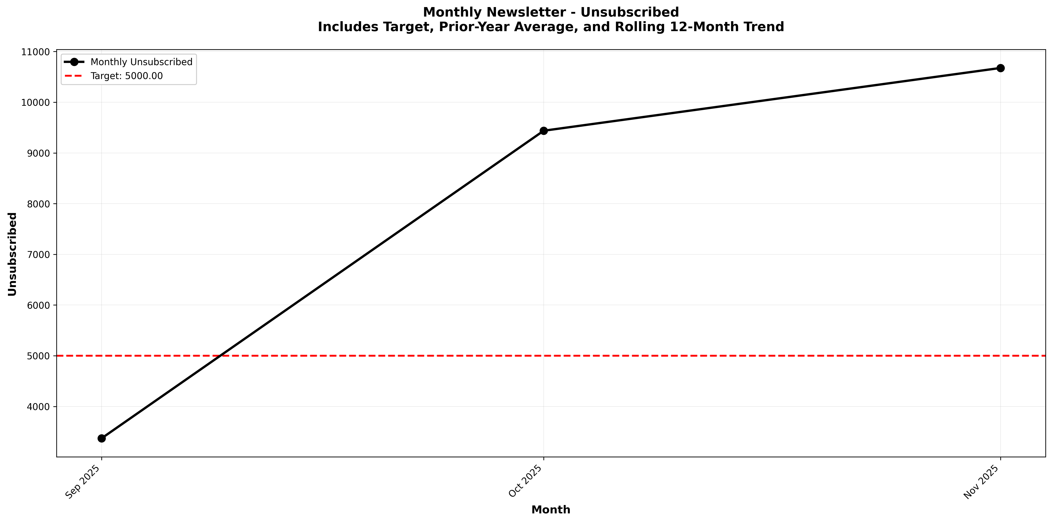
Chart: visualizations/general_newsletter_monthly/monthly_unsubscribed.png
Source: outputs/general_newsletter/monthly_table.csv
Insights:
• Current month: 10,676 vs 9,438 last month (+1,238, +13.1% MoM) (unfavorable)
• Performance is 36.4% above the 6-month average (avg = 7,828) → High CV vs 6Mo Avg
• Goal missed: (target = 5,000; actual = 10,676; +113.5% above goal)
• Trend: Not enough data for 6-month trend (3 points)
Leak Rate
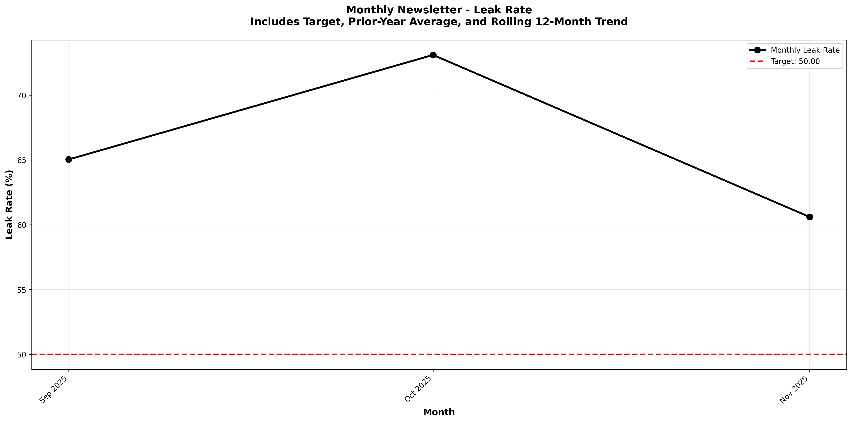
Chart: visualizations/general_newsletter_monthly/monthly_leak_rate.png
Source: outputs/general_newsletter/monthly_table.csv
Insights:
• Current month: 60.60% vs 73.11% last month (12.50%, -17.1% MoM) (favorable)
• Performance is 8.5% below the 6-month average (avg = 66.25%) → Low CV vs 6Mo Avg
• Goal missed: (target = 50.00%; actual = 60.60%; +21.2% above goal)
• Trend: Not enough data for 6-month trend (3 points)

Newsletter Series: New Deals
Deal Open Rate
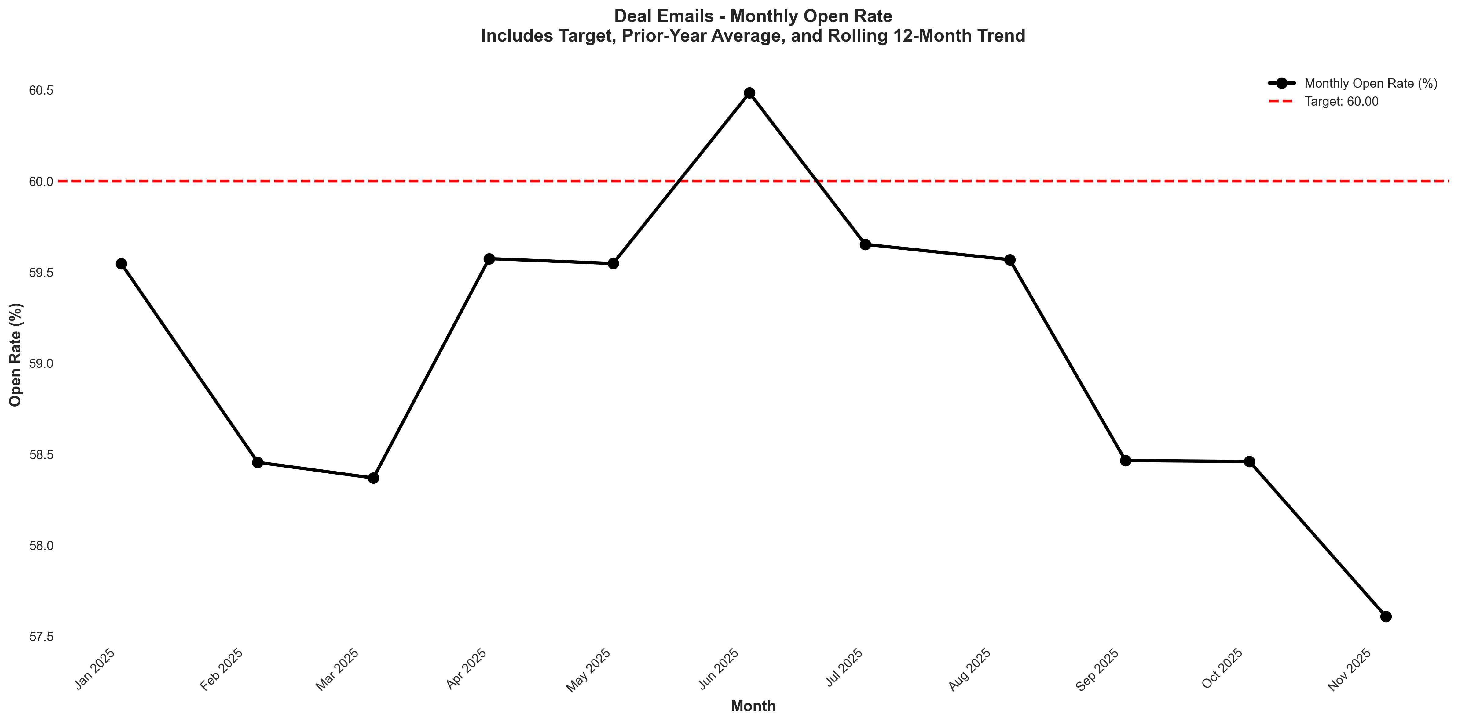
Chart: visualizations/newsletter_series_monthly/deal_open_rate.png
Source: outputs/newsletter_series/02_deal_emails.csv
Insights:
• Current month: 56.03% vs 56.50% last month (0.47%, -0.8% MoM) (unfavorable)
• Performance is 2.4% below the 6-month average (avg = 57.39%) → Normal (Near Avg)
• Goal missed by 6.6% (target = 60.00%; actual = 56.03%)
• Trend: ↓ Falling (6mo) | ↓ Falling (12mo) | ↓ Falling (24mo)
Deal Verified CTR
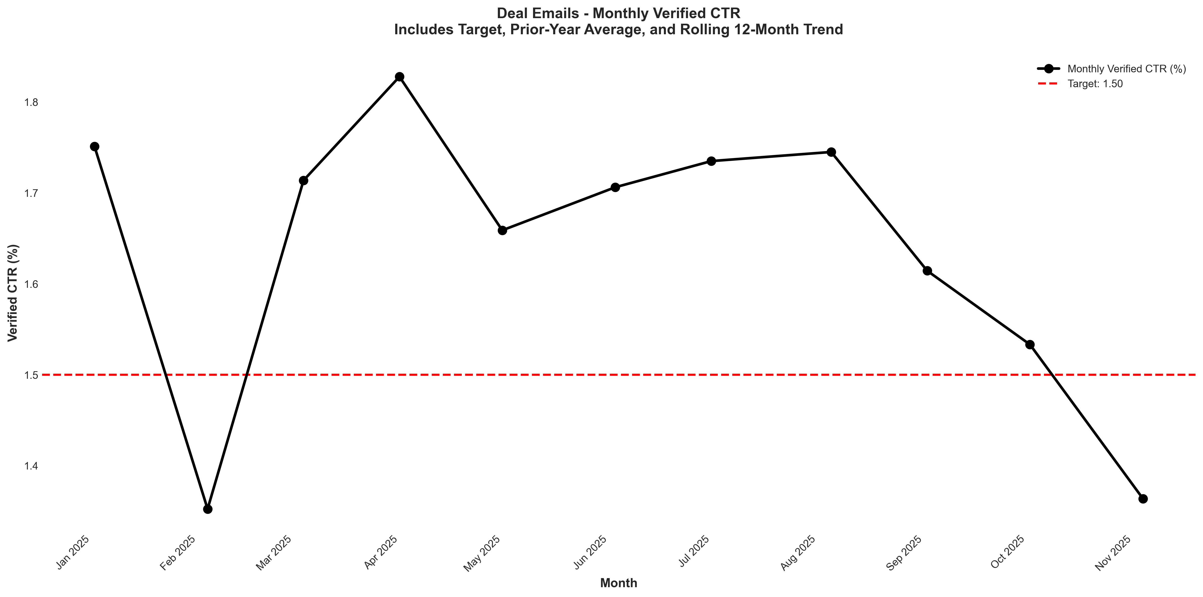
Chart: visualizations/newsletter_series_monthly/deal_verified_ctr.png
Source: outputs/newsletter_series/02_deal_emails.csv
Insights:
• Current month: 1.31% vs 1.49% last month (0.18%, -12.1% MoM) (unfavorable)
• Performance is 4.1% below the 6-month average (avg = 1.37%) → Normal (Near Avg)
• Goal missed by 12.7% (target = 1.50%; actual = 1.31%)
• Trend: → Stable (6mo) | ↓ Falling (12mo) | ↓ Falling (24mo)
Deal Unsubscribe Rate
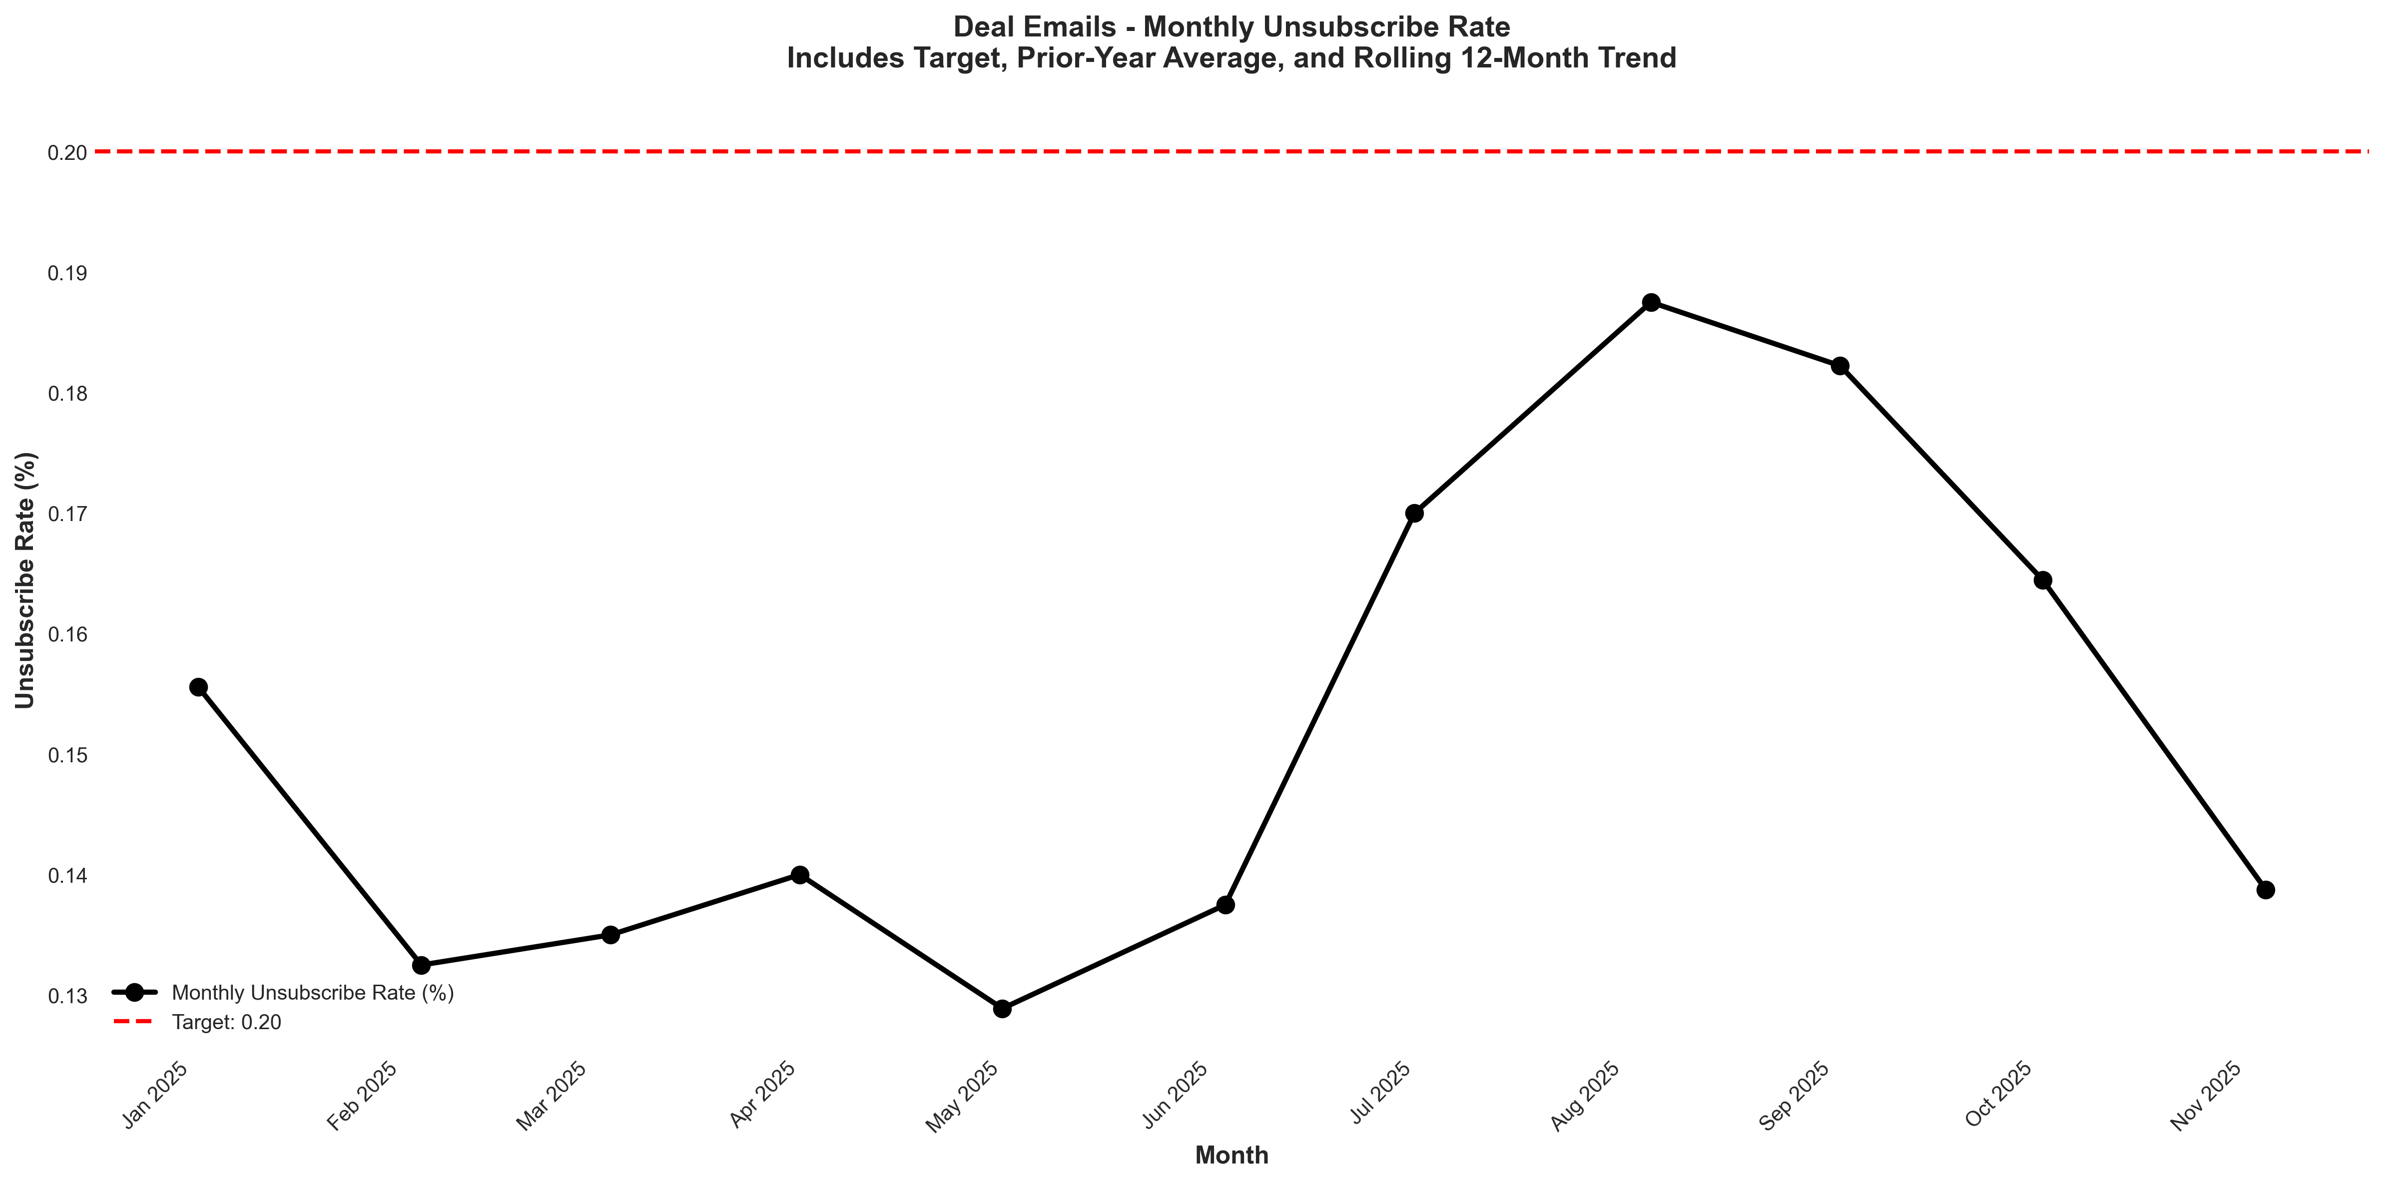
Chart: visualizations/newsletter_series_monthly/deal_unsubscribe.png
Source: outputs/newsletter_series/02_deal_emails.csv
Insights:
• Current month: 0.15% vs 0.12% last month (+0.03%, +25.0% MoM) (unfavorable)
• Performance is 9.8% above the 6-month average (avg = 0.14%) → High CV vs 6Mo Avg
• Goal met: Yes (target = 0.20%; actual = 0.15%; 25.0% below goal)
• Trend: → Stable (6mo) | ↓ Falling (12mo) | ↓ Falling (24mo)

Newsletter Series: Off-Market
Off-Market Open Rate
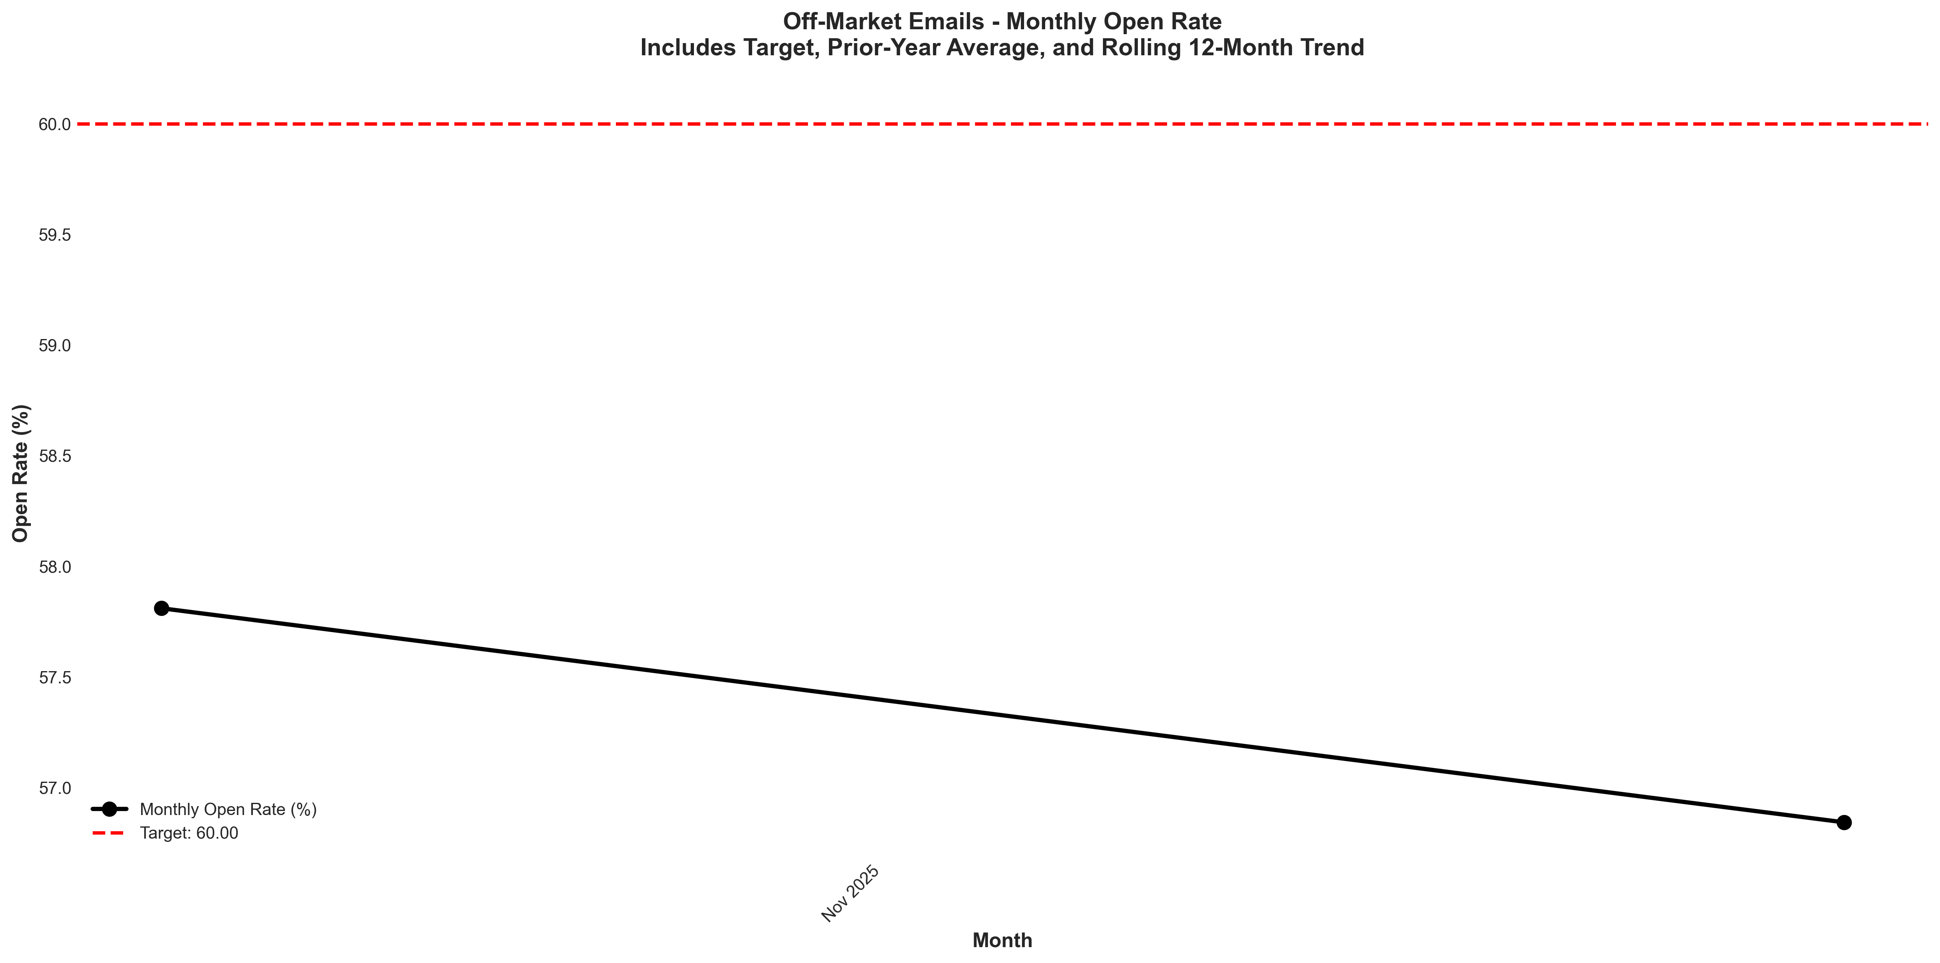
Chart: visualizations/newsletter_series_monthly/offmarket_open_rate.png
Source: outputs/newsletter_series/03_offmarket_emails.csv
Insights:
• Current month: 55.09% vs 57.67% last month (2.58%, -4.5% MoM) (unfavorable)
• Performance is 3.4% below the 6-month average (avg = 57.04%) → Normal (Near Avg)
• Goal missed by 8.2% (target = 60.00%; actual = 55.09%)
• Trend: Not enough data for 6-month trend (5 points)
Off-Market Verified CTR
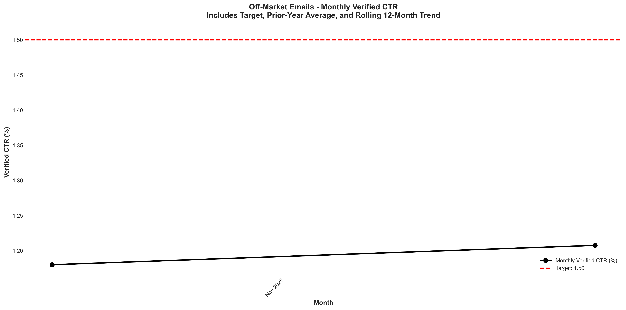
Chart: visualizations/newsletter_series_monthly/offmarket_verified_ctr.png
Source: outputs/newsletter_series/03_offmarket_emails.csv
Insights:
• Current month: 1.10% vs 1.37% last month (0.27%, -19.7% MoM) (unfavorable)
• Performance is 8.5% below the 6-month average (avg = 1.20%) → Low CV vs 6Mo Avg
• Goal missed by 26.7% (target = 1.50%; actual = 1.10%)
• Trend: Not enough data for 6-month trend (5 points)
Off-Market Unsubscribe Rate
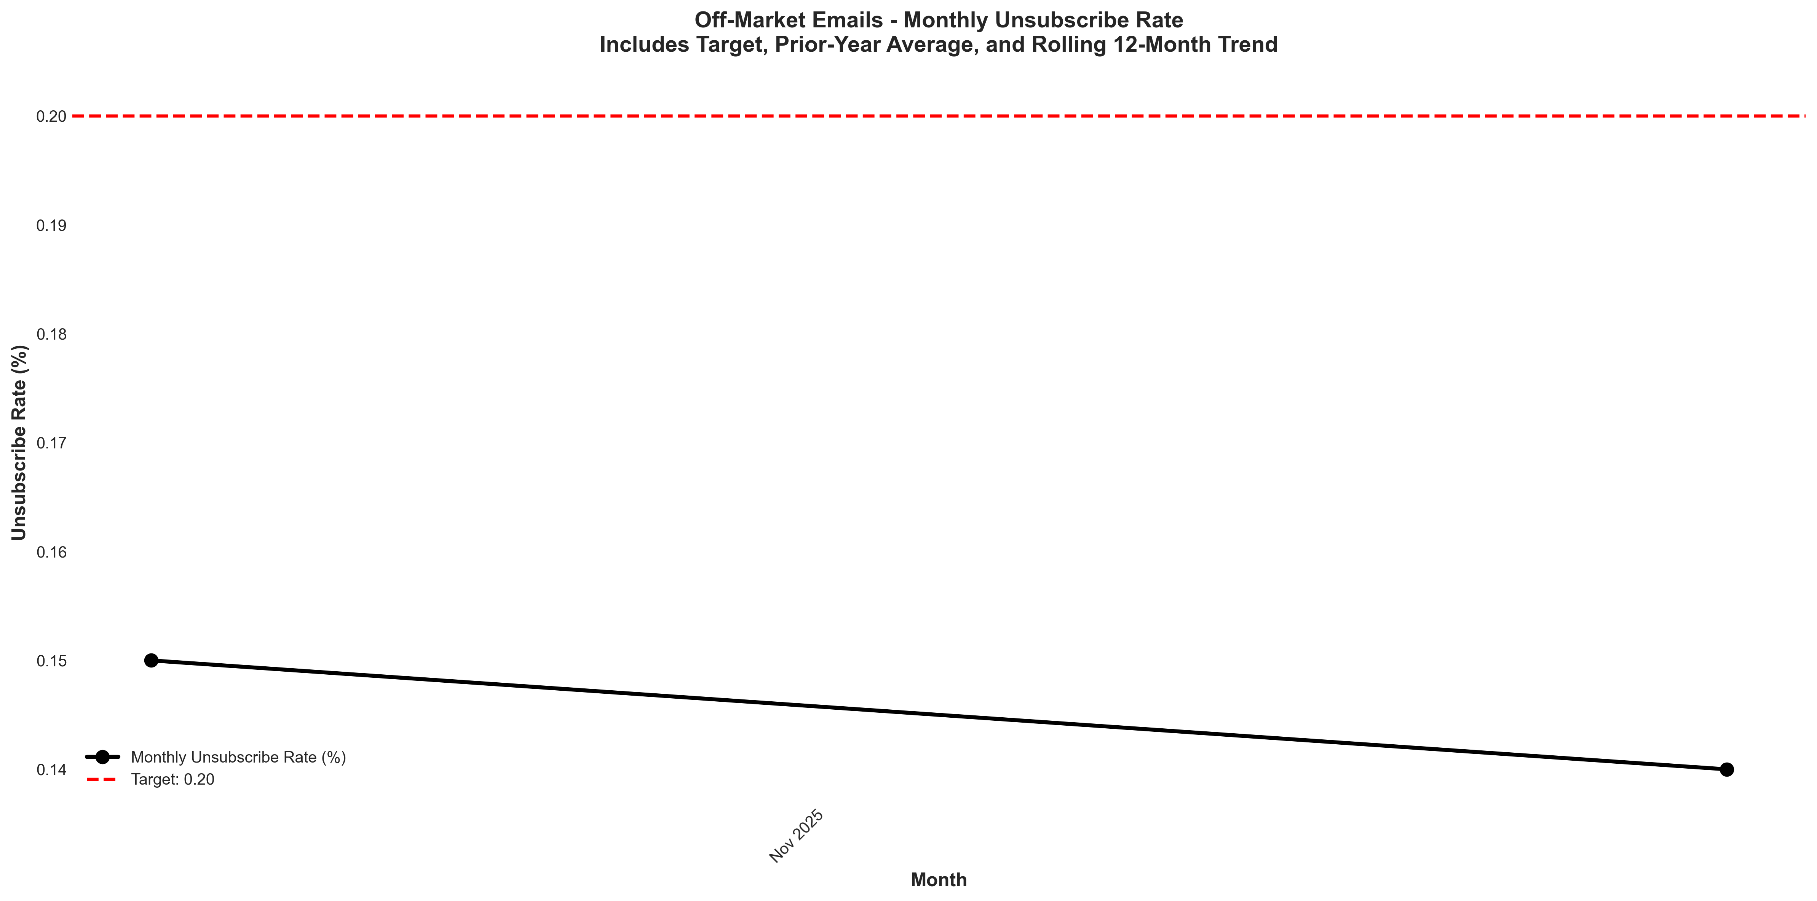
Chart: visualizations/newsletter_series_monthly/offmarket_unsubscribe.png
Source: outputs/newsletter_series/03_offmarket_emails.csv
Insights:
• Current month: 0.15% vs 0.13% last month (+0.02%, +15.4% MoM) (unfavorable)
• Performance is 5.6% above the 6-month average (avg = 0.14%) → High CV vs 6Mo Avg
• Goal met: Yes (target = 0.20%; actual = 0.15%; 25.0% below goal)
• Trend: Not enough data for 6-month trend (5 points)

Newsletter Series: Podcasts
Podcast Open Rate
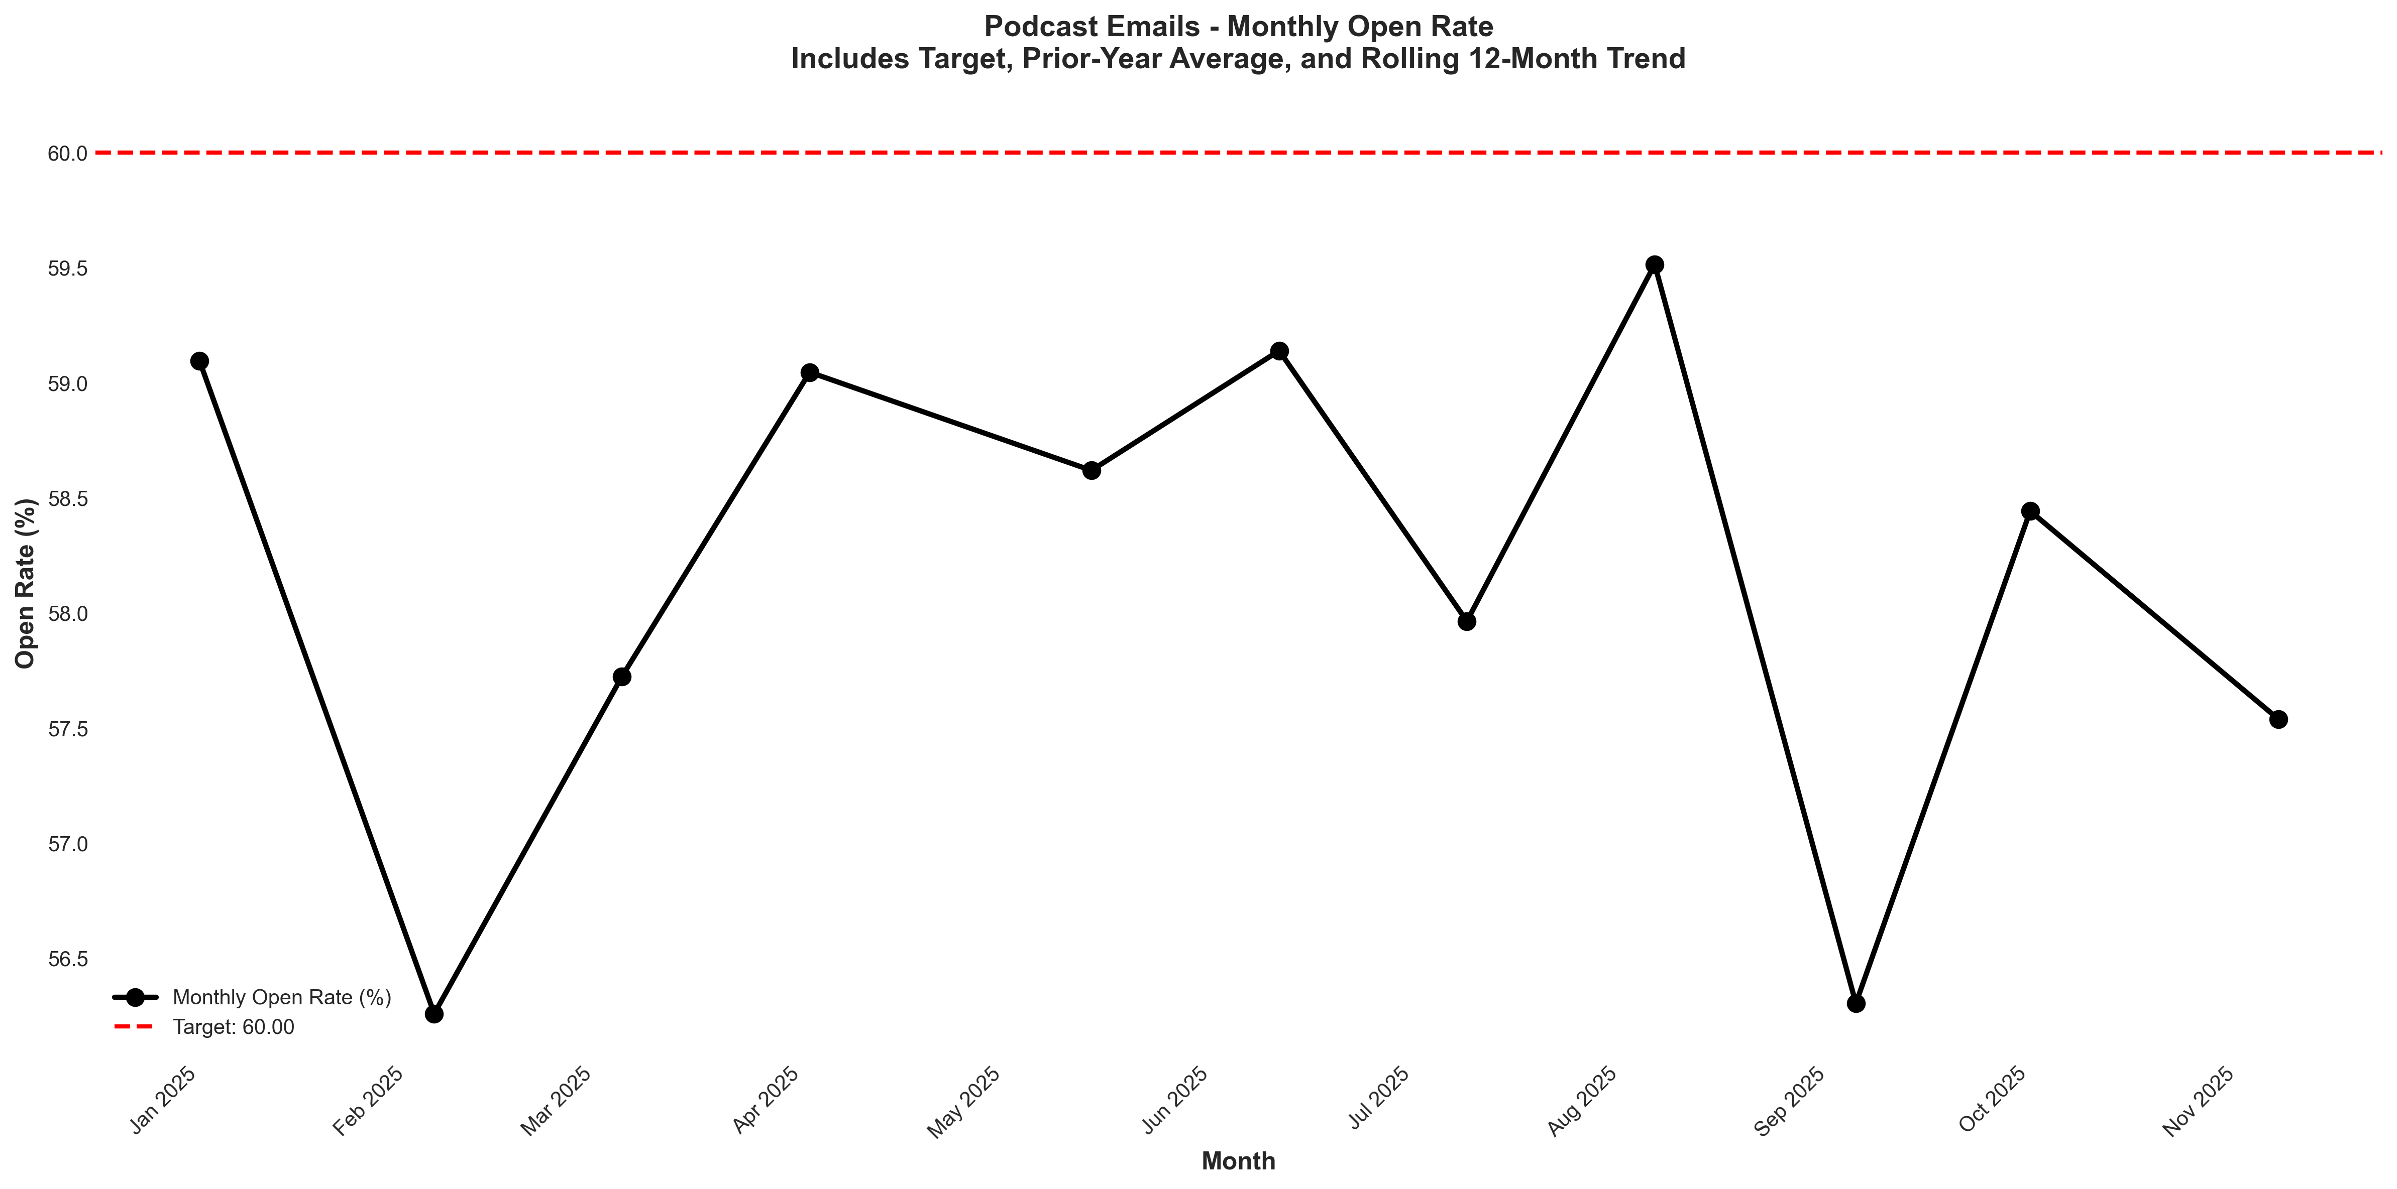
Chart: visualizations/newsletter_series_monthly/podcast_open_rate.png
Source: outputs/newsletter_series/04_podcast_emails.csv
Insights:
• Current month: 56.67% vs 58.06% last month (1.39%, -2.4% MoM) (unfavorable)
• Performance is 2.4% below the 6-month average (avg = 58.05%) → Normal (Near Avg)
• Goal missed by 5.5% (target = 60.00%; actual = 56.67%)
• Trend: → Stable (6mo) | → Stable (12mo) | → Stable (24mo)
Podcast Verified CTR
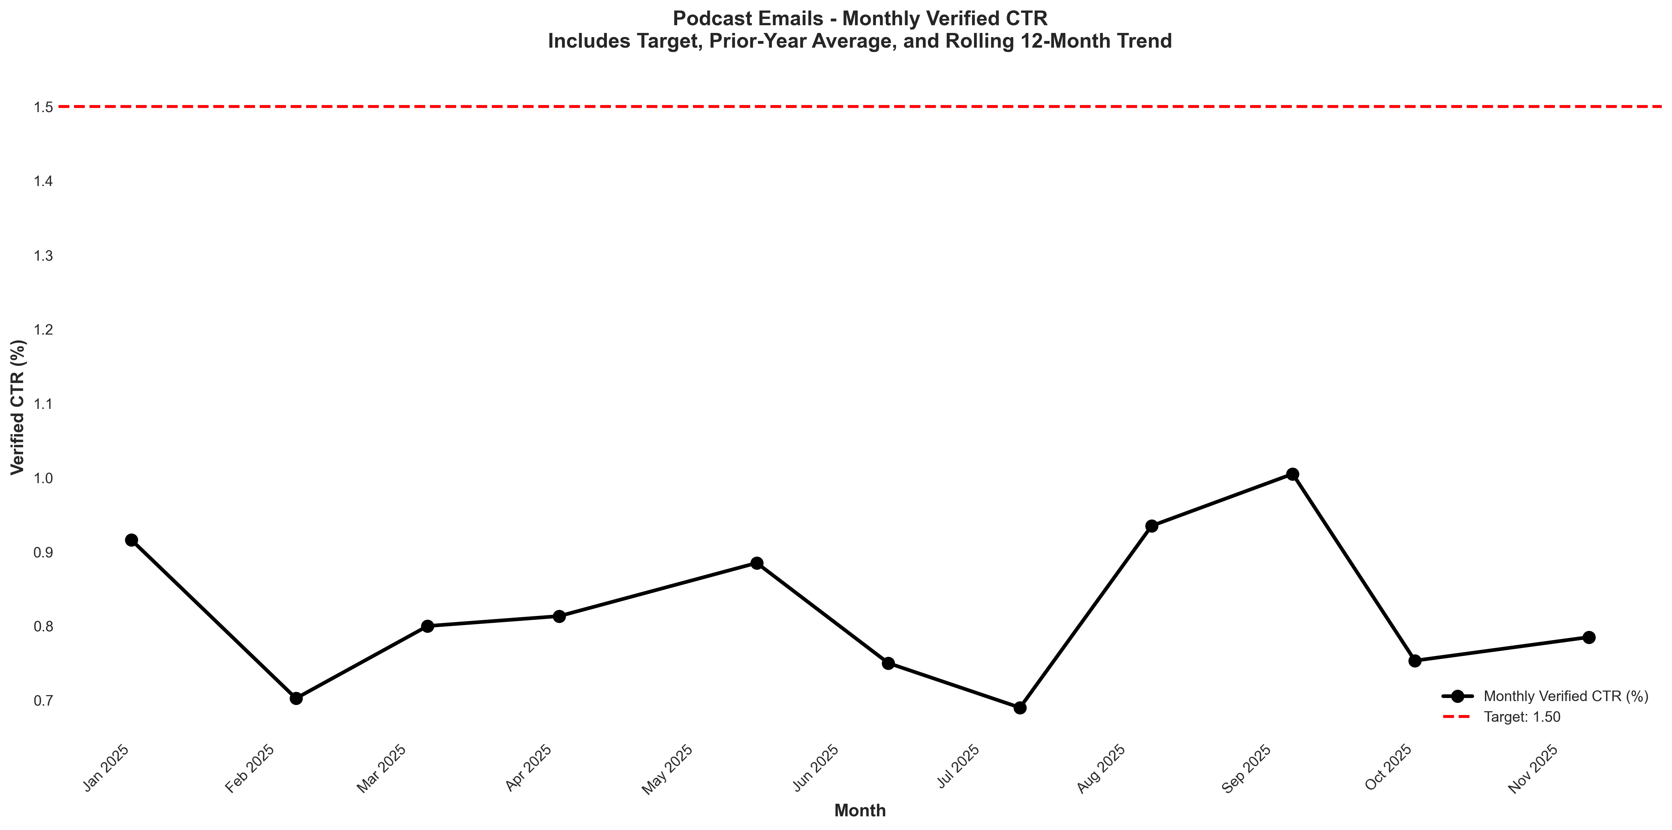
Chart: visualizations/newsletter_series_monthly/podcast_verified_ctr.png
Source: outputs/newsletter_series/04_podcast_emails.csv
Insights:
• Current month: 0.65% vs 0.70% last month (0.05%, -7.1% MoM) (unfavorable)
• Performance is 13.9% below the 6-month average (avg = 0.76%) → Low CV vs 6Mo Avg
• Goal missed by 56.7% (target = 1.50%; actual = 0.65%)
• Trend: → Stable (6mo) | ↓ Falling (12mo) | ↑ Rising (24mo)
Podcast Unsubscribe Rate
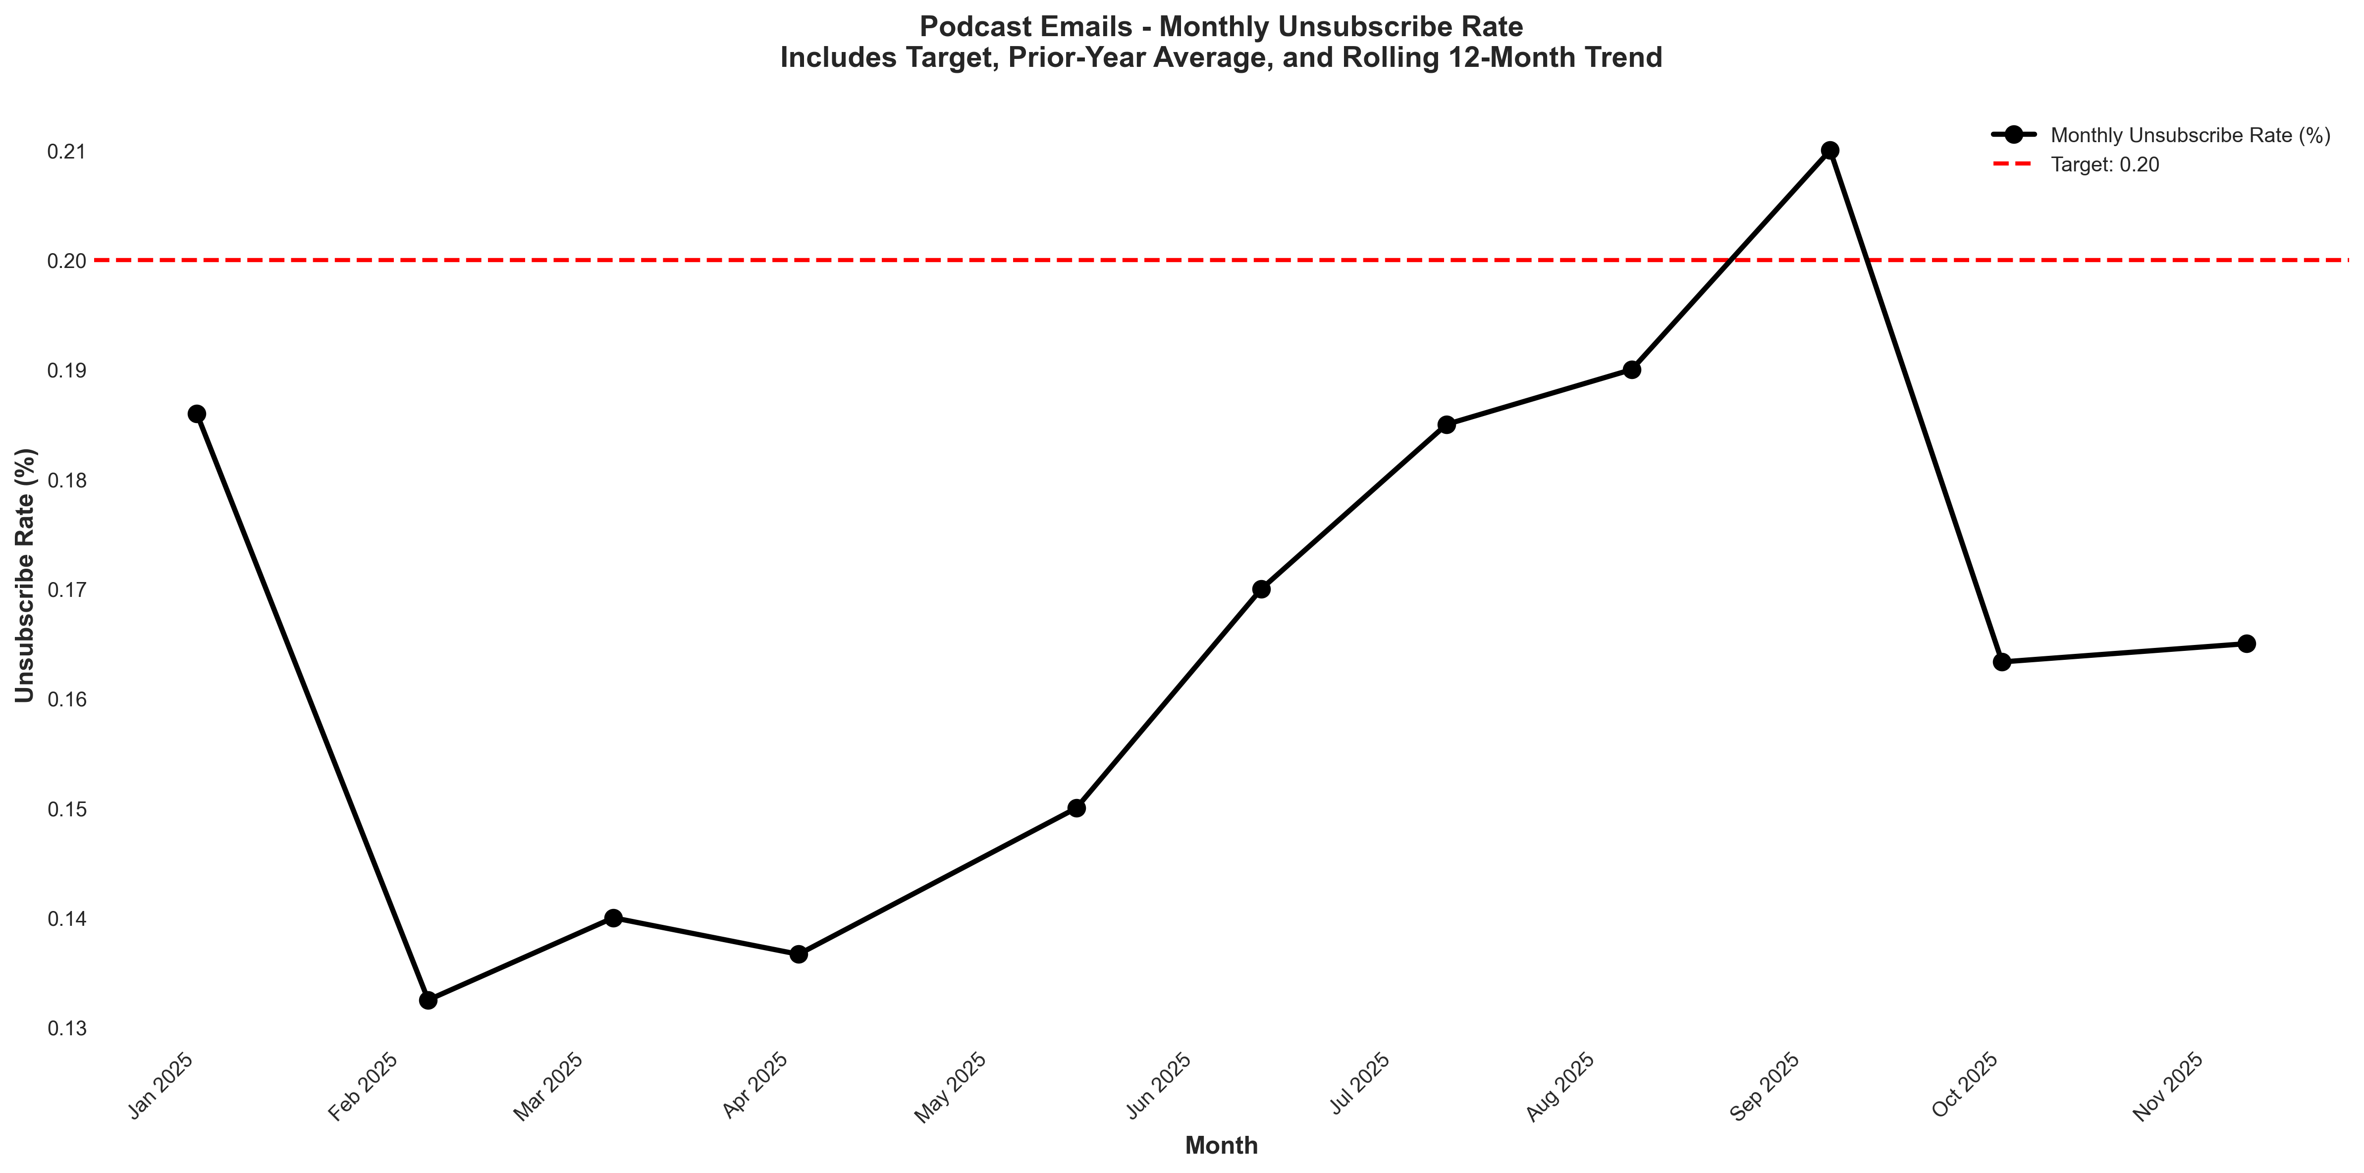
Chart: visualizations/newsletter_series_monthly/podcast_unsubscribe.png
Source: outputs/newsletter_series/04_podcast_emails.csv
Insights:
• Current month: 0.20% vs 0.15% last month (+0.05%, +33.3% MoM) (unfavorable)
• Performance is 21.2% above the 6-month average (avg = 0.17%) → High CV vs 6Mo Avg
• Goal met: Yes (target = 0.20%; actual = 0.20%; 0.0% below goal)
• Trend: → Stable (6mo) | ↓ Falling (12mo) | ↑ Rising (24mo)

Newsletter Series: Case Study
Case Study Open Rate
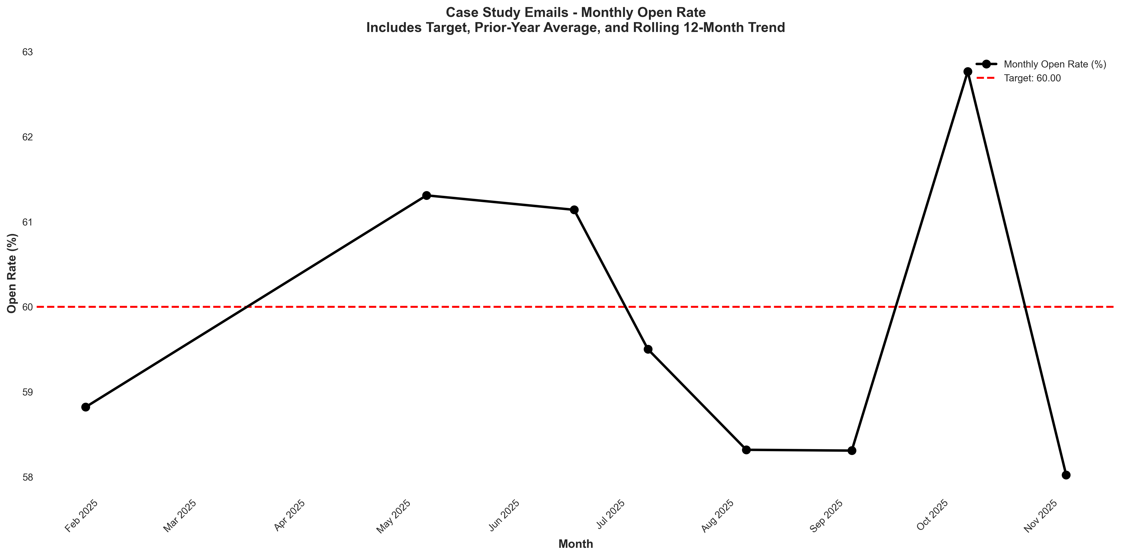
Chart: visualizations/newsletter_series_monthly/case_study_open_rate.png
Source: outputs/newsletter_series/01_case_study_emails.csv
Insights:
• Current month: 56.62% vs 58.02% last month (1.40%, -2.4% MoM) (unfavorable)
• Performance is 2.7% below the 6-month average (avg = 58.18%) → Normal (Near Avg)
• Goal missed by 5.6% (target = 60.00%; actual = 56.62%)
• Trend: → Stable (6mo) | → Stable (12mo) | → Stable (24mo)
Case Study Verified CTR
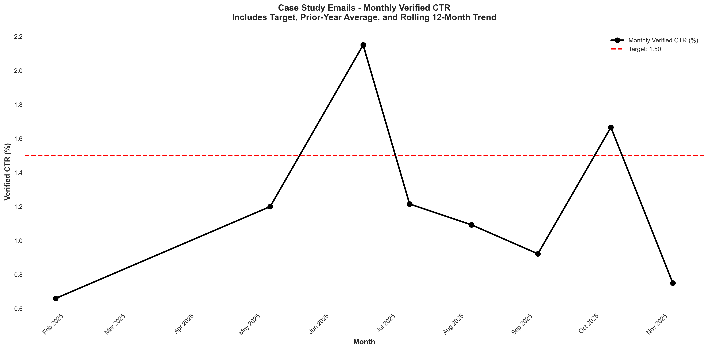
Chart: visualizations/newsletter_series_monthly/case_study_verified_ctr.png
Source: outputs/newsletter_series/01_case_study_emails.csv
Insights:
• Current month: 0.64% vs 0.81% last month (0.17%, -21.0% MoM) (unfavorable)
• Performance is 10.9% below the 6-month average (avg = 0.72%) → Low CV vs 6Mo Avg
• Goal missed by 57.3% (target = 1.50%; actual = 0.64%)
• Trend: ↓ Falling (6mo) | ↓ Falling (12mo) | ↓ Falling (24mo)
Case Study Unsubscribe Rate
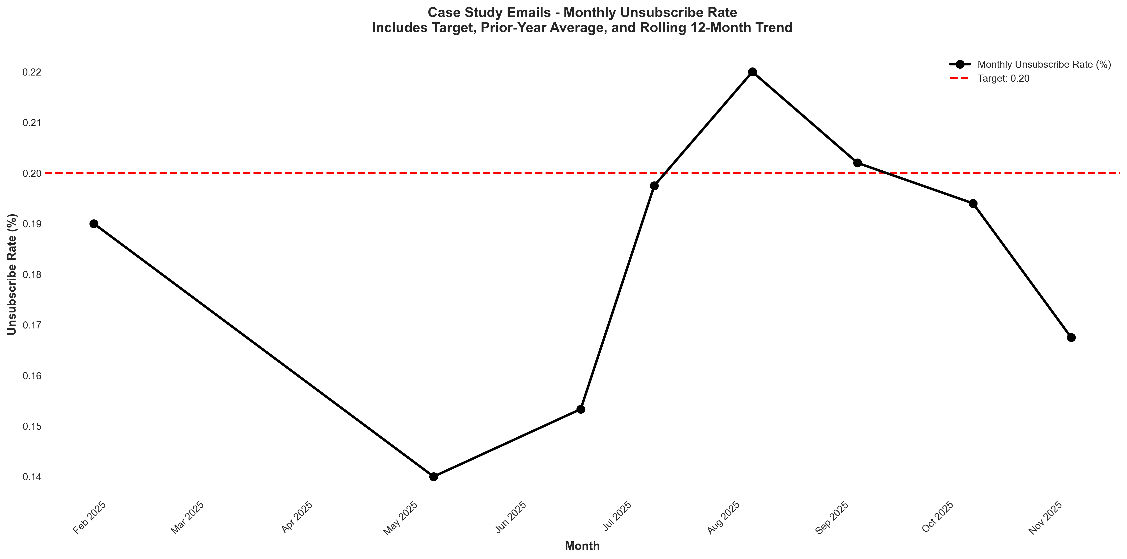
Chart: visualizations/newsletter_series_monthly/case_study_unsubscribe.png
Source: outputs/newsletter_series/01_case_study_emails.csv
Insights:
• Current month: 0.15% vs 0.18% last month (0.03%, -16.7% MoM) (favorable)
• Performance is 10.9% below the 6-month average (avg = 0.17%) → Low CV vs 6Mo Avg
• Goal met: Yes (target = 0.20%; actual = 0.15%; 25.0% below goal)
• Trend: → Stable (6mo) | ↓ Falling (12mo) | ↓ Falling (24mo)

Section 2: Sales Metrics

Lead Time & Deal Upgrade
Average Lead Time
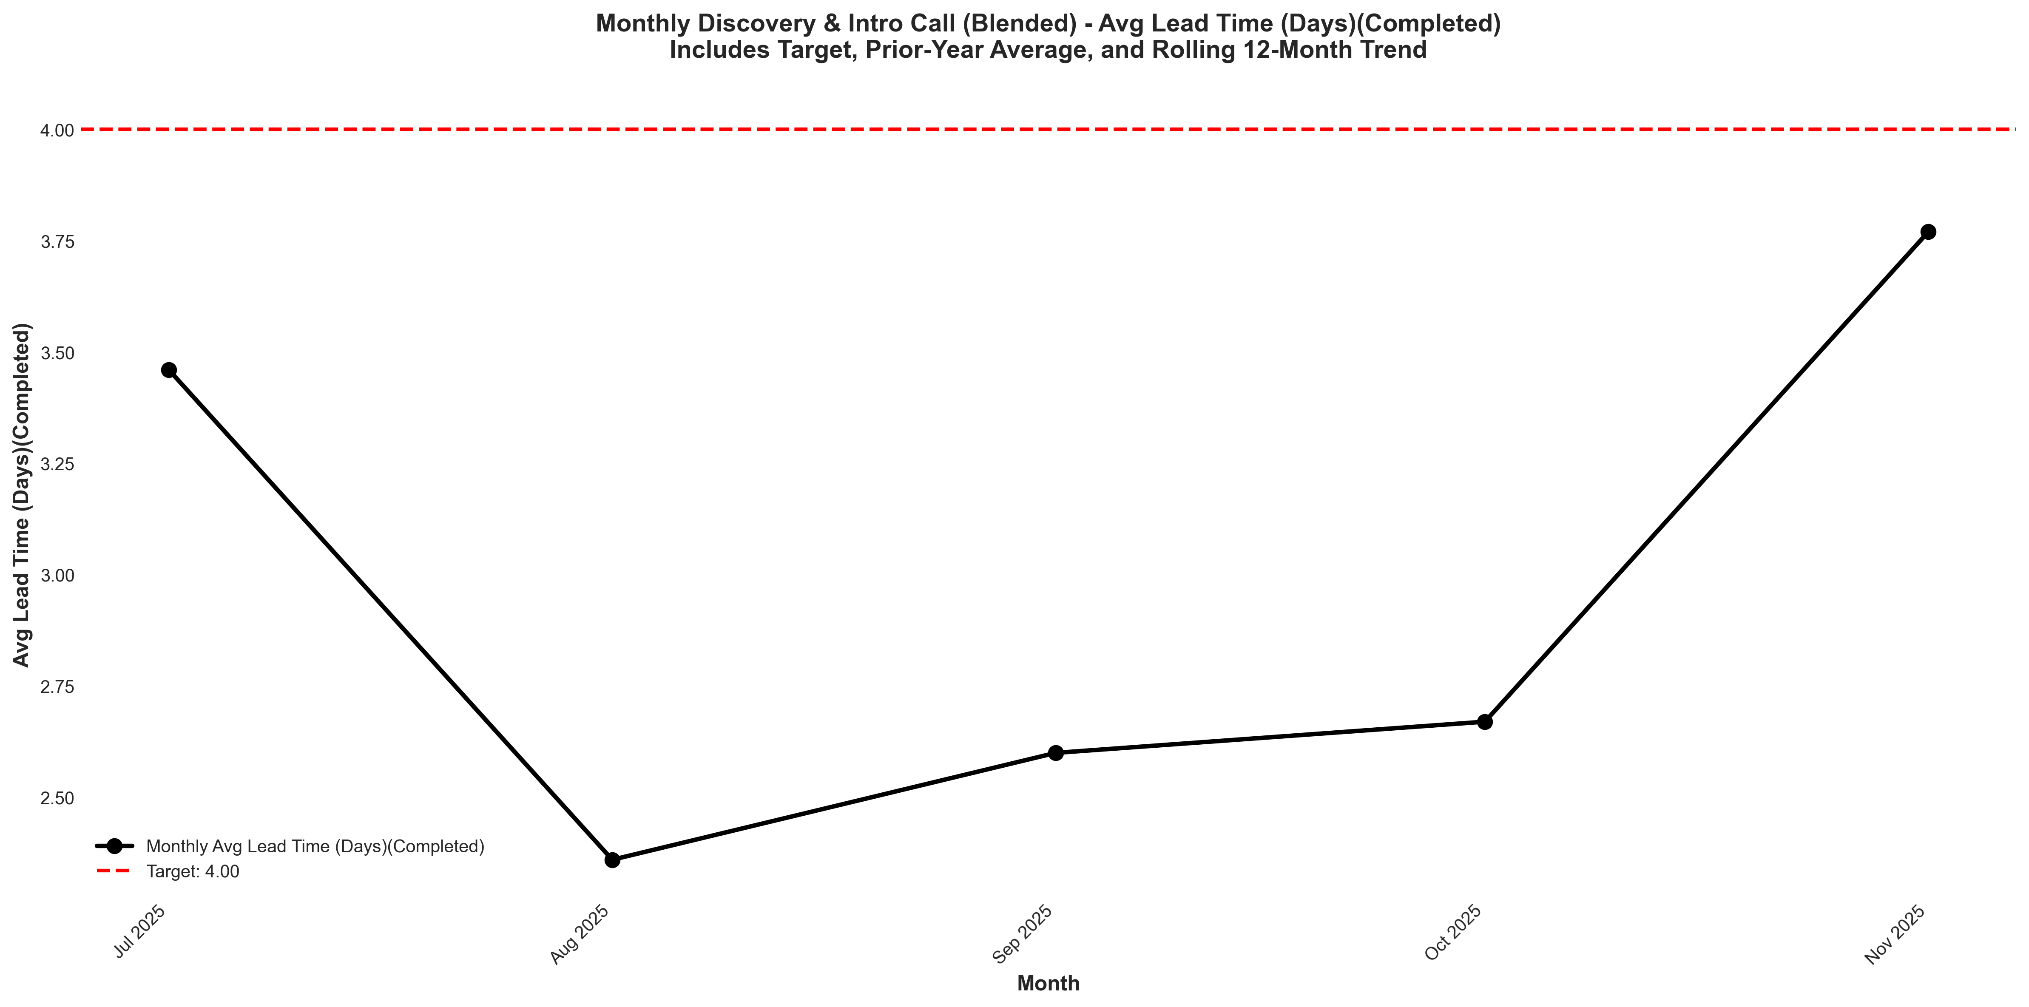
Chart: visualizations/discovery_intro_blended_monthly/monthly_avg_lead_time_completed.png
Source: outputs/discovery_intro/monthly_discovery_intro_blended.csv
Insights:
• Current month: 3.77 vs 2.67 last month (+1.10, +41.2% MoM) (unfavorable)
• Performance is 26.9% above the 6-month average (avg = 2.97) → High CV vs 6Mo Avg
• Goal met: Yes (target = 4.00; actual = 3.77; 5.8% below goal)
• Trend: Not enough data for 6-month trend (5 points)
Deal Upgrade Visits
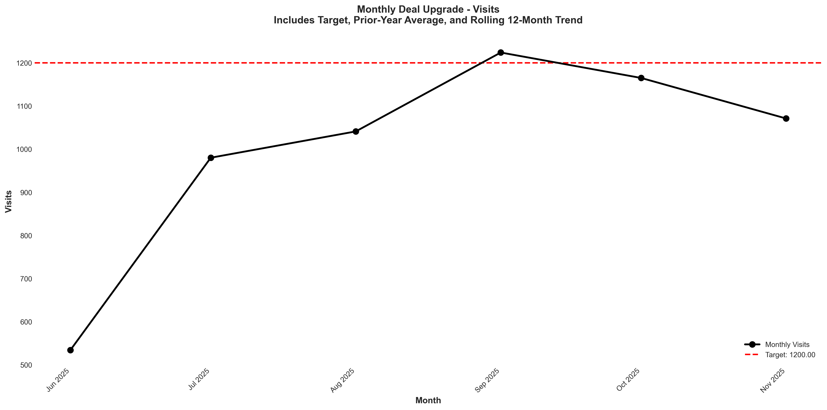
Chart: visualizations/deal_upgrade_monthly/monthly_visits.png
Source: outputs/deal_upgrade/monthly_deal_upgrade.csv
Insights:
• Current month: 1,071 vs 1,165 last month (94.00, -8.1% MoM) (unfavorable)
• Performance is 6.8% above the 6-month average (avg = 1,002) → High CV vs 6Mo Avg
• Goal missed by 10.8% (target = 1,200; actual = 1,071)
• Trend: ↑ Rising (6mo)
Deal Upgrade CVR
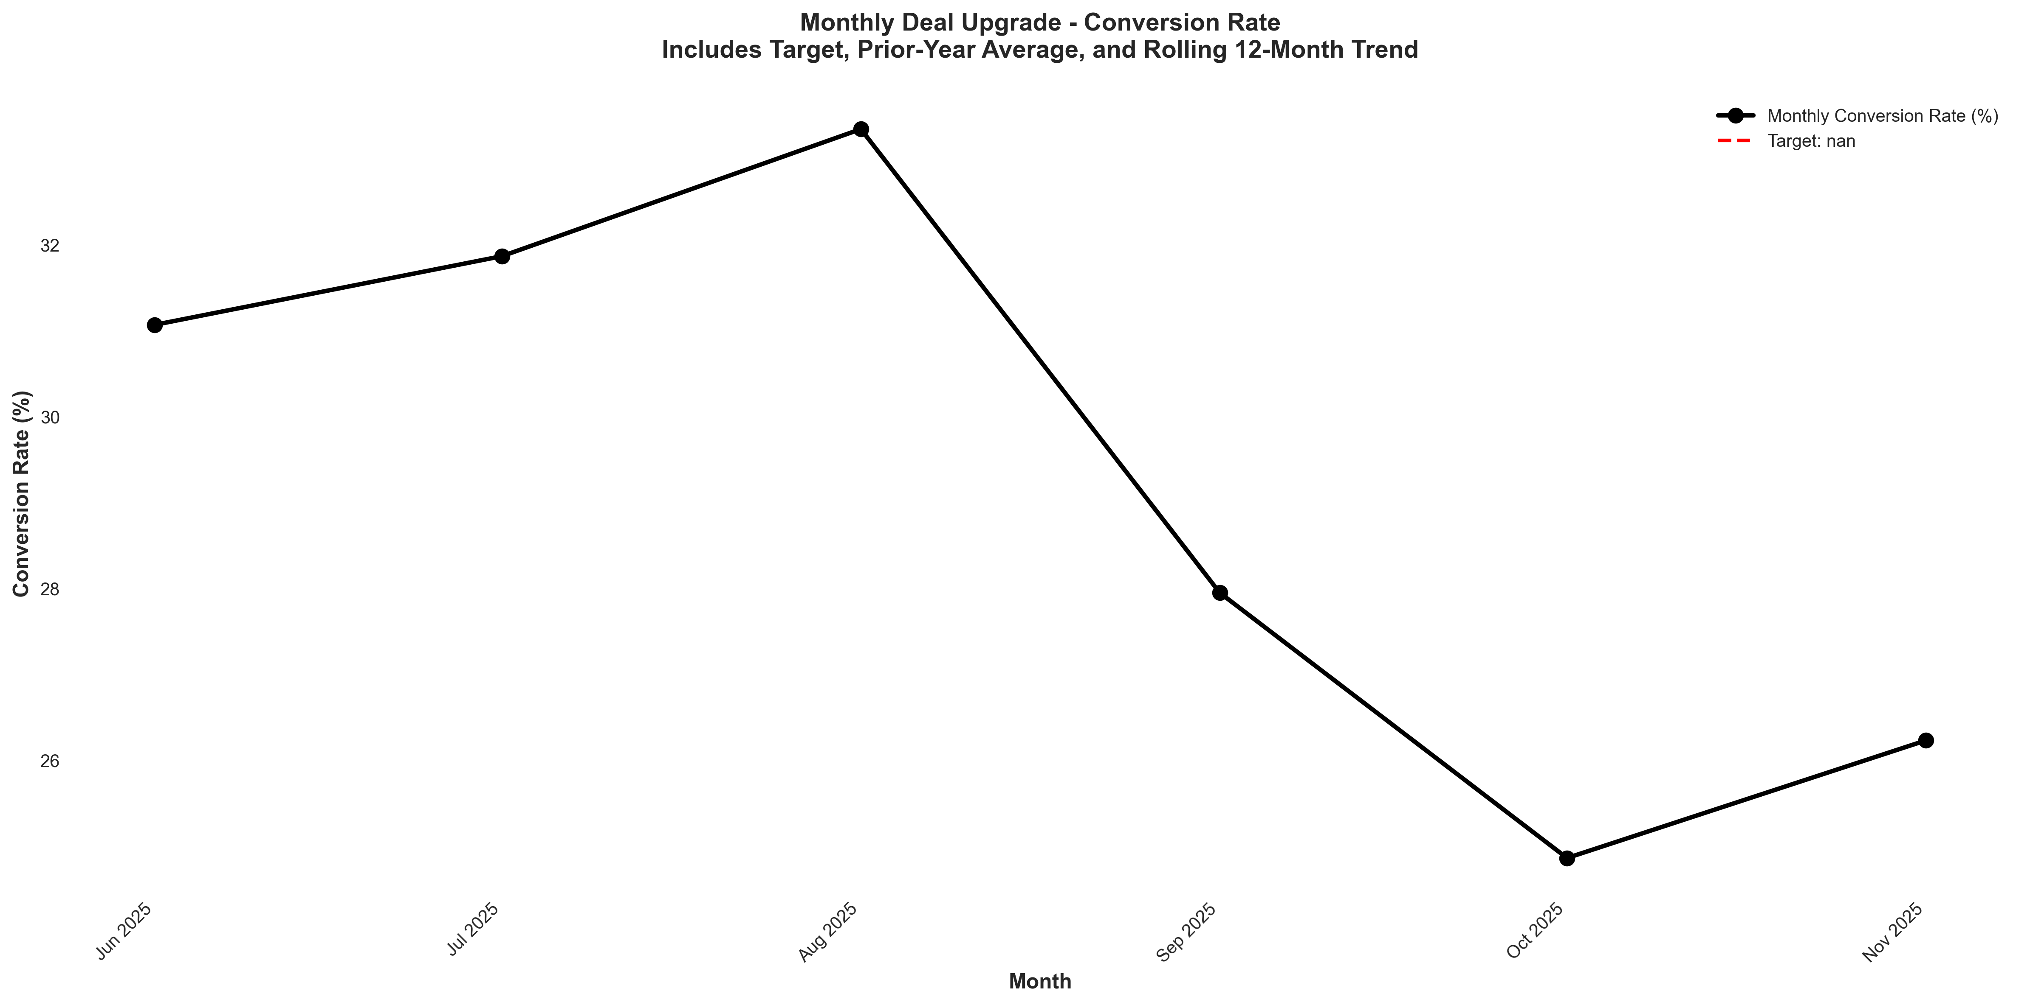
Chart: visualizations/deal_upgrade_monthly/monthly_conversion_rate.png
Source: outputs/deal_upgrade/monthly_deal_upgrade.csv
Insights:
• Current month: 26.23% vs 24.86% last month (+1.37%, +5.5% MoM) (favorable)
• Performance is 10.2% below the 6-month average (avg = 29.22%) → Low CV vs 6Mo Avg
• Trend: ↓ Falling (6mo)

Pro Site Funnel
Pro Site Visits
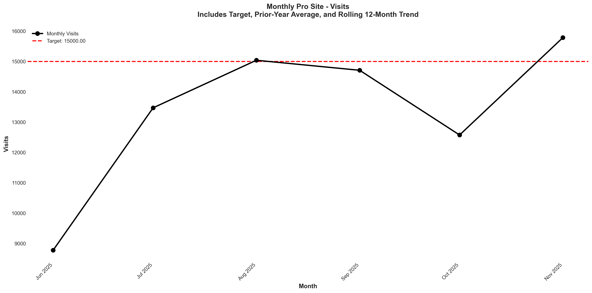
Chart: visualizations/pro_site_monthly/monthly_visits.png
Source: outputs/pro_site/monthly_pro_site.csv
Insights:
• Current month: 15,784 vs 12,575 last month (+3,209, +25.5% MoM) (favorable)
• Performance is 17.9% above the 6-month average (avg = 13,392) → High CV vs 6Mo Avg
• Goal met: Yes (target = 15,000; actual = 15,784; +5.2% above goal)
• Trend: ↑ Rising (6mo)
Pro Site CVR
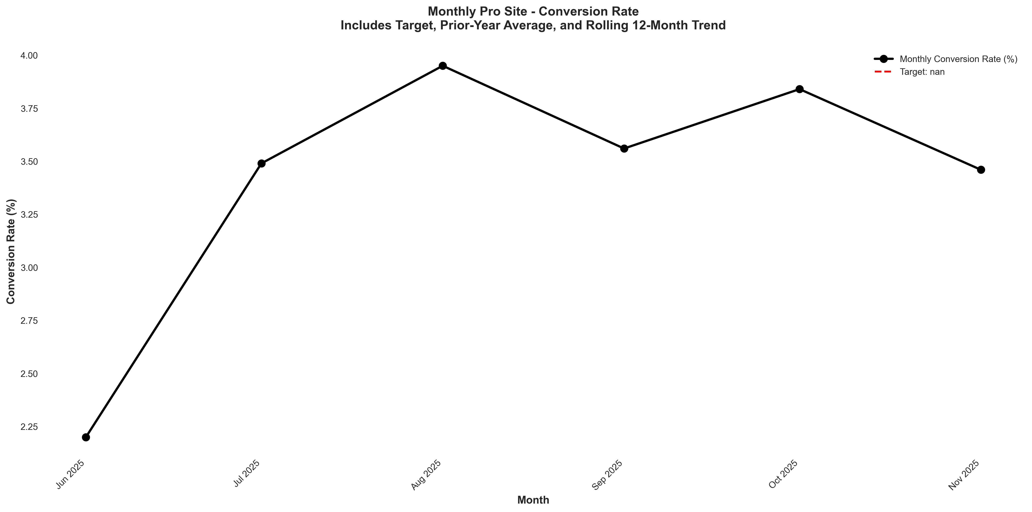
Chart: visualizations/pro_site_monthly/monthly_conversion_rate.png
Source: outputs/pro_site/monthly_pro_site.csv
Insights:
• Current month: 3.46% vs 3.84% last month (0.38%, -9.9% MoM) (unfavorable)
• Performance is 1.3% above the 6-month average (avg = 3.42%) → Normal (Near Avg)
• Trend: ↑ Rising (6mo)

Booked Calls
Booked Calls - Closers (Discovery Call)
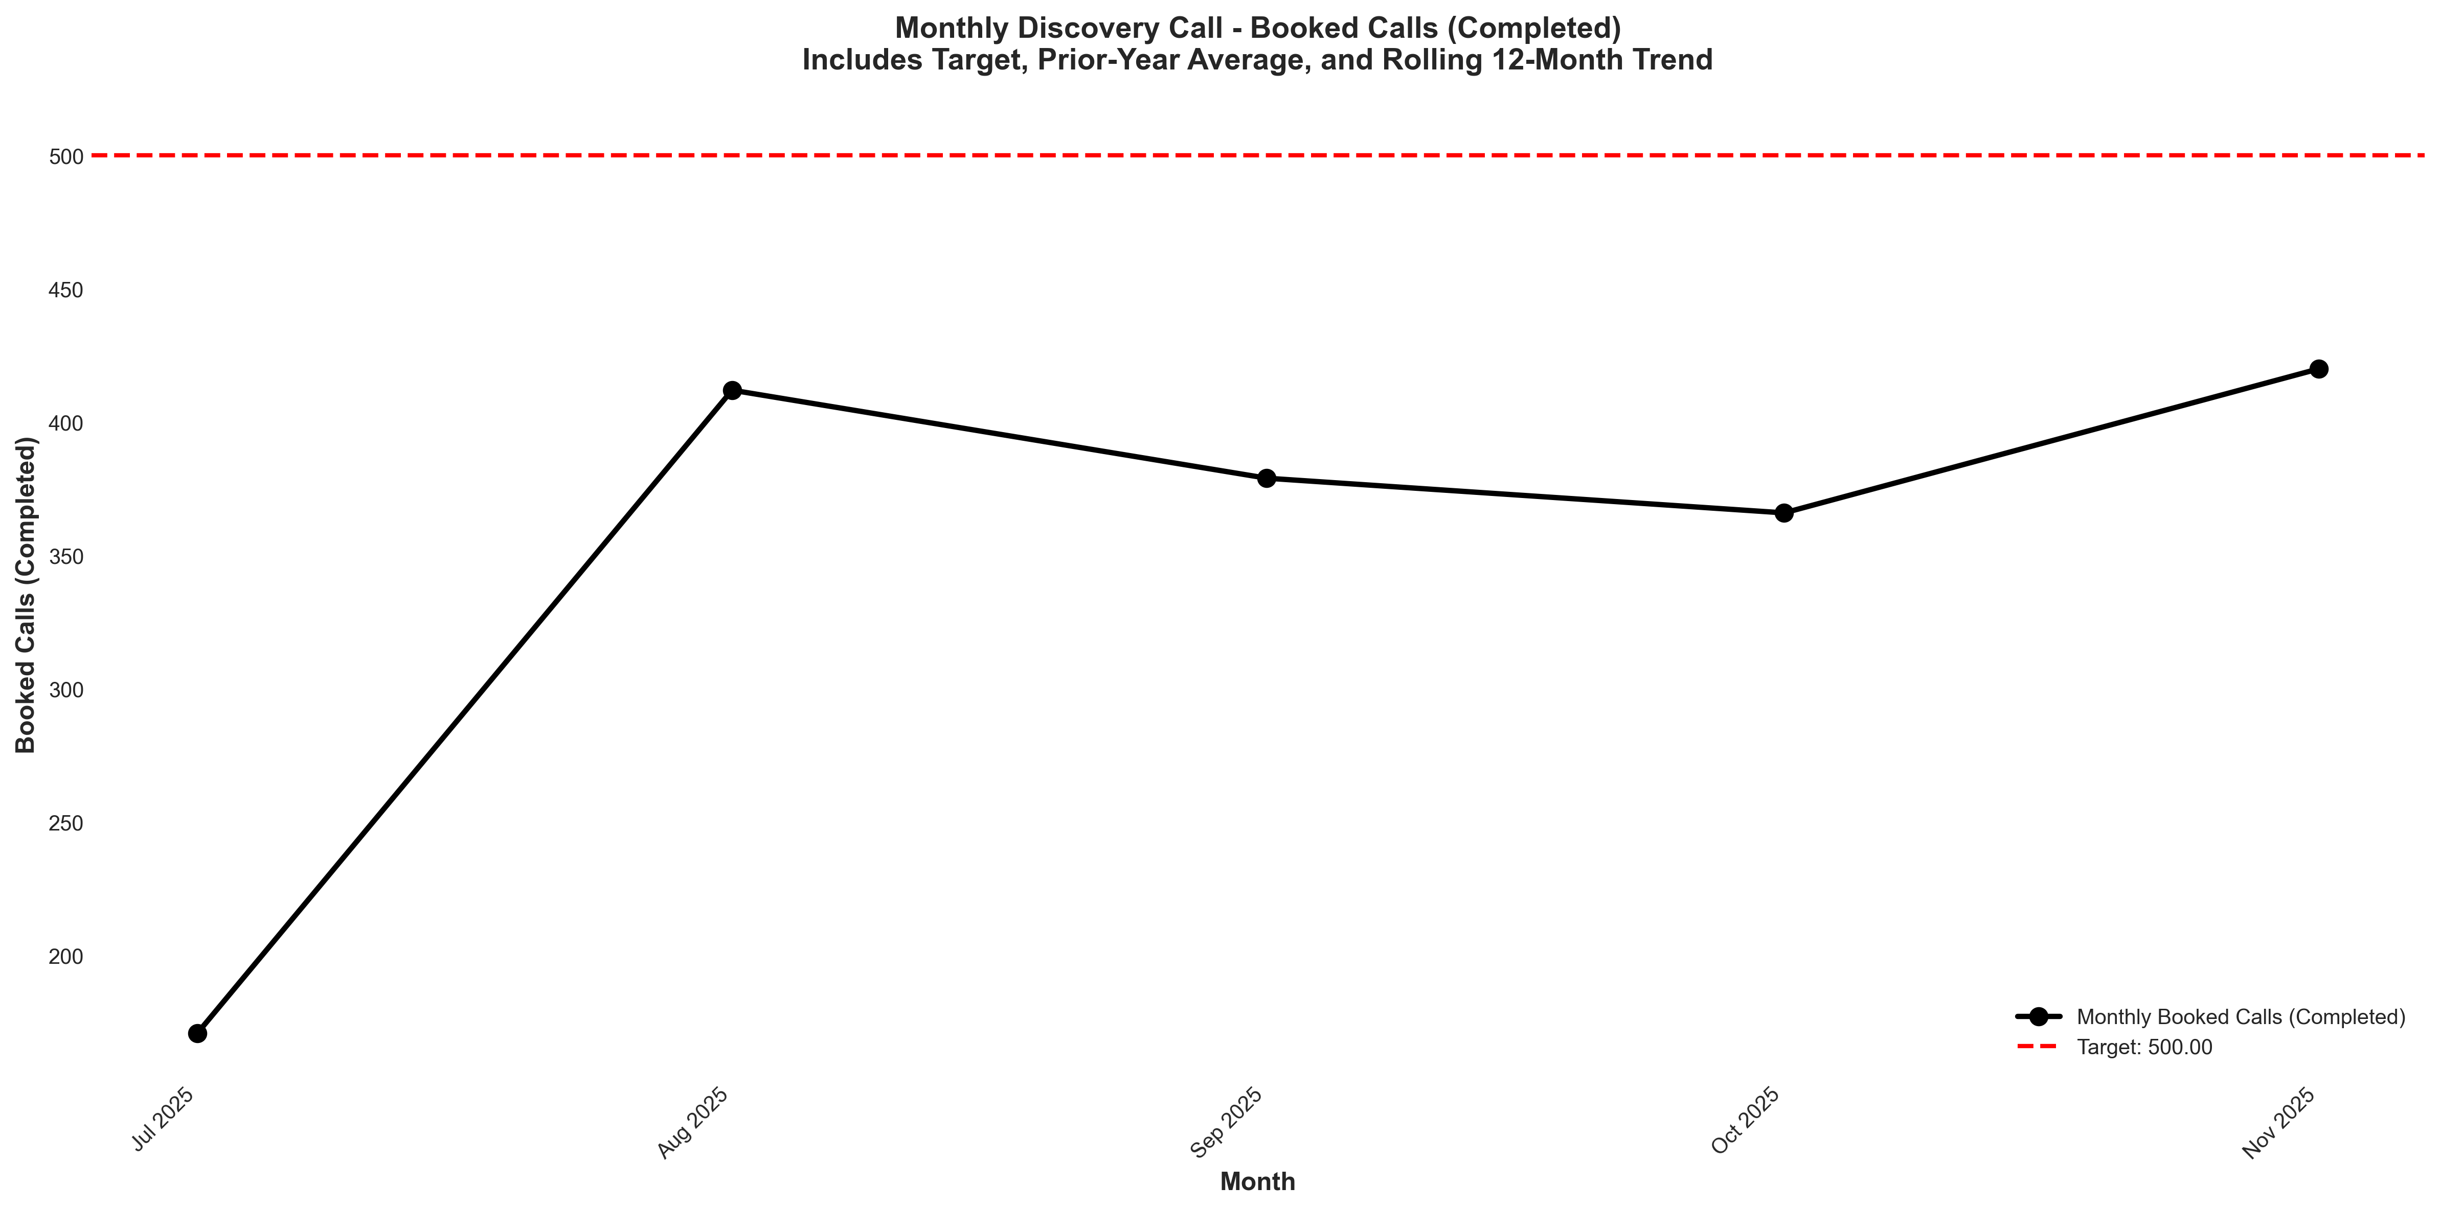
Chart: visualizations/discovery_call_monthly/monthly_booked_calls_completed.png
Source: outputs/discovery_intro/monthly_discovery_call.csv
Insights:
• Current month: 420 vs 366 last month (+54.00, +14.8% MoM) (favorable)
• Performance is 20.1% above the 6-month average (avg = 350) → High CV vs 6Mo Avg
• Goal missed by 16.0% (target = 500; actual = 420)
• Trend: Not enough data for 6-month trend (5 points)
Booked Calls - Setters (Intro Call)
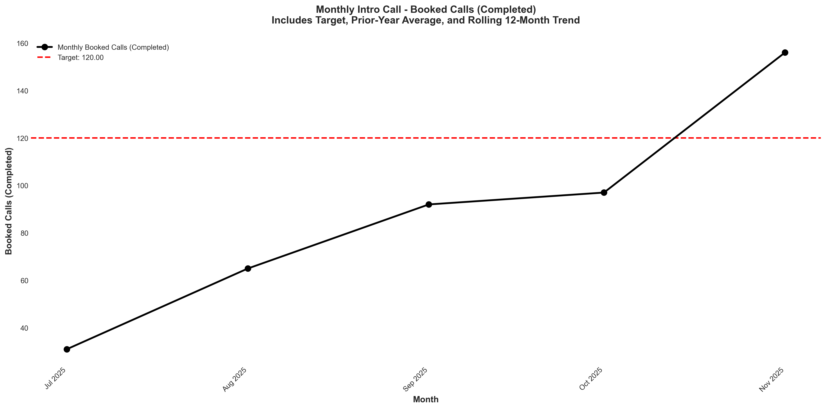
Chart: visualizations/intro_call_monthly/monthly_booked_calls_completed.png
Source: outputs/discovery_intro/monthly_intro_call.csv
Insights:
• Current month: 156 vs 97.00 last month (+59.00, +60.8% MoM) (favorable)
• Performance is 76.9% above the 6-month average (avg = 88.20) → High CV vs 6Mo Avg
• Goal met: Yes (target = 120; actual = 156; +30.0% above goal)
• Trend: Not enough data for 6-month trend (5 points)

Sales Pipeline: Calls
Scheduled Calls
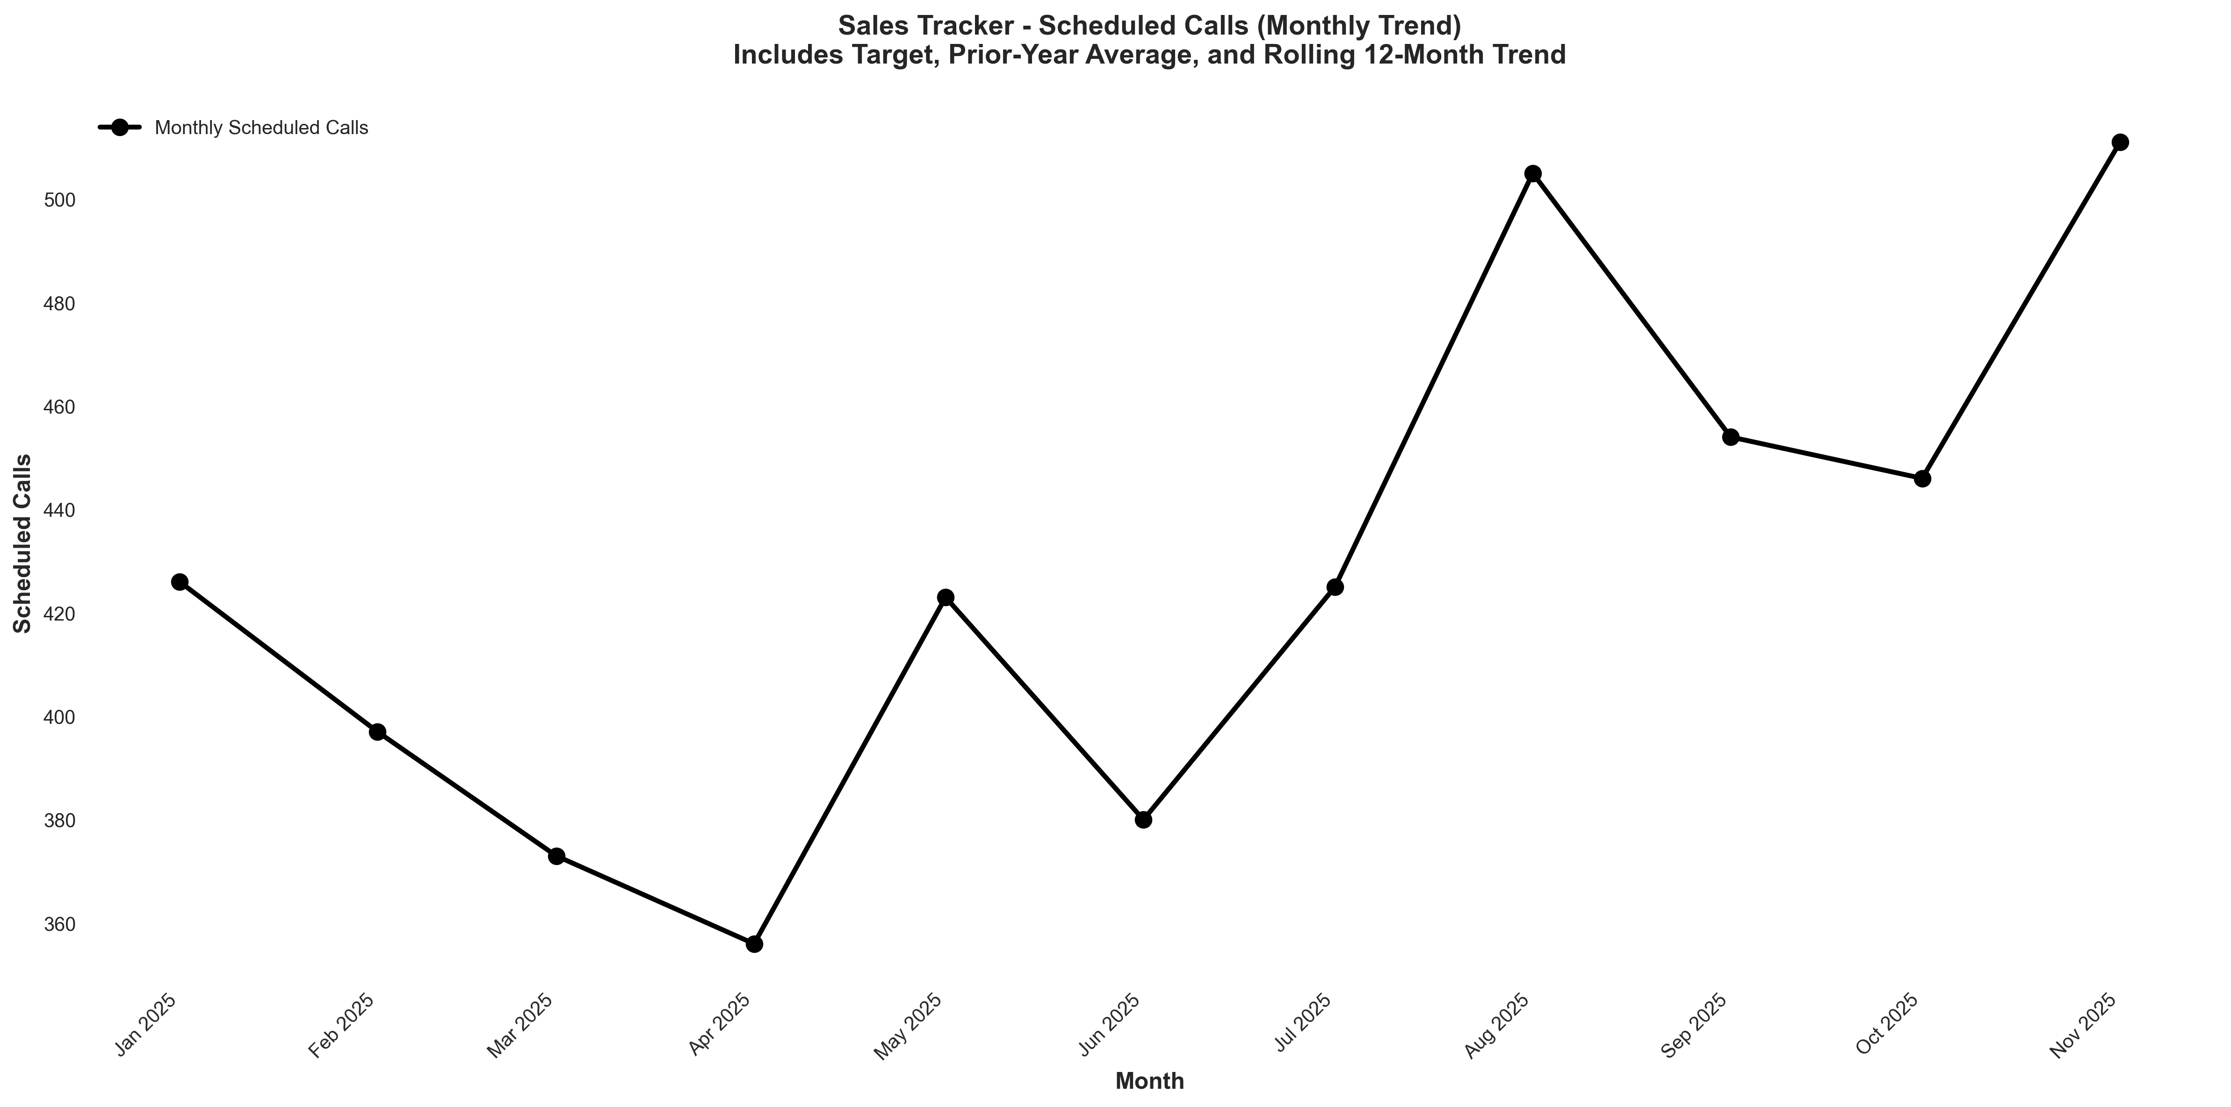
Chart: visualizations/sales_tracker_monthly/monthly_sched_calls.png
Source: outputs/sales_tracker/monthly_sales_tracker.csv
Insights:
• Current month: 511 vs 446 last month (+65.00, +14.6% MoM) (favorable)
• Performance is 12.7% above the 6-month average (avg = 454) → High CV vs 6Mo Avg
• Trend: → Stable (6mo) | ↑ Rising (12mo)
Live Calls
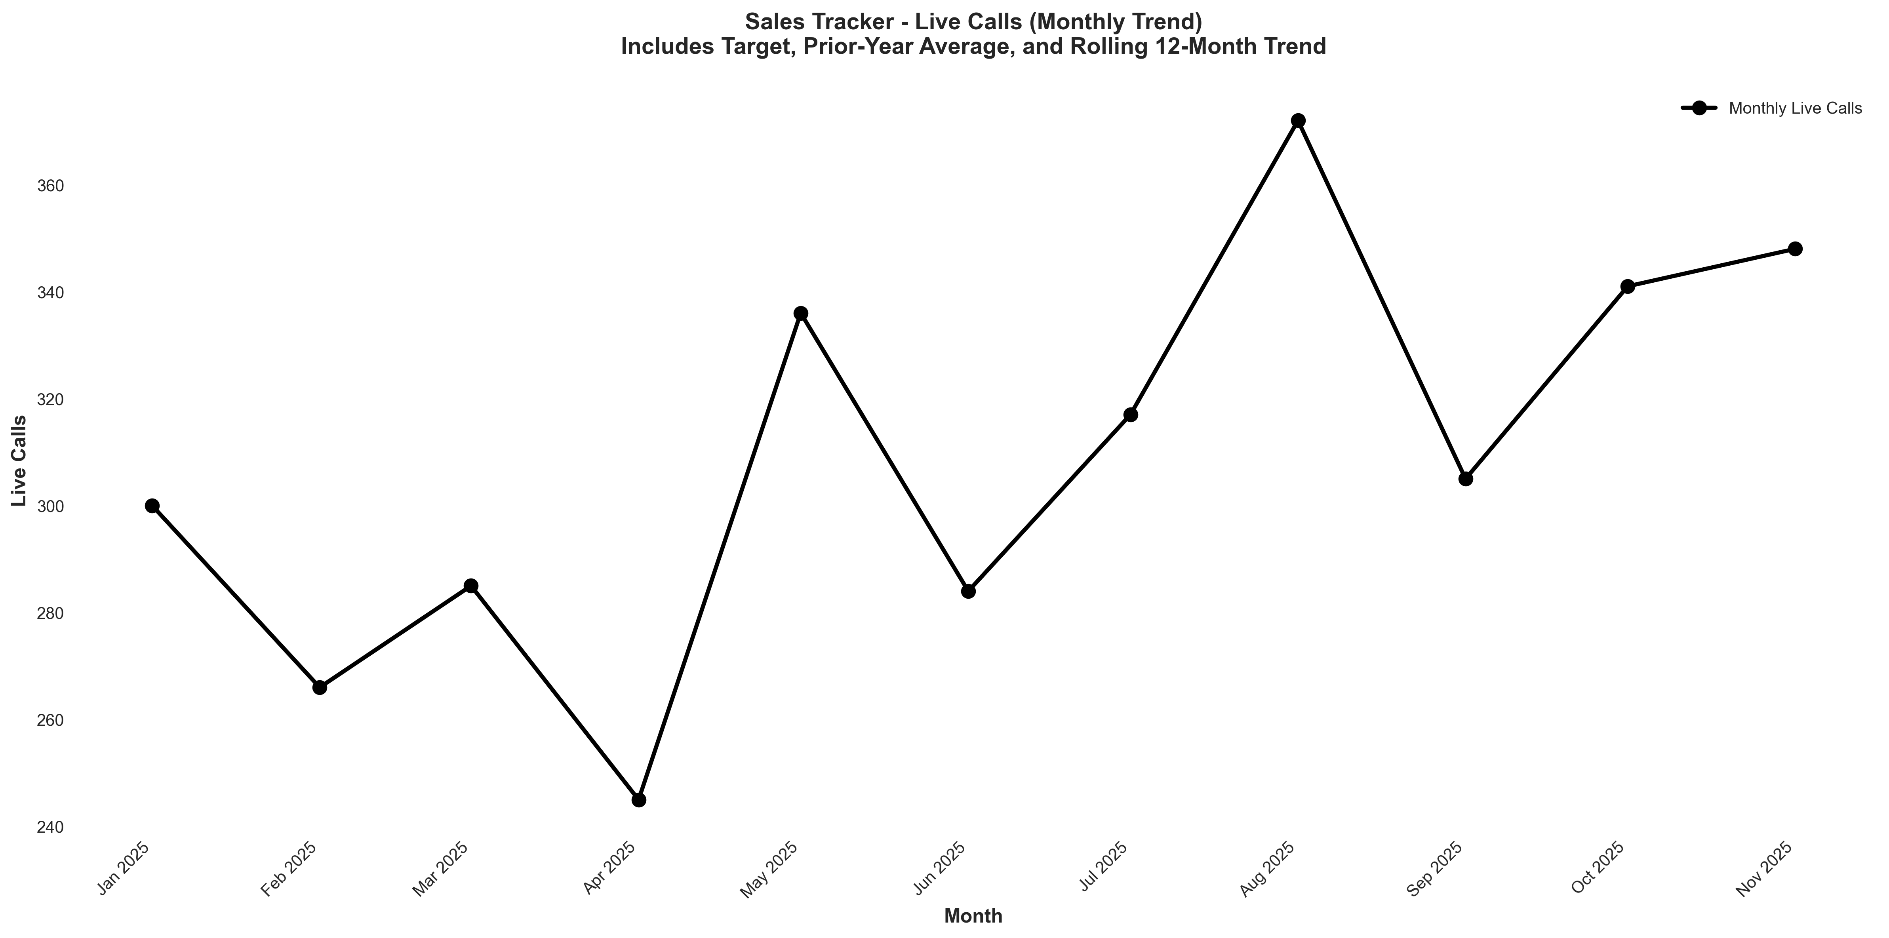
Chart: visualizations/sales_tracker_monthly/monthly_live_calls.png
Source: outputs/sales_tracker/monthly_sales_tracker.csv
Insights:
• Current month: 348 vs 341 last month (+7.00, +2.1% MoM) (favorable)
• Performance is 6.2% above the 6-month average (avg = 328) → High CV vs 6Mo Avg
• Trend: → Stable (6mo) | ↑ Rising (12mo)
Show Rate
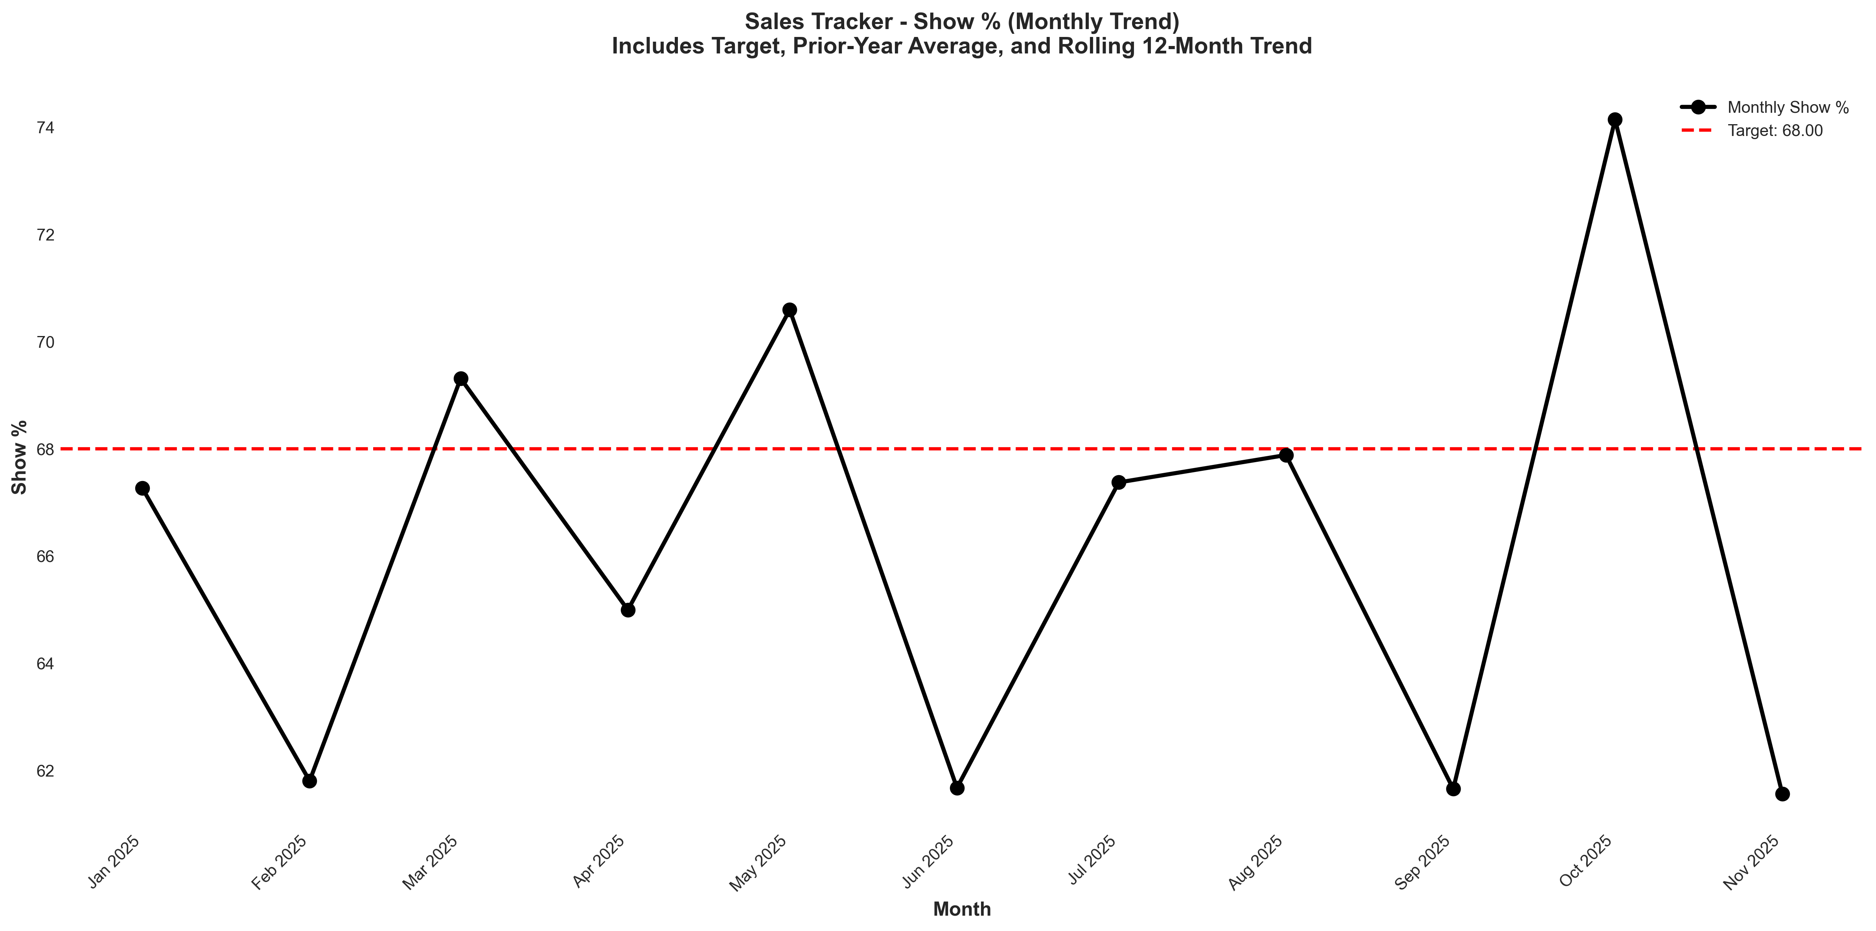
Chart: visualizations/sales_tracker_monthly/monthly_show_pct.png
Source: outputs/sales_tracker/monthly_sales_tracker.csv
Insights:
• Current month: 61.56% vs 74.14% last month (12.58%, -17.0% MoM) (unfavorable)
• Performance is 6.3% below the 6-month average (avg = 65.71%) → Low CV vs 6Mo Avg
• Goal missed by 9.5% (target = 68.00%; actual = 61.56%)
• Trend: → Stable (6mo) | → Stable (12mo)

Offers
Offers
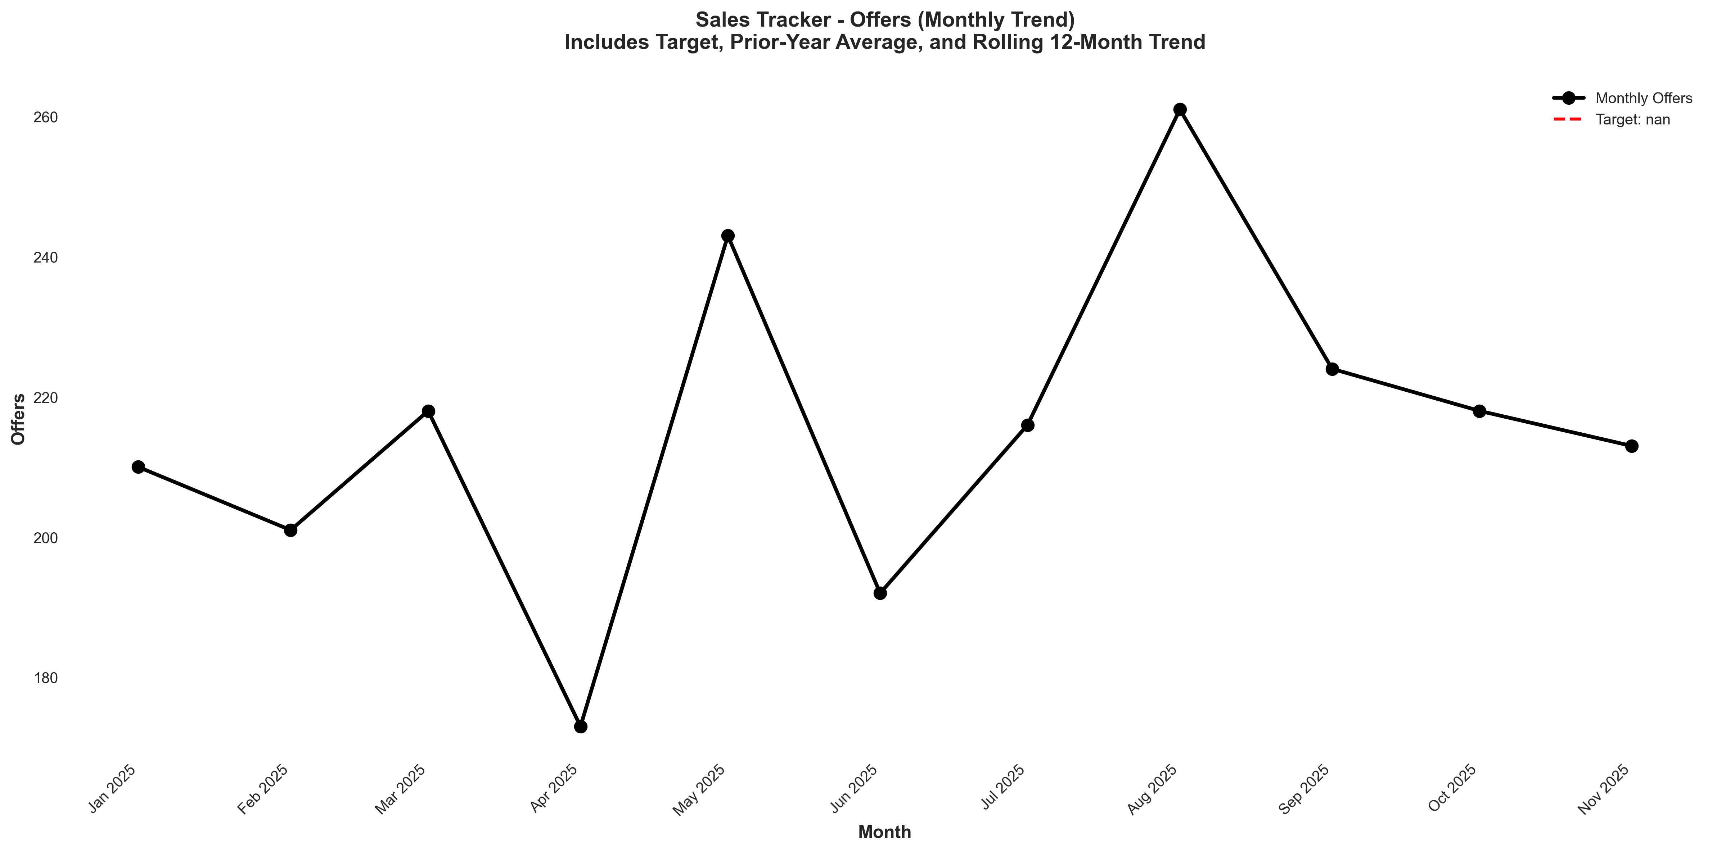
Chart: visualizations/sales_tracker_monthly/monthly_offers.png
Source: outputs/sales_tracker/monthly_sales_tracker.csv
Insights:
• Current month: 213 vs 218 last month (5.00, -2.3% MoM) (unfavorable)
• Performance is 3.5% below the 6-month average (avg = 221) → Normal (Near Avg)
• Trend: → Stable (6mo) | ↑ Rising (12mo)
Offer Rate
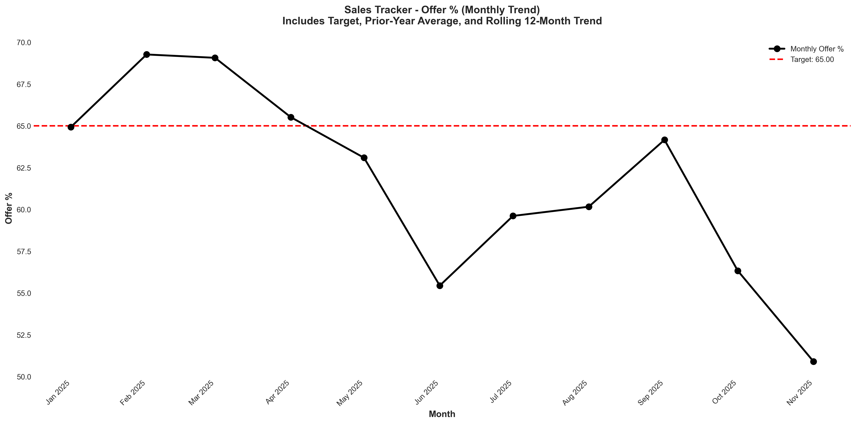
Chart: visualizations/sales_tracker_monthly/monthly_offer_pct.png
Source: outputs/sales_tracker/monthly_sales_tracker.csv
Insights:
• Current month: 50.90% vs 56.33% last month (5.43%, -9.6% MoM) (unfavorable)
• Performance is 11.9% below the 6-month average (avg = 57.77%) → Low CV vs 6Mo Avg
• Goal missed by 21.7% (target = 65.00%; actual = 50.90%)
• Trend: → Stable (6mo) | ↓ Falling (12mo)

Closes
Closes
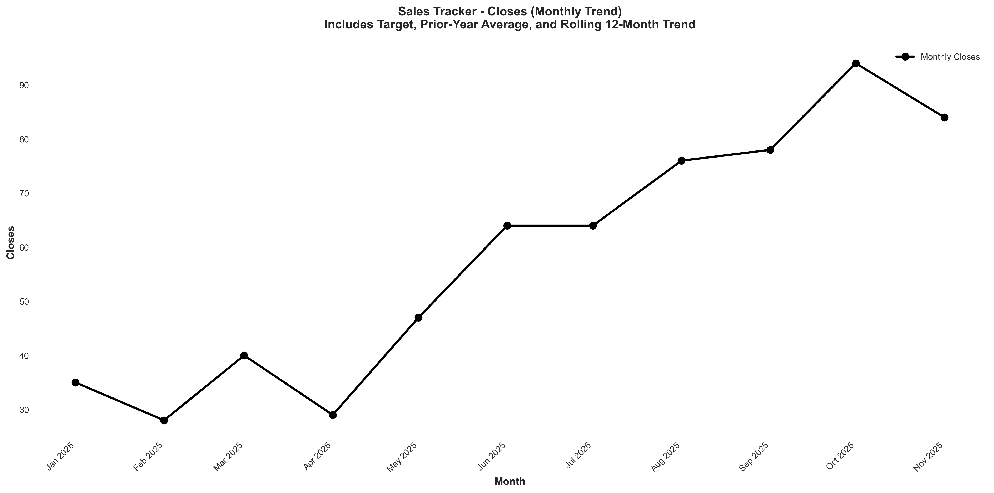
Chart: visualizations/sales_tracker_monthly/monthly_close_1.png
Source: outputs/sales_tracker/monthly_sales_tracker.csv
Insights:
• Current month: 84.00 vs 94.00 last month (10.00, -10.6% MoM) (unfavorable)
• Performance is 9.6% above the 6-month average (avg = 76.67) → High CV vs 6Mo Avg
• Goal met: Yes (target = 80.00; actual = 84.00; +5.0% above goal)
• Trend: ↑ Rising (6mo) | ↑ Rising (12mo)
Offer to Close Rate
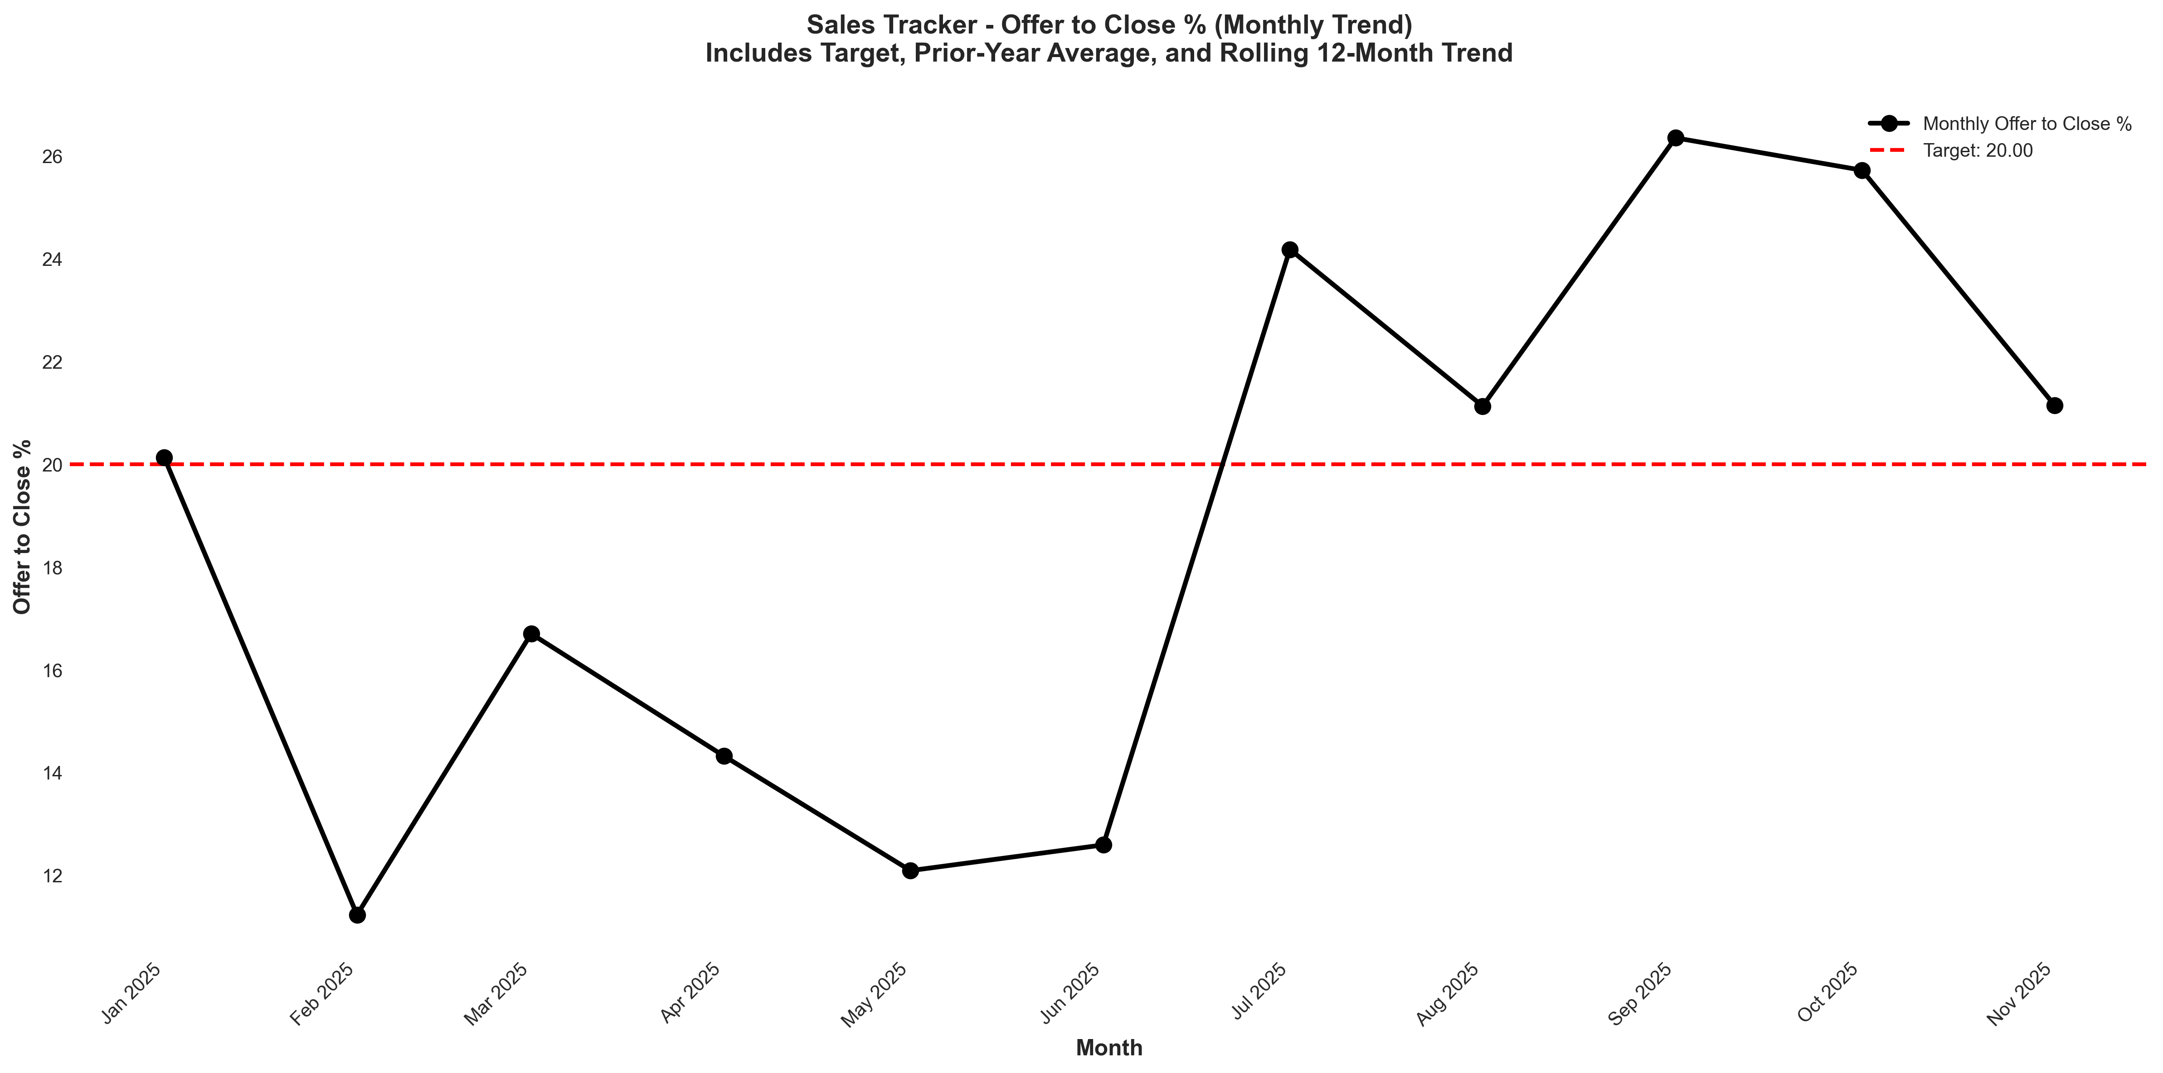
Chart: visualizations/sales_tracker_monthly/monthly_offer_to_close_pct.png
Source: outputs/sales_tracker/monthly_sales_tracker.csv
Insights:
• Current month: 21.14% vs 25.72% last month (4.58%, -17.8% MoM) (unfavorable)
• Performance is 3.3% below the 6-month average (avg = 21.85%) → Normal (Near Avg)
• Goal met: Yes (target = 20.00%; actual = 21.14%; +5.7% above goal)
• Trend: ↑ Rising (6mo) | ↑ Rising (12mo)

