Quarterly Business Review (QBR)

Reporting Quarter: 01/01/2024 to 12/31/2025

Report Generated: December 31, 2025 at 12:20 AM

Table of Contents
Right-click and select 'Update Field' to generate Table of Contents

Executive Summary
NEWSLETTER PERFORMANCE
• New Subscribers: 41,801 (+706.5% QoQ) (favorable)
• Growth Rate: 8.58%
• Newsletter Conversion Rate: 17.31%
• Blended Open Rate: 58.90%
• Blended CTR: 1.41%
SALES PERFORMANCE
• Live Calls: 936 (-5.8% QoQ) (unfavorable)
• Show Rate: 68.1%
• Offers: 590 (-15.8% QoQ) (unfavorable)
• Closes: 213 (-2.3% QoQ) (unfavorable)
• Offer to Close Rate: 23.0%

Section 1: Newsletter Metrics

Landing Page Funnel
Newsletter Visits
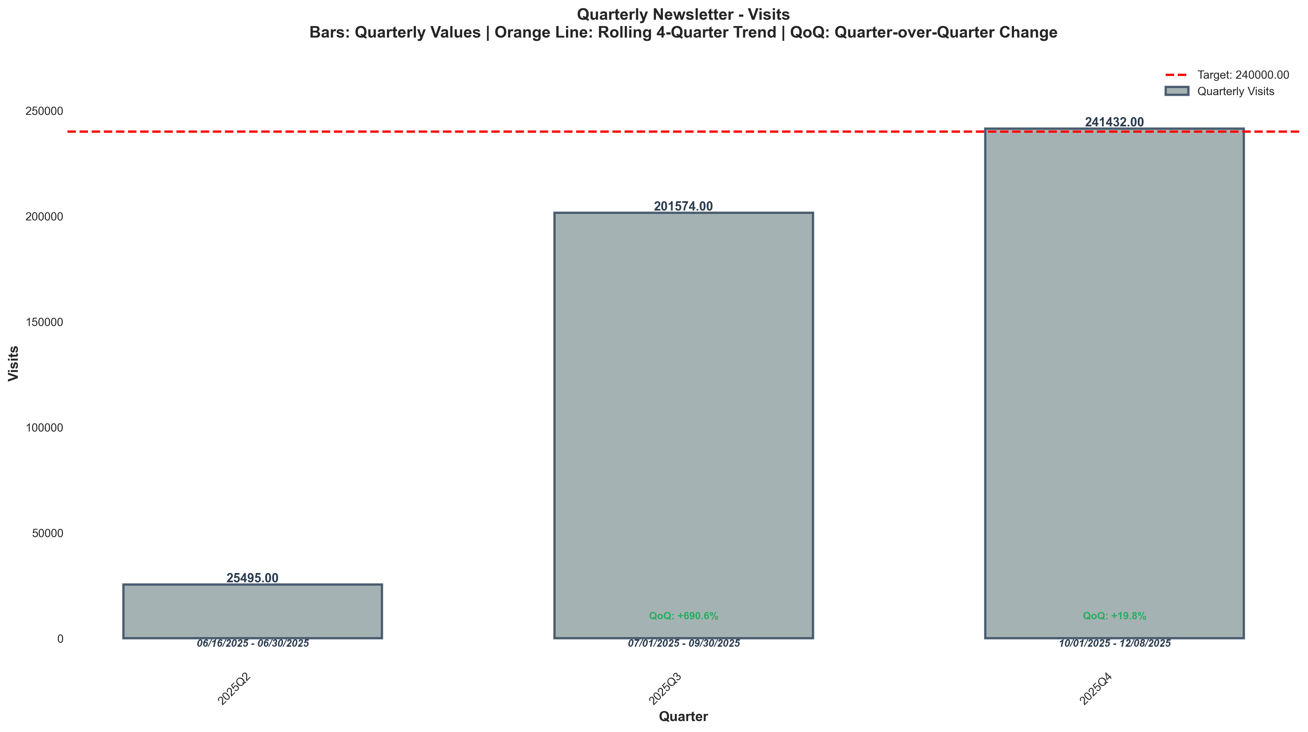
Chart: visualizations/newsletter_quarterly/quarterly_visits.png
Source: outputs/newsletter/quarterly_newsletter.csv
Insights:
• Current quarter: 241,432 vs 201,574 last quarter (+39,858, +19.8% QoQ) (favorable)
• Performance is 54.6% above the 3-quarter average (avg = 156,167) → High CV vs 3Q Avg
• Goal met: Yes (target = 240,000; actual = 241,432; +0.6% above goal)
Newsletter Visit Duration
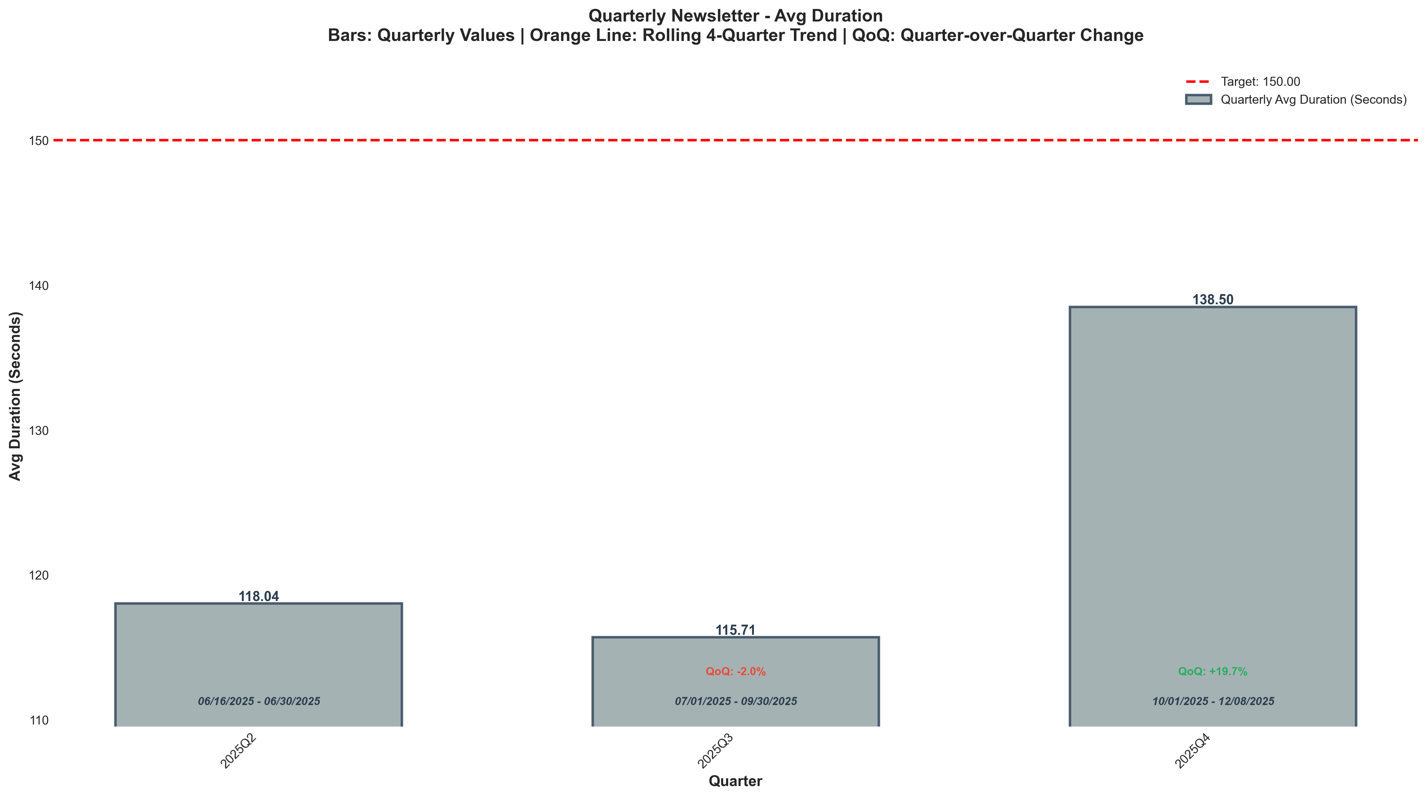
Chart: visualizations/newsletter_quarterly/quarterly_avg_duration.png
Source: outputs/newsletter/quarterly_newsletter.csv
Insights:
• Current quarter: 138 vs 116 last quarter (+22.79, +19.7% QoQ) (favorable)
• Performance is 11.6% above the 3-quarter average (avg = 124) → High CV vs 3Q Avg
• Goal missed: (target = 150; actual = 138; 7.7% below goal)
Newsletter Bounce Rate
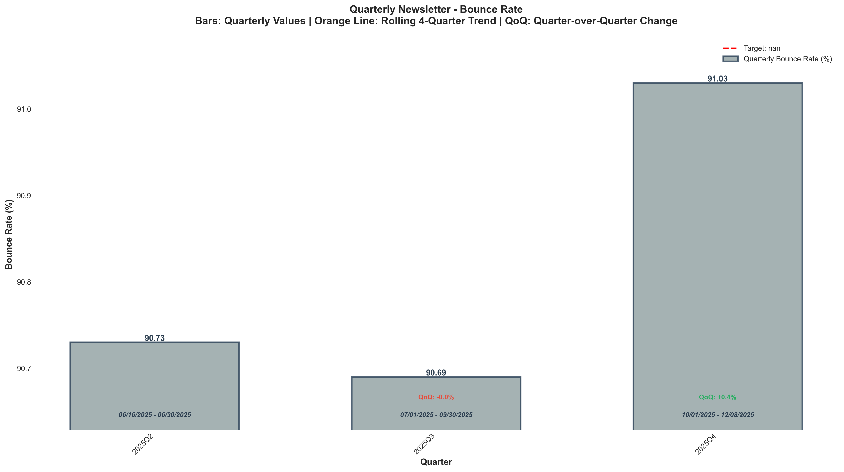
Chart: visualizations/newsletter_quarterly/quarterly_bounce_rate.png
Source: outputs/newsletter/quarterly_newsletter.csv
Insights:
• Current quarter: 91.03% vs 90.69% last quarter (+0.34%, +0.4% QoQ) (unfavorable)
• Performance is 0.2% above the 3-quarter average (avg = 90.82%) → Normal (Near Avg)
Newsletter CVR %
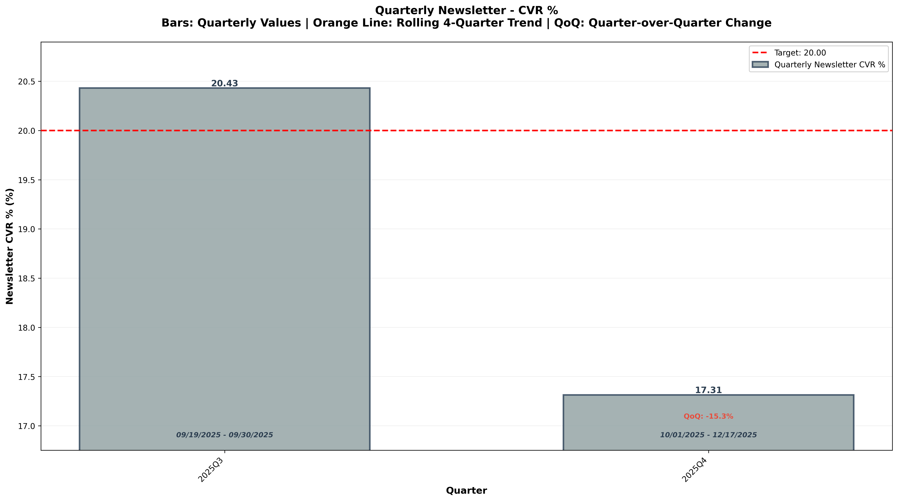
Chart: visualizations/general_newsletter_quarterly/quarterly_newsletter_cvr.png
Source: outputs/general_newsletter/quarterly_table.csv
Insights:
• Current quarter: 17.31% vs 20.43% last quarter (3.12%, -15.3% QoQ) (unfavorable)
• Performance is 8.3% below the 2-quarter average (avg = 18.87%) → Low CV vs 2Q Avg
• Goal missed: (target = 20.00%; actual = 17.31%; 13.4% below goal)

Engagement Metrics
Blended Open Rate
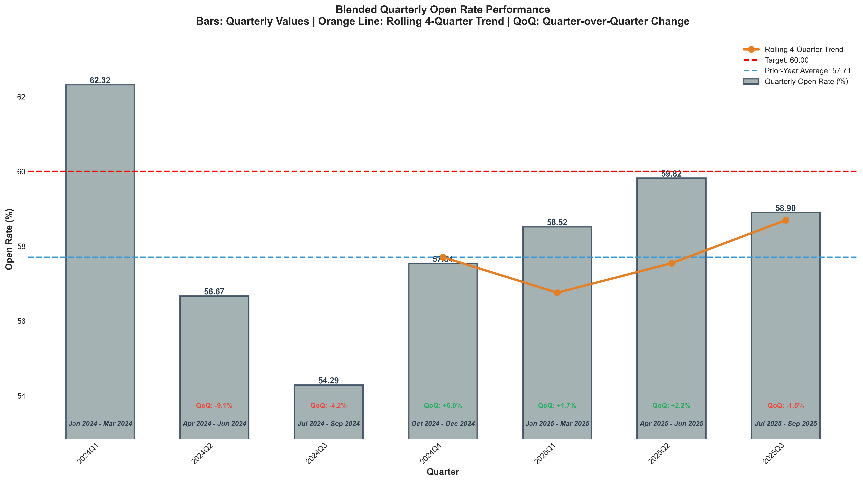
Chart: visualizations/newsletter_series_quarterly/blended_open_rate.png
Source: outputs/newsletter_series/09_blended_quarterly.csv
Insights:
• Current quarter: 58.90% vs 59.82% last quarter (0.92%, -1.5% QoQ) (unfavorable)
• Performance is 2.2% above the 6-quarter average (avg = 57.62%) → Normal (Near Avg)
• Goal missed: (target = 60.00%; actual = 58.90%; 1.8% below goal)
• Trend: 4Q: → Stable | 6Q: → Stable
Blended Verified Click-Through Rate
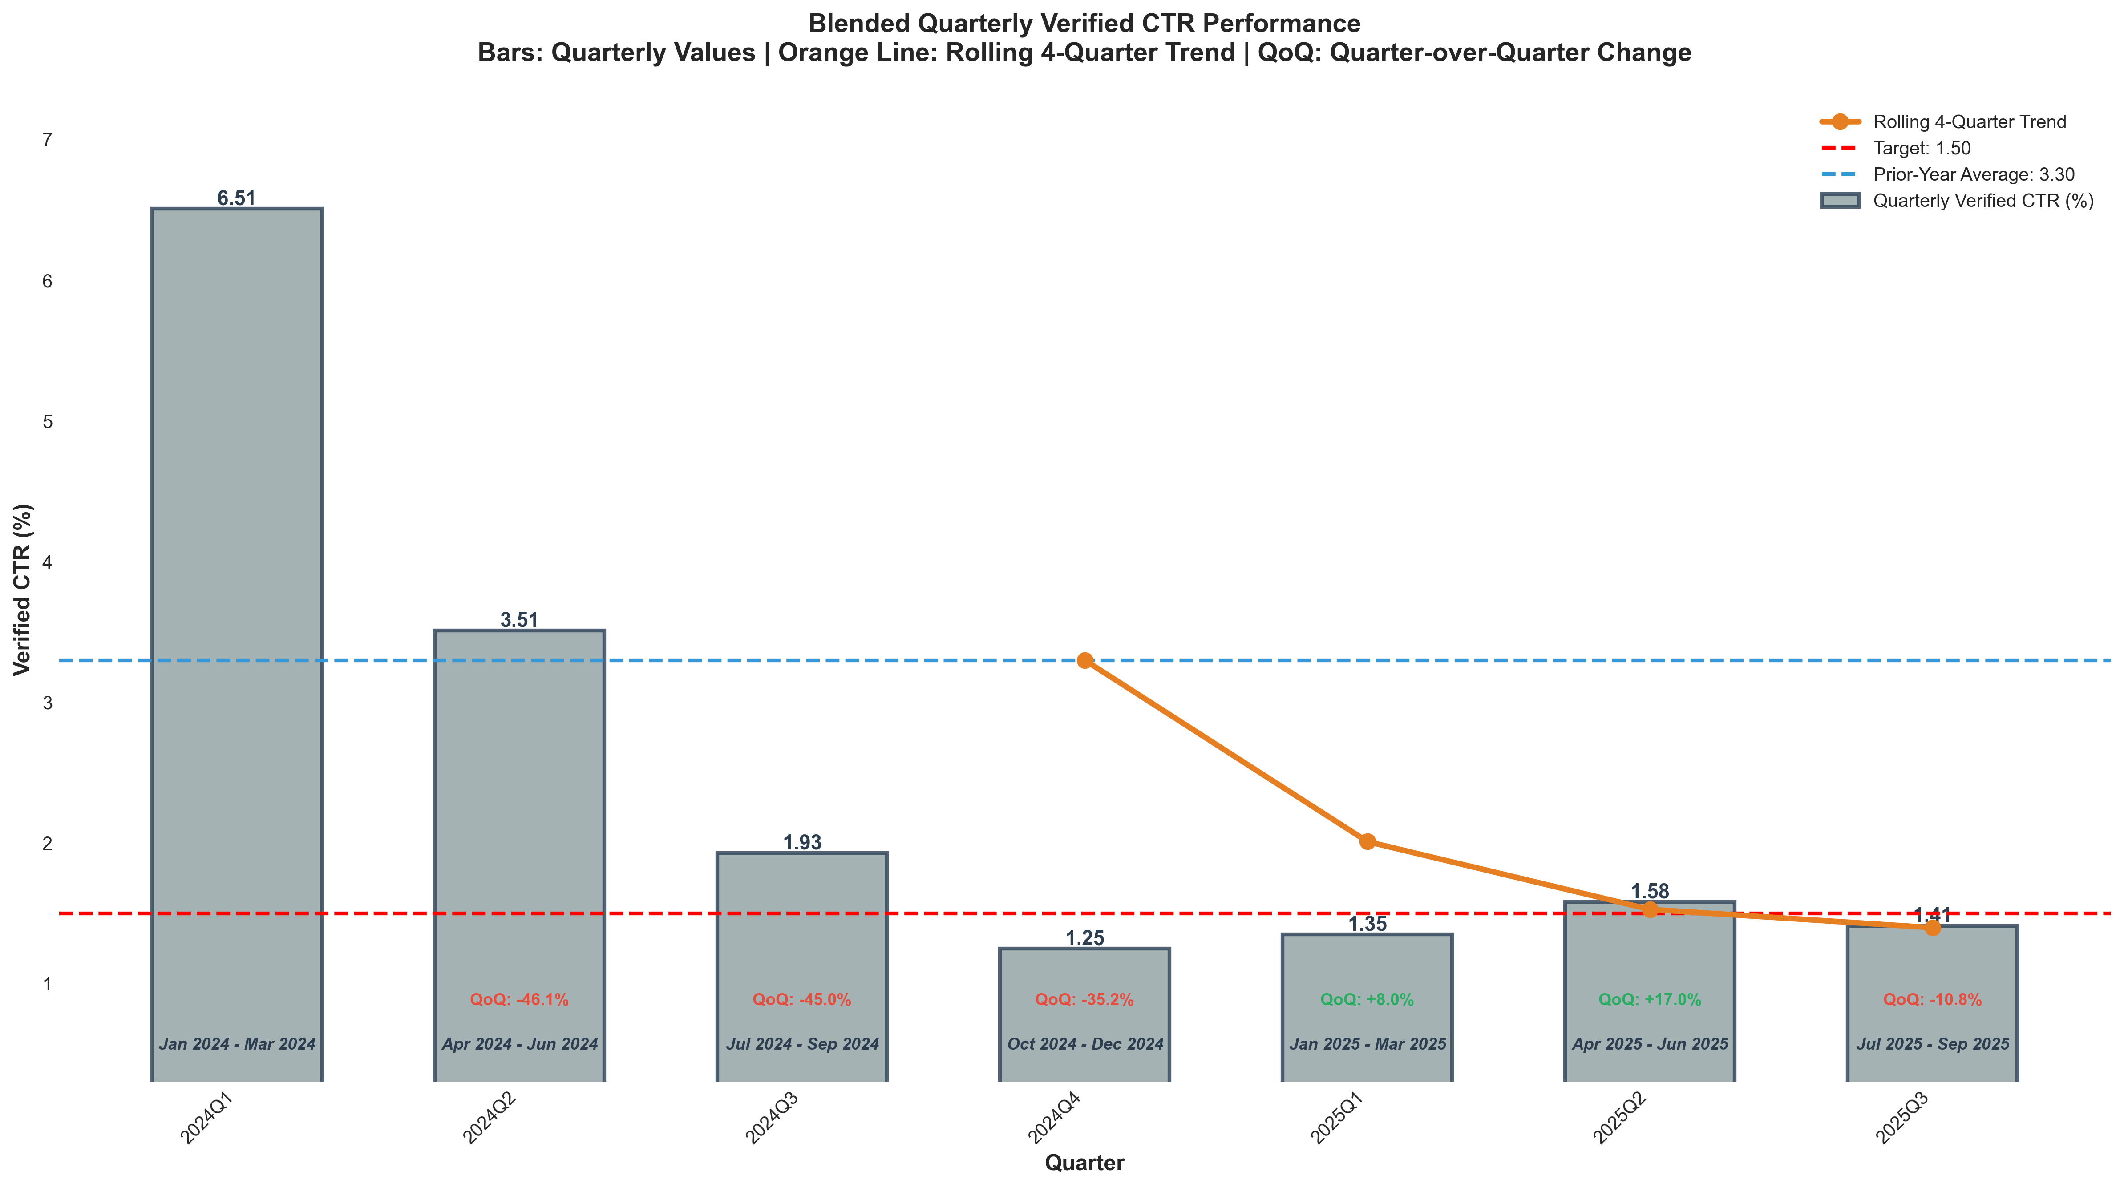
Chart: visualizations/newsletter_series_quarterly/blended_verified_ctr.png
Source: outputs/newsletter_series/09_blended_quarterly.csv
Insights:
• Current quarter: 1.41% vs 1.58% last quarter (0.17%, -10.8% QoQ) (unfavorable)
• Performance is 23.3% below the 6-quarter average (avg = 1.84%) → Low CV vs 6Q Avg
• Goal missed: (target = 1.50%; actual = 1.41%; 6.0% below goal)
• Trend: 4Q: ↑ Rising | 6Q: ↓ Falling
Blended Unsub Rate
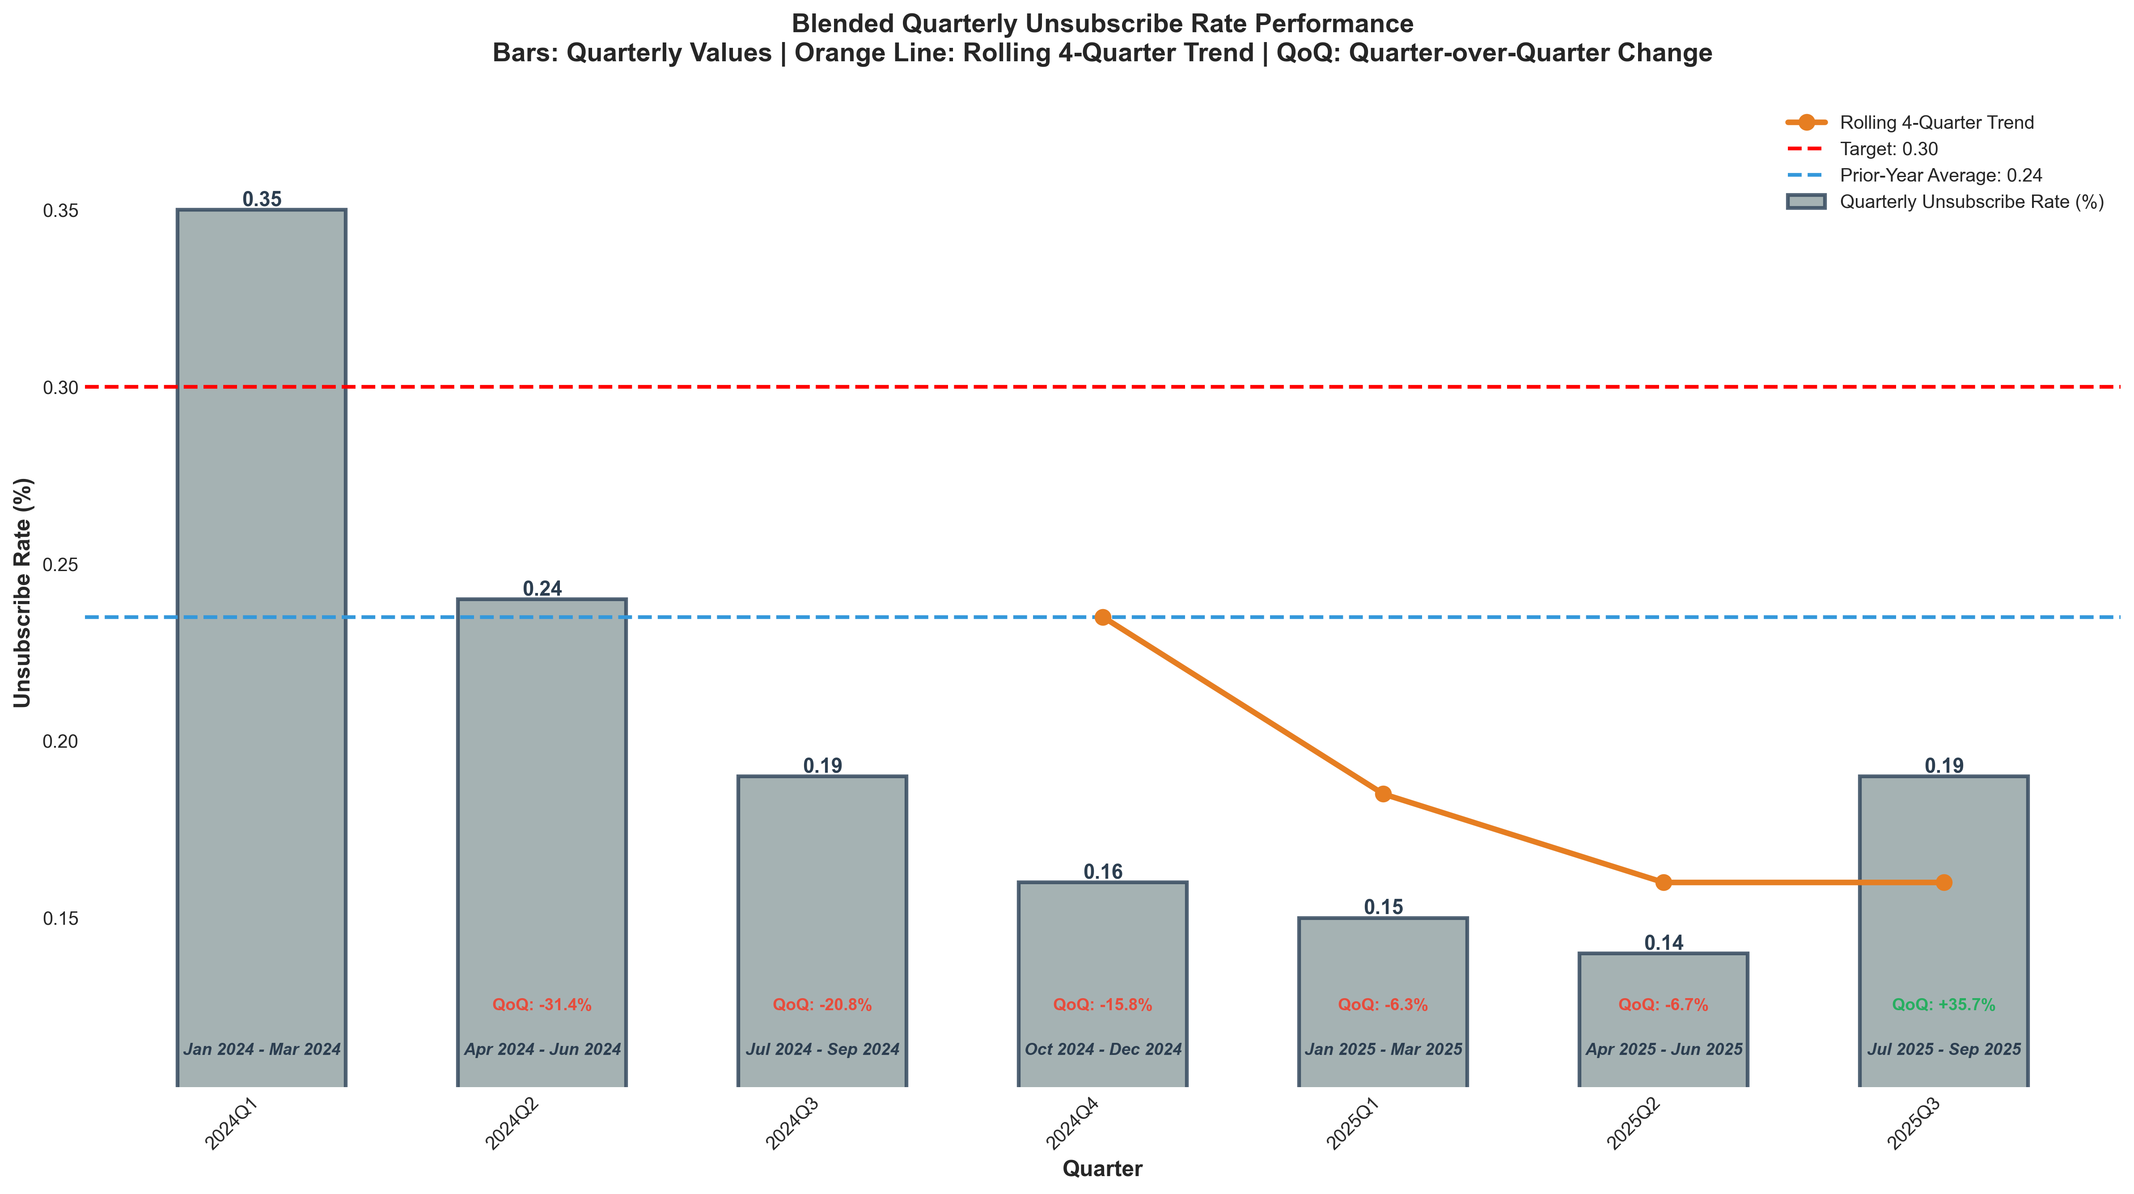
Chart: visualizations/newsletter_series_quarterly/blended_unsubscribe_rate.png
Source: outputs/newsletter_series/09_blended_quarterly.csv
Insights:
• Current quarter: 0.19% vs 0.14% last quarter (+0.05%, +35.7% QoQ) (unfavorable)
• Performance is 6.5% above the 6-quarter average (avg = 0.18%) → High CV vs 6Q Avg
• Goal met: Yes (target = 0.30%; actual = 0.19%; 36.7% below goal)
• Trend: 4Q: → Stable | 6Q: ↓ Falling

Growth & Churn
Growth Rate
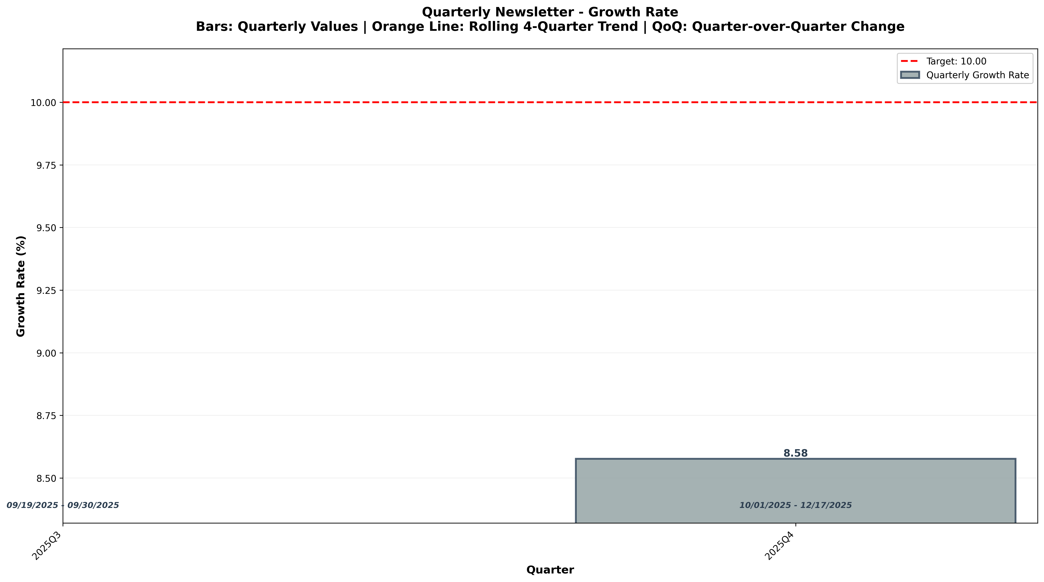
Chart: visualizations/general_newsletter_quarterly/quarterly_growth_rate.png
Source: outputs/general_newsletter/quarterly_table.csv
Insights:
⚠ Not enough data points (1)
New Subscribers
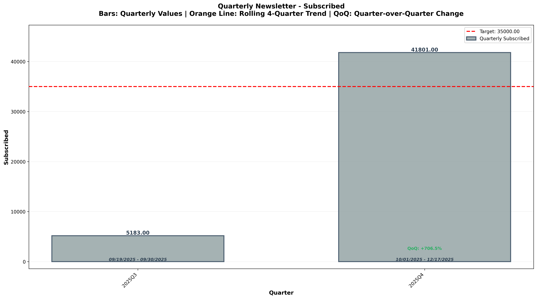
Chart: visualizations/general_newsletter_quarterly/quarterly_subscribed.png
Source: outputs/general_newsletter/quarterly_table.csv
Insights:
• Current quarter: 41,801 vs 5,183 last quarter (+36,618, +706.5% QoQ) (favorable)
• Performance is 77.9% above the 2-quarter average (avg = 23,492) → High CV vs 2Q Avg
• Goal met: Yes (target = 35,000; actual = 41,801; +19.4% above goal)
Unsubscribes
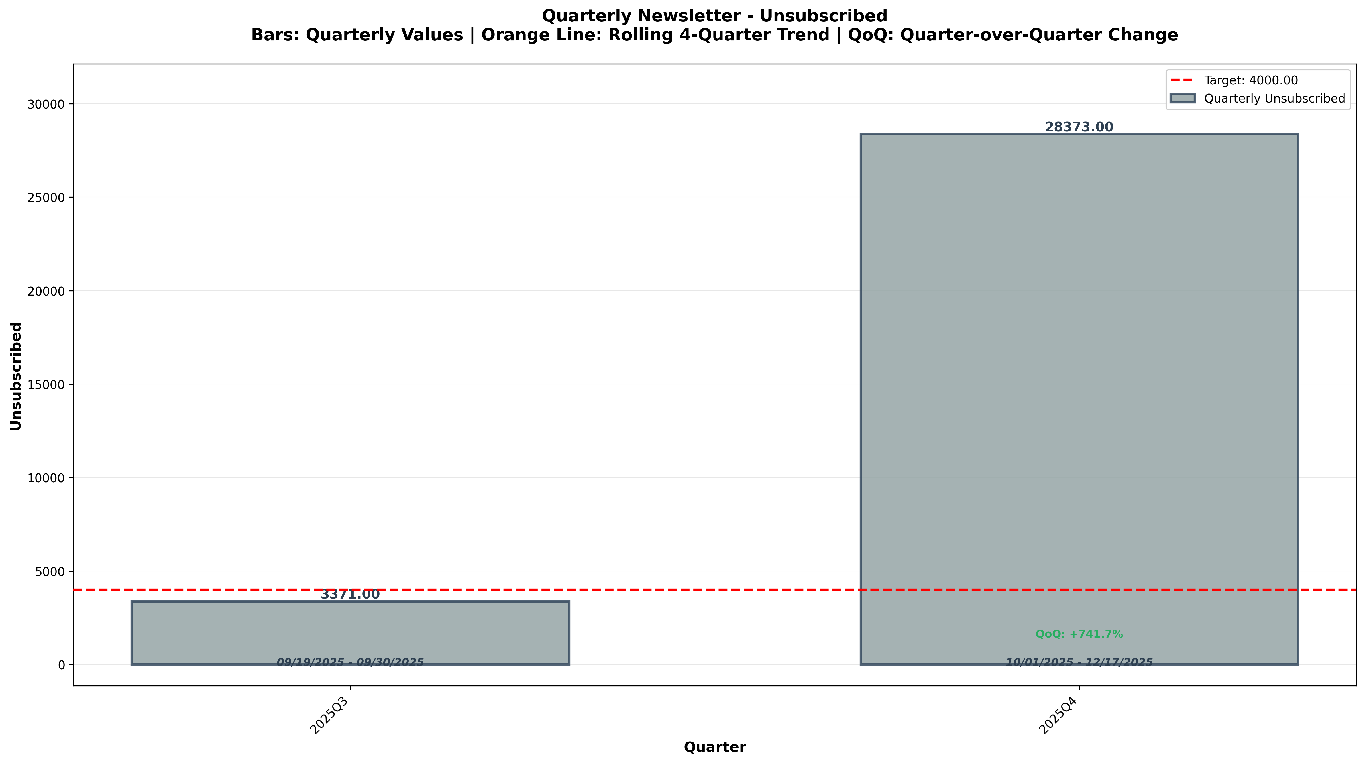
Chart: visualizations/general_newsletter_quarterly/quarterly_unsubscribed.png
Source: outputs/general_newsletter/quarterly_table.csv
Insights:
• Current quarter: 28,373 vs 3,371 last quarter (+25,002, +741.7% QoQ) (unfavorable)
• Performance is 78.8% above the 2-quarter average (avg = 15,872) → High CV vs 2Q Avg
• Goal missed: (target = 4,000; actual = 28,373; +609.3% above goal)
Leak Rate
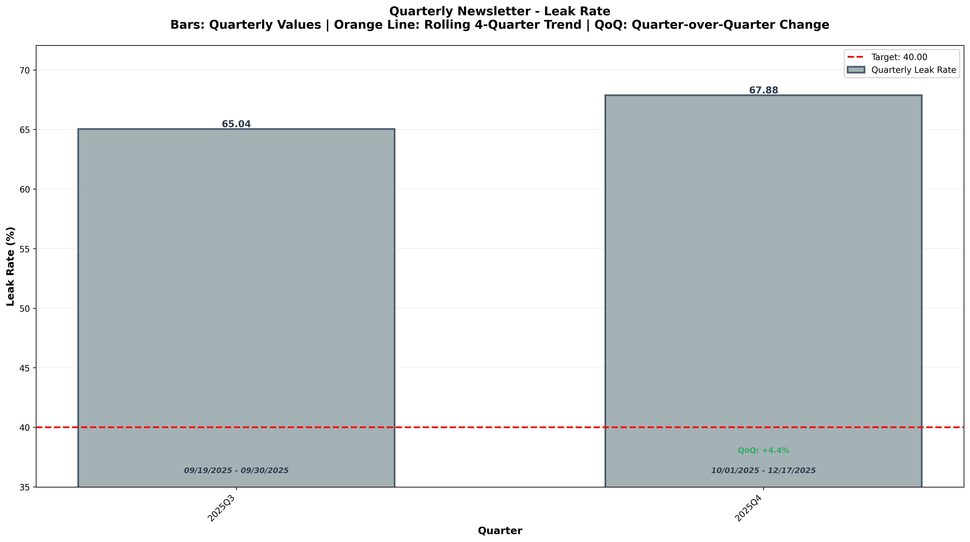
Chart: visualizations/general_newsletter_quarterly/quarterly_leak_rate.png
Source: outputs/general_newsletter/quarterly_table.csv
Insights:
• Current quarter: 67.88% vs 65.04% last quarter (+2.84%, +4.4% QoQ) (unfavorable)
• Performance is 2.1% above the 2-quarter average (avg = 66.46%) → Normal (Near Avg)
• Goal missed: (target = 40.00%; actual = 67.88%; +69.7% above goal)

Section 2: Sales Metrics

Lead Time & Deal Upgrade
Average Lead Time
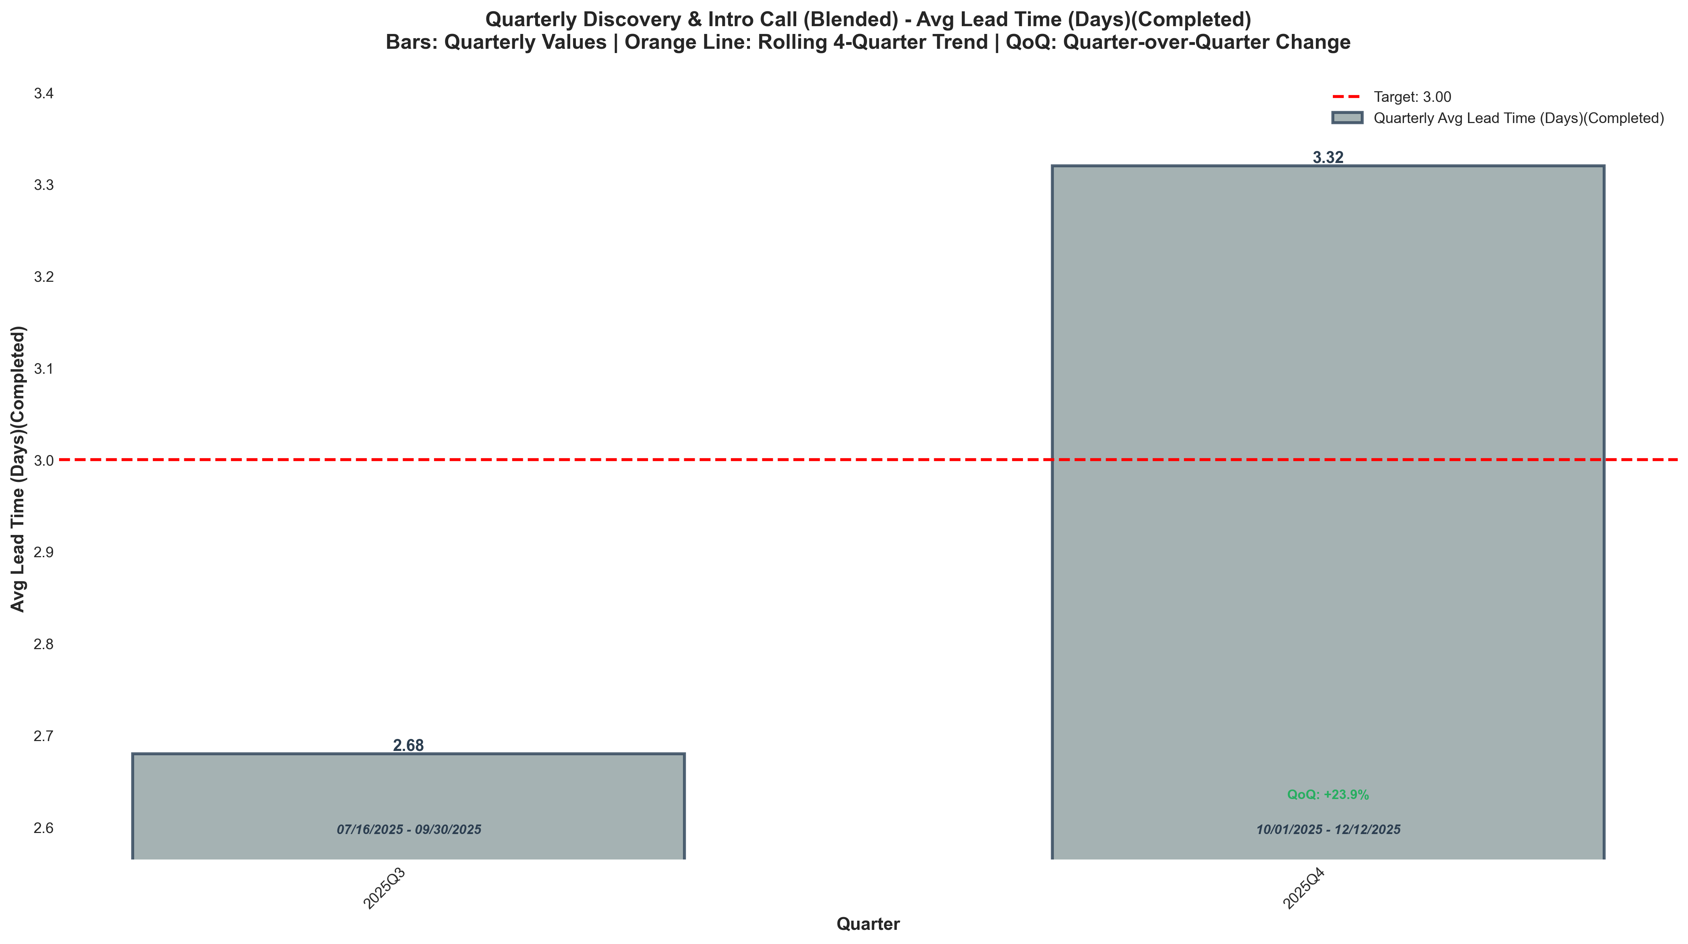
Chart: visualizations/discovery_intro_blended_quarterly/quarterly_avg_lead_time_completed.png
Source: outputs/discovery_intro/quarterly_discovery_intro_blended.csv
Insights:
• Current quarter: 3.32 vs 2.68 last quarter (+0.64, +23.9% QoQ) (unfavorable)
• Performance is 10.7% above the 2-quarter average (avg = 3.00) → High CV vs 2Q Avg
• Goal missed: (target = 3.00; actual = 3.32; +10.7% above goal)
Deal Upgrade Visits
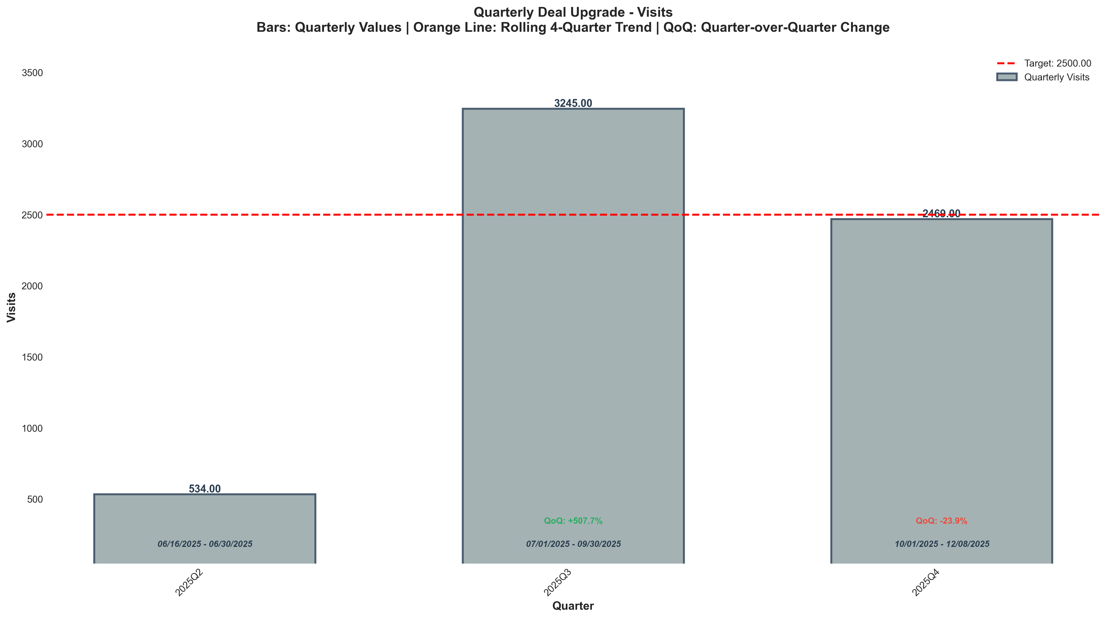
Chart: visualizations/deal_upgrade_quarterly/quarterly_visits.png
Source: outputs/deal_upgrade/quarterly_deal_upgrade.csv
Insights:
• Current quarter: 2,469 vs 3,245 last quarter (776, -23.9% QoQ) (unfavorable)
• Performance is 18.5% above the 3-quarter average (avg = 2,083) → High CV vs 3Q Avg
• Goal missed: (target = 2,500; actual = 2,469; 1.2% below goal)
Deal Upgrade CVR
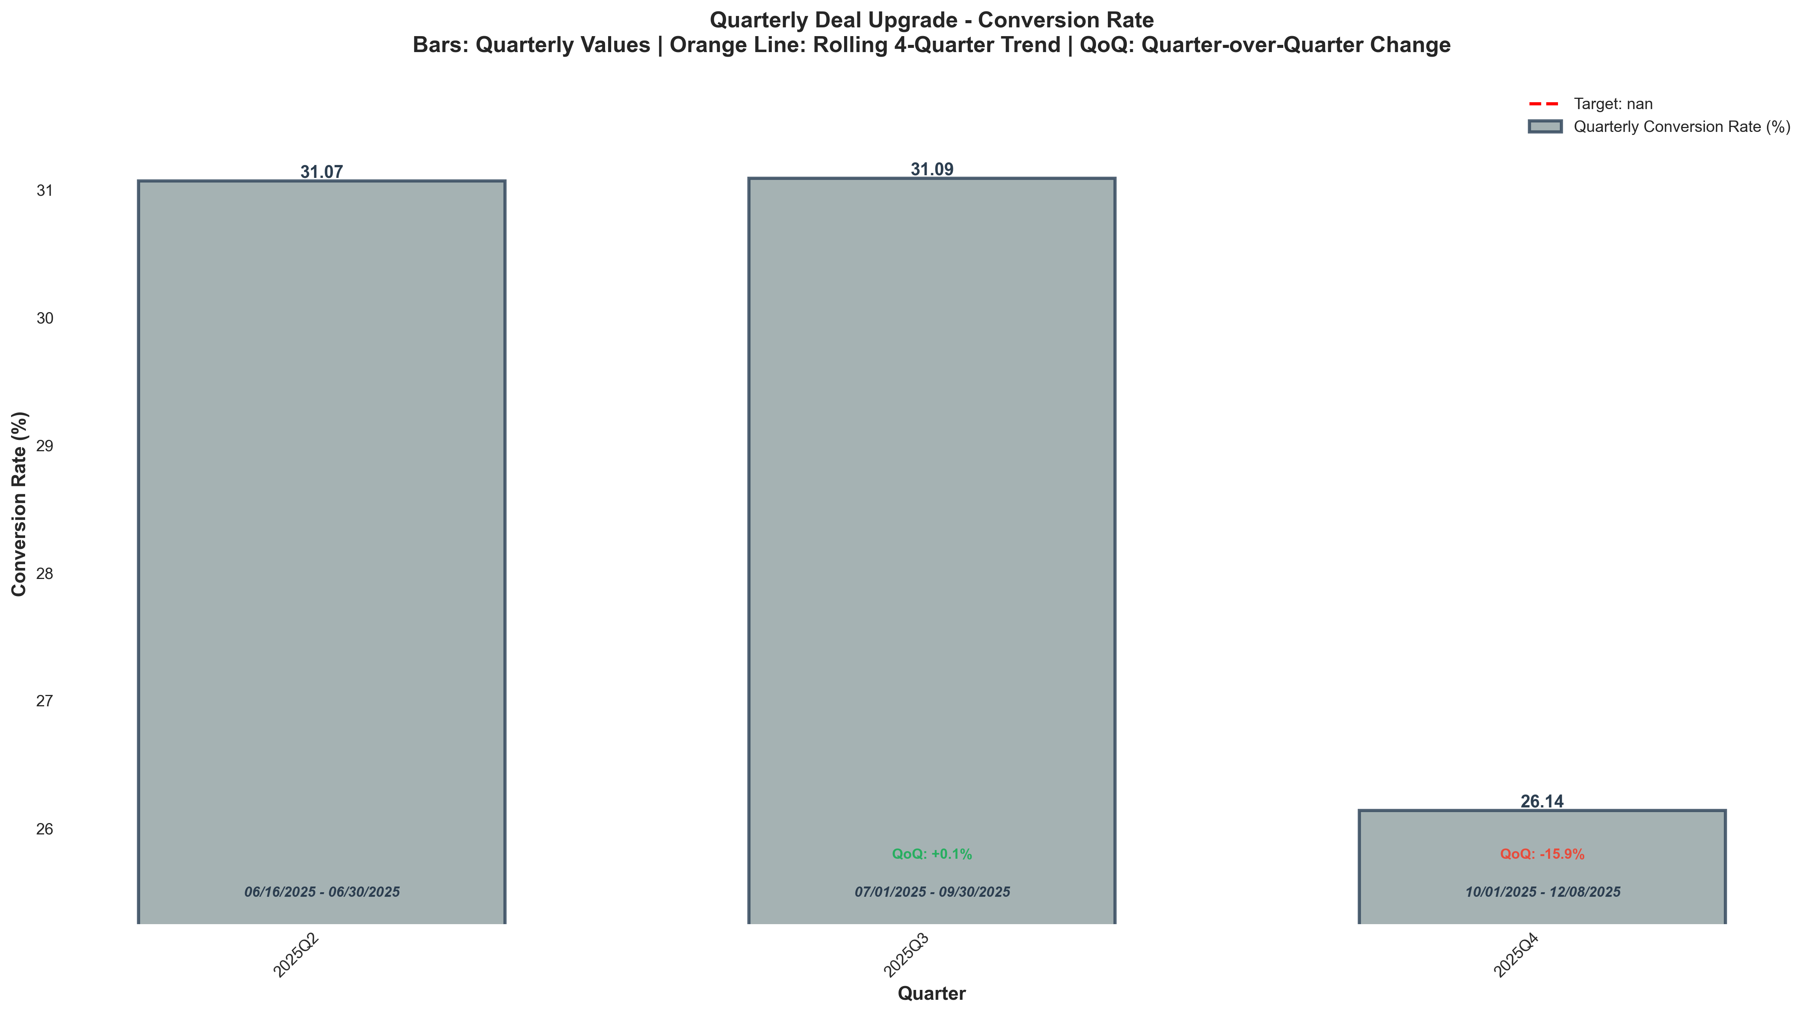
Chart: visualizations/deal_upgrade_quarterly/quarterly_conversion_rate.png
Source: outputs/deal_upgrade/quarterly_deal_upgrade.csv
Insights:
• Current quarter: 26.14% vs 31.09% last quarter (4.95%, -15.9% QoQ) (unfavorable)
• Performance is 11.2% below the 3-quarter average (avg = 29.43%) → Low CV vs 3Q Avg

Pro Site Funnel
Pro Site Visits
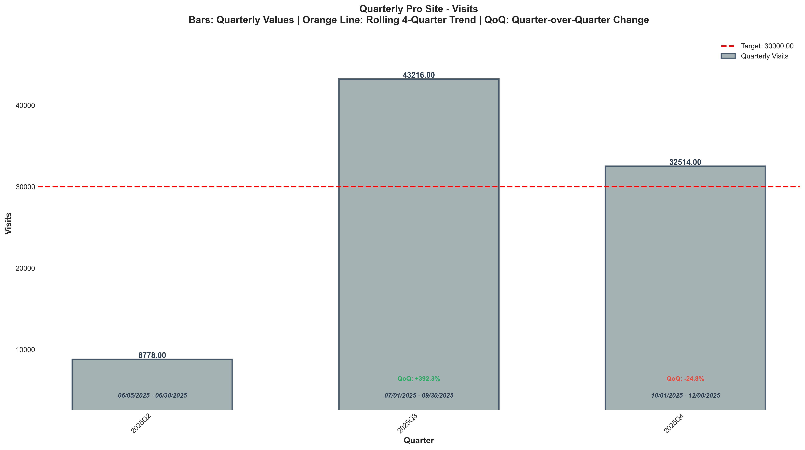
Chart: visualizations/pro_site_quarterly/quarterly_visits.png
Source: outputs/pro_site/quarterly_pro_site.csv
Insights:
• Current quarter: 32,514 vs 43,216 last quarter (10,702, -24.8% QoQ) (unfavorable)
• Performance is 15.4% above the 3-quarter average (avg = 28,169) → High CV vs 3Q Avg
• Goal met: Yes (target = 30,000; actual = 32,514; +8.4% above goal)
Pro Site CVR
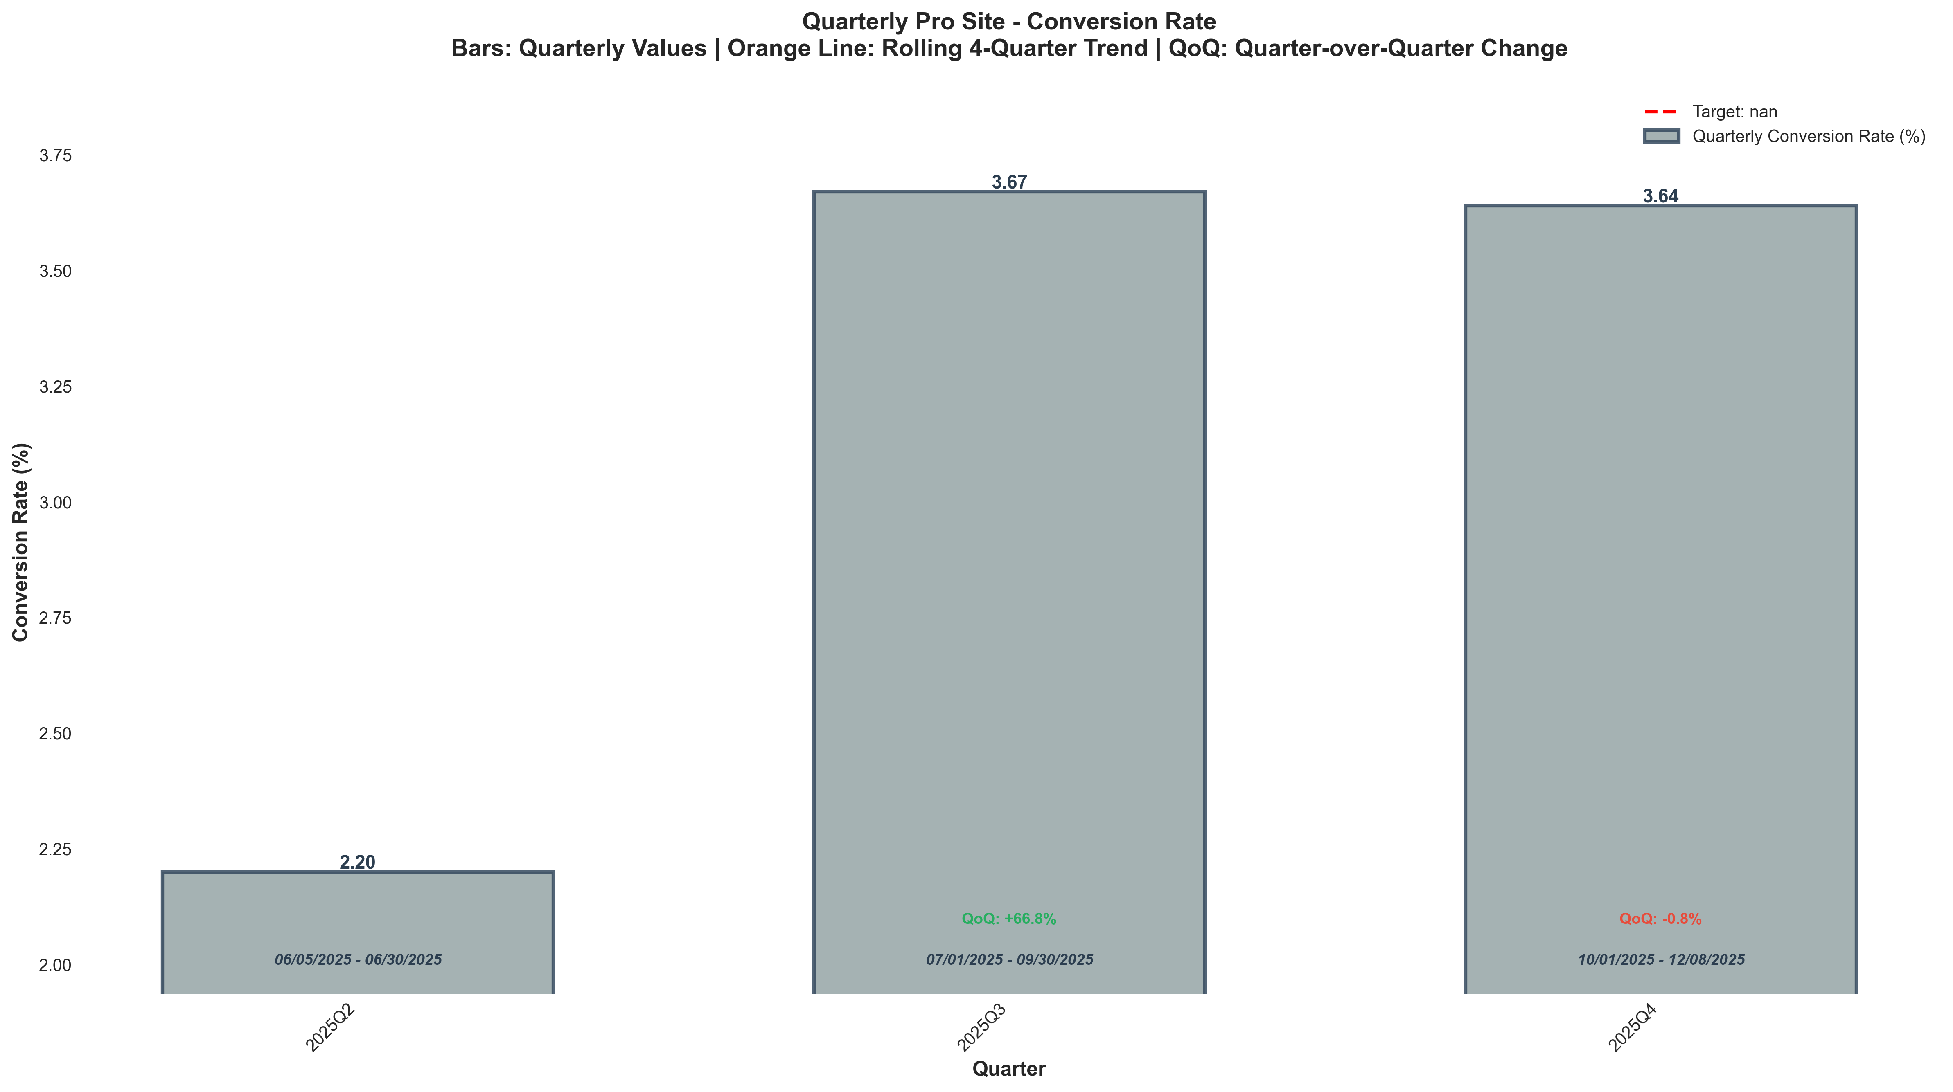
Chart: visualizations/pro_site_quarterly/quarterly_conversion_rate.png
Source: outputs/pro_site/quarterly_pro_site.csv
Insights:
• Current quarter: 3.64% vs 3.67% last quarter (0.03%, -0.8% QoQ) (unfavorable)
• Performance is 14.8% above the 3-quarter average (avg = 3.17%) → High CV vs 3Q Avg

Booked Calls
Booked Calls - Closers (Discovery Call)
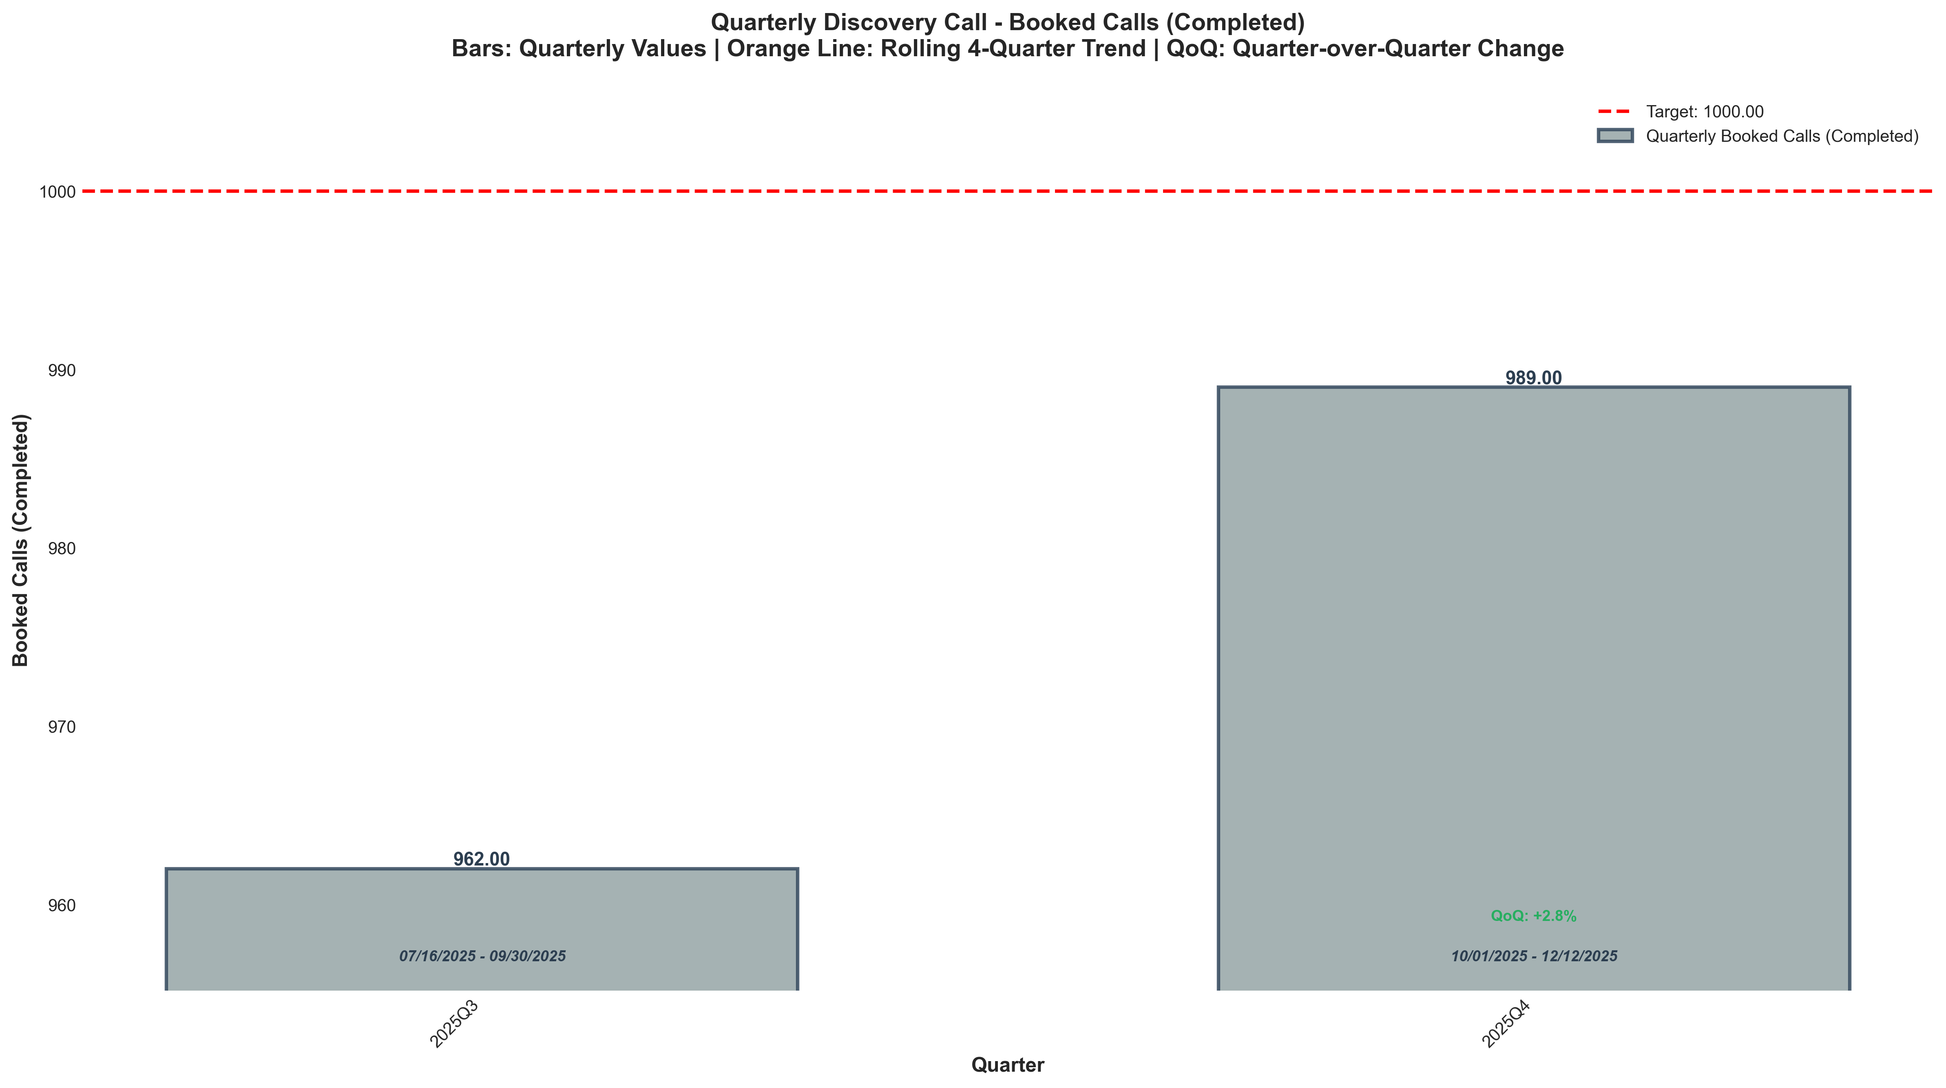
Chart: visualizations/discovery_call_quarterly/quarterly_booked_calls_completed.png
Source: outputs/discovery_intro/quarterly_discovery_call.csv
Insights:
• Current quarter: 989 vs 962 last quarter (+27.00, +2.8% QoQ) (favorable)
• Performance is 1.4% above the 2-quarter average (avg = 976) → Normal (Near Avg)
• Goal missed: (target = 1,000; actual = 989; 1.1% below goal)
Booked Calls - Setters (Intro Call)
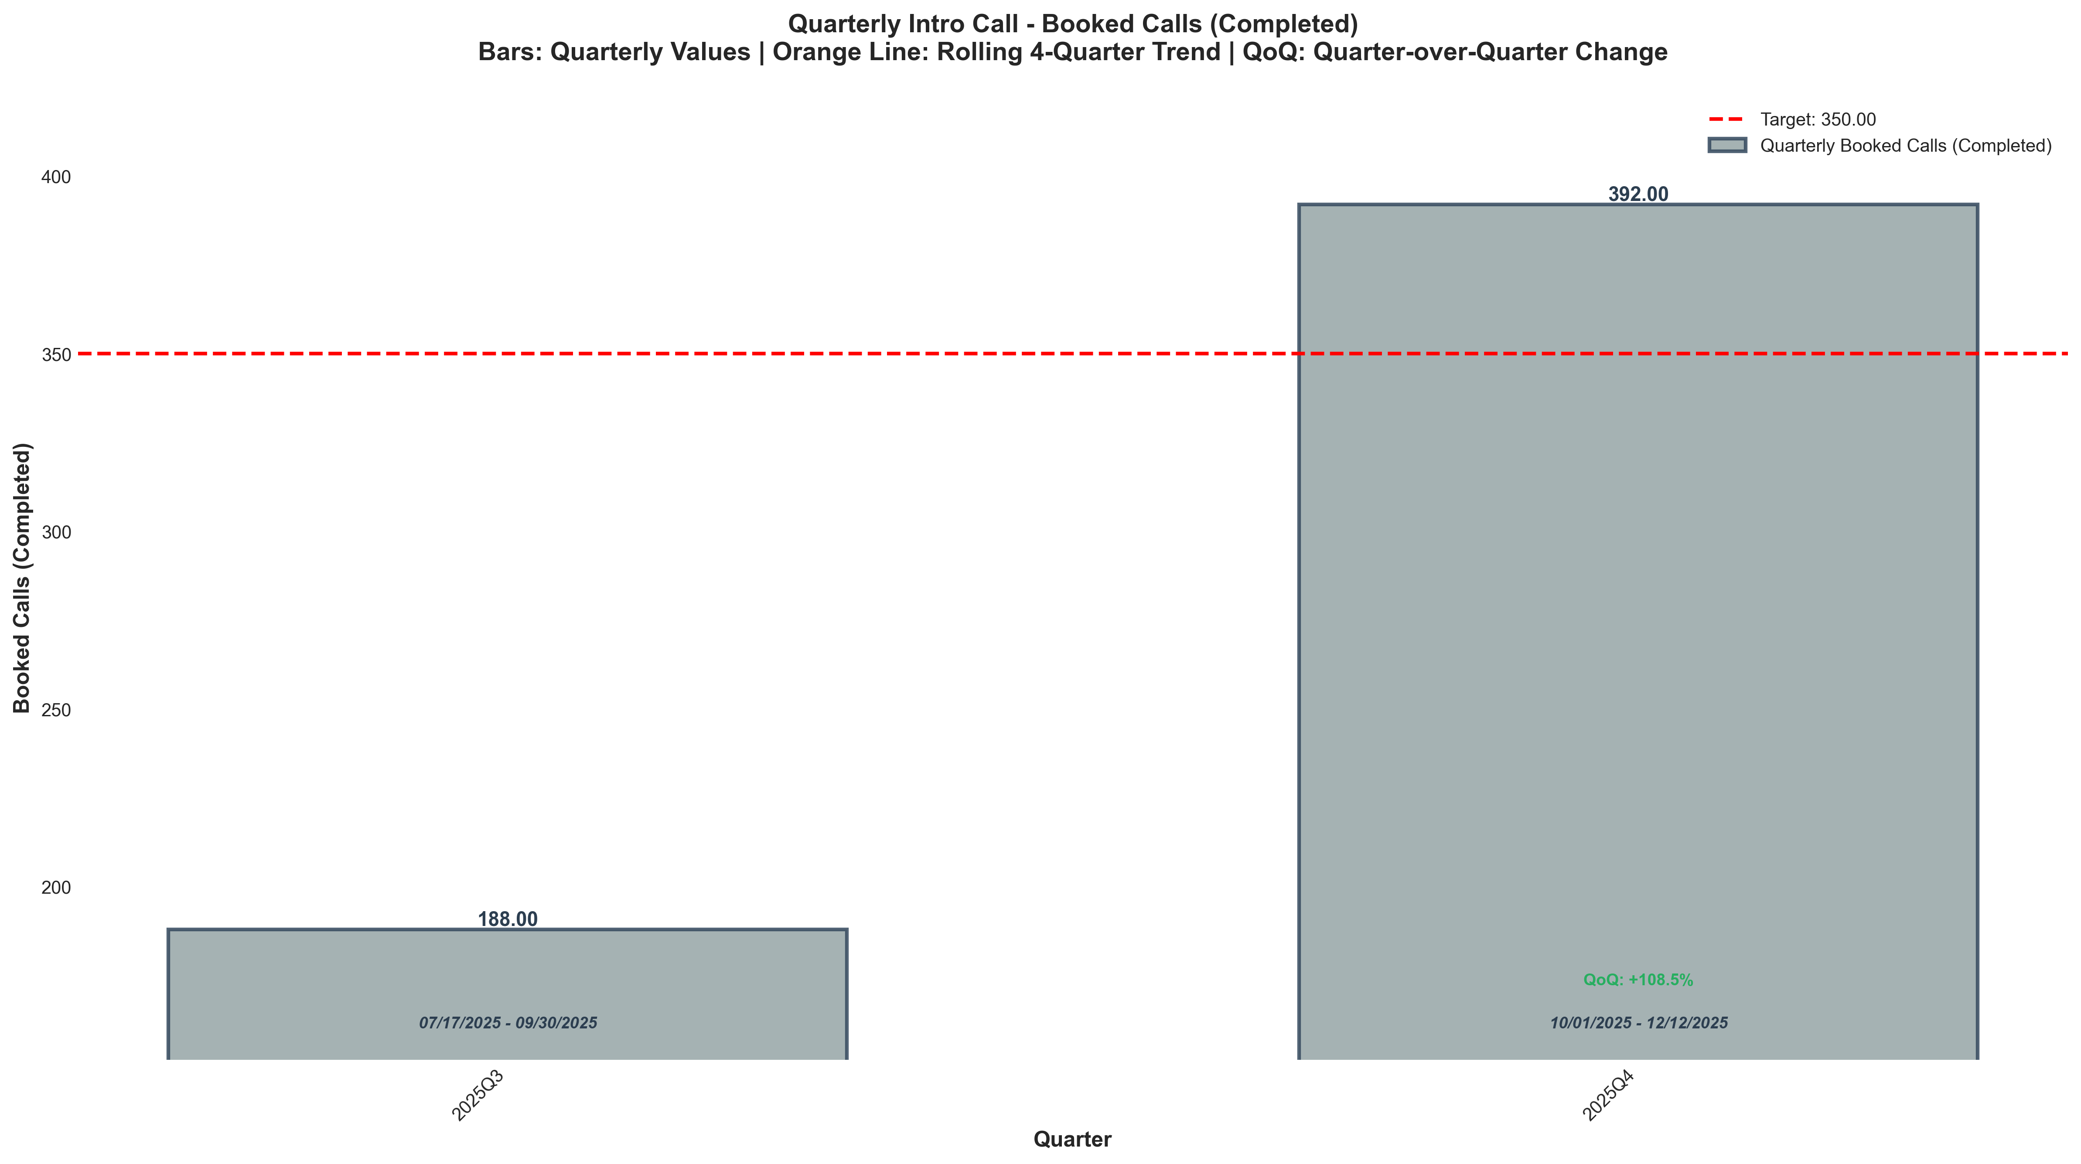
Chart: visualizations/intro_call_quarterly/quarterly_booked_calls_completed.png
Source: outputs/discovery_intro/quarterly_intro_call.csv
Insights:
• Current quarter: 392 vs 188 last quarter (+204, +108.5% QoQ) (favorable)
• Performance is 35.2% above the 2-quarter average (avg = 290) → High CV vs 2Q Avg
• Goal met: Yes (target = 350; actual = 392; +12.0% above goal)

Sales Pipeline: Calls
Scheduled Calls
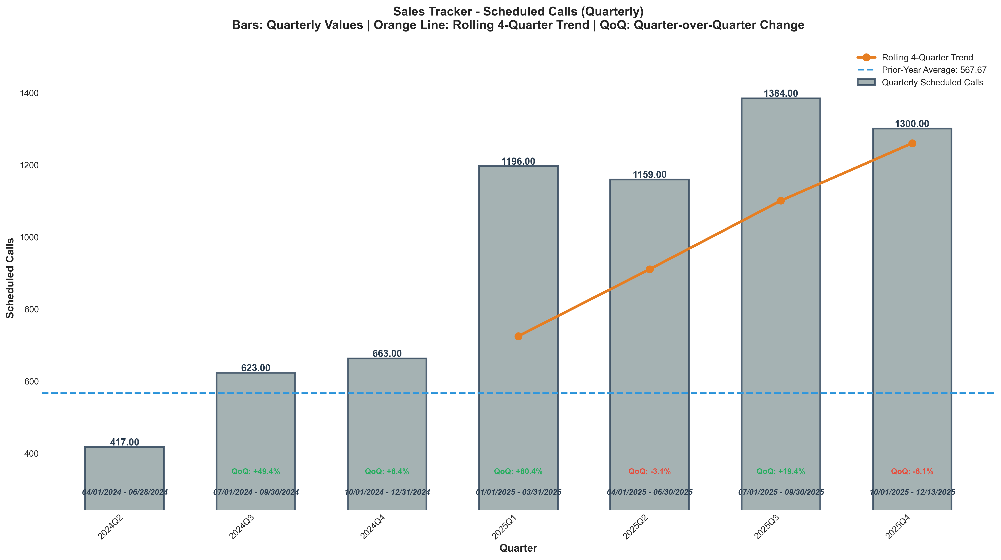
Chart: visualizations/sales_tracker_quarterly/quarterly_sched_calls.png
Source: outputs/sales_tracker/quarterly_sales_tracker.csv
Insights:
• Current quarter: 1,300 vs 1,384 last quarter (84.00, -6.1% QoQ) (unfavorable)
• Performance is 23.3% above the 6-quarter average (avg = 1,054) → High CV vs 6Q Avg
• Trend: 4Q: ↑ Rising | 6Q: ↑ Rising
Live Calls
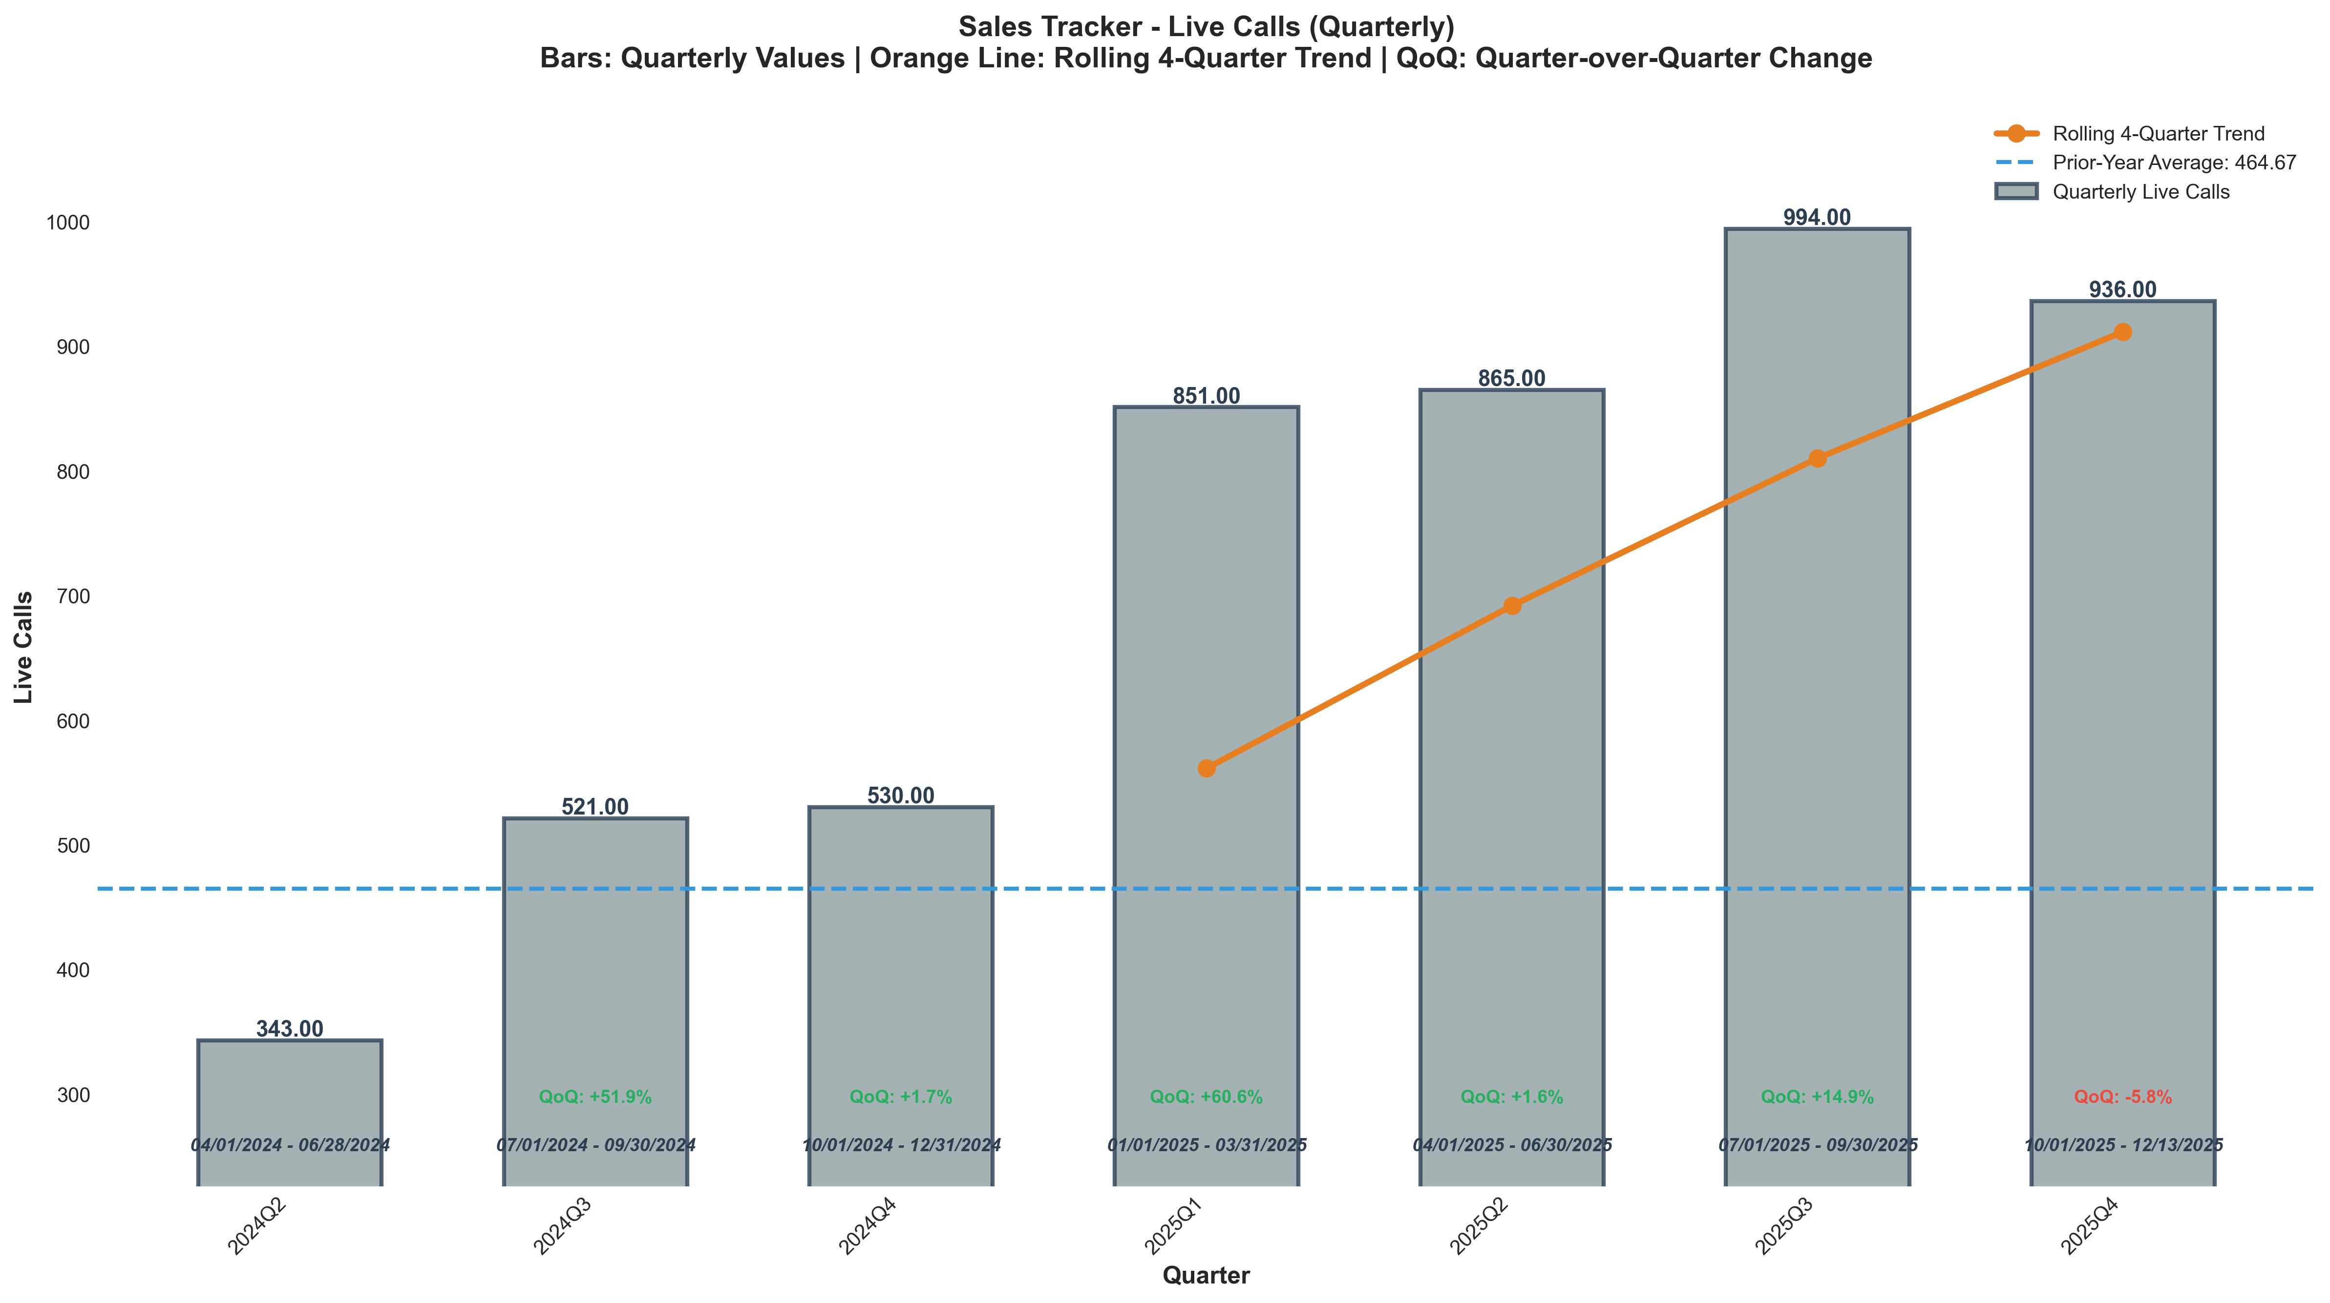
Chart: visualizations/sales_tracker_quarterly/quarterly_live_calls.png
Source: outputs/sales_tracker/quarterly_sales_tracker.csv
Insights:
• Current quarter: 936 vs 994 last quarter (58.00, -5.8% QoQ) (unfavorable)
• Performance is 19.6% above the 6-quarter average (avg = 783) → High CV vs 6Q Avg
• Trend: 4Q: ↑ Rising | 6Q: ↑ Rising
Show Rate
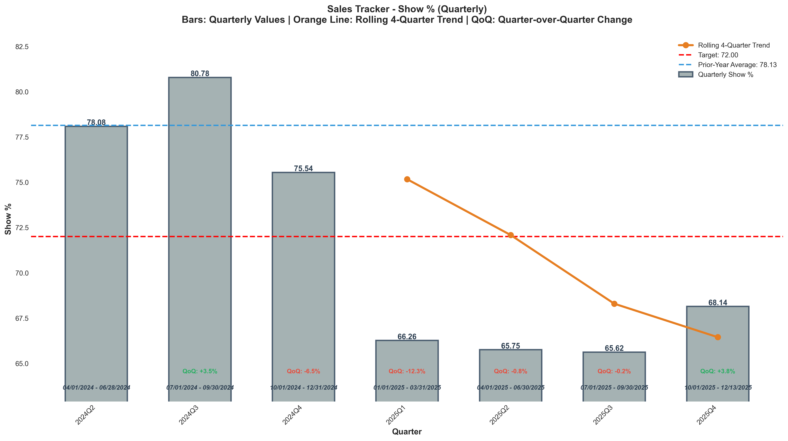
Chart: visualizations/sales_tracker_quarterly/quarterly_show_pct.png
Source: outputs/sales_tracker/quarterly_sales_tracker.csv
Insights:
• Current quarter: 68.14% vs 65.62% last quarter (+2.52%, +3.8% QoQ) (favorable)
• Performance is 3.1% below the 6-quarter average (avg = 70.35%) → Normal (Near Avg)
• Goal missed: (target = 72.00%; actual = 68.14%; 5.4% below goal)
• Trend: 4Q: → Stable | 6Q: ↓ Falling

Offers
Offers
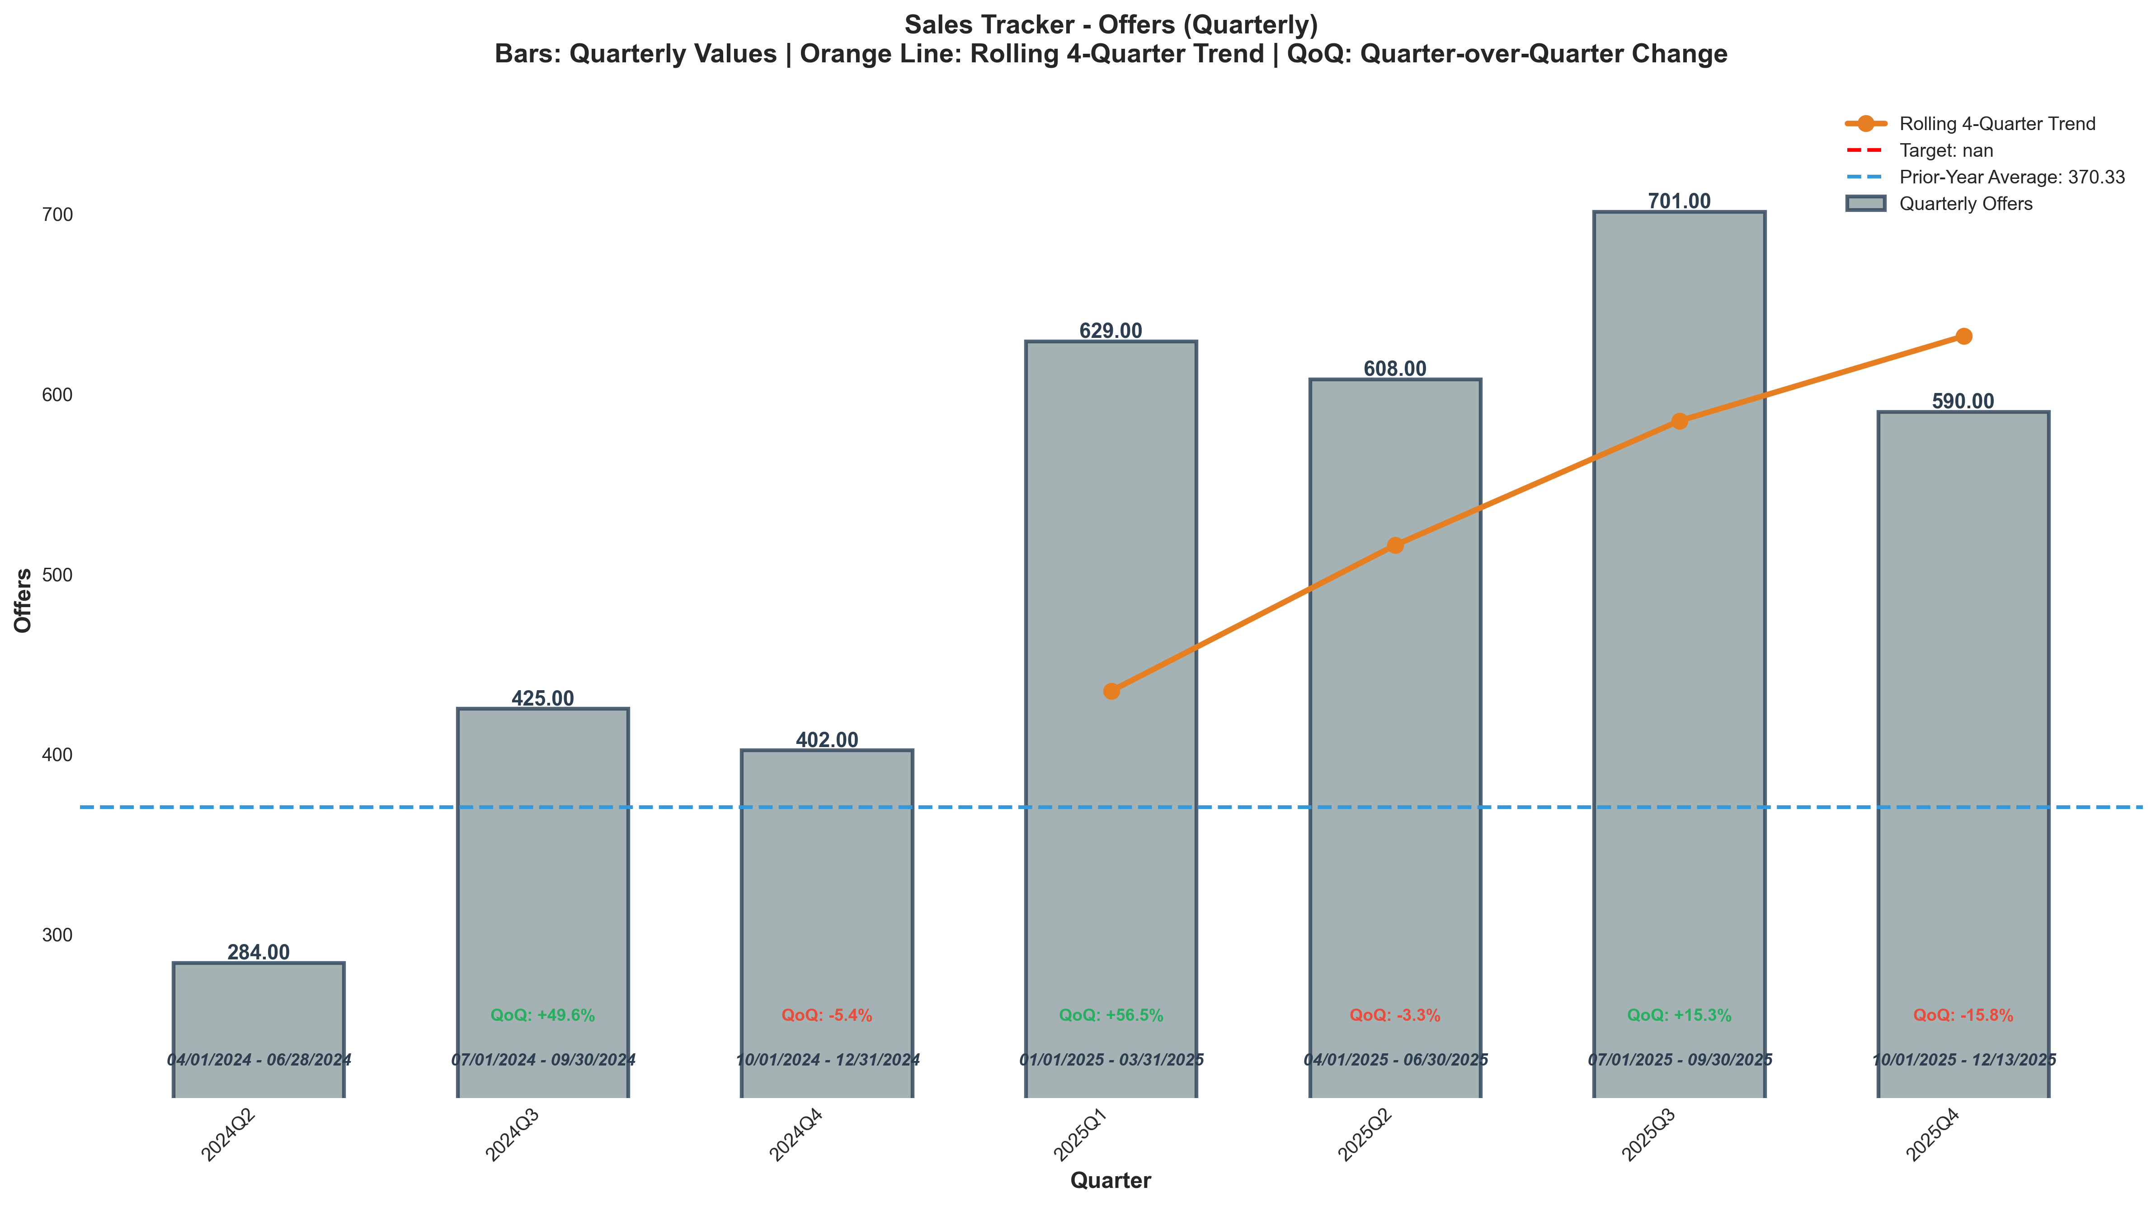
Chart: visualizations/sales_tracker_quarterly/quarterly_offers.png
Source: outputs/sales_tracker/quarterly_sales_tracker.csv
Insights:
• Current quarter: 590 vs 701 last quarter (111, -15.8% QoQ) (unfavorable)
• Performance is 5.5% above the 6-quarter average (avg = 559) → High CV vs 6Q Avg
• Trend: 4Q: → Stable | 6Q: ↑ Rising
Offer Rate
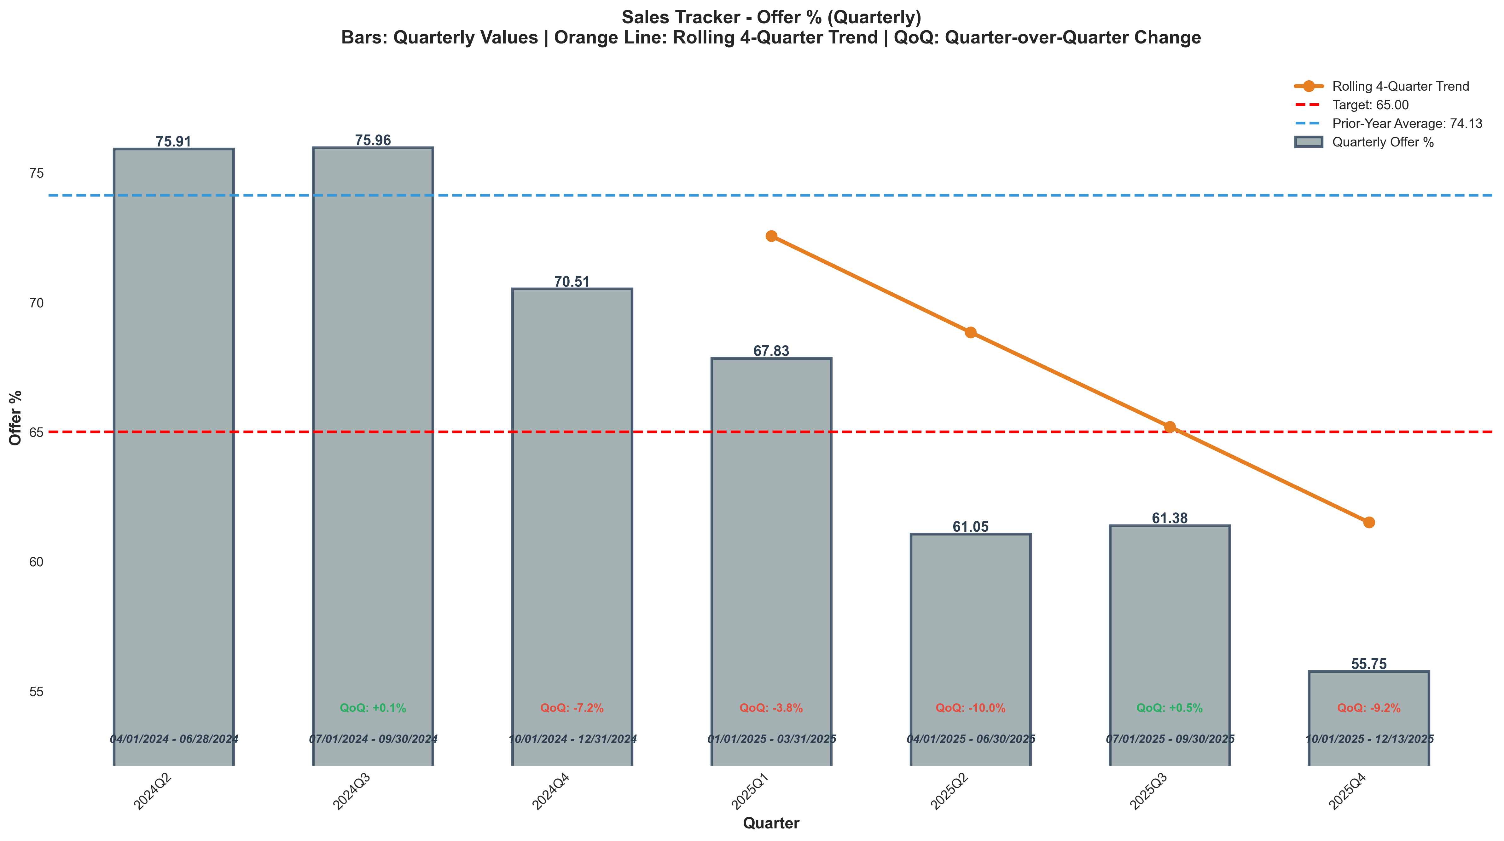
Chart: visualizations/sales_tracker_quarterly/quarterly_offer_pct.png
Source: outputs/sales_tracker/quarterly_sales_tracker.csv
Insights:
• Current quarter: 55.75% vs 61.38% last quarter (5.63%, -9.2% QoQ) (unfavorable)
• Performance is 14.8% below the 6-quarter average (avg = 65.41%) → Low CV vs 6Q Avg
• Goal missed: (target = 65.00%; actual = 55.75%; 14.2% below goal)
• Trend: 4Q: ↓ Falling | 6Q: ↓ Falling

Closes
Closes
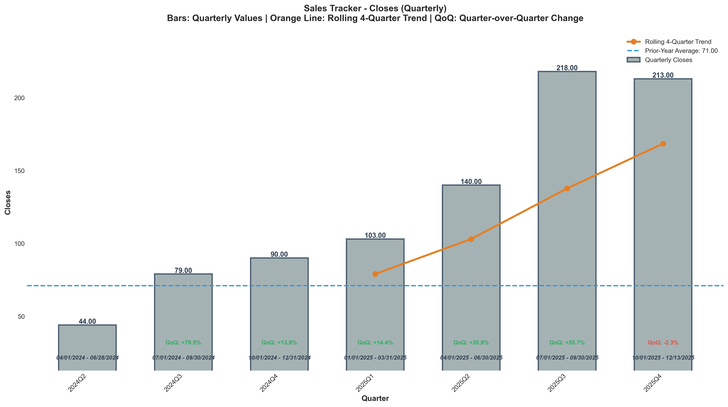
Chart: visualizations/sales_tracker_quarterly/quarterly_close_1.png
Source: outputs/sales_tracker/quarterly_sales_tracker.csv
Insights:
• Current quarter: 213 vs 218 last quarter (5.00, -2.3% QoQ) (unfavorable)
• Performance is 51.6% above the 6-quarter average (avg = 140) → High CV vs 6Q Avg
• Goal met: Yes (target = 200; actual = 213; +6.5% above goal)
• Trend: 4Q: ↑ Rising | 6Q: ↑ Rising
Offer to Close Rate
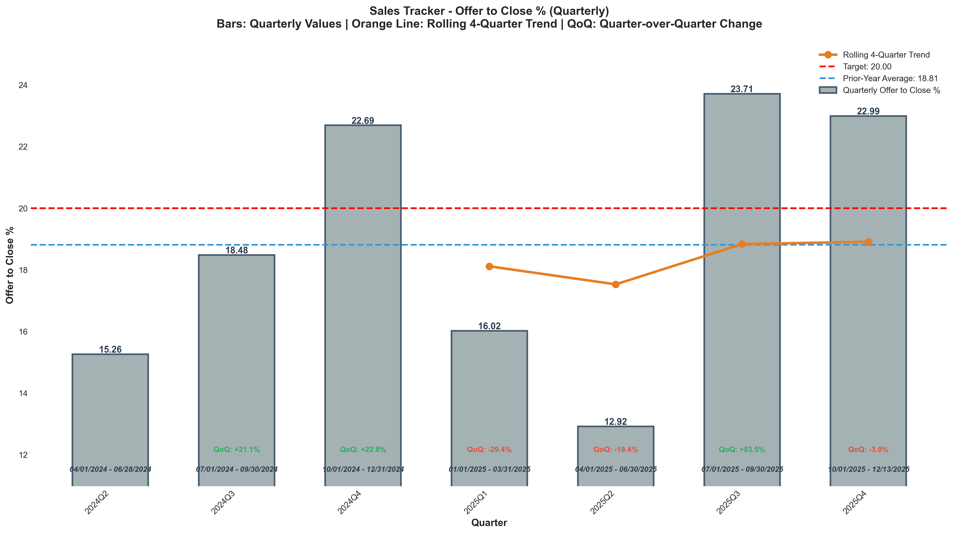
Chart: visualizations/sales_tracker_quarterly/quarterly_offer_to_close_pct.png
Source: outputs/sales_tracker/quarterly_sales_tracker.csv
Insights:
• Current quarter: 22.99% vs 23.71% last quarter (0.72%, -3.0% QoQ) (unfavorable)
• Performance is 18.1% above the 6-quarter average (avg = 19.47%) → High CV vs 6Q Avg
• Goal met: Yes (target = 20.00%; actual = 22.99%; +14.9% above goal)
• Trend: 4Q: ↑ Rising | 6Q: → Stable

