Weekly Business Review (WBR)

Reporting Week: 11/30/2025 to 12/06/2025

Report Generated: December 31, 2025 at 12:20 AM

Table of Contents
Right-click and select 'Update Field' to generate Table of Contents

Executive Summary
NEWSLETTER PERFORMANCE
Key Improvements:
• Auto Unsubs decreased by 9997.0%
• Leak Rate decreased by 3589.0%
• List Unsub Rate decreased by 3286.0%
Areas of Concern:
• Active Unsubs increased by 55983.0%
• Blended Unsub Rate increased by 1333.0%
• Growth Rate (%) decreased by 581.0%
SALES PERFORMANCE
Key Improvements:
• Closer Availability increased by 11478.0%
• S2C Calls increased by 8750.0%
• Booked Calls (Closers) increased by 5783.0%
Areas of Concern:
• Offer to Close decreased by 3417.0%
• Closer Fill Rate decreased by 3181.0%
• CVR % decreased by 1650.0%

Section 1: Newsletter Metrics
Core Metrics — Weekly Overview (WoW)
Metric | 11/23/2025 - 11/29/2025 | 11/30/2025 - 12/06/2025 | WoW | 6 Wk Average (10/26/2025 - 12/06/2025)
Visits | 33821 | 37997 | +12.35% | 29825
CVR % | 13.24% | 12.50% | -5.59% | 13.72%
New Subscribers | 4477 | 4750 | +6.10% | 4092.67
Active Unsubs | 356 | 2349 | +559.83% | 303.83
Auto Unsubs | 3099 | 1 | -99.97% | 29.5
Unsubscribes | 3455 | 2350 | -31.98% | 333.33
Leak Rate | 77.17% | 49.47% | -35.89% | 8.14%
Net New Subscribers | 2540 | 2454 | -3.39% | 1683
List Unsub Rate | 2.10% | 1.41% | -32.86% | 0.20%
Total Subscribers | 164839 | 167250 | +1.46%
Growth Rate (%) | 1.55% | 1.46% | -5.81% | 1.00%
Blended Open Rate | 56.18% | 55.6% | -1.03% | 57.38%
Blended Click Rate | 1.03% | 1.14% | +10.68% | 1.1%
Blended Unsub Rate | 0.15% | 0.17% | +13.33% | 0.15%
Source: outputs/newsletter_analysis/weekly_newsletter_metrics.xlsx
Core Metrics — Monthly Overview (MoM)
Metric | 10/01/2025 - 10/28/2025 | 11/01/2025 - 11/28/2025 | MoM
Visits | 60443 | 120443 | +99.27%
CVR % | 19.01% | 13.52% | -28.88%
New Subscribers | 11488 | 16289 | +41.79%
Active Unsubs | 4321 | 5467 | +26.52%
Auto Unsubs | 1357 | 4478 | +229.99%
Unsubscribes | 5678 | 9945 | +75.15%
Leak Rate | 49.43% | 61.05% | +23.51%
Net New Subscribers | 2848 | 6010 | +111.03%
List Unsub Rate | 3.59% | 6.05% | +68.52%
Total Subscribers | 158149 | 164354 | +3.92%
Growth Rate (%) | 1.74% | 3.62% | +108.05%
Blended Open Rate | 57.44% | 56.71% | -1.27%
Blended Click Rate | 0.7% | 0.62% | -11.43%
Blended Unsub Rate | 0.17% | 0.15% | -11.76%
Source: outputs/newsletter_analysis/monthly_newsletter_metrics.xlsx

Landing Page Funnel
Newsletter Visits
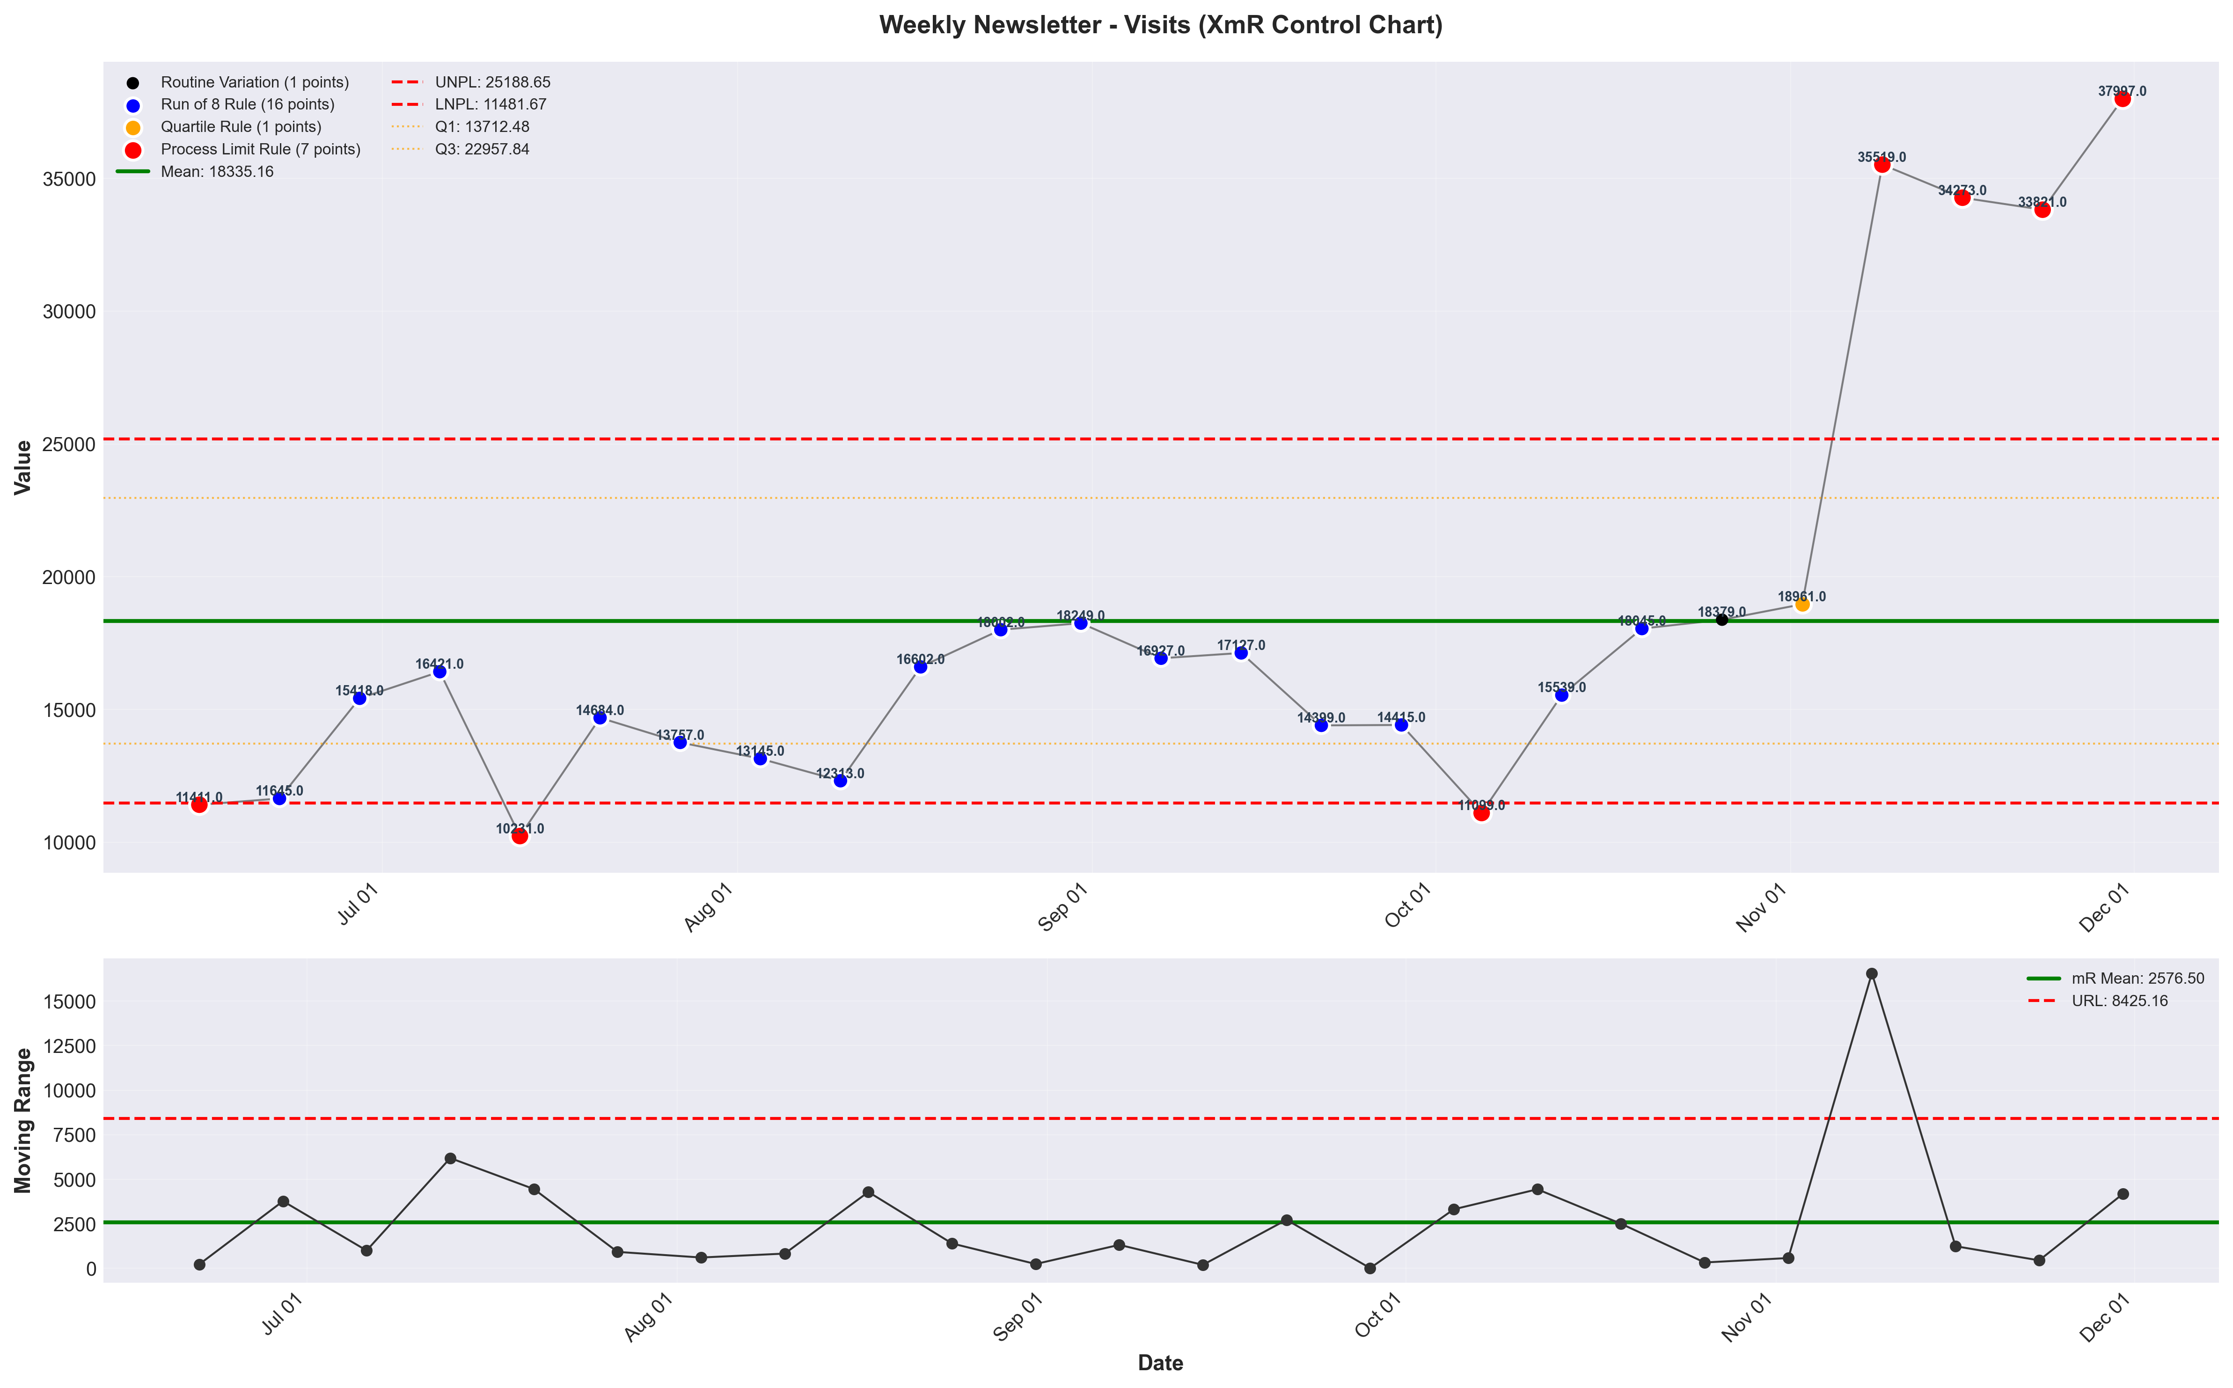
visualizations/newsletter_weekly/weekly_visits.png
Source: outputs/newsletter/weekly_newsletter.csv
Insights:
Current week: 37,997 (up 12.35% WoW from 33,821) (favorable)
6-week average: 29,825 — classification: High CV vs 6Wk Avg
Trends: 6wk ↑ Rising | 12wk ↑ Rising | 24wk ↑ Rising
Newsletter Visit Duration
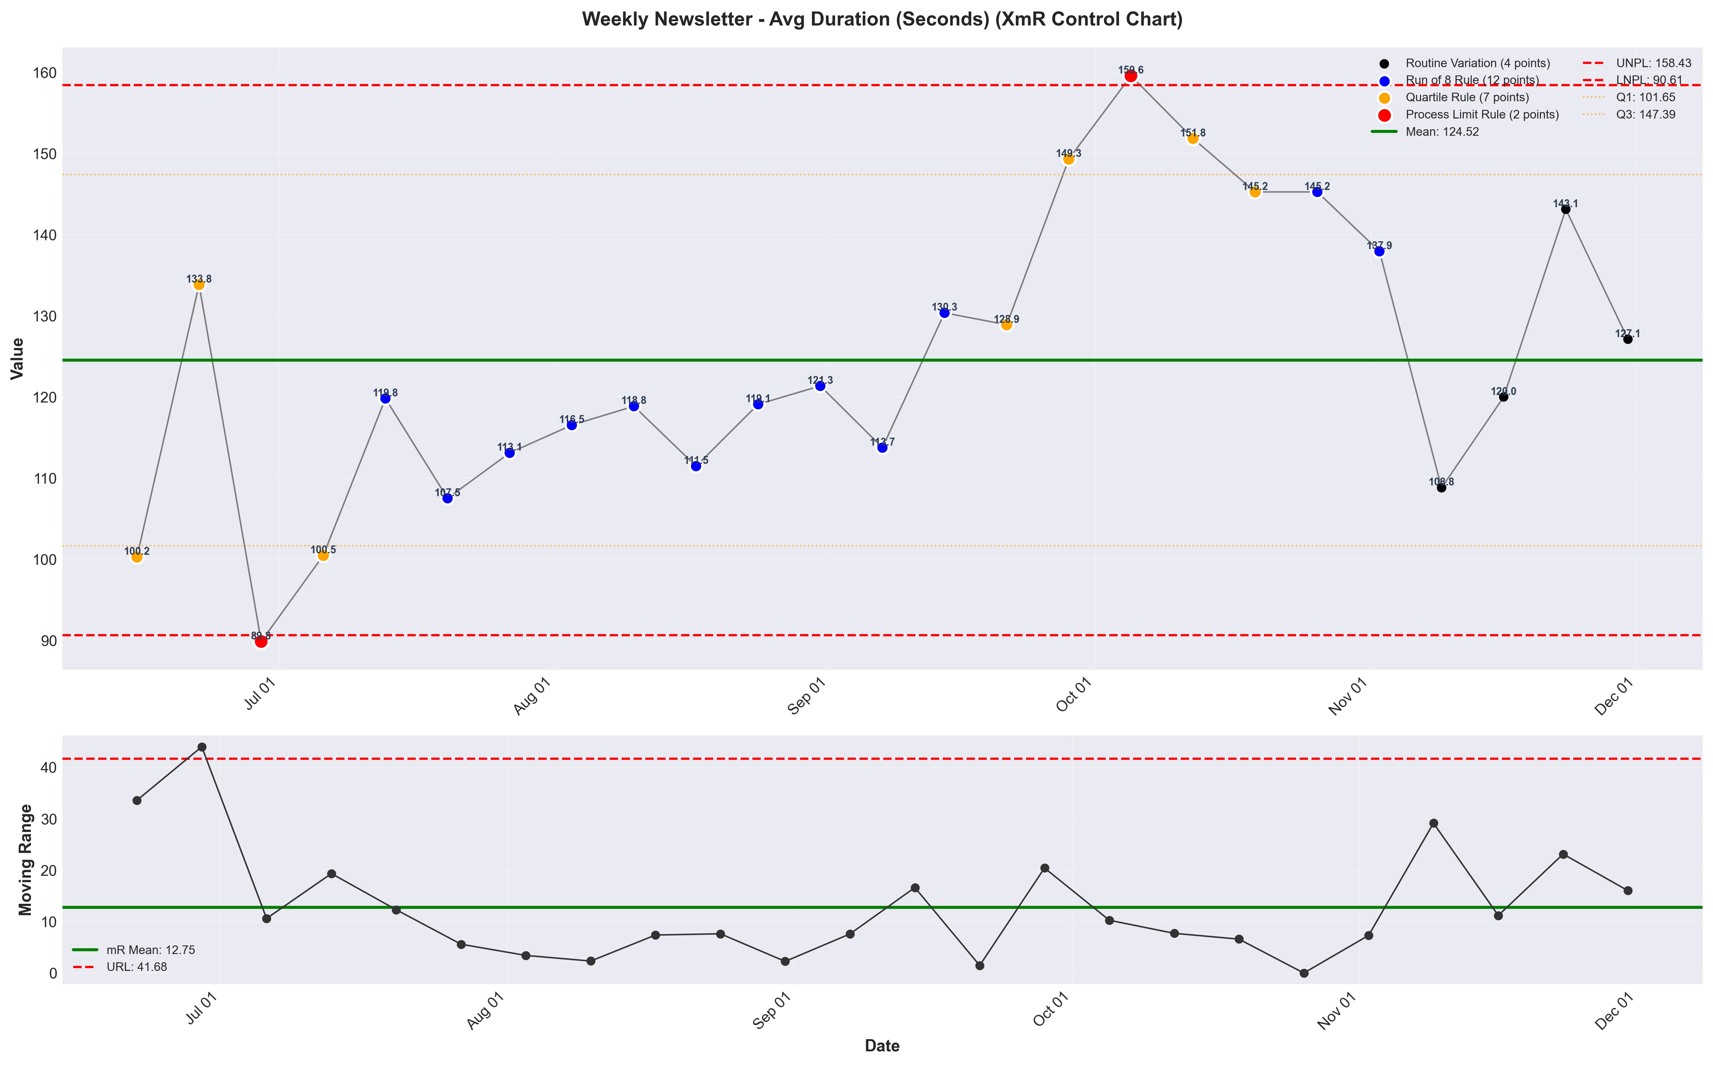
visualizations/newsletter_weekly/weekly_avg_duration.png
Source: outputs/newsletter/weekly_newsletter.csv
Insights:
Current week: 127 (down 11.19% WoW from 143) (unfavorable)
6-week average: 130 — classification: Normal
Trends: 6wk → Stable | 12wk ↓ Falling | 24wk ↑ Rising
Newsletter Bounce Rate
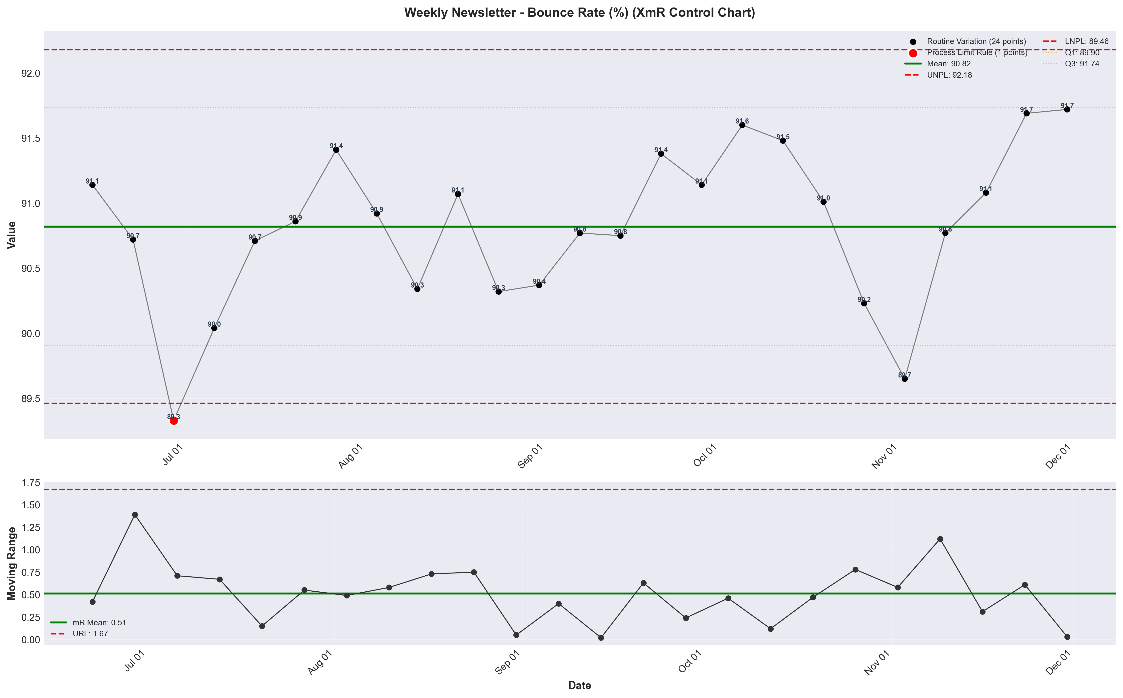
visualizations/newsletter_weekly/weekly_bounce_rate.png
Source: outputs/newsletter/weekly_newsletter.csv
Insights:
Current week: 91.72% (no change from previous week)
6-week average: 90.86% — classification: Normal
Trends: 6wk ↑ Rising | 12wk → Stable | 24wk ↑ Rising
Newsletter CVR %
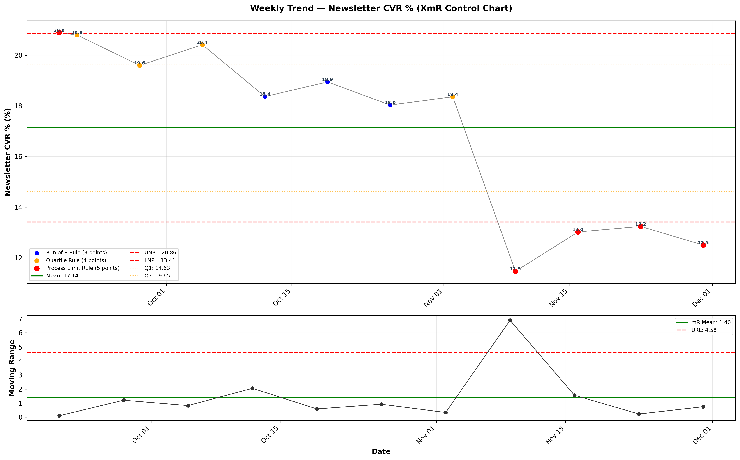
visualizations/general_newsletter_weekly/weekly_newsletter_cvr.png
Source: outputs/general_newsletter/weekly_table.csv
Insights:
Current week: 12.50% (down 5.56% WoW from 13.24%) (unfavorable)
6-week average: 14.44% — classification: Low CV vs 6Wk Avg
Trends: 6wk ↓ Falling | 12wk ↓ Falling

Engagement Metrics
Blended Open Rate
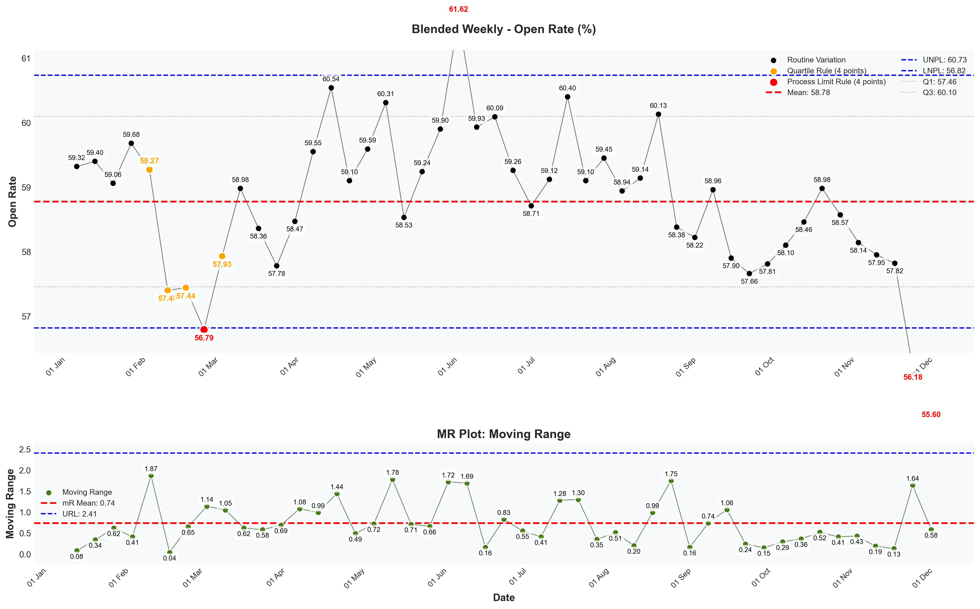
visualizations/newsletter_series_weekly/blended_open_rate.png
Source: outputs/newsletter_series/06_blended_weekly.csv
Insights:
Current week: 55.60% (down 1.03% WoW from 56.18%) (unfavorable)
6-week average: 57.38% — classification: Normal
Trends: 6wk ↓ Falling | 12wk → Stable | 24wk ↓ Falling
Blended Verified Click-Through Rate
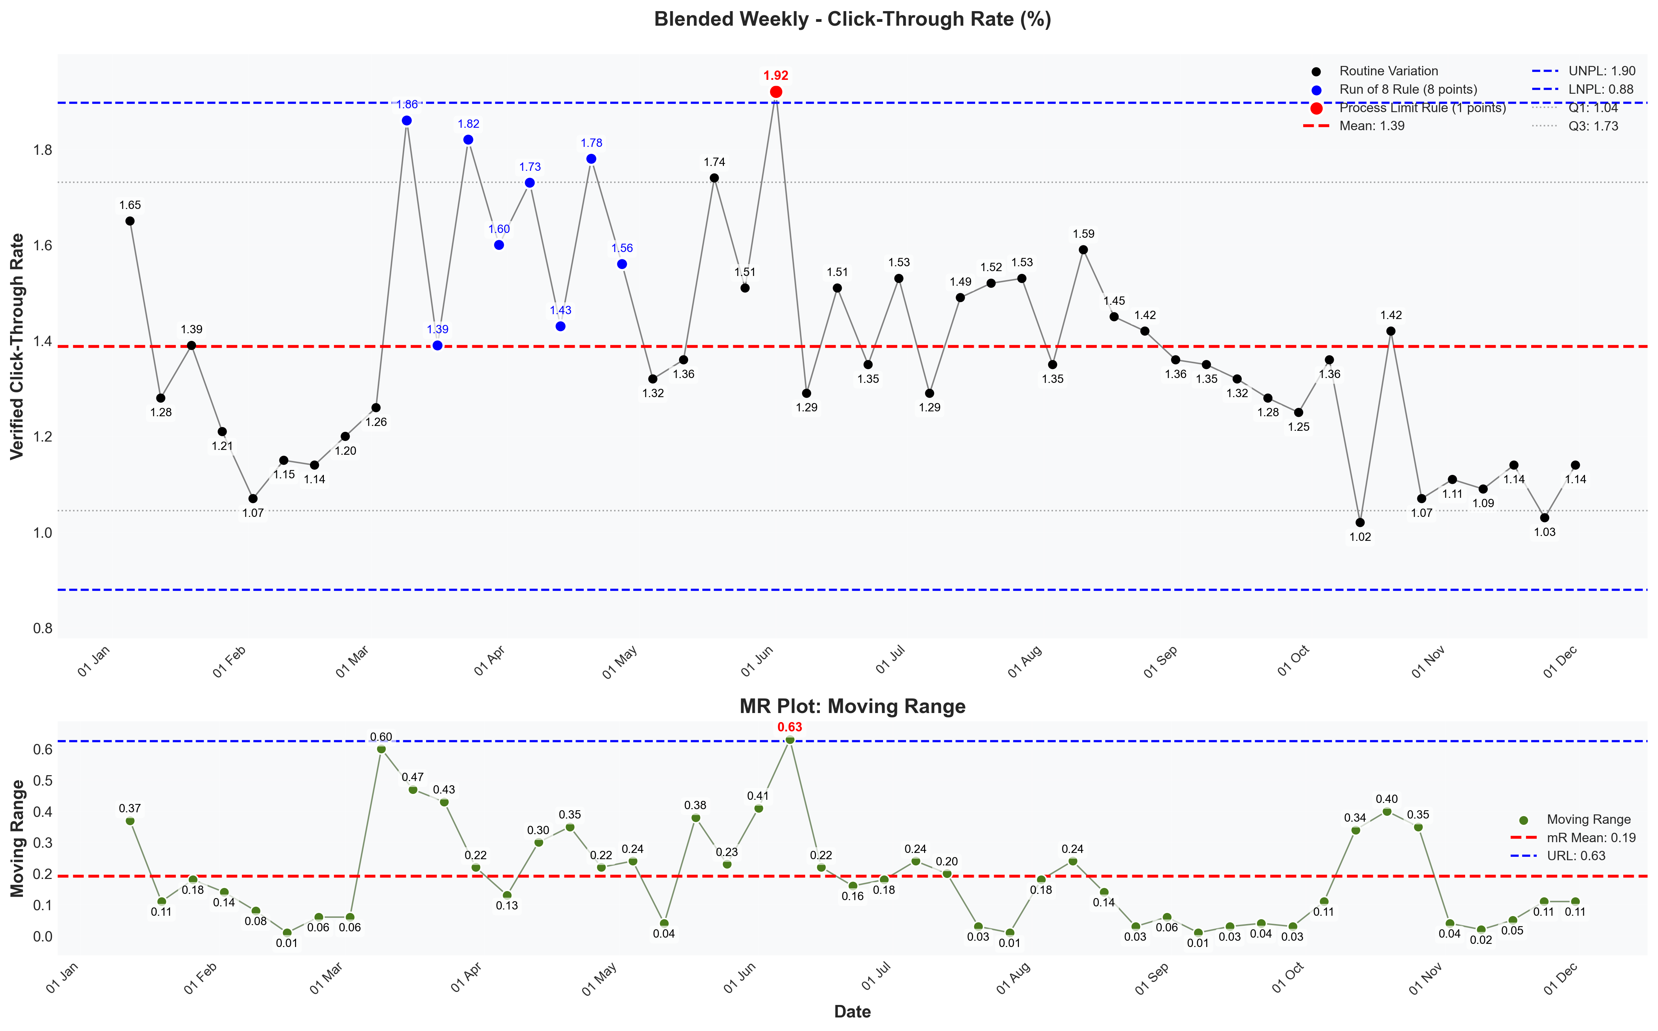
visualizations/newsletter_series_weekly/blended_verified_ctr.png
Source: outputs/newsletter_series/06_blended_weekly.csv
Insights:
Current week: 1.14% (up 10.68% WoW from 1.03%) (favorable)
6-week average: 1.10% — classification: Normal
Trends: 6wk → Stable | 12wk ↓ Falling | 24wk ↓ Falling
Blended Unsub Rate
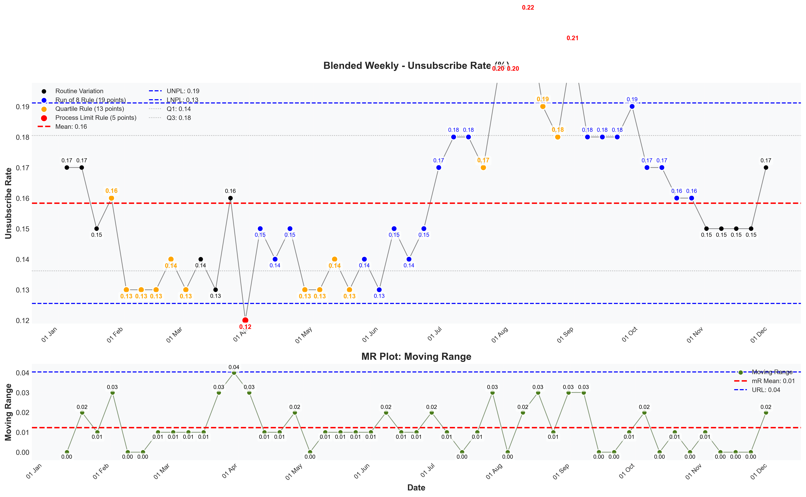
visualizations/newsletter_series_weekly/blended_unsubscribe_rate.png
Source: outputs/newsletter_series/06_blended_weekly.csv
Insights:
Current week: 0.17% (up 13.33% WoW from 0.15%) (unfavorable)
6-week average: 0.15% — classification: Normal
Trends: 6wk → Stable | 12wk ↓ Falling | 24wk ↓ Falling

Growth & Churn
Growth Rate
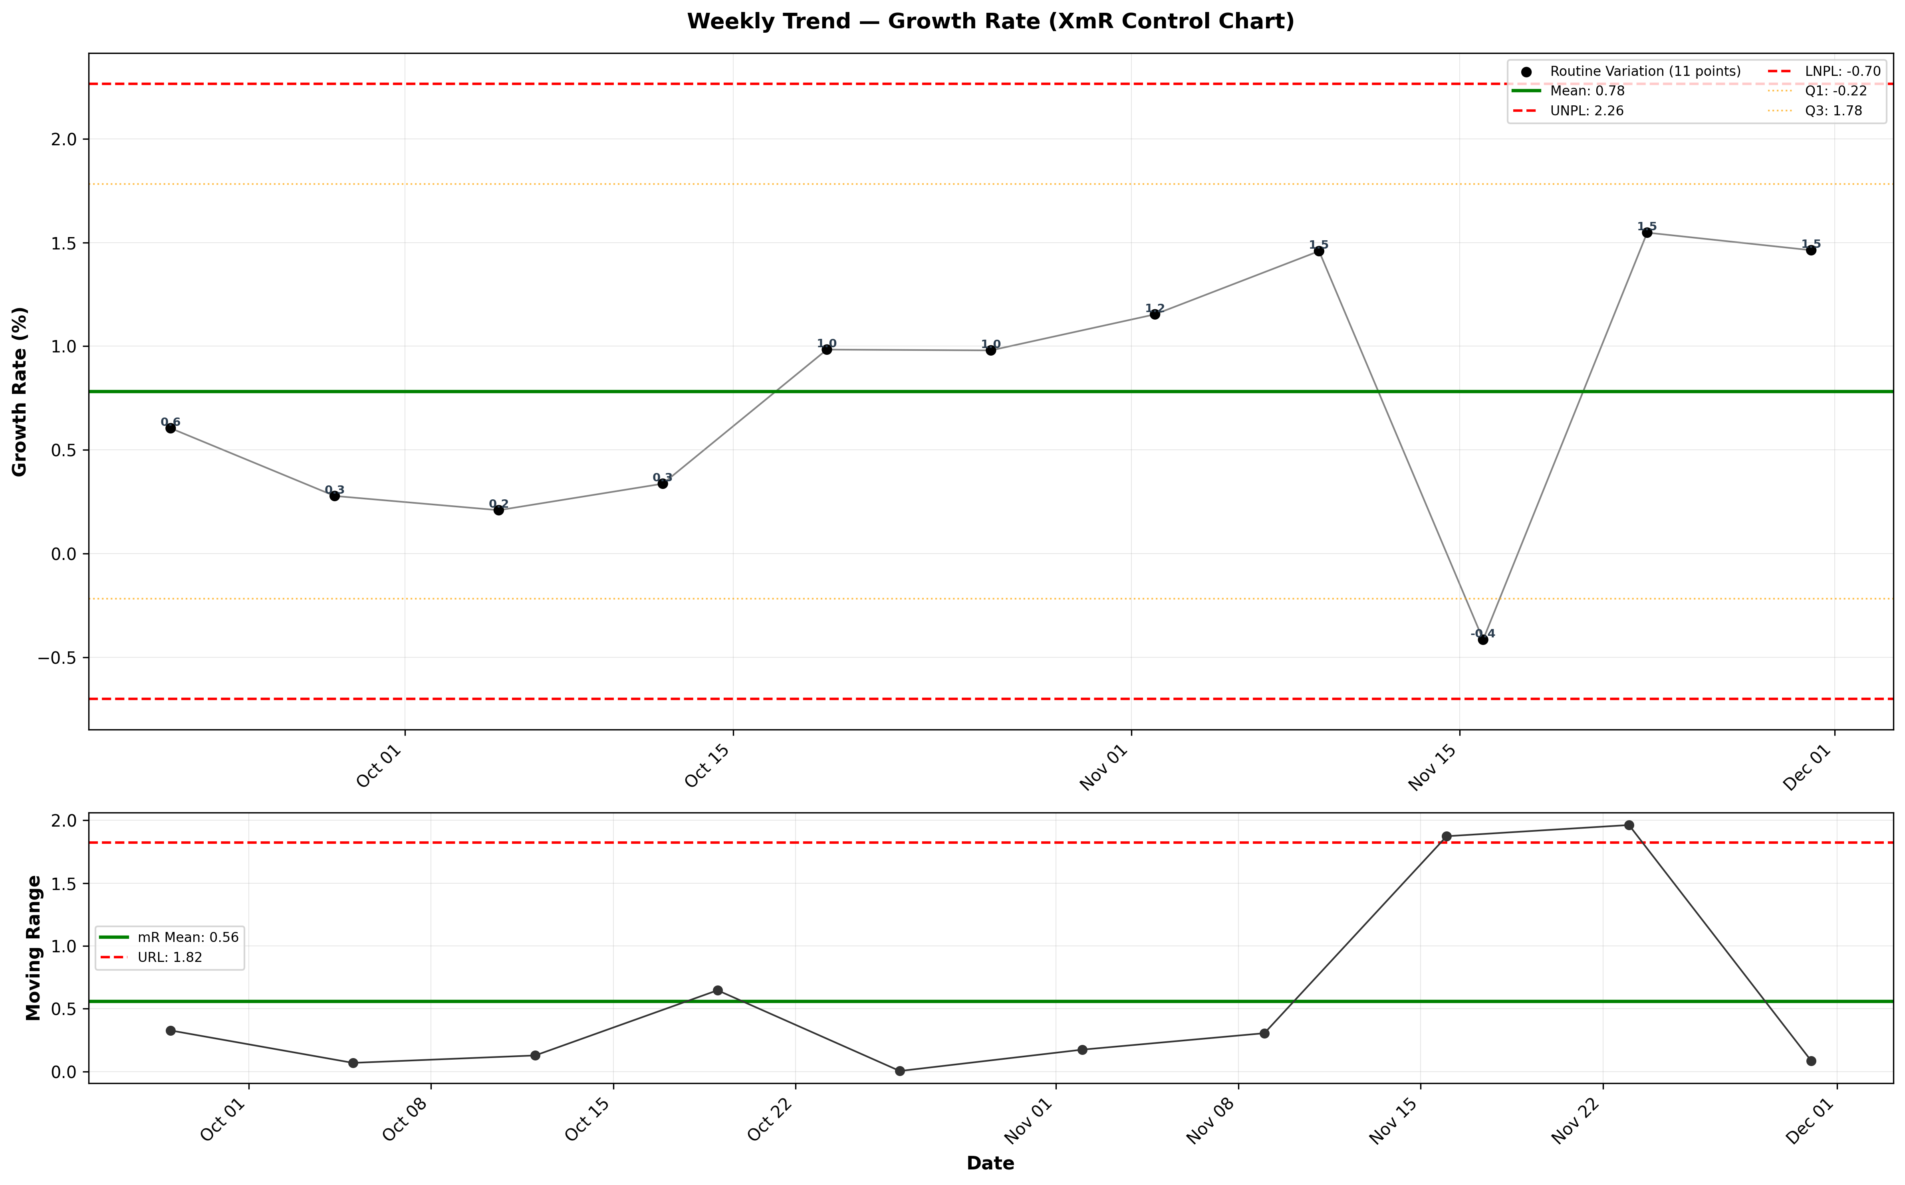
visualizations/general_newsletter_weekly/weekly_growth_rate.png
Source: outputs/general_newsletter/weekly_table.csv
Insights:
Current week: 1.46% (down 5.48% WoW from 1.55%) (unfavorable)
6-week average: 1.03% — classification: High CV vs 6Wk Avg
Trends: 6wk ↓ Falling
New Subscribers
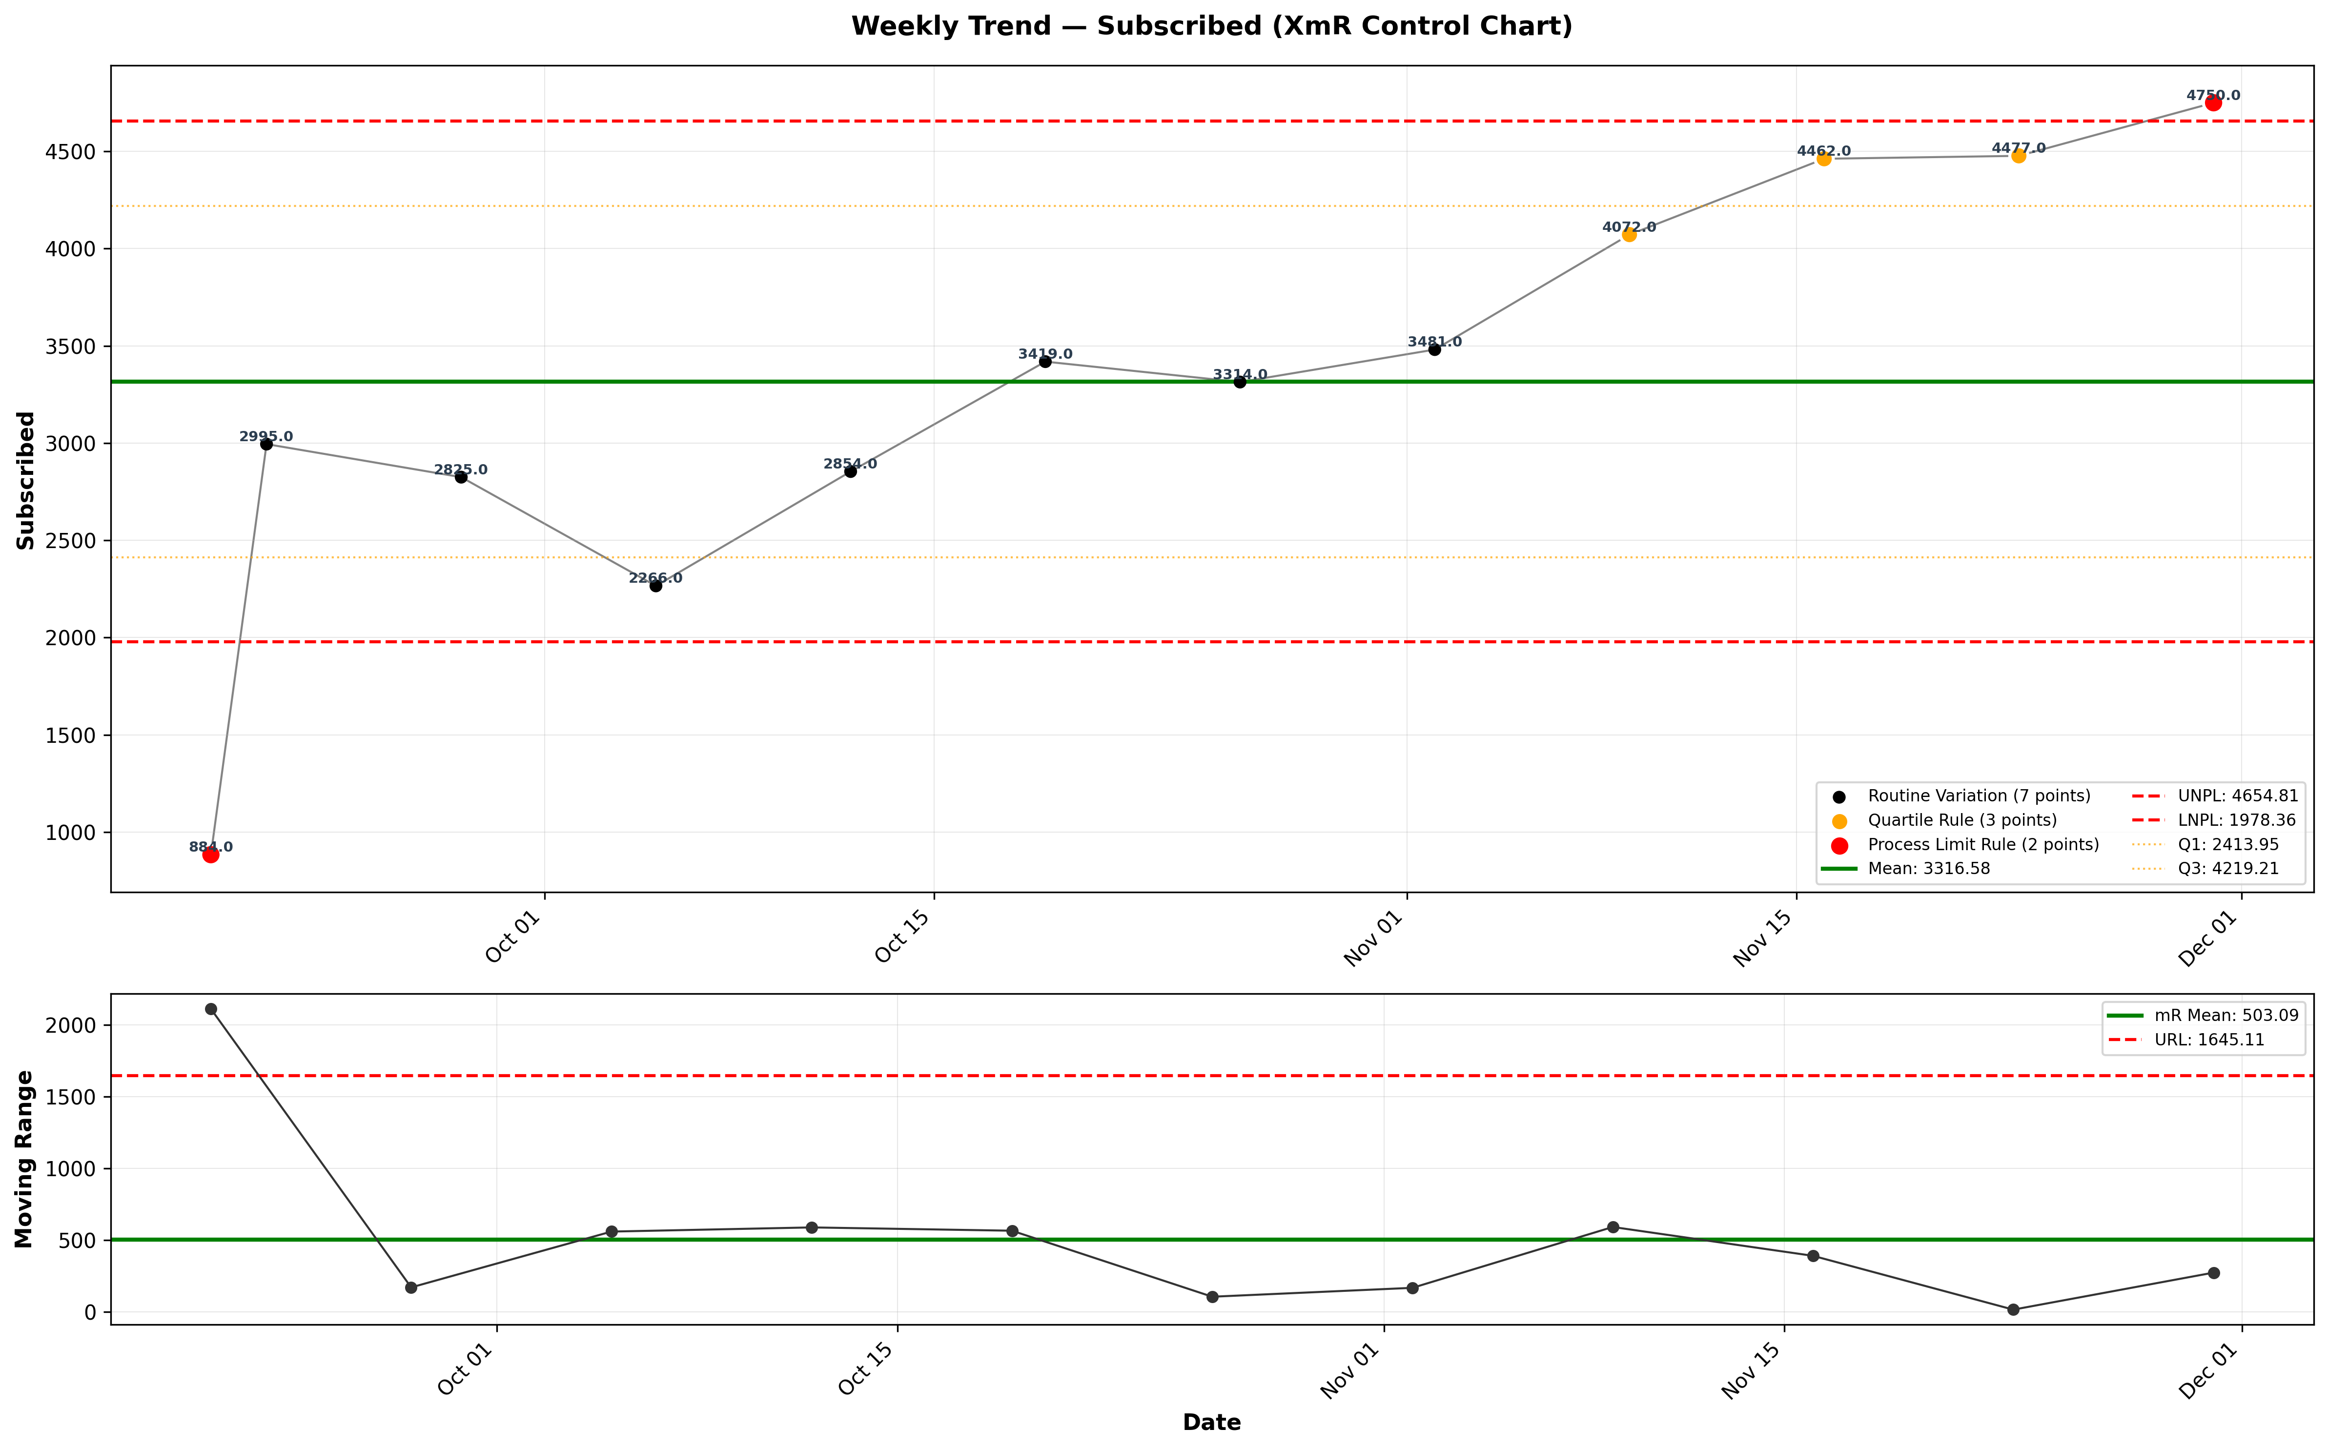
visualizations/general_newsletter_weekly/weekly_subscribed.png
Source: outputs/general_newsletter/weekly_table.csv
Insights:
Current week: 4,750 (up 6.10% WoW from 4,477) (favorable)
6-week average: 4,093 — classification: High CV vs 6Wk Avg
Trends: 6wk ↑ Rising | 12wk ↑ Rising
Unsubscribes
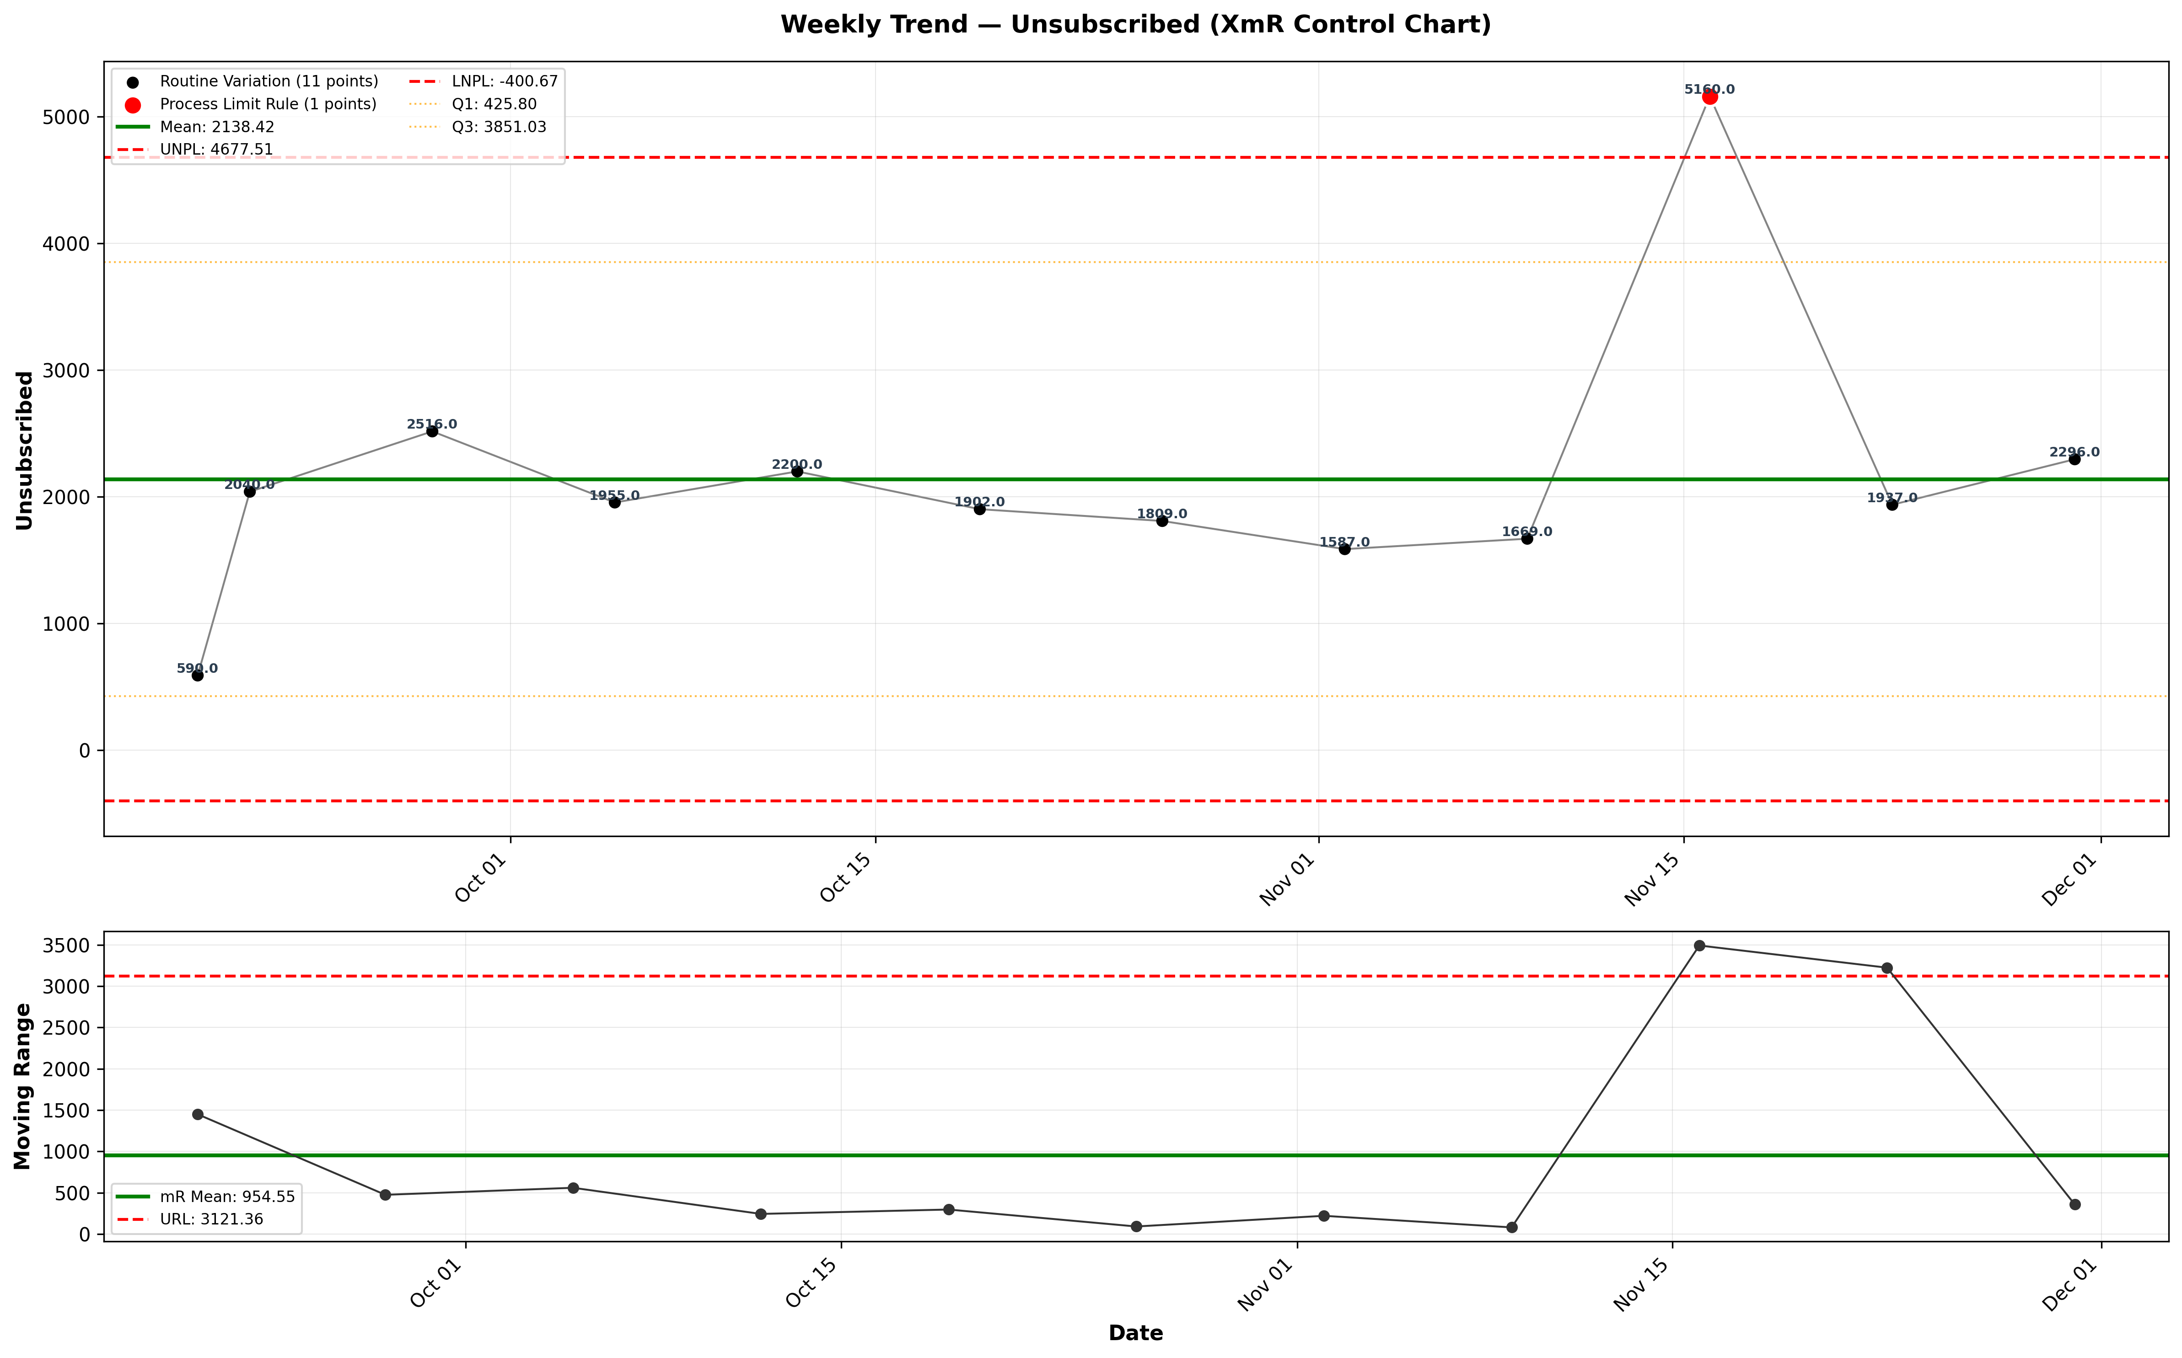
visualizations/general_newsletter_weekly/weekly_unsubscribed.png
Source: outputs/general_newsletter/weekly_table.csv
Insights:
Current week: 2,296 (up 18.53% WoW from 1,937) (unfavorable)
6-week average: 2,410 — classification: Normal
Trends: 6wk ↑ Rising | 12wk ↑ Rising
Leak Rate
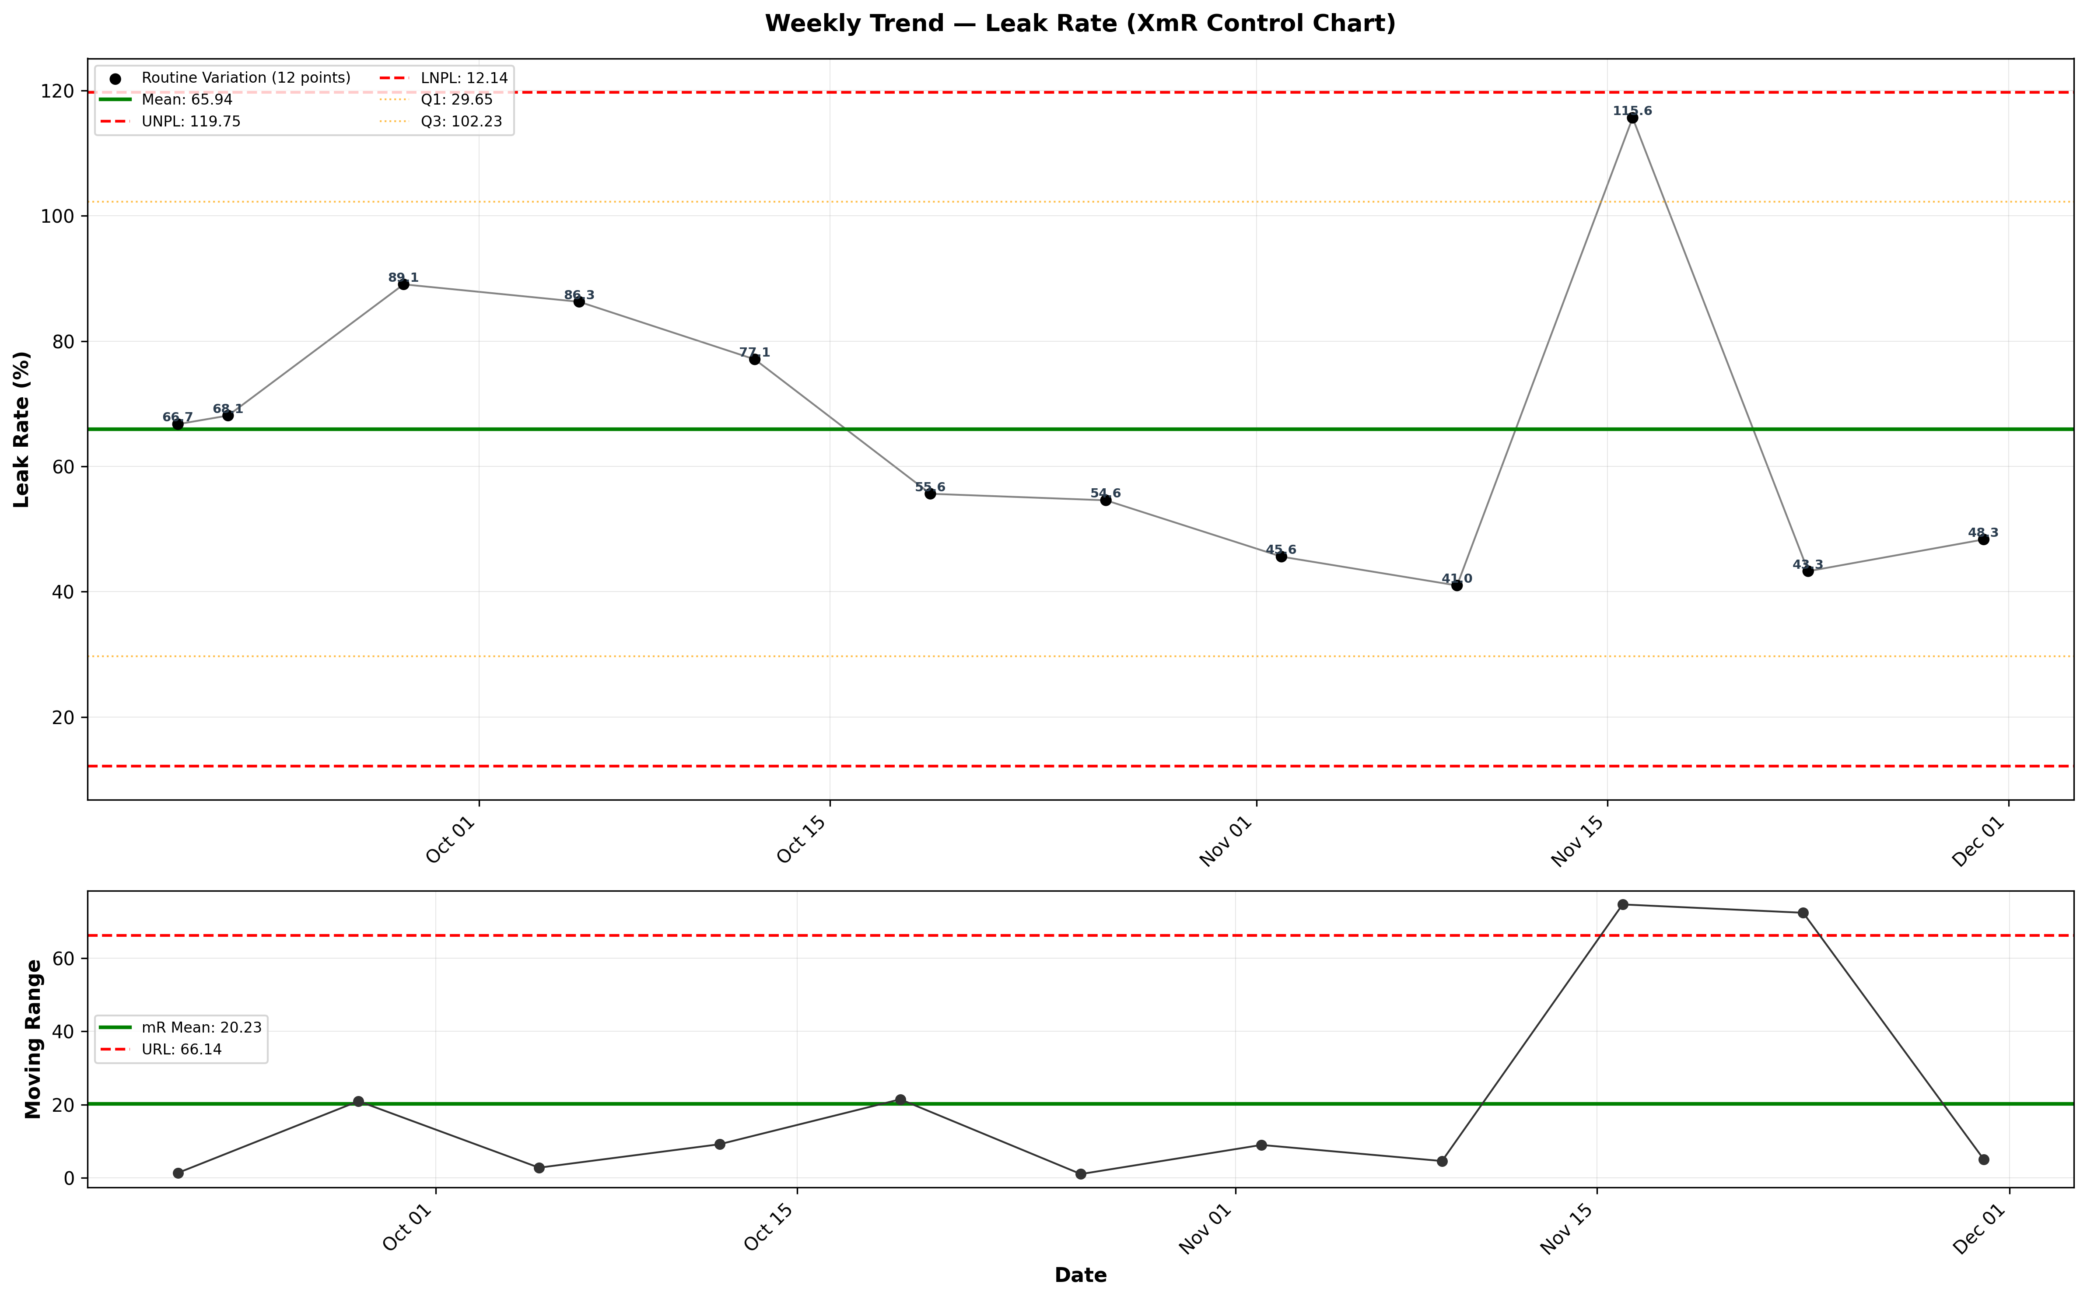
visualizations/general_newsletter_weekly/weekly_leak_rate.png
Source: outputs/general_newsletter/weekly_table.csv
Insights:
Current week: 48.34% (up 11.72% WoW from 43.27%) (unfavorable)
6-week average: 58.07% — classification: Low CV vs 6Wk Avg
Trends: 6wk ↑ Rising | 12wk ↓ Falling

Newsletter Series: New Deals
Deal Open Rate
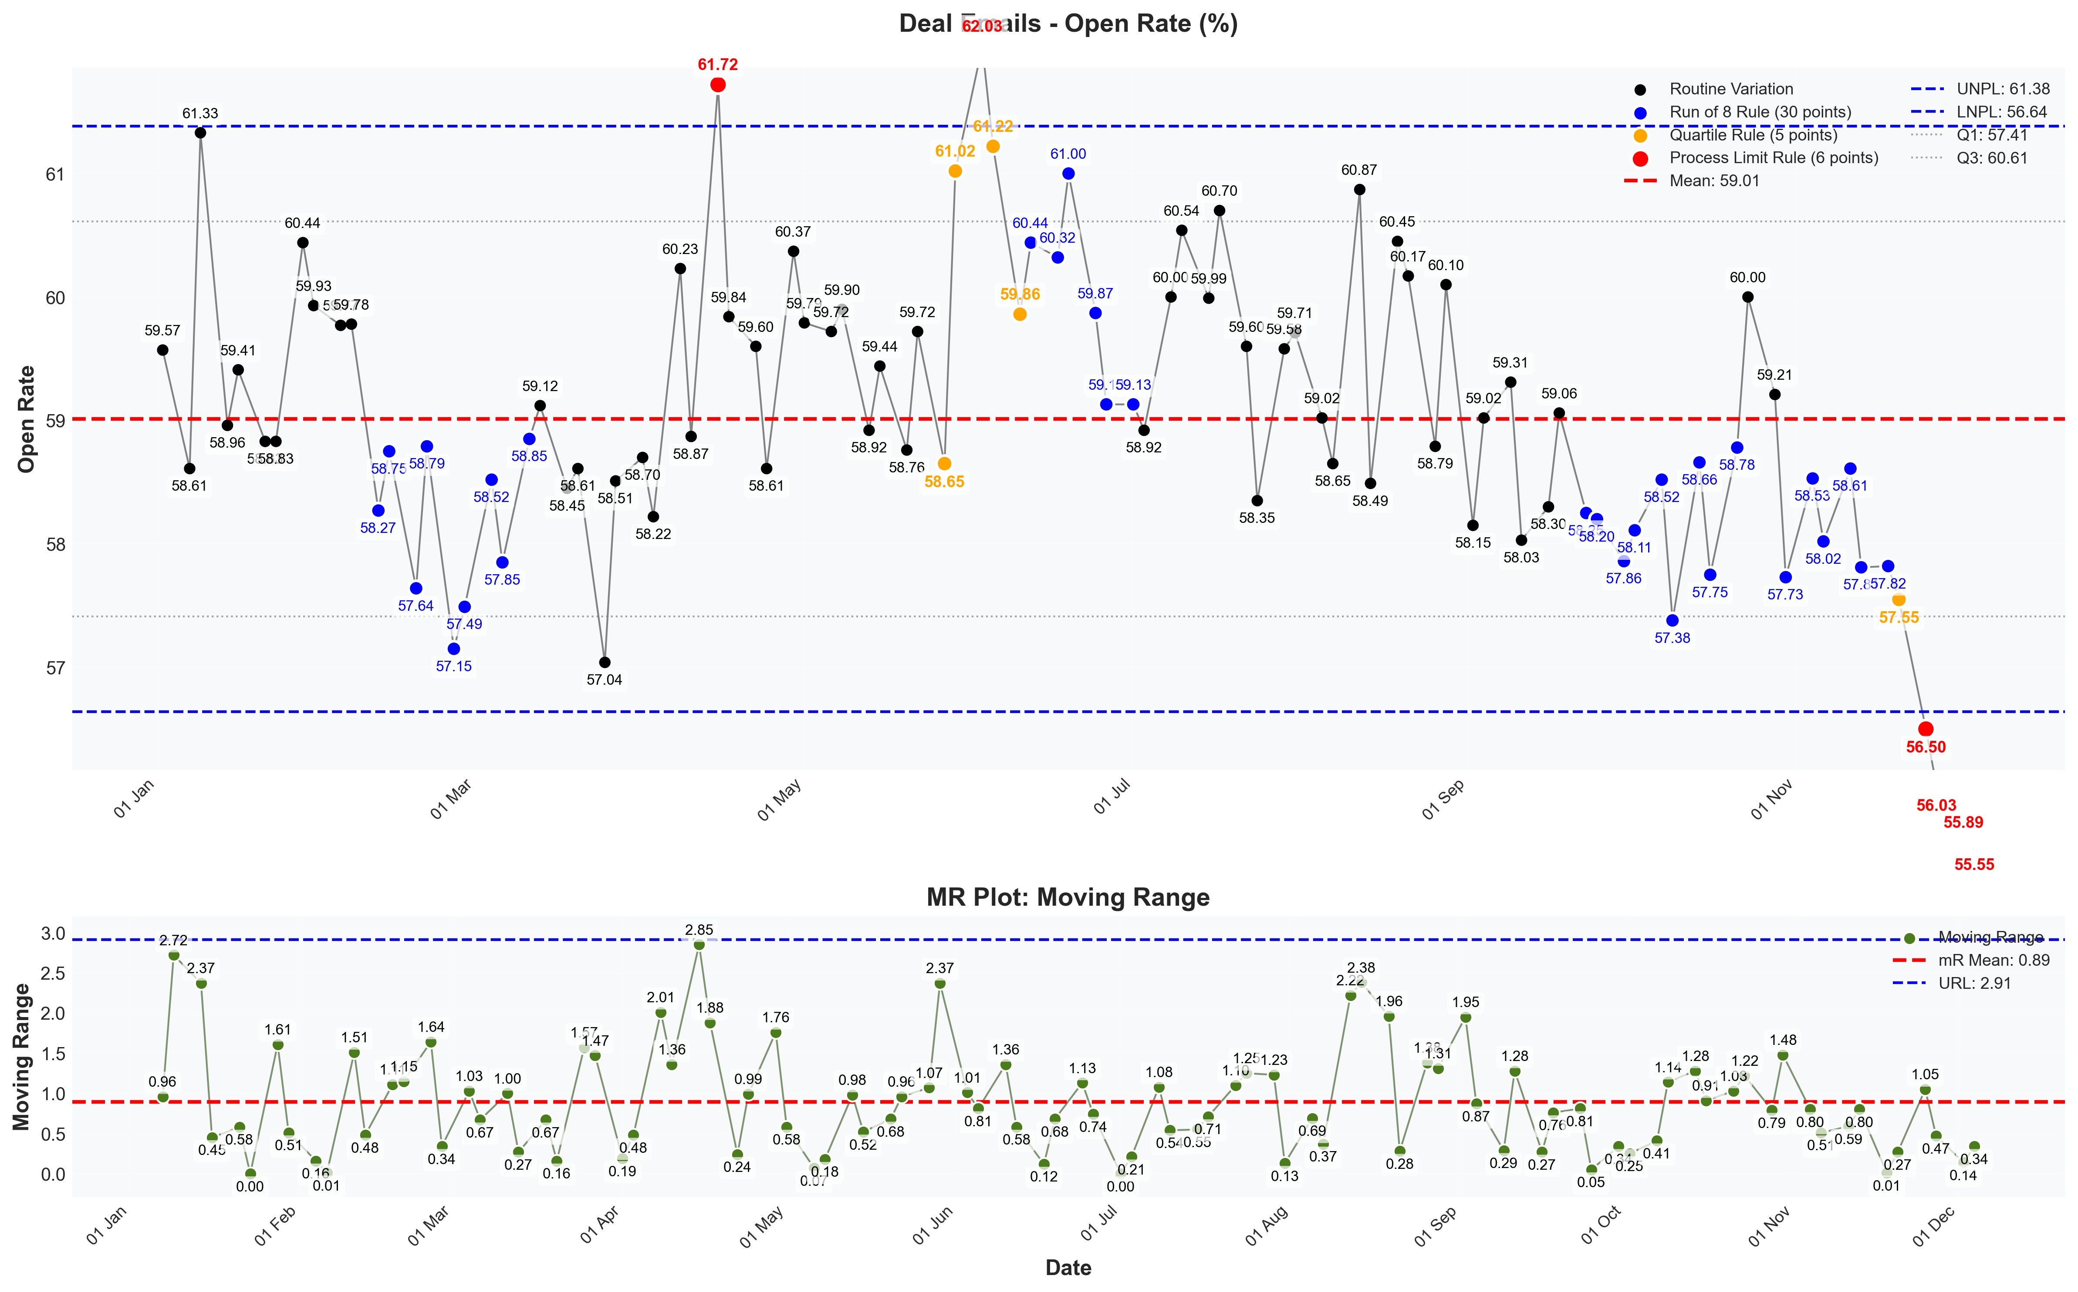
visualizations/newsletter_series_weekly/deal_open_rate.png
Source: outputs/newsletter_series/02_deal_emails.csv
Insights:
Current week: 55.55% (down 0.61% WoW from 55.89%) (unfavorable)
6-week average: 56.56% — classification: Normal
Trends: 6wk ↓ Falling | 12wk ↓ Falling | 24wk ↓ Falling
Deal Verified CTR
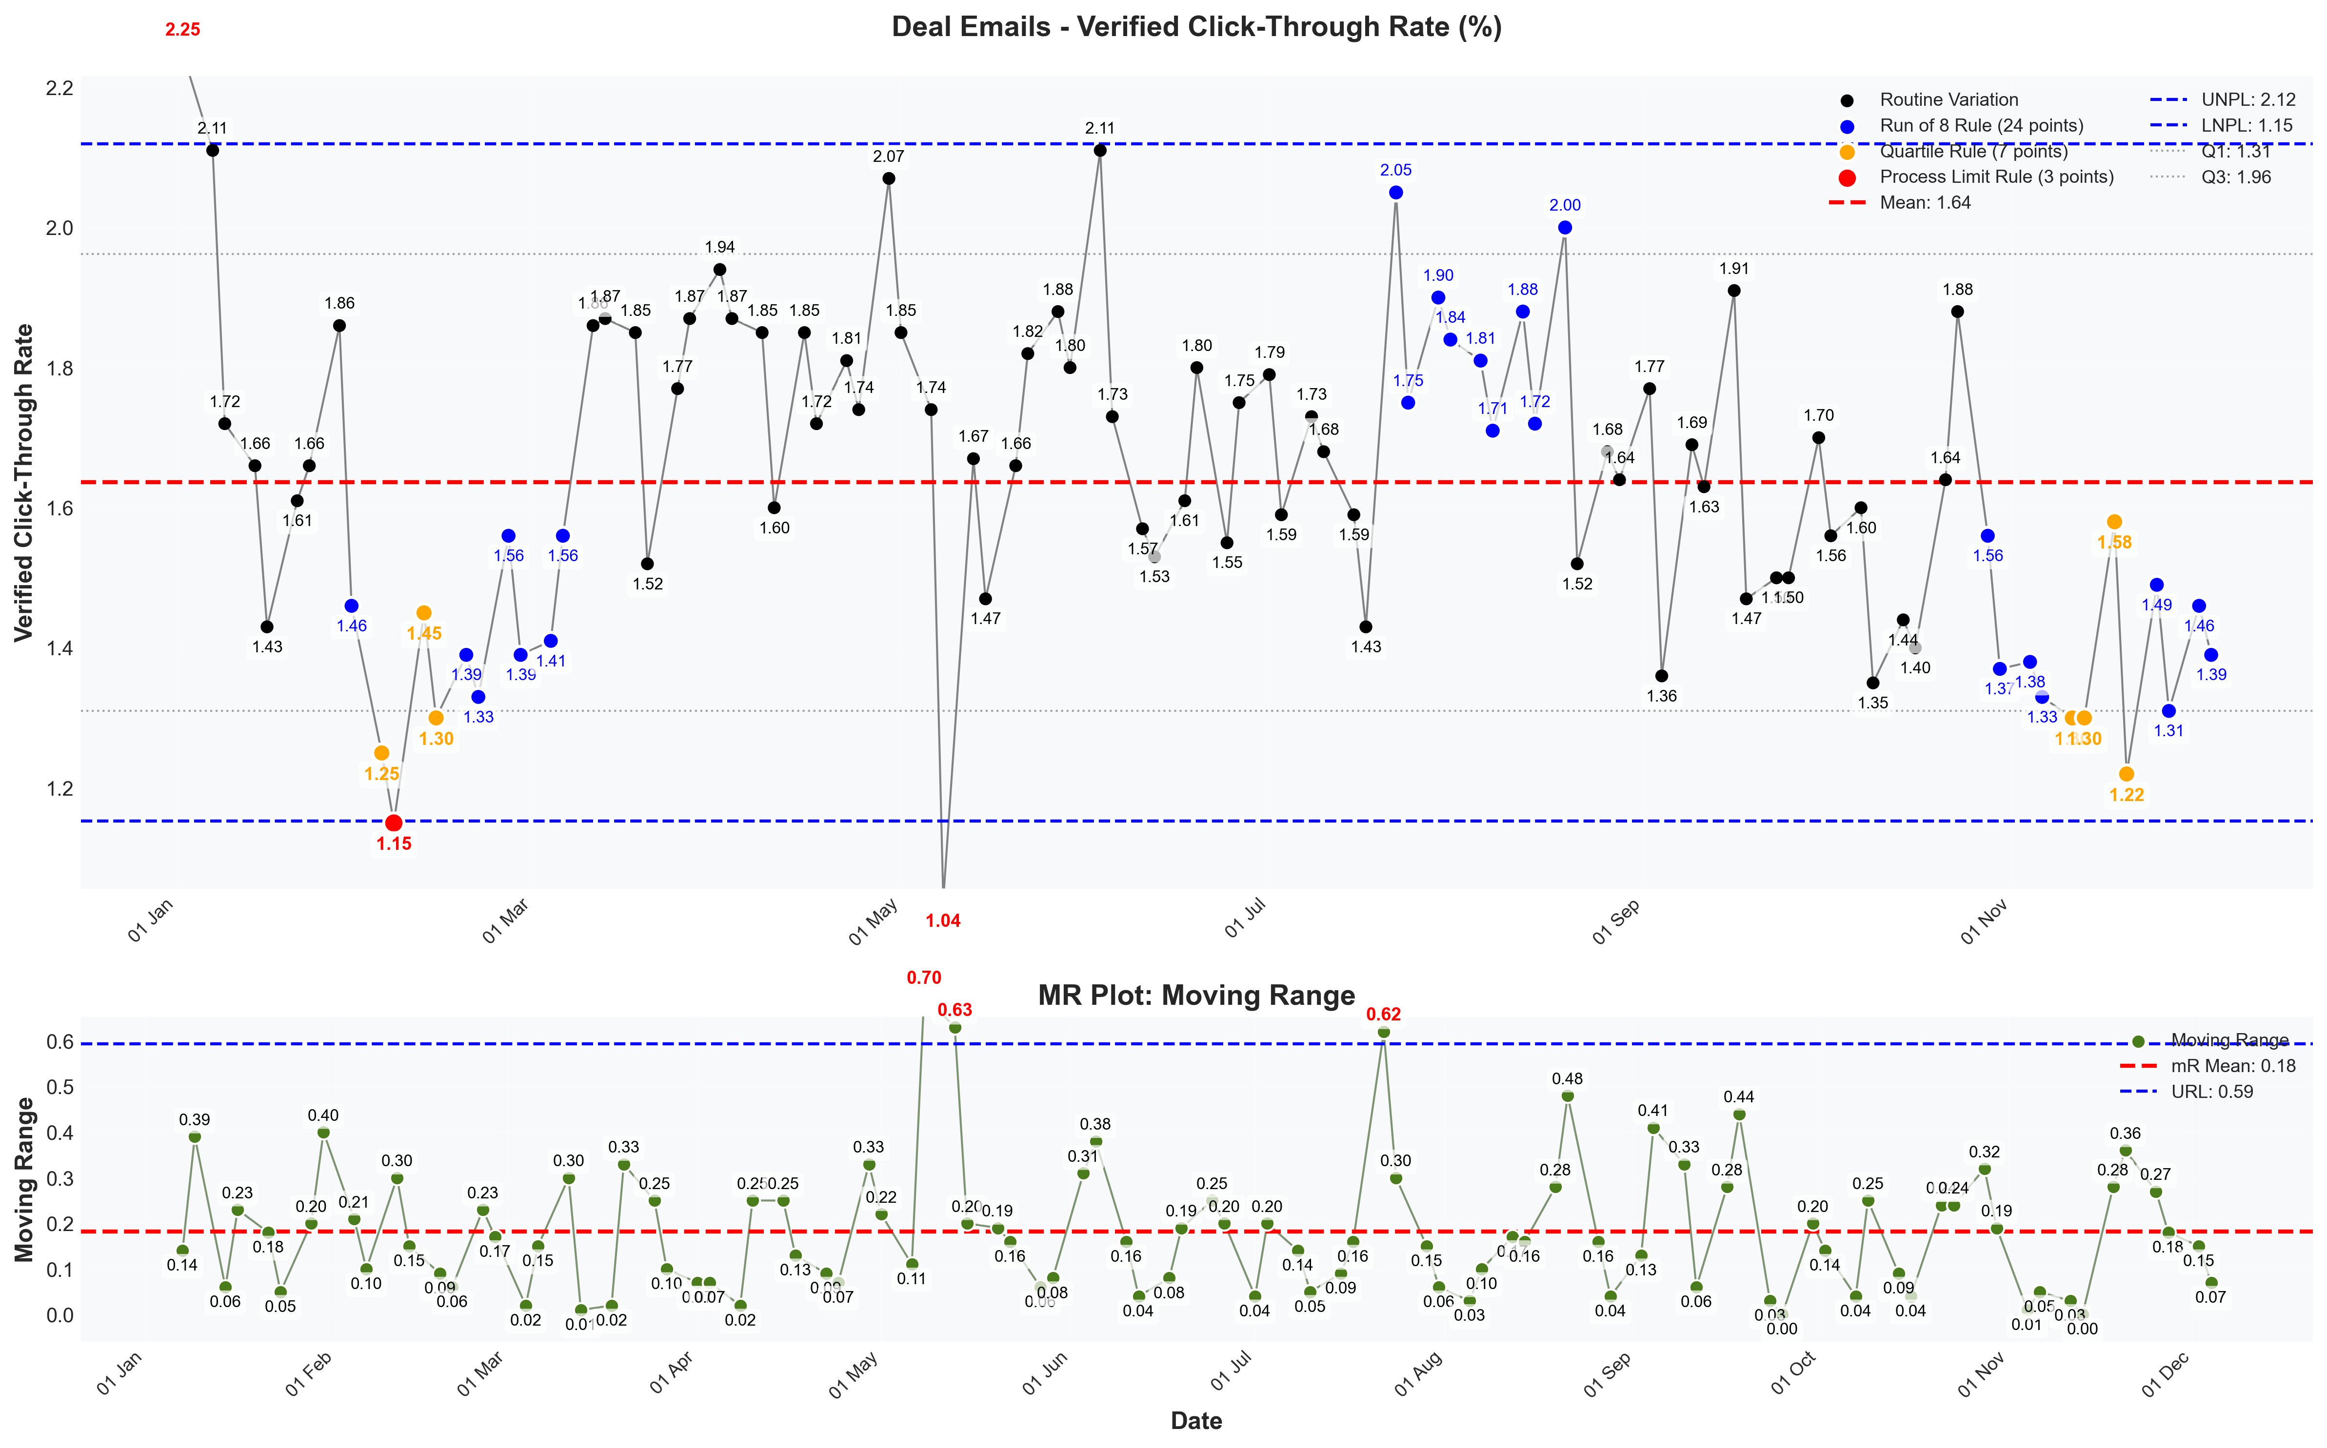
visualizations/newsletter_series_weekly/deal_verified_ctr.png
Source: outputs/newsletter_series/02_deal_emails.csv
Insights:
Current week: 1.39% (down 4.79% WoW from 1.46%) (unfavorable)
6-week average: 1.41% — classification: Normal
Trends: 6wk → Stable | 12wk → Stable | 24wk ↓ Falling
Deal Unsubscribe Rate
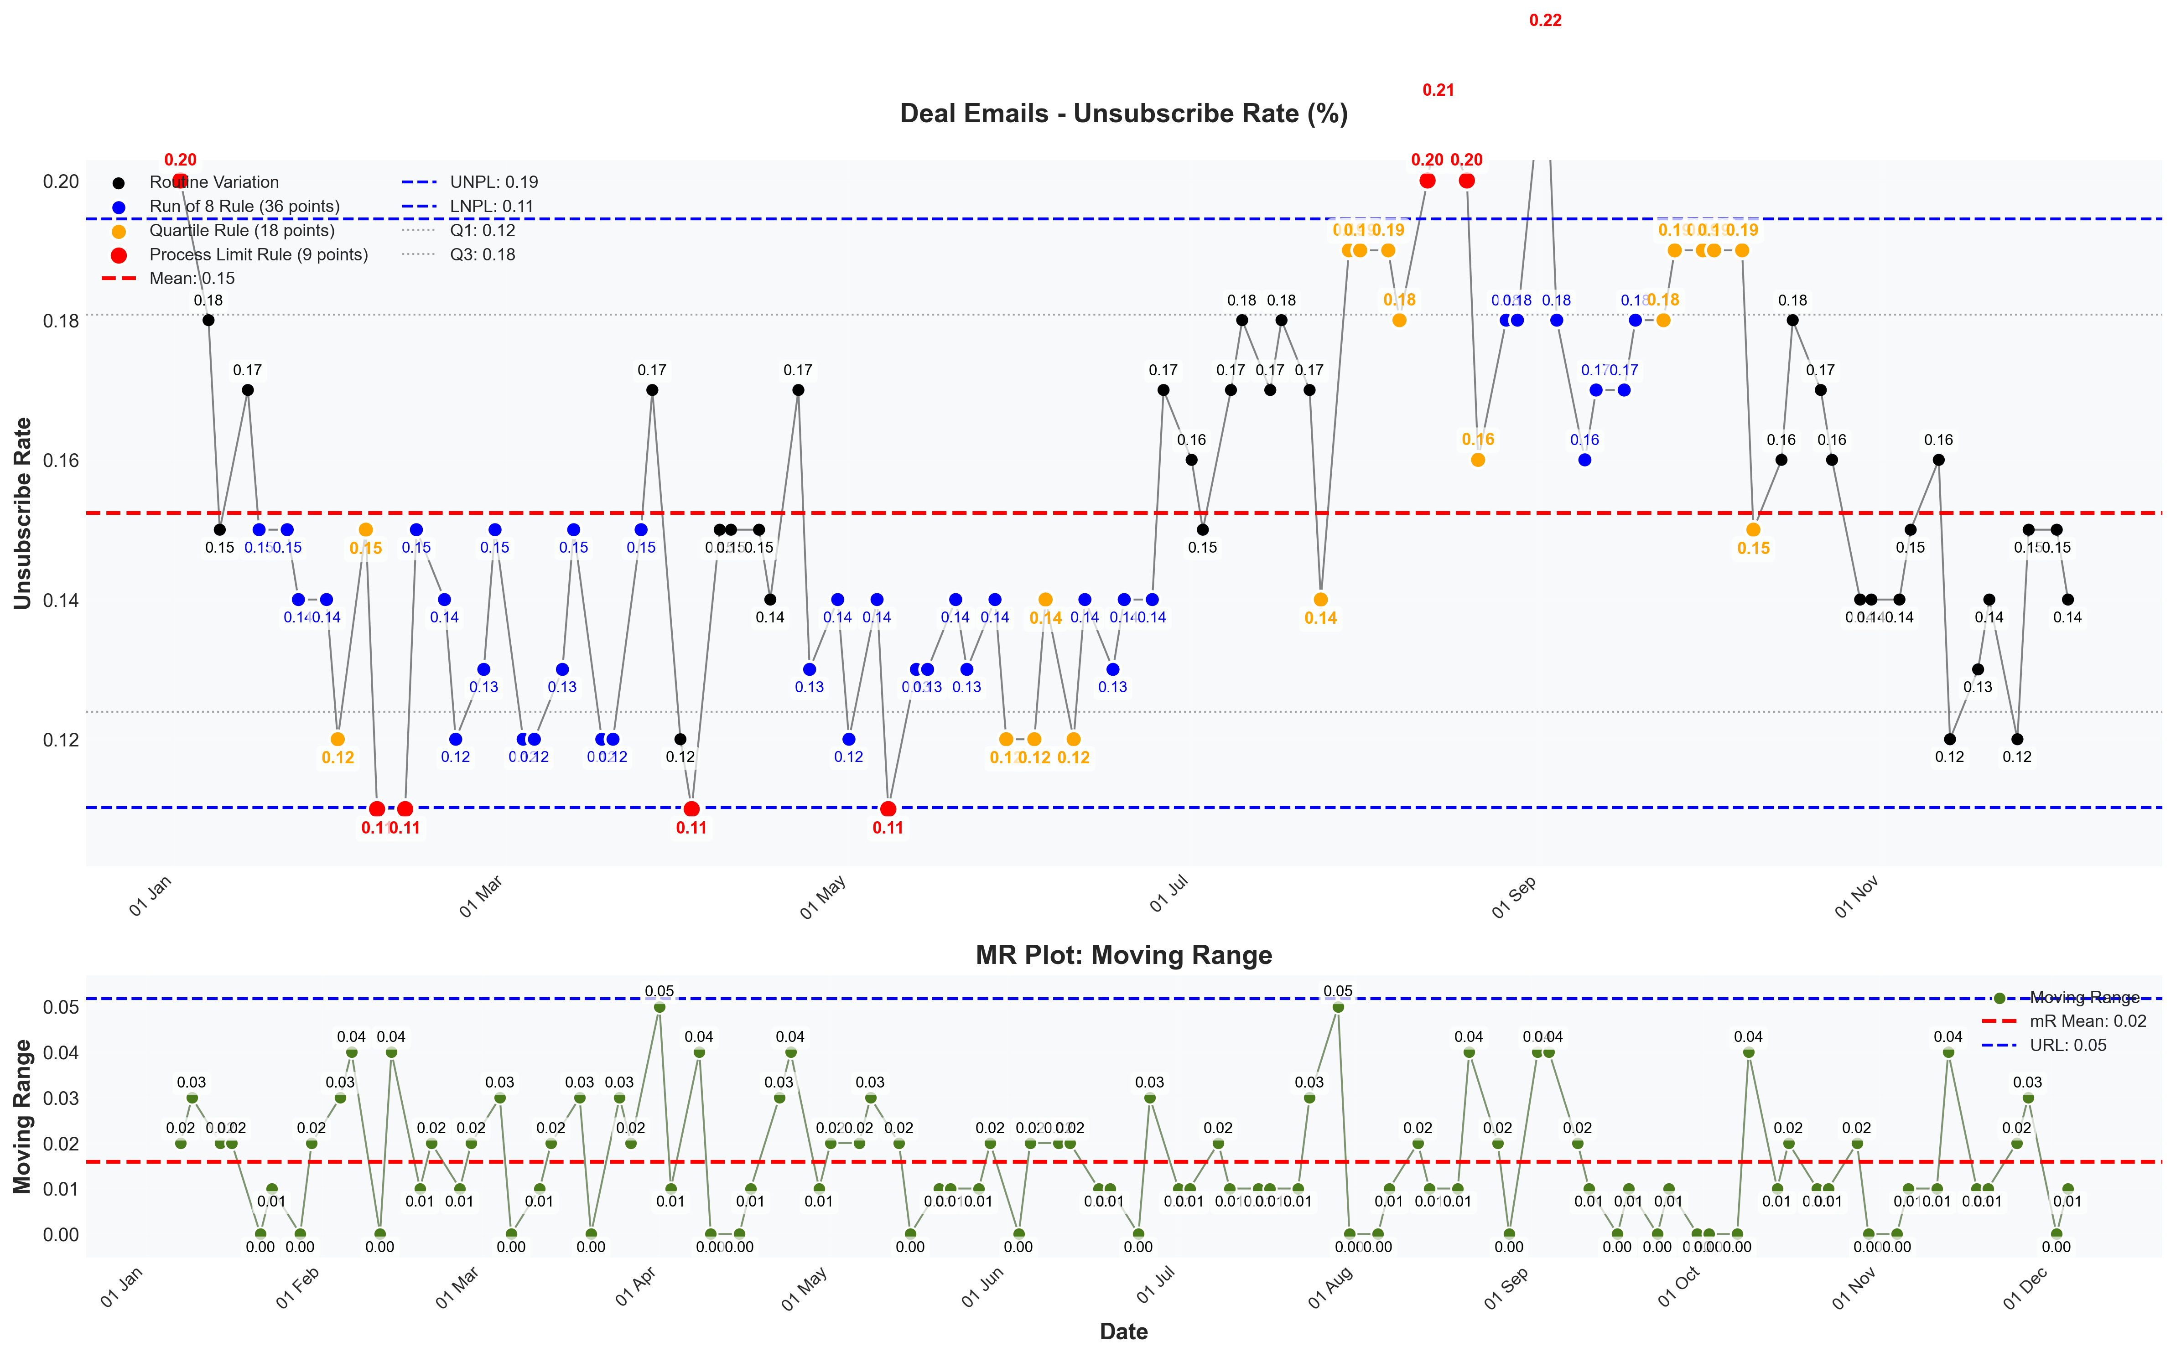
visualizations/newsletter_series_weekly/deal_unsubscribe_rate.png
Source: outputs/newsletter_series/02_deal_emails.csv
Insights:
Current week: 0.14% (down 6.67% WoW from 0.15%) (favorable)
6-week average: 0.14% — classification: Normal
Trends: 6wk ↑ Rising | 12wk → Stable | 24wk ↓ Falling

Newsletter Series: Off-Market
Off-Market Open Rate
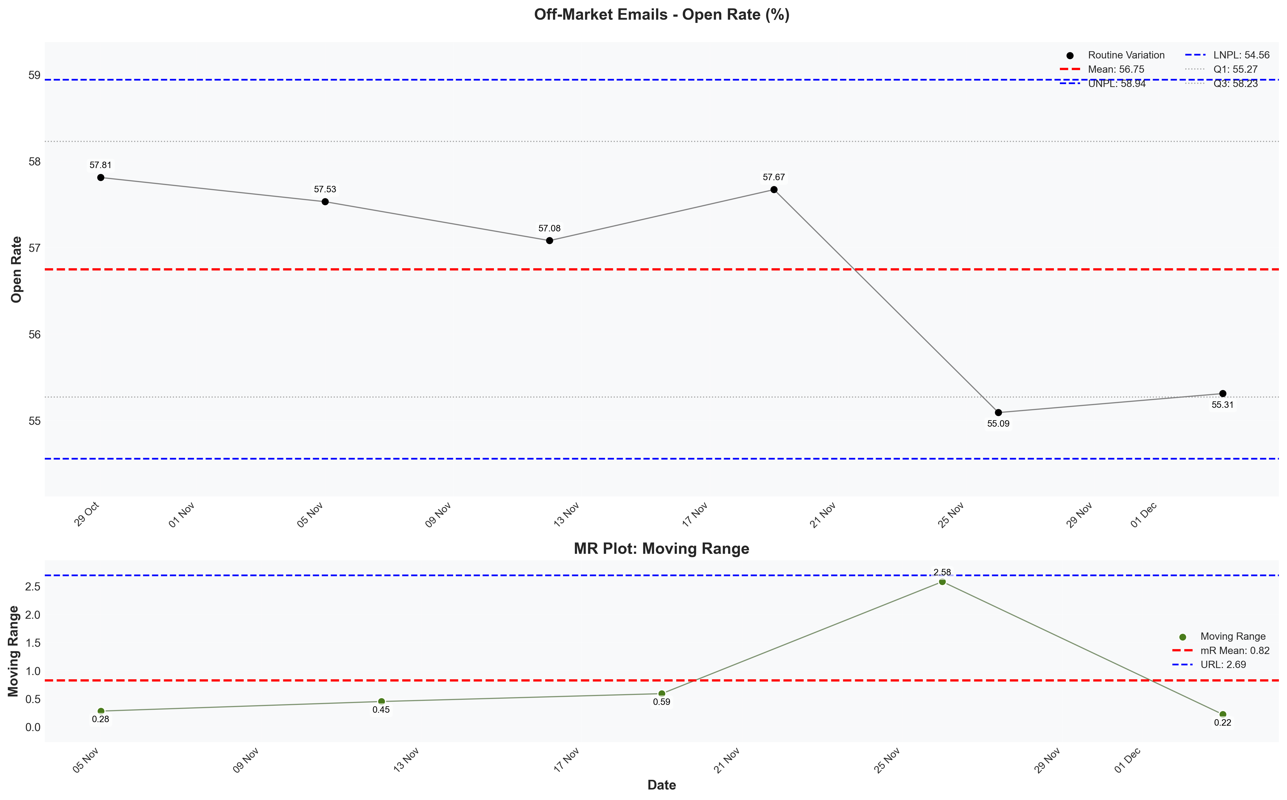
visualizations/newsletter_series_weekly/offmarket_open_rate.png
Source: outputs/newsletter_series/03_offmarket_emails.csv
Insights:
Current week: 55.31% (up 0.40% WoW from 55.09%) (favorable)
6-week average: 56.75% — classification: Normal
Trends: 6wk ↓ Falling
Off-Market Verified CTR
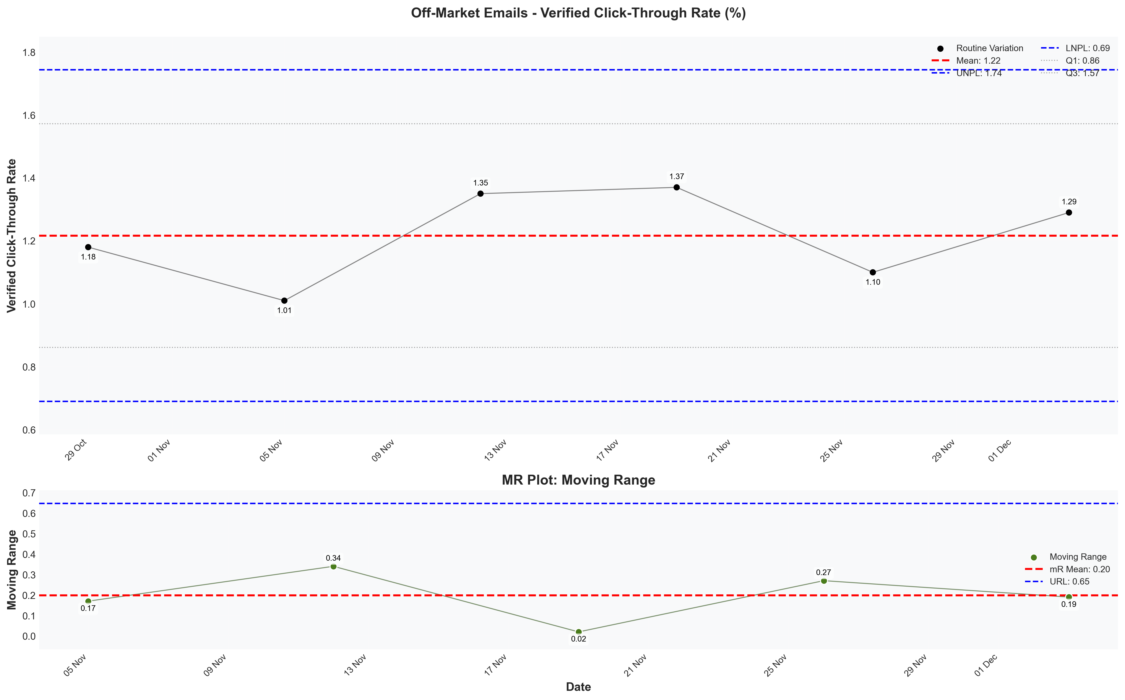
visualizations/newsletter_series_weekly/offmarket_verified_ctr.png
Source: outputs/newsletter_series/03_offmarket_emails.csv
Insights:
Current week: 1.29% (up 17.27% WoW from 1.10%) (favorable)
6-week average: 1.22% — classification: Normal
Trends: 6wk → Stable
Off-Market Unsubscribe Rate
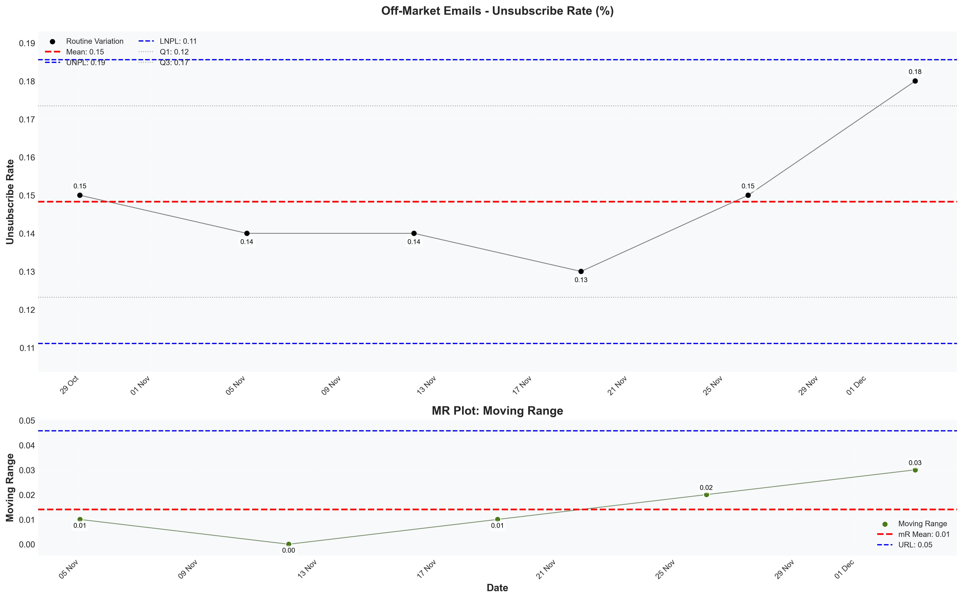
visualizations/newsletter_series_weekly/offmarket_unsubscribe_rate.png
Source: outputs/newsletter_series/03_offmarket_emails.csv
Insights:
Current week: 0.18% (up 20.00% WoW from 0.15%) (unfavorable)
6-week average: 0.15% — classification: High CV vs 6Wk Avg
Trends: 6wk → Stable

Newsletter Series: Podcasts
Podcast Open Rate
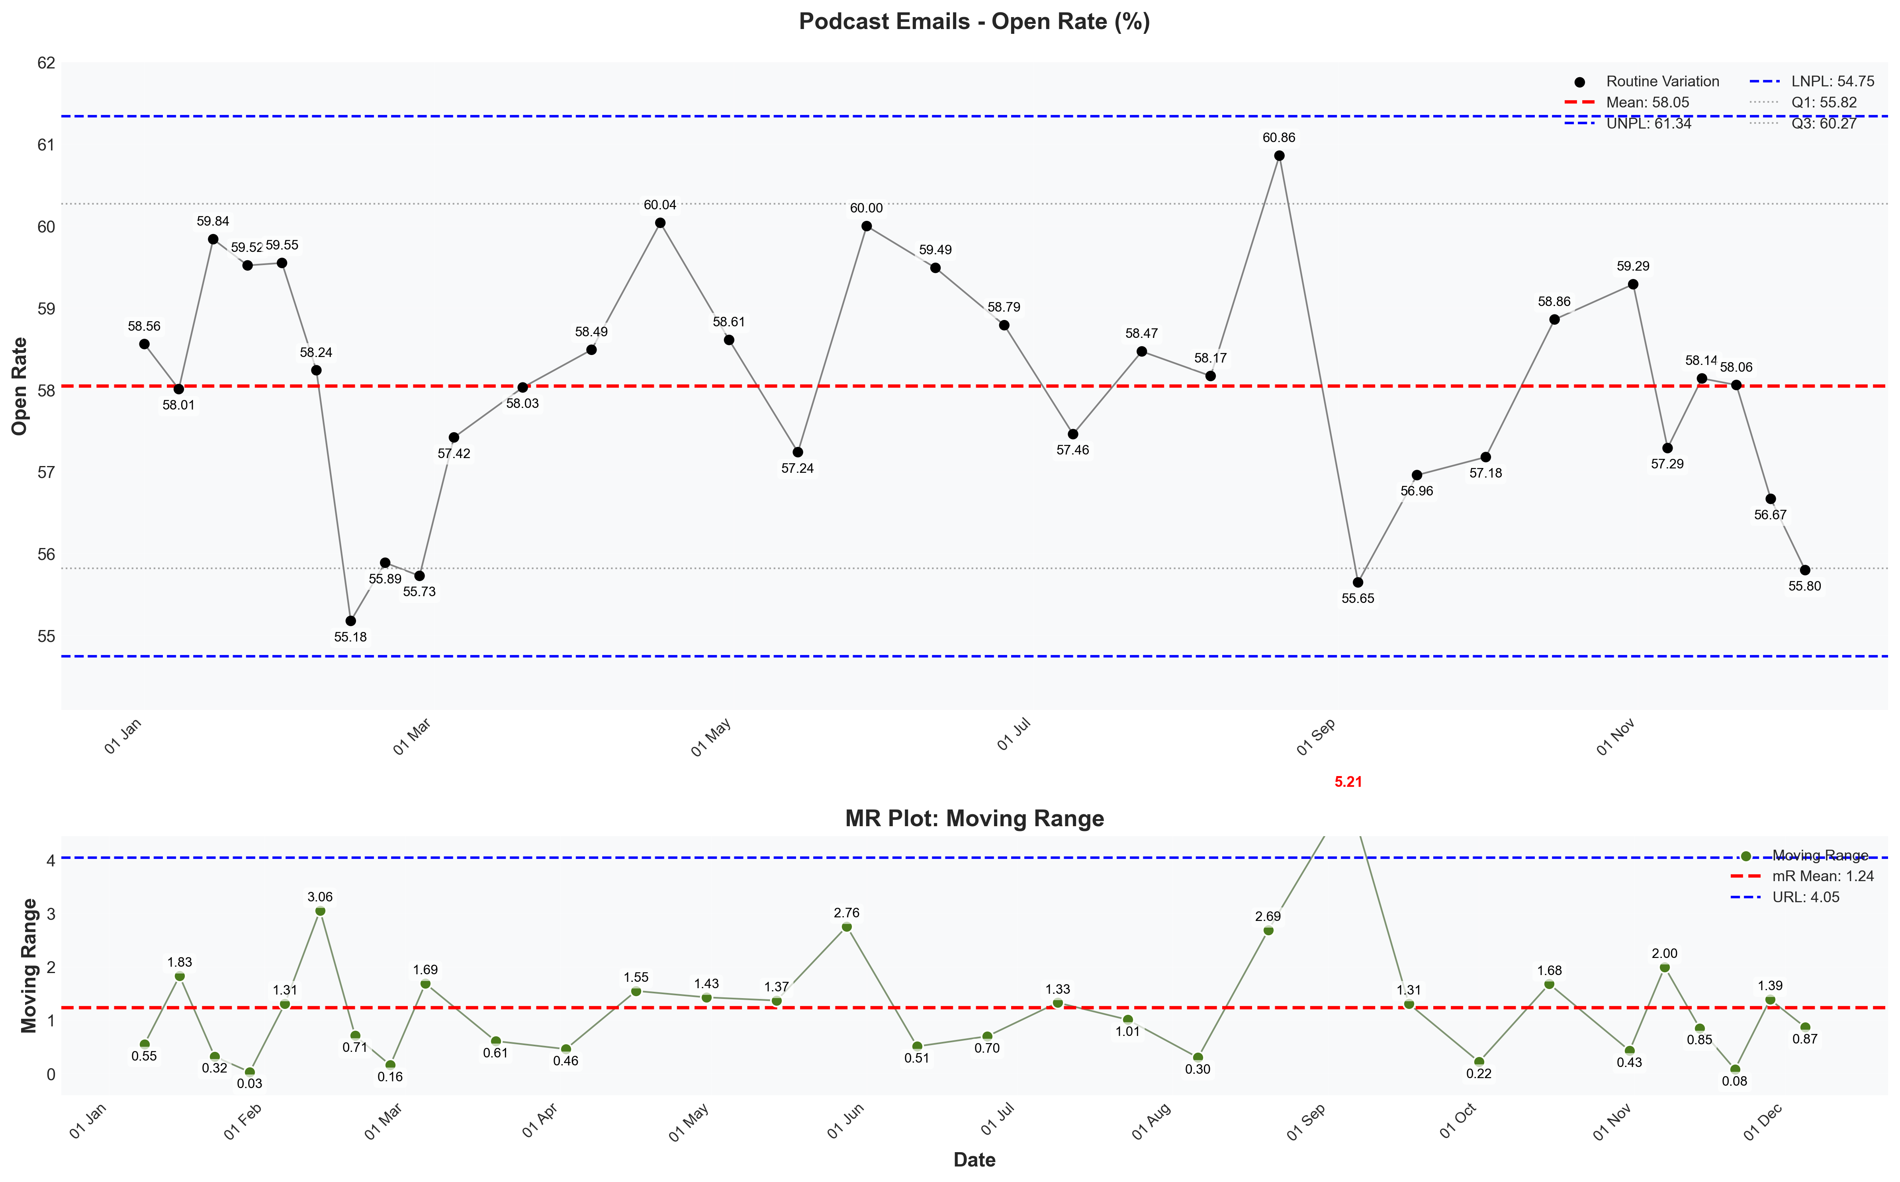
visualizations/newsletter_series_weekly/podcast_open_rate.png
Source: outputs/newsletter_series/04_podcast_emails.csv
Insights:
Current week: 55.80% (down 1.54% WoW from 56.67%) (unfavorable)
6-week average: 57.54% — classification: Normal
Trends: 6wk ↓ Falling | 12wk → Stable | 24wk → Stable
Podcast Verified CTR
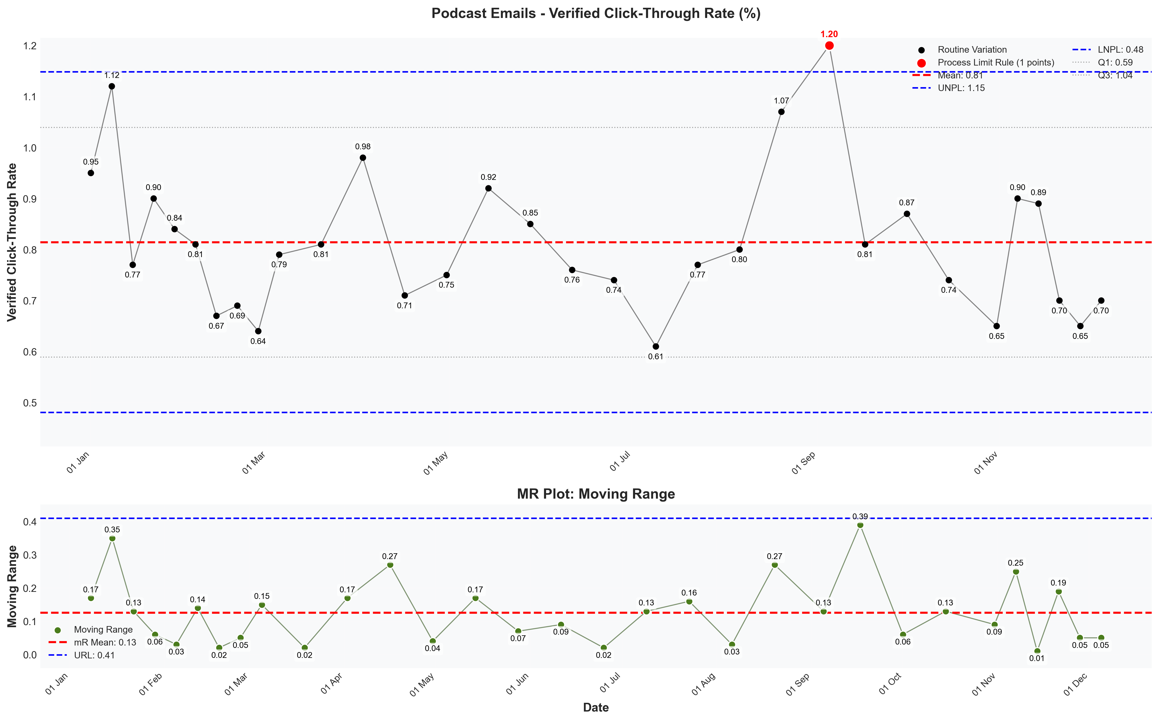
visualizations/newsletter_series_weekly/podcast_verified_ctr.png
Source: outputs/newsletter_series/04_podcast_emails.csv
Insights:
Current week: 0.70% (up 7.69% WoW from 0.65%) (favorable)
6-week average: 0.75% — classification: Normal
Trends: 6wk ↓ Falling | 12wk ↓ Falling | 24wk ↑ Rising
Podcast Unsubscribe Rate
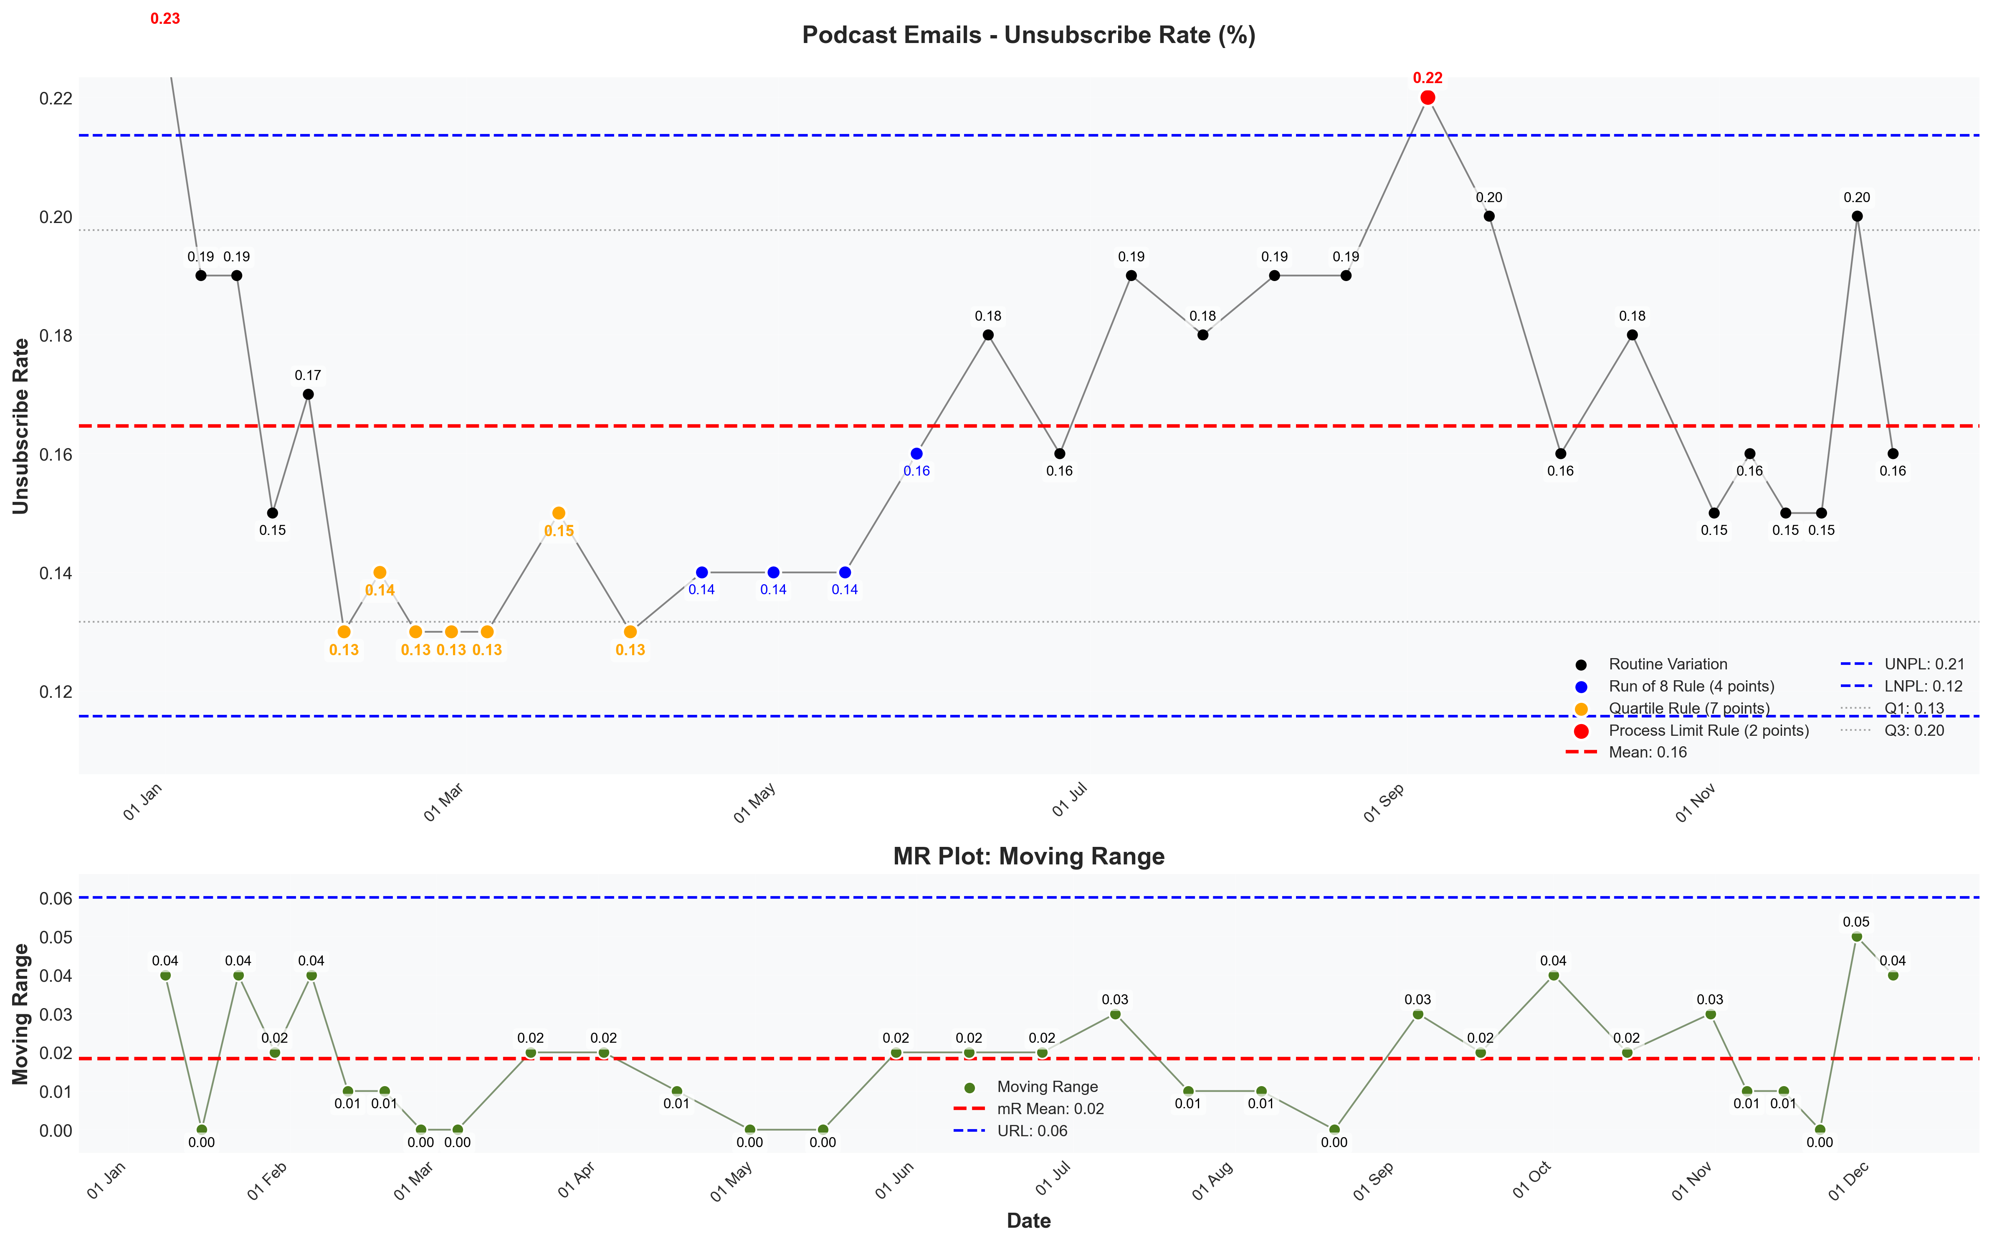
visualizations/newsletter_series_weekly/podcast_unsubscribe_rate.png
Source: outputs/newsletter_series/04_podcast_emails.csv
Insights:
Current week: 0.16% (down 20.00% WoW from 0.20%) (favorable)
6-week average: 0.16% — classification: Normal
Trends: 6wk ↑ Rising | 12wk ↓ Falling | 24wk ↑ Rising

Newsletter Series: Case Study
Case Study Open Rate
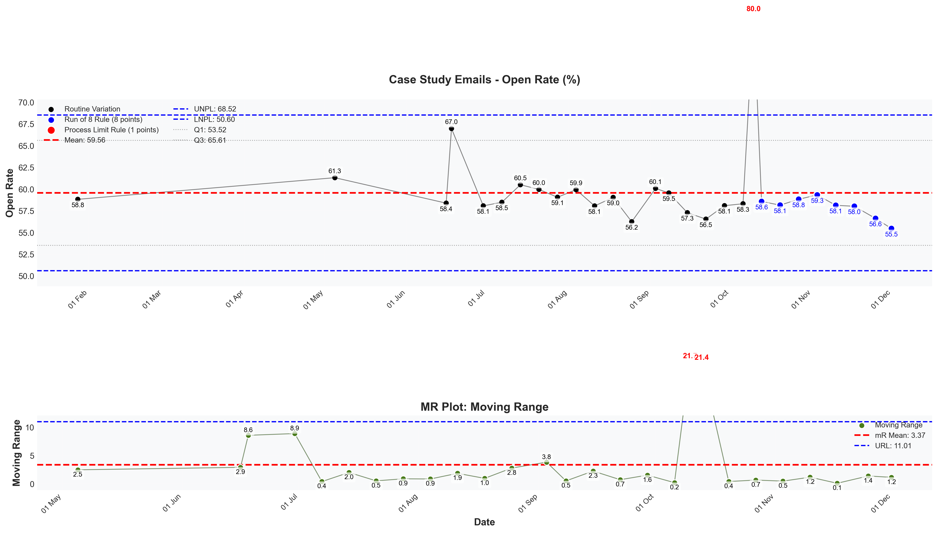
visualizations/newsletter_series_weekly/case_study_open_rate.png
Source: outputs/newsletter_series/01_case_study_emails.csv
Insights:
Current week: 55.46% (down 2.05% WoW from 56.62%) (unfavorable)
6-week average: 57.73% — classification: Normal
Trends: 6wk ↓ Falling | 12wk ↓ Falling | 24wk → Stable
Case Study Verified CTR
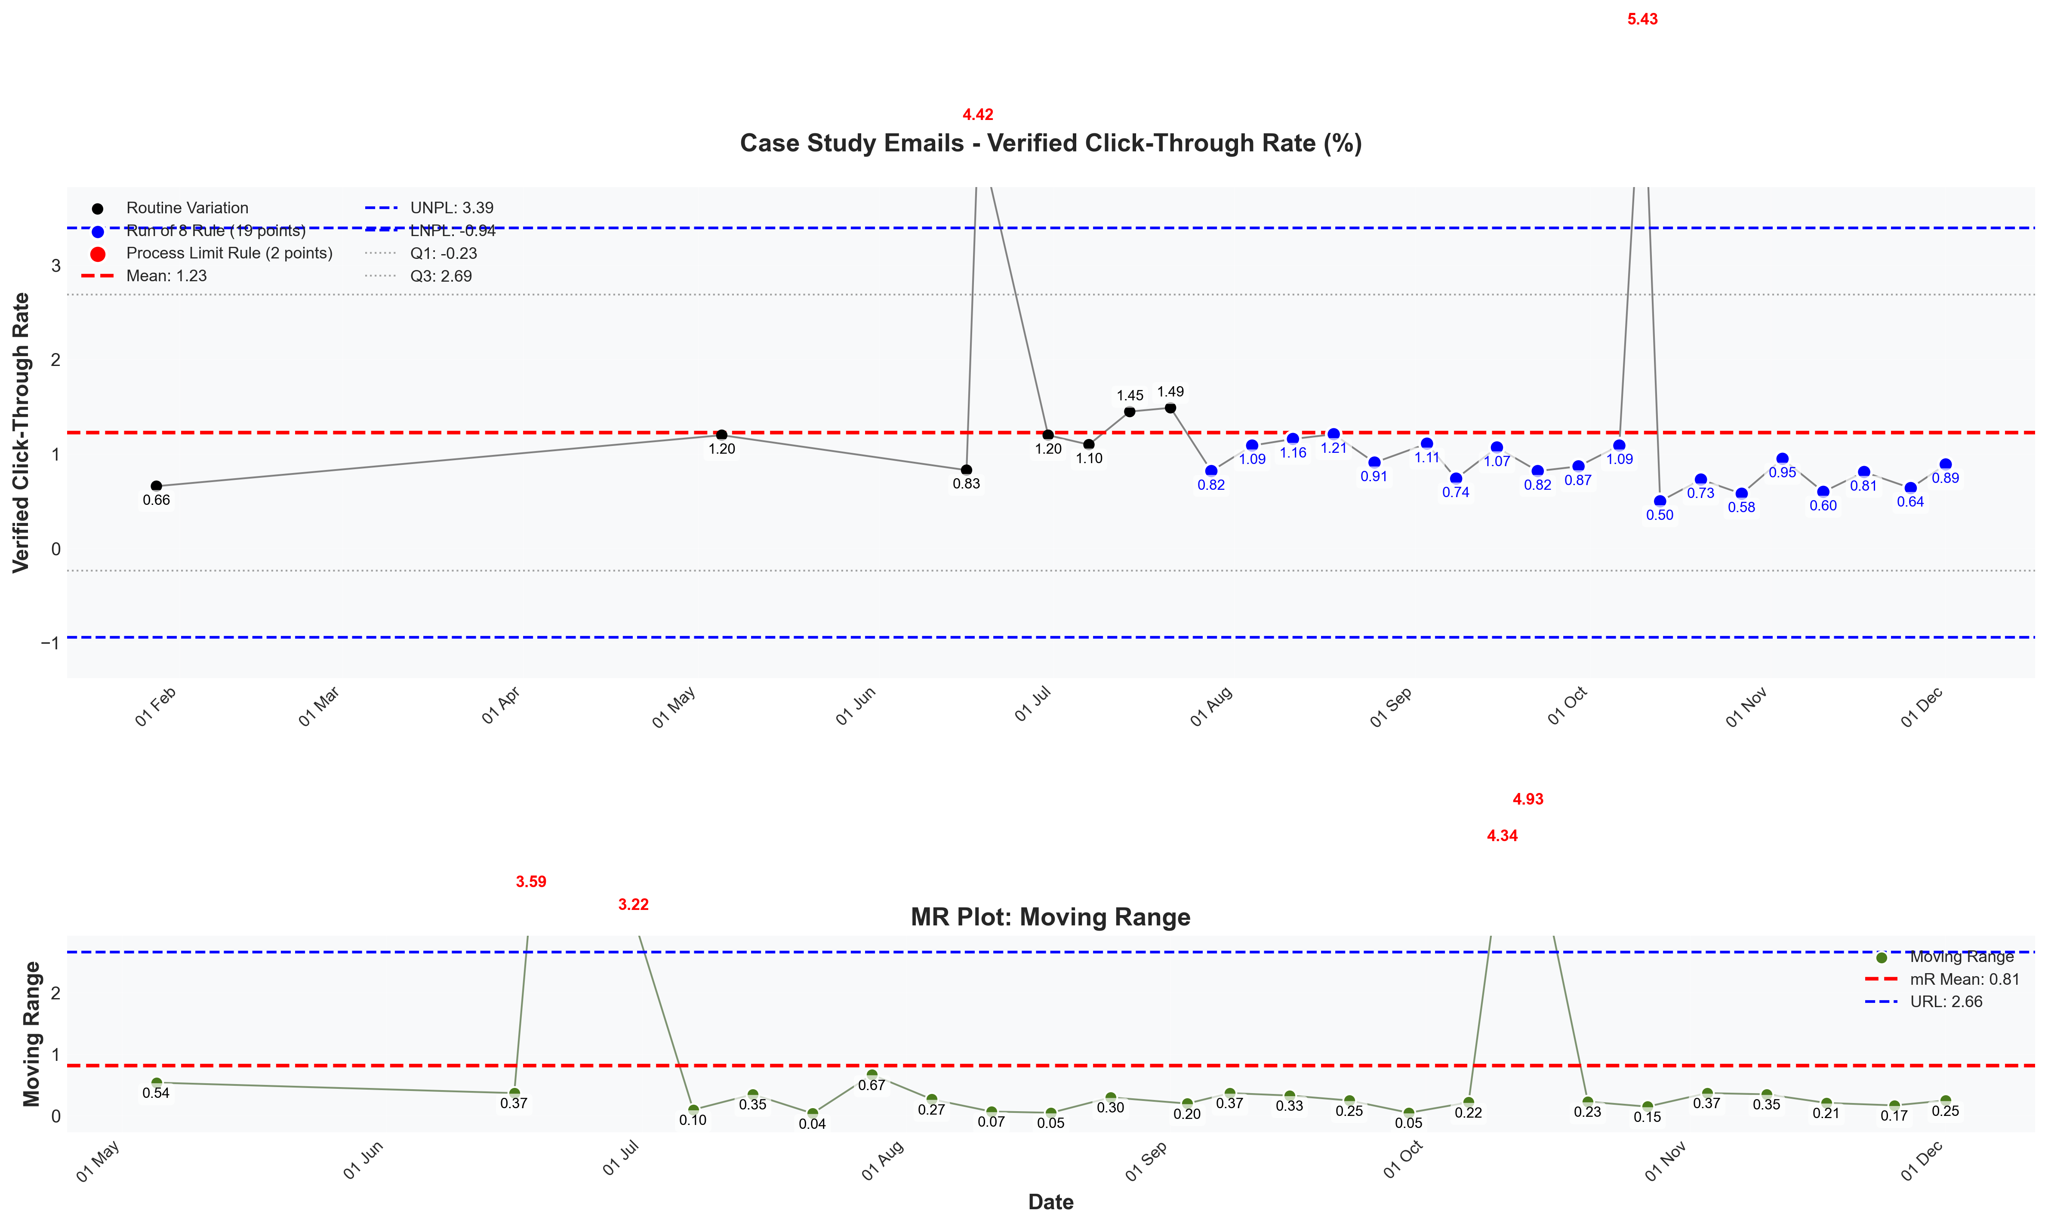
visualizations/newsletter_series_weekly/case_study_verified_ctr.png
Source: outputs/newsletter_series/01_case_study_emails.csv
Insights:
Current week: 0.89% (up 39.06% WoW from 0.64%) (favorable)
6-week average: 0.74% — classification: High CV vs 6Wk Avg
Trends: 6wk ↑ Rising | 12wk ↓ Falling | 24wk → Stable
Case Study Unsubscribe Rate
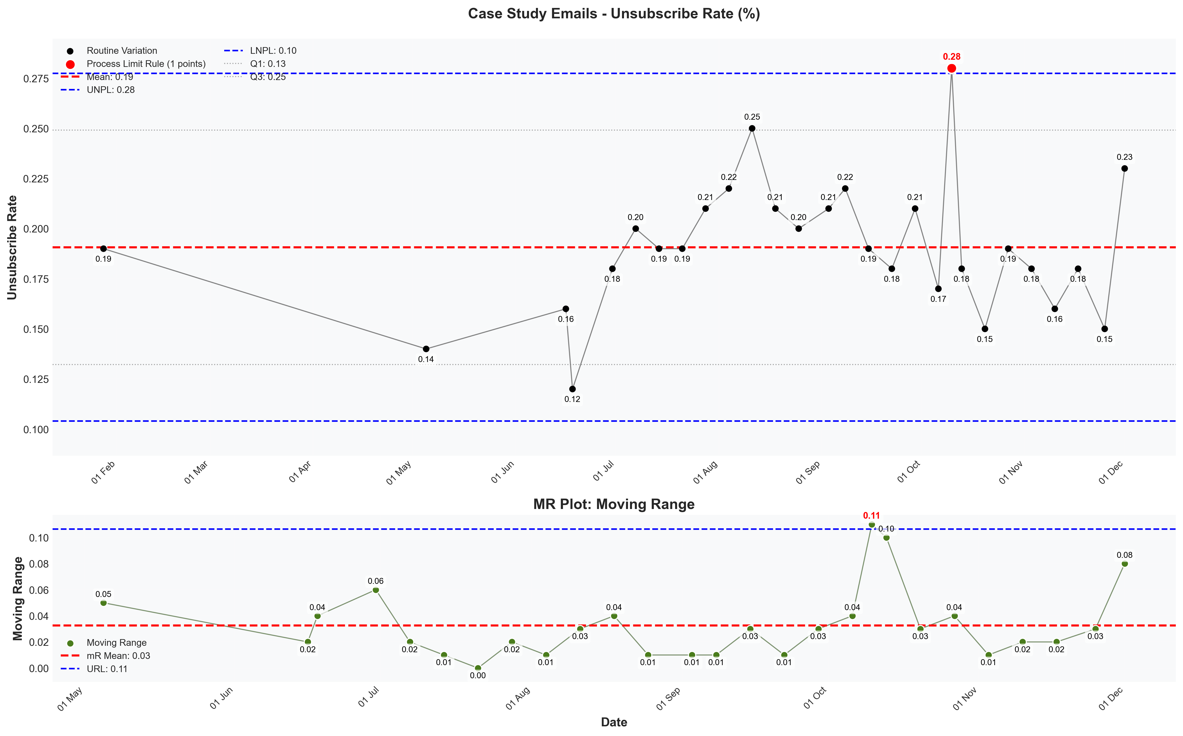
visualizations/newsletter_series_weekly/case_study_unsubscribe_rate.png
Source: outputs/newsletter_series/01_case_study_emails.csv
Insights:
Current week: 0.23% (up 53.33% WoW from 0.15%) (unfavorable)
6-week average: 0.18% — classification: High CV vs 6Wk Avg
Trends: 6wk → Stable | 12wk ↓ Falling | 24wk ↓ Falling

Section 2: Sales Metrics
Core Metrics [Pro Sales] — Weekly Overview (WoW)
Metric | 11/23/2025 - 11/29/2025 | 11/30/2025 - 12/06/2025 | WoW
Visits | 3294 | 4010 | +21.74%
CVR % | 3.94% | 3.29% | -16.50%
Partial Typeform Submissions
Complete Typeform Submissions
Booked Calls (Closers) | 83 | 131 | +57.83%
Follow-up Calls | 28 | 25 | -10.71%
S2C Calls | 16 | 30 | +87.50%
Total Closer Calls Booked | 127 | 186 | +46.46%
Closer Availability | 115 | 247 | +114.78%
Closer Fill Rate | 110.43% | 75.30% | -31.81%
Booked Calls (Setters) | 40 | 61 | +52.50%
Scheduled Calls | 118 | 178 | +50.85%
Live Calls | 79 | 124 | +56.96%
Show Rate | 64.25% | 61.31% | -4.58%
Avg. Days Booked Out | 4.04 | 3.53 | -12.62%
Offers | 52 | 77 | +48.08%
Offer Rate | 58.65% | 56.27% | -4.06%
Closes | 27 | 33 | +22.22%
Offer to Close | 36.2% | 23.83% | -34.17%
Source: outputs/sales_metrics_analysis/weekly_sales_metrics.xlsx
Core Metrics [Pro Sales] — Monthly Overview (MoM)
Metric | 10/01/2025 - 10/28/2025 | 11/01/2025 - 11/28/2025 | MoM/MTD
Visits | 10528 | 15163 | +44.03%
CVR % | 4.0% | 3.33% | -16.75%
Partial Typeform Submissions
Complete Typeform Submissions
Booked Calls (Closers) | 315 | 403 | +27.94%
Booked Calls (Setters) | 89 | 144 | +61.80%
Scheduled Calls | 408 | 493 | +20.83%
Live Calls | 306 | 338 | +10.46%
Show Rate | 70.65% | 56.09% | -20.61%
Average Lead Time | 2.53 | 3.8 | +50.20%
Offers | 200 | 207 | +3.50%
Offer Rate | 59.53% | 47.43% | -20.33%
Closes | 65 | 67 | +3.08%
Offer to Close | 19.97% | 23.5% | +17.68%
Source: outputs/sales_metrics_analysis/monthly_sales_metrics.xlsx

Lead Time & Deal Upgrade
Average Lead Time
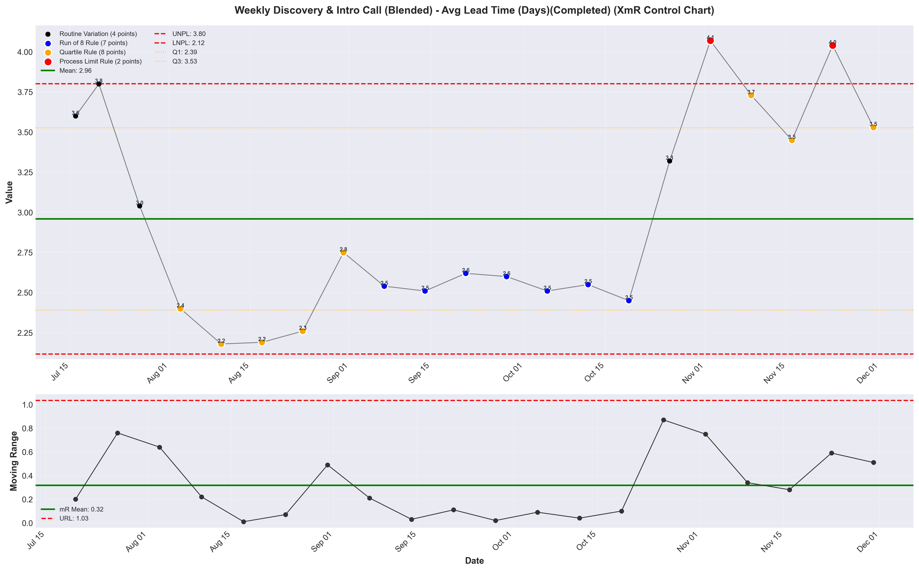
visualizations/discovery_intro_blended_weekly/weekly_avg_lead_time_completed.png
Source: outputs/discovery_intro/weekly_discovery_intro_blended.csv
Insights:
Current week: 3.53 (down 12.62% WoW from 4.04) (unfavorable)
6-week average: 3.69 — classification: Normal
Trends: 6wk → Stable | 12wk ↑ Rising
Deal Upgrade Visits
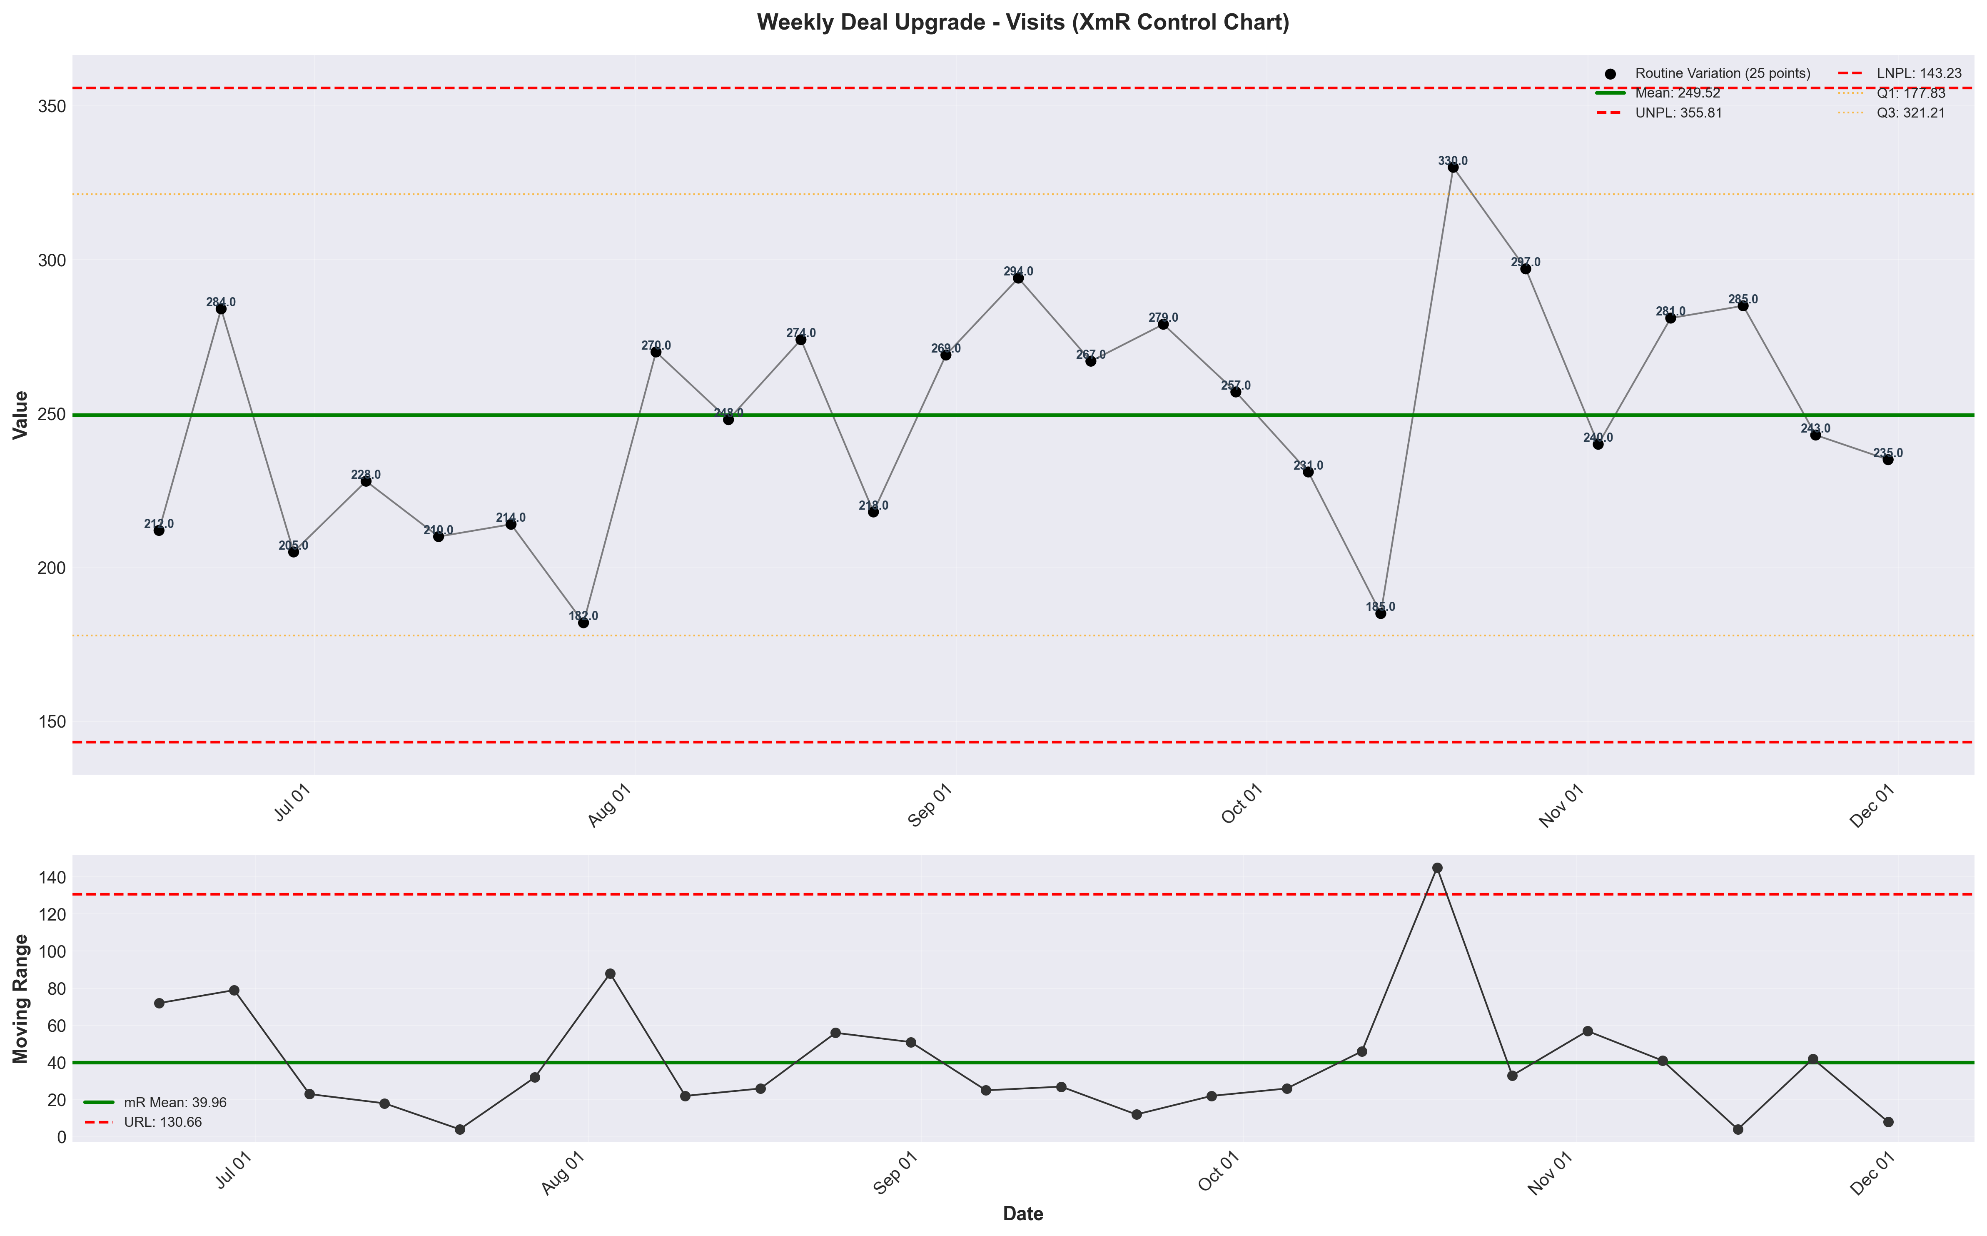
visualizations/deal_upgrade_weekly/weekly_visits.png
Source: outputs/deal_upgrade/weekly_deal_upgrade.csv
Insights:
Current week: 235 (down 3.29% WoW from 243) (unfavorable)
6-week average: 264 — classification: Low CV vs 6Wk Avg
Trends: 6wk → Stable | 12wk → Stable | 24wk ↑ Rising
Deal Upgrade CVR
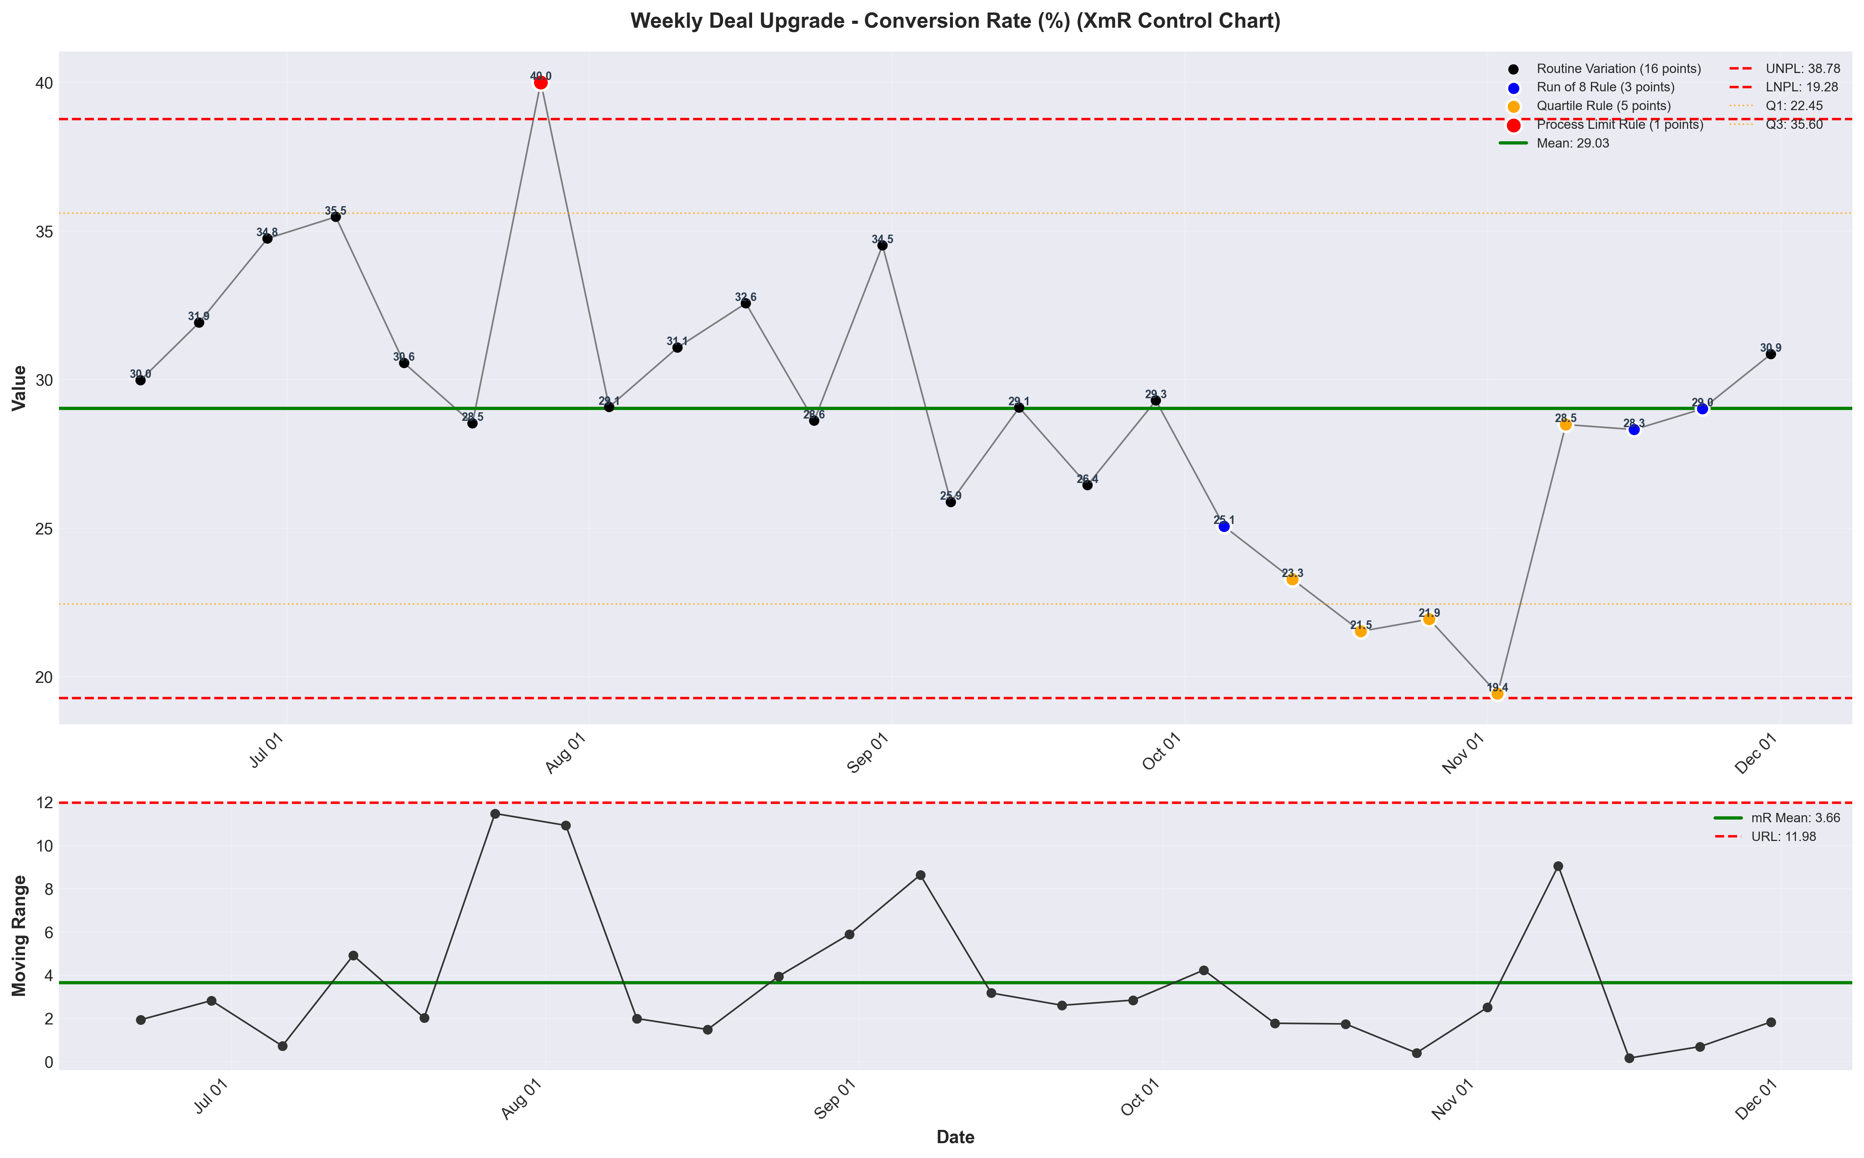
visualizations/deal_upgrade_weekly/weekly_conversion_rate.png
Source: outputs/deal_upgrade/weekly_deal_upgrade.csv
Insights:
Current week: 30.86% (up 6.34% WoW from 29.02%) (favorable)
6-week average: 26.34% — classification: High CV vs 6Wk Avg
Trends: 6wk ↑ Rising | 12wk → Stable | 24wk ↓ Falling

Pro Site Funnel
Pro Site Visits
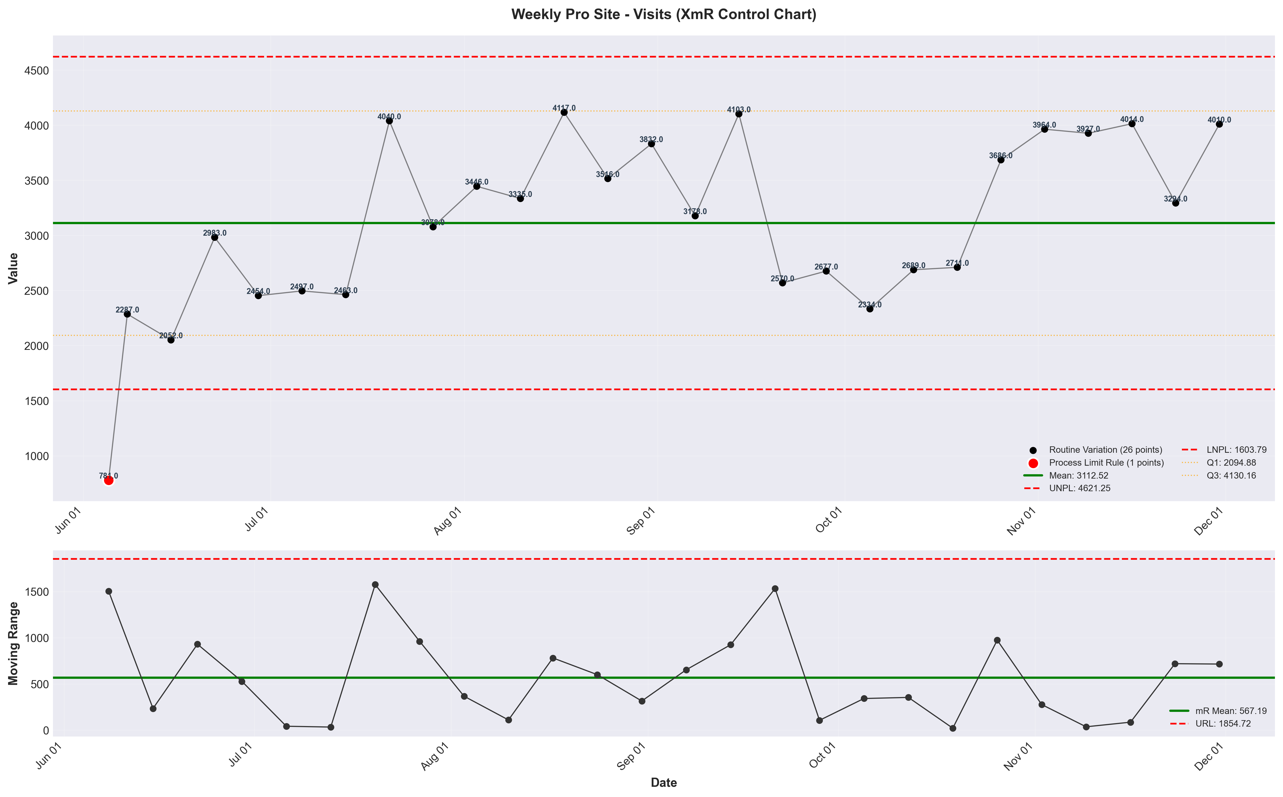
visualizations/pro_site_weekly/weekly_visits.png
Source: outputs/pro_site/weekly_pro_site.csv
Insights:
Current week: 4,010 (up 21.74% WoW from 3,294) (favorable)
6-week average: 3,816 — classification: Normal
Trends: 6wk → Stable | 12wk ↑ Rising | 24wk → Stable
Pro Site CVR
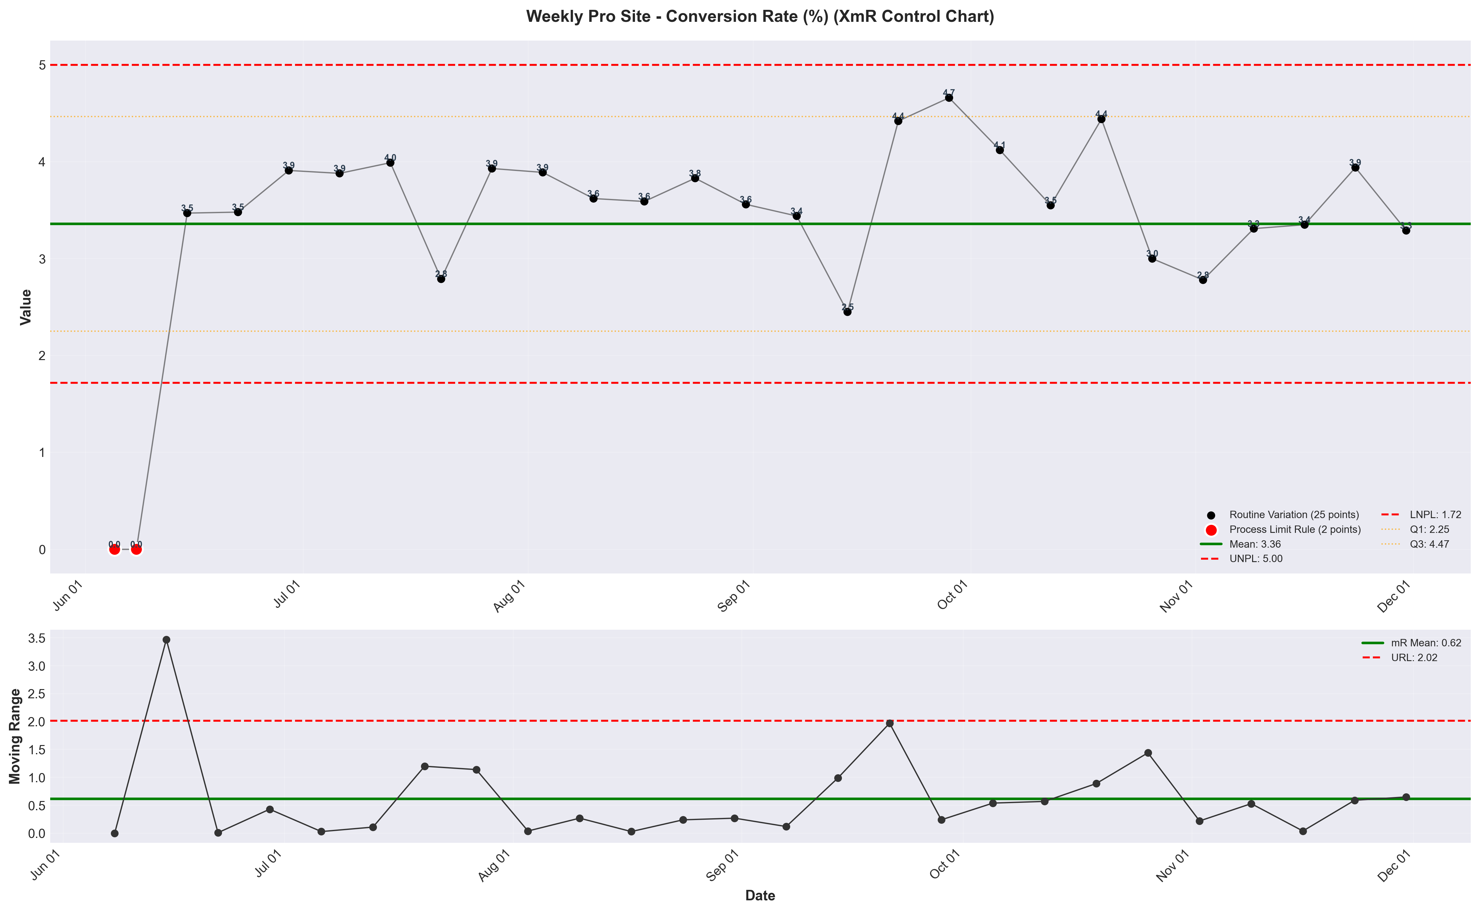
visualizations/pro_site_weekly/weekly_conversion_rate.png
Source: outputs/pro_site/weekly_pro_site.csv
Insights:
Current week: 3.29% (down 16.50% WoW from 3.94%) (unfavorable)
6-week average: 3.28% — classification: Normal
Trends: 6wk ↑ Rising | 12wk ↓ Falling | 24wk → Stable

Booked Calls
Booked Calls - Closers (Discovery Call)
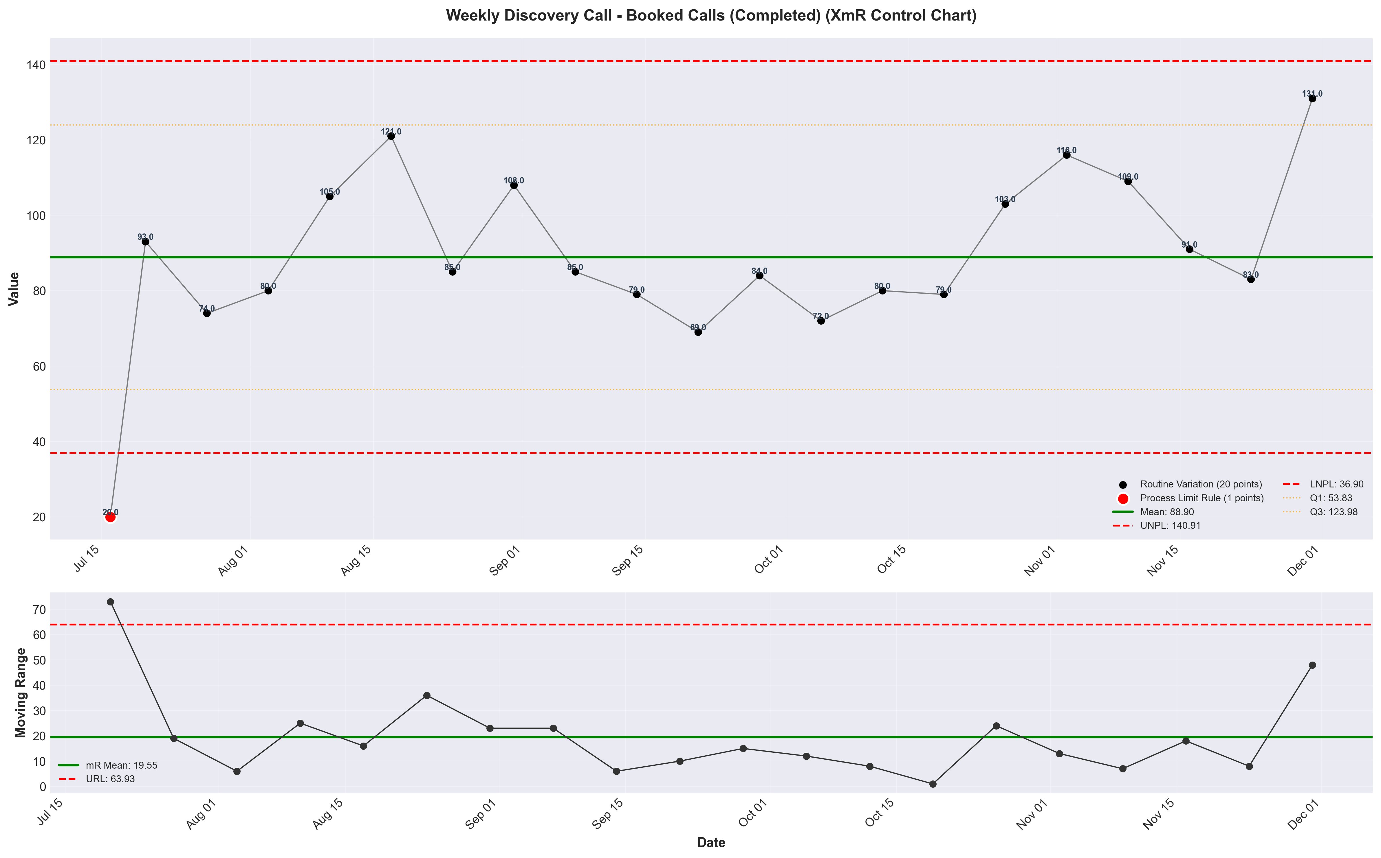
visualizations/discovery_call_weekly/weekly_booked_calls_completed.png
Source: outputs/discovery_intro/weekly_discovery_call.csv
Insights:
Current week: 131 (up 57.83% WoW from 83.00) (favorable)
6-week average: 106 — classification: High CV vs 6Wk Avg
Trends: 6wk → Stable | 12wk ↑ Rising
Booked Calls - Setters (Intro Call)
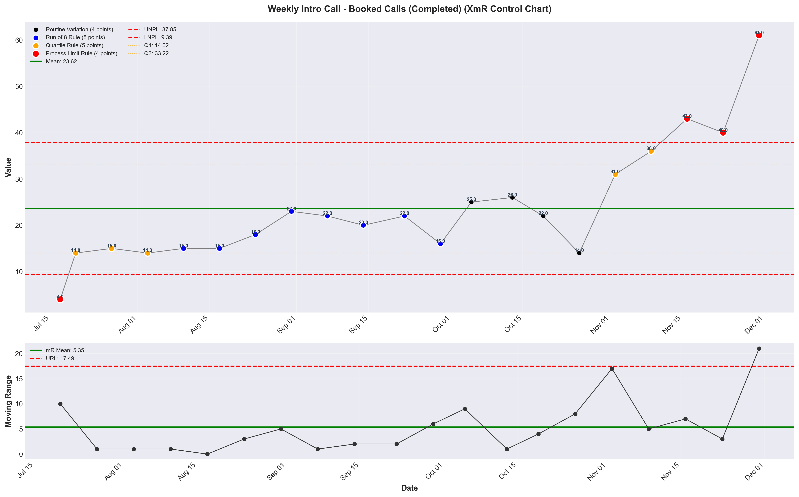
visualizations/intro_call_weekly/weekly_booked_calls_completed.png
Source: outputs/discovery_intro/weekly_intro_call.csv
Insights:
Current week: 61.00 (up 52.50% WoW from 40.00) (favorable)
6-week average: 37.50 — classification: High CV vs 6Wk Avg
Trends: 6wk ↑ Rising | 12wk ↑ Rising

Sales Pipeline: Calls
Scheduled Calls
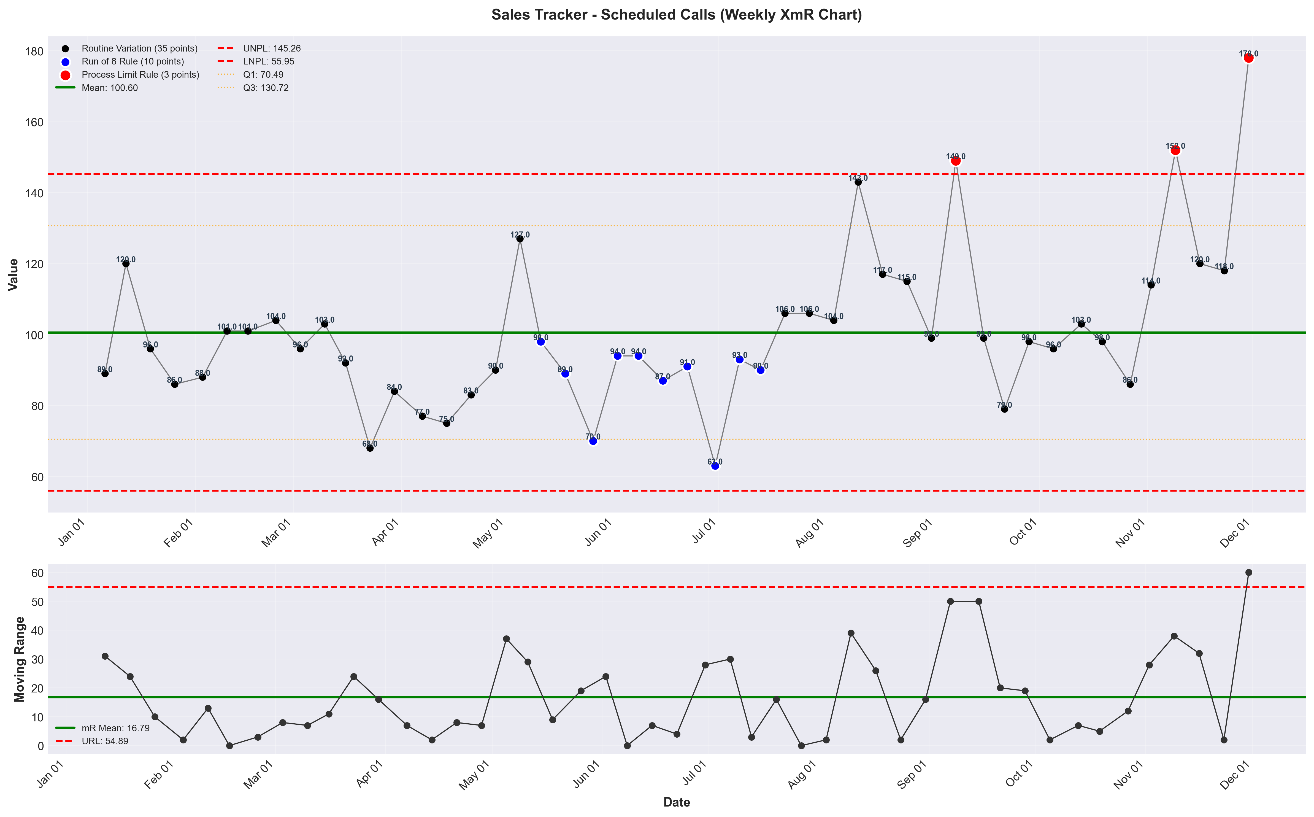
visualizations/sales_tracker_weekly/weekly_sched_calls.png
Source: outputs/sales_tracker/weekly_sales_tracker.csv
Insights:
Current week: 178 (up 50.85% WoW from 118) (favorable)
6-week average: 128 — classification: High CV vs 6Wk Avg
Trends: 6wk ↑ Rising | 12wk ↑ Rising | 24wk ↑ Rising
Live Calls
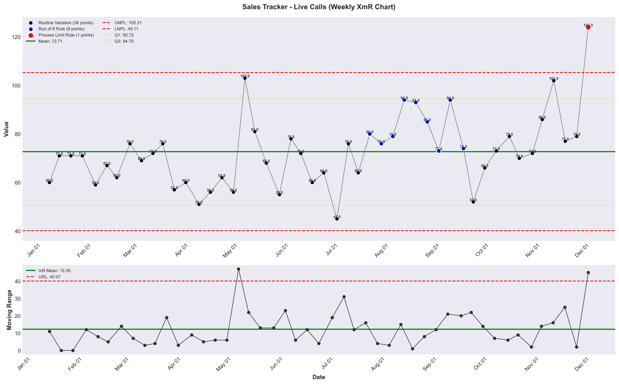
visualizations/sales_tracker_weekly/weekly_live_calls.png
Source: outputs/sales_tracker/weekly_sales_tracker.csv
Insights:
Current week: 124 (up 56.96% WoW from 79.00) (favorable)
6-week average: 90.00 — classification: High CV vs 6Wk Avg
Trends: 6wk → Stable | 12wk ↑ Rising | 24wk ↑ Rising
Show Rate
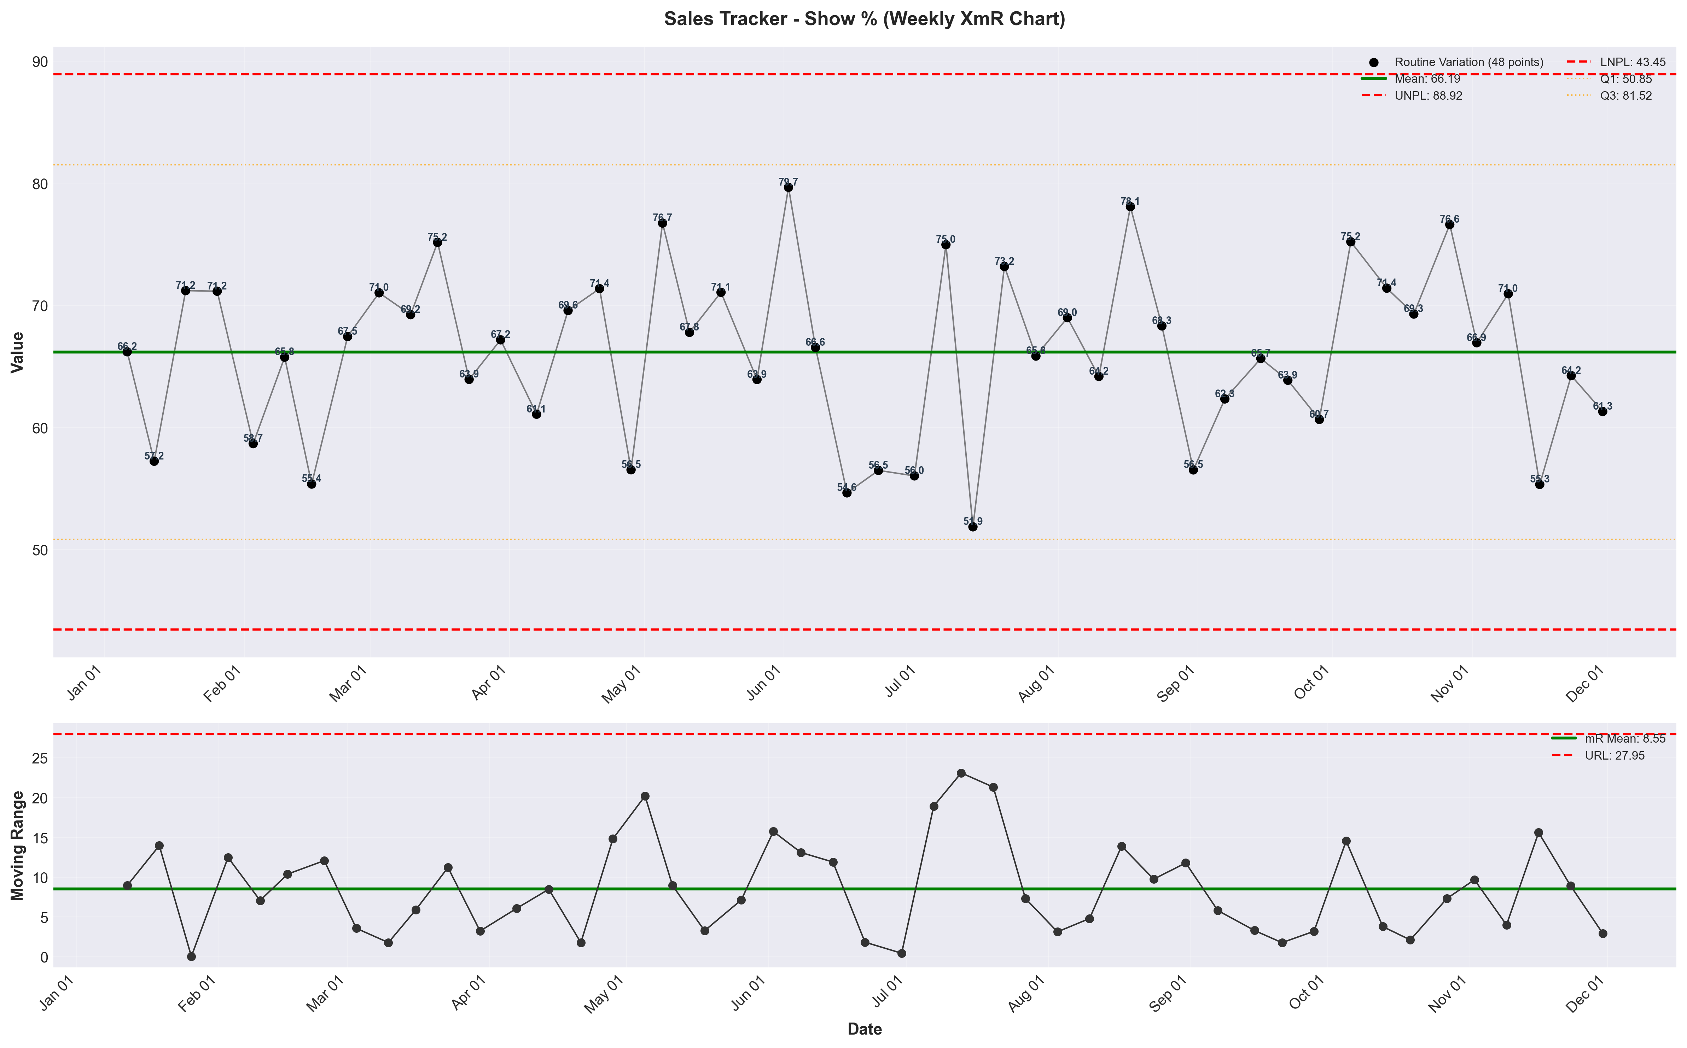
visualizations/sales_tracker_weekly/weekly_show_pct.png
Source: outputs/sales_tracker/weekly_sales_tracker.csv
Insights:
Current week: 61.31% (down 4.58% WoW from 64.25%) (unfavorable)
6-week average: 65.90% — classification: Normal
Trends: 6wk ↓ Falling | 12wk → Stable | 24wk → Stable

Offers
Offers
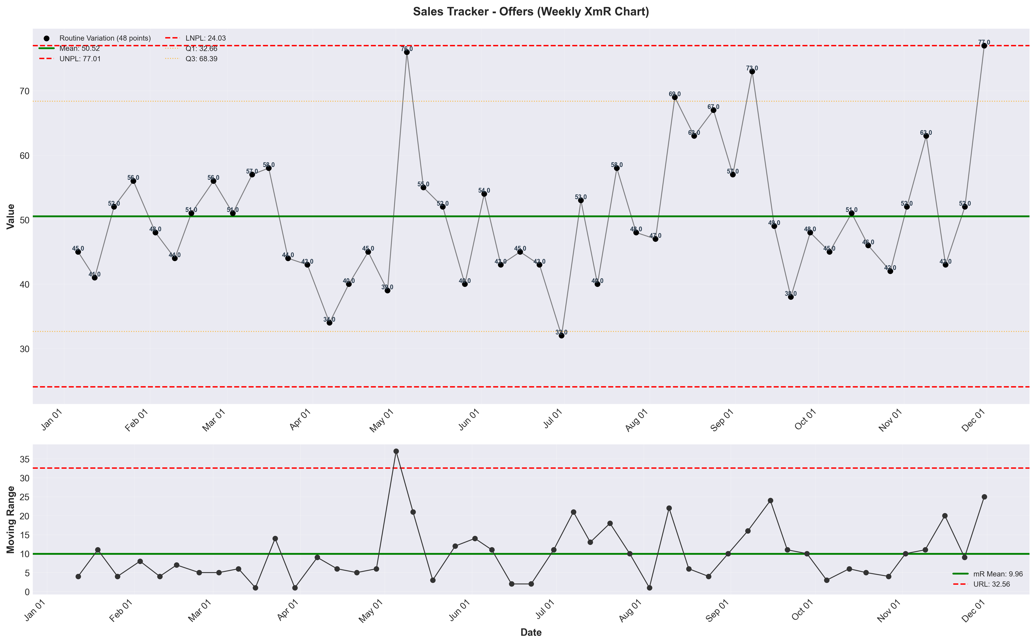
visualizations/sales_tracker_weekly/weekly_offers.png
Source: outputs/sales_tracker/weekly_sales_tracker.csv
Insights:
Current week: 77.00 (up 48.08% WoW from 52.00) (favorable)
6-week average: 54.83 — classification: High CV vs 6Wk Avg
Trends: 6wk ↑ Rising | 12wk ↑ Rising | 24wk ↓ Falling
Offer Rate
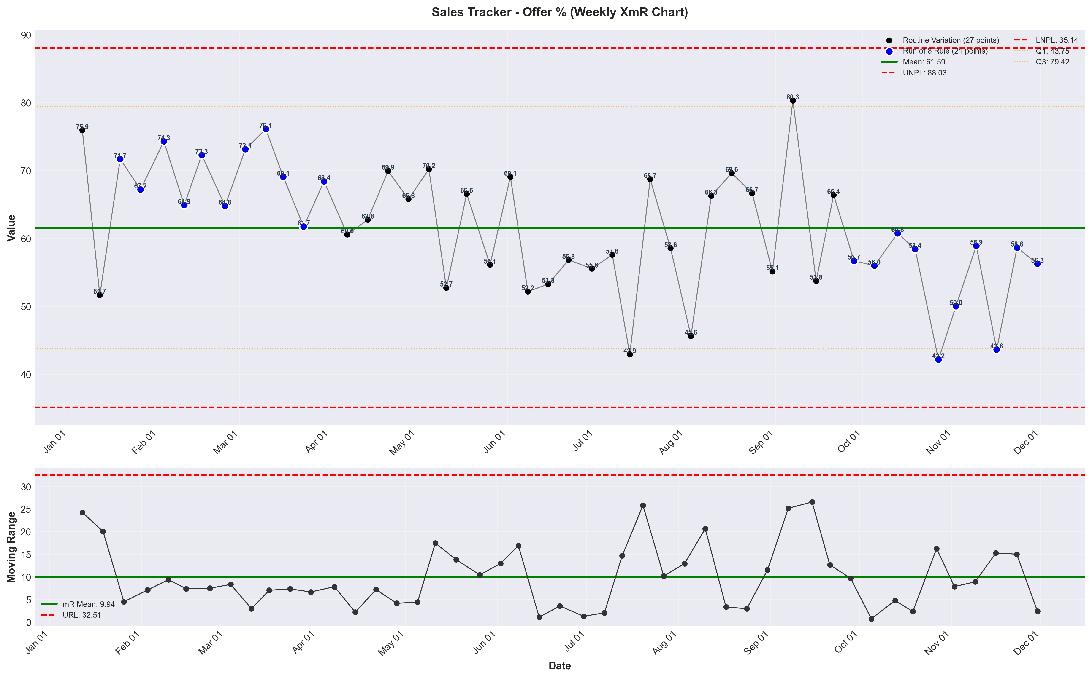
visualizations/sales_tracker_weekly/weekly_offer_pct.png
Source: outputs/sales_tracker/weekly_sales_tracker.csv
Insights:
Current week: 56.27% (down 4.06% WoW from 58.65%) (unfavorable)
6-week average: 51.61% — classification: Normal
Trends: 6wk → Stable | 12wk ↓ Falling | 24wk ↓ Falling

Closes
Closes
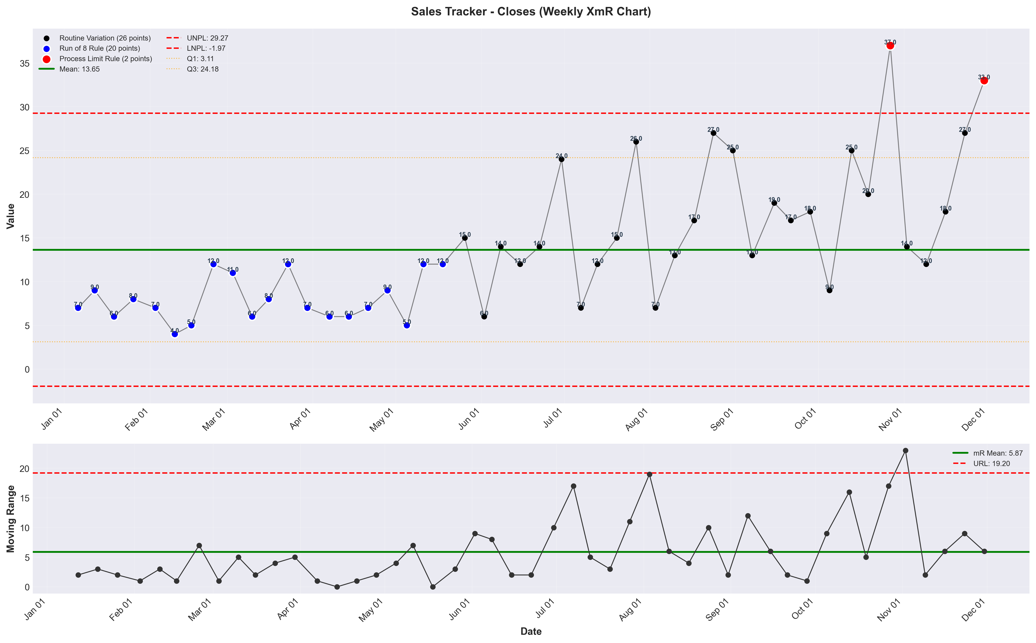
visualizations/sales_tracker_weekly/weekly_close_1.png
Source: outputs/sales_tracker/weekly_sales_tracker.csv
Insights:
Current week: 33.00 (up 22.22% WoW from 27.00) (favorable)
6-week average: 23.50 — classification: High CV vs 6Wk Avg
Trends: 6wk ↑ Rising | 12wk ↑ Rising | 24wk ↑ Rising
Offer to Close Rate
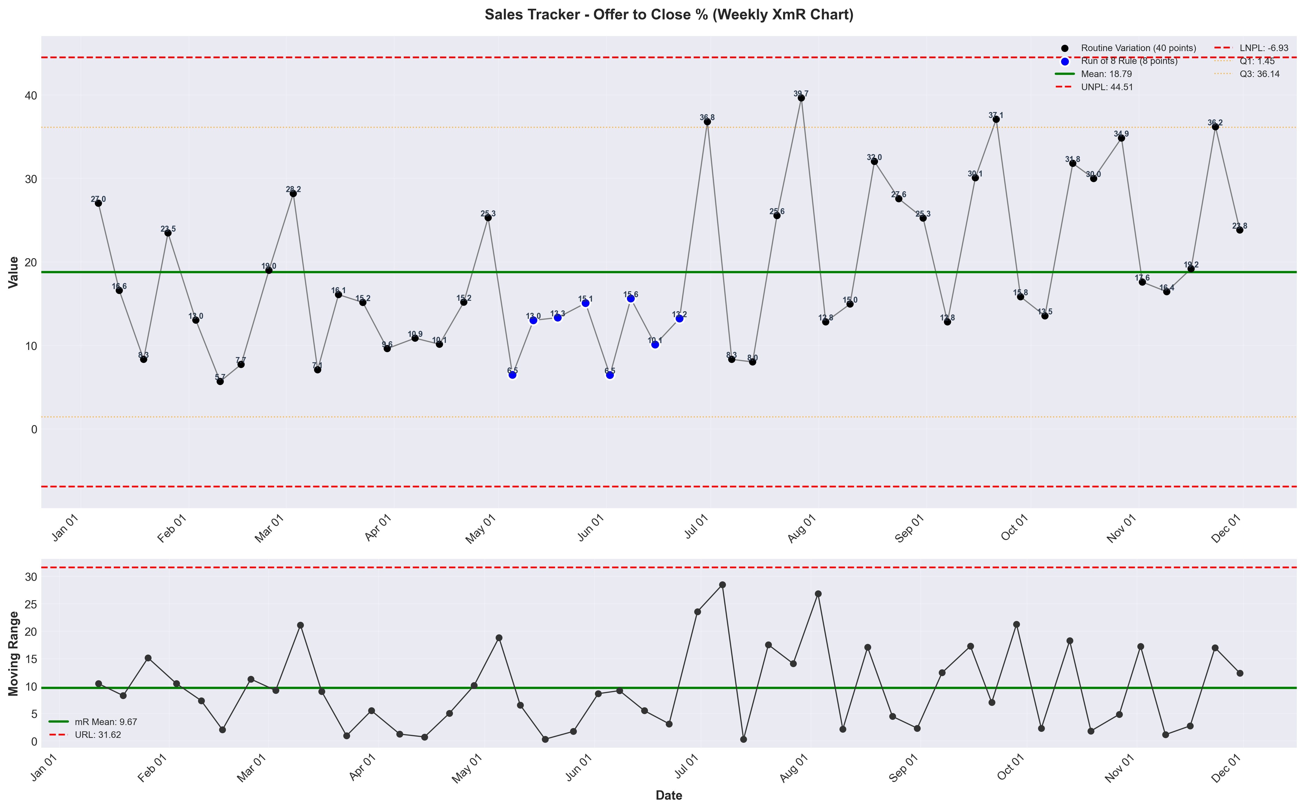
visualizations/sales_tracker_weekly/weekly_offer_to_close_pct.png
Source: outputs/sales_tracker/weekly_sales_tracker.csv
Insights:
Current week: 23.83% (down 34.17% WoW from 36.20%) (unfavorable)
6-week average: 24.68% — classification: Normal
Trends: 6wk ↑ Rising | 12wk ↓ Falling | 24wk ↑ Rising

