**Maria Angel Palacios Sarmiento**

**PROJECT 1**

**CS-341-002**

**When string is 0:**

**When string has no valid characters, from input alphabet:**



**Case 1:**

**Case 2:**

**Case 3:**

**Csse 4:**

**Case 5:**

**Case 6:**

**Case 7:**

**Case 8:**

**Case 9:**

**Case 10:**

**Case 11:**

**Case 12:**

**Case 13:**

**Case 14:**

**Case 15:**

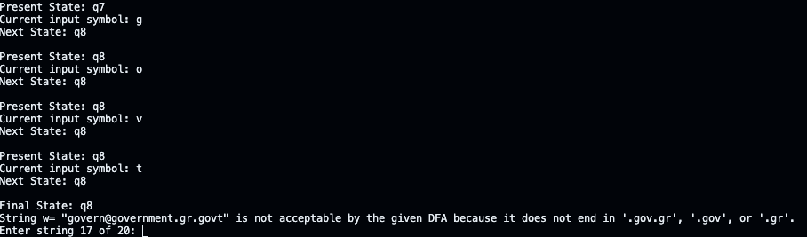

**Case 17:**

**Case 18:**

**Case 19:**

**Case 20:**

