1. What is the difference between Vectors and Matrices?
   1. A vector is a row or column of numbers (r x 1, c x 1)
   2. A matrix is a 2 dimensional vector (m x n)
2. What are the assumptions of a Linear Regression?
   1. No multi collinearity
   2. The relationship between independent and dependent variable is linear
   3. The residuals of a linear regression follows normal distribution
3. Gradient Descent is an optimization algorithm
4. For linear regression, a mean squared error is a convex function and that is why Gradient Descent helps to optimize the cost function by subtraction.
5. Logistic Regression is a binary classification algorithm.
   1. 1/1+expt
   2. Cost function = $f\left(x\right)=-\frac{1}{m}\sum{y\left(i\right)\log\left(y\left(i^\right)\right)+(1-y\left(i\right))(1-log⁡(y\left(i^\right))}$
6. Softmax Regression is a multinomial classification algorithm

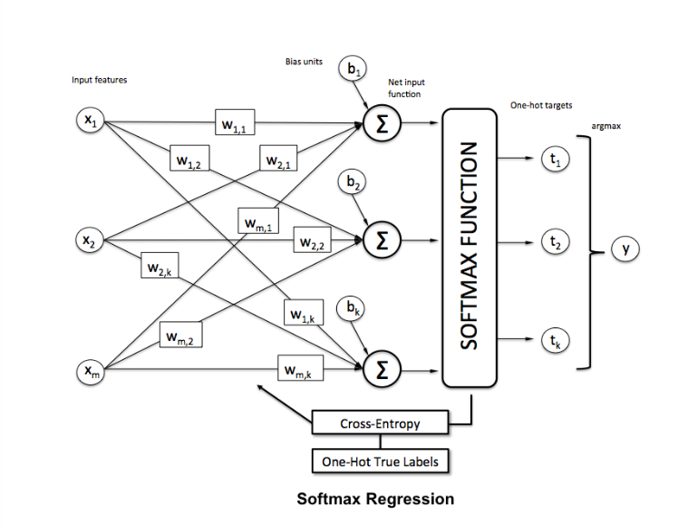

1. Good link for understanding Softmax Regression
   1. <https://www.kdnuggets.com/2016/07/softmax-regression-related-logistic-regression.html>
2. Numpy Reference Manual (Answer in ChatGPT)

The NumPy library is a powerful numerical computing library for Python. It provides a wide range of functions and methods for working with arrays and matrices, as well as mathematical operations, linear algebra functions, random number generation, and more. While I can't provide the full NumPy reference manual here, I can give you an overview of some key components and functionalities of the library.

1. NumPy Arrays:
   * Creating Arrays: np.array, np.zeros, np.ones, np.arange, np.linspace
   * Array Attributes: shape, ndim, dtype, size
   * Indexing and Slicing: array indexing, array slicing
   * Array Operations: element-wise operations, array broadcasting
   * Array Methods: reshape, transpose, flatten, concatenate, split, sort
2. Mathematical Functions:
   * Universal Functions (ufuncs): np.add, np.subtract, np.multiply, np.divide, np.exp, np.log, np.sin, np.cos, etc.
   * Linear Algebra: np.dot, np.matmul, np.linalg.inv, np.linalg.det, np.linalg.eig, np.linalg.svd, np.linalg.solve, etc.
3. Random Number Generation:
   * Simple Random Data: np.random.rand, np.random.randn, np.random.randint
   * Random Permutations: np.random.shuffle, np.random.permutation
   * Distributions: np.random.normal, np.random.uniform, np.random.binomial, np.random.choice, etc.
4. Array Manipulation:
   * Shape Manipulation: np.reshape, np.resize, np.transpose, np.squeeze
   * Joining and Splitting: np.concatenate, np.vstack, np.hstack, np.split
   * Adding and Removing Elements: np.append, np.insert, np.delete
5. File Input/Output:
   * Loading and Saving Arrays: np.load, np.save, np.savetxt, np.loadtxt
6. Other Functions:
   * Statistical Functions: np.mean, np.median, np.std, np.var, np.min, np.max, np.sum
   * Logical Functions: np.all, np.any, np.logical_and, np.logical_or, np.logical_not
   * Sorting and Searching: np.sort, np.argsort, np.searchsorted
   * Set Operations: np.unique, np.intersect1d, np.union1d, np.setdiff1d

The NumPy library provides a comprehensive set of functions and methods for numerical computing. For detailed information about specific functions and their parameters, I recommend referring to the official NumPy documentation at: <https://numpy.org/doc/1.21/>

Top of Form

Regenerate response

Bottom of Form