* **Creating Test Plan**

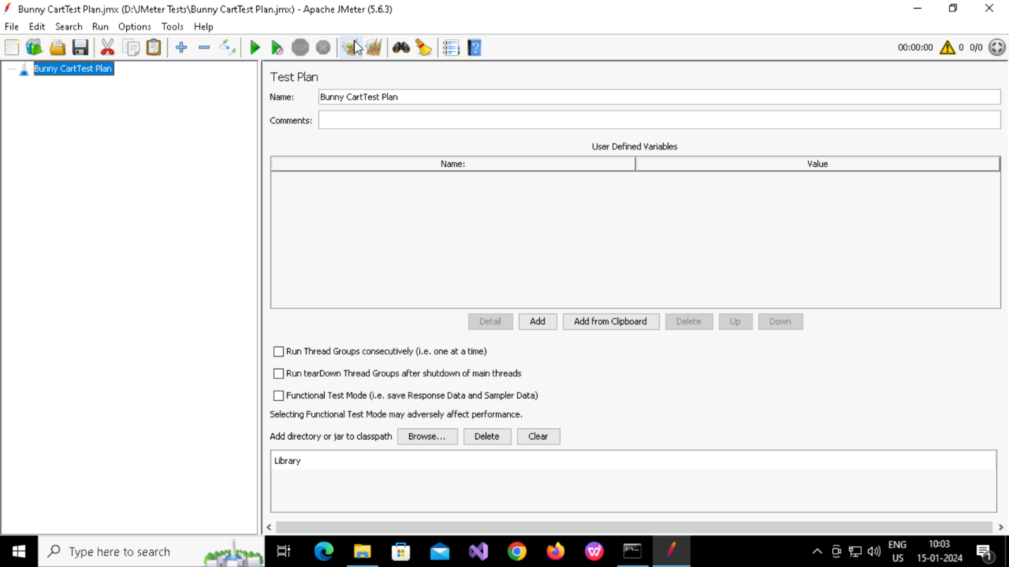

* **Creating Thread Group**

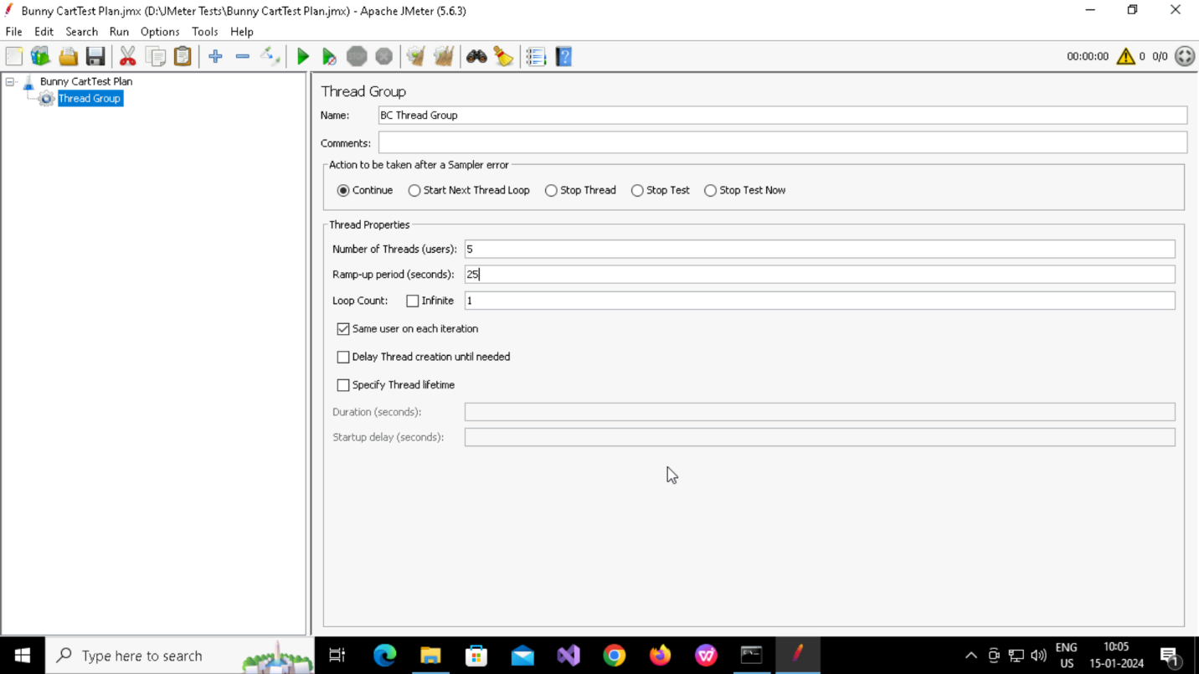

* **Adding Sampler**

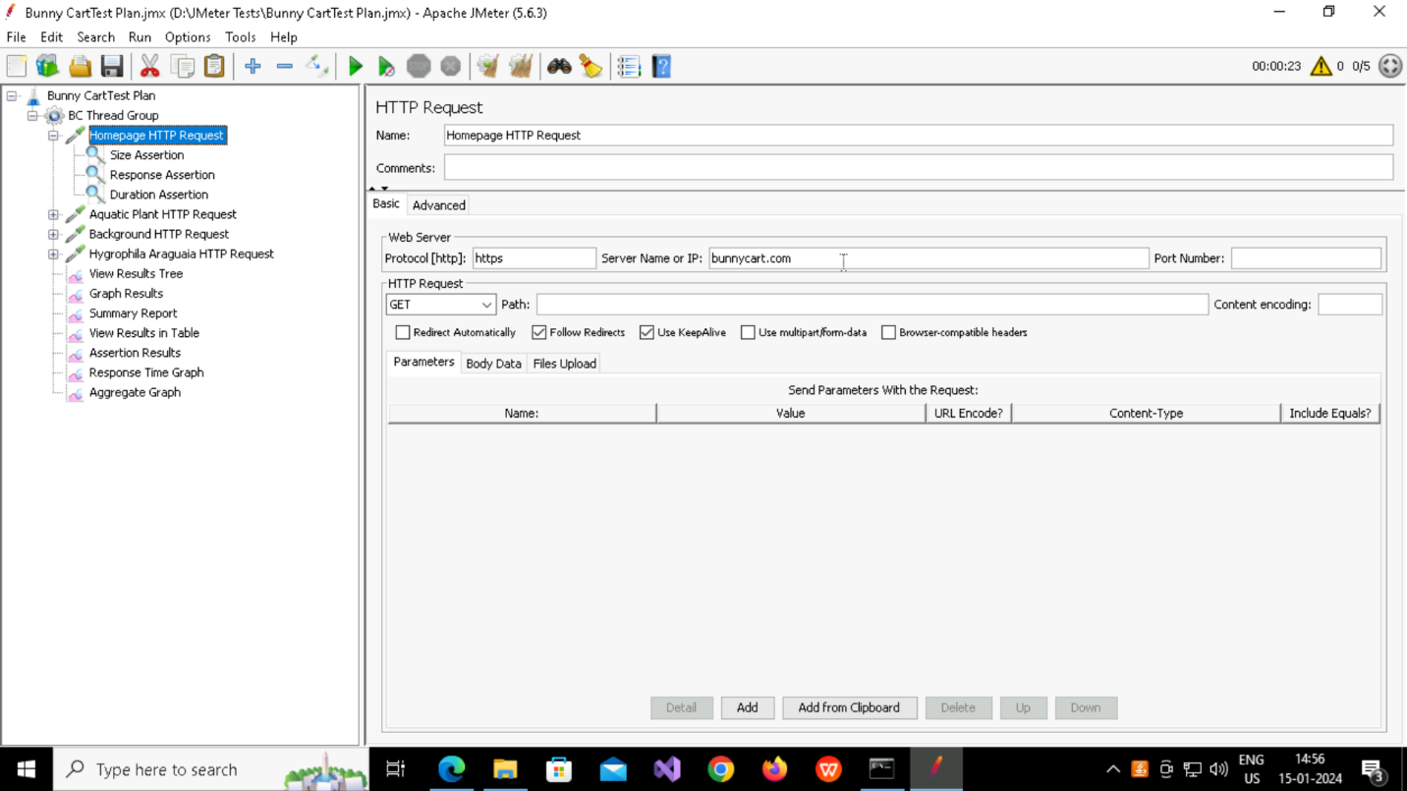

* **Adding Assertions**

**Response Assertion**

**Duration Assertion**

**Size Assertion**

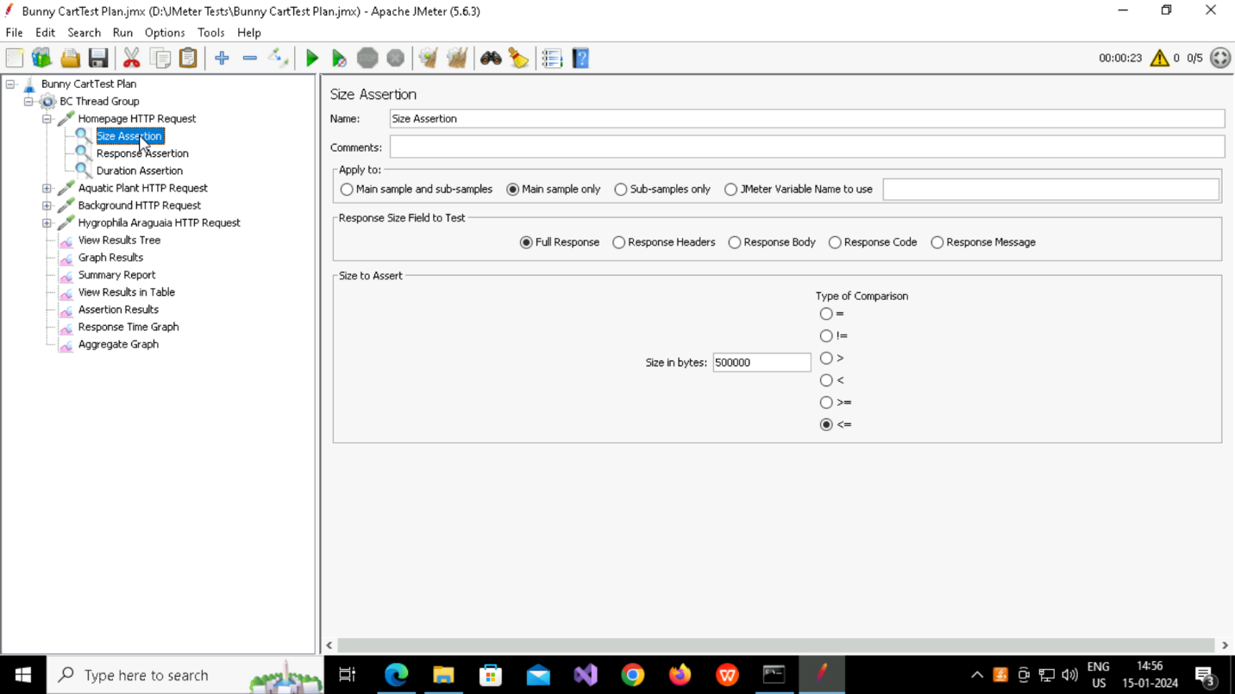

* **Adding Listener**

**View Result Tree**

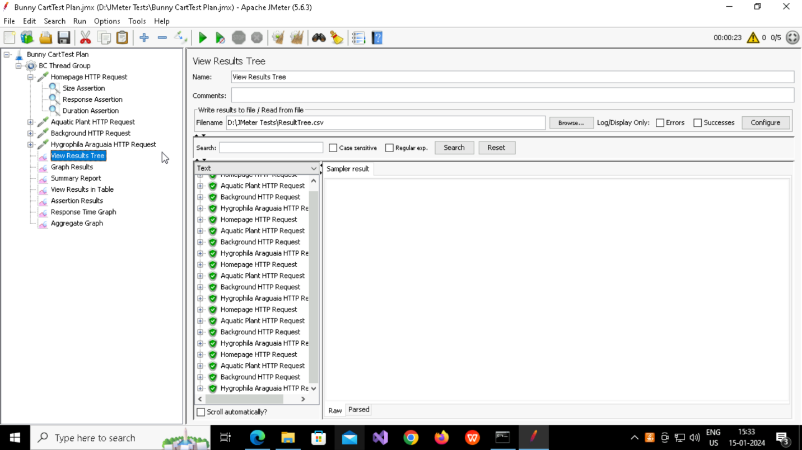

**Graph Result**

**Assertion Result**

**Response Time Graph**

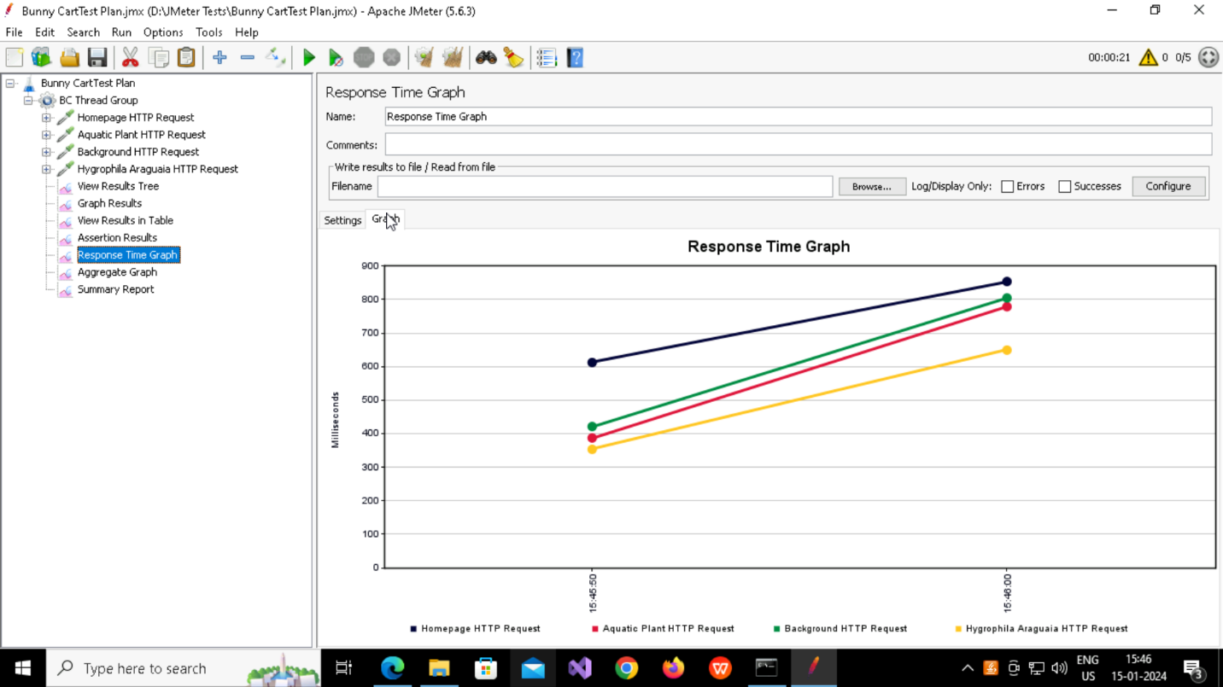

**View Result In Table**

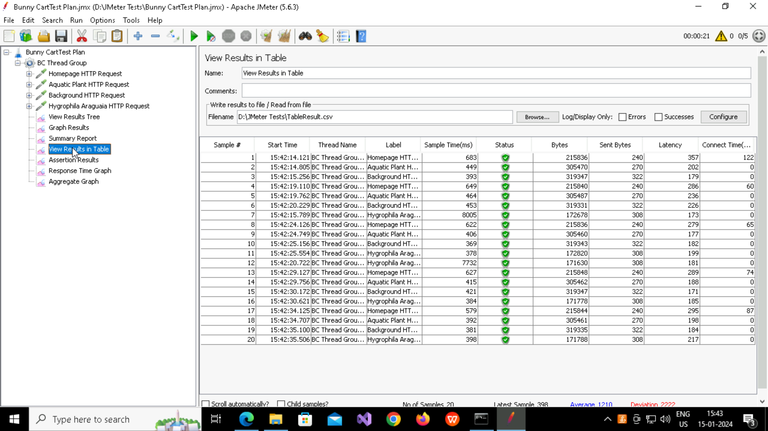

**Aggregate Result**

**Summary Report**

**Questions And Answers**

* What is the average response time for the homepage of the website?

Ans:719

* Did all requests meet the assertion criteria? If not, what failed?

Ans.Yes