* [https://petstore.swagger.io/#/user](https://petstore.swagger.io/" \l "/user" \t "_blank)
* Creating Workspace

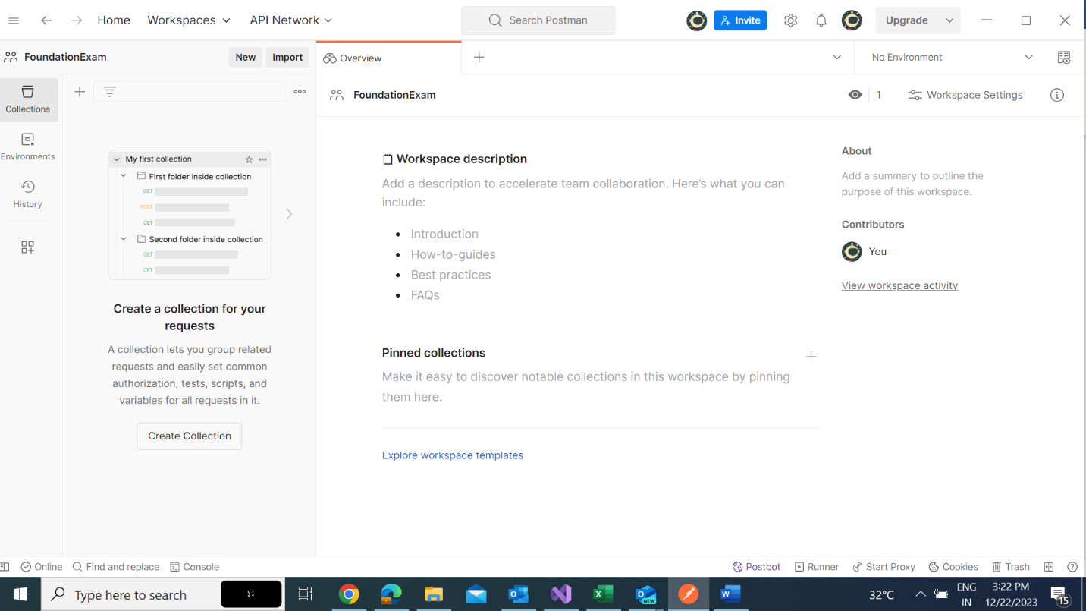

* Creating Collection

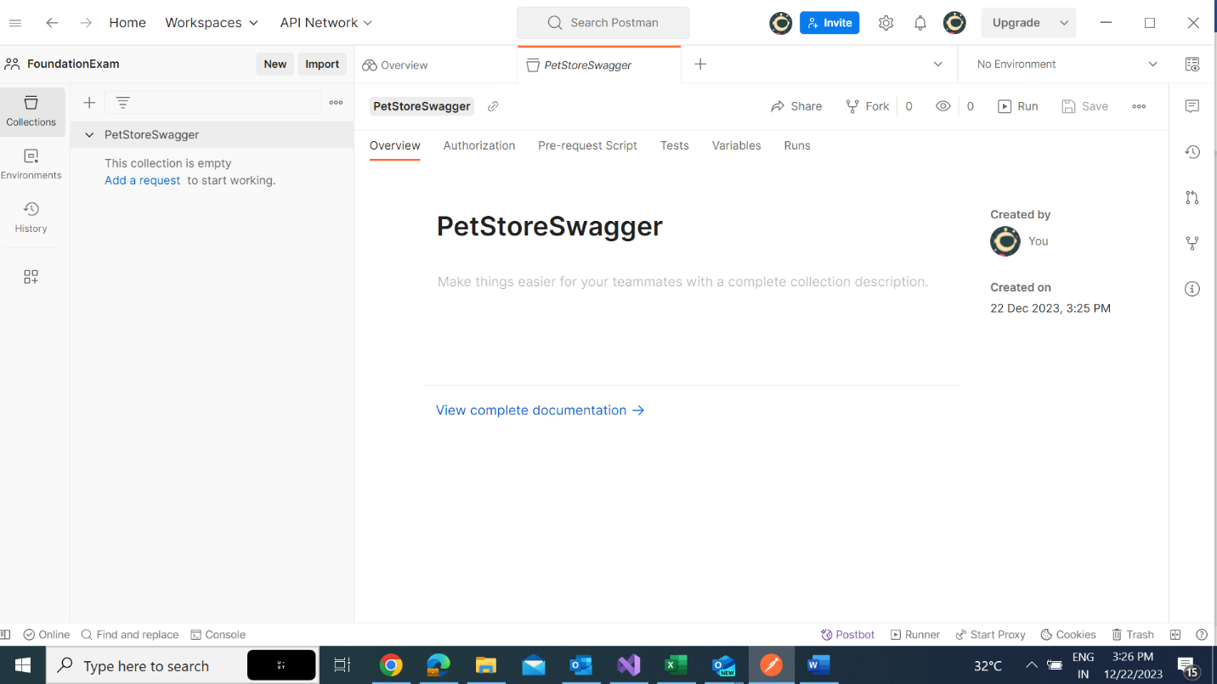

* Creating Environment

**Get**

* Get request with response.

**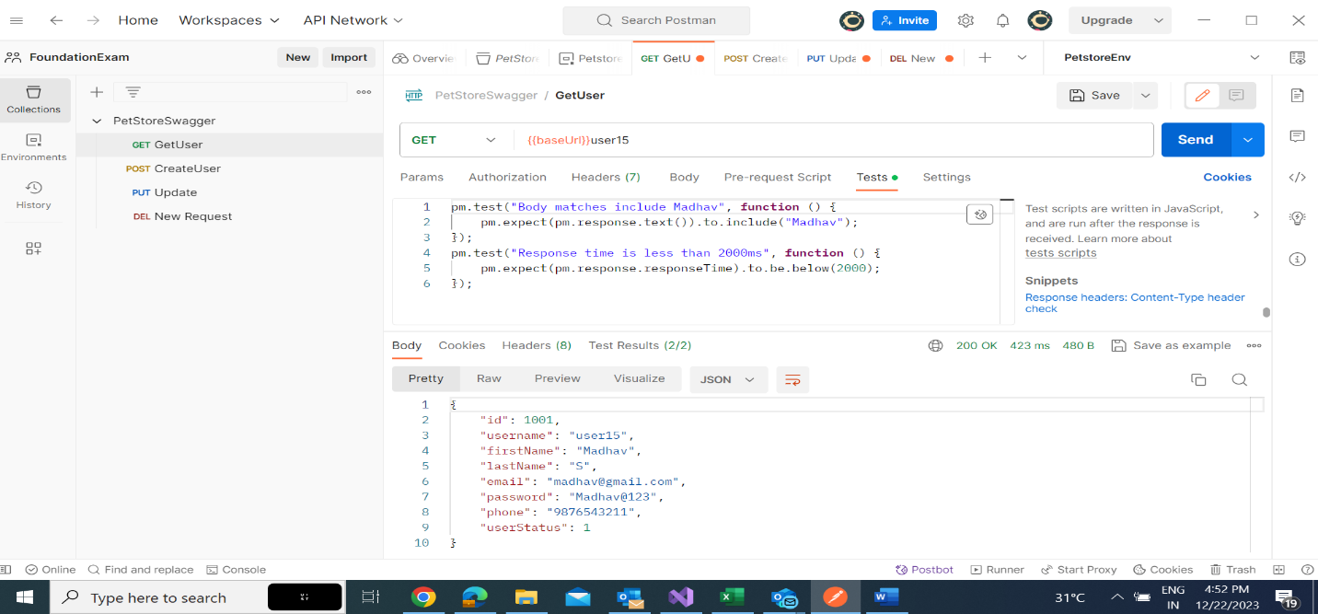**

* Response time less than 2000 test and Body include string test and results

**POST**

* Post request and response

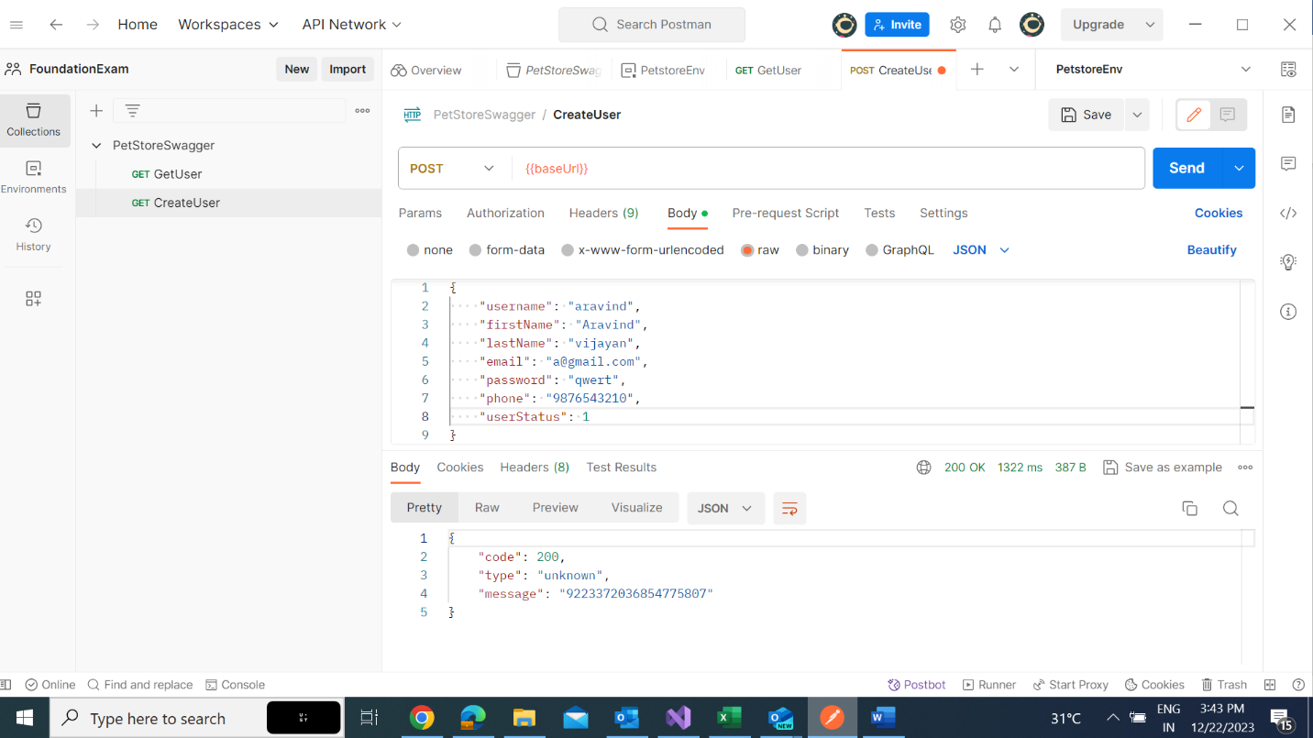

* Post successful Test and results

**UPDATE**

* Update Request and response

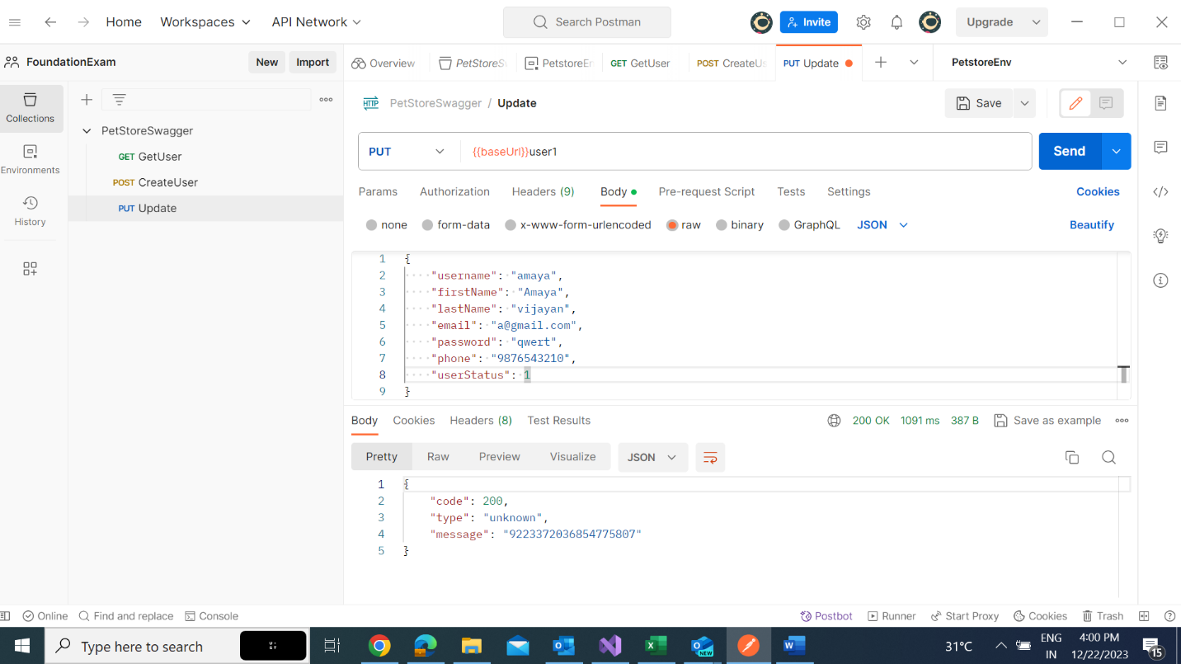

* Type Check test and result

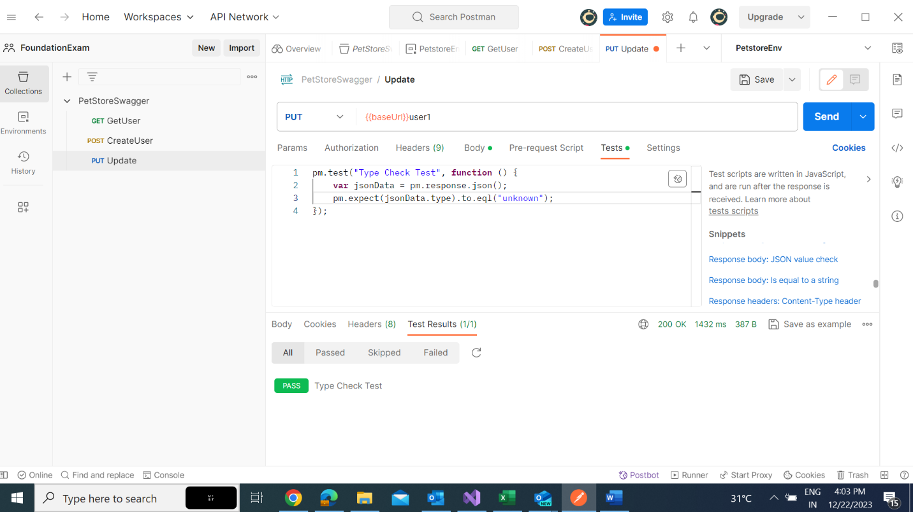

**DELETE**

* Delete Request with response

* Responsebody messaage check and result.

