**Stackoverflow**

**- Assignment 2 –**

Bogdan Maria

CTI – English

Group 30434, semigroup 1

**Contents**

**1.** **Introduction** 3

**2.** **Tech Stack** 3

**3.** **Architecture** 3

**4.** **Implementation** 4

**5.** **Close-up** 4

**6.** **Bibliography** 6

# **Introduction**

The assignment consists in the frontend part of the StackOverflow web-site, which is a simpler version of the well known site, where users can ask technical questions related to their work and other users can reply/post answers.

The users are also able to react to other users’ questions or answers – each question or answer has a vote that will appear next to them and users can see this vote. The vote is computed based on all of the reacts that a question or answer has.

# **Tech Stack**

* ANGULAR
* TypeScript
* HTML
* CSS

# **Architecture**

The architecture of an Angular application relies on certain fundamental concepts. The basic building blocks of the Angular framework are Angular components that are organized into NgModules. NgModules collect related code into functional sets; an Angular application is defined by a set of NgModules. An application always has at least a root module that enables bootstrapping, and typically has many more feature modules.

Components define views, which are sets of screen elements that Angular can choose among and modify according to the program logic and data. Any generated component contains one .html and one .css file. These files are used for formatting and styling the components.

Another important part of any Angular project is the routing part: the navigation between different pages of the application.

# **Implementation**

The project contains 6 pages: home page, users page, questions page, answers page, login and register page. Each page is represented as a separate component and I also have a global component, namely nav-bar – which is the header menu of the entire pplication.

All the data that is displayed, is read from .json files – representing the data that would eventually come from the backend.

The home page contains the menu that is used the access the other pages: Users, Answers, Questions and also, it contains 3 buttons: Log in, Log out and Register.

The Users page contains the table with all the users and their corresponding information: email, score and 2 buttons for deleting and banning each user – buttons to be used by an admin.

The Questions page contains a table with all the questions and their corresponding data: title, content, tags, votes. There is also a search bar, where the user can search for a question, a button to ask new question, a button to sort the questions and some other button to edit, delete, like, dislike and view answers.

The Answers page also contains a table with all the questions and their corresponding data, like: content, votes and some action buttons: edit, delete, like and dislike.

# **Close-up**

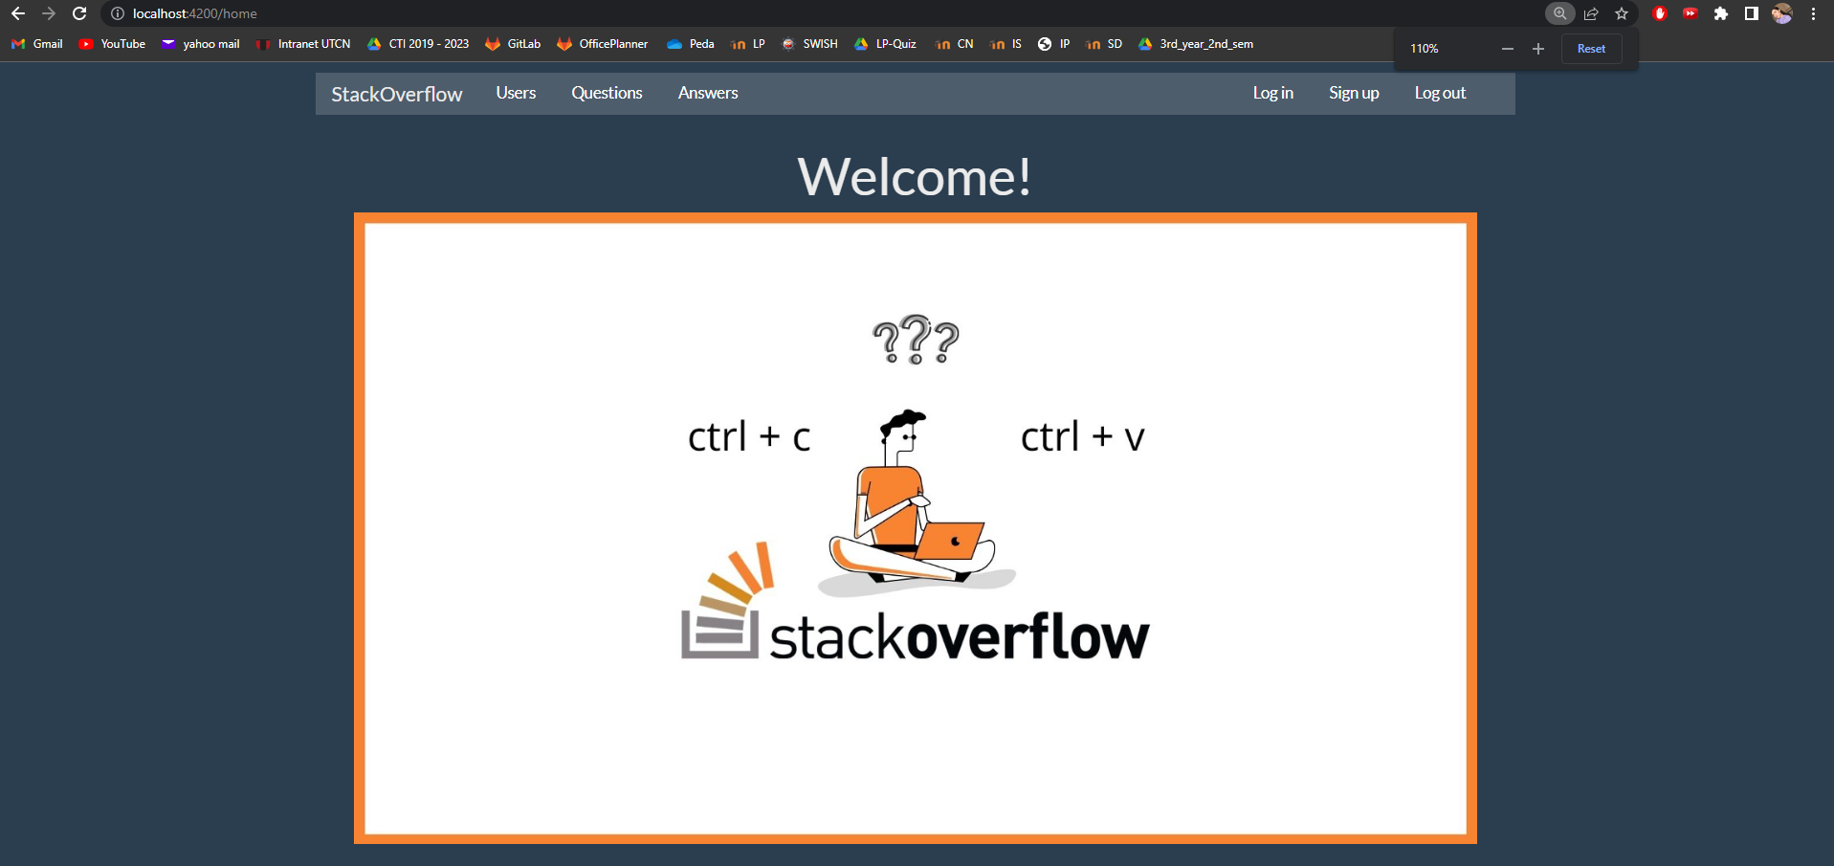

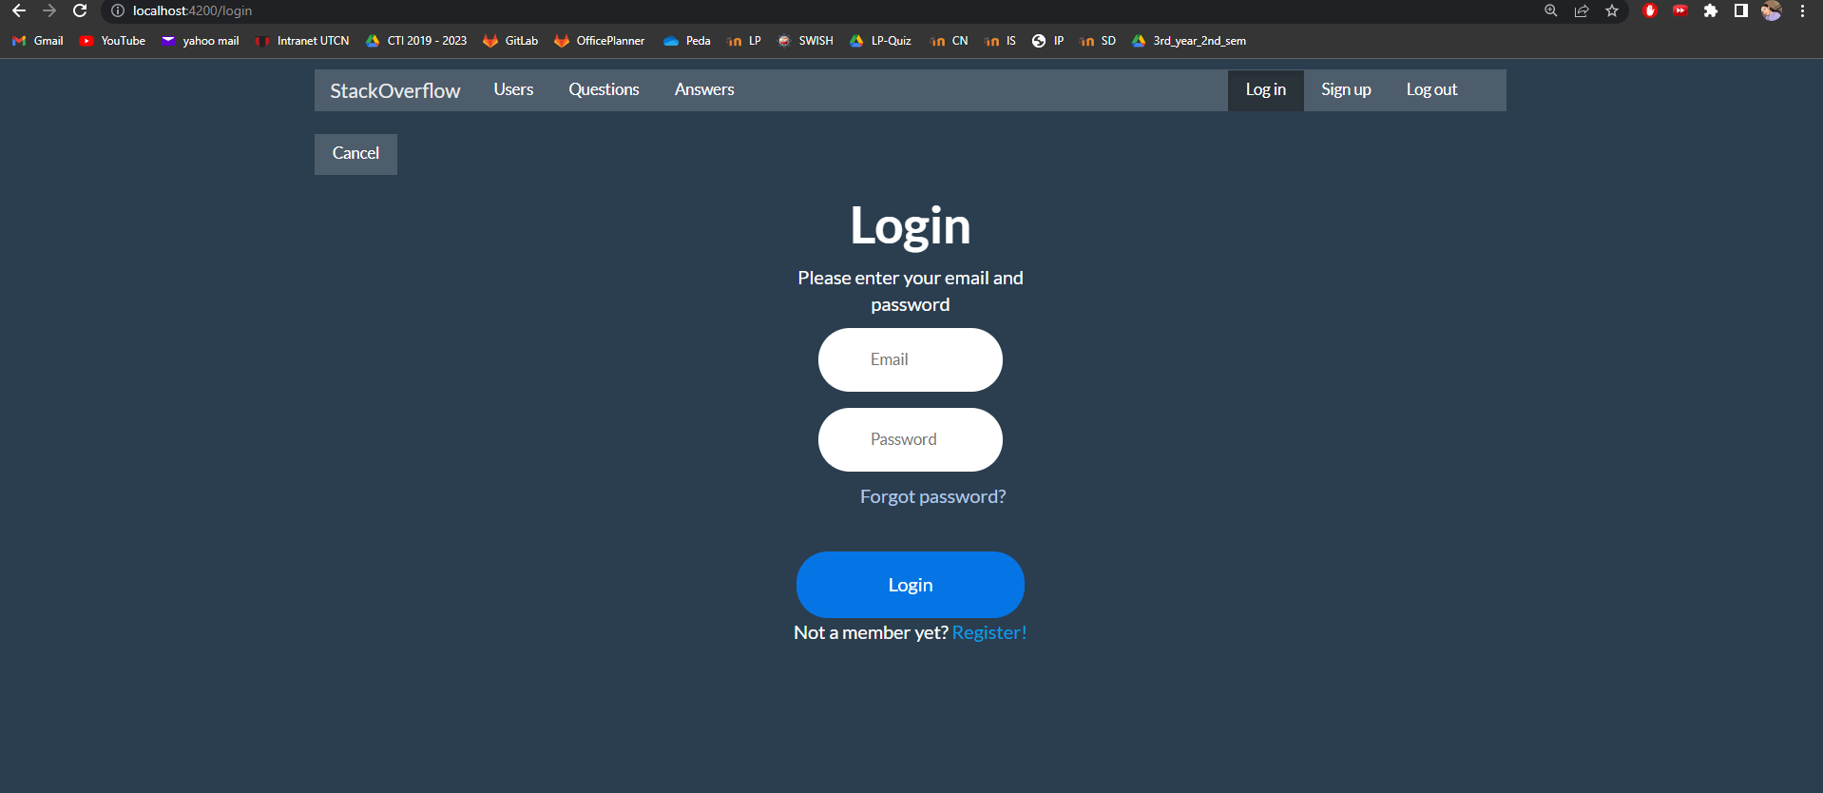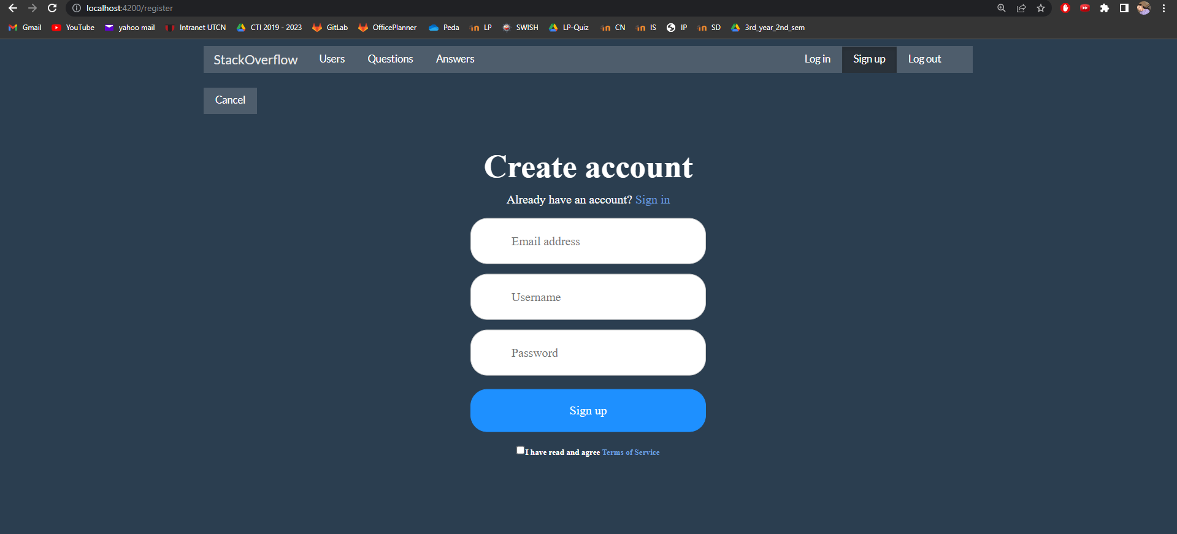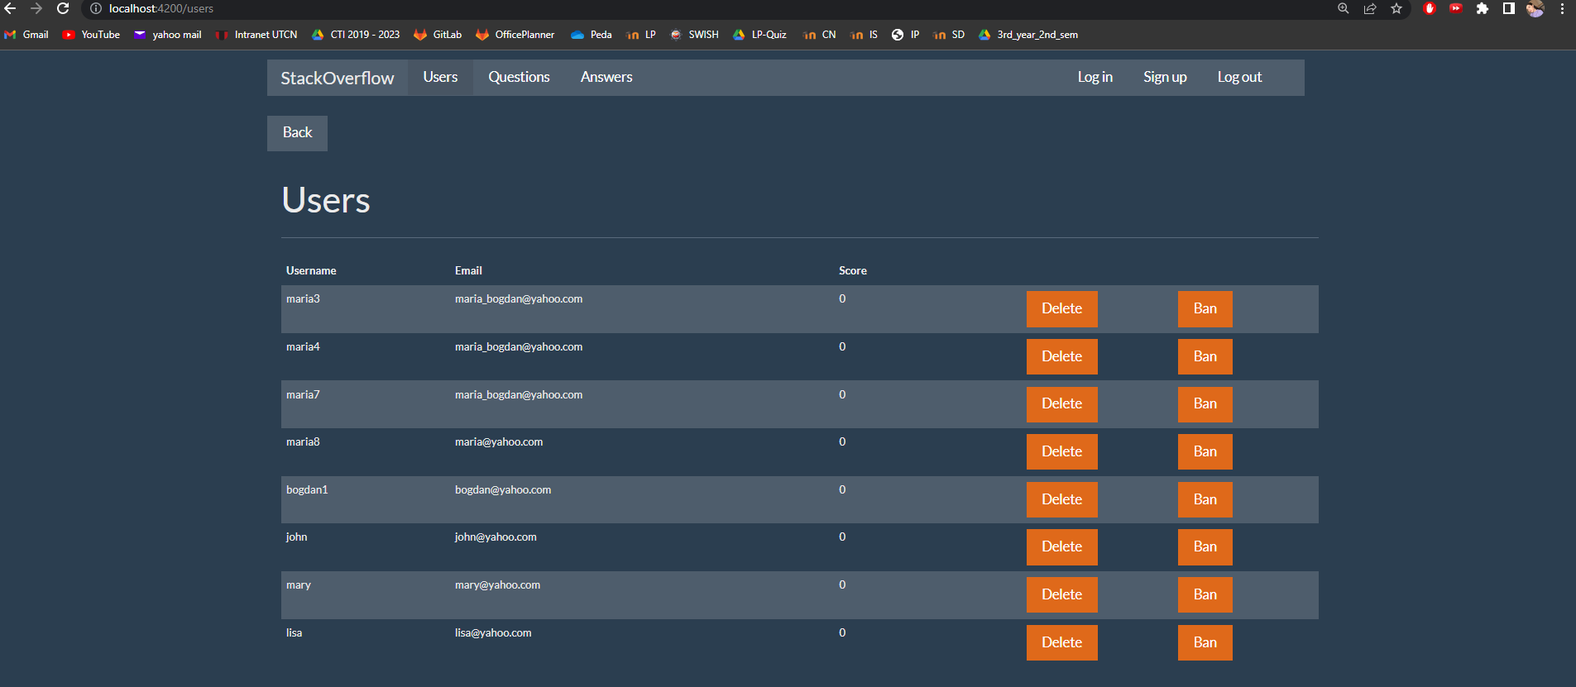

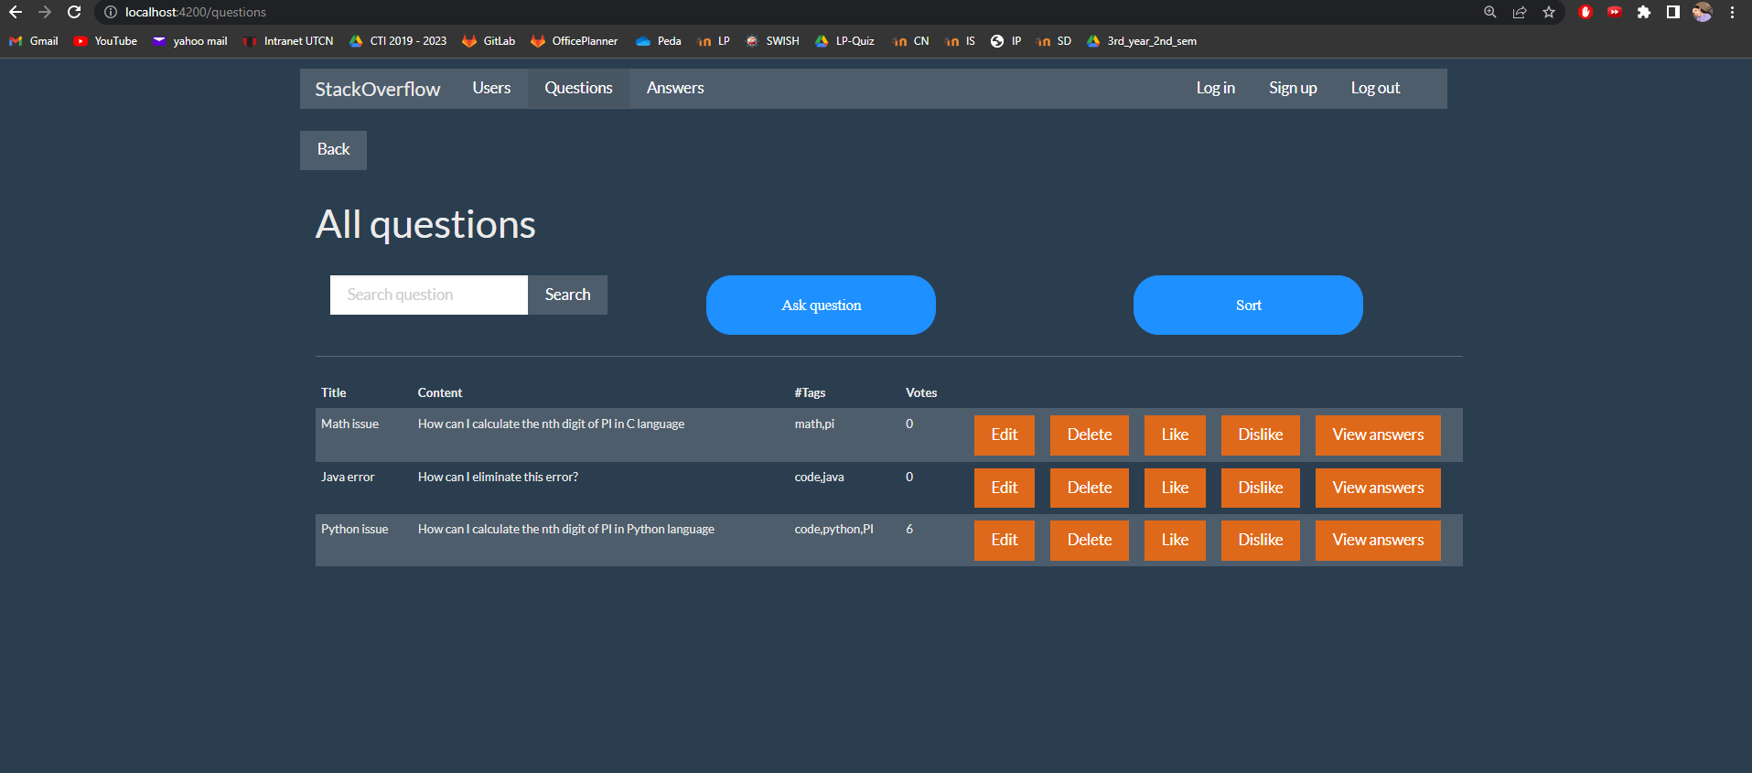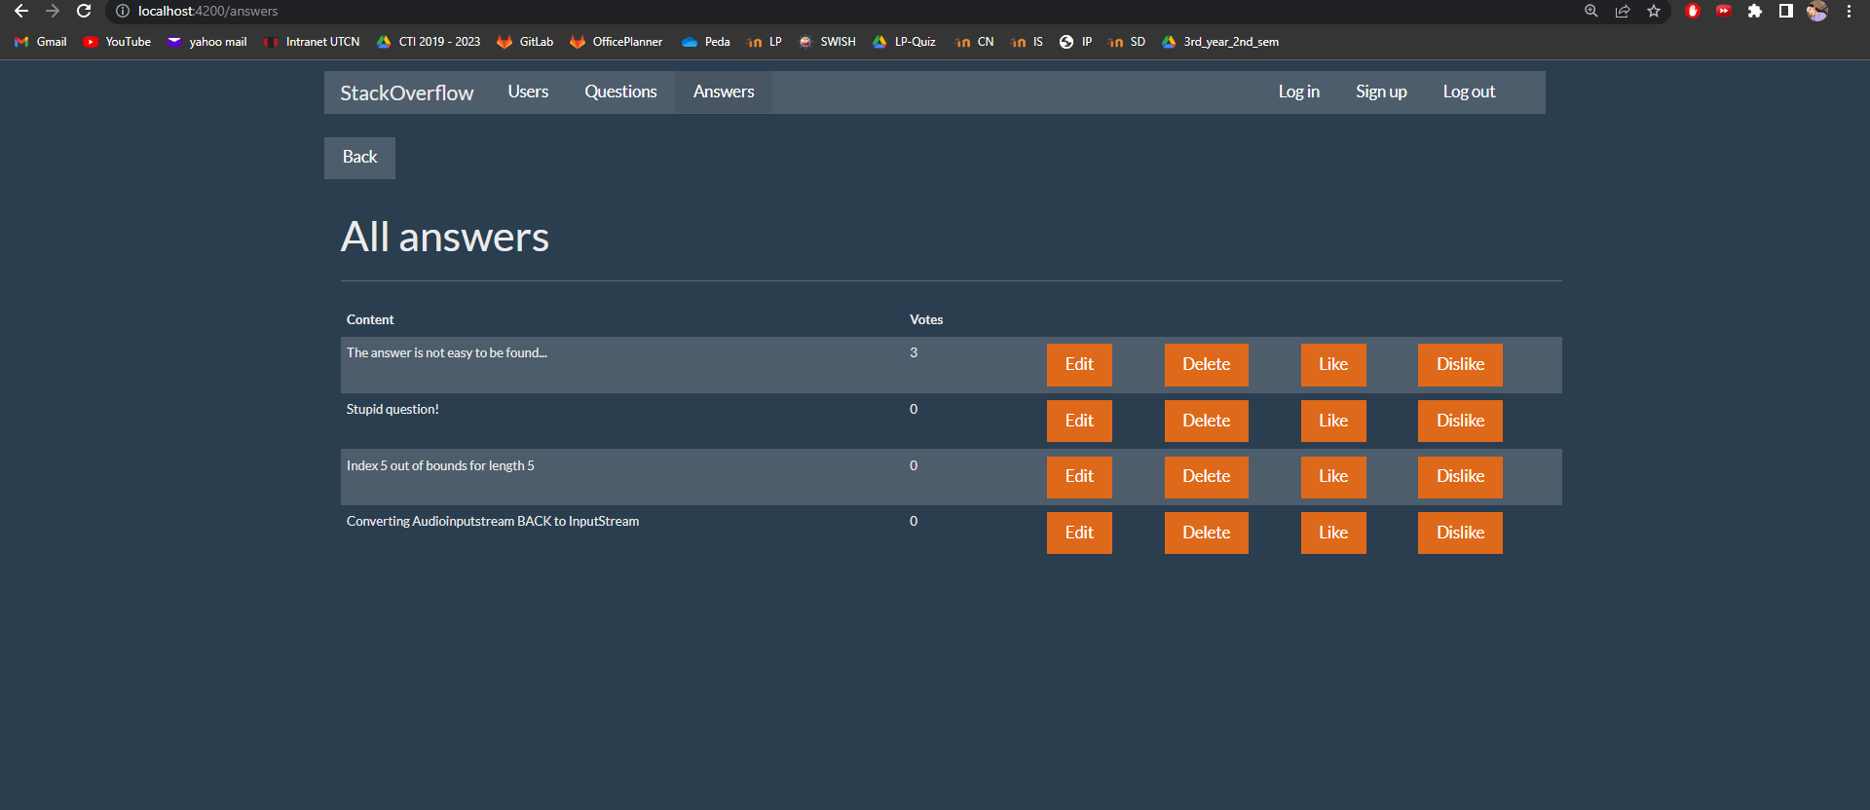

# **Bibliography**

* <https://angular.io/>
* <https://angular.io/start/start-routing>
* <https://angular.io/guide/component-overview>