Title: Structural Analysis of Disease-Associated Protein Glycosylation Sites Using Integrated Glycoproteomic and Structural Data
Maria Kim ¹
¹ Department of Biochemistry and Molecular Medicine, George Washington University, Washington, DC 20052

Abstract
Protein glycosylation is a ubiquitous post-translational modification that modulates protein folding, stability, and molecular recognition through both covalent attachment of glycans and non-covalent glycan-protein interactions. Disease-associated mutations are frequently observed at or near glycosylation sites; however, the structural mechanisms by which these variants perturb glycoprotein function remain poorly defined. In particular, it is unclear to what extent pathogenic effects arise from disruption of glycosylation sequons versus alteration of local glycan-amino acid interactions via non-covalent bonds. Here, we present an integrated computational framework to investigate the structural consequences of mutations affecting glycosylation sites across two mechanistic classes: (i) variants that induce gain or loss of N-linked sequons and thereby alter glycan occupancy, and (ii) variants that disrupt non-covalent interactions between glycans and proximal residues. Glycosylation annotations from GlyGen and UniProtKB were mapped onto experimentally determined and predicted protein structures, followed by structural characterization of site accessibility, local environment, and proximity to functional domains. Disease-associated missense variants were evaluated using PolyPhen-2 and modeled in structural context. Selected cases were further analyzed using energy minimization and molecular dynamics simulations to assess local conformational effects and stability. Application of this framework to representative glycoproteins demonstrates that both loss/gain of glycosylation and perturbation of glycan-protein interactions can induce localized structural changes with potential functional consequences. In particular, variants that introduce or disrupt sequons may alter steric constraints, while mutations in glycan-contacting residues can weaken stabilizing interactions within the local structural environment. Together, these results establish a structure-informed approach for interpreting disease-associated variation at glycosylation sites and highlight the importance of considering both covalent and non-covalent mechanisms in glycoprotein dysfunction.

Introduction
Protein glycosylation is a prevalent post-translational modification in eukaryotic cells, in which glycans are covalently attached to specific amino acids, most commonly asparagine (N-linked) or serine/threonine (O-linked)¹. Glycans influence protein folding, stability, trafficking, and molecular recognition, thereby contributing to immune signaling, receptor activation, and cell-cell communication^{1,2}. Alterations in glycosylation are implicated in cancer, autoimmune disorders, congenital glycosylation defects, neurodegeneration, and infectious diseases^{1,3-5}.
Changes in glycan composition and occupancy can alter protein structure and function, influencing cellular pathways and disease progression^{6,7}. Advances in glycoproteomics, particularly mass spectrometry (MS)-based analysis of intact glycopeptides, have enabled large-scale identification of glycosylation sites across the proteome, revealing disease-associated patterns ⁸. However, these approaches provide limited information about glycan-protein spatial interactions, including disruption of glycosylation sequons versus alteration of local glycan non-covalent interactions, which are critical for protein folding and function.
To overcome intrinsic limitations in analytical proteomics and glycoproteomics technologies, structural visualization and analysis tools have been developed. PyMOL⁹ allows 3D visualization of atomic coordinates from structures and enables in silico mutagenesis to explore how sequence changes may affect structure. However, it displays only static conformations and cannot capture dynamic interactions.
Energy minimization methods, such as the YASARA Energy Minimization Server¹⁰, refine local geometries by resolving steric clashes and optimizing bond angles, but they are limited to nearby low-energy states and do not reflect time-dependent behavior. Molecular dynamics (MD) simulations implemented in packages such as AMBER¹¹, CHARMM¹², or GROMACS¹³ model atomic motions over time using physics-based force fields and known bond lengths and dihedral angles. MD provides insight into conformational flexibility, stability, and the effects of mutations or glycan modifications, though simulations are computationally intensive and sensitive to initial conditions.
Machine learning approaches, like AlphaFold¹⁴, predict accurate static structures from amino acid sequences, making them valuable in the absence of experimental data, but they do not explicitly model post-translational modifications or dynamic changes. Sequence-based tools, such as PolyPhen-2¹⁵, prioritize variants based on conservation and structural features but offer limited mechanistic detail.
Together, these methods are complementary: visualization tools provide structural context, predictive algorithms highlight potentially impactful variants, and physics-based simulations reveal dynamic and mechanistic effects.
Therefore, the goal of this study is to identify and classify disease-associated structural changes in glycan-protein interactions: (i) variants that induce gain or loss of N-linked sequons and thereby alter glycan occupancy, and (ii) variants that disrupt non-covalent interactions between glycans and proximal residues.

Results

Computational Pipeline for Glycosylation and Variant Analysis
We developed a computational workflow that integrates glycoproteomic annotations, structural data, and variant information to systematically analyze disease-associated glycosylation sites. The pipeline: (1) maps experimentally determined and predicted glycosylation sites from GlyGen¹⁶ onto PDB structures¹⁷; (2) annotates structural features such as secondary structure; (3) incorporates variant information from genomic databases¹⁸ to identify potential gain- or loss-of-glycosylation events.
This approach enables assessment of how genetic variation may impact glycosylation patterns and protein function, prioritizing variants for further experimental evaluation.

Structural Context of Glycosylation Sites
Representative proteins were visualized in PyMOL to evaluate site accessibility, neighboring domains, and nearby disease-associated variants. Two case studies illustrate the utility of this pipeline.

Case Study 1: protein kinase C-binding protein NELL2 Glycosylation Site N635
The N635 site in NELL2 (PDB 10FT) is predicted to be glycosylated but is unresolved in the crystal structure. We generated a structural model using ColabFold/AlphaFold^{14,19} and refined it via YASARA energy minimization. The ovarian cancer-associated N635H mutation, reported in GlyGen, disrupts the predicted glycosylation site. Structural comparison indicates subtle local conformational changes near N635H, potentially affecting local interactions and stability (Figure 1).

Case Study 2: N-sulfoglucosamine sulfohydrolase (SGSH; Sulfamidase) and M88T Variant
N-sulfoglucosamine sulfohydrolase (PDB 4MHX, Figure 2), a lysosomal enzyme whose deficiency causes Sanfilippo syndrome A (MPS IIIA), contains four established N-linked glycosylation sites (Asn41, Asn151, Asn264, Asn413)^{20,21}. The M88T variant, one of ~100 reported disease-associated mutations, creates a new N-linked sequon (N86-G87-T88).
We modeled the mutation and glycosylation on the SGSH dimer using CHARMM-GUI Glycan Reader & Modeler¹². While modeling a full Man5 glycan was not feasible, the N-acetylglucosamine (NAG) core at N86 was revealed to be positioned adjacent to a nearby α-helix (Figure 3). This suggests that a mature glycan could introduce steric constraints. PolyPhen-2 classifies M88T as probably damaging (score 0.992; sensitivity 0.70; specificity 0.97).
Overall, our workflow demonstrates that combining structural modeling, glycosylation mapping, and variant annotation can reveal potential mechanistic links between disease-associated mutations and glycosylation changes. Both case studies illustrate how predicted gains or losses of glycosylation may influence local structure and protein function, providing a framework for prioritizing variants for experimental validation.

Case Study 3: fucosylated Fc fragment of human IgG1
To investigate glycan-protein interactions within a protein context where a glycan interacts with residues that are nearby due to the tertiary structure, we examined the fucosylated Fc fragment of human IgG1 (PDB 3AVE, Figure 4).The N-linked glycan attached to Asn297 (PDB numbering; UniProt P01857 Asn180; GlyTouCan ID G80858MF) adopts a complex, core-fucosylated biantennary structure composed of N-acetylglucosamine (NAG), mannose, and fucose residues. Using PyMOL, we identified putative hydrogen bond interactions within 3.2 Å based on donor-acceptor atom type and geometric proximity (Figure 4A). Notably, the carbonyl oxygen (O7) of the N-acetyl group on the NAG residue at Asn297 is positioned within hydrogen-bonding distance (~2.8 Å) of the guanidinium nitrogen (NE) of Arg301 (PDB; UniProt Arg184) (Figure 4C). This interaction suggests a stabilizing contact between the glycan and the protein surface, highlighting how tertiary structure can bring distant residues into functional proximity.

Systematic Quantification of Glycan-Protein Non-Covalent Contacts
The manual PyMOL analysis in Case Study 3 identified a single hydrogen bond within a 3.2 Å donor-acceptor cutoff, but provides no information about electrostatic, CH-π, hydrophobic, or van der Waals contacts that collectively constitute the glycan-protein interaction landscape. To characterize this landscape systematically and reproducibly, we developed a Python parser (glycan-contacts.py) using Biopython²²’s NeighborSearch²³ to enumerate all glycan atom-protein atom pairs within an 8 Å shell, then classify each pair in strict priority order: H-bond, Electrostatic, CH-π, Hydrophobic, van der Waals. Distance cutoffs were drawn from the primary literature: 3.5 Å for H-bonds²⁴ (heavy-atom donor-acceptor distance), 6.0 Å for electrostatic contacts²⁵, 4.5 Å for CH-π interactions²⁶ (glycan carbon to aromatic ring centroid), and 4.0 Å for van der Waals contacts²⁷. Glycan HETATM residues were identified by Chemical Component Dictionary²⁸ (CCD) code, and the output was deduplicated to one row per glycan-residue × protein-residue × interaction-type triple, retaining the closest atom pair per triple.
The parser was applied to three glycoproteins with the most resolved glycan structures: the fucosylated IgG1 Fc fragment (PDB 3AVE)²⁹, the human CD2 adhesion domain (PDB 2WAH)³⁰, and a related CD2 structure (PDB 1GYA)³¹. For all three protein structures combined, the parser recovered 171 unique glycan-residue contact pairs across four glycan residue types (NAG, BMA, MAN, FUC), with hydrophobic contacts (n = 63) and van der Waals contacts (n = 51) being the most numerous, followed by electrostatic (n = 27), H-bond (n = 20), and CH-π (n = 10) contacts (Figure 5). In 3AVE and 2WAH, the NAG contacts are concentrated on residues 264-265 and 301, consistent with the known glycan-engaging surface of those proteins (Figure 6A and B). In 1GYA, the contact profile is smaller but notably enriched for electrostatic interactions (n = 7), matching the abundance of basic residues (Lys69, Lys71) near the N-glycosylation site (Figure 6C). The MAN7 O4-Lys71 NZ contact at 3.228 Å is classified as an H-bond, while MAN7 O2-Lys69 NZ (3.825 Å) and MAN7 O3-Lys71 NZ (3.915 Å) are classified as electrostatic contacts, illustrating how the charged lysine side chains engage mannose hydroxyls at multiple distances (Table 1). The heatmap of 3AVE contact counts (Figure 6A) shows that NAG residues dominate the interface, with the highest contact densities at protein residues 264, 265, and 301 across both glycan chains (chains C and D), reflecting the symmetric engagement of both Fc subunits.
Internal validation was performed by confirming recovery of the NAG(O7)-Arg301(NE) hydrogen bond first identified in Case Study 3. The parser returned this contact at 2.722 Å (chain C) and 2.841 Å (chain D), consistent with the ~2.8 Å distance measured manually in PyMOL, confirming that the geometric criteria are correctly calibrated. In 2WAH, the equivalent interaction is also recovered symmetrically: NAG2 O7-Arg301 NE H-bonds appear in both chain C (3.062 Å) and chain D (2.841 Å), reflecting the homodimeric symmetry of the CD2 structure. The combined distance distribution across 3AVE, 2WAH and 1GYA (Figure 7) shows that H-bonds cluster below 3.5 Å as expected, van der Waals contacts are concentrated between 3.5 and 4.0 Å, and hydrophobic and electrostatic contacts extend to their respective cutoffs with no discontinuities, confirming that the priority-order classification produces well-separated, physically interpretable populations. Together, this contact dataset provides the structural foundation for overlaying disease-associated variants and prioritizing residues for pathogenicity scoring in the next stage of the pipeline.

Discussion
We present a computational framework for analyzing protein glycosylation sites in structural context by integrating glycoproteomic annotations, experimental or predicted structures, and variant data. Disease-associated mutations were modeled and subjected to local energy minimization to assess potential structural consequences, providing site-specific insight beyond sequence-based predictions.
The NELL2 N635H mutation illustrates how loss of a predicted glycosylation site may induce subtle local changes, consistent with observations that sequon-disrupting variants often occur in flexible regions³². In SGSH, the M88T variant introduces a novel N86-G87-T88 sequon. Modeling of the N-acetylglucosamine (NAG) core indicates proximity to a neighboring α-helix, suggesting that extension to a full N-linked glycan could introduce steric constraints. This inference is based on energy-minimized models of the SGSH dimer and does not account for dynamic rearrangements of the backbone, sidechains, or glycans, which could affect interactions at the dimer interface. Prior work³³ similarly predicts disruption of the dimer interface due to steric hindrance from a bound glycan, supporting the importance of local structural environment.
A key aspect of this study is the explicit consideration of glycan-protein interactions within the three-dimensional (tertiary) structure of proteins. Glycans can form non-covalent interactions with residues that are distant in the primary amino acid sequence but brought into proximity through folding. In the fucosylated Fc fragment of IgG1 the N-linked glycan at Asn297 (PDB numbering²⁹; UniProt³⁴ Asn180, P01857) engages in a putative hydrogen bond with Arg301 (PDB; UniProt Arg184) despite the interaction not being predictable from sequence proximity alone. Residue numbering in the PDB structure differs from canonical UniProt positions; both are indicated here to facilitate cross-referencing. This example illustrates the importance of structural context for understanding how glycans contribute to protein stability and local interaction networks.
Systematic contact analysis across 3AVE, 2WAH, and 1GYA reveals that glycan-protein interactions are mechanistically diverse and cannot be adequately captured by a single distance threshold applied to a single interaction type. In 3AVE, hydrophobic contacts between glycan carbon atoms and nonpolar protein sidechains are the most numerous class, outnumbering H-bonds nearly three to one. In 1GYA, electrostatic contacts between mannose hydroxyls and the ε-amino groups of Lys69 and Lys71 account for nearly half of all classified contacts. This diversity has direct implications for variant interpretation: a disease-associated missense mutation at a residue engaged solely in van der Waals contact with a glycan might be ranked lower than one that disrupts an H-bond, yet the cumulative energetic contribution of multiple weak contacts can be substantial. The contact table produced by the parser therefore provides a richer basis for variant prioritization than sequence-based tools alone, by explicitly linking each protein residue to the type and distance of its glycan interaction before any pathogenicity score is applied.
The recovery of the NAG(O7)-Arg301(NE) hydrogen bond in both 3AVE and 2WAH confirms that the parser’s geometric criteria are correctly calibrated and that this contact is structurally reproducible across independently determined crystal structures. This interaction involves the acetamido carbonyl oxygen, a functional group conserved across all GlcNAc residues in N-linked glycans, paired with a basic sidechain nitrogen positioned four residues C-terminal to the glycosylation site. The recurrence of this motif across both structures suggests it may represent a general organizational principle in which basic residues flanking N-glycosylation sequons make stabilizing contacts with the proximal GlcNAc, consistent with prior crystallographic analyses of IgG1 Fc glycan-protein contacts.
The contact classification carries several limitations worth noting. The parser uses heavy-atom distance cutoffs without explicit hydrogen positions; H-bond assignments therefore rely on donor-acceptor element identity and distance alone, which can overcount bonds in structures with moderate resolution or unfavorable geometry, and cannot distinguish donor from acceptor orientation without N-H⋯O angle information. An optional DSSP secondary-structure annotation module is included in the parser, which would enable downstream analysis of whether glycan contacts are preferentially distributed at loops versus α-helices or β-strands; this question has not yet been addressed in the current dataset. Future steps of the pipeline will overlay ClinVar and UniProt germline variants together with COSMIC somatic variants onto this contact table, then apply PolyPhen-2, SIFT, and CADD pathogenicity scoring. Residues classified as making H-bond or Electrostatic contacts with glycans will be prioritized, because disruption of directional or charge-mediated interactions is expected to be more mechanistically consequential than loss of peripheral van der Waals contacts.
Importantly, the present analysis is based on static structural models and therefore provides only a preliminary view of glycan-mediated interactions. In reality, glycan-protein contacts are dynamic and may fluctuate over time. Future work will extend this framework using molecular dynamics simulations (e.g., with AMBER, CHARMM, or GROMACS) to evaluate how single-nucleotide variants affecting either glycosylation sequons or glycan-interacting residues alter structural behavior. Such simulations would enable direct observation of changes in interaction networks, including the formation or loss of hydrogen bonds, van der Waals contacts, and other non-covalent interactions, providing a more mechanistic understanding of variant impact.
An additional limitation arises from incomplete experimental structures, where glycans are often partially resolved or entirely absent. In such cases, glycosylation modeling can be performed using GLYCAM-Web³⁵, developed by Robert J. Woods at the University of Georgia Complex Carbohydrate Research Center. This platform enables construction of three-dimensional glycan structures through a point-and-click interface, generating experimentally consistent conformations using the GLYCAM force field for energy minimization. Integration of GLYCAM-Web into the workflow allows systematic modeling of glycans onto protein structures lacking resolved carbohydrate moieties, improving coverage and enabling more comprehensive structural analyses.
Our approach provides direct structural context, allowing visualization of both steric constraints and non-covalent interaction networks. However, structural modeling remains limited by the quality of input structures, approximations in energy minimization, and the absence of explicit solvent and dynamic effects. Broader benchmarking against experimental glycoproteomic and mutagenesis datasets will be required to evaluate predictive performance.
While the pipeline is designed to scale across glycoproteins and variant datasets, the current study is limited to a small number of representative samples. Extending to larger datasets will require automated modeling workflows and increased computational resources. Future refinements incorporating molecular dynamics simulations, improved glycan modeling, and integration of high-resolution experimental data will enhance the ability to capture both static and dynamic aspects of glycan-protein interactions.
Together, this work establishes a structure-informed framework for interpreting disease-associated variation at glycosylation sites, emphasizing that both covalent changes in glycan occupancy and non-covalent interactions within the folded protein contribute to glycoprotein function and dysfunction.

References
1 Schjoldager, K. T., Narimatsu, Y., Joshi, H. J. & Clausen, H. Global view of human protein glycosylation pathways and functions. Nat Rev Mol Cell Biol 21, 729-749 (2020). https://doi.org/10.1038/s41580-020-00294-x
2 Breloy, I. & Hanisch, F. G. Functional Roles of O-Glycosylation. Molecules 23 (2018). https://doi.org/10.3390/molecules23123063
3 He, M., Zhou, X. & Wang, X. Glycosylation: mechanisms, biological functions and clinical implications. Signal Transduct Target Ther 9, 194 (2024). https://doi.org/10.1038/s41392-024-01886-1
4 Loke, I., Kolarich, D., Packer, N. H. & Thaysen-Andersen, M. Emerging roles of protein mannosylation in inflammation and infection. Mol Aspects Med 51, 31-55 (2016). https://doi.org/10.1016/j.mam.2016.04.004
5 Rodrigues, J. G. et al. Glycosylation in cancer: Selected roles in tumour progression, immune modulation and metastasis. Cell Immunol 333, 46-57 (2018). https://doi.org/10.1016/j.cellimm.2018.03.007
6 Hülsmeier, A. J., Tobler, M., Burda, P. & Hennet, T. Glycosylation site occupancy in health, congenital disorder of glycosylation and fatty liver disease. Sci Rep 6, 33927 (2016). https://doi.org/10.1038/srep33927
7 Reily, C., Stewart, T. J., Renfrow, M. B. & Novak, J. Glycosylation in health and disease. Nat Rev Nephrol 15, 346-366 (2019). https://doi.org/10.1038/s41581-019-0129-4
8 Chernykh, A., Kawahara, R. & Thaysen-Andersen, M. Towards structure-focused glycoproteomics. Biochem Soc Trans 49, 161-186 (2021). https://doi.org/10.1042/bst20200222
9 PyMOL v. 3.1 (2020).
10 Ozvoldik, K., Stockner, T. & Krieger, E. YASARA Model-Interactive Molecular Modeling from Two Dimensions to Virtual Realities. J Chem Inf Model 63, 6177-6182 (2023). https://doi.org/10.1021/acs.jcim.3c01136
11 Case, D. A. et al. AmberTools. J Chem Inf Model 63, 6183-6191 (2023). https://doi.org/10.1021/acs.jcim.3c01153
12 Jo, S., Kim, T., Iyer, V. G. & Im, W. CHARMM-GUI: a web-based graphical user interface for CHARMM. J Comput Chem 29, 1859-1865 (2008). https://doi.org/10.1002/jcc.20945
13 Páll, S. et al. Heterogeneous parallelization and acceleration of molecular dynamics simulations in GROMACS. J Chem Phys 153, 134110 (2020). https://doi.org/10.1063/5.0018516
14 Jumper, J. et al. Highly accurate protein structure prediction with AlphaFold. Nature 596, 583-589 (2021). https://doi.org/10.1038/s41586-021-03819-2
15 Adzhubei, I. A. et al. A method and server for predicting damaging missense mutations. Nat Methods 7, 248-249 (2010). https://doi.org/10.1038/nmeth0410-248
16 York, W. S. et al. GlyGen: Computational and Informatics Resources for Glycoscience. Glycobiology 30, 72-73 (2020). https://doi.org/10.1093/glycob/cwz080
17 Burley, Stephen K. et al. Updated resources for exploring experimentally-determined PDB structures and Computed Structure Models at the RCSB Protein Data Bank. Nucleic Acids Research 53, D564-D574 (2024). https://doi.org/10.1093/nar/gkae1091
18 Dingerdissen, H. M. et al. BioMuta and BioXpress: mutation and expression knowledgebases for cancer biomarker discovery. Nucleic Acids Res 46, D1128-d1136 (2018). https://doi.org/10.1093/nar/gkx907
19 Mirdita, M. et al. ColabFold: making protein folding accessible to all. Nat Methods 19, 679-682 (2022). https://doi.org/10.1038/s41592-022-01488-1
20 Fiorentino, F. et al. Strategies and clinical outcome of 250 cycles of Preimplantation Genetic Diagnosis for single gene disorders. Hum Reprod 21, 670-684 (2006). https://doi.org/10.1093/humrep/dei382
21 Sidhu, N. S. et al. Structure of sulfamidase provides insight into the molecular pathology of mucopolysaccharidosis IIIA. Acta Crystallogr D Biol Crystallogr 70, 1321-1335 (2014). https://doi.org/10.1107/s1399004714002739
22 Cock, P. J. et al. Biopython: freely available Python tools for computational molecular biology and bioinformatics. Bioinformatics 25, 1422-1423 (2009). https://doi.org/10.1093/bioinformatics/btp163
23 Hamelryck, T. & Manderick, B. PDB file parser and structure class implemented in Python. Bioinformatics 19, 2308-2310 (2003). https://doi.org/10.1093/bioinformatics/btg299
24 Pauling, L. The Nature of the Chemical Bond and the Structure of Molecules and Crystals. (Cornell University Press, 1939).
25 Leach, A. Molecular Modelling: Principles and Applications. (Pearson, 2001).
26 Scheiner, S. Noncovalent Forces. (Springer, 2015).
27 Bondi, A. van der Waals Volumes and Radii. The Journal of Physical Chemistry 68 (1964). https://doi.org/doi:10.1021/j100785a001
28 consortium, w. Protein Data Bank: the single global archive for 3D macromolecular structure data. Nucleic Acids Research 47, D520-D528 (2019). https://doi.org/10.1093/nar/gky949
29 Matsumiya, S. et al. Structural comparison of fucosylated and nonfucosylated Fc fragments of human immunoglobulin G1. J Mol Biol 368, 767-779 (2007). https://doi.org/10.1016/j.jmb.2007.02.034
30 Crispin, M. et al. Carbohydrate and domain architecture of an immature antibody glycoform exhibiting enhanced effector functions. J Mol Biol 387, 1061-1066 (2009). https://doi.org/10.1016/j.jmb.2009.02.033
31 Wyss, D. F. et al. Conformation and function of the N-linked glycan in the adhesion domain of human CD2. Science 269, 1273-1278 (1995). https://doi.org/10.1126/science.7544493
32 Mazumder, R., Morampudi, K. S., Motwani, M., Vasudevan, S. & Goldman, R. Proteome-wide analysis of single-nucleotide variations in the N-glycosylation sequon of human genes. PLoS One 7, e36212 (2012). https://doi.org/10.1371/journal.pone.0036212
33 Gana, R. & Vasudevan, S. Ridge regression estimated linear probability model predictions of O-glycosylation in proteins with structural and sequence data. BMC Mol Cell Biol 20, 21 (2019). https://doi.org/10.1186/s12860-019-0200-9
34 Consortium, T. U. UniProt: the Universal Protein Knowledgebase in 2025. Nucleic Acids Research 53, D609-D617 (2024). https://doi.org/10.1093/nar/gkae1010
35 Grant, O. C. et al. Generating 3D Models of Carbohydrates with GLYCAM-Web. bioRxiv, 2025.2005.2008.652828 (2025). https://doi.org/10.1101/2025.05.08.652828

Figure Legends
Figure 1. Structural comparison of wild-type and N635H mutant NELL2. Structural alignment of wild-type protein kinase C-binding protein NELL2 (cyan) with the N635H mutant (magenta) based on the structure from the RCSB Protein Data Bank (PDB ID: 10FT). The mutation corresponds to substitution of Asparagine (N) with Histidine (H) at residue position 635. The superposition highlights local structural differences introduced by the mutation within the protein kinase C-binding protein NELL2 fold.
Figure 2. Structural organization of N-sulfoglucosamine sulfohydrolase (SGSH). Structural visualization of SGSH (sulfamidase) obtained from the RCSB Protein Data Bank (PDB ID: 4MHX). (A) Overall structure of the SGSH homodimer, illustrating the quaternary arrangement of the two subunits. (B) Localization of residue Met88 (M88) at the dimer interface, suggesting a potential role in stabilizing inter-chain interactions. (C) Close-up view of M88 in chain A, highlighting its positioning relative to neighboring residues at the interface.
Figure 3. Glycan-associated steric environment in SGSH. Structural visualization of SGSH (PDB ID: 4MHX) showing a modeled N-acetylglucosamine (NAG) moiety attached at Asn86 (N86). The glycan is positioned in proximity to surrounding residues, revealing potential steric constraints within the local environment. Distances between the NAG heavy atoms and neighboring residues suggest possible steric clashes that may influence glycan accommodation or local conformational stability.
Figure 4. Hydrogen bond analysis and glycan structure in the fucosylated IgG1 Fc fragment.
Structural visualization of the fucosylated Fc fragment of human IgG1 obtained from the RCSB Protein Data Bank (PDB ID: 3AVE). (A) Putative hydrogen bond interactions identified as donor-acceptor atom pairs within 3.2 Å, determined using geometric criteria in PyMOL. Distances indicate potential hydrogen bonds based on atom type and proximity. (B) Representation of the N-linked glycan attached to Asn297 (N297; GlyTouCan ID G80858MF). The glycan is a complex, core-fucosylated biantennary structure composed of N-acetylglucosamine, mannose, and fucose residues. (C) The carbonyl oxygen (O7) of the N-acetyl group on the NAG residue at Asn297 (chain D, residue 2) is positioned within hydrogen-bonding distance (~2.8 Å) of the guanidinium nitrogen (NE) of Arg301 (R301). This geometry is consistent with a potential hydrogen bond, suggesting a stabilizing interaction between the glycan and the protein surface.
Figure 5. Contact distance distribution across all three glycoprotein structures. Heavy-atom distances (Å) for all unique glycan-protein contact pairs identified by glycan-contacts.py in 3AVE, 2WAH, and 1GYA combined (n = 171 total contacts). Each interaction type is shown as a separate overlapping histogram (bin width = 0.2 Å). Dashed vertical lines indicate the classification cutoff for each interaction type: H-bond (3.5 Å), van der Waals (4.0 Å), CH-π (4.5 Å), hydrophobic (5.0 Å), and electrostatic (6.0 Å). Contact counts per type are indicated in the legend. H-bonds cluster below 3.5 Å as expected; van der Waals contacts are concentrated between 3.5 and 4.0 Å; hydrophobic contacts span 3.5-5.0 Å with a mode near 4.0-4.5 Å; and the single electrostatic contact extending to ~6.0 Å reflects a long-range charge interaction between a mannose hydroxyl and a lysine side chain. The absence of counts between classification boundaries confirms that the priority-order assignment produces non-overlapping, physically interpretable populations.
Figure 6. Glycan residue × protein residue contact count heatmaps. Each cell shows the number of unique contact pairs (across all interaction types) between a given glycan residue (CCD code, y-axis) and protein residue number (x-axis), as identified by glycan_contacts.py at an 8 Å outer cutoff. Protein residue numbers follow PDB chain numbering. (A) 3AVE - IgG1 Fc. Four glycan residue types are resolved: N-acetylglucosamine (NAG), β-D-mannose (BMA), α-D-mannose (MAN), and fucose (FUC). NAG contacts are distributed across 13 protein residues (241-334), with the highest densities at residues 264 (n = 8), 265 (n = 10), and 301 (n = 10), representing the core glycan-engaging surface of the CH2 domain. BMA and MAN contacts are confined to residues 241 and 243, consistent with their position in the inner mannose core. FUC contacts are restricted to residues 295-299, reflecting the spatial proximity of core fucose to the protein surface below the glycan attachment point. (B) 2WAH - CD2 adhesion domain. Contacts involve NAG, MAN, and BMA residues across both protein chains (contacts pooled). NAG contacts are most numerous and concentrated at residues 265 (n = 10), 297 (n = 6), and 301 (n = 10), mirroring the 3AVE contact topology. MAN contacts extend to residues 376 and 377, reflecting the reach of the outer mannose antennae. BMA contacts are restricted to residues 241 and 243. (C) 1GYA - CD2 adhesion domain. Two glycan residue types are resolved: NAG and MAN. NAG contacts are concentrated at residues 63 (n = 4) and 65 (n = 3), while MAN makes four contacts with residue 71, corresponding to the dense basic-residue cluster (Lys63, Lys65, Lys71) near the glycosylation site.
Figure 7. Non-covalent glycan-protein contacts by interaction type across three structures. Bar charts showing the count of unique glycan-residue × protein-residue contact pairs per interaction type for 3AVE (IgG1 Fc, left), 2WAH (CD2 adhesion domain, center), and 1GYA (CD2 adhesion domain, right), as classified by glycan_contacts.py. Interaction types are assigned in strict priority order (H-bond → Electrostatic → CH-π → Hydrophobic → van der Waals) using literature-grounded heavy-atom distance cutoffs (3.5, 6.0, 4.5, 5.0, and 4.0 Å respectively), ensuring each contact pair receives exactly one classification. Hydrophobic contacts are the most numerous class in all three structures. In 3AVE, hydrophobic (n = 35) and van der Waals (n = 28) contacts together account for 68% of the total contact network, consistent with the largely nonpolar environment of the Fc CH2 glycan-binding surface. In 2WAH, the contact profile is qualitatively similar to 3AVE, with hydrophobic (n = 21) and van der Waals (n = 19) contacts dominating. In 1GYA, the profile is markedly different: hydrophobic and electrostatic contacts are equal in number (n = 7 each), reflecting the abundance of lysine residues (Lys63, Lys65, Lys69, Lys71) surrounding the glycosylation site in this structure.
Table 1. Top contacts from the 3AVE glycan-protein contact table, ordered by heavy-atom distance. Each row represents the closest atom pair for a unique glycan-residue × protein-residue × interaction-type triple, as output by glycan_contacts.py. Columns: PDB identifier; glycan chain; glycan residue name (CCD code) and residue number (PDB chain numbering); glycan atom name and element; protein chain; protein residue name and number; protein atom name and element; heavy-atom distance (Å); and assigned interaction type. Contacts are sorted in ascending order of distance. The two shortest distances (2.305 and 2.318 Å) correspond to the NAG1-Asn297 interface and reflect the geometry of the covalent N-glycosidic bond attachment; these contacts are retained in the table because they fall above the 1.8 Å covalent-bond exclusion threshold applied by the parser, but should be interpreted in the context of the amide-glycan linkage geometry rather than as purely non-covalent contacts. The NAG2(O7)-Arg301(NE) H-bonds at 2.722 Å (chain C) and 2.841 Å (chain D) correspond to the interaction identified in Case Study 3 by PyMOL and validate the parser's geometric criteria. NAG7(O3)-Lys246(NZ) H-bonds (2.763 and 2.869 Å) indicate additional contacts between the outer GlcNAc antenna and a lysine sidechain. FUC8(O5)-Gln295(OE1) at 3.347 Å and MAN6(O3)-Arg301(NH2) at 3.354/3.479 Å represent contacts between the non-core glycan residues and protein sidechains, demonstrating that the interaction network extends well beyond the proximal NAG-Asn linkage. Ellipsis (…) indicates that the full table contains additional rows not shown here.

Figures
Figure 1
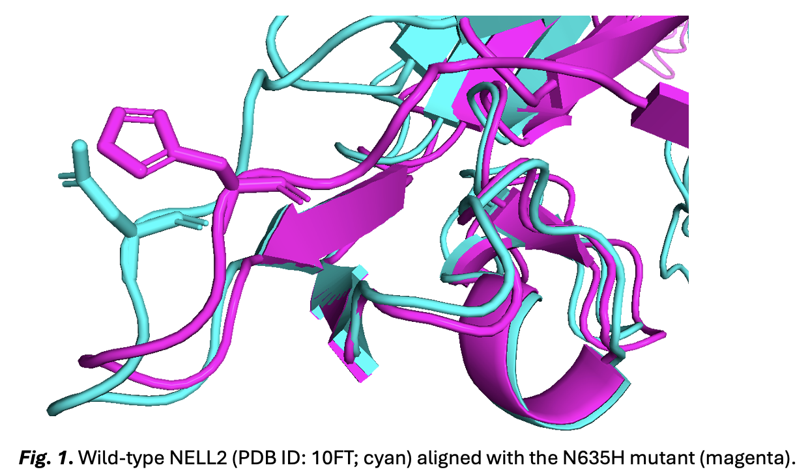
Figure 2
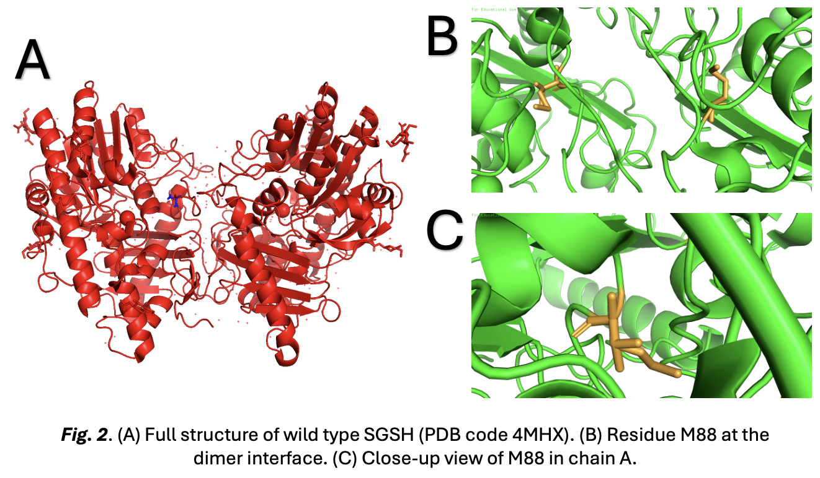
Figure 3
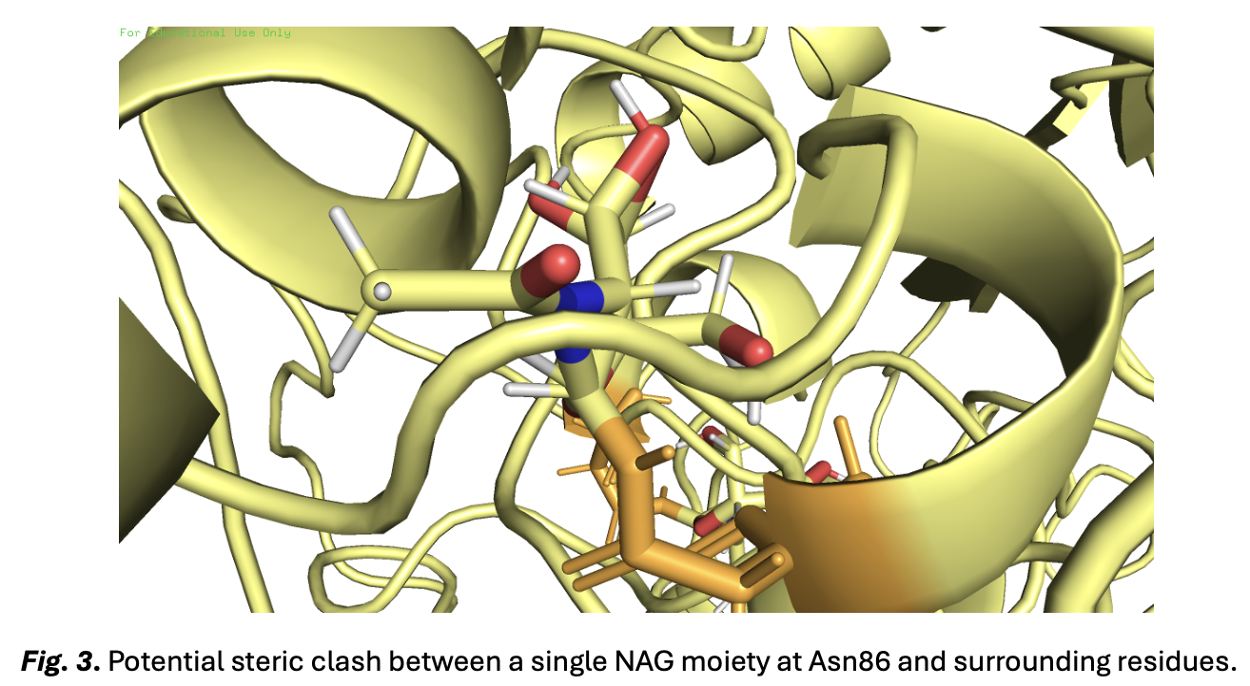
Figure 4
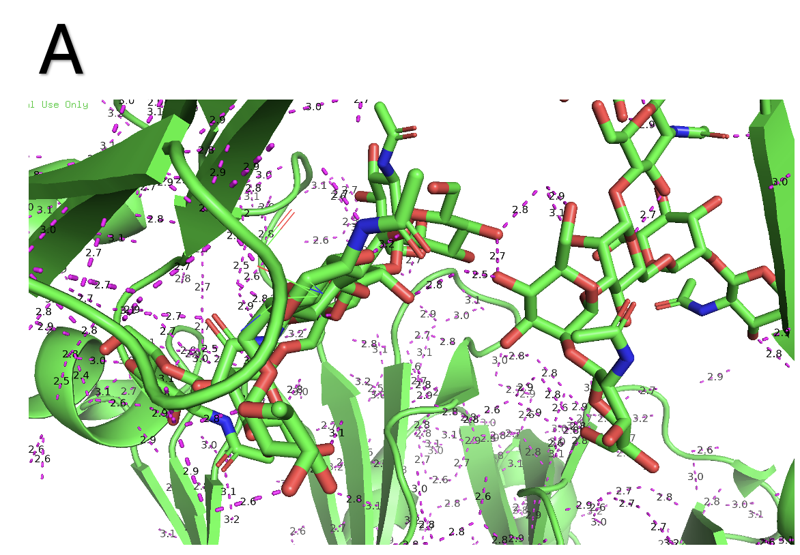

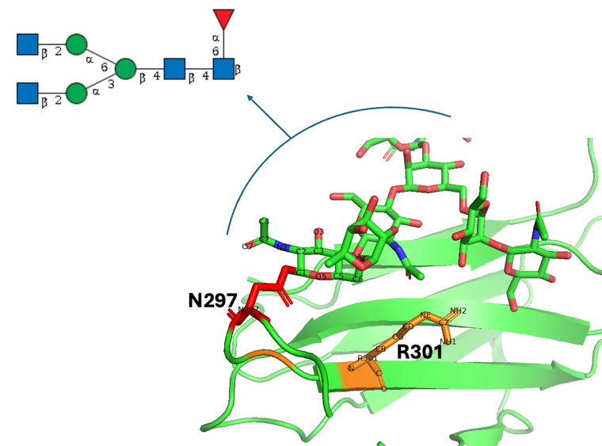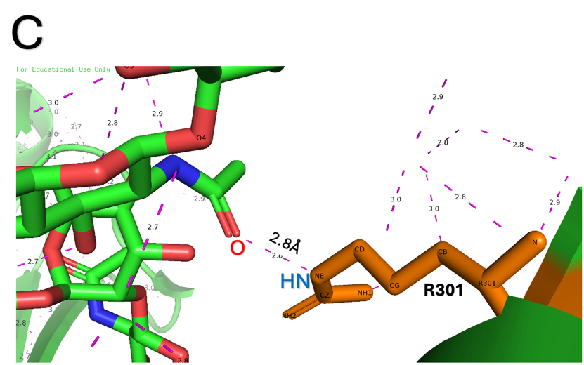
C
B

Figure 5
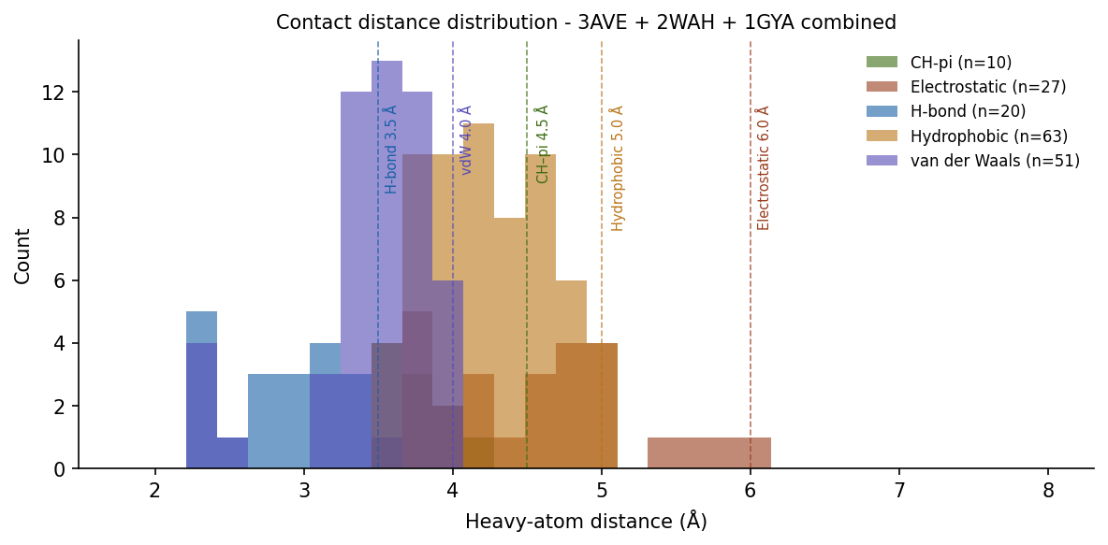
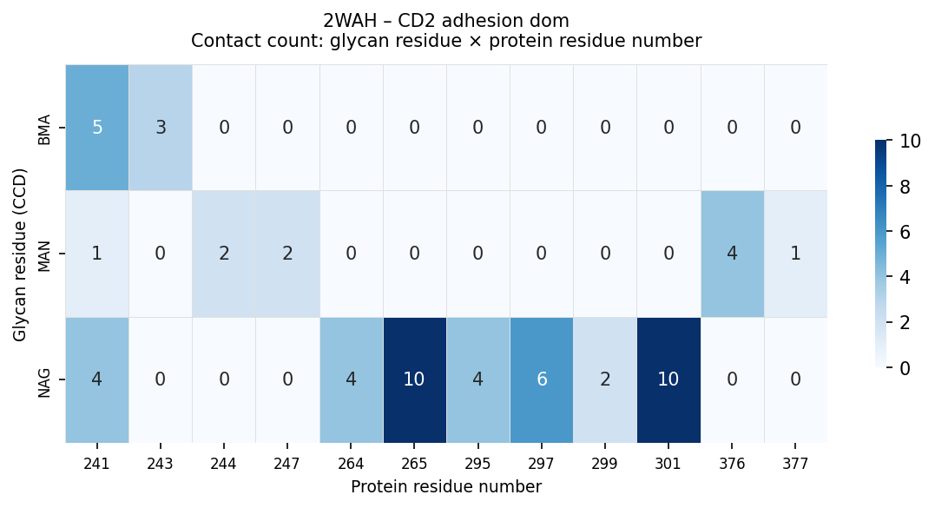
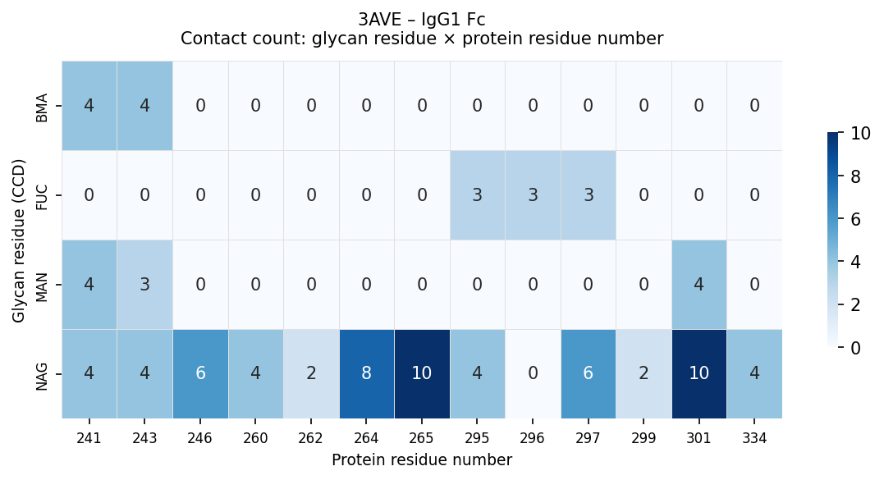
Figure 6
B
A

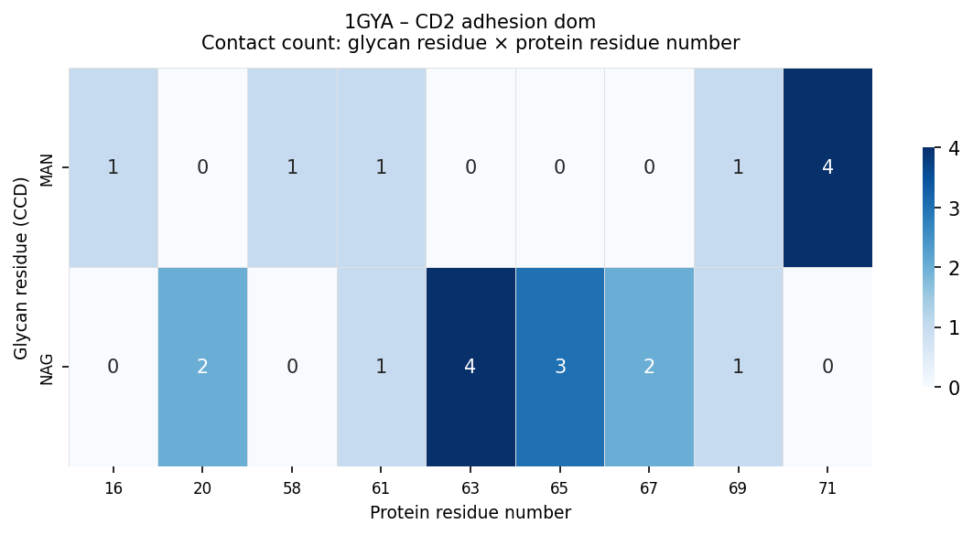
C
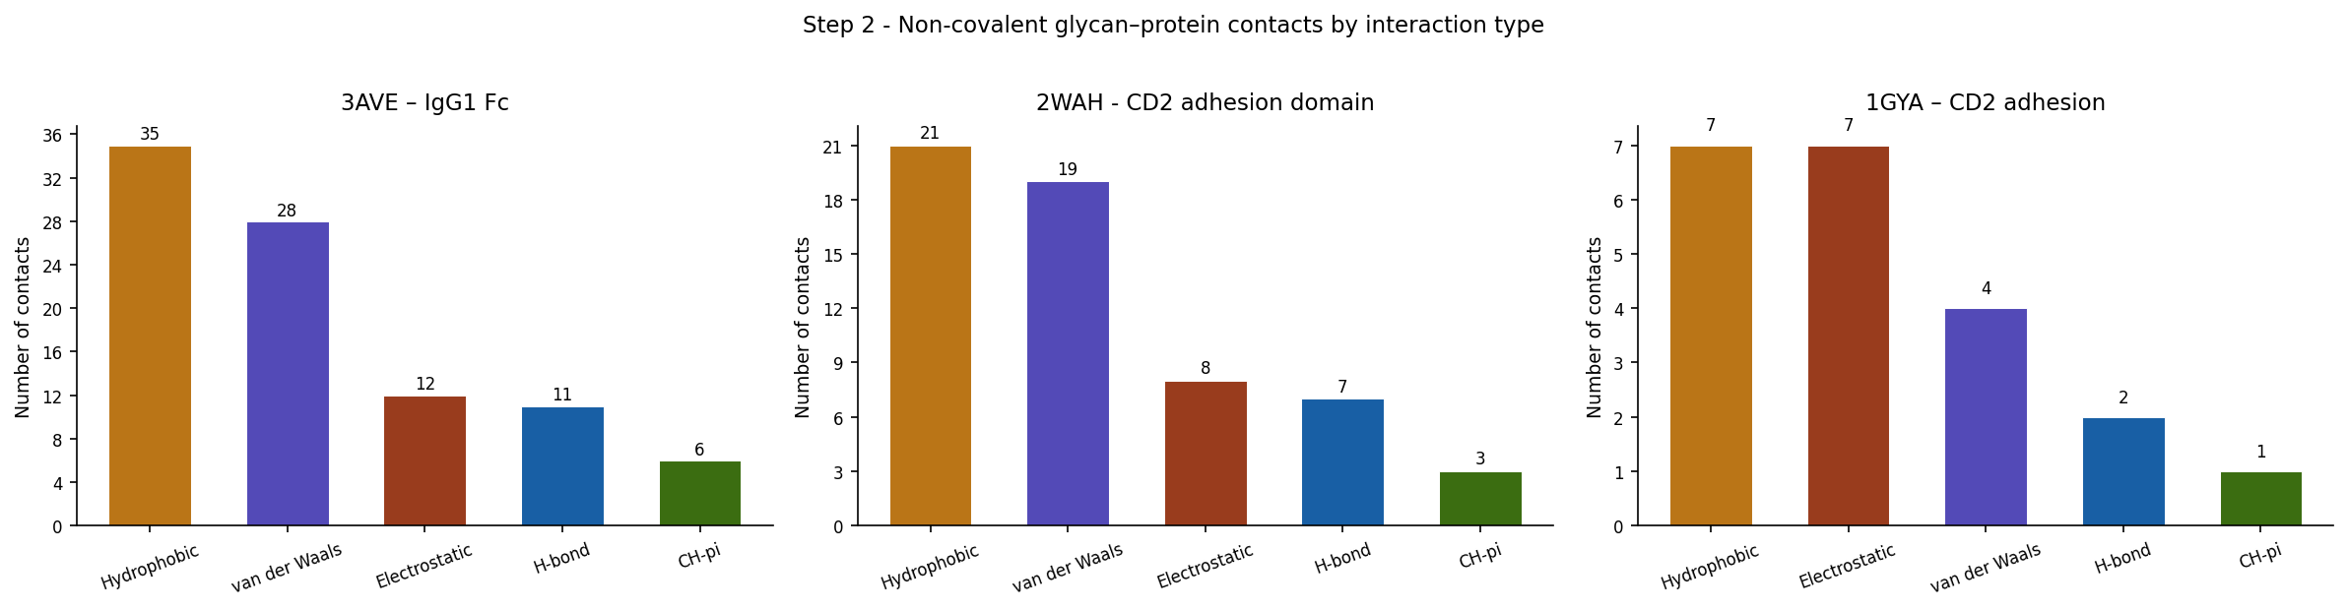
Figure 7

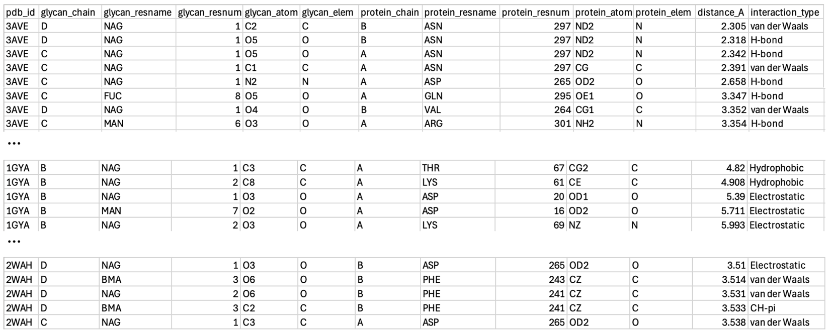
Table 1

