|  |  |  |  |  |
| --- | --- | --- | --- | --- |
| **MATLAB File Name** | **Sensors Utilized** | **Acc Placement Aclarations** | **Subject’s Position During Measurement** | **Key Findings from Results** |
| **Test1_Seated**  Folder: Plux_Logger | Plux (ECG + acc)  SensorLogger (acc: Headphones) | Plux: Left arm (deltoid)  Mobile Phone: Right shoulder | Sitting in a chair |  |
| **Test2_Seated**  Folder: Plux_Logger | Plux (ECG + acc)  SensorLogger (acc: Mobile Phone+ Headphones) | Plux: Left arm (deltoid)  Mobile Phone: Right shoulder | Sitting in a chair | Mobile Phone  Bioplux_Z |
| **Test3_Standup**  Folder: Plux_Logger | Plux (ECG + acc)  SensorLogger (acc: Mobile Phone+ Headphones) | Plux: Left arm (deltoid)  Mobile Phone: Right shoulder | Stand up | Mobile Phone |
| **Test4_Seated**  Folder: Plux_Logger | Plux (ECG + acc)  SensorLogger (acc: Mobile Phone+ Headphones) | Plux: Left clavicle  Mobile Phone: Right shoulder | Sitting in a chair | BioPlux |
| **Test5_Seated**  Folder: Plux_Logger | Plux (ECG + acc)  SensorLogger (acc: Mobile Phone+ Headphones) | Plux: Left side of the neck (yugular)  Mobile Phone: Right shoulder | Sitting in a chair | BioPlux  Mobile Phone |
| **Test6_Seated**  Folder: Plux_Logger | Plux (ECG + acc)  SensorLogger (acc: Mobile Phone+ Headphones) | Plux: Sternum  Mobile Phone: Right shoulder | Sitting in a chair | Mobile Phone |
| **Test7_Seated**  Folder: Plux_Logger | Plux (ECG + acc)  SensorLogger (acc: Mobile Phone+ Headphones) | Plux: Sternum  Mobile Phone: Right shoulder | Sitting in a chair | Mobile Phone  BioPlux |
| **Bed_near**  Folder: Bed | SensorLogger (acc: Mobile Phone) | Near my left side of the chest | Lying on the bed |  |
| **Bed_under**  Folder: Bed | SensorLogger (acc: Mobile Phone) | Under my left side of the chest | Lying on the bed |  |
| **Mattress_1**  Folder: Bed | SensorLogger (acc: Mobile Phone) | Plux: Sternum  Mobile Phone: Near my left side of the chest | Lying on the mattress | BioPlux  Mobile Phone |
| **Mattress_2**  Folder: Bed | SensorLogger (acc: Mobile Phone) | Plux: Sternum  Mobile Phone: Near my left side of the chest | Lying on the mattress | Mobile Phone |

**POWER SPECTRUM IMPLEMENTATION**

* **Choosing a specific window**

Obtain specific segments of the accelerometer signals (x, y z)

window_scg_x=dataArrayPlux(30000:65000, 3);

* **Filtering**

Filter the windows using bpFilt, the filter that is the one configured for the accelerometer signals up in the code (band-pass filter from 1-14Hz, 4th order and the corresponding sample frequency).

scg_x_filtered = filtfilt(bpFilt, window_scg_x);

* **Module calculation**

Obtain the magnitude of the filtered signals (x, y z).

mod=sqrt(scg_x_filtered.^2 + scg_y_filtered.^2 + scg_z_filtered.^2);

* **Fast Fourier Transform**

Transform the filtered signals and the module to the frequency domain, best visualization of the frequency components of the signal.

fft_scg_x = fft(scg_x_filtered);

* **Unilateral Spectrum (Real Signal)**

Only compute the positive values of the FFT (floor(L/2)+1). Calculation of the magnitude of the FFT (abs) and normalize it by L, the length of the signal.

L = length(window_scg_x);

P1_x = abs(fft_scg_x(1:floor(L/2)+1))/L;

* **Frequency vector associated with the spectral power**

This help to associate the power values back to their respective frequencies.

f_one_sided = Fs*(0:(floor(L/2)))/L;

* **Only work with frequencies that are less 30 Hz**

Index that contains only frequencies that less or equal than 30 Hz (x axes in the graphic)

idx = f_one_sided <= 30;

* **Consider the band of 0.8-1.8 Hz, where the SCG/BCG signal should appear**

idx_band = f_one_sided >= 0.8 & f_one_sided <= 1.8;

* **Total Spectral Power Calculation**

Calculated by summing the squares of the magnitudes of the FFT calculation, we get the total energy in the signal.

total_power_x = sum(P1_x.^2);

* **Spectral Power in the Band [0.8-1.8 Hz] Calculation**

Summing up the power in just the band using the index that select this correct frequency range.

band_power_x = sum(P1_x(idx_band).^2);

* **Divide the Band Power with the Total Power (Ratios)**

This help as to visualize and quantify how much of the total spectrum power is concentrated in the band of interest. Show the values in the command window.

ratio_x = band_power_x / total_power_x;

* **Plot the Power Spectrum in the frequency of interest (<30 Hz)**

The x axis is represented by f_one_sided(idx).

The y axis is represented by P1_x(idx).

plot(f_one_sided(idx), P1_x(idx));



**Ratio Calculation Mobile Phone:**

Ratio X-axis: 0.47688

Ratio Y-axis: 0.19674

Ratio Z-axis: 0.22438

Ratio of the module: 0.055021

**Ratio Calculation Headphones:**

Ratio X-axis: 0.034749

Ratio Y-axis: 0.034394

Ratio Z-axis: 0.011299

Ratio of the module: 0.0060535

**Ratio Calculation BioPlux:**

Ratio X-axis: 0.092575

Ratio Y-axis: 0.22375

Ratio Z-axis: 0.11846

Ratio of the module: 0.019672

**Test 2**

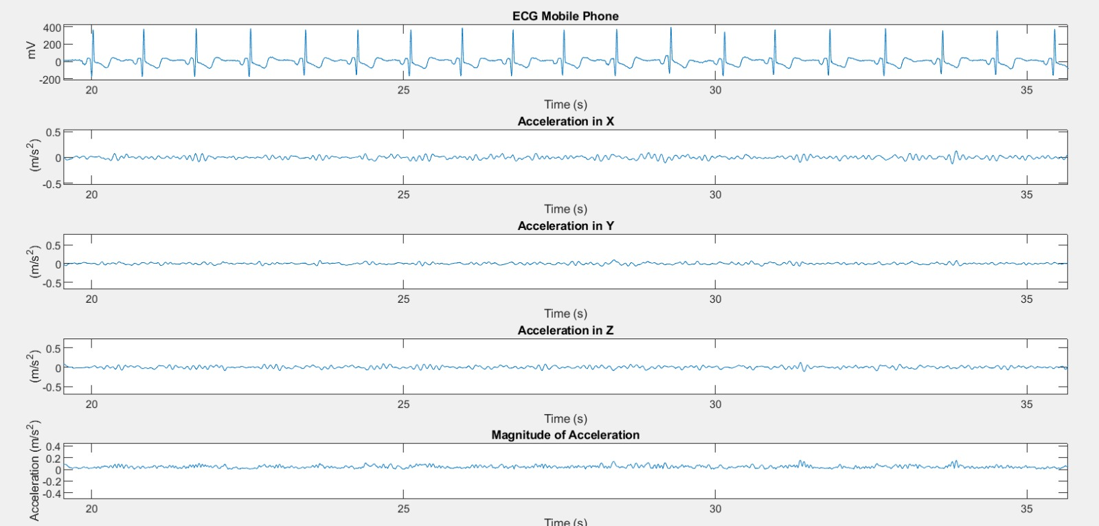**Test 3**

******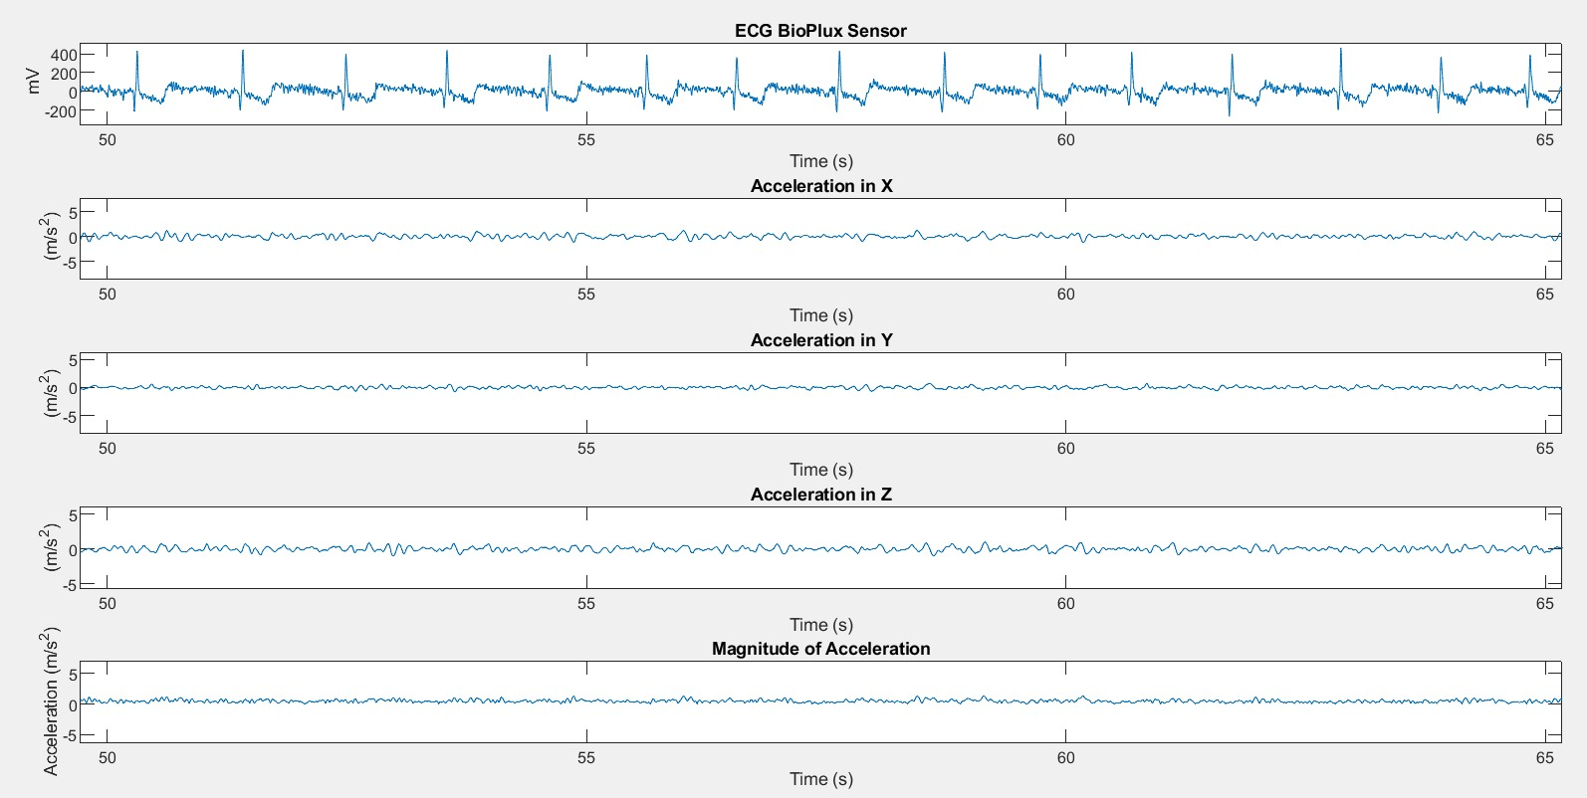Test 4**

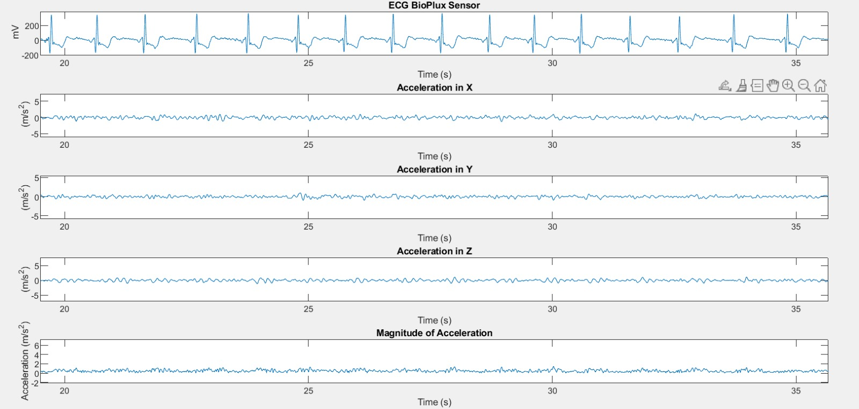**Test_5**

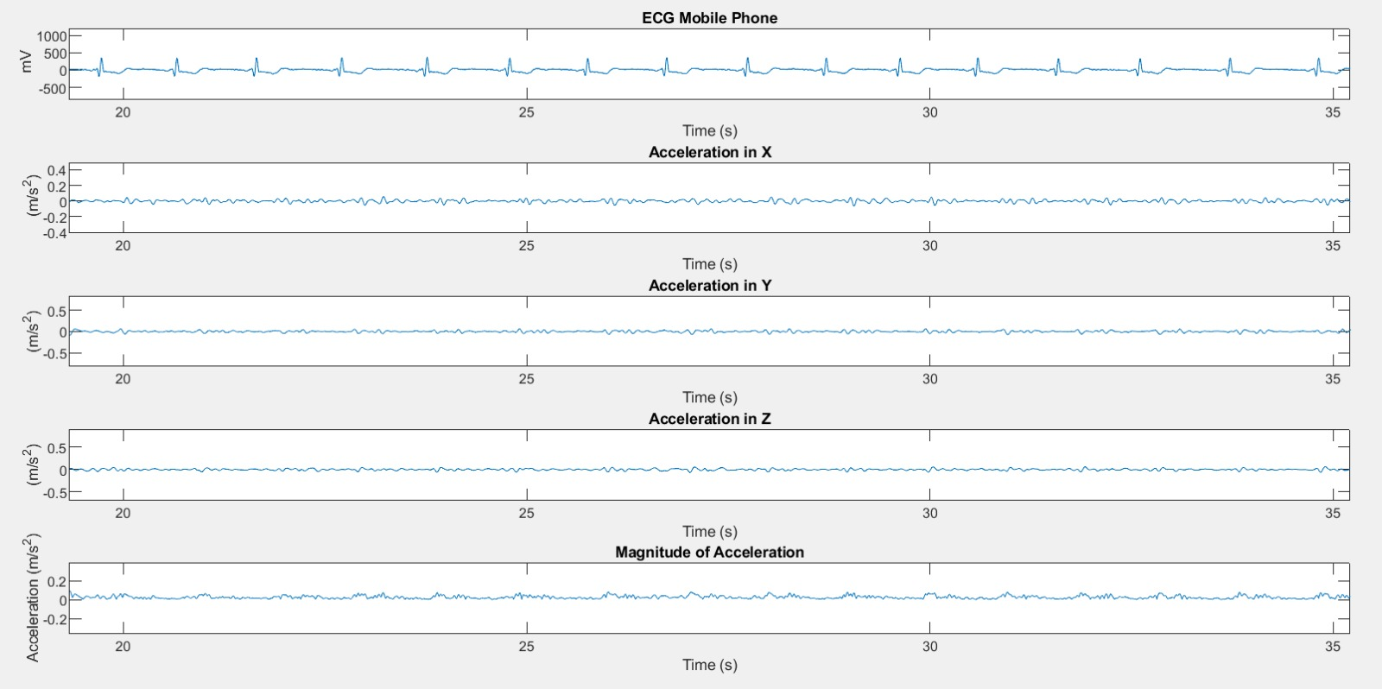

**Test_6****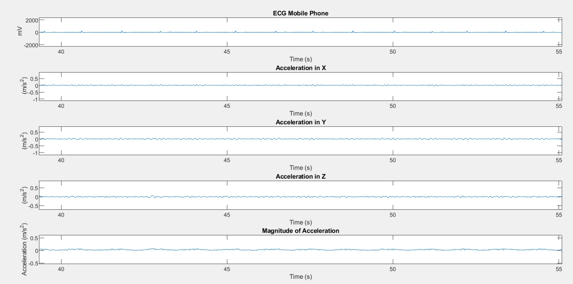**

**Test 7**

**Mattress_1**

**Mattress_2**