LAPORAN PENGERJAAN UJI KOMPETENSI KEJURUAN

WEB GALERI FOTO



PROGRAM STUDI RPL

SMK MAHARDHIKA BATUJAJAR

2023-2024

KOMPETENSI KEAHLIAN : Rekayasa Perangkat Lunak KELAS : XII RPL 2

NAMA LENGKAP : Maria Desyana N

NIS : 2122.10.411

PAKET SOAL : 3

JENIS APLIKASI : Web Gallery Foto

ALOKASI WAKTU : 24 jam

# PENJADWALAN KEGIATAN

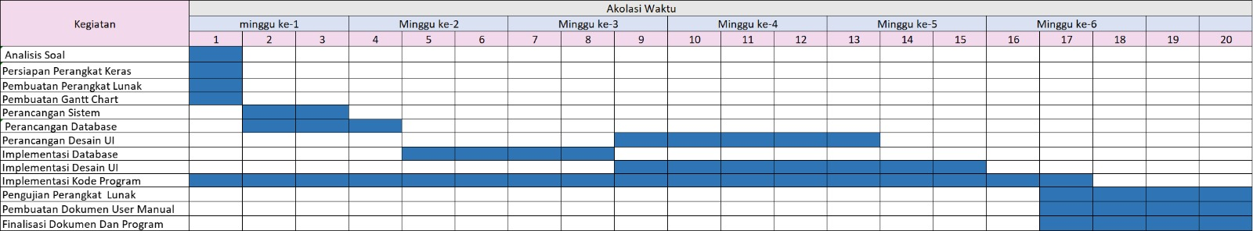

# PERSIAPAN PERANGKAT KERAS

* *Laptop: HP*
* *Processor: Intel(R) Core(TM) i5-6300U CPU @ 2.40GHz (4 CPUs), ~2.5GHz*
* *Memory: 8192MB RAM*
* *Kyboard*
* *Monitor*
* *Mouse*

# PERSIAPAN PERANGKAT LUNAK

* Visual Code
* Microsoft Excel
* Microsoft Word
* Astah Pro
* Balsamiq
* Xampp
* Goggle Chrome

# PERANCANGAN ALGORITMA APLIKASI

Aktivity Diagram

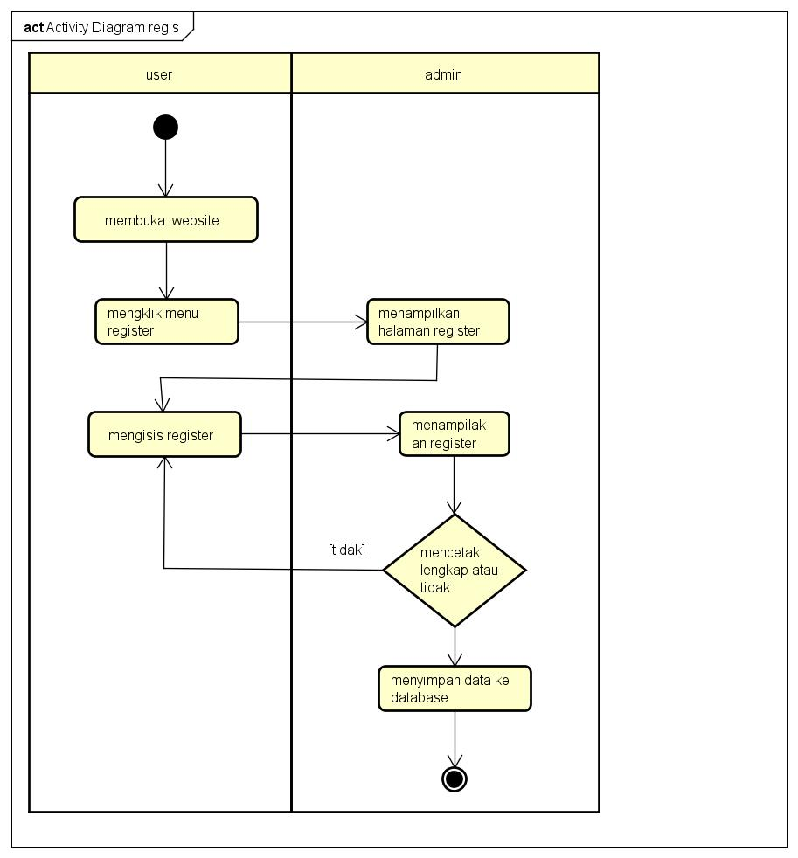

1.1 Activity Diagram Tampilan Registrasi

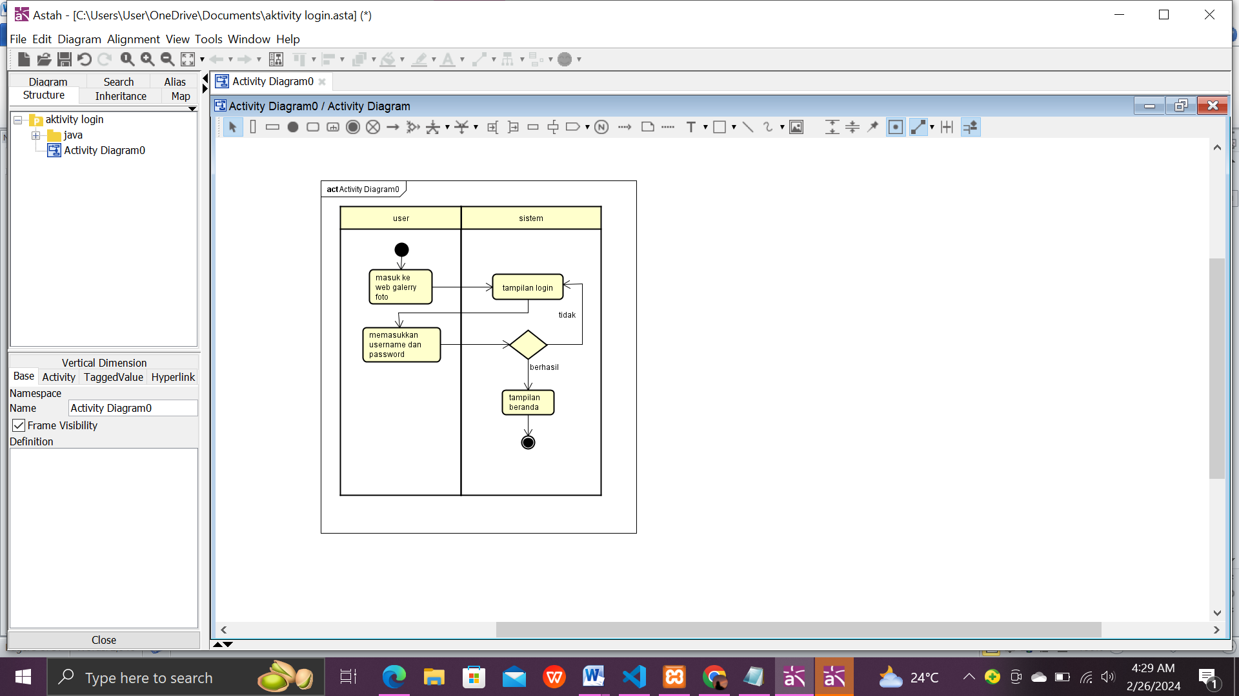

*1.2 Activity Diagram Tampilan Login*

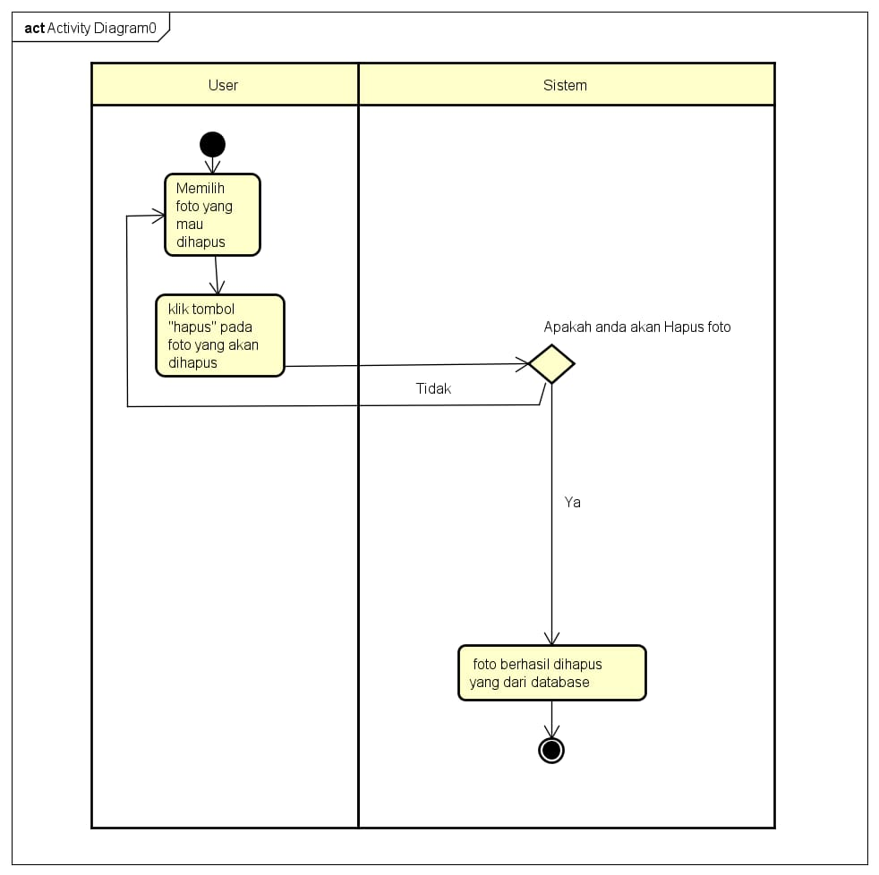

*1.3 Activity Diagram Tampilan Hapus*

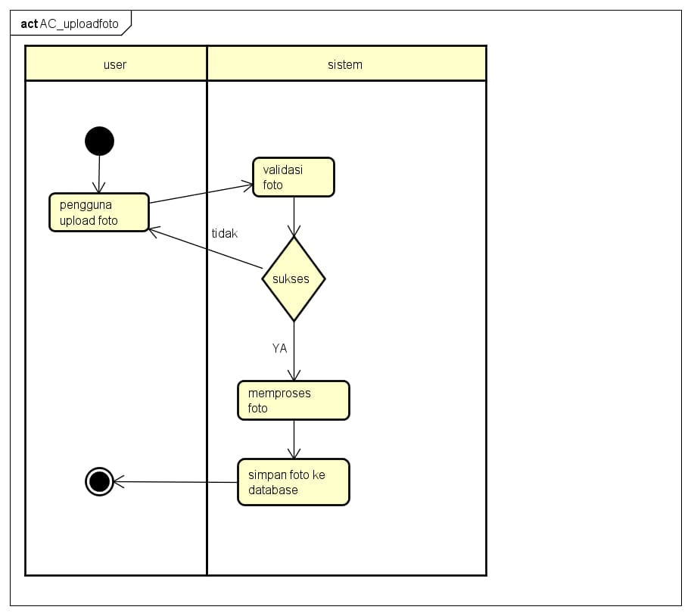

*1.4 Activity Diagram Tampilan Upload Foto*

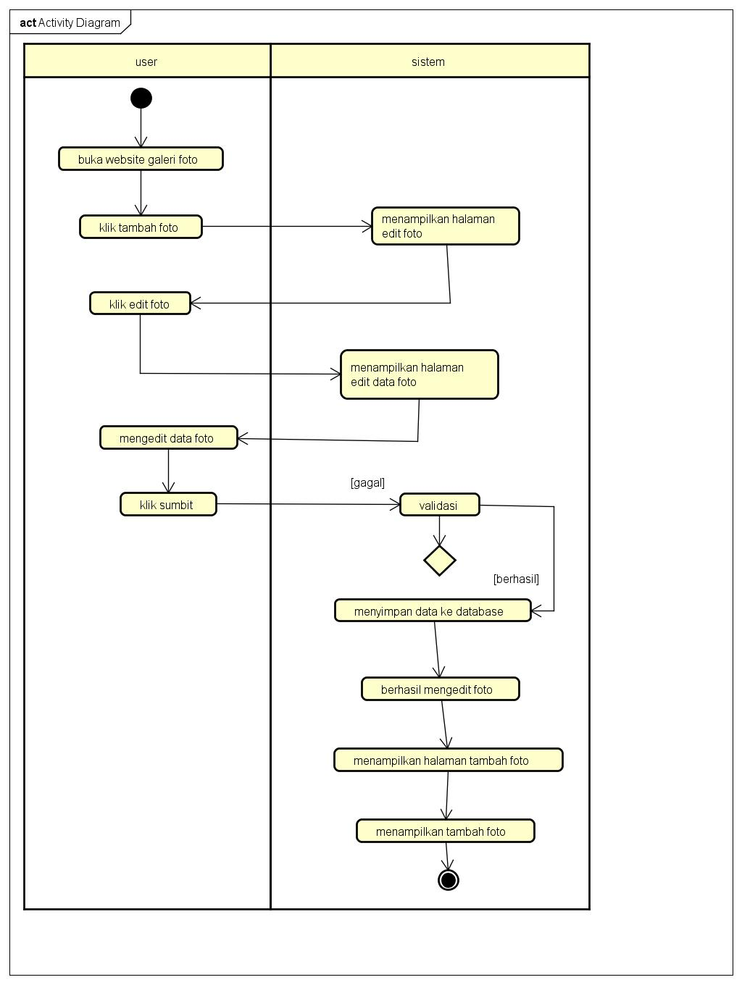

*1.5 Activity Diagram Tampilan Edit Foto*

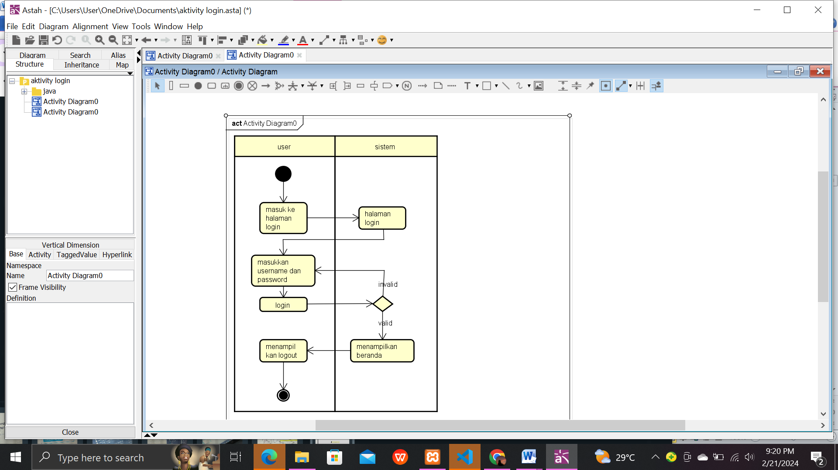

*1.6 Activity Diagram Tampilan Logout*

# PERANCANGAN DESAIN BASIS DATA

# ERD

image

Menambahkan

user

Tersimpan

category

# 

# DUMMY DATA

1. tb_admin

|  |  |  |  |  |  |  |  |
| --- | --- | --- | --- | --- | --- | --- | --- |
| **No** | **Admin_id** | **Admin_name** | **Username** | **Password** | **Admin_telp** | **Admin_email** | **Admin_address** |
| 1 | 123 | Laura | Lau | 12345 | 081234535498 | sayamanusia@gmail.com | Batujajar |
| 2 | 321 | Cahya | Cahya | 23456 | 089745634266 | cahyann@gmail.com | Cimahi |
| 3 | 234 | Cantika | Tika | 3456 | 089765465312 | can@gmail.com | Padalarang |
| 4 | 345 | Syifa | Syifa | 4567 | 089543862960 | syifaaa@gmail.com | Cimareme |
| 5 | 456 | Diana | Diana | 5678 | 088765432123 | diann@gmail.com | Jakarta |
| 6 | 567 | Siska | Siska | 6789 | 088769876548 | siskazenn@gmail.com | Batujajar |
| 7 | 577 | Aura | Aura | 0987 | 082345678917 | uraa@gmail.com | Batujajar |
| 8 | 789 | Fani | Fann | 98765 | 082313445261 | fanfanii@gmail.com | Cimahi |
| 9 | 098 | Lala | Lala | 2345 | 080293847569 | lalala@gmail.com | Jakarta |
| 10 | 874 | Sintya | Sintya | 1265 | 081018010180 | Sintya77@gmail.com | Cimahi |

1. tb_image

|  |  |  |  |  |  |  |  |  |
| --- | --- | --- | --- | --- | --- | --- | --- | --- |
| **NO** | **Category_id** | **Category_name** | **Admin_id** | **Admin_name** | **Image_name** | **Image_description** | **Image_description** | **image** |
| 1 | Senja.jpg |  | senja |  | Lala | senja | Senja adalah langit sore. |  |
| 2 | Langit.jpg |  | langit |  | Lala | langit | Langit adalah bagian atas dari permukaan bumi. |  |
| 3 | Pertualangan.jpeg |  | pertualangan |  | Lala | pertualangan | Pertualangan adalah seseorang yang suka mencari pengalaman yang sulit dan berbahaya. |  |
| 4 | Butterfly.jpg |  | kupukupu |  | Sintya | kupukupu | Kupu kupu adalah seranga yang tergolong kedalamordo lepidoptera. |  |
| 5 | Laut.jpeg |  | laut |  | Aura | laut | Laut adalah kumpulan air asin dalam jumlah yang banyak dan luas yang menggenangi dan membagi deretan atas benua dan pulau. |  |
| 6 | Hewan.jpg |  | hewan |  | Siska | hewan | Hewan adalah organisme eukariotik multiselluler yang membentuk kerajaan biologi animalia. |  |
| 7 | Tumbuhan.jpg |  | tumbuhan |  | Fani | tumbuhan | Tumbuhan adalah yang di dalamnya terdiri atas beberapa klad. |  |
| 8 | Astronot.jpg |  | astronot |  | Tika | astronot | Astronot adalah peran dan tanggujng jawab untuk mengatur satelit untuk keburtuhan teknologi dan komunikasi seluruh negara di dunia. |  |
| 9 | Sejarah.jpg |  |  |  | Diana |  |  |  |
| 10 | Planet.jpg |  |  |  | Cantika |  |  |  |

1. tb_like

|  |  |  |  |  |  |
| --- | --- | --- | --- | --- | --- |
| No | Like_id | Image_id | Admin_name | Suka | Tanggal_like |
| 1 | 10 | 31 | Laut | 1 | 07/01/2024 |
| 2 | 11 | 32 | senja | 1 | 08/02/2024 |
| 3 | 12 | 33 | langit | 1 | 10/02/2024 |
| 4 | 13 | 34 | pertualangan | 1 | 13/02/20224 |
| 5 | 14 | 35 | kupukupu | 0 | 15/02/2024 |
| 6 | 15 | 36 | laut | 1 | 07/01/2024 |
| 7 | 16 | 37 | hewan | 1 | 08/02/2024 |
| 8 | 17 | 38 | tumbuhan | 1 | 10/02/2024 |
| 9 | 18 | 39 | astronot | 1 | 13/02/20224 |
| 10 | 19 | 40 |  | 0 | 15/02/2024 |

1. tb_komentarfoto

|  |  |  |  |  |  |  |
| --- | --- | --- | --- | --- | --- | --- |
| No | Komentar_id | Image_id | Admin_id | Admin_name | Isi_komentar | Tanggal_komentar |
| 1 | 3 | 50 | 4 | Laura | hallo | 06/01/2024 |
| 2 | 9 | 40 | 2 | Cahya | bagus | 08/01/2024 |
| 3 | 8 | 30 | 2 | Cantika | Saya suka | 10/02/2024 |
| 4 | 10 | 20 | 2 | Syifa | waw | 15/02/20224 |
| 5 | 1 | 10 | 2 | Diana | keren | 19/02/2024 |
| 6 | 7 | 15 | 2 | Siska | Pingin bisa ngelukis | 07/01/2024 |
| 7 | 5 | 35 | 2 | Aura | Indah hasilnya | 08/02/2024 |
| 8 | 6 | 45 | 2 | Fani | good | 10/02/2024 |
| 9 | 4 | 25 | 2 | Lala | Seni mengartikan rasa | 13/02/20224 |
| 10 | 2 | 45 | 2 | Sintya | kece | 21/02/2024 |

## PEMBUATAN BASIS DATA (MySQL Code)

1. *tb_admin*

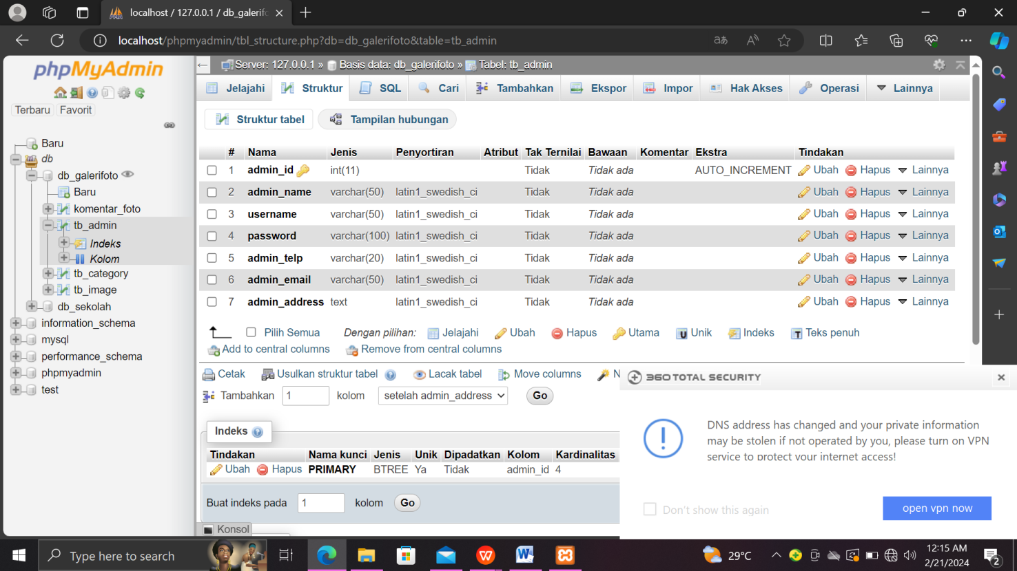

1. *tb_image*

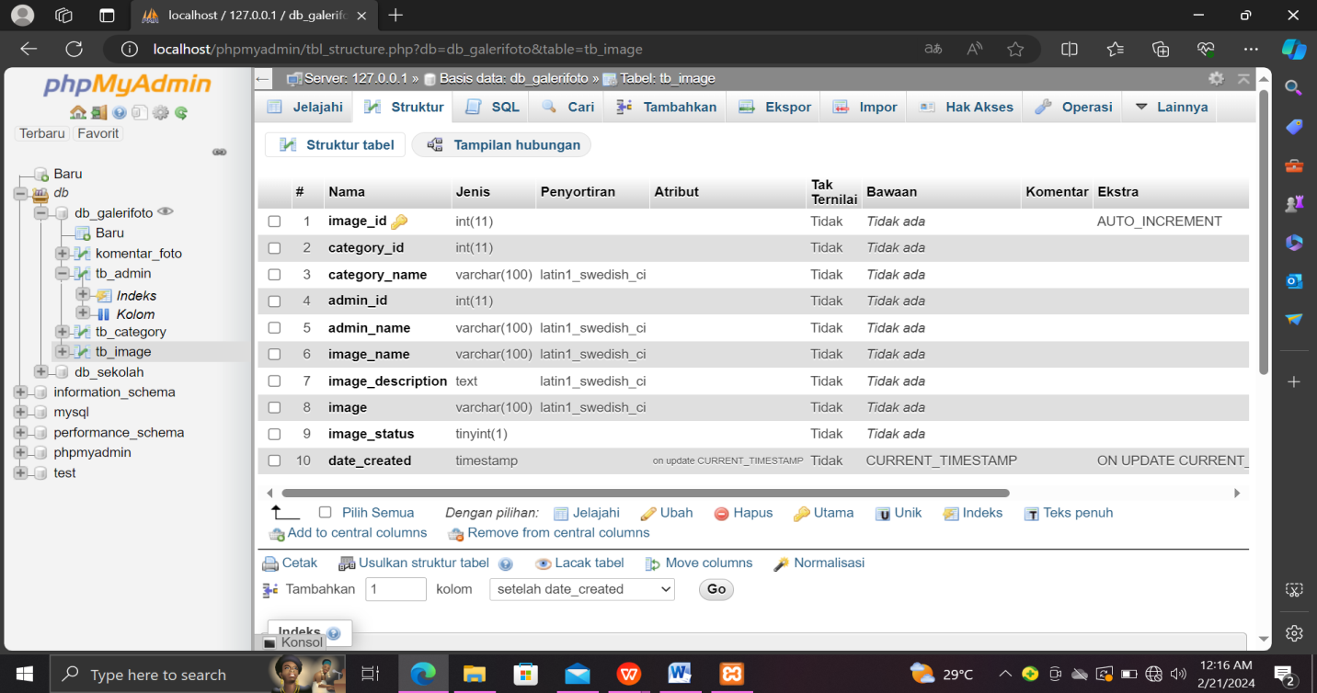

1. *tb_category*

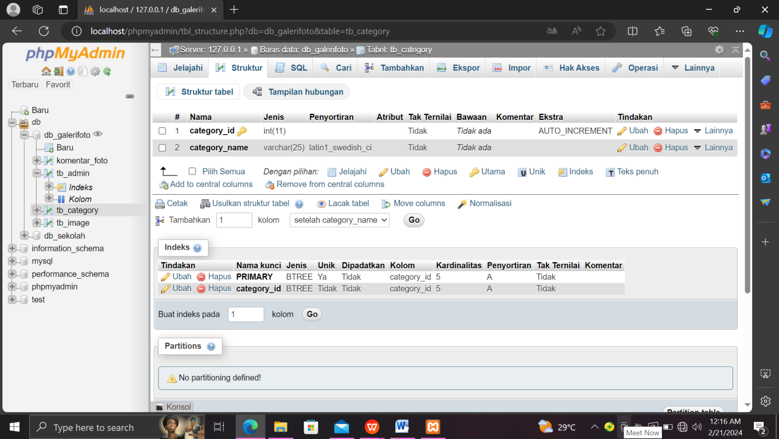

1. *tb_likefoto*

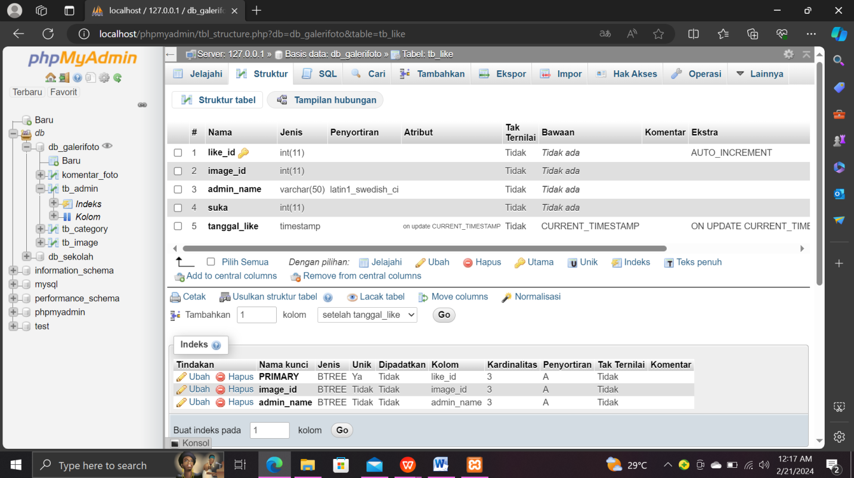

1. *tb_komentarfoto*

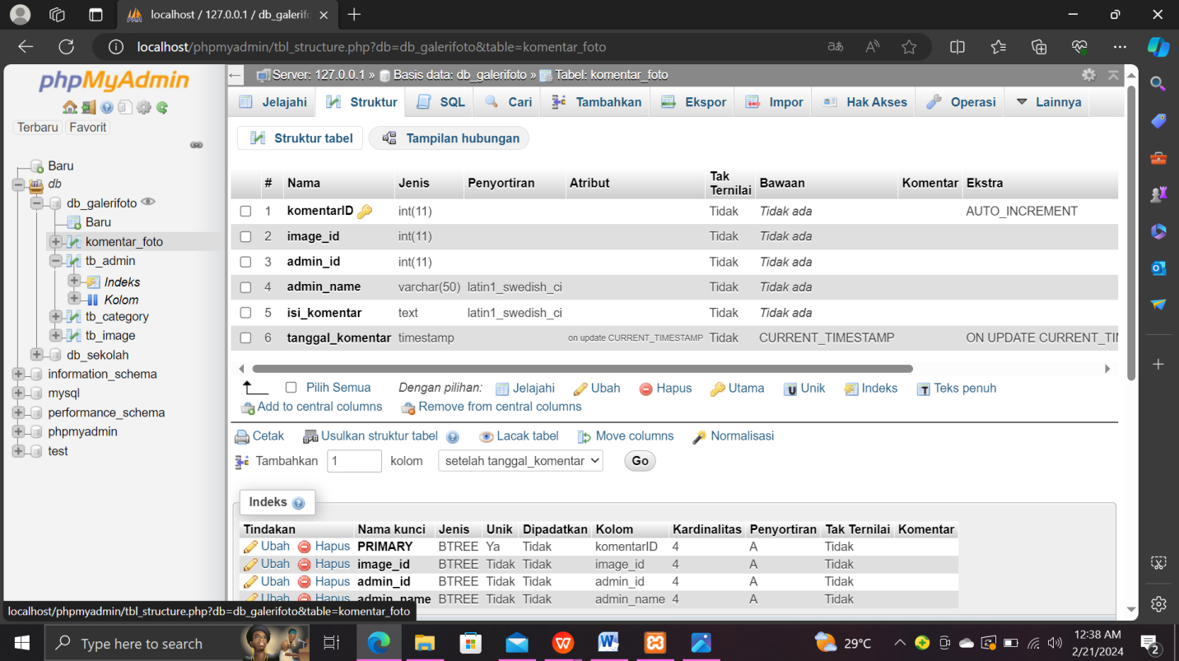

# PERANCANGAN TAMPILAN ANTARMUKA (UI) WEB

# Use Case web Gallery Foto

# 

# Skenario Use Case

# Nama : Registrasi

# ID : UC2

# Deskripsi :

# Aktor : User

# 

|  |  |
| --- | --- |
| Aksi Aktor | Reaksi Skenario |
| Membuka sistem dengan menggunakan domain http:/localhost/ |  |
| klik halaman registrasi |  |
|  | Halaman registrasi |
| Memasukkan Nama user, Password, Nomor telepon, Email, Alamat |  |
|  | Berhasil registrasi |
| Scenario alternative |  |
|  |  |
| Skenario eksepsi |  |

# Nama : Login

# ID : UC2

# Deskripsi :

# Aktor : User

|  |  |
| --- | --- |
| Aksi Aktor | Reaksi Skenario |
| Membuka sistem dengan menggunakan domain http:/localhost/ |  |
|  | Tampilan login |
|  |  |
| Isi username dan password |  |
|  | Berhasil login |
|  | Jika gagal login,cek kembali username atau password |
| Scenario alternative |  | |
|  |  | |
| Skenario eksepsi |  | |

# Nama : Tambah Foto

# ID : UC2

# Deskripsi :

# Aktor : User

|  |  |
| --- | --- |
| Aksi Aktor | Reaksi Skenario |
|  | 1. Tampilan tambah data |
| 2. masuk ke tampilan tambah data |  |
| Kemudian, pilih nama kateory, masukkan nama, nama foto,deskripsi foto, tambah foto,pilih lalu klik submit |  |
|  | Tambah foto berhasil |
|  | jika tambah foto tidak berhasil maka akan kembali ke halaman tambah foto |
| Scenario alternative |  | |
|  |  | |
| Skenario eksepsi |  | |

# 

# Nama : Galery

# ID : UC2

# Deskripsi :

# Aktor : User

|  |  |
| --- | --- |
| Aksi Aktor | Reaksi Skenario |
|  | 1.Tampilan gallery |
| 2. klik foto yang anda pilih |  |
| Anda bisa like dan komen foto tersebut |  |
| Jika anda ingin mengedit data foto | Tampilan edit data |
|  | Jika edit data berhasil foto pun akan otomatis berubah |
| Scenario alternative |  | |
|  |  | |
| Skenario eksepsi |  | |

* **Mockup**

1. Tampilan Beranda (sebelum login) 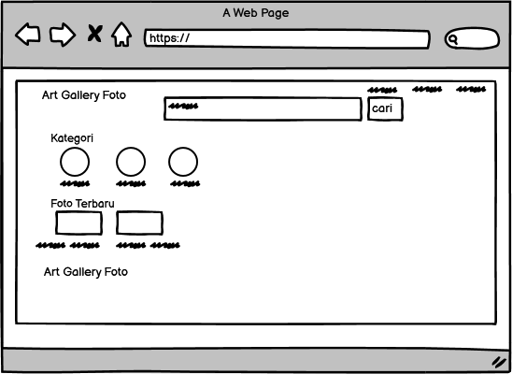
2. Tampilan Registrasi

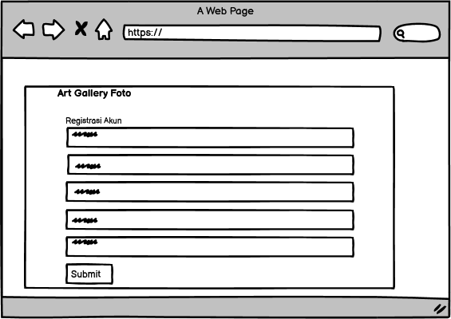

1. Tampilan Login

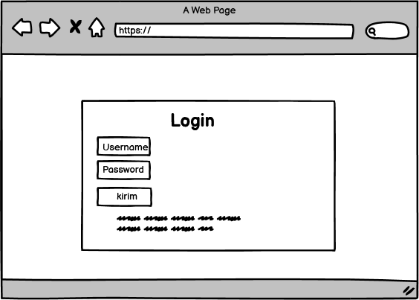

1. Tampilan Detail-image

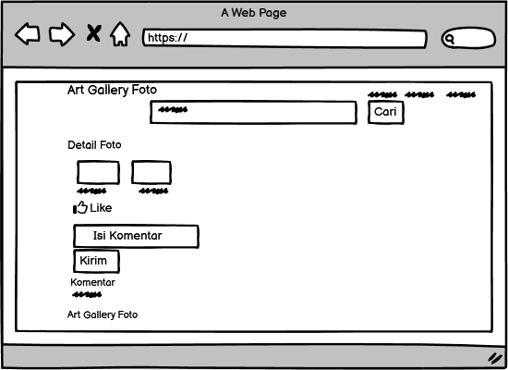

## Data Foto

## 

## Edit Foto

## 

1. **PEMBUATAN STYLE WEB (CSS)**

File style.css

|  |
| --- |
| @charset "utf-8";  /* CSS Document */  * {  padding:0;  margin:0;  font-family:'Garamond', Garamond;  }  body {  background-color:#d174d1;  }  a {  color: beige;  text-decoration:none;  }  #bg-login {  display: flex;  height: 100vh;  justify-content: center;  align-items: center;  }  .box-login {  width: 300px;  min-height: 200px;  border:1px solid #050505;  background-color: #d4b8ead7;  padding:15px;  box-sizing:border-box;  }  .box-login h2 {  text-align:center;  margin-bottom:15px;  }  .input-control {  width:100%;  padding:10px;  margin-bottom:25px;  box-sizing:border-box;  }  .btn {  padding:8px 15px;  background-color: #050505;  color: #fff;  border:none;  cursor: pointer;  }  header {  background-color:#050505;    }  .like {  background-image: url(../img/like.png);    background-repeat: no-repeat;  background-position: 4px 5px;  border: none;  cursor: pointer;  height: 30px;  padding-left: 30px;  vertical-align: middle;  color: hsl(0, 5%, 4%);  border-color: hsl(286, 25%, 67%);  -webkit-box-shadow: inset 0 1px 0 hsl(0, 100%, 100%),0 1px 0 hsla(0, 0%, 0%, .08);  box-shadow: inset 0 1px 0 hsl(0, 100%, 100%),0 1px 0 hsla(0, 0%, 0%, .08); }  header h1 {  float:left;  padding:10px 0; }  header ul {  float:right; }  header ul li {  display:inline-block; }  header ul li a {  padding:20px 0 20px 15px;  display: inline-block; }  footer {  padding:25px 0; }  .container {    width: 80%;  margin: 0 auto; }  .container:after {  content:'';  display: block;  clear:both; }  .section {  padding:25px 0; }  .box {  background-color:#d4b8ead7;  border:1px solid hsla(282, 86%, 39%, 0.868);  padding:15px;  box-sizing: border-box;  margin:10px 0 25px 0; }  .box:after {  content: '';  display: block;  clear: both; }  .table {  width: 100%;  border-collapse: collapse; }  .table tr {  height: 30px; }  .table tr td {  padding:5px 10px; }  .search {  padding:15px 0;  background-color: #fff;  border:1px solid #d174d1;  text-align: center; }  .search input[type=text] {  width: 60%;  padding:10px; }  .search input[type=submit] {  padding:12px 15px;  background-color:#070707;  color: #fff;  border:none;  cursor:pointer; }  .col-5 {  width:20%;  height:100px;  text-align: center;  float: left;  padding:10px;  box-sizing: border-box; }  .col-4 {  width:25%;  height: 230px;  border:1px solid #fff;  float: left;  padding:10px;  box-sizing: border-box;  margin-bottom: 10px; }  .col-4:hover {  box-shadow: 0 0 3px #fff; }  .col-4 img {  width: 100%; }  .col-4 .nama {  font-weight: bold;  color: #fdfcfc;  margin-bottom: 5px;  padding-top:5px; }  .col-4 .admin {  color: #fff;  font-size:14px; }  .col-4 .admin1 {  font-weight: bold;  color: #fff;  font-size:12px;  padding-top:5px; }  .footer {  padding:25px 0;  background-color: #0b0b0b;  color: #fff;  text-align: center; }  .footer p {  margin-bottom: 10px; }  .footer small {  margin-top: 25px;  display: inline-block; }  .col-2 {  width: 50%;  min-height: 200px;  padding:10px;  box-sizing: border-box;  float: left; }  .col-2 img {  border:1px solid #f9f9f9;  padding:5px;  box-sizing: border-box; }  .col-2 h3 {  margin-bottom: 10px; }  .col-2 h4 {  color: #fcf9fc; }  .col-2 p {  margin:15px 0;  text-align: justify;  line-height: 25px;  font-size: 14px; }  .col-7 {  width: 50%;  min-height: 200px;  padding:10px;  box-sizing: border-box;  float: left;  padding-bottom:inherit;  padding-top:inherit; }  .input {  width: fit-content;  padding:10px;  margin-bottom:12px;  background-color: #d49ccb;  box-sizing: content-box;  border-radius:0px 35px 35px 35px; }  @media screen and (max-width: 768px) {  .container {  width: 90%;  } .col-5 {  width:50%;  margin-bottom: 10px;  } .col-4 {  width:50%;  height: 300px; }  .col-2 {  width:100%;  }  } |

1. **PEMBUATAN KODE WEB (PHP/JS)**

File index.php

|  |
| --- |
| <?php      include 'db.php';      $kontak = mysqli_query($conn, "SELECT admin_telp, admin_email, admin_address FROM tb_admin WHERE admin_id = 2");      $a = mysqli_fetch_object($kontak);  ?>  <!DOCTYPE html PUBLIC "-//W3C//DTD XHTML 1.0 Transitional//EN" "http://www.w3.org/TR/xhtml1/DTD/xhtml1-transitional.dtd">  <html xmlns="http://www.w3.org/1999/xhtml">  <head>  <meta charset="utf-8">  <meta name="viewport" content="width=device-width, beige-scale=1">  <title>Art Gallery Website</title>  <link rel="stylesheet" type="text/css" href="css/style.css">  </head>  <body>      <!-- header -->      <header>          <div class="container">          <h1><a href="index.php">Art Gallery Website</a></h1>          <ul>              <li><a href="galeri.php">Galeri</a></li>             <li><a href="registrasi.php">Registrasi</a></li>             <li><a href="login.php">Login</a></li>          </ul>          </div>      </header>        <!-- search -->      <div class="search">          <div class="container">              <form action="galeri.php">                <input type="text" name="search" placeholder="Cari Foto" />                <input type="submit" name="cari" value="Cari Foto" />              </form>          </div>      </div>        <!-- category -->      <div class="section">          <div class="container">            <h3>Kategori</h3>                    <?php                      $kategori = mysqli_query($conn, "SELECT * FROM tb_category ORDER BY category_id DESC");                      if(mysqli_num_rows($kategori) > 0){                          while($k = mysqli_fetch_array($kategori)){                  ?>                      <a href="galeri.php?kat=<?php echo $k['category_id'] ?>">                          <div class="col-5">                          <img src="img/icon.png" width="70px" style="margin-bottom:7px;" />                          <p><?php echo $k['category_name'] ?></p>                          </div>                      </a>                  <?php }}else{ ?>                       <p>Kategori tidak ada</p>                  <?php } ?>              </div>          </div>      </div>        <!-- new product -->     <div class="section">          <div class="container">         <h3>Foto Terbaru</h3>              <?php                $foto = mysqli_query($conn, "SELECT * FROM tb_image WHERE image_status = 1 ORDER BY image_id DESC LIMIT 8");                if(mysqli_num_rows($foto) > 0){                    while($p = mysqli_fetch_array($foto)){            ?>            <a href="detail-image.php?id=<?php echo $p['image_id'] ?>">            <div class="col-4">                <img src="img/foto/<?php echo $p['image'] ?>" height="150px" />                <p class="nama"><?php echo substr($p['image_name'], 0, 30)  ?></p>                <p class="admin">Nama User : <?php echo $p['admin_name'] ?></p>                <p class="nama"><?php echo $p['date_created']  ?></p>            </div>            </a>            <?php }}else{ ?>                <p>Foto tidak ada</p>            <?php } ?>         </div>      </div>        <!-- footer -->       <footer>          <div class="container">              <small> - Art Gallery Website</small>          </div>      </footer>  </body>  </html> |

File db.php

|  |
| --- |
| <?php  $hostname = 'localhost';  $username = 'root';  $password = '';  $dbname = 'db_galerifoto';    $conn = mysqli_connect($hostname, $username, $password, $dbname) or die ('gagal terhubung ke database');  ?> |

CRUD file

* Tambah-image.php

|  |
| --- |
| <?php      session_start();      include 'db.php';      if($_SESSION['status_login'] != true){          echo '<script>window.location="login.php"</script>';      }  ?>  <!DOCTYPE html PUBLIC "-//W3C//DTD XHTML 1.0 Transitional//EN" "http://www.w3.org/TR/xhtml1/DTD/xhtml1-transitional.dtd">  <html xmlns="http://www.w3.org/1999/xhtml">  <head>  <meta charset="utf-8">  <meta name="viewport" content="width=device-width, initial-scale=1">  <title>Art Gallery Website</title>  <link rel="stylesheet" type="text/css" href="css/style.css">  </head>  <body>      <!-- header -->      <header>          <div class="container">          <h1><a href="dashboard.php">Art Gallery Website</a></h1>          <ul>             <li><a href="dashboard.php">Dashboard</a></li>             <li><a href="profil.php">Profil</a></li>             <li><a href="data-image.php">Data Foto</a></li>             <li><a href="Keluar.php">Keluar</a></li>          </ul>          </div>      </header>        <!-- content -->      <div class="section">          <div class="container">              <h3>Tambah Data Foto</h3>              <div class="box">                   <form action="" method="POST" enctype="multipart/form-data">                       <?php   $result = mysqli_query($conn,"select * from tb_category");                        $jsArray = "var prdName = new Array();\n";  echo '<select class="input-control" name="kategori" onchange="document.getElementById(\'prd_name\').value = prdName[this.value]" required>    <option>-Pilih Kategori Foto-</option>';    while ($row = mysqli_fetch_array($result)) {  echo   ' <option value="' . $row['category_id'] . '">' . $row['category_name'] . '</option>';  $jsArray .= "prdName['" . $row['category_id'] . "'] = '" . addslashes($row['category_name']) . "';\n";}echo '</select>';?>                     </select>                     <input type="hidden" name="nama_kategori" id="prd_name">                     <input type="hidden" name="adminid" value="<?php echo $_SESSION['a_global']->admin_id ?>">                     <input type="text" name="namaadmin" class="input-control" value="<?php echo $_SESSION['a_global']->admin_name ?>" readonly="readonly">                     <input type="text" name="nama" class="input-control" placeholder="Nama Foto" required>                     <textarea class="input-control" name="deskripsi" placeholder="Deskripsi"></textarea><br />                     <input type="file" name="gambar" class="input-control" required>                     <select class="input-control" name="status">                         <option value="">--Pilih--</option>                         <option value="1">Aktif</option>                         <option value="0">Tidak Aktif</option>                     </select>                     <input type="submit" name="submit" value="Submit" class="btn">                 </form>                 <?php                     if(isset($_POST['submit'])){                           // print_r($_FILES[gambar']);                         // menampung inputan dari form                         $kategori  = $_POST['kategori'];                         $nama_ka   = $_POST['nama_kategori'];                         $ida       = $_POST['adminid'];                         $user      = $_POST['namaadmin'];                         $nama      = $_POST['nama'];                         $deskripsi = $_POST['deskripsi'];                         $status    = $_POST['status'];                           // menampung data file yang diupload                         $filename = $_FILES['gambar']['name'];                         $tmp_name = $_FILES['gambar']['tmp_name'];                           $type1 = explode('.', $filename);                         $type2 = $type1[1];                         $newname = 'foto'.time().'.'.$type2;                           // menampung data format file yang diizinkan                         $tipe_diizinkan = array('jpg', 'jpeg', 'png', 'gif');                           // validasi format file                         if(!in_array($type2, $tipe_diizinkan)){                            // jika format file tidak ada di dalam tipe diizinkan                            echo '<script>alert("Format file tidak diizinkan")</script>';                           }else{                             // jika format file sesuai dengan yang ada di dalam array tipe diizinkan                             // proses upload file sekaligus insert ke database                             move_uploaded_file($tmp_name, '.img/foto/'.$newname);                               $insert = mysqli_query($conn, "INSERT INTO tb_image VALUES (                                         null,                                         '".$kategori."',                                         '".$nama_ka."',                                         '".$ida."',                                         '".$user."',                                         '".$nama."',                                         '".$deskripsi."',                                         '".$newname."',                                         '".$status."',                                         null                                             ) ");                               if($insert){                                 echo '<script>alert("Tambah Foto berhasil")</script>';                                 echo '<script>window.location="data-image.php"</script>';                             }else{                                 echo 'gagal'.mysqli_error($conn);                               }                         }                         }                 ?>          </div>          </div>      </div>        <!-- footer -->      <footer>          <div class="container">              <small>- Art Gallery Website</small>          </div>      </footer>      <script>              CKEDITOR.replace( 'deskripsi' );      </script>      <script type="text/javascript"><?php echo $jsArray; ?></script>  </body>  </html> |

* Edit-image.php

|  |
| --- |
| <?php      session_start();      include 'db.php';      if($_SESSION['status_login'] != true){          echo '<script>window.location="login.php"</script>';      }      $produk = mysqli_query($conn, "SELECT * FROM  tb_image WHERE image_id = '".$_GET['id']."'");      if(mysqli_num_rows($produk) == 0){          echo '<script>window.location="data-image.php"</script>';      }      $p = mysqli_fetch_object($produk);  ?>  <!DOCTYPE html PUBLIC "-//W3C//DTD XHTML 1.0 Transitional//EN" "http://www.w3.org/TR/xhtml1/DTD/xhtml1-transitional.dtd">  <html xmlns="http://www.w3.org/1999/xhtml">  <head>  <meta charset="utf-8">  <meta name="viewport" content="width=device-width, initial-scale=1">  <title>Art Gallery Website</title>  <link rel="stylesheet" type="text/css" href="css/style.css">  <script src="https://cdn.ckeditor.com/4.20.0/standard/ckeditor.js"></script>  </head>  <body>      <!-- header -->       <header>          <div class="container">          <h1><a href="dashboard.php">Art Gallery Website</a></h1>          <ul>             <li><a href="dashboard.php">Dashboard</a></li>             <li><a href="profil.php">Profil</a></li>             <li><a href="data-image.php">Data Foto</a></li>             <li><a href="Keluar.php">Keluar</a></li>          </ul>          </div>      </header>        <!-- content -->      <div class="section">          <div class="container">              <h3>Edit Data Foto</h3>              <div class="box">      <form action="" method="POST" enctype="multipart/form-data">              <input type="text" name="kategori" class="input-control" placeholder="Kategori Foto" value="<?php echo $p->category_name ?>" readonly="readonly">              <input type="text" name="namauser" class="input-control" placeholder="Nama User" value="<?php echo $p->admin_name ?>" readonly="readonly">              <input type="text" name="nama" class="input-control" placeholder="Nama Foto" value="<?php echo $p->image_name ?>" required>                       <img src="img/foto/<?php echo $p->image ?>" width="100px" />                     <input type="hidden" name="foto" value="<?php echo $p->image ?>" />                     <input type="file" name="gambar" class="input-control">                     <textarea class="input-control" name="deskripsi" placeholder="Deskripsi"><?php echo $p->image_description ?></textarea><br />                     <select class="input-control" name="status">                         <option value="">--Pilih--</option>                         <option value="1" <?php echo ($p->image_status == 1)? 'selected':''; ?>>Aktif</option>                         <option value="0"<?php echo ($p->image_status == 0)? 'selected':''; ?>>Tidak Aktif</option>                     </select>                     <input type="submit" name="submit" value="Submit" class="btn">                 </form>                 <?php                     if(isset($_POST['submit'])){                        // data inputan dari form                      $kategori  = $_POST['kategori'];                      $user      = $_POST['namauser'];                      $nama      = $_POST['nama'];                      $deskripsi = $_POST['deskripsi'];                      $status    = $_POST['status'];                      $foto      = $_POST['foto'];                        // data gambar yang baru                      $filename = $_FILES['gambar']['name'];                      $tmp_name = $_FILES['gambar']['tmp_name'];                        //jika admin ganti gambar                      if($filename != ''){                            $type1 = explode('.', $filename);                          $type2 = $type1[1];                          $newname = 'img/foto/'.time().'.'.$type2;                            // menampung data format file yang diizinkan                          $tipe_diizinkan = array('jpg', 'jpeg', 'png', 'gif');                          // validasi format file                        if(!in_array($type2, $tipe_diizinkan)){                          // jika format file tidak ada di dalam tipe diizinkan                          echo '<script>alert("Format file tidak diizinkan")</script>';                          }else{                          unlink('img/foto/'.$foto);                          move_uploaded_file($tmp_name, 'img/foto/'.$newname);                          $namagambar = $newname;                        }                        }else{                         // jika admin tidak ganti gambar                         $namagambar = $foto;                        }                        //query update data produk                      $update = mysqli_query($conn, "UPDATE tb_image SET                                             category_name       = '".$kategori."',                                             admin_name          = '".$user."',                                             image_name          = '".$nama."',                                             image_description   = '".$deskripsi."',                                             image               = '".$namagambar."',                                             image_status        = '".$status."'                                             WHERE image_id      = '".$p->image_id."' ");                       if($update){                          echo '<script>alert("Ubah data berhasil")</script>';                          echo '<script>window.location="data-image.php"</script>';                       }else{                          echo 'gagal'.mysqli_error($conn);                               }                    }                 ?>          </div>          </div>      </div>        <!-- footer -->       <footer>          <div class="container">              <small> - Art Gallery Website</small>          </div>      </footer>      <script>              CKEDITOR.replace( 'deskripsi' );      </script>  </body>  </html> |

* Proses-hapus.php

|  |
| --- |
| <?php     include 'db.php';       if(isset($_GET['idp'])){         $foto = mysqli_query($conn, "SELECT image FROM tb_image WHERE image_id = '".$_GET['idp']."' ");         $p = mysqli_fetch_object($foto);           unlink('img/foto/'.$p->image);          $delete = mysqli_query($conn, "DELETE FROM tb_image WHERE image_id = '".$_GET['idp']."' ");        echo '<script>window.location="data-image.php"</script>';     }  ?> |

1. **UJI COBA**

* **Blackbox**

1. Pengujian Form Registrsi

|  |  |  |  |  |  |
| --- | --- | --- | --- | --- | --- |
| No | Skenario Pengujian | Test Case | Hasil yang diharapkan | Hasil Pengujian | Kesimpulan |
| 1 | Nama user, username, password, nomor telepon, email, alamat tidak diisi kemudian klik submit | Nama user(kosong)  Password(kosong)  Nomor telepon(kosong)  Email(kosong)  Alamat(kosong) | Sistem akan menampilkan  “harap isi bidang ini” | Sesuai harapan | Valid |
| 2 | Mengetikkan nama user, ,username, password, dan nomor telepon, email, alamat dikosongkan kemudian klik submit | Nama user(diisi)  Username(diisi)  Password(diisi)  Nomor telepon(kosong)  Email(kosong) | Sistem akan menampilkan “harap isi bidang ini” | Sesuai harapan | Valid |
| 3. | Nama user, username, password, nomor telepon, email, alamat diisi kemudian klik submit | Nama user(diisi)  Username(diisi)  Password(diisi)  Nomor telepon(diisi)  Email(diisi) | Sistem akan meampilka  “registrasi berhasil” | Sesuai harapan | Valid |

1. Pengujian Form Login

|  |  |  |  |  |  |
| --- | --- | --- | --- | --- | --- |
| No | Skenario Pengujian | Test Case | Hasil yang diharapkan | Hasil Pengujian | Kesimpulan |
| 1 | Username dan Password tidak diisi kemudian klik tombol login | Username(kosong)  Password(kosong) | Sistem akan menolak dan menampilkan pesan  “username atau password anda salah” | Sesuai harapan | Valid |
| 2 | Mengetikkan tombol username,dan password dikosongkan kemudian klik tombol login | Username (diisi)  Password(tidak diisi) | Sistem akan menolak dan menampilkan pesan  “username atau password anda salah” | Sesuai harapan | Valid |
| 3 | Mengetikkan tombol password, dan username dikosongkan kemudian klik tombol login | Password (diisi)  Username(tidak diisi) | Sistem akan menolak dan menampilkan pesan  “username atau password anda salah” | Sesuai harapan | Valid |

1. Pengujian Form Tambah Foto

|  |  |  |  |  |  |
| --- | --- | --- | --- | --- | --- |
| No | Skenario Pengujian | Test Case | Hasil yang diharapkan | Hasil Pengujian | Kesimpulan |
| 1. | Pilih kategori,nama foto, deskripsi dikosongkan dan pilih foto,pilih status diisi | Pilih kategori(kosong)  Nama foto(kosong)  Deskripsi(kosong)  Pilih foto(diisi)  Pilih status(diisi) | Sistem akan meampilka  “registrasi berhasil” | Sesuai harapan | Valid |
| 2 | Pilih kategori,nama foto, deskripsi pilih foto,pilih status diisi | Pilih kategori(diisi)  Nama foto(diisi)  Deskripsi(diisi)  Pilih foto(diisi)  Pilih status(diisi) | Sistem akan menampilkan  “tambah data berhasil” | Sesuai harapan | Valid |

1. Pengujian Forn Hapus

|  |  |  |  |  |  |
| --- | --- | --- | --- | --- | --- |
| No | Skenario Pengujian | Test Case | Hasil yang diharapkan | Hasil Pengujian | Kesimpulan |
| 1 | Hapus data di klik untuk hapus | Hapus data foto | Sistem akan menampilkan  “anda yakin akan menghapus” | Sesuai harapan | Valid |

1. **REVISI**
2. **PENENTUAN DOMAIN DAN HOSTING**
3. **UPLOAD WEB KE HOSTING**

https://galerimar.000webhostapp.com/

1. **UPLOAD WEB KE GITHUB**

https://github.com/mariadesyana71/margallery

1. **PEMBUATAN USER GUIDANCE**