HOTEL DATA ANALYSIS
Executive KPI Snapshot
KPI | Result
Total bookings | 119,390
Cancelled bookings | 44,224
Cancellation rate | 37.04%
Average ADR | 101.83
Average lead time | 104.01 days
Average stay | 3.43 nights
Repeat guests | 3.19%
Estimated booking value | 42.72M
Estimated cancelled booking value | 16.73M

Dashboard 1 — Cancellation Risk & Booking Management
1. City Hotel has significantly higher cancellation exposure
Observation:
City Hotel recorded a 41.71% cancellation rate, compared with 27.98% for Resort Hotel — a 13.73 percentage-point gap.
Business Impact:
City Hotel faces substantially greater demand uncertainty, increasing the risk of unused room inventory and inefficient capacity planning.
Recommendation:
Prioritize City Hotel for cancellation-reduction initiatives and target a 5 percentage-point reduction in cancellation rate. At the current booking volume, this represents approximately 5,970 fewer cancellations if achieved across the dataset.
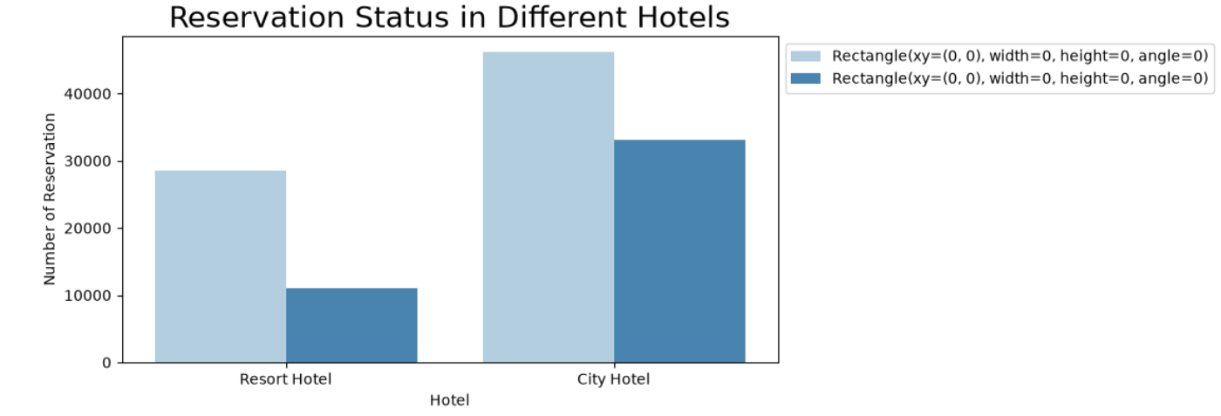

2. Overall cancellation is a major revenue-risk area
Observation:
44,224 of 119,390 bookings (37.04%) were cancelled, representing approximately 16.73M in estimated cancelled booking value.
Business Impact:
Cancellation represents approximately 39.15% of total estimated booking value, creating significant revenue uncertainty.
Recommendation:
Set a measurable target to reduce cancellation by 5 percentage points. Based on the current average cancelled-booking value, this could protect approximately 2.26M in potential booking value.
Note: this is estimated booking value, not realized revenue.
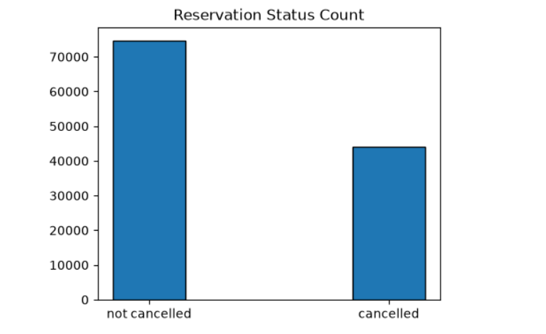

3. Online TA is the dominant acquisition segment but carries material cancellation risk
Observation:
Online TA accounts for 47.44% of all bookings and has a 36.72% cancellation rate.
Business Impact:
Because nearly half of booking volume comes from this segment, even a modest improvement in its cancellation rate can materially improve inventory predictability.
Recommendation:
Introduce differentiated cancellation terms or advance-payment incentives for high-risk Online TA bookings and target a 5 percentage-point reduction in cancellations within this segment.
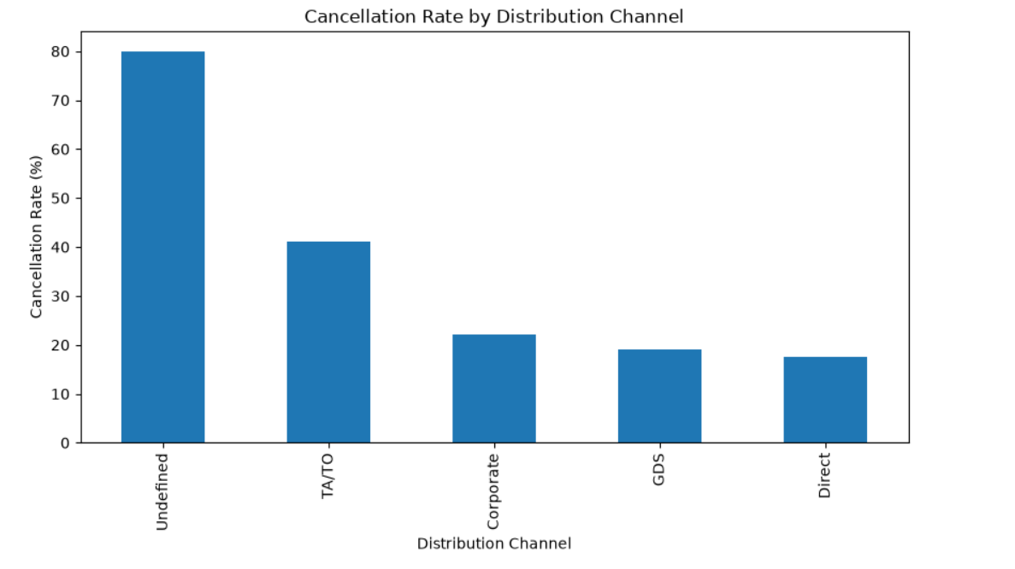

4. Groups represent a high cancellation-risk segment
Observation:
Group bookings have a 61.06% cancellation rate, substantially above the overall 37.04% rate.
Business Impact:
Group cancellations can create large blocks of suddenly available inventory and negatively affect occupancy planning.
Recommendation:
Introduce stricter group confirmation deadlines and staged deposits, with a target of reducing group cancellation by 10 percentage points.
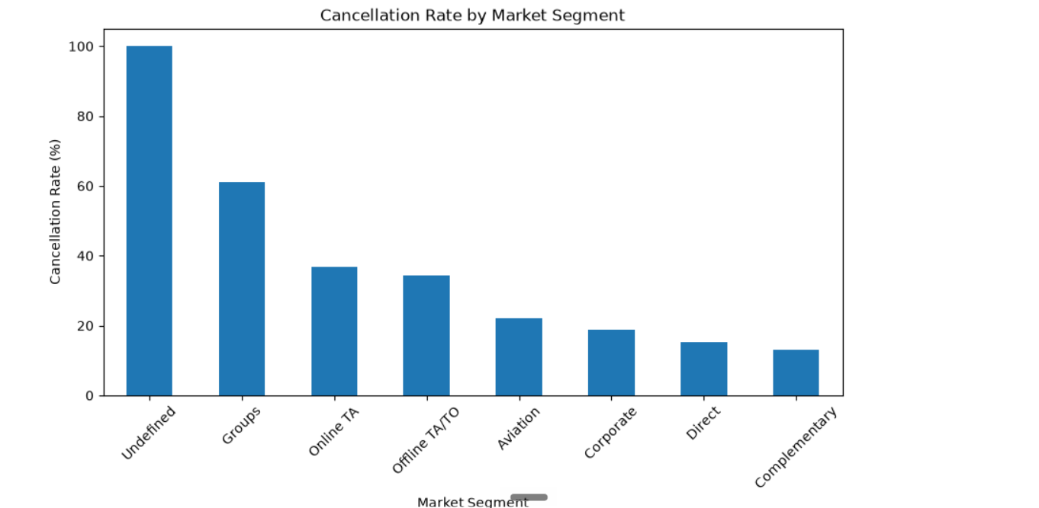

5. Deposit policy shows an extreme cancellation pattern
Observation:
Cancellation rates were:
- Non Refund: 99.36%
- No Deposit: 28.38%
- Refundable: 22.22%
Business Impact:
The Non Refund category shows an exceptionally high cancellation rate and requires investigation into booking quality, data definitions and channel behavior.
Recommendation:
Audit the Non Refund booking workflow and channel mix before changing policy. Use deposit type as a cancellation-risk feature rather than assuming causation.
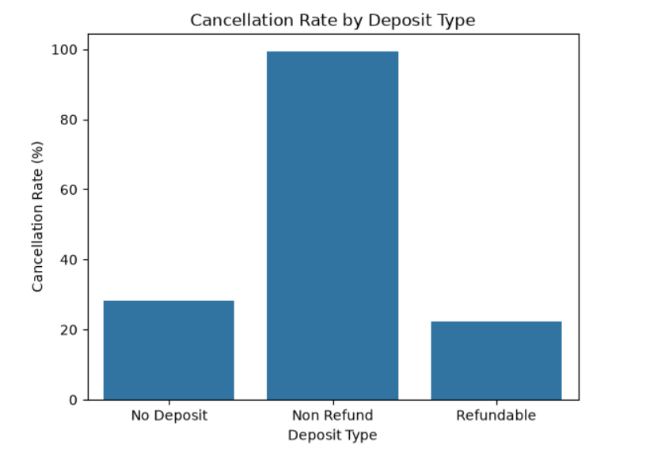

Dashboard 2 — Pricing & Revenue Optimization
6. Online TA generates the highest ADR among major segments
Observation:
Average ADR by major segment:
- Online TA: 117.20
- Direct: 115.45
- Offline TA/TO: 87.35
- Groups: 79.48
- Corporate: 69.36
Business Impact:
Online TA and Direct bookings generate approximately 30–70% higher ADR than several lower-priced segments.
Recommendation:
Prioritize high-ADR Direct and Online TA demand during high-demand periods while using targeted promotions for lower-ADR segments during weaker demand periods.
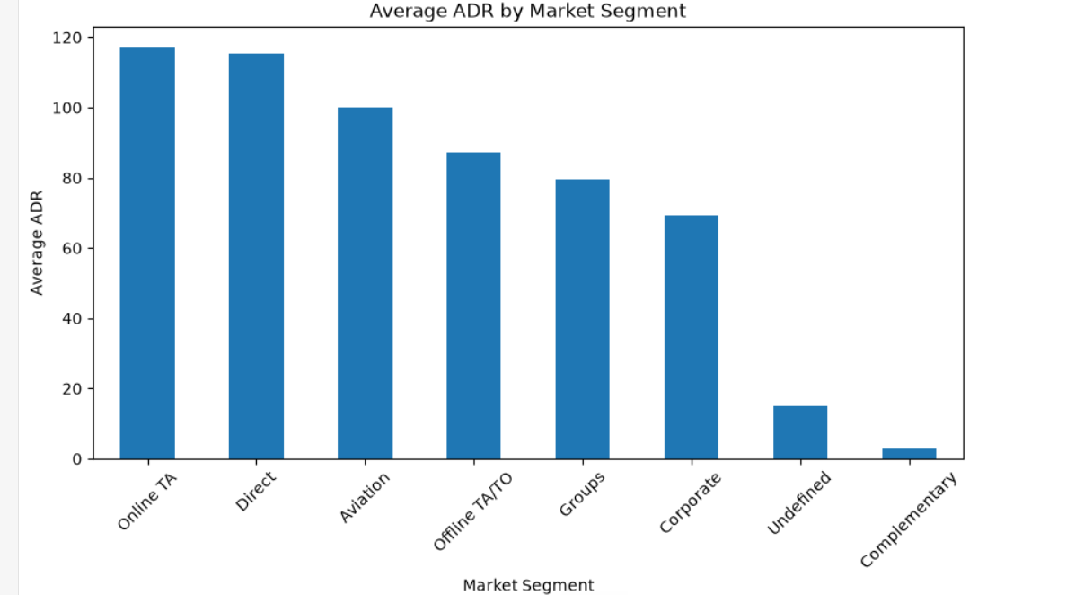

7. High-volume segments do not necessarily equal high-value segments
Observation:
Online TA contributes 47.44% of bookings, while Groups contribute 16.66% and Direct contributes 10.47%.
Business Impact:
Booking volume alone does not capture commercial value; hotels need to evaluate volume + ADR + cancellation rate together.
Recommendation:
Adopt a segment scorecard using three KPIs:
Booking Volume + ADR + Cancellation Rate
rather than optimizing solely for booking volume.

Dashboard 3 — Customer & Channel Strategy
8. Direct bookings show comparatively strong booking quality
Observation:
Direct bookings have a 15.34% cancellation rate, compared with 36.72% for Online TA.
Business Impact:
Direct bookings provide a substantially more predictable demand base while maintaining a high average ADR of 115.45.
Recommendation:
Increase direct-booking acquisition through loyalty benefits, direct-booking discounts and targeted CRM campaigns, with a measurable objective of increasing Direct booking share above the current 10.47%.

9. Corporate bookings have low cancellation but lower ADR
Observation:
Corporate bookings show an 18.73% cancellation rate and 69.36 ADR.
Business Impact:
Corporate customers provide relatively predictable demand but at a significantly lower ADR than Online TA and Direct segments.
Recommendation:
Develop corporate volume contracts around occupancy periods where rooms would otherwise remain underutilized, while protecting ADR during peak demand.

10. Cancellation according to country
Observation:
Portugal has the highest cancellation rate at 70%.
Business Impact: High cancellations may lead to revenue uncertainty, inefficient capacity planning, and increased booking management costs.
Recommendation: Investigate Portugal-specific cancellation drivers, customer booking patterns, pricing, and service feedback. Improve service quality where evidence indicates gaps and introduce targeted booking policies to reduce cancellations.

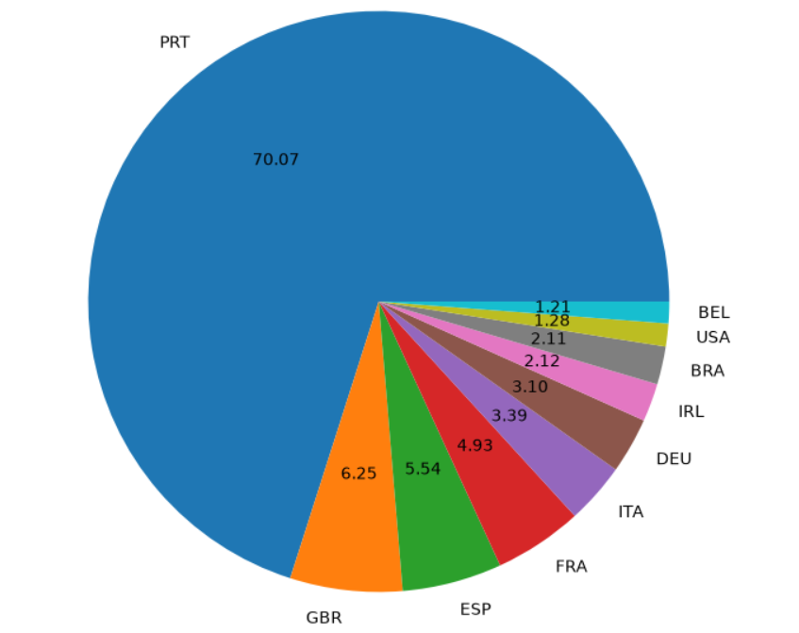

Observation:
August is the month with the highest number of confirmed reservations and the least number of canceled.
Business Impact:
Cancellations are most common when prices are greatest and are least common when they are lowest. Therefore the cost of accommodation is solely responsible for the cancellation.
Recommendation:
In the month of January hotels can start marketing campaigns with a reasonable amount to increase their revenue as the cancellation is the highest in this month.



