**Diagramma UML**

Ogni utente può avere come **role** quello di admin o user (semplice). Nella fase di creazione, in cui si presuppone che un utente possa avere 1 unico **profile** (Web Developer, Data Analyst ed ecc), si va a definire anche la **category** a cui appartiene che è di fatto si forma andando a definire l’insieme delle **knowledge** specifiche del profilo. A queste si assegna una specifica **level** (può scegliere tra junior, middle e senior). Tale level è assegnata anche al profilo. Per le knowledge l’utente può scegliere tra una voce già presente a DB, perché inserita da altri utenti, o digitarne una nuova.

Per creare il diagramma UML, mostrato di seguito, si è fatto uso di ***EdrawMax***.

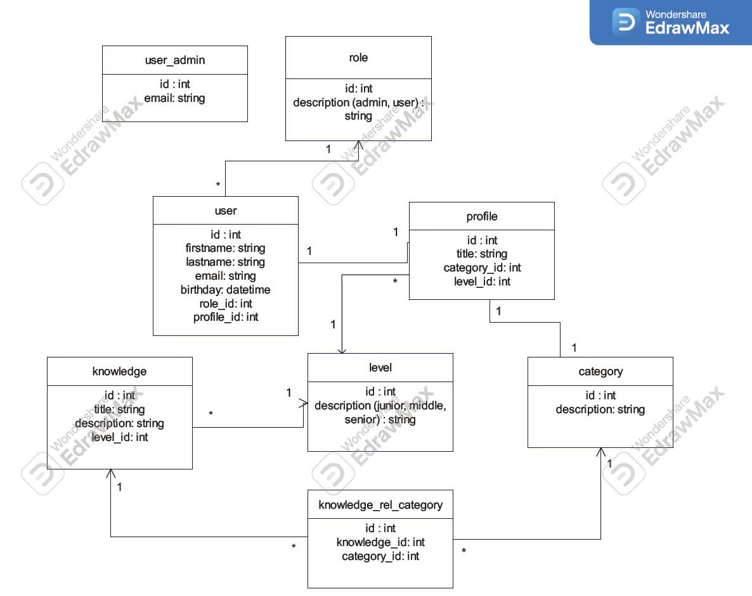

**Creazione Database**

Si riporta il contenuto del file dump per creare il database:

*-- --------------------------------------------------------*

*-- Host: 127.0.0.1*

*-- Versione server: 8.0.33 - MySQL Community Server - GPL*

*-- S.O. server: Win64*

*-- HeidiSQL Versione: 12.8.0.6908*

*-- --------------------------------------------------------*

*/*!40101 SET @OLD_CHARACTER_SET_CLIENT=@@CHARACTER_SET_CLIENT */;*

*/*!40101 SET NAMES utf8 */;*

*/*!50503 SET NAMES utf8mb4 */;*

*/*!40103 SET @OLD_TIME_ZONE=@@TIME_ZONE */;*

*/*!40103 SET TIME_ZONE='+00:00' */;*

*/*!40014 SET @OLD_FOREIGN_KEY_CHECKS=@@FOREIGN_KEY_CHECKS, FOREIGN_KEY_CHECKS=0 */;*

*/*!40101 SET @OLD_SQL_MODE=@@SQL_MODE, SQL_MODE='NO_AUTO_VALUE_ON_ZERO' */;*

*/*!40111 SET @OLD_SQL_NOTES=@@SQL_NOTES, SQL_NOTES=0 */;*

*-- Dump della struttura del database project_challenge*

***CREATE******DATABASE******IF******NOT******EXISTS*** *`project_challenge` /*!40100 DEFAULT CHARACTER SET utf8mb4 COLLATE utf8mb4_0900_ai_ci */ /*!80016 DEFAULT ENCRYPTION='N' */;*

***USE*** *`project_challenge`;*

*-- Dump della struttura di tabella project_challenge.category*

***CREATE******TABLE******IF******NOT******EXISTS*** *`category` (*

*`id`* ***int******NOT******NULL******AUTO_INCREMENT****,*

*`description`* ***varchar****(255)* ***NOT******NULL******DEFAULT*** *'',*

*`created_at`* ***timestamp******NOT******NULL******DEFAULT*** *(****now****()),*

*`updated_at`* ***timestamp******NOT******NULL******DEFAULT*** *(****now****()),*

***PRIMARY******KEY*** *(`id`)*

*)* ***ENGINE****=****InnoDB******AUTO_INCREMENT****=4* ***DEFAULT******CHARSET****=****utf8mb4******COLLATE****=utf8mb4_0900_ai_ci;*

*-- Dump dei dati della tabella project_challenge.category: ~1 rows (circa)*

***INSERT******IGNORE******INTO*** *`category` (`id`, `description`, `created_at`, `updated_at`)* ***VALUES***

*(3, 'Web Designer', '2025-07-26 15:50:28', '2025-07-26 15:50:28');*

*-- Dump della struttura di tabella project_challenge.knowledge*

***CREATE******TABLE******IF******NOT******EXISTS*** *`knowledge` (*

*`id`* ***int******NOT******NULL******AUTO_INCREMENT****,*

*`title`* ***varchar****(255)* ***NOT******NULL******DEFAULT*** *'',*

*`description`* ***varchar****(255)* ***DEFAULT*** *'',*

*`level_id`* ***int******NOT******NULL******DEFAULT*** *'0',*

*`created_at`* ***timestamp******NOT******NULL******DEFAULT*** *(****now****()),*

*`updated_at`* ***timestamp******NOT******NULL******DEFAULT*** *(****now****()),*

***PRIMARY******KEY*** *(`id`),*

***KEY*** *`FK_knowledge_level` (`level_id`),*

***CONSTRAINT*** *`FK_knowledge_level`* ***FOREIGN******KEY*** *(`level_id`)* ***REFERENCES*** *`level` (`id`)*

*)* ***ENGINE****=****InnoDB******AUTO_INCREMENT****=7* ***DEFAULT******CHARSET****=****utf8mb4******COLLATE****=utf8mb4_0900_ai_ci;*

*-- Dump dei dati della tabella project_challenge.knowledge: ~3 rows (circa)*

***INSERT******IGNORE******INTO*** *`knowledge` (`id`, `title`, `description`, `level_id`, `created_at`, `updated_at`)* ***VALUES***

*(4, '', 'Figma', 2, '2025-07-26 15:50:28', '2025-07-26 15:50:28'),*

*(5, '', 'HTML', 1, '2025-07-26 15:50:28', '2025-07-26 15:50:28'),*

*(6, '', 'CSS', 1, '2025-07-26 15:50:28', '2025-07-26 15:50:28');*

*-- Dump della struttura di tabella project_challenge.knowledge_rel_category*

***CREATE******TABLE******IF******NOT******EXISTS*** *`knowledge_rel_category` (*

*`id`* ***int******NOT******NULL******AUTO_INCREMENT****,*

*`knowledge_id`* ***int******NOT******NULL******DEFAULT*** *'0',*

*`category_id`* ***int******NOT******NULL******DEFAULT*** *'0',*

*`created_at`* ***timestamp******NOT******NULL******DEFAULT*** *(****now****()),*

*`updated_at`* ***timestamp******NOT******NULL******DEFAULT*** *(****now****()),*

***PRIMARY******KEY*** *(`id`),*

***KEY*** *`FK_knowledge_rel_category_knowledge_id` (`knowledge_id`),*

***KEY*** *`FK_knowledge_rel_category_category_id` (`category_id`),*

***CONSTRAINT*** *`FK_knowledge_rel_category_category_id`* ***FOREIGN******KEY*** *(`category_id`)* ***REFERENCES*** *`category` (`id`),*

***CONSTRAINT*** *`FK_knowledge_rel_category_knowledge_id`* ***FOREIGN******KEY*** *(`knowledge_id`)* ***REFERENCES*** *`knowledge` (`id`)*

*)* ***ENGINE****=****InnoDB******AUTO_INCREMENT****=7* ***DEFAULT******CHARSET****=****utf8mb4******COLLATE****=utf8mb4_0900_ai_ci;*

*-- Dump dei dati della tabella project_challenge.knowledge_rel_category: ~3 rows (circa)*

***INSERT******IGNORE******INTO*** *`knowledge_rel_category` (`id`, `knowledge_id`, `category_id`, `created_at`, `updated_at`)* ***VALUES***

*(4, 4, 3, '2025-07-26 15:50:28', '2025-07-26 15:50:28'),*

*(5, 5, 3, '2025-07-26 15:50:28', '2025-07-26 15:50:28'),*

*(6, 6, 3, '2025-07-26 15:50:28', '2025-07-26 15:50:28');*

*-- Dump della struttura di tabella project_challenge.level*

***CREATE******TABLE******IF******NOT******EXISTS*** *`level` (*

*`id`* ***int******NOT******NULL******AUTO_INCREMENT****,*

*`description`* ***varchar****(50)* ***NOT******NULL******DEFAULT*** *'0',*

*`created_at`* ***timestamp******NOT******NULL******DEFAULT*** *(****now****()),*

*`updated_at`* ***timestamp******NOT******NULL******DEFAULT*** *(****now****()),*

***PRIMARY******KEY*** *(`id`)*

*)* ***ENGINE****=****InnoDB******AUTO_INCREMENT****=4* ***DEFAULT******CHARSET****=****utf8mb4******COLLATE****=utf8mb4_0900_ai_ci;*

*-- Dump dei dati della tabella project_challenge.level: ~3 rows (circa)*

***INSERT******IGNORE******INTO*** *`level` (`id`, `description`, `created_at`, `updated_at`)* ***VALUES***

*(1, 'junior', '2025-07-26 17:41:47', '2025-07-26 17:41:47'),*

*(2, 'middle', '2025-07-26 17:41:47', '2025-07-26 17:41:47'),*

*(3, 'senior', '2025-07-26 17:41:47', '2025-07-26 17:41:47');*

*-- Dump della struttura di tabella project_challenge.profile*

***CREATE******TABLE******IF******NOT******EXISTS*** *`profile` (*

*`id`* ***int******NOT******NULL******AUTO_INCREMENT****,*

*`title`* ***varchar****(255)* ***NOT******NULL******DEFAULT*** *'',*

*`category_id`* ***int******NOT******NULL******DEFAULT*** *(0),*

*`level_id`* ***int******NOT******NULL******DEFAULT*** *(0),*

*`created_at`* ***timestamp******NOT******NULL******DEFAULT*** *(****now****()),*

*`updated_at`* ***timestamp******NOT******NULL******DEFAULT*** *(****now****()),*

***PRIMARY******KEY*** *(`id`),*

***KEY*** *`FK_profile_category` (`category_id`),*

***KEY*** *`FK_profile_level` (`level_id`),*

***CONSTRAINT*** *`FK_profile_category`* ***FOREIGN******KEY*** *(`category_id`)* ***REFERENCES*** *`category` (`id`),*

***CONSTRAINT*** *`FK_profile_level`* ***FOREIGN******KEY*** *(`level_id`)* ***REFERENCES*** *`level` (`id`)*

*)* ***ENGINE****=****InnoDB******AUTO_INCREMENT****=3* ***DEFAULT******CHARSET****=****utf8mb4******COLLATE****=utf8mb4_0900_ai_ci;*

*-- Dump dei dati della tabella project_challenge.profile: ~1 rows (circa)*

***INSERT******IGNORE******INTO*** *`profile` (`id`, `title`, `category_id`, `level_id`, `created_at`, `updated_at`)* ***VALUES***

*(2, 'Web Designer', 3, 1, '2025-07-26 15:50:28', '2025-07-26 15:50:28');*

*-- Dump della struttura di tabella project_challenge.role*

***CREATE******TABLE******IF******NOT******EXISTS*** *`role` (*

*`id`* ***int******NOT******NULL******AUTO_INCREMENT****,*

*`description`* ***varchar****(255)* ***CHARACTER******SET******utf8mb4******COLLATE*** *utf8mb4_0900_ai_ci* ***NOT******NULL****,*

*`created_at`* ***timestamp******NOT******NULL******DEFAULT*** *(****now****()),*

*`updated_at`* ***timestamp******NOT******NULL******DEFAULT*** *(****now****()),*

***PRIMARY******KEY*** *(`id`)*

*)* ***ENGINE****=****InnoDB******AUTO_INCREMENT****=3* ***DEFAULT******CHARSET****=****utf8mb4******COLLATE****=utf8mb4_0900_ai_ci;*

*-- Dump dei dati della tabella project_challenge.role: ~2 rows (circa)*

***INSERT******IGNORE******INTO*** *`role` (`id`, `description`, `created_at`, `updated_at`)* ***VALUES***

*(1, 'admin', '2025-07-26 17:42:55', '2025-07-26 17:42:55'),*

*(2, 'user', '2025-07-26 17:42:55', '2025-07-26 17:42:55');*

*-- Dump della struttura di tabella project_challenge.user*

***CREATE******TABLE******IF******NOT******EXISTS*** *`user` (*

*`id`* ***int******NOT******NULL******AUTO_INCREMENT****,*

*`firstname`* ***varchar****(255)* ***NOT******NULL******DEFAULT*** *'',*

*`lastname`* ***varchar****(255)* ***NOT******NULL******DEFAULT*** *'',*

*`email`* ***varchar****(255)* ***NOT******NULL******DEFAULT*** *'',*

*`birthday`* ***datetime******DEFAULT******NULL****,*

*`role_id`* ***int******NOT******NULL******DEFAULT*** *(0),*

*`profile_id`* ***int******NOT******NULL******DEFAULT*** *(0),*

*`created_at`* ***timestamp******NOT******NULL******DEFAULT*** *(****now****()),*

*`updated_at`* ***timestamp******NOT******NULL******DEFAULT*** *(****now****()),*

***PRIMARY******KEY*** *(`id`),*

***KEY*** *`FK_user_profile` (`profile_id`),*

***KEY*** *`FK_user_role` (`role_id`),*

***CONSTRAINT*** *`FK_user_profile`* ***FOREIGN******KEY*** *(`profile_id`)* ***REFERENCES*** *`profile` (`id`),*

***CONSTRAINT*** *`FK_user_role`* ***FOREIGN******KEY*** *(`role_id`)* ***REFERENCES*** *`role` (`id`)*

*)* ***ENGINE****=****InnoDB******AUTO_INCREMENT****=2* ***DEFAULT******CHARSET****=****utf8mb4******COLLATE****=utf8mb4_0900_ai_ci;*

*-- Dump dei dati della tabella project_challenge.user: ~1 rows (circa)*

***INSERT******IGNORE******INTO*** *`user` (`id`, `firstname`, `lastname`, `email`, `birthday`, `role_id`, `profile_id`, `created_at`, `updated_at`)* ***VALUES***

*(1, 'Mario', 'Rossi', 'mario.rossi@gmail.com', '2025-07-26 17:50:28', 2, 2, '2025-07-26 15:50:28', '2025-07-26 15:50:28');*

*-- Dump della struttura di tabella project_challenge.user_admin*

***CREATE******TABLE******IF******NOT******EXISTS*** *`user_admin` (*

*`id`* ***int******NOT******NULL******AUTO_INCREMENT****,*

*`email`* ***varchar****(255)* ***NOT******NULL******DEFAULT*** *'',*

*`created_at`* ***timestamp******NOT******NULL******DEFAULT*** *(****now****()),*

*`updated_at`* ***timestamp******NOT******NULL******DEFAULT*** *(****now****()),*

***PRIMARY******KEY*** *(`id`)*

*)* ***ENGINE****=****InnoDB******DEFAULT******CHARSET****=****utf8mb4******COLLATE****=utf8mb4_0900_ai_ci;*

*-- Dump dei dati della tabella project_challenge.user_admin: ~0 rows (circa)*

*/*!40103 SET TIME_ZONE=IFNULL(@OLD_TIME_ZONE, 'system') */;*

*/*!40101 SET SQL_MODE=IFNULL(@OLD_SQL_MODE, '') */;*

*/*!40014 SET FOREIGN_KEY_CHECKS=IFNULL(@OLD_FOREIGN_KEY_CHECKS, 1) */;*

*/*!40101 SET CHARACTER_SET_CLIENT=@OLD_CHARACTER_SET_CLIENT */;*

*/*!40111 SET SQL_NOTES=IFNULL(@OLD_SQL_NOTES, 1) */;*