**Laboratorio 6**

Actividad 1

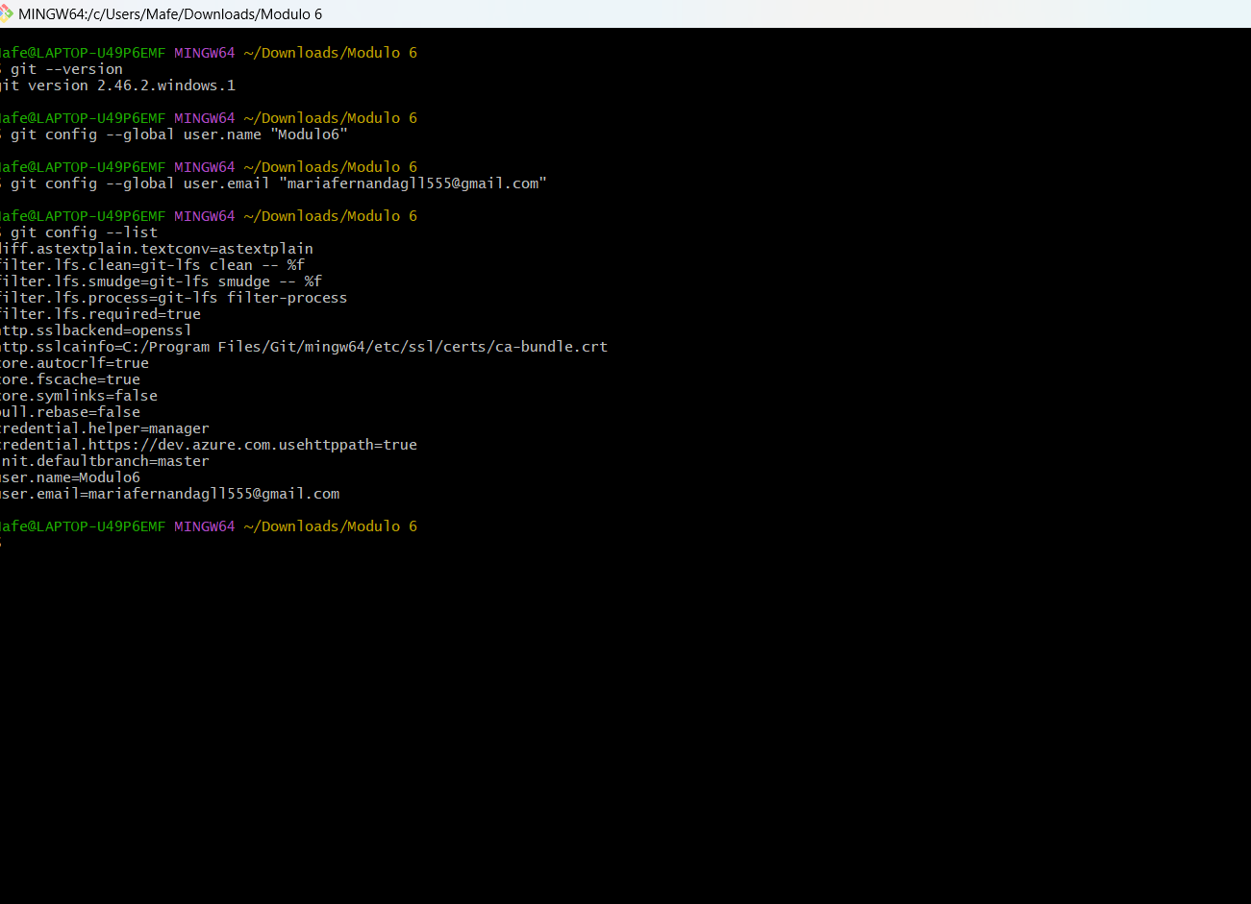

Actividad de la 1 a la 5

Mafe@LAPTOP-U49P6EMF MINGW64 ~/Downloads/Modulo 6

$ git --version

git version 2.46.2.windows.1

Mafe@LAPTOP-U49P6EMF MINGW64 ~/Downloads/Modulo 6

$ git config --global user.name "Modulo6"

Mafe@LAPTOP-U49P6EMF MINGW64 ~/Downloads/Modulo 6

$ git config --global user.email "mariafernandagll555@gmail.com"

Mafe@LAPTOP-U49P6EMF MINGW64 ~/Downloads/Modulo 6

$ git config --list

diff.astextplain.textconv=astextplain

filter.lfs.clean=git-lfs clean -- %f

filter.lfs.smudge=git-lfs smudge -- %f

filter.lfs.process=git-lfs filter-process

filter.lfs.required=true

http.sslbackend=openssl

http.sslcainfo=C:/Program Files/Git/mingw64/etc/ssl/certs/ca-bundle.crt

core.autocrlf=true

core.fscache=true

core.symlinks=false

pull.rebase=false

credential.helper=manager

credential.https://dev.azure.com.usehttppath=true

init.defaultbranch=master

user.name=Modulo6

user.email=mariafernandagll555@gmail.com

Mafe@LAPTOP-U49P6EMF MINGW64 ~/Downloads/Modulo 6

$ mkdir Repositorio6

mkdir: cannot create directory ‘Repositorio6’: File exists

Mafe@LAPTOP-U49P6EMF MINGW64 ~/Downloads/Modulo 6

$ cd Repositorio6

Mafe@LAPTOP-U49P6EMF MINGW64 ~/Downloads/Modulo 6/Repositorio6

$ git init

Initialized empty Git repository in C:/Users/Mafe/Downloads/Modulo 6/Repositorio6/.git/

Mafe@LAPTOP-U49P6EMF MINGW64 ~/Downloads/Modulo 6/Repositorio6 (master)

$ echo "Mi primer repositorio"> README.md

Mafe@LAPTOP-U49P6EMF MINGW64 ~/Downloads/Modulo 6/Repositorio6 (master)

$ git add README.MD

Mafe@LAPTOP-U49P6EMF MINGW64 ~/Downloads/Modulo 6/Repositorio6 (master)

$ git commit -m "Commit inicial: Añadir README.md"

On branch master

Initial commit

Untracked files:

(use "git add <file>..." to include in what will be committed)

README.md

nothing added to commit but untracked files present (use "git add" to track)

Mafe@LAPTOP-U49P6EMF MINGW64 ~/Downloads/Modulo 6/Repositorio6 (master)

$ git commit -m "Commit inicial: Añadir README.md"

On branch master

Initial commit

Untracked files:

(use "git add <file>..." to include in what will be committed)

README.md

nothing added to commit but untracked files present (use "git add" to track)

Mafe@LAPTOP-U49P6EMF MINGW64 ~/Downloads/Modulo 6/Repositorio6 (master)

$ git add .

warning: in the working copy of 'README.md', LF will be replaced by CRLF the next time Git touches it

Mafe@LAPTOP-U49P6EMF MINGW64 ~/Downloads/Modulo 6/Repositorio6 (master)

$ git branch desarrollo

fatal: not a valid object name: 'master'

Mafe@LAPTOP-U49P6EMF MINGW64 ~/Downloads/Modulo 6/Repositorio6 (master)

$ git checkout desarrollo

error: pathspec 'desarrollo' did not match any file(s) known to git

Mafe@LAPTOP-U49P6EMF MINGW64 ~/Downloads/Modulo 6/Repositorio6 (master)

$ git commit -m "Commit inicial: Anadir READ.md"

[master (root-commit) 6f01fbe] Commit inicial: Anadir READ.md

1 file changed, 1 insertion(+)

create mode 100644 README.md

Mafe@LAPTOP-U49P6EMF MINGW64 ~/Downloads/Modulo 6/Repositorio6 (master)

$ git branch desarrollo

Mafe@LAPTOP-U49P6EMF MINGW64 ~/Downloads/Modulo 6/Repositorio6 (master)

$ git branch desarrollo

fatal: a branch named 'desarrollo' already exists

Mafe@LAPTOP-U49P6EMF MINGW64 ~/Downloads/Modulo 6/Repositorio6 (master)

$ git checkout desarrollo

Switched to branch 'desarrollo'

Mafe@LAPTOP-U49P6EMF MINGW64 ~/Downloads/Modulo 6/Repositorio6 (desarrollo)

$ echo "Este es un cambio en la rama desarrollo">> README.md

Mafe@LAPTOP-U49P6EMF MINGW64 ~/Downloads/Modulo 6/Repositorio6 (desarrollo)

$ git add .

warning: in the working copy of 'README.md', LF will be replaced by CRLF the next time Git touches it

Mafe@LAPTOP-U49P6EMF MINGW64 ~/Downloads/Modulo 6/Repositorio6 (desarrollo)

$ git commit -m "Modificar README.md en la rama desarrollo"

[desarrollo 367b323] Modificar README.md en la rama desarrollo

1 file changed, 1 insertion(+)

Mafe@LAPTOP-U49P6EMF MINGW64 ~/Downloads/Modulo 6/Repositorio6 (desarrollo)

$ git checkout main

error: pathspec 'main' did not match any file(s) known to git

Mafe@LAPTOP-U49P6EMF MINGW64 ~/Downloads/Modulo 6/Repositorio6 (desarrollo)

$ git checkout master

Switched to branch 'master'

Mafe@LAPTOP-U49P6EMF MINGW64 ~/Downloads/Modulo 6/Repositorio6 (master)

$ got merge desarrollo

bash: got: command not found

Mafe@LAPTOP-U49P6EMF MINGW64 ~/Downloads/Modulo 6/Repositorio6 (master)

$ git merge desarrollo

Updating 6f01fbe..367b323

Fast-forward

README.md | 1 +

1 file changed, 1 insertion(+)

Mafe@LAPTOP-U49P6EMF MINGW64 ~/Downloads/Modulo 6/Repositorio6 (master)

$ git remote add origin https://github.com/mariafernandagordilloll555/Modulo6.git

Mafe@LAPTOP-U49P6EMF MINGW64 ~/Downloads/Modulo 6/Repositorio6 (master)

$ git push -M origin master

error: unknown switch `M'

usage: git push [<options>] [<repository> [<refspec>...]]

-v, --[no-]verbose be more verbose

-q, --[no-]quiet be more quiet

--[no-]repo <repository>

repository

--[no-]all push all branches

--[no-]branches alias of --all

--[no-]mirror mirror all refs

-d, --[no-]delete delete refs

--[no-]tags push tags (can't be used with --all or --branches or --mirror)

-n, --[no-]dry-run dry run

--[no-]porcelain machine-readable output

-f, --[no-]force force updates

--[no-]force-with-lease[=<refname>:<expect>]

require old value of ref to be at this value

--[no-]force-if-includes

require remote updates to be integrated locally

--[no-]recurse-submodules (check|on-demand|no)

control recursive pushing of submodules

--[no-]thin use thin pack

--[no-]receive-pack <receive-pack>

receive pack program

--[no-]exec <receive-pack>

receive pack program

-u, --[no-]set-upstream

set upstream for git pull/status

--[no-]progress force progress reporting

--[no-]prune prune locally removed refs

--no-verify bypass pre-push hook

--verify opposite of --no-verify

--[no-]follow-tags push missing but relevant tags

--[no-]signed[=(yes|no|if-asked)]

GPG sign the push

--[no-]atomic request atomic transaction on remote side

-o, --[no-]push-option <server-specific>

option to transmit

-4, --ipv4 use IPv4 addresses only

-6, --ipv6 use IPv6 addresses only

Mafe@LAPTOP-U49P6EMF MINGW64 ~/Downloads/Modulo 6/Repositorio6 (master)

$ git push -u orogin master

fatal: 'orogin' does not appear to be a git repository

fatal: Could not read from remote repository.

Please make sure you have the correct access rights

and the repository exists.

Mafe@LAPTOP-U49P6EMF MINGW64 ~/Downloads/Modulo 6/Repositorio6 (master)

$ git push -u origin master

Enumerating objects: 6, done.

Counting objects: 100% (6/6), done.

Delta compression using up to 4 threads

Compressing objects: 100% (3/3), done.

Writing objects: 100% (6/6), 546 bytes | 273.00 KiB/s, done.

Total 6 (delta 0), reused 0 (delta 0), pack-reused 0 (from 0)

To https://github.com/mariafernandagordilloll555/Modulo6.git

* [new branch] master -> master

branch 'master' set up to track 'origin/master'.

Mafe@LAPTOP-U49P6EMF MINGW64 ~/Downloads/Modulo 6/Repositorio6 (master)

$ git push -u origin master

Everything up-to-date

branch 'master' set up to track 'origin/master'.

Mafe@LAPTOP-U49P6EMF MINGW64 ~/Downloads/Modulo 6/Repositorio6 (master)

$

