Documentation about the investigation of the behaviour of electron backscattering observed in various Geant4-based simulation configurations
T. Basaglia¹, M. C. Han², G. Hoff³, C. H. Kim², S. H. Kim², M. G. Pia⁴, P. Saracco⁴
¹CERN, Geneva, Switzerland
²Hanyang University, Seoul, Korea
³CAPES, Brasilia, Brazil
⁴INFN Sezione di Genova, Italy
29 April 2015
DRAFT

Introduction
This document describes how to observe features of electron backscattering in various Geant4-based simulation configurations, which may deserve further investigation to fully understand the underlying causes of the behaviour reported in [1]. The most prominent issue identified in [1] is the apparent suppression of electron backscattering in some simulation configurations. This document shows how to reproduce this observed behaviour using the relevant Geant4 application code made available in a public repository. It also illustrates a series of scenarios that have been investigated after the completion of [1] as further steps to characterize the observed behaviour.
It is worthwhile to note that both [1] and this document have a mere descriptive scope, i.e. they consist of a detailed documentation of the observed behaviour: this is the necessary starting point for further quests to identify its underlying causes and, if appropriate, to consider future improvements.
The course of actions documented in this note reflects the intellectual and practical path taken by our team to investigate the behaviour of electron backscattering simulation following the outcome of the first project cycle summarized in [1]. The methodology adopted in this investigation has its foundation in established best practice of scientific research, which consists of first isolating the subject of investigation in the simplest possible context where it manifests its effects. In this context, the behaviour of backscattering simulation is studied in the simplest possible setting that retains all the conceptual features that are instrumental to exhibit the bare essence of the apparent problem (geometrical model of the experiments, primary particle source and physics settings), while being exempt from the risk of accidental side effects from other unessential Geant4 [2,3] and user application components that manipulate the pristine product of the simulation, such as the definition of hits in sensitive volumes and their scoring, user actions involving higher level algorithms (e.g. to produce experimental-equivalent observables), and data analysis algorithms.
Only a minimal set of user application “ingredients” is sufficient to reproduce the actualization of the apparently problematic behaviour observed in [1]. The observation of the occurrence, or apparent suppression, of backscattered electrons in its most elementary manifestation, i.e. based on Geant4 built-in graphical visualization capabilities, facilitates its unambiguous identification free from any user’s algorithm manipulation. Hopefully this lightweight simulation application would be the starting point for in-depth study of the underlying causes of the observed behaviour, which has been addressed neither by [1] nor by this document yet: any scientist genuinely motivated to investigate it is free to complement the initial open source application code with whatever additional functionality he/she may deem useful to dig into the subject.
It is worthwhile to note that at the present stage defining the observed behaviour of electron backscattering as a “problem” appears premature. More research is needed to identify its causes.

Simulation environment
The open source simulation code bssim, based on Geant4, is publicly available in a git repository at https://github.com/mariagraziapia/bssim.
The simulation assumes a standard Scientific Linux 6 (SL6) environment, with the default C++ compiler that comes with SL6, CLHEP4 versions installed as appropriate and available OpenGL.
The procedure to create an executable simulation is outlined in Figure 1.
Figure 1 Procedure to build the simulation executable.
- Setup the environment corresponding to the desired Geant4 version, e.g. for Geant4 10.1:
cd [your_path_to]/bssim/setup
source setup101.csh (to be previously adapted to reflect the user’s own environment)
(or source setup10p04.csh, source setup 9.6p03.csh etc. for other Geant4 versions)
- Create Geant4 libraries (unless Geant4 is already installed in the user’s computational environment):
cd $G4INSTALL/source
gmake
- Get the bssim simulation application code by cloning the git repository or downloading the code as a zip file, as documented in https://github.com/mariagraziapia/bssim
- Build the simulation application:
cd [your_path_to]/bssim/
gmake
The simulation can be executed by the command:
$G4WORKDIR/Linux-g++/bssim macroName.mac > optionalOutputFile
where macroName.mac is one of the macro files mentioned in the following sections.
A generic macro, which contains various configuration options commented out and enables one of them, is provided in the git repository in vis_opt3.mac. The macros mentioned in the following sections are also available in the git repository; they enable the simulation of 200 events, but the user is free to modify them to simulate any desired number of events.
The snapshots included in the following sections, taken with KSnapshot, derive from the execution of the simulation application based on Geant4 10.1, unless explicitly stated otherwise.

Original configuration
The “original configuration” corresponds to the configuration in the simulation study documented in [1].
It is worthwhile to stress that this configuration was not hand-picked as an intentional selection among a set of configuration options, let alone was motivated by any hidden intent: it was implemented by a student in Seoul, Korea as the simplest conceptual approach to reproduce a generic model of backscattering experiments, based on the requirements distilled by various team members from an extensive study of the literature of electron backscattering experiments. The bibliography of [1] lists a large collection of such experimental references.
The requirements document concerning the experimental model to be simulated is shown in Figure 2: despite its informal look, its content and format was adequate for the purpose in the context of an agile software development process adopted for the simulation application. It encompasses requirements pertinent to the first development cycle along with other requirements intended for future development cycles, which are foreseen for the study of further physical observables, not yet addressed at the stage of ongoing research documented in [1].

Geometry
The original geometry is sketched below; the sizes are not to scale for better visibility of the various components. It consists of a Target (G4Box) and a detection system placed in the backward hemisphere, which mimics typical experimental setups for electron backscattering measurements documented in the literature. The backward detection system consists of a hemispherical shell (Detector), a hemispherical shell (Coating) and a hemispherical cavity, which may be filled with galactic vacuum or another gas consistent with experimental specifications. The centre of the spheres corresponding to the hemispherical shells and hemispherical cavity is in (0,0,0). All volumes are placed in the World. The Target and Inside volumes are adjacent (i.e. they share a boundary surface at z=0). The Inside, Coating and Detector volumes are also adjacent (i.e. outer radius of the inner component = inner radius of the outer component).
Possible overlaps of the volumes present in the simulation setup are checked by means of the appropriate flag in G4VPlacement; no overlaps are detected. As an example of the result of these checks, the relevant excerpt of the output produced by the simulation run described in section 3.4 is shown below in Figure 3.
Given the simplicity of the experimental configuration, no attempts were made to optimize the geometrical model for computational performance, since this is not a concern in the investigated experimental scenario.
Figure 2 Simulation application requirements document.
userDetector->Construct() start.
Checking overlaps for volume Target ... OK!
Target placed in World
Checking overlaps for volume Detector ... OK!
Detector placed in World
Checking overlaps for volume Coating ... OK!
Coating placed in World
Checking overlaps for volume Inside ... OK!
Empty volume between target and coating placed in World
Figure 3 Excerpt of a simulation output showing the check of volume overlaps performed at geometry construction time.

Target
Inside
Detector
Coating
Figure 4 Sketch of the original experimental configuration (not to scale). A picture produced by Geant4 visualization is visible in Figure 2 of the previously cited paper.
The original geometry is encoded in the DetectorConstruction class with default parameters reproducing a typical experimental configuration with a semi-infinite target.

Single scattering
This option corresponds to instantiating a G4EmStandardPhysicsSS PhysicsConstructor in the PhysicsList. A macro vis_original_ss.mac is supplied in the git repository, which encodes this configuration.
This simulation can be executed by means of the command:
$G4WORKDIR/Linux-g++/bssim vis_original_ss.mac > original_ss.out
A snapshot of the observed backscattering is shown in Figure 5: backscattered electrons are visible as red lines.
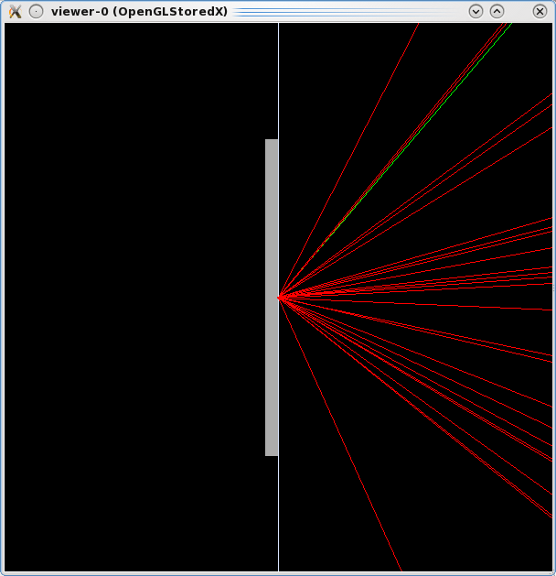
Figure 5 Original configuration, G4EmStandardPhysicsSS PhysicsConstructor, simulation based on Geant4 10.1: backscattered electrons are clearly visible as red lines on the right side; green lines represent photons.

WVI Standard Electromagnetic PhysicsConstructor
This option corresponds to instantiating a G4EmStandardPhysicsWVI PhysicsConstructor in the PhysicsList. A macro vis_original_wvi.mac is supplied in the git repository, which encodes this configuration.
Please note that the multiple scattering configuration applied by G4EmStandardPhysicsWVI does not involve any step limitation.
This simulation can be executed by means of the command:
$G4WORKDIR/Linux-g++/bssim vis_original_wvi.mac > original_wvi.out
A snapshot of the observed backscattering is shown in Figure 6: backscattered electrons are visible as red lines.
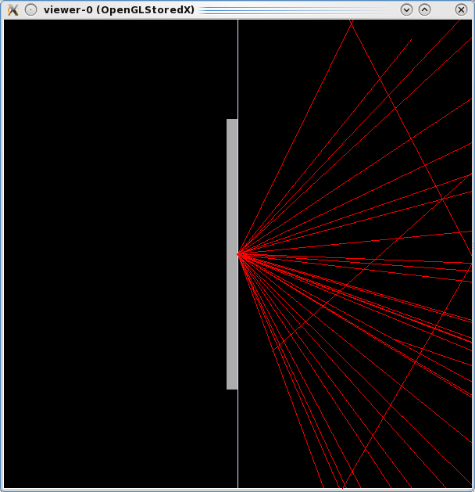
Figure 6 Original configuration, G4EmStandardPhysicsWVI PhysicsConstructor, simulation based on Geant4 10.1: backscattered electrons are clearly visible as red lines on the right side.

Standard Electromagnetic PhysicsConstructor, option 1
This option corresponds to instantiating a G4EmStandardPhysics_option1 PhysicsConstructor in the PhysicsList. A macro vis_original_opt1.mac is supplied in the git repository, which encodes this configuration.
Please note that the multiple scattering configuration applied by G4EmStandardPhysics_option1 involves “Minimal” step limitation and default “RangeFactor” value.
This simulation can be executed by means of the command:
$G4WORKDIR/Linux-g++/bssim vis_original_opt1.mac > original_opt1.out
A snapshot of the observed backscattering is shown in Figure 7: backscattered electrons are visible as red lines.
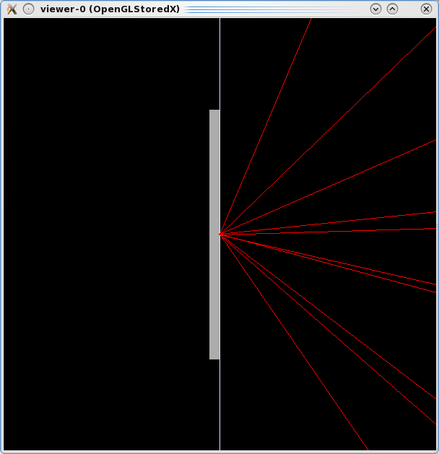
Figure 7 Original configuration, G4EmStandardPhysics_option1 PhysicsConstructor, simulation based on Geant4 10.1: backscattered electrons are clearly visible as red lines on the right side.

Standard Electromagnetic PhysicsConstructor, option 2
This option corresponds to instantiating a G4EmStandardPhysics_option2 PhysicsConstructor in the PhysicsList. A macro vis_original_opt2.mac is supplied in the git repository, which encodes this configuration.
Please note that the multiple scattering configuration applied by G4EmStandardPhysics_option2 involves “Minimal” step limitation and default “RangeFactor” value.
This simulation can be executed by means of the command:
$G4WORKDIR/Linux-g++/bssim vis_original_opt2.mac > original_opt2.out
A snapshot of the observed backscattering is shown in Figure 8: backscattered electrons are visible as red lines.
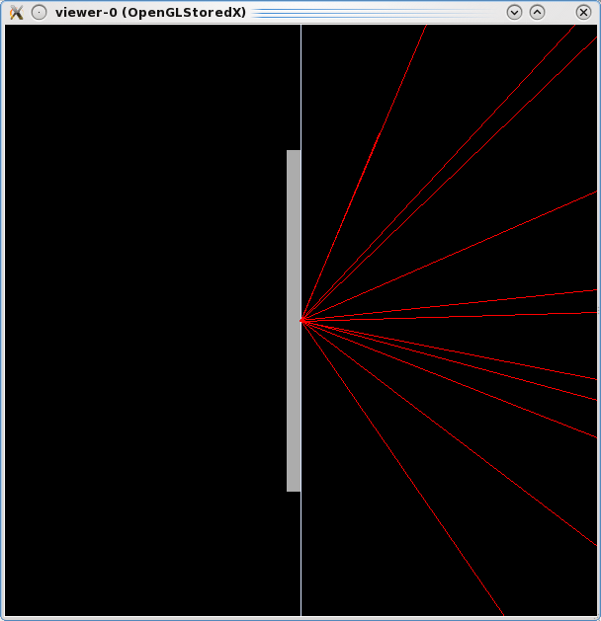
Figure 8 Original configuration, G4EmStandardPhysics_option2 PhysicsConstructor, simulation based on Geant4 10.1: backscattered electrons are clearly visible as red lines on the right side.

Standard Electromagnetic PhysicsConstructor, option 3
This option corresponds to instantiating a G4EmStandardPhysics_option3 PhysicsConstructor in the PhysicsList. A macro vis_original_opt3.mac is supplied in the git repository, which encodes this configuration.
Please note that the multiple scattering configuration applied by G4EmStandardPhysics_option3 involves “DistanceToBoundary” step limitation.
This simulation can be executed by means of the command:
$G4WORKDIR/Linux-g++/bssim vis_original_opt3.mac > original_opt3.out
A snapshot of the observed result is shown in Figure 9: backscattered electrons are not visible on the right side of the picture, only a tiny shower associated with the penetration of primary electrons is visible in the target.

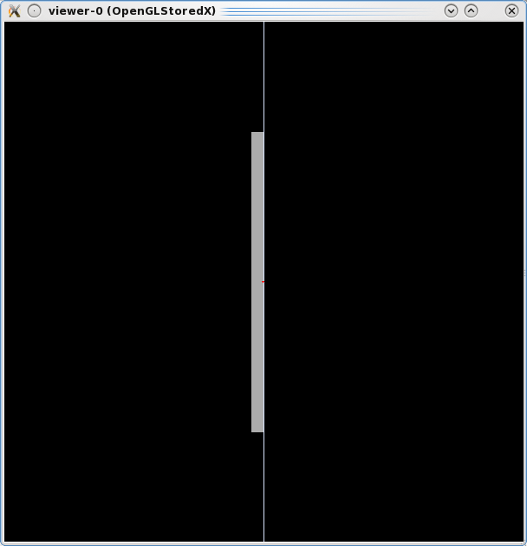
Figure 9 Original configuration, G4EmStandardPhysics_option3 PhysicsConstructor, simulation based on Geant4 10.1: backscattered electrons are not visible on the right side of the picture.

Standard Electromagnetic PhysicsConstructor, option 4
This option corresponds to instantiating a G4EmStandardPhysics_option4 PhysicsConstructor in the PhysicsList. A macro vis_original_opt4.mac is supplied in the git repository, which encodes this configuration.
Please note that the multiple scattering configuration applied by G4EmStandardPhysics_option4 involves “DistanceToBoundary” step limitation in Geant4 versions up to 10.0, “SafetyPlus” step limitation in Geant4 10.1 and again “DistanceToBoundary” in Geant4 10.1p01. RangeFactor values are set differently in the various versions.
This simulation can be executed by means of the command:
$G4WORKDIR/Linux-g++/bssim vis_original_opt4.mac > original_opt4.out
The attempt to run the simulation with Geant4 10.1 produces frequent messages as in the excerpt of the output shown in Figure 10, which are not produced with Geant4 10.0p04 nor with Geant4 9.6p03. This behaviour hints to some underlying anomaly, perhaps associated with the “SafetyPlus” step limitation algorithm.
Snapshots of the observed results of the simulation obtained with Geant4 10.1, 10.0p04 and 9.6p03 are shown in Figure 11. Backscattered electrons are not visible on the right side with Geant4 9.6; a single backward electron is observed with Geant4 10.0p04; caution should be exercised in interpreting the snapshot produced with Geant4 10.1 due to the previously mentioned apparently anomalous messages present in the output file. No snapshot related to Geant4 10.1p01 is shown in this note as we have not installed Geant4 10.1p01 in our computing environment yet. The delay of installing Geant4 10.1p01 is due to lack of time, not of goodwill.

Figure 10 Excerpt of the output of the simulation with Geant4 10.1 and G4EmStandardPhysics_option4 PhysicsConstructor.
---> Begin of event: 0
G4ParticleChange::CheckIt : the local time goes back !! Difference: 0.155157[ns]
e- E=0.1 pos=0, 0, 0.0255 global time=0.155157 local time=0.155157 proper time=0.129763
G4ParticleChange::CheckIt : the proper time goes back !! Difference: 0.129763[ns]
e- E=0.1 pos=0, 0, 0.0255 global time=0.155157 local time=0.155157 proper time=0.129763
-----------------------------------------------
G4ParticleChange Information
-----------------------------------------------
# of 2ndaries : 0
-----------------------------------------------
Energy Deposit (MeV): 0
Non-ionizing Energy Deposit (MeV): 0
Track Status : Alive
True Path Length (mm) : -25.5
Stepping Control : 0
Mass (GeV) : 0
Charge (eplus) : 0
MagneticMoment : 0
: = 0*[e hbar]/[2 m]
Position - x (mm) : 0
Position - y (mm) : 0
Position - z (mm) : 0
Time (ns) : 0
Proper Time (ns) : 0
Momentum Direct - x : 0
Momentum Direct - y : 0
Momentum Direct - z : 1
Kinetic Energy (MeV): 0.1
Velocity (/c): 0.548
Polarization - x : 0
Polarization - y : 0
Polarization - z : 0
Touchable (pointer) : 0x3c55970
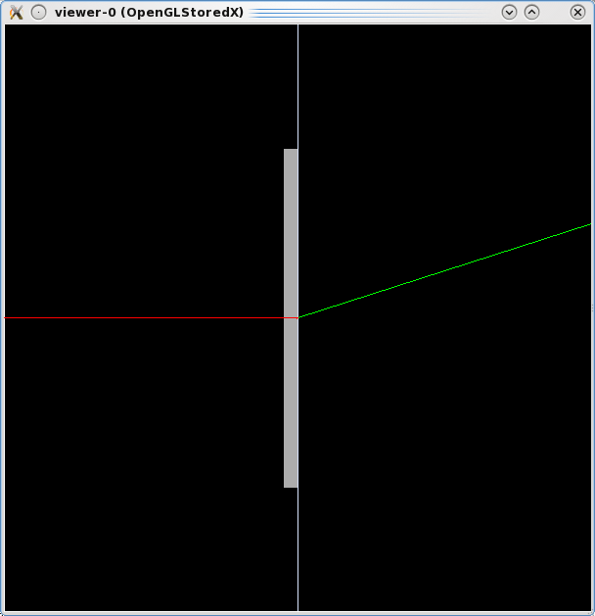 | 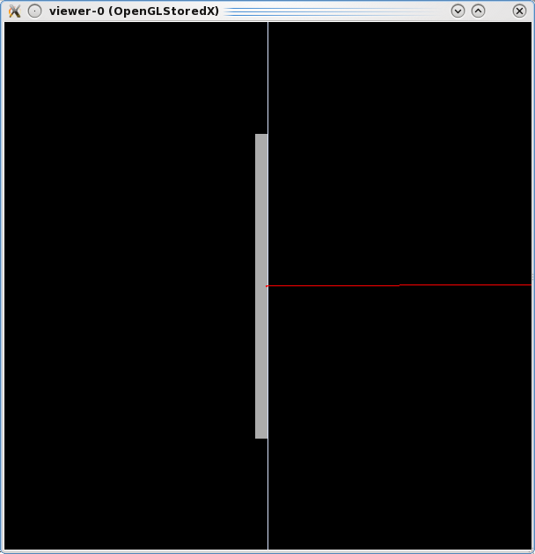 | 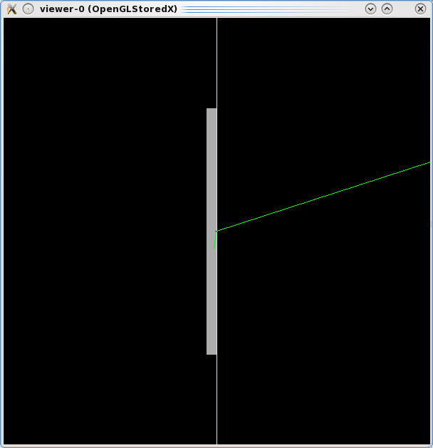
Figure 11 Original configuration, G4EmStandardPhysics_option4 PhysicsConstructor, simulation based on Geant4 10.1 (left), 10.0p04 (centre) and 9.6p03 (right). Green lines represent photons, red lines are electrons (which could be either primary or secondary ones).

Livermore Electromagnetic PhysicsConstructor
This option corresponds to instantiating a G4EmLivermorePhysics PhysicsConstructor in the PhysicsList. A macro vis_original_livermore.mac is supplied in the git repository, which encodes this configuration.
Please note that the multiple scattering configuration applied by G4EmLivermorePhysics involves “DistanceToBoundary” step limitation.
This simulation can be executed by means of the command:
$G4WORKDIR/Linux-g++/bssim vis_original_livermore.mac > original_livermore.out
A snapshot of the observed result is shown in Figure 12: backscattered electrons are not visible on the right side of the picture, only a tiny shower associated with the penetration of primary electrons is visible in the target.
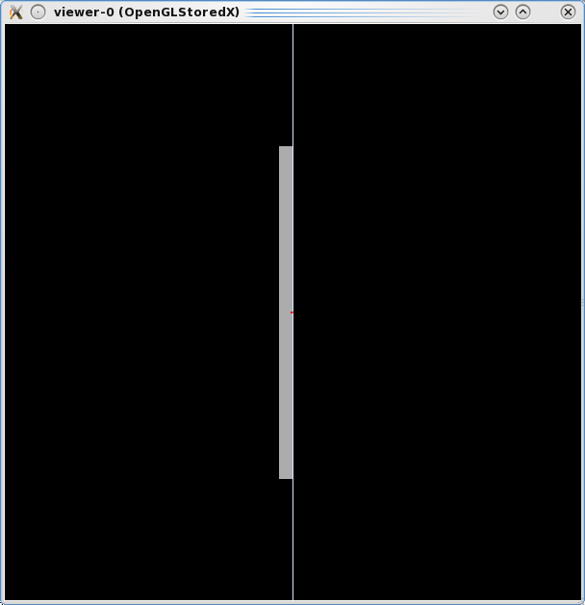
Figure 12 Original configuration, G4EmLivermorePhysics PhysicsConstructor, simulation based on Geant4 10.1: backscattered electrons are not visible on the right side of the picture.

Standard Electromagnetic PhysicsConstructor
This option corresponds to instantiating a G4EmStandardPhysics PhysicsConstructor in the PhysicsList. A macro vis_original_std.mac is supplied in the git repository, which encodes this configuration.
Please note that the multiple scattering configuration applied by G4EmStandardPhysics does not involve any step limitation explicitly.
This simulation can be executed by means of the command:
$G4WORKDIR/Linux-g++/bssim vis_original_std.mac > original_std.out
Snapshots of the observed results of the simulation obtained with Geant4 10.1, 10.0p04 and 9.6p03 are shown inFigure 13. Backscattered electrons are not visible with Geant4 10.1 and 10.0p04, while they are visible with Geant4 9.3p03. No snapshot related to Geant4 9.6p04 is shown as we have not installed Geant4 9.6p04 in our computing environment yet. The delay of installing Geant4 9.6p04 is due to lack of time so far, not of goodwill.
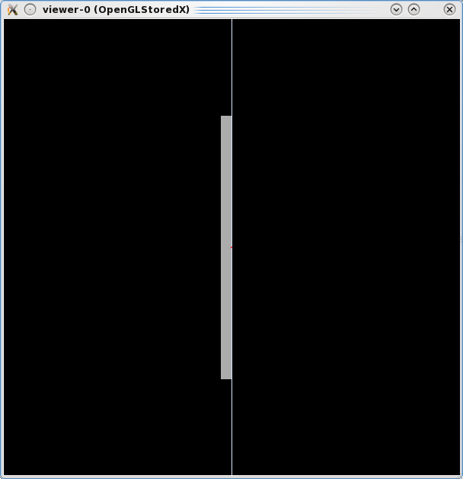 | 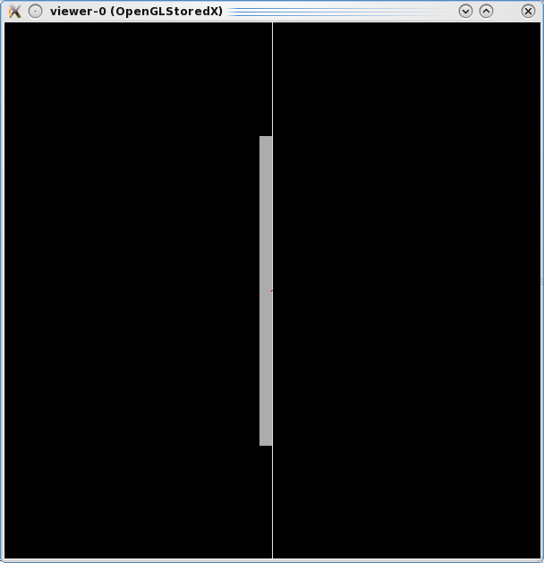 | 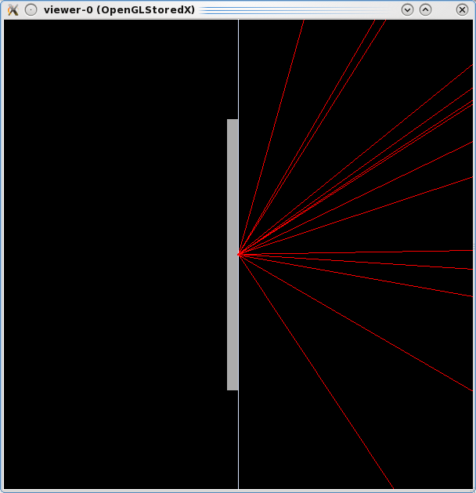
Figure 13 Original configuration, G4EmStandardPhysics PhysicsConstructor, simulation based on Geant4 10.1 (left), 10.0p04 (centre) and 9.6p03 (right).

Configurations with displaced target or source

Displaced target
The observed absence of backscattered electrons in configurations involving “DistanceToBoundary” step limitation (G4EmStandardPhysics_option3, G4EmStandardPhysics_option4, G4EmLivermorePhysics) hints to some possible interplay between multiple scattering and a volume boundary. This hypothesis can be investigated by displacing the target, which in original configuration is adjacent to the backward hemispherical cavity, in the forward direction along the z axis. This displacement would affect the acceptance of the detector, since part of the solid angle would not be covered, and consequently the quantification of the backscattering fraction would be altered; nevertheless, valuable qualitative information can be derived from this test case through the visualization of the outcome of the simulation.

Standard Electromagnetic option 3-4 and Livermore PhysicsConstructors
The /changeTarget/shiftZ command can be used to displace the target of the desired amount along the z axis. Macros vis_zshift_opt3.mac, vis_zshift_opt4.mac, vis_zshift_livermore.mac are supplied in the git repository to perform simulations with displaced targets and G4EmStandardPhysics_option3, G4EmStandardPhysics_option4 and G4EmLivermorePhysics; the displacement along z is set to 1 pm in these macros.
These simulations can be executed by means of the following commands, respectively:
$G4WORKDIR/Linux-g++/bssim vis_zshift_opt3.mac > zshift_opt3.out
$G4WORKDIR/Linux-g++/bssim vis_zshift_opt4.mac > zshift_opt4.out
$G4WORKDIR/Linux-g++/bssim vis_zshift_livermore.mac > zshift_livermore.out
Snapshots of the observed simulation outcome are shown in Figure 14; they are produced with Geant4 10.1 for the test cases with G4EmStandardPhysics_option3 and G4EmLivermorePhysics, and with Geant4 10.0p04 for G4EmStandardPhysics_option4 due to the previously mentioned apparent anomaly observed with Geant4 10.1 in this physics configuration. Backscattered electrons, which were not visible in these physics configurations in the original target position, are now visible.
This empirical observation of previously suppressed backscattering in physics configurations involving “DistanceToBoundary” step limitation suggests that in-depth investigations would be useful to identify the algorithm responsible for the observed behavior.

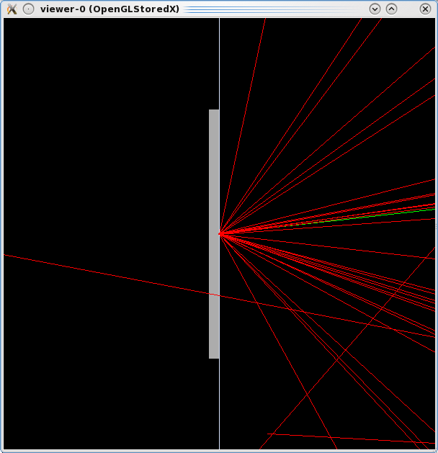 | 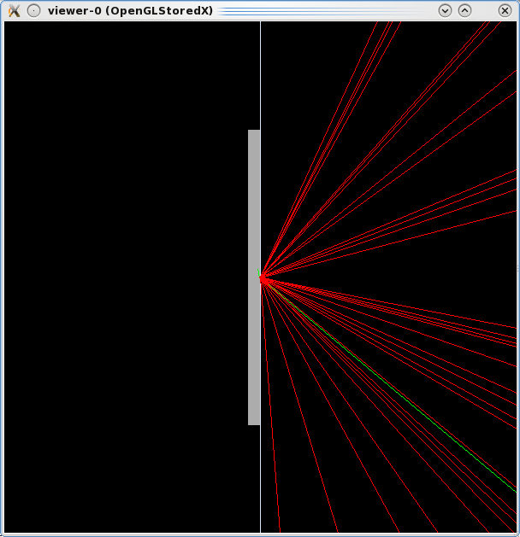 | 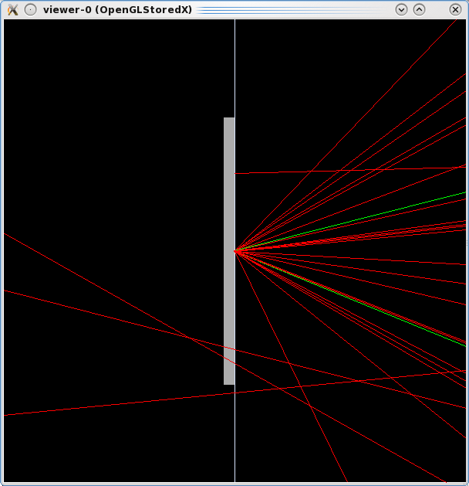
Figure 14 Configuration with target shifted by 1 pm along z: G4EmStandardPhysics_option3 (left) and G4EmLivermorePhysics (right) PhysicsConstructors with Geant4 10.1 (left), G4EmStandardPhysics_option4 (centre) with Geant4 10.0p04. Backscattered electrons, which were not visible in these physics configurations in the original target position, are now visible.
A displacement larger than 0.5 pm appears to be critical to avoid backscattering suppression with these physics configuration, as is shown in Figure 15: backscattering is suppressed with the G4EmLivermorePhysics physics configuration when the target is displaced along z by 0.499 pm (left side of Figure 15), while it is visible when it is displaced by at least 0.501 pm (right side of Figure 15). This empirical observation hints to some correlation with the concept of “surface thickness”.

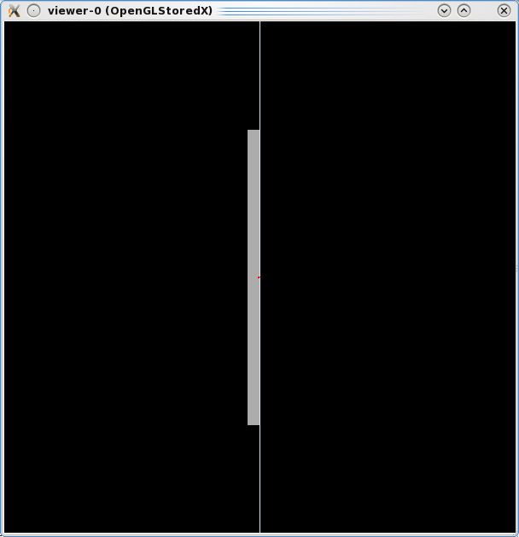 | 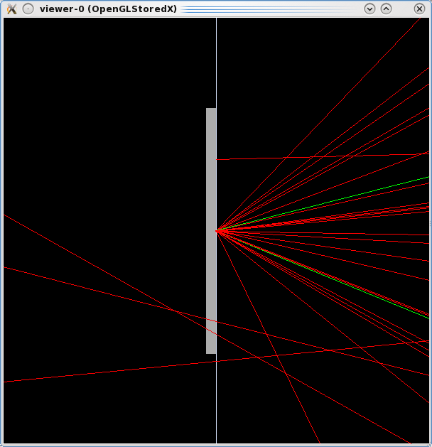
Figure 15 Configuration with target displaced along z and G4EmLivermorePhysics PhysicsConstructor: 0.499 pm displacement (left) and 0.501 pm (right). Backscattered electrons are visible when the target is displaced by more than 0.5 pm.

Standard Electromagnetic PhysicsConstructor
A displacement of the target along z also affects the behaviour observed with the G4EmStandardPhysics PhysicsConstructor. Backscattering, which appeared to be suppressed in the original configuration with Geant4 versions 10.1 and 10.0p04, is visible when the target is displaced, similarly to what is documented in the previous section. The effect is illustrated in Figure 16, which shows snapshots deriving from simulations based on Geant4 10.1 (left) and 10.0p04 (right), respectively. Backscattering remains visible with Geant4 9.6p03, as it was already with the original configuration. This empirical observation suggests that, although the G4EmStandardPhysics PhysicsConstructor did not explicitly involve “DistanceToBoundary” step limitation, it could perhaps involve directly or indirectly algorithms with relation to similar concepts, which exhibit similar sensitivity to the displacement of the target volume.
This test case can be reproduced by means of the vis_zshift_std.mac macro, which is supplied in the git repository. The displacement along z is set to 1 pm in this macro macro. The simulation can be executes through the command:
$G4WORKDIR/Linux-g++/bssim vis_zshift_std.mac > zshift_std.out

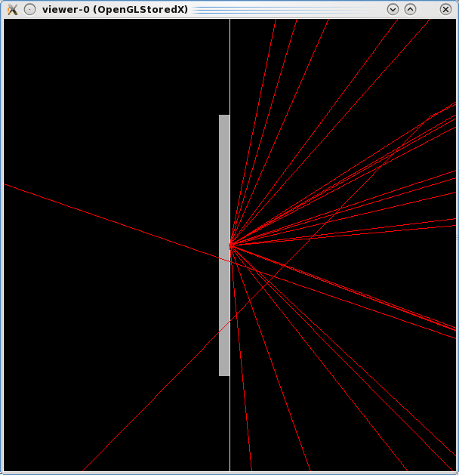 | 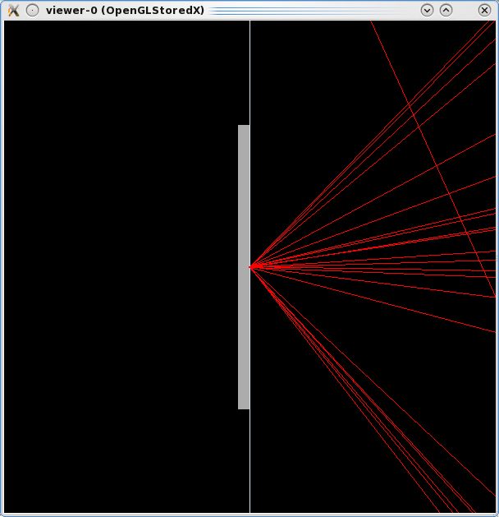
Figure 16 Configuration with target shifted by 1 pm along z and G4EmStandardPhysics PhysicsConstructor: simulation based on Geant4 10.1 (left) and 10.0p04 (right). Backscattered electrons, which were not visible in this physics configuration in the original target position, are now visible.

Other Electromagnetic PhysicsConstructors
Electron backscattering remains visible with G4EmStandardPhysicsSS, G4EmStandardPhysicsWVI G4EmStandardPhysics_option1 and G4EmStandardPhysics_option2 PhysicsConstructors, when the target is shifted along z. It was visible in the original target position with these physics settings.

Displaced primary particle source
Primary electrons are generated with momentum direction along the z axis and energy of 100 keV. In the original configuration the origin of primary electrons is placed in the point (0,0,0), i.e. on the boundary surface between the Target and Inside volumes.
The same investigations reported in section 4.1 can be repeated with a geometrical setup identical to the original configuration, but displacing the position of the primary particle source backwards (i.e. placing it in the “Inside” cavity rather than on the boundary surface between the “Inside” cavity and the target) by using the /source/zVertex command.
In the test cases illustrated below the primary particle’s z coordinate was displaced by 2 mm, i.e. the origin of primary electrons was placed in the point (0,0,-2), where the units are mm.

Standard Electromagnetic option 3-4 and Livermore PhysicsConstructors
Macros vis_zvtx_opt3.mac, vis_zvtxt_opt4.mac, vis_zvtx_livermore.mac are supplied in the git repository to perform simulations with displaced primary particle source and G4EmStandardPhysics_option3, G4EmStandardPhysics_option4 and G4EmLivermorePhysics.
These simulations can be executed by means of the following commands, respectively:
$G4WORKDIR/Linux-g++/bssim vis_zvtx_opt3.mac > zvtx_opt3.out
$G4WORKDIR/Linux-g++/bssim vis_zvtx_opt4.mac > zvtx_opt4.out
$G4WORKDIR/Linux-g++/bssim vis_zvtx_livermore.mac > zvtx_livermore.out
Snapshots of the observed simulation outcome are shown in Figure 17; they are produced with Geant4 10.1 for the test cases with G4EmStandardPhysics_option3 and G4EmLivermorePhysics, and with Geant4 10.0p04 for G4EmStandardPhysics_option4 due to the previously mentioned apparent anomaly observed with Geant4 10.1 in this physics configuration. Backscattered electrons, which were not visible in these physics configurations in the original primary source position, are now visible.
This empirical observation of previously suppressed backscattering suggests that in-depth investigations would be useful to identify the algorithm responsible for the observed behavior.
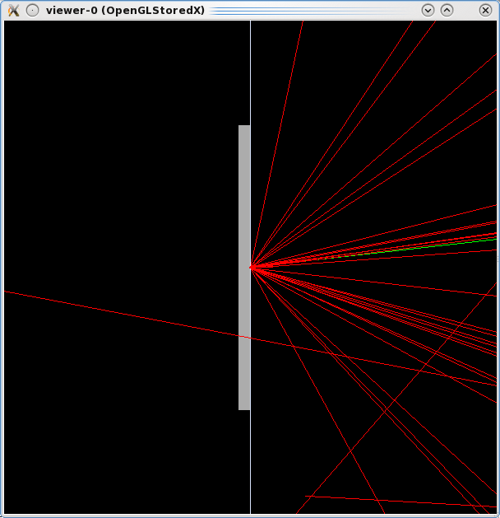 | 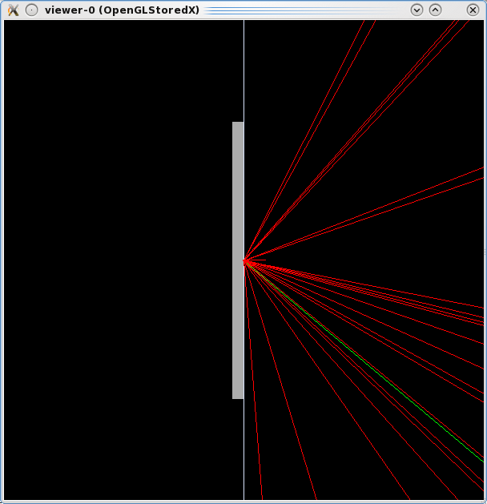 | 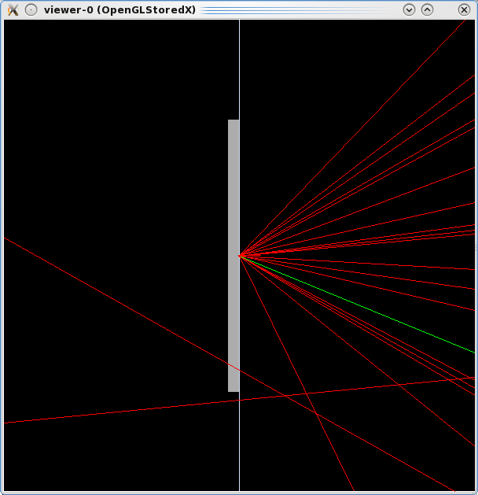
Figure 17 Configuration with primary source displaced by 2 mm backwards along z: G4EmStandardPhysics_option3 (left) and G4EmLivermorePhysics (right) PhysicsConstructors with Geant4 10.1 (left), G4EmStandardPhysics_option4 (centre) with Geant4 10.0p04. Backscattered electrons, which were not visible in these physics configurations in the original primary source position, are now visible.

Standard Electromagnetic PhysicsConstructor
A displacement of the primary source along z also affects the behaviour observed with the G4EmStandardPhysics PhysicsConstructor. Backscattering, which appeared to be suppressed in the original configuration with Geant4 versions 10.1 and 10.0p04, is visible when the primary source is displaced, similarly to what is documented in the previous section. The effect is illustrated in , which shows snapshots deriving from simulations based on Geant4 10.1 (left) and 10.0p04 (right), respectively. Backscattering remains visible with Geant4 9.6p03, as it was already with the original configuration.
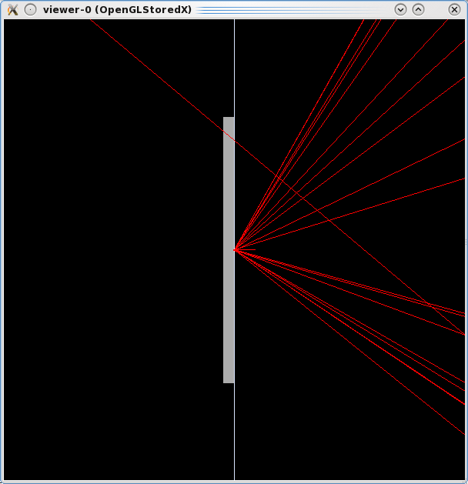 | 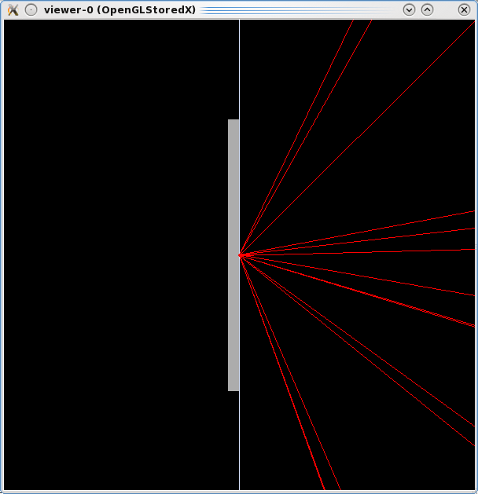
Figure 18 Configuration with primary particle source displaced by 2 mm along z and G4EmStandardPhysics PhysicsConstructor: simulation based on Geant4 10.1 (left) and 10.0p04 (right). Backscattered electrons, which were not visible in this physics configuration in the original target position, are now visible

Other Electromagnetic PhysicsConstructors
Electron backscattering remains visible with G4EmStandardPhysicsSS, G4EmStandardPhysicsWVI G4EmStandardPhysics_option1 and G4EmStandardPhysics_option2 PhysicsConstructors, when the primary particle source is displaced along z. It was also visible in the original position with these physics settings.

Configuration with a hierarchy of backward hemispheres
A test case involving a hierarchy of hemispheres (i.e. hemispheres placed inside one another) rather than independent volumes individually placed in the World was suggested by Gabriele Cosmo in the course of the investigations that followed the study documented in [1]. In this configuration the three volumes Detector, Coating and Inside are defined as full hemispheres, while in the original configuration Detector and Coating were hemispherical shells and Inside was a full hemisphere; their sizes and positions are the same as in the original configuration.
It is worthwhile to stress that this geometry arrangement was not implemented in the simulation used for [1].
A hierarchical arrangement of hemispheres can be selected through the command:
/changeDetector/hierarchy true
Possible overlaps of the volumes present in the simulation setup are checked by means of the appropriate flag in G4VPlacement; no overlaps are detected. As an example of the result of these checks, the relevant excerpt of the output produced by the simulation run described in section 5.1.1 is shown below in Figure 19.
userDetector->Construct() start.
Checking overlaps for volume Target ... OK!
Target placed in World
Checking overlaps for volume Detector ... OK!
Detector placed in hierarchy
Checking overlaps for volume Coating ... OK!
Coating placed in hierarchy
Checking overlaps for volume Inside ... OK!
Empty volume between target and coating placed in hierarchy
Figure 19 Excerpt of a simulation output showing the successful check of volume overlaps performed at geometry construction time with a hierarchy of three hemispheres.
For convenience, only the test cases with a hierarchy of hemispheres concerning the G4EmStandardPhysics_option3 PhysicsConstructor are reported below. Similar test cases involving other physics options can be easily reproduced modifying the macros available in the git repository for G4EmStandardPhysics_option3; to facilitate this operation, commands to select other physics options are already present in the macros, although commented out.

Hierarchical hemispheres, original target and primary source position
In this configuration the positions of the target and of the primary particle source are the same as in the original configuration. This simulation can be executed by means of the following commands:
$G4WORKDIR/Linux-g++/bssim vis_hiera_opt3.mac > hiera_opt3.out
Backscattered electrons are visible, as shown in Figure 20. Nevertheless, messages hinting to some anomaly appear in the simulation output; an excerpt is illustrated in Figure 21. No such messages were issued in the original configuration, where no hierarchy of hemispheres was present.
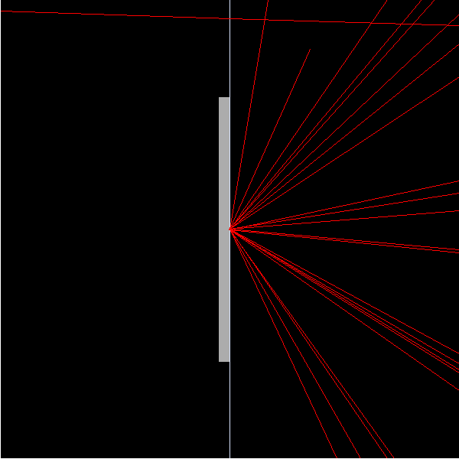
Figure 20 Configuration with a hierarchy of hemispheres, target and primary source positioned as in the original configuration, with G4EmStandardPhysics_option3 PhysicsConstructor: backscattered electrons are visible.
Figure 21 Excerpt of apparent anomalies in the simulation output involving a configuration with hierarchical hemispheres.
---> Begin of event: 0
-------- WWWW ------- G4Exception-START -------- WWWW -------
*** G4Exception : GeomNav1002
issued by : G4Navigator::ComputeStep()
Track stuck or not moving.
Track stuck, not moving for 10 steps
in volume -Coating- at point (0,0,0)
direction: (0,0,1).
Potential geometry or navigation problem !
Trying pushing it of 1e-07 mm ...Potential overlap in geometry!
*** This is just a warning message. ***
-------- WWWW -------- G4Exception-END --------- WWWW -------
G4VParticleChange::CheckIt : the true step length is negative !! Difference: 1e-07[MeV]
e- E=0.1 pos=0, 0, 1e-10
-----------------------------------------------
G4ParticleChange Information
-----------------------------------------------
# of 2ndaries : 0
-----------------------------------------------
Energy Deposit (MeV): 0
Non-ionizing Energy Deposit (MeV): 0
Track Status : Alive
True Path Length (mm) : -1e-07
Stepping Control : 0
Mass (GeV) : 0
Charge (eplus) : 0
MagneticMoment : 0
: = 0*[e hbar]/[2 m]
Position - x (mm) : 0
Position - y (mm) : 0
Position - z (mm) : 0
Time (ns) : 0
Proper Time (ns) : 0
Momentum Direct - x : 0
Momentum Direct - y : 0
Momentum Direct - z : 1
Kinetic Energy (MeV): 0.1
Velocity (/c): 0.548
Polarization - x : 0
Polarization - y : 0
Polarization - z : 0
Touchable (pointer) : 0x2f212b8
G4ParticleChange::CheckIt : the local time goes back !! Difference: 2.3139e-07[ns]
e- E=0.1 pos=0, 0, 3.80289e-08 global time=2.3139e-07 local time=2.3139e-07 proper time=1.93519e-07
G4ParticleChange::CheckIt : the proper time goes back !! Difference: 1.93519e-07[ns]
e- E=0.1 pos=0, 0, 3.80289e-08 global time=2.3139e-07 local time=2.3139e-07 proper time=1.93519e-07

Hierarchical hemispheres, displaced target
In this configuration the position of the primary particle source is the same as in the original configuration, while the target is displaced by 1 pm along z as in section 4.1.
This simulation can be executed by means of the following command:
$G4WORKDIR/Linux-g++/bssim vis_hiera_zshift_opt3.mac > hiera_zshift_opt3.out
Backscattered electrons are visible, as shown in Figure 22. Nevertheless, messages hinting to some anomaly appear in the simulation output, similar to those illustrated in Figure 21 concerning the previous use case.
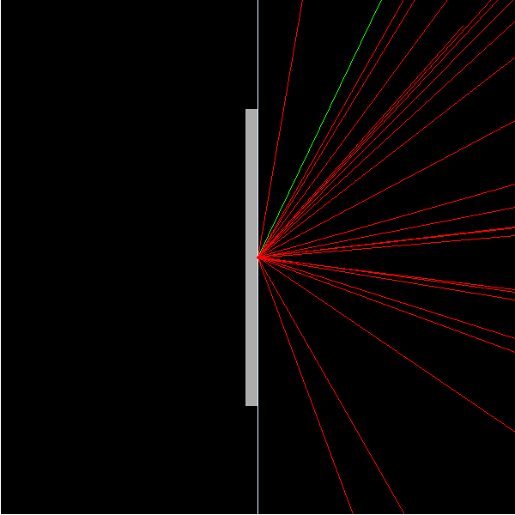
Figure 22 Configuration with a hierarchy of hemispheres, target displaced by 1 pm along z and primary source positioned as in the original configuration, G4EmStandardPhysics_option3 PhysicsConstructor: backscattered electrons are visible.

Hierarchical hemispheres, displaced primary source
In this configuration the position of the target is the same as in the original configuration, while the primary particle source is displaced backward by 2 mm along z as in section 4.2.
This simulation can be executed by means of the following command:
$G4WORKDIR/Linux-g++/bssim vis_hiera_zvtx_opt3.mac > hiera_zvtx_opt3.out
Backscattered electrons are visible, as shown in Figure 23. Nevertheless, messages hinting to some anomaly appear in the simulation output, as illustrated in Figure 24. It is worthwhile to note that these anomalies are only partly similar to those illustrated in Figure 21 concerning the previous use cases, as they do not encompass enay “G4Exception: GeomNav1002”.
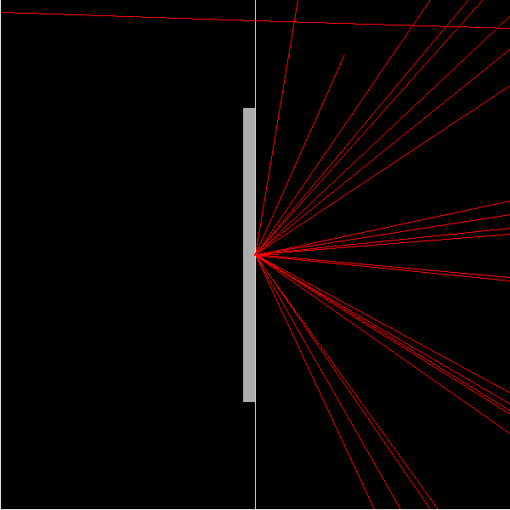
Figure 23 Configuration with a hierarchy of hemispheres, target as in the original configuration and primary source displaced backward by 2 mm along z, G4EmStandardPhysics_option3 PhysicsConstructor: backscattered electrons are visible.
Figure 24 Excerpt of apparent anomalies in the simulation output corresponding to a configuration with hierarchical hemispheres and displaced target.
---> Begin of event: 0
G4ParticleChange::CheckIt : the local time goes back !! Difference: 2.3139e-07[ns]
e- E=0.1 pos=0, 0, 3.80289e-08 global time=0.0121694 local time=0.0121694 proper time=0.0101777
G4ParticleChange::CheckIt : the proper time goes back !! Difference: 1.93519e-07[ns]
e- E=0.1 pos=0, 0, 3.80289e-08 global time=0.0121694 local time=0.0121694 proper time=0.0101777
-----------------------------------------------
G4ParticleChange Information
-----------------------------------------------
# of 2ndaries : 0
-----------------------------------------------
Energy Deposit (MeV): 0
Non-ionizing Energy Deposit (MeV): 0
Track Status : Alive
True Path Length (mm) : -3.8e-05
Stepping Control : 0
Mass (GeV) : 0
Charge (eplus) : 0
MagneticMoment : 0
: = 0*[e hbar]/[2 m]
Position - x (mm) : 0
Position - y (mm) : 0
Position - z (mm) : 0
Time (ns) : 0.0122
Proper Time (ns) : 0.0102
Momentum Direct - x : 0
Momentum Direct - y : 0
Momentum Direct - z : 1
Kinetic Energy (MeV): 0.1
Velocity (/c): 0.548
Polarization - x : 0
Polarization - y : 0
Polarization - z : 0
Touchable (pointer) : 0x32db2c0

Comments and questions
We stress that the study reported in [1] and its follow-up are just scientific research projects that document observables simulated with public versions of an open source Monte Carlo code (Geant4) with respect to experimental data available in the literature. There is no hidden intent to exalt, nor to denigrate any persons, institutes, computer codes, theoretical, phenomenological or empirical physics models.
Some inconsistencies appear in the simulation outcome of different configurations, apart from some understandable differences that may derive from intrinsic characteristics of some physics modeling approaches (e.g. it is not surprising that a single Coulomb scattering model would produce a more accurate backscattering observable than other physics settings intended for fast simulation). An apparent inconsistency is the suppression of electron backscattering with some physics configurations, while in the same scenario backscattering is observed with other physics configurations (e.g. backscattering seen with G4EmStandardPhysics_option2, but not with G4EmStandardPhysics_option3 in the original configuration. Another apparent inconsistency is related to the presence or suppression of electron backscattering in a given physics configuration, depending on the position of the target or of the primary particle source.
It is unclear whether these inconsistencies derive from peculiarities of the simulation scenario or from other algorithms. Investigations to clarify the current situation are desirable. From an experimental user’s perspective, one can formulate some questions:
- Is the boundary surface between the target and the Inside hemisphere compatible with currently implemented algorithms involved in electron transport? If it is not, it would be desirable that appropriate actions are taken to prevent the creation of user geometries incompatible with existing algorithms, or to modify current algorithms to address such a requirement. If it is, guidelines for ensuring consistent behaviour would be helpful.
- Is the generation of primary particles at volume boundaries, with well-defined direction and energy, supported by current algorithms? If not, it would be desirable that appropriate actions are taken to prevent the creation of user geometries involving the generation of primary particles at boundary surfaces that are not supported, or to modify current algorithms to support such experimental scenarios. If it is supported indeed, guidelines for ensuring consistent behaviour would be helpful.
- How much can the geometry checks done when instantiating a placement be trusted? Should shared surfaces be treated as overlaps?
- What is the origin of the apparent anomalies reported in the output of simulations with a hierarchy of hemispheres? Why don’t these messages appear in simulations with independently placed hemispherical shells and hemisphere?
- Are capabilities and limitations of implemented algorithms documented in proper venues (Geant4 documentation and the literature)? If not (or not yet completely), what effort can be put in place to improve the current situation? Let’s not forget that the presence of epistemic uncertainties (i.e. gaps of knowledge) in a software system can be source of systematic effects in observables produced by it.
Help to devise the answers would be appreciated.

Conclusions
An investigation of the behaviour of backscattering simulation documented in [1] has been performed. The source code to reproduce it is publicly available in GitHub; this document serves both as documentation about how to use the application and as research guideline for further investigations.
Electron backscattering appears to be produced in some simulation configurations (e.g. involving G4EmStandardPhysicsSS, G4EmStandardPhysicsWVI G4EmStandardPhysics_option1 and G4EmStandardPhysics_option2 PhysicsConstructors), while its presence appears to be affected by the position of the target or of the primary particle source in other configurations of electromagnetic PhysicsConstructors. No volume overlaps are signalled by geometry checks at construction time. Messages hinting to some anomalies appear in the course of simulations involving a hierarchy of hemispheres.
The outcome of this investigation hints to some interplay between algorithms pertaining to the domains of geometry, physics and primary particle generation. More research is needed to understand the origin of the observed behaviour. The identification and documentation of methods and tools to model realistic experimental scenarios of backscattering experiments, and to produce consistent simulated observables, would be helpful.

Acknowledgements
The authors thank Gabriele Cosmo for valuable discussions.

References
- S. H. Kim et al., “Validation Test of Geant4 Simulation of Electron Backscattering”, IEEE Trans. Nucl. Sci., vol. 62, no. 2, pp. 451-479, 2015.
- S. Agostinelli et al., “Geant4 - a simulation toolkit,” Nucl. Instrum. Methods Phys. Res. A, vol. 506, no. 3, pp. 250–303, 2003.
- J. Allison et al., “Geant4 developments and applications,” IEEE Trans. Nucl. Sci., vol. 53, no. 1, pp. 270–278, 2006.
- L. Lönnblad, “CLHEP—a project for designing a C++ class library for high energy physics”, Comp. Phys. Comm., vol. 84, pp. 307-316, 1994.

