Observation of electron backscattering produced with G4CoulombScatteringModel and G4eSingleCoulombScattering Model

T. Basaglia1, M. C. Han2, G. Hoff3, C. H. Kim2, S. H. Kim2, M. G. Pia4, P. Saracco4

*1CERN, Geneva, Switzerland*

*2Hanyang University, Seoul, Korea*

*3CAPES, Brasilia, Brazil*

*4INFN Sezione di Genova, Italy*

Corresponding author: Maria.Grazia.Pia@cern.ch

**Abstract**. An investigation is documented to verify whether backscattered electrons are visible with G4CoulombScatteringModel and with G4eSingleCoulombScatteringModel in the same experimental scenario.

1. Introduction

This document describes how to observe features of electron backscattering in various Geant4 [1][2] based simulation configurations involving single scattering in the physics settings.

The investigations described in this note were carried out with Geant4 version geant4-10-02-ref-01, released on 31 January 2016; similar results, concerning the apparent absence of backscattered electrons with G4eSingleCoulombScatteringModel [3][4], were also observed with geant4-10-02-cand-03 in December 2015 and were reported to the authors (Mauro.Tacconi@mib.infn.it) on 8 December 2015. M. Tacconi replied on 28 January 2016 that he sees backscattered electrons with test58 and informed us that “nella nuova patch in uscita abbiamo corretto un problema sotto i 223 keV dove non venivano generate interazioni” (*in the new patch to be going out we corrected a problem below 223 keV where no interactions were generated*).

The apparent inconsistency between what is observed by the authors of G4eSingleCoulombScatteringModel and by us in apparently identical simulation scenarios is presumably due to a mismatch in the information conveyed to users, or in our misunderstanding of it. Hopefully, this note will help clarifying the apparent inconsistency in observing backscattered electrons with G4eSingleCoulombScatteringModel.

1. Simulation code and settings

The testing environment for electron backscattering simulation described here has been previously described and made available to the management of the Geant4 collaboration (and to the public at large). Therefore this document includes only a brief summary of the main features of the code, with focus on extensions and settings that are specific to testing G4CoulombScatteringModel and G4eSingleCoulombScattering Model.

## Source code

The open source *bssim* simulation code, based on Geant4, is publicly available in a git repository at <https://github.com/mariagraziapia/bssim>.

## Geometry

The experimental model implemented in *bssim* is sketched in Figure 1; the sizes are not to scale for better visibility of the various components. It consists of a Target (G4Box) and a detection system placed in the backward hemisphere, which mimics typical experimental setups for electron backscattering measurements documented in the literature. The backward detection system consists of a hemispherical shell (Detector), a hemispherical shell (Coating) and a hemispherical cavity, which may be filled with galactic vacuum or another gas consistent with experimental specifications. The centre of the spheres corresponding to the hemispherical shells and hemispherical cavity is in (0,0,0). All volumes are placed in the World. The Target and Inside volumes are adjacent (i.e. they share a boundary surface at z=0). The Inside, Coating and Detector volumes are also adjacent (i.e. outer radius of the inner component = inner radius of the outer component).

Possible overlaps of the volumes present in the simulation setup are checked by means of the appropriate flag in G4VPlacement; no overlaps are detected.

Given the simplicity of the experimental configuration, no attempts were made to optimize the geometrical model for computational performance, since this is not a concern in the investigated experimental scenario.

The geometry is encoded in the DetectorConstruction class with default parameters reproducing a typical experimental configuration with a semi-infinite target.

Target

Inside

Detector

Coating

Figure 1 Sketch of the experimental configuration (not to scale).

## Physics configuration

The *bssim* simulation can be configured with predefined electromagnetic PhysicsConstructors distributed with Geant4. Three additional PhysicsConstructors are available in the git repository specifically for the investigation of single scattering models. The available physics configurations are listed in Table 1.

|  |  |
| --- | --- |
| **PhysicsConstructor** | **Description** |
| G4EmLivermorePhysics | Predefined Geant4 electromagnetic PhysicsConstructor |
| G4EmStandardPhysics | Predefined Geant4 electromagnetic PhysicsConstructor |
| G4EmStandardPhysics_option1 | Predefined Geant4 electromagnetic PhysicsConstructor |
| G4EmStandardPhysics_option2 | Predefined Geant4 electromagnetic PhysicsConstructor |
| G4EmStandardPhysics_option3 | Predefined Geant4 electromagnetic PhysicsConstructor |
| G4EmStandardPhysics_option4 | Predefined Geant4 electromagnetic PhysicsConstructor |
| G4EmStandardPhysicsGS | Predefined Geant4 electromagnetic PhysicsConstructor |
| G4EmStandardPhysicsSS | Predefined Geant4 electromagnetic PhysicsConstructor |
| G4EmStandardPhysicsWVI | Predefined Geant4 electromagnetic PhysicsConstructor |
| EmStandardPhysicsSSM | Clone of G4EmStandardPhysicsSS, modified to force the use of G4eSingleCoulombScatteringModel |
| PhysListEmStandardISS | Clone of test58/PhysListEmStandardISS, modified to encompass hardcoded *th = 21 eV* setting, reproducing the setting of *th* in test58/SiElectron.mac |
| PhysListEmStandardSSM | Clone of TestEm5/PhysListEmStandardSSM |

Table 1 Physics configurations available in bssim.

## How to run bssim simulations

The simulation assumes a Scientific Linux 6 (SL6) environment, with appropriate C++ compiler supporting Geant4 10.2 features (we used gcc 4.9.3. in our computing environment).

The procedure to create an executable simulation is outlined in Figure 2.

The simulation can be executed by the command:

$G4WORKDIR/Linux-g++/bssim macroName.mac > optionalOutputFile

where macroName.mac is one of the macro files mentioned in the following sections.

The snapshots included in the following sections, taken with KSnapshot, derive from the execution of the simulation application based on Geant4 10.2, tag geant4-10-02-ref-01, unless explicitly stated otherwise. They are the result of the accumulation of several simulated events (>100 in general) superimposed on the same scene.

Figure 2 - Procedure to build the simulation executable.

* Setup the environment corresponding to the desired Geant4 version, e.g. for Geant4 10.2, tag geant4-10-02-ref-01:

cd *[your_path_to]*/bssim/setup

source setup102ref01.csh *(to be previously adapted to reflect the user’s own environment)*

* Create Geant4 libraries (unless Geant4 is already installed in the user’s computational environment):

cd $G4INSTALL/source

gmake

* Get the *bssim* simulation application code from https://github.com/mariagraziapia/bssim by cloning the git repository or downloading the code as a zip file, as documented in
* Build the simulation application:

cd *[your_path_to]/*bssim/

gmake

## Macros for single scattering simulations

The macros listed in Table 2 are provided in <https://github.com/mariagraziapia/bssim> specifically for this investigation of electron single scattering. They enable a simulation with a silicon target, shaped as a box of size 25x25x5 mm and a beam of 1 MeV electrons orthogonally incident on it. According to the Geant4 Physics Reference Manual, Version: geant4 10.2 (4 December 2015), chapter 6, section 6.7, p. 97, “this model well simulates the interacting process for low scattering angles and it is suitable for high energy electrons (from 200 keV) incident on medium light target nuclei”, the experimental configuration encoded in the macros corresponds to the domain of applicability of G4eSingleCoulombScatteringModel (which presumably is mistyped in section 6.7 of the Geant4 Physics Reference Manual as G4eSingleScatteringModel, while it is listed correctly in section 6.2, p. 66).

|  |  |
| --- | --- |
| Macro | **Description** |
| vis_mott_ss.mac | For simulation with G4EmStandardPhysicsSS |
| vis_mott_ssm.mac | For simulation with EmStandardPhysicsSSM *(clone of G4EmStandardPhysicsSS)* |
| vis_mott_test58.mac | For simulation with PhysListEmStandardISS *(clone of test58/PhysListEmStandardISS)* |
| vis_mott_TestEm5.mac | For simulation with PhysListEmStandardSSM *(clone of TestEm5/PhysListEmStandardSSM)* |

Table 2 Macros to investigate electron backscattering produced with single scattering models.

1. Single scattering simulations

Four simulation configurations are investigated:

1. Simulation with G4CoulombScattering, predefined in G4EmStandardPhysicsSS
2. Simulation with G4eSingleCoulombScattering, with a clone of G4EmStandardPhysicsSS
3. Simulation with G4eSingleCoulombScattering, with a clone of test58/PhysListEmStandardISS
4. Simulation with G4eSingleCoulombScattering, with a clone of TestEm5/PhysListEmStandardSSM

## G4CoulombScattering: simulation with G4EmStandardPhysicsSS

This option corresponds to instantiating a G4EmStandardPhysicsSS PhysicsConstructor in the PhysicsList, which uses G4CoulombScatteringModel. A macro vis_mott_ss.mac is supplied in the git repository, which encodes this configuration.

This simulation can be executed by means of the command:

$G4WORKDIR/Linux-g++/bssim vis_mott_ss.mac

A snapshot of the observed backscattering is shown in Figure 3: backscattered electrons are visible as red lines on the right side of the picture.

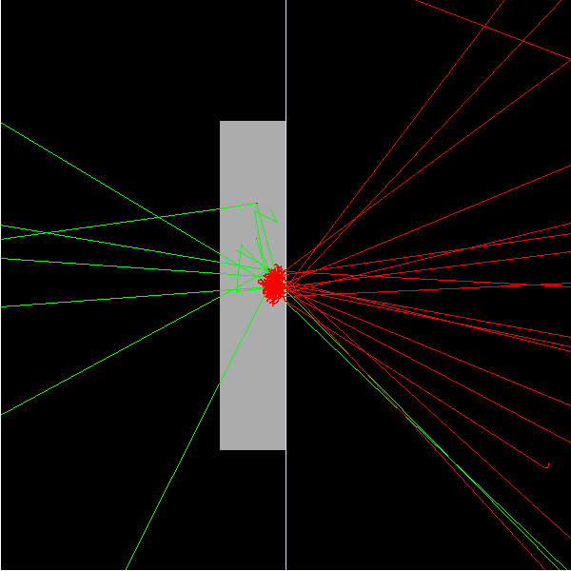

Figure 3 Simulation with G4CoulombScatteringModel, instantiated in the G4EmStandardPhysicsSS PhysicsConstructor: backscattered electrons are clearly visible as red lines on the right side; green lines represent photons.

## G4eSingleCoulombScattering: simulation with a clone of G4EmStandardPhysicsSS

This option corresponds to instantiating a EmStandardPhysicsSSM PhysicsConstructor in the PhysicsList, which is a clone of G4EmStandardPhysicsSS, modified to force the use of G4eSingleCoulombScatteringModel. Please note that the option of using G4eSingleCoulombScatteringModel was originally present in G4EmStandardPhysicsSS; the modification consists of just forcing this option to be always active.

A macro vis_mott_ssm.mac is supplied in the git repository, which encodes this configuration. This simulation can be executed by means of the command:

$G4WORKDIR/Linux-g++/bssim vis_mott_ssm.mac

A snapshot of the outcome is shown in Figure 4: backscattered electrons are not visible. It is also worthwhile to note that the shower shape in the target looks qualitatively different in the two simulations, which are executed in the same experimental scenario and with the same physics code of G4EmStandardPhysicsSS, apart from replacing G4CoulombScatteringModel with G4eSingleCoulombScatteringModel.

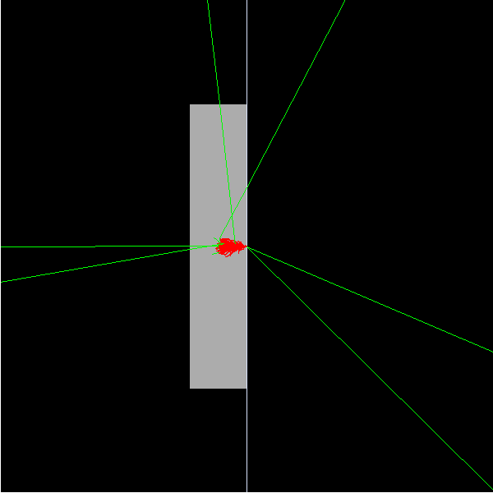

Figure 4 Simulation with G4eSingleCoulombScattering, instantiated in a clone of the G4EmStandardPhysicsSS PhysicsConstructor: backscattered electrons are not visible; red lines represent electrons, green lines represent photons.

## G4eSingleCoulombScattering: simulation with a clone of test58/PhysListEmStandardISS

This option corresponds to instantiating a PhysListEmStandardISS PhysicsConstructor in the PhysicsList (a clone of test58/PhysListEmStandardISS), which uses G4eSingleCoulombScatteringModel. Test58 was pointed out by the authors of G4eSingleCoulombScatteringModel as an example about how to use it.

A macro vis_mott_test58.mac is supplied in the git repository, which encodes this configuration. This simulation can be executed by means of the command:

$G4WORKDIR/Linux-g++/bssim vis_mott_test58.mac

A snapshot of the outcome is shown in Figure 5: backscattered electrons are not visible.

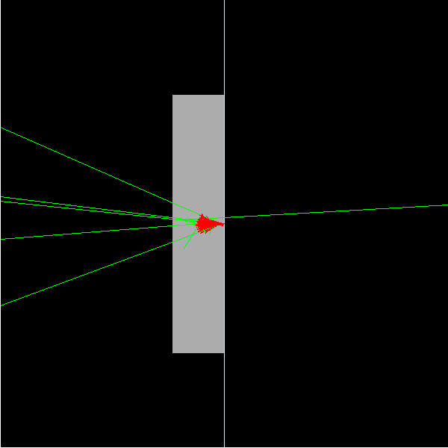

Figure 5 Simulation with G4eSingleCoulombScattering, instantiated in a clone of test58/ PhysListEmStandardISS: backscattered electrons are not visible; red lines represent electrons, green lines represent photons.

## G4eSingleCoulombScattering: simulation with a clone of TestEm5/PhysListEmStandardSSM

This option corresponds to instantiating a PhysListEmStandardSSM PhysicsConstructor in the PhysicsList (a clone of TestEm5/PhysListEmStandardSSM), which uses G4eSingleCoulombScatteringModel.

A macro vis_mott_TestEm5.mac is supplied in the git repository, which encodes this configuration. This simulation can be executed by means of the command:

$G4WORKDIR/Linux-g++/bssim vis_mott_TestEm5.mac

A snapshot of the outcome is shown in Figure 6: backscattered electrons are not visible.

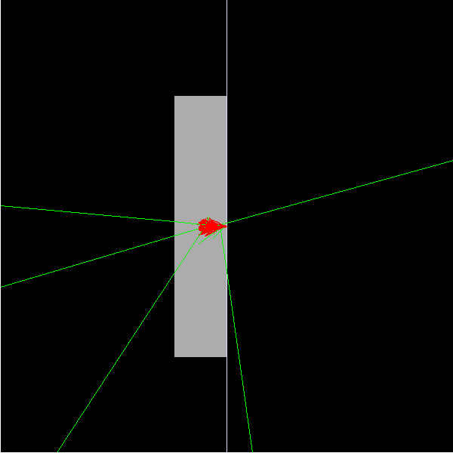

Figure 6 Simulation with G4eSingleCoulombScattering, instantiated in a clone of TestEm5/PhysListEmStandardSSM: backscattered electrons are not visible; red lines represent electrons, green lines represent photons.

1. Cross-check with G4EmStandardPhysics

A simulation in the same experimental scenario was executed with G4EmStandardPhysics for verification. A macro vis_mott_std.mac is supplied in the git repository, which encodes this configuration. This simulation can be executed by means of the command:

$G4WORKDIR/Linux-g++/bssim vis_mott_std.mac

A snapshot of the outcome is shown in Figure 7: backscattered electrons are visible as red lines on the right side of the picture.

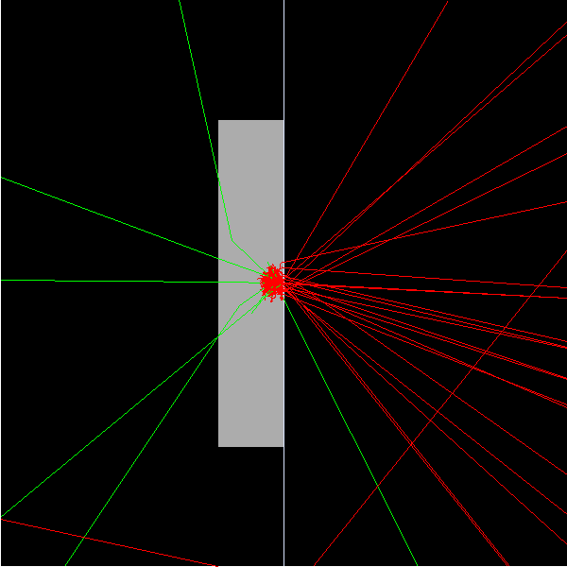

Figure 7 Simulation with the G4EmStandardPhysics PhysicsConstructor: backscattered electrons are clearly visible as red lines on the right side; green lines represent photons.

1. Conclusions

In the same experimental scenario, geometrical model and primary particle generation configuration, backscattered electrons are visible in simulations involving G4CoulombScatteringModel (e.g. using G4EmStandardPhysicsSS), while they do not appear in simulations involving G4eSingleCoulombScatteringModel, which use PhysicsConstructors cloned from G4EmStandardPhysicsSS, test58/PhysListEmStandardISS and TestEm5/PhysListEmStandardSSM.

Since the authors of G4eSingleCoulombScatteringModel stated that they can see backscattered electrons with test58, the apparent discrepancy of observations is presumably due to a mismatch in the instructions about how to use G4eSingleCoulombScatteringModel available to users, or our misunderstanding of them. A clarification would be appreciated; hopefully this detailed report can be helpful to identify the correct settings to observe backscattered electrons with G4eSingleCoulombScattering in the *bssim* simulation scenario.

Acknowledgements

The authors thank Mauro Tacconi for information about G4eSingleCoulombScatteringModel.

The EmStandardPhysicsSSM, PhysListEmStandardISS and PhysListEmStandardSSM PhysicsConstructors included in *bssim* have been cloned for testing purpose from G4EmStandardPhysicsSS, test58/PhysListEmStandardISS and TestEm5/PhysListEmStandardSSM, respectively. Credit for their code goes to their original authors.

References

1. S. Agostinelli et al., “Geant4 - a simulation toolkit,” *Nucl. Instrum. Methods Phys. Res. A*, vol. 506, no. 3, pp. 250–303, 2003.
2. J. Allison et al., “Geant4 developments and applications,” *IEEE Trans. Nucl. Sci*., vol. 53, no. 1, pp. 270–278, 2006.
3. M. Boschini et al., Nuclear and Non-Ionizing Energy-Loss of Electrons with Low and Relativistic Energies in Materials and Space Environment, Proc. of the ICATPP Conference on Cosmic Rays for Particle and Astroparticle Physics, October 3–7 (2011), Villa Olmo, Como, Italy, S. Giani, C. Leroy, L. Price, P. G. Rancoita and R. Ruchri, Editors, World Scientific, Singapore (2012); arXiv 1111.4042.
4. M. Boschini et al., Rad. Phys. Chem. 90 (2013), 39–66.